LAB 1
Define SPA and its benefits.
SPA (Single-Page Application) is a web application that dynamically updates a single HTML page without reloading the entire page during navigation.
Benefits:
- Faster user experience
- Less bandwidth usage
- Smooth transitions (no full page reload)
- Reusable components
Define React and Identify Its Working.
React is a JavaScript library developed by Facebook for building fast and interactive user interfaces.
How React Works:
- Uses components to build UI
- Uses Virtual DOM to optimize updates
- Renders changes efficiently with reconciliation
Differences Between SPA and MPA.
Feature | SPA | MPA
Page Load | Loads once, dynamic content updates | Loads new pages for each request
Speed | Faster after first load | Slower with full page reloads
SEO | Harder (requires SSR for best SEO) | Easier (each page is separate)
Development | Mostly client-side | Server + client-side
Pros & Cons of SPA
Pros:
- Fast navigation
- Responsive UI
- Reduced server load
Cons:
- Poor SEO (unless SSR used)
- First load can be large
- More complex front-end logic

Explain About React
React is:
- Component-based
- Declarative (you describe what UI should look like)
- Maintained by Meta (Facebook)

Define Virtual DOM
Virtual DOM is:
- A lightweight copy of the real DOM
- React uses it to detect changes and update only the changed parts of the DOM efficiently.

Features of React
- Component-Based Architecture
- JSX (JavaScript + HTML)
- Virtual DOM
- Unidirectional Data Flow
- React Hooks (for state and effects).

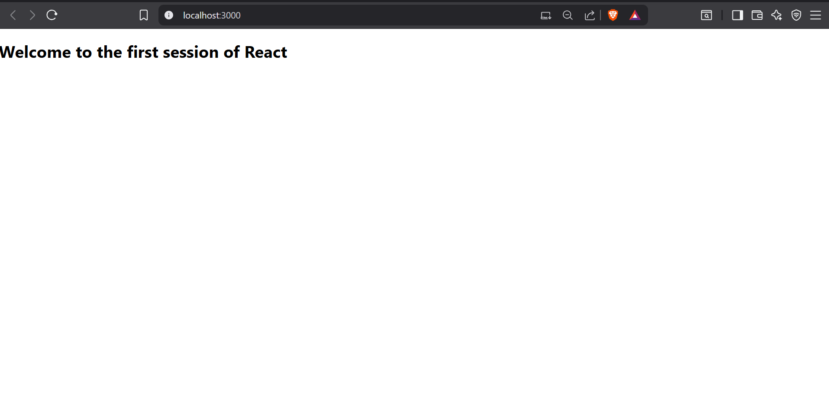
App.js
import React from 'react';
function App() {
return (
<div>
<h1>Welcome to the first session of React</h1>
</div>
);
}
export default App;

LAB 2
1. Explain React Components
A React component is a self-contained, reusable building block of a UI (User Interface). Think of it like a Lego block — each block represents part of the UI, and when combined, they make the full application.
There are two main types of components:
- Class Components (older, but still used)
- Function Components (modern, preferred way)

2. Identify the Differences Between Components and JavaScript Functions
Feature | React Components | JavaScript Functions
Purpose | Build UI and manage rendering logic | Perform operations or return values
Syntax | Use JSX (JavaScript + HTML-like syntax) | Use plain JavaScript
Return Type | Returns JSX (UI elements) | Returns primitive values or objects
Lifecycle Methods | Supported (in class components) | Not applicable
State Management | Can manage state and hooks | Cannot manage React state by default

3. Identify the Types of Components
React has two primary types of components:
- Class Components
  - Created using class keyword
  - Must have a render() method
  - Can use lifecycle methods like componentDidMount()
- Function Components
  - Created using plain JavaScript functions
  - Use React Hooks like useState, useEffect
  - More concise and preferred in modern React

4. Explain Class Component
A Class Component is a traditional way of writing React components using ES6 class syntax. It looks like this:
jsx
CopyEdit
class MyComponent extends React.Component {
render() {
return <h1>Hello from class component</h1>;
}
}
Features:
- Uses render() method to return JSX
- Can have a constructor for initializing state
- Supports lifecycle methods

5. Explain Function Component
A Function Component is a simpler way to create components using a function:
jsx
CopyEdit
function MyComponent() {
return <h1>Hello from function component</h1>;
}
Or with arrow function:
jsx
CopyEdit
const MyComponent = () => <h1>Hello</h1>;
With state using Hooks:
jsx
CopyEdit
const Counter = () => {
const [count, setCount] = useState(0);
return <button onClick={() => setCount(count + 1)}>Click {count}</button>;
};

6. Define Component Constructor
The constructor in a class component is a special function that runs when the component is created. It’s often used to:
- Initialize state
- Bind event handlers
Example:
jsx
CopyEdit
class MyComponent extends React.Component {
constructor(props) {
super(props);
this.state = { name: 'React' };
}
}
Note: super(props) must be called to use this.props.
7. Define render() Function
The render() function is required in class components and is used to describe what the UI should look like. It returns JSX.
Example:
jsx
CopyEdit
render() {
return (
<div>
<h1>Hello from render()</h1>
</div>
);
}

About.js
import React from 'react';

class About extends React.Component {
render() {
return (
<div>
<h2>Welcome to the About page of the Student Management Portal</h2>
</div>
);
}
} export default Contact;

Contact.js
import React from 'react';

class Contact extends React.Component {
render() {
return (
<div>
<h2>Welcome to the Contact page of the Student Management Portal</h2>
</div>
);
}
}

export default Contact;
home.js
import React from 'react';

class Home extends React.Component {
render() {
return (
<div>
<h2>Welcome to the Home page of Student Management Portal</h2>
</div>
);
}
}

export default Home;

App.js
import React from 'react';
import './App.css';
import Home from './components/home';
import About from './components/About';
import Contact from './components/contact';

function App() {
return (
<div className="App">
<Home />
<About />
<Contact />
</div>
);
}

export default App;

OUTPUT
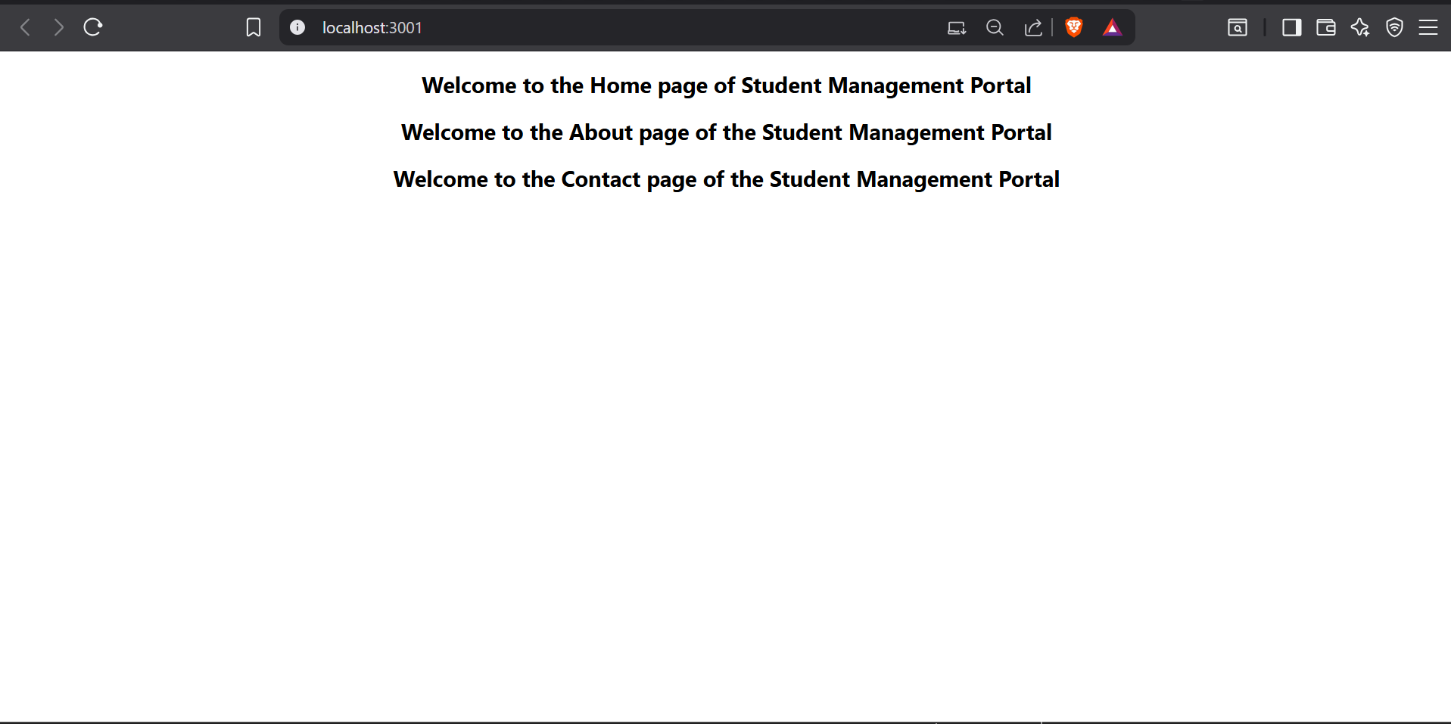

LAB 3
App.js
import React from 'react';
import { CalculateScore } from './Components/CalculateScore';

function App() {
return (
<div>
<CalculateScore
Name="Steeve"
School="DNV Public School"
total={284}
goal={3}
/>
</div>
);
}

export default App;

CalculateScore.js
import '../Stylesheets/mystyle.css';

const percentToDecimal = (decimal) => {
return (decimal ).toFixed(2) + '%';
};

const calcScore = (total, goal) => {
return percentToDecimal(total / goal);
};

export const CalculateScore = ({ Name, School, total, goal }) => (
<div className="formatstyle">
<h1 className="heading">Student Details:</h1>

<div className="Name">
<b><span> Name: </span></b>
<span>{Name}</span>
</div>

<div className="School">
<b><span> School: </span></b>
<span>{School}</span>
</div>

<div className="Total">
<b><span>Total:</span></b>
<span>{total}</span>
<span> Marks</span>
</div>

<div className="Score">
<b>Score:</b>
<span> {calcScore(total, goal)}</span>
</div>
</div>
);

myStyle.css

.Name {
font-weight: 300;
color: blue;
}

.School {
color: crimson;
}

.Total {
color: darkmagenta;
}

.formatstyle {
text-align: center;
font-size: large;
}

.Score {
color: forestgreen;
}

.heading {
color: brown;
}

OUTPUT
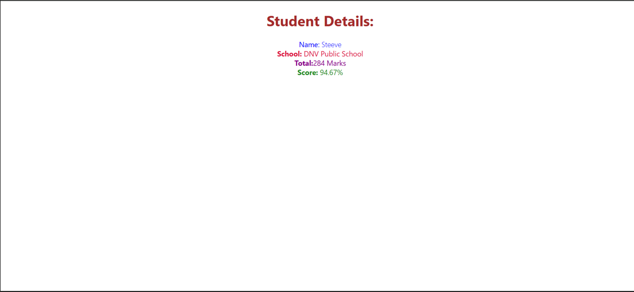
LAB 4
1. Explain the Need and Benefits of Component Lifecycle
What is the Component Lifecycle?
In React, a component lifecycle refers to the series of methods that are called at different stages of a component’s existence — from creation, updating, to removal (unmounting).
Why is it Needed?
- To control what happens before, during, and after rendering
- To fetch data, set timers, or manipulate the DOM at the right moment
- To optimize performance and avoid memory leaks
- To respond to prop or state changes
Benefits
Benefit | Explanation
Control over behavior | You can decide what should happen when the component mounts, updates, or unmounts.
Data fetching timing | Fetch data after the component is ready (componentDidMount or useEffect).
Cleanup actions | Remove timers or subscriptions before a component unmounts (componentWillUnmount).
Optimization | Prevent unnecessary re-renders with methods like shouldComponentUpdate.

2. Identify Various Lifecycle Hook Methods
Lifecycle methods exist mainly in Class Components (though Function Components use Hooks instead).
Class Component Lifecycle Methods:
Phase | Method Name | Description
Mounting | constructor() | Initializes state and bindings
 | static getDerivedStateFromProps() | Syncs state with props
 | render() | Returns JSX for rendering
 | componentDidMount() | Called once after first render (used for API calls, DOM setup)
Updating | shouldComponentUpdate() | Controls whether re-rendering happens
 | getSnapshotBeforeUpdate() | Captures values (like scroll position) before update
 | componentDidUpdate() | Called after updates
Unmounting | componentWillUnmount() | Cleanup tasks (timers, listeners) before component is destroyed
Error Handling | componentDidCatch() | Catches rendering errors
Function Component Equivalent (using Hooks):
Hook | Equivalent Lifecycle
useEffect(() => {}, []) | componentDidMount()
useEffect(() => {... return () => {...} }, []) | componentDidMount() + componentWillUnmount()
useEffect(() => {}, [dependencies]) | componentDidUpdate()
useLayoutEffect | Similar to getSnapshotBeforeUpdate

3. List the Sequence of Steps in Rendering a Component
Let’s look at the full lifecycle flow in class components:
Mounting (Component is being created)
- constructor()
- static getDerivedStateFromProps()
- render()
- componentDidMount()

Updating (Props or state changes)
- static getDerivedStateFromProps()
- shouldComponentUpdate()
- render()
- getSnapshotBeforeUpdate()
- componentDidUpdate()

Unmounting (Component is removed from DOM)
componentWillUnmount()
CODE
Post.js
- // src/Post.js
- class Post {
- constructor(id, title, body) {
- this.id = id;
- this.title = title;
- this.body = body;
- }
- }

- export default Post;
Posts.js

- // src/Posts.js
- import React from "react";
- import Post from "./Post";

- class Posts extends React.Component {
- constructor(props) {
- super(props);
- this.state = {
- posts: [],
- };
- }
- loadPosts() {
- fetch("https://jsonplaceholder.typicode.com/posts")
- .then((response) => response.json())
- .then((data) => {
- const postObjects = data.map(
- (item) => new Post(item.id, item.title, item.body)
- );
- this.setState({ posts: postObjects });
- })
- .catch((error) => {
- console.error("Error loading posts:", error);
- alert("Error loading posts");
- });
- }
- componentDidMount() {
- this.loadPosts();
- }
- componentDidCatch(error, info) {
- alert("An error occurred in Posts component.");
- console.error("Caught error:", error, info);
- }
- render() {
- return (
- <div>
- <h1>Blog Posts</h1>
- {this.state.posts.map((post) => (
- <div key={post.id}>
- <h2>{post.title}</h2>
- <p>{post.body}</p>
- <hr />
- </div>
- ))}
- </div>
- );
- }
- }
- export default Posts;

App.js

- // src/App.js
- import React from "react";

- import Posts from "./Components/Posts";

- function App() {
- return (
- <div className="App">
- <Posts />
- </div>
- );
- }
- export default App;

Output
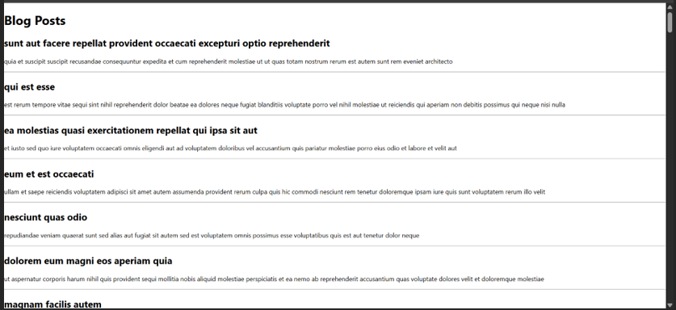
LAB 5
CODE:

App.css

.App {
text-align: center;
}

.App-logo {
height: 40vmin;
pointer-events: none;
}

@media (prefers-reduced-motion: no-preference) {
.App-logo {
animation: App-logo-spin infinite 20s linear;
}
}

.App-header {
background-color: #282c34;
min-height: 100vh;
display: flex;
flex-direction: column;
align-items: center;
justify-content: center;
font-size: calc(10px + 2vmin);
color: white;
}

.App-link {
color: #61dafb;
}

@keyframes App-logo-spin {
from {
transform: rotate(0deg);
}
to {
transform: rotate(360deg);
}
}

Cohort.js

class Cohort {
constructor(cohortCode,
startDate,
technology,
trainerName,
coachName,
currentStatus) {
this.cohortCode = cohortCode;
this.coachName = coachName;
this.trainerName = trainerName;
this.technology = technology;
this.startDate = startDate;
this.currentStatus = currentStatus;
}
}
const CohortsData =[
new Cohort('INTADMDF10','22-Feb-2022', '.NET FSD', 'Jojo Jose','Aathma', 'Scheduled'),
new Cohort('ADM21JF014','10-Sep-2021', 'Java FSD', 'Elisa Smith','Apoorv', 'Ongoing'),
new Cohort('CDBJF21025','24-Dec-2021', 'Java FSD', 'John Doe','Aathma', 'Ongoing'),
new Cohort('INTADMJF12','22-Feb-2022', 'Java FSD', 'To Be Assigned','Ibrahim', 'Scheduled'),
new Cohort('CDE22JF011','24-Dec-2021', 'Java FSD', 'Emma Swan','Apoorv', 'Ongoing'),
new Cohort('INTADMDF09','22-Feb-2022', 'Dataware Housing', 'Babjee Rao','Aathma', 'Scheduled'),
new Cohort('ADM22DF001','10-Sep-2021', '.NET FSD', 'Marie Curie','Ibrahim', 'Ongoing'),
];
export {Cohort, CohortsData};

CohortDetails.js

// src/CohortDetails.js
import React from 'react';
import styles from './CohortDetails.module.css'; // ✅ Import CSS Module

function CohortDetails(props) {
const { cohort } = props;

// Conditional color logic for h3
const titleStyle = {
color: cohort.currentStatus === 'Ongoing' ? 'green' : 'blue'
};

return (
<div className={styles.box}> {/* ✅ Apply box style */}
<h3 style={titleStyle}>
{cohort.cohortCode} - <span>{cohort.technology}</span>
</h3>
<dl>
<dt>Started On</dt>
<dd>{cohort.startDate}</dd>

<dt>Current Status</dt>
<dd>{cohort.currentStatus}</dd>

<dt>Coach</dt>
<dd>{cohort.coachName}</dd>

<dt>Trainer</dt>
<dd>{cohort.trainerName}</dd>
</dl>
</div>
);
}

export default CohortDetails;

CohortDetails.module.css

/* src/CohortDetails.module.css */
.box {
width: 300px;
display: inline-block;
margin: 10px;
padding: 10px 20px;
border: 1px solid black;
border-radius: 10px;
}

dt {
font-weight: 500;
}

App.js

// src/App.js
import React from 'react';
import './App.css';
import { CohortsData } from './Cohort';
import CohortDetails from './CohortDetails';

function App() {
return (
<div className="App">
<h1>Cohorts Details</h1>
<div style={{ display: 'flex', flexWrap: 'wrap', justifyContent: 'center' }}>
{CohortsData.map((cohort, index) => (
<CohortDetails key={index} cohort={cohort} />
))}
</div>
</div>
);
}

export default App;

Output
