React-9 HOL:
import React from 'react';
import ListOfPlayers from './components/ListOfPlayers';
import ScoreBelow70 from './components/ScoreBelow70';
import { OddPlayers, EvenPlayers } from './components/OddEvenPlayers';
import MergedPlayers from './components/MergedPlayers';

function App() {
const flag = true;

const players = [
{ name: 'Jack', score: 50 },
{ name: 'Michael', score: 70 },
{ name: 'John', score: 40 },
{ name: 'Ann', score: 61 },
{ name: 'Elisabeth', score: 61 },
{ name: 'Sachin', score: 95 },
{ name: 'Dhoni', score: 100 },
{ name: 'Virat', score: 84 },
{ name: 'Jadeja', score: 64 },
{ name: 'Raina', score: 75 },
{ name: 'Rohit', score: 80 },
];

const IndianTeam = ['Sachin1', 'Dhoniz', 'Virat3', 'Rohit4', 'Yuvarajs', 'Raina6'];

const T20Players = ['First Player', 'Second Player', 'Third Player'];
const RanjiTrophyPlayers = ['Fourth Player', 'Fifth Player', 'Sixth Player'];
const IndianPlayers = [...T20Players, ...RanjiTrophyPlayers];

if (flag) {
return (
<div>
<h1>List of Players</h1>
<ListOfPlayers players={players} />
<hr />
<h1>List of Players having Scores Less than 70</h1>
<ScoreBelow70 players={players} />
</div>
);
} else {
return (
<div>
<h1>Indian Team</h1>
<h2>Odd Players</h2>
{OddPlayers(IndianTeam)}
<hr />
<h2>Even Players</h2>
{EvenPlayers(IndianTeam)}
<hr />
<h2>List of Indian Players Merged:</h2>
<MergedPlayers IndianPlayers={IndianPlayers} />
</div>
);
}
}

export default App;

Components:
import React from 'react';

function ListOfPlayers({ players }) {
return (
<ul>
{players.map((item, index) => (
<li key={index}>
Mr. {item.name} <span>{item.score}</span>
</li>
))}
</ul>
);
}

export default ListOfPlayers;

import React from 'react';

function MergedPlayers({ IndianPlayers }) {
return (
<ul>
{IndianPlayers.map((player, index) => (
<li key={index}>Mr. {player}</li>
))}
</ul>
);
}

export default MergedPlayers;

import React from 'react';

export function OddPlayers([first, , third, , fifth]) {
return (
<ul>
<li>First: {first}</li>
<li>Third: {third}</li>
<li>Fifth: {fifth}</li>
</ul>
);
}

export function EvenPlayers([, second, , fourth, , sixth]) {
return (
<ul>
<li>Second: {second}</li>
<li>Fourth: {fourth}</li>
<li>Sixth: {sixth}</li>
</ul>
);
}
import React from 'react';

function ScoreBelow70({ players }) {
const filtered = players.filter((item) => item.score < 70);
return (
<ul>
{filtered.map((item, index) => (
<li key={index}>
Mr. {item.name} <span>{item.score}</span>
</li>
))}
</ul>
);
}

export default ScoreBelow70;

Output:
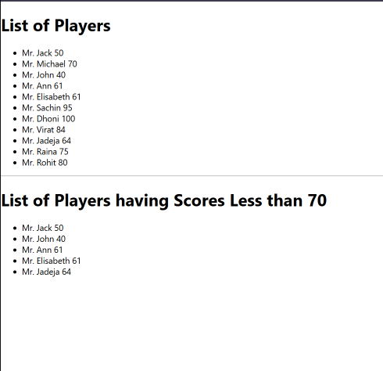

React-10 HOL:
import React from "react";
const officeList = [ { Name: "DBS", Rent: 50000, Address: "Chennai" }, { Name: "Regus", Rent: 70000, Address: "Bangalore" }, { Name: "SmartWorks", Rent: 65000, Address: "Mumbai" } ];
function App() { return (

Office Space at Affordable Range
{/* ✅ Load image from public folder */}
{officeList.map((office, index) => {
const rentColor = office.Rent <= 60000 ? "red" : "green";
return (
<div key={index}>
<h2>Name: {office.Name}</h2>
<h3 style={{ color: rentColor }}>Rent: Rs. {office.Rent}</h3>
<h3>Address: {office.Address}</h3>
</div>
);
})}
</div>
); }
export default App;

OUTPUT:
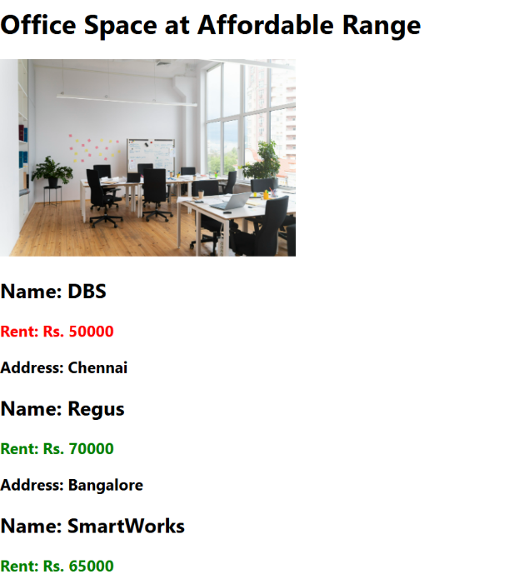

React-11 HOL:
import React from "react";
import CurrencyConvertor from "./CurrencyConvertor";

class App extends React.Component {
constructor(props) {
super(props);
this.state = {
counter: 0
};
}

increment = () => {
this.setState({ counter: this.state.counter + 1 });
};

sayHello = () => {
console.log("Hello! You clicked increment.");
alert("Hello from React!");
};

handleIncrementClick = () => {
this.increment();
this.sayHello();
};

decrement = () => {
this.setState({ counter: this.state.counter - 1 });
};

sayWelcome = (msg) => {
alert(msg);
};

handleSyntheticEvent = (e) => {
e.preventDefault(); // Synthetic event
alert("I was clicked");
};

render() {
return (
<div>
<h1>React Events Demo</h1>
<h2>Counter: {this.state.counter}</h2>

<button onClick={this.handleIncrementClick}>Increment</button>{" "}
<button onClick={this.decrement}>Decrement</button>

<br /><br />
<button onClick={() => this.sayWelcome("Welcome to React!")}>
Say Welcome
</button>

<br /><br />
<button onClick={this.handleSyntheticEvent}>Synthetic Event (OnPress)</button>

<br /><br />
<CurrencyConvertor />
</div>
);
}
}

export default App;
OUTPUT:
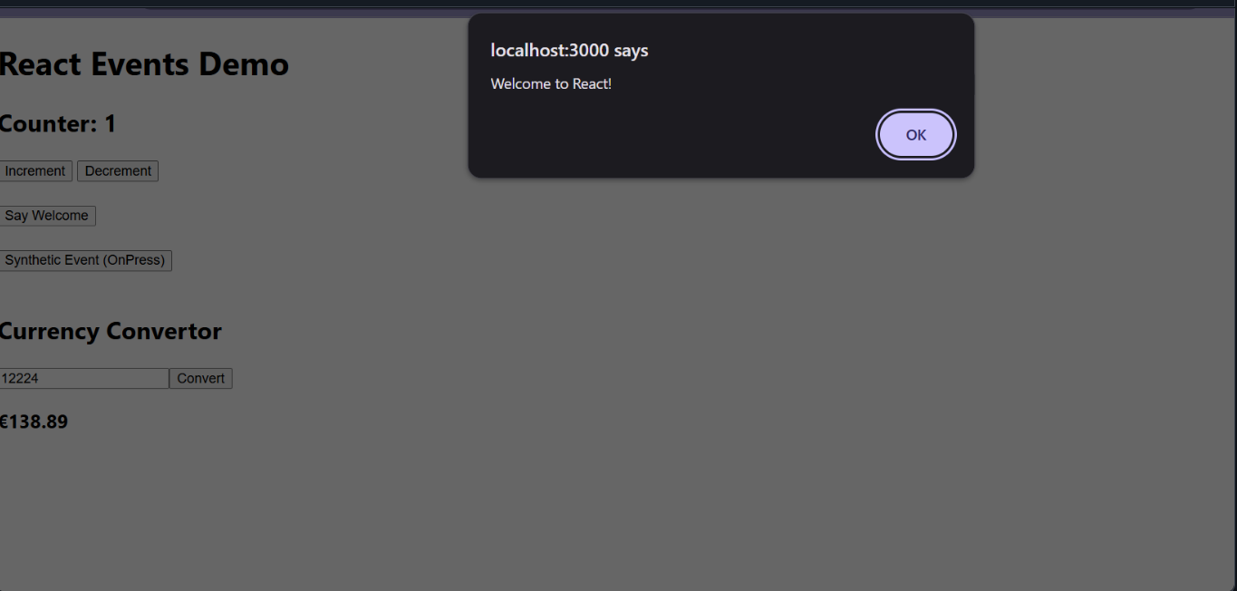

React-12 HOL:
import React, { useState } from 'react';
import GuestGreeting from './GuestGreeting';
import UserGreeting from './UserGreeting';

function LoginButton({ onClick }) {
return <button onClick={onClick}>Login</button>;
}

function LogoutButton({ onClick }) {
return <button onClick={onClick}>Logout</button>;
}

function Greeting({ isLoggedIn }) {
if (isLoggedIn) {
return <UserGreeting />;
}
return <GuestGreeting />;
}

function App() {
const [isLoggedIn, setIsLoggedIn] = useState(false);

const handleLoginClick = () => setIsLoggedIn(true);
const handleLogoutClick = () => setIsLoggedIn(false);

return (
<div style={{ padding: '20px' }}>
<h1>✈️ Ticket Booking App</h1>
{isLoggedIn ? (
<LogoutButton onClick={handleLogoutClick} />
) : (
<LoginButton onClick={handleLoginClick} />
)}
<Greeting isLoggedIn={isLoggedIn} />
</div>
);
}

export default App;
OUTPUT:
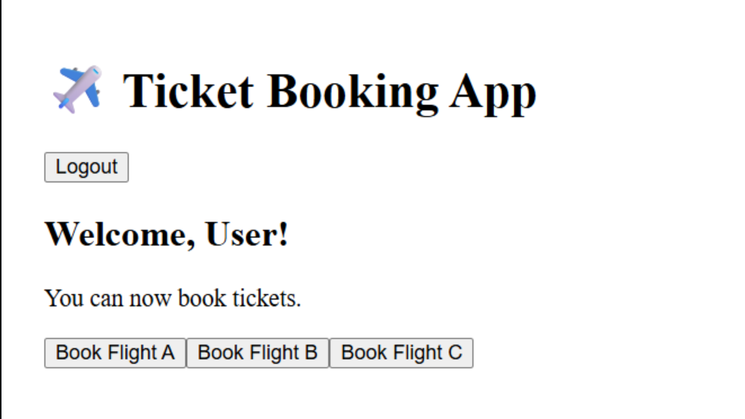
React-HOL 13 :
import React, { useState } from 'react';
import BlogDetails from './Components/BlogDetails';
import BookDetails from './Components/BookDetails';
import CourseDetails from './Components/CourseDetails';

function App() {
const [showBlog, setShowBlog] = useState(true);
const [showCourse, setShowCourse] = useState(true);

return (
<div style={{ padding: '20px' }}>
<button onClick={() => setShowBlog(!showBlog)}>
{showBlog ? "Hide Blog" : "Show Blog"}
</button>
<button onClick={() => setShowCourse(!showCourse)}>
{showCourse ? "Hide Course" : "Show Course"}
</button>

<BookDetails />
<BlogDetails show={showBlog} />
<CourseDetails show={showCourse} />
</div>
);
}

export default App;

Components:
import React from 'react';

function BlogDetails({ show }) {
if (!show) return null; // Conditional rendering

return (
<div className="v1">
<h1>Blog Details</h1>
<h3>React Learning</h3>
<h4>Stephen Biz</h4>
<p>Welcome to learning React!</p>
<h3>Installation</h3>
<h4>Schewzdenier</h4>
<p>You can install React from npm.</p>
</div>
);
}

export default BlogDetails;

import React from 'react';

export const books = [
{ id: 101, bname: 'Master React', price: 670 },
{ id: 102, bname: 'Deep Dive into Angular 11', price: 800 },
{ id: 103, bname: 'Mongo Essentials', price: 450 },
];

function BookDetails() {
return (
<div className="st2">
<h1>Book Details</h1>
<ul>
{books.map(book => (
<div key={book.id}>
<h3>{book.bname}</h3>
<h4>{book.price}</h4>
</div>
))}
</ul>
</div>
);
}

export default BookDetails;

import React from 'react';

const courseList = [
{ id: 1, name: "Angular", date: "6/3/20201" },
{ id: 2, name: "React", date: "6/3/20201" },
];

function CourseDetails({ show }) {
if (!show) return null;

return (
<div className="mystyle1">
<h1>Course Details</h1>
{courseList.map(course => (
<div key={course.id}>
<h3>{course.name}</h3>
<p>{course.date}</p>
</div>
))}
</div>
);
}

export default CourseDetails;

OUTPUT:
