**ADVANCED SQL**

1. **Exercise 1: Ranking & Window Functions**

Goal: Use ROW_NUMBER(), RANK(), DENSE_RANK(), OVER(), and PARTITION BY.

Scenario:

Find the top 3 most expensive products in each category using different ranking functions.

Steps:

1. Use ROW_NUMBER() to assign a unique rank within each category.

2. Use RANK() and DENSE_RANK() to compare how ties are handled.

3. Use PARTITION BY Category and ORDER BY Price DESC.

**Solution:**

CREATE TABLE RetailProducts (

ProductID INT PRIMARY KEY,

ProductName VARCHAR(100),

Category VARCHAR(50),

Price DECIMAL(10, 2)

);

INSERT INTO RetailProducts (ProductID, ProductName, Category, Price) VALUES

(1, 'Laptop A', 'Electronics', 1000.00),

(2, 'Laptop B', 'Electronics', 950.00),

(3, 'Laptop C', 'Electronics', 950.00),

(4, 'Phone A', 'Electronics', 600.00),

(5, 'Phone B', 'Electronics', 550.00),

(6, 'Shirt A', 'Clothing', 50.00),

(7, 'Shirt B', 'Clothing', 60.00),

(8, 'Shirt C', 'Clothing', 60.00),

(9, 'Jacket A', 'Clothing', 120.00),

(10, 'Jacket B', 'Clothing', 110.00);

SELECT ProductID,ProductName,Category,Price,

ROW_NUMBER() OVER (PARTITION BY Category ORDER BY Price DESC) AS RowNum,

RANK() OVER (PARTITION BY Category ORDER BY Price DESC) AS RankNum,

DENSE_RANK() OVER (PARTITION BY Category ORDER BY Price DESC) AS DenseRankNum

FROM RetailProducts;

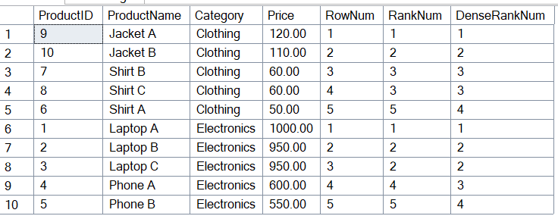

2. Exercise 1: Create a Stored Procedure

Goal: Create a stored procedure to retrieve employee details by department.

Steps:

1. Define the stored procedure with a parameter for DepartmentID.

2. Write the SQL query to select employee details based on the DepartmentID.

3. Create a stored procedure named `sp_InsertEmployee` with the following code:

CREATE PROCEDURE sp_InsertEmployee

@FirstName VARCHAR(50),

@LastName VARCHAR(50),

@DepartmentID INT,

@Salary DECIMAL(10,2),

@JoinDate DATE

AS

BEGIN

INSERT INTO Employees (FirstName, LastName, DepartmentID, Salary, JoinDate)

VALUES (@FirstName, @LastName, @DepartmentID, @Salary, @JoinDate);

END

**QUERY**

-- Departments Table

CREATE TABLE Departments (

DepartmentID INT PRIMARY KEY,

DepartmentName VARCHAR(100)

);

-- Employees Table

CREATE TABLE Employees (

EmployeeID INT PRIMARY KEY IDENTITY(1,1),

FirstName VARCHAR(50),

LastName VARCHAR(50),

DepartmentID INT FOREIGN KEY REFERENCES Departments(DepartmentID),

Salary DECIMAL(10,2),

JoinDate DATE

);

-- Departments Data

INSERT INTO Departments (DepartmentID, DepartmentName) VALUES

(1, 'HR'),

(2, 'Finance'),

(3, 'IT'),

(4, 'Marketing');

-- Employees Data

INSERT INTO Employees (FirstName, LastName, DepartmentID, Salary, JoinDate) VALUES

('John', 'Doe', 1, 5000.00, '2020-01-15'),

('Jane', 'Smith', 2, 6000.00, '2019-03-22'),

('Michael', 'Johnson', 3, 7000.00, '2018-07-30'),

('Emily', 'Davis', 4, 5500.00, '2021-11-05');

GO -- Separate previous statements (like INSERTs)

CREATE PROCEDURE sp_GetEmployeesByDepartment

@DepartmentID INT

AS

BEGIN

SELECT

E.EmployeeID,

E.FirstName,

E.LastName,

D.DepartmentName,

E.Salary,

E.JoinDate

FROM Employees E

INNER JOIN Departments D ON E.DepartmentID = D.DepartmentID

WHERE E.DepartmentID = @DepartmentID;

END;

GO -- Ends the batch

CREATE PROCEDURE sp_InsertEmployee

@FirstName VARCHAR(50),

@LastName VARCHAR(50),

@DepartmentID INT,

@Salary DECIMAL(10,2),

@JoinDate DATE

AS

BEGIN

INSERT INTO Employees (FirstName, LastName, DepartmentID, Salary, JoinDate)

VALUES (@FirstName, @LastName, @DepartmentID, @Salary, @JoinDate);

END;

EXEC sp_InsertEmployee

@FirstName = 'Alice',

@LastName = 'Brown',

@DepartmentID = 3,

@Salary = 7500.00,

@JoinDate = '2023-06-01';

EXEC sp_GetEmployeesByDepartment @DepartmentID = 3;

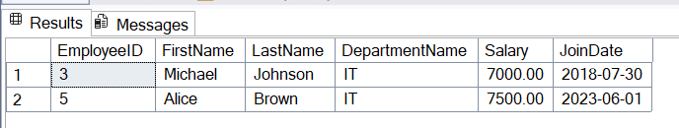

5. Exercise 5: Return Data from a Stored Procedure

Goal: Create a stored procedure that returns the total number of employees in a

department.

Steps:

1. Define the stored procedure with a parameter for DepartmentID.

2. Write the SQL query to count the number of employees in the specified department.

3. Save the stored procedure by executing the Stored procedure content.

**QUERY**

-- Departments Table

CREATE TABLE Departments (

DepartmentID INT PRIMARY KEY,

DepartmentName VARCHAR(100)

);

-- Employees Table

CREATE TABLE Employees (

EmployeeID INT PRIMARY KEY IDENTITY(1,1),

FirstName VARCHAR(50),

LastName VARCHAR(50),

DepartmentID INT FOREIGN KEY REFERENCES Departments(DepartmentID),

Salary DECIMAL(10,2),

JoinDate DATE

);

-- Departments Data

INSERT INTO Departments (DepartmentID, DepartmentName) VALUES

(1, 'HR'),

(2, 'Finance'),

(3, 'IT'),

(4, 'Marketing');

-- Employees Data

INSERT INTO Employees (FirstName, LastName, DepartmentID, Salary, JoinDate) VALUES

('John', 'Doe', 1, 5000.00, '2020-01-15'),

('Jane', 'Smith', 2, 6000.00, '2019-03-22'),

('Michael', 'Johnson', 3, 7000.00, '2018-07-30'),

('Emily', 'Davis', 4, 5500.00, '2021-11-05');

**Working query**

CREATE PROCEDURE sp_GetEmployeeCountByDepartment

@DepartmentID INT

AS

BEGIN

SELECT

COUNT(*) AS TotalEmployees

FROM

Employees

WHERE

DepartmentID = @DepartmentID;

END;

GO

EXEC sp_GetEmployeeCountByDepartment @DepartmentID = 3;

