**Face_recognition_based_attendance_system**

A python GUI integrated attendance system using face recognition to take attendance.

In this python project, I have made an attendance system which takes attendance by using face recognition technique. I have also integrated it with GUI (Graphical user interface) so it can be easy to use by anyone. GUI for this project is also made on python using tkinter.

TECHNOLOGY USED:

1. tkinter for whole GUI
2. OpenCV for taking images and face recognition

**cv2.face.LBPHFaceRecognizer_create()**

1. CSV, NumPy, Pandas, datetime etc. for other purposes.

FEATURES:

1. Easy to use with interactive GUI support.
2. Password protection for new person registration.
3. Creates/Updates CSV file for details of students on registration.
4. Creates a new CSV file every day for attendance and marks attendance with proper date and time.
5. Displays live attendance updates for the day on the main screen in tabular format with Id, name, date and time.

MAIN SCREEN

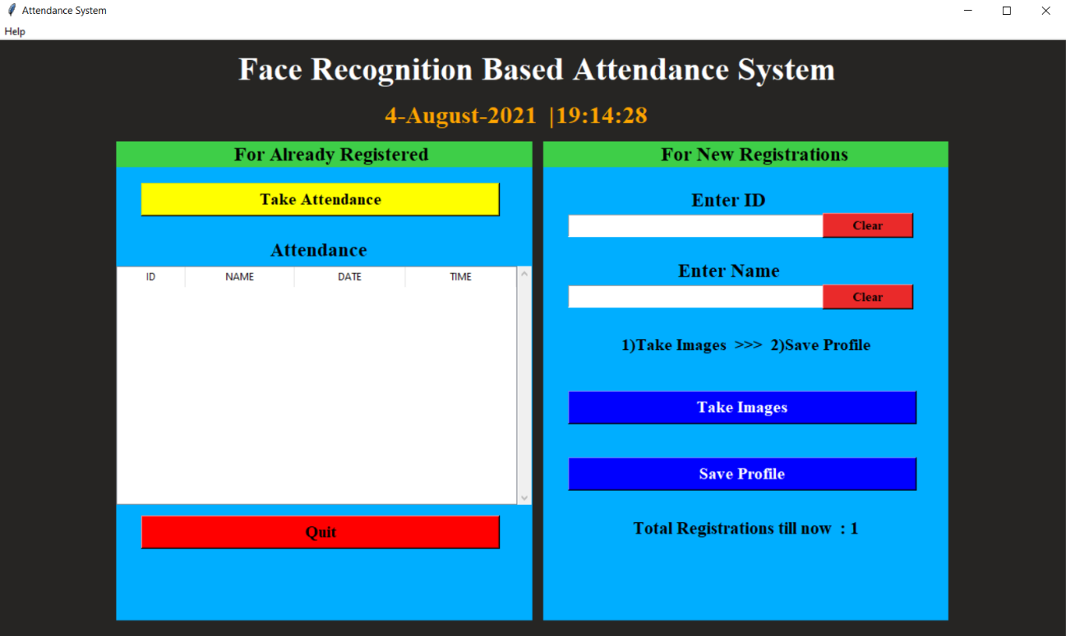

REGISTER

1. we capture the different angle images of registered students.
2. It almost captures around 60 pictures of each student.

* *The camera automatically stops when it gets enough pictures*
* *The images get saved into the* ***TrainingImage*** *folder*

1. Need to save your profile.

* *It is password protected.* ***Password: siri***
* *All these trained images are saved in XML format.*
* *Name, roll number, Date and Timings of all students are stored in an excel sheet.*

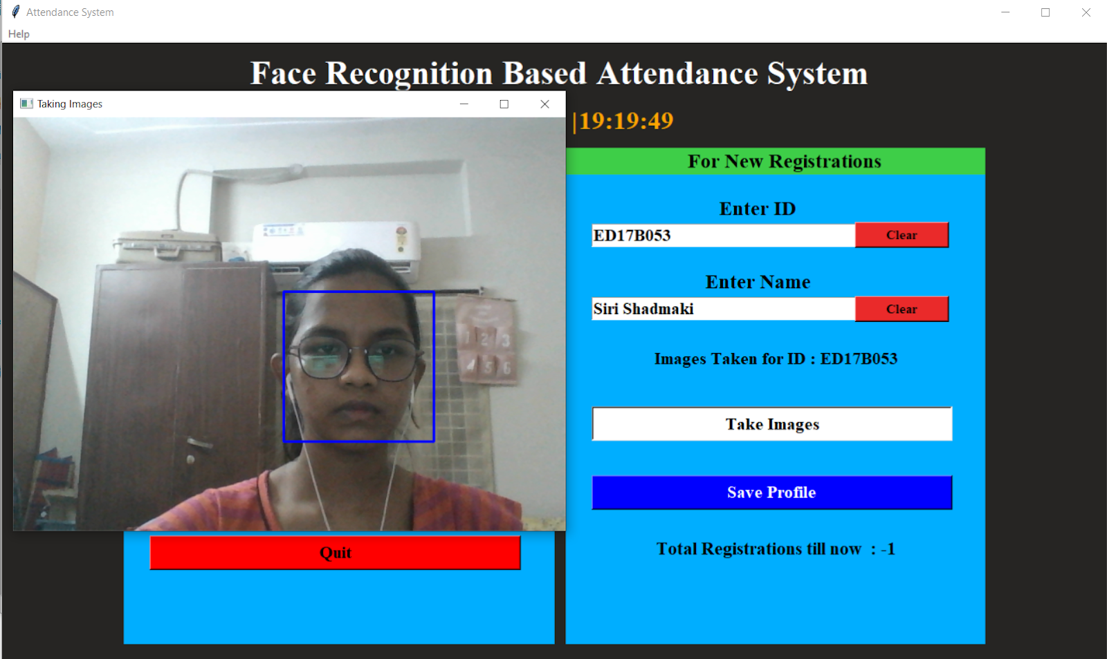

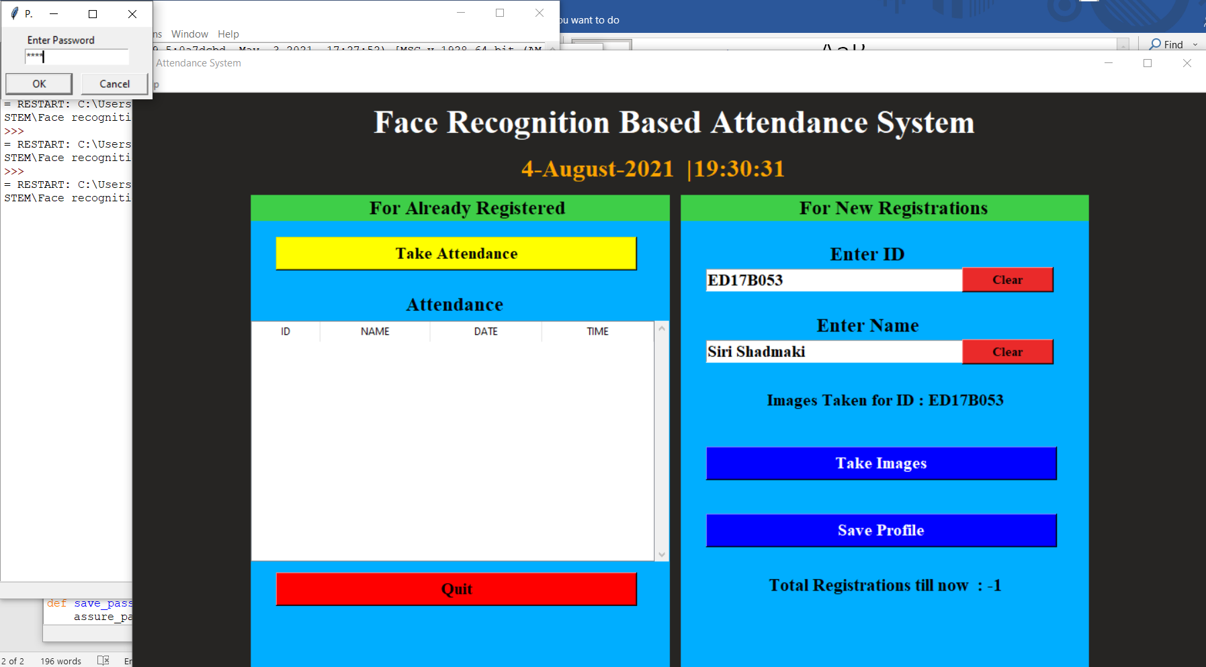

* All the captured images further trained using machine learning algorithms.
* For training images, we used a built-in machine learning classifier **(haar_cascade_classifier).**

HELP OPTION IN MENU BAR

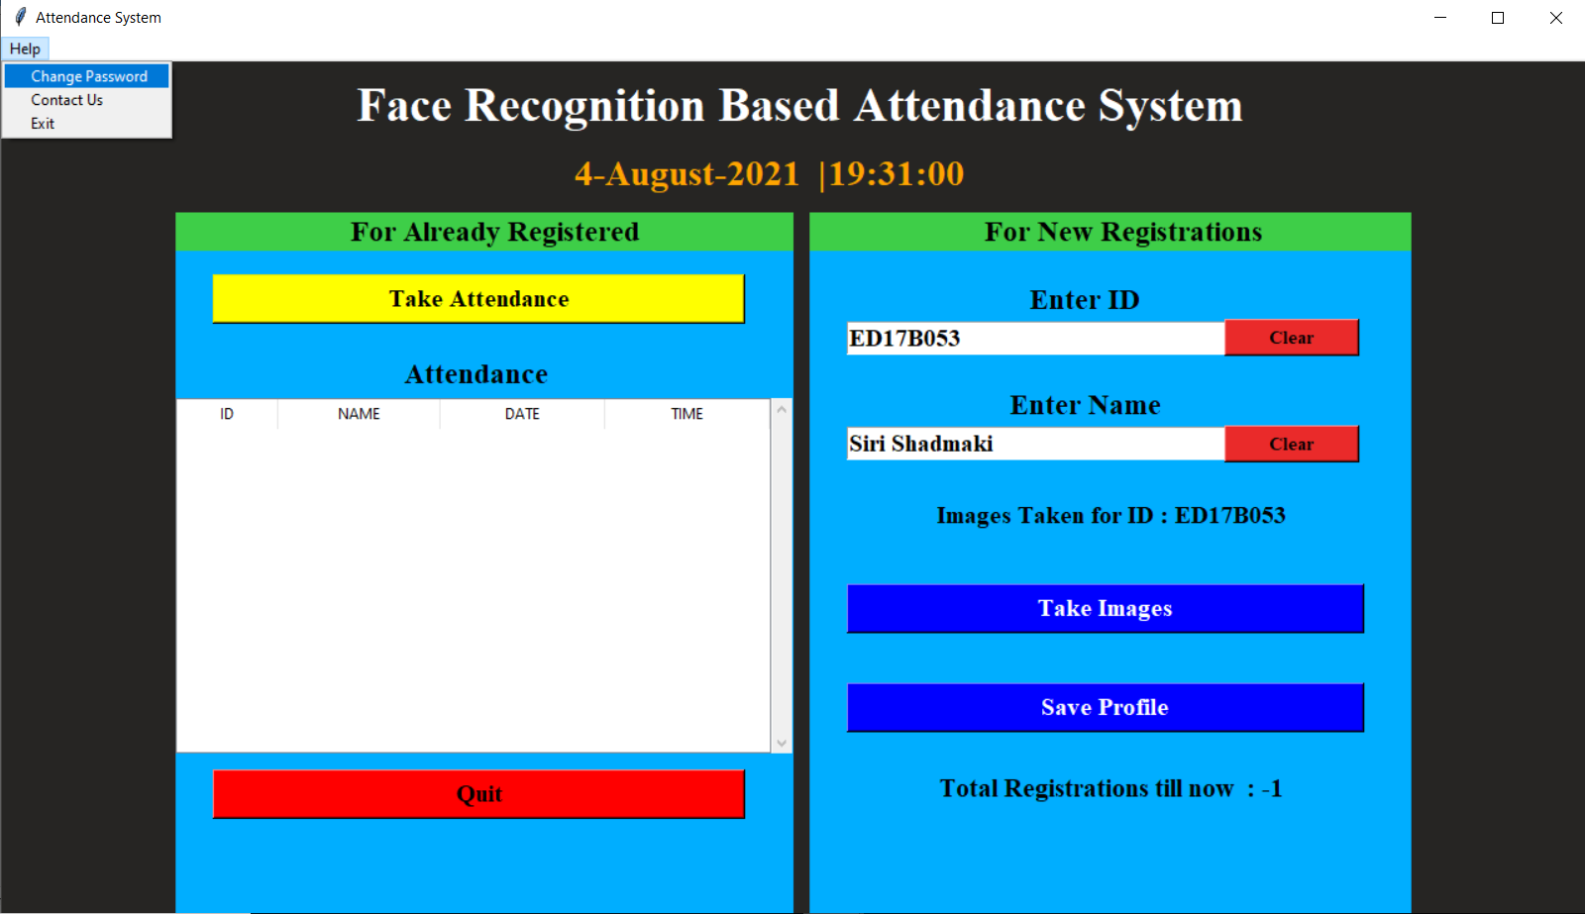

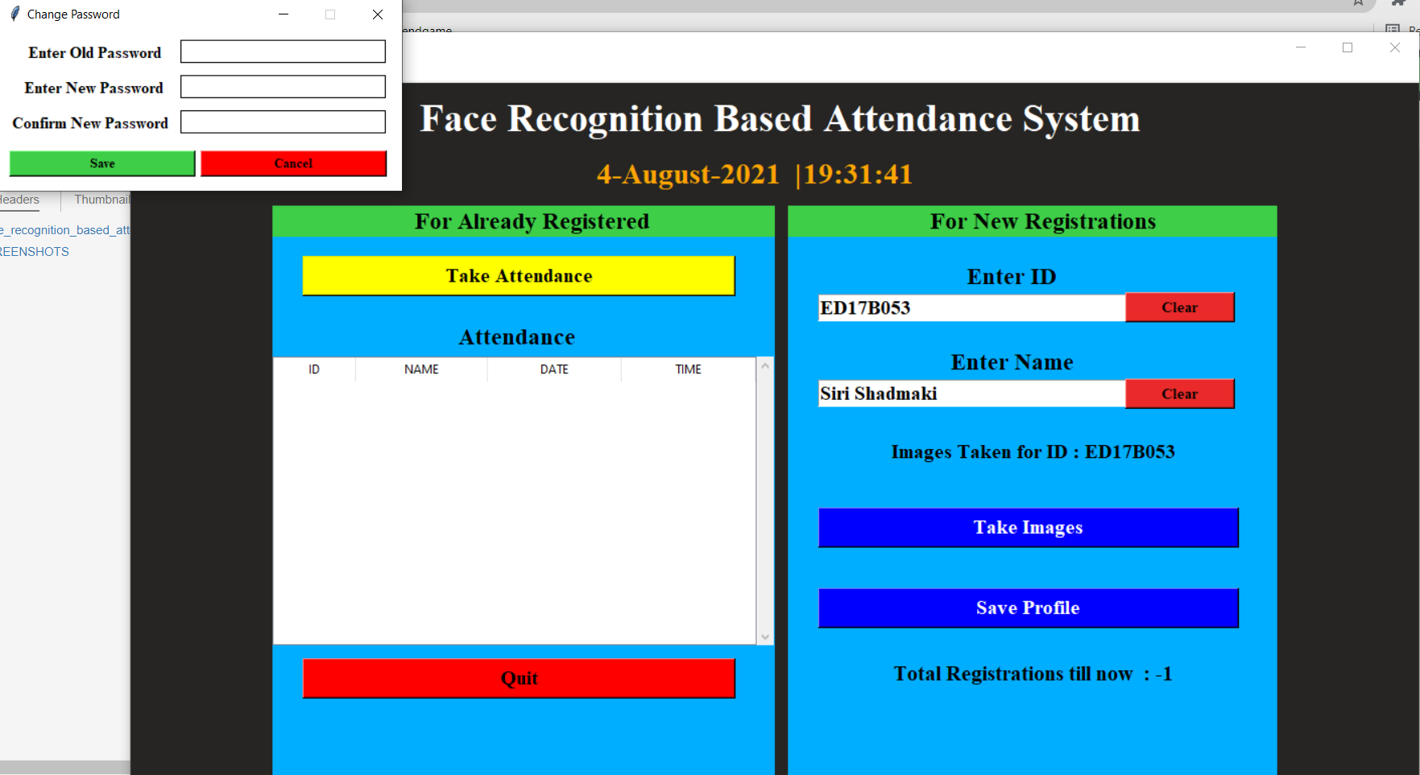

TAKE ATTENDANCE

1. Switches on the camera and Name, Roll Number will be displayed
2. Press **“q”** to quit
3. Displays live attendance updates for the day on the main screen in tabular format with Id, name, date and time.

