SCRAPRIGHT’s Disaster Recovery (DR) Strategy Document

1. Executive Summary
This document outlines the Disaster Recovery (DR) strategy for a Scarpright’s .NET application hosted in Azure.
The system currently resides in the “South Central US” and includes multiple application VMs, SQL VMs, a domain controller, and a firewall.
This DR plan focuses on a Warm DR approach and basic comparison with Cold targeting a recovery time of under 2 hours (by warm approach) in case of a complete regional outage.

2. Current Architecture Overview
The current setup includes the following components:
- 3 IIS App VMs (Standard E16ads v5)
- 3 SQL Server VMs (Standard D16as v4)
- Internal Load Balancer (IIS-LB-Internal)
- 1 Domain Controller (DC01)
- 1 WatchGuard Firewall (SRFireboxCloud)
- 11 Public IPs
- Premium and Standard SSD disks for data and OS

3. DR Strategy Overview
Warm DR Strategy:
- Azure Site Recovery (ASR) to replicate VMs to the DR region
- Pre-provisioned infrastructure in DR (Load Balancer, Public IPs, NSGs, etc.)
- Traffic Manager for DNS-based failover
Cold DR Strategy:
- Backup-based recovery (e.g., VM snapshots, SQL backups)
- No compute resources provisioned until a failover event
- Longer RTO but lower cost

4. Cost Comparison: Warm vs Cold DR
Cost Element | Warm DR (Est.) | Cold DR (Est.) | Notes
ASR Replication (8 VMs) | $200 - 300 | $0 | ASR not used in cold DR
Premium SSD (~10.75 TiB) | $1,500 – 1700 | $800–1,000 | Estimated based on storage costs
Standard SSD (~17.66 TiB) | $1,100 – 1500 | $700–900 | Lower cost if backups only
Standard HDD (4 GiB) | $10 | $10 | Negligible
Traffic Manager | $25 | $25 | Same for both DR types
Total Monthly | $2,835 - 3535 | $1,535 - 1935 | Warm DR includes active replication
Recovery Time | ~ 2 hours | ~ 8-10 hours (as new resources need to be created) | -

5. Detailed Warm DR Cost Breakdown
Includes:
- VM replication for 8 servers via ASR (~$25 each/month)
- Disk costs: Premium SSD (OS/Data), Standard SSD
- Traffic Manager for DNS failover
- No compute costs unless failover occurs

6. Public IP Management in DR
- 11 Public IPs exist in the “South Central” region
- DR region will pre-provision matching Standard SKU IPs
- DNS failover handled by Azure Traffic Manager or manual change
- Avoid hardcoded IPs in app configs; use FQDNs where possible

7. Failover Process (Manual Steps)
1. Traffic Manager detects failure or switch triggered manually
2. DR VMs are brought online (via ASR)
3. Public IPs assigned to Load Balancer and Firewall
4. NAT/firewall rules verified
5. Secondary DC01 authenticates users in DR
6. Application becomes accessible via same DNS name

8. Architecture Diagrams
- Current “South Central” Region architecture
- Warm DR Region layout
- Network flow and component mapping

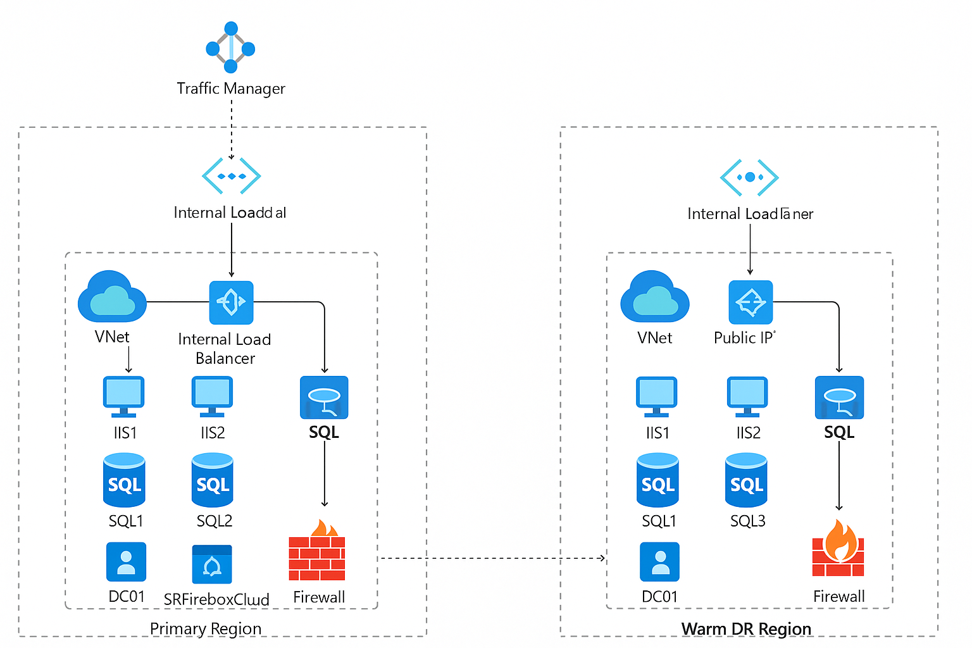

9. Assumptions
- All VMs are Gen 1 (V1)
- SQL DR uses ASR, not Always On
- WatchGuard firewall supports DR licensing
- DNS is managed externally or via Azure DNS
- No multi-site clustering require
- Pricing vary(minor) based on the Region selection
- Licensing of SQL and other proprietary software’s supports DR licensing.

10. Recommendations
- Pre-stage firewall and licensing in DR
- Schedule regular DR drills
- Monitor ASR replication health
- Re-evaluate DR architecture and cost semi-annually

