Recommendation for VM Downsizing
As part of ongoing cost optimization efforts, we have analyzed the resource utilization of the IIS server virtual machines (VMs) hosted in Azure. The review of CPU and memory metrics over the past month indicates significant underutilization of the current VM sizes. Based on this, downsizing the VMs is recommended to achieve cost savings without compromising performance.

Current VM Setup
1. IIS1 - Standard E16ads v5 (16 vCPUs, 128 GiB memory)
2. IIS2 - Standard E16ads v5 (16 vCPUs, 128 GiB memory)
3. IIS3 - Standard E20as v4 (20 vCPUs, 160 GiB memory)

Utilization Analysis
The performance metrics for the last month indicate the following trends:
- **CPU Usage**: Average utilization across all VMs is between 8% and 15%, with occasional spikes up to 35-40%. This is well below the provisioned capacity.
- **Memory Usage**: Average available memory is consistently between 68% and 78%, indicating that only 20-30% of the allocated memory is being used.
These figures clearly show that the VMs are oversized for the workload being handled.

Recommendation for Downsizing
To optimize costs while maintaining sufficient headroom for workload spikes, it is recommended to downgrade the VMs as follows:
- IIS1: Move from Standard E16ads v5 → Standard D16s v5 (16 vCPUs, 64 GiB memory)
- IIS2: Move from Standard E16ads v5 → Standard D16s v5 (16 vCPUs, 64 GiB memory)
- IIS3: Move from Standard E20as v4 → Standard D16s v5 (16 vCPUs, 64 GiB memory)
This ensures the workloads still have sufficient resources while better aligning capacity with actual usage.

Estimated Cost Savings
The following approximate monthly savings can be achieved (based on East US pay-as-you-go rates):
- **IIS1**: E16ads v5 (~$1,050/month) → D16s v5 (~$600/month) → **Savings: ~$450/month**
- **IIS2**: E16ads v5 (~$1,050/month) → D16s v5 (~$600/month) → **Savings: ~$450/month**
- **IIS3**: E20as v4 (~$1,300/month) → D16s v5 (~$600/month) → **Savings: ~$700/month**
➡ **Total Potential Savings: ~$1000 per month (~$12,000 annually)**

Conclusion
Downsizing the IIS VMs is strongly recommended as it reduces costs significantly while still providing sufficient CPU and memory capacity for current workloads. The recommended sizes align with observed utilization patterns and ensure cost efficiency without impacting performance or reliability.

CPU USAGE (Last 30 days)
MAX CPU reached: IIS1 42.49%, IIS2: 19.06, IIS3: 42.97

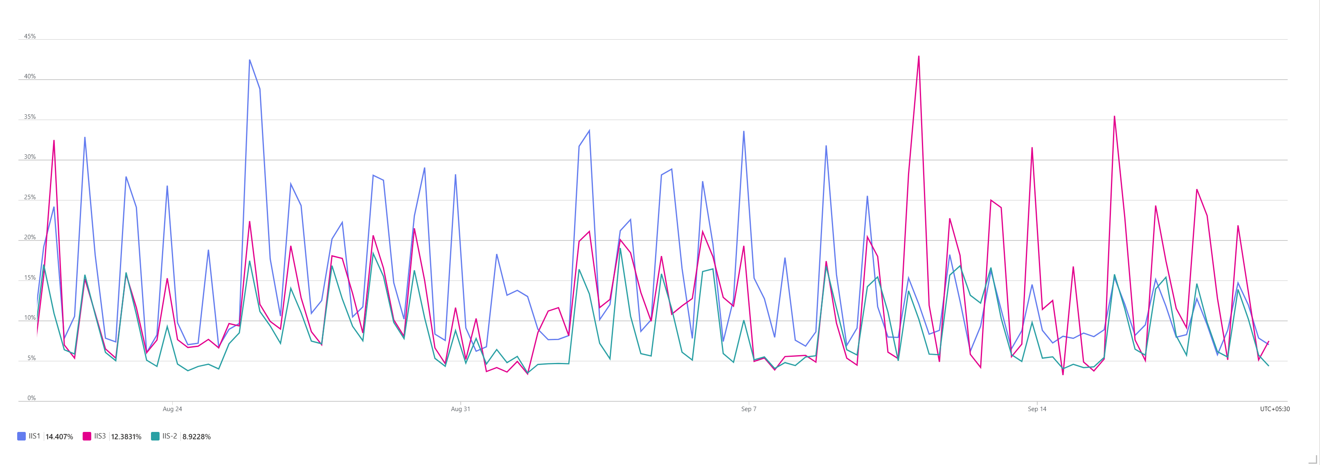

Average used: IIS1:14.4%, IIS2:12.3%, IIS3: 8.9%

MEMORY AVALIABLE (LAST 30 Days)
Minimum availability out of 100%: IIS1 61.02%, IIS2: 63.3%, IIS3: 73.1%

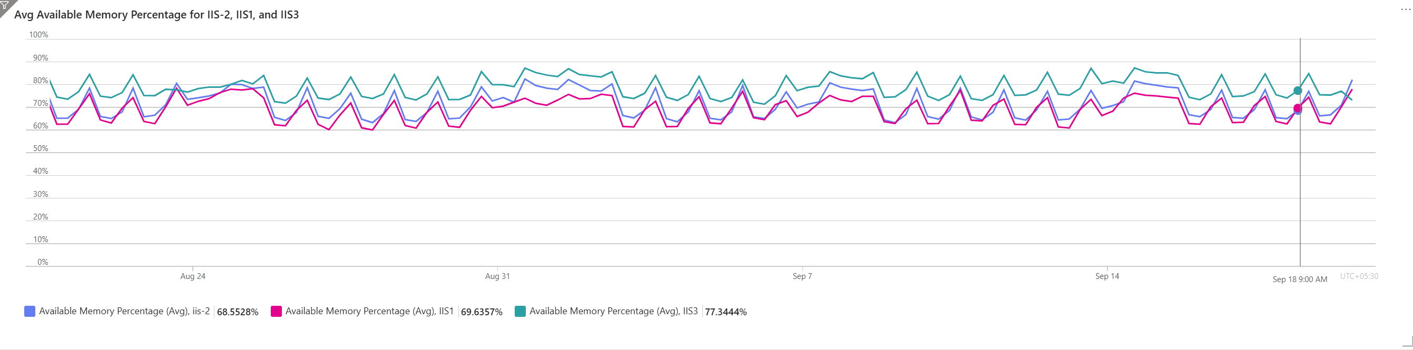

Average Free Memory: IIS1-69.04%, IIS2: 71.55%, IIS3: 78.63%

