Aurora Store - Style Guide

How To Use This Style Guide
Each section shows a breakdown of a particular widget or element in the Aurora store. Callout labels corresponds to information regarding the component shown. Use the CSS classes to search the main CSS file to locate the necessary code to make changes or updates. Use the image paths to locate the images you want to edit or replace.

Color Swatches
 | Default content text / Departments Drop-down  #4D4D4D
 | Page Headers / SKUs / Current Breadcrumb  #777777
 | Tab Container Tabs  #666666
 | Store Links  #006ECC
 | Default Orange / Prices  #CA4200
 | Hover Background  #D9E9F7

Text Styles
Page Headers
color: #666666; font-size: 24px;
Body Content
color: #4D4D4D; font-size: 12px;
Product Details Header
color: #777777; font-size: 22px;
Subsection Header
color: #4D4D4D; font-size: 14px;
Facet Column Header
color: #777777; font-size: 11px;
Facet Column Items
color: #777777; font-size: 12px;

Button & Icon Images

Button and icon images are used across the Aurora store. To better understanding where some of these elements are used, screen captures are provided showing them across different pages and widgets in the Aurora store.

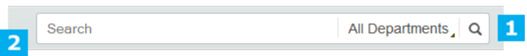

1. Search Submit Icon
Default: images\colors\color1\widget_search\search_submit.png
Hover: images\colors\color1\widget_search\search_submit_hover.png

2. Search Field Background
Left Image: images\colors\color1\widget_search\search_left_border.png
Center Image: images\colors\color1\widget_search\search_tile_bg.png
Right Image: images\colors\color1\widget_search\search_right_border.png

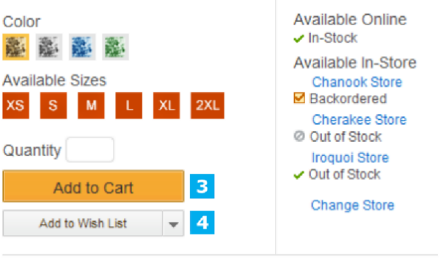

3. Primary Button: Default, Hover, Disabled
Left Image: images\colors\color1\buttons\primary_button_left_sprite.png
Center Image: images\colors\color1\buttons\primary_button_sprite.png
Right Image: images\colors\color1\buttons\primary_button_right_sprite.png
Button Text CSS: .button_primary > .button_text
Note: Primary Button also has a larger version used as a ‘add to cart’ button across the store. The button sections are located in the same directory as the primary button. The file names are: add_to_cart_large_sprite.png, add_to_cart_large_hover_sprite.png

4. Secondary Button: Default, Hover, Disabled
Left Image: images\colors\color1\buttons\secondary_button_left_sprite.png
Center Image: images\colors\color1\buttons\secondary_button_sprite.png
Right Image: images\colors\color1\buttons\secondary_button_right_sprite.png
Button Text CSS: .button_secondary > .button_text
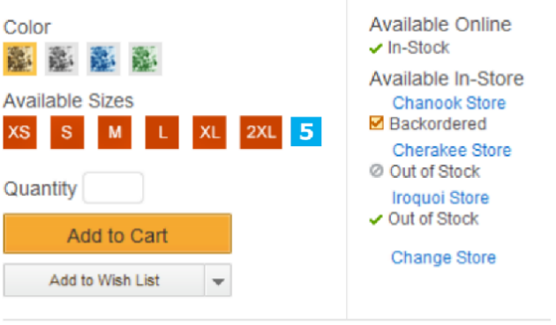

5. Product Sizes
XS
Default: images/colors/color1/sizes/size_xs.png
Selected: images/colors/color1/sizes/size_xs_selected.png
Disabled: images/colors/color1/sizes/size_xs_disabled.png
S
Default: images/colors/color1/sizes/size_s.png
Selected: images/colors/color1/sizes/size_s_selected.png
Disabled: images/colors/color1/sizes/size_s_disabled.png
M
Default: images/colors/color1/sizes/size_m.png
Selected: images/colors/color1/sizes/size_m_selected.png
Disabled: images/colors/color1/sizes/size_m_disabled.png
L
Default: images/colors/color1/sizes/size_l.png
Selected: images/colors/color1/sizes/size_l_selected.png
Disabled: images/colors/color1/sizes/size_l_disabled.png
XL
Default: images/colors/color1/sizes/size_xl.png
Selected: images/colors/color1/sizes/size_xl_selected.png
Disabled: images/colors/color1/sizes/size_xl_disabled.png
2XL
Default: images/colors/color1/sizes/size_xxl.png
Selected: images/colors/color1/sizes/size_xxl_selected.png
Disabled: images/colors/color1/sizes/size_xxl_disabled.png
3XL
Default: images/colors/color1/sizes/size_xxxl.png
Selected: images/colors/color1/sizes/size_xxxl_selected.png
Disabled: images/colors/color1/sizes/size_xxxl_disabled.png
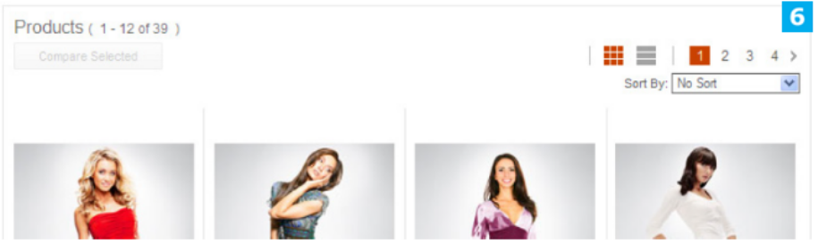

6. Paging Controls
Grid Icon
Default: images/colors/color1/widget_product_listing/grid_icon.png
Hover: images/colors/color1/widget_product_listing/grid_icon_active.png
List Icon
Default: images/colors/color1/widget_product_listing/list_icon.png
Hover: images/colors/color1/widget_product_listing/list_icon_active.png
Arrow - Left
Default: images/colors/color1/widget_product_listing/left_arrow.png
Hover: images/colors/color1/widget_product_listing/left_arrow_hover.png
Arrow - Right
Default: images/colors/color1/widget_product_listing/right_arrow.png
Hover: images/colors/color1/widget_product_listing/right_arrow_hover.png
Numbers
The number values are presented in an unordered list. The styling can be found under the following class:
CSS: .widget_product_listing > .middle > .left_border > .right_border > .content > .header_bar > .paging_controls > .num_showing

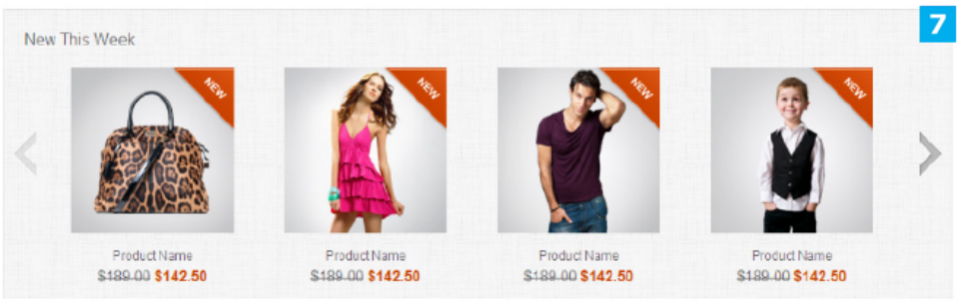

7. Carousel Widget - Arrows & background
 | Left Arrow: images\colors\color1\widget_carousel\left_arrow_sprite.png  Right Arrow: images\colors\color1\widget_carousel\right_arrow_sprite.png  Background image: images\colors\color1\widget_carousel\widget_bg.png

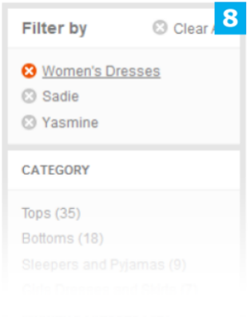
8. Close Icon (Circular)
images/colors/color1/close_circle_sprite.png

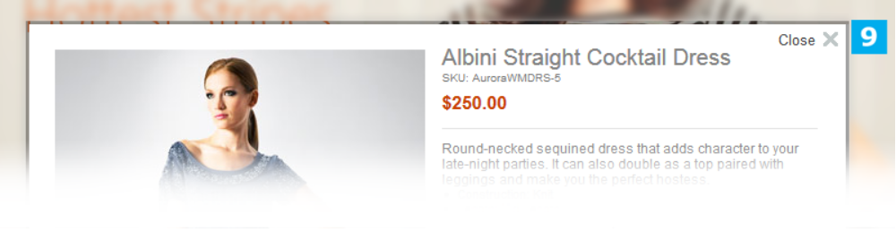
9. Close Icon (Regular)
images/colors/color1/close_sprite.png

Masthead (General Styling)

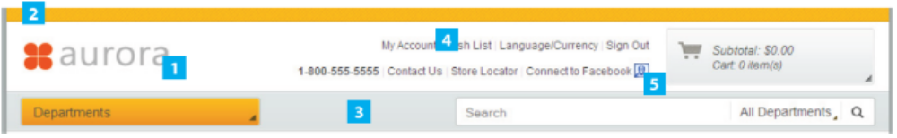
1. Company Logo
Image: images/colors/color1/widget_masthead_logo/logo.png
CSS: div#widget_masthead_logo .logo

2. Top Strip
Image: images/colors/color1/masthead_top_bg.png
CSS: #masthead > .top

3. Navigation
Image: images/colors/color1/masthead_navigation_bg.png
CSS: #masthead > .navigation

4. Links
CSS Default: div#widget_masthead_links div.masthead_links ul li a
CSS Hover: div#widget_masthead_links div.masthead_links ul li a:hover
CSS Phone #: .bold (ontop of Default class)

5. Social Network Icon
Image: images/colors/color1/widget_masthead_social/social_networking.jpg
Note: 16px X 16px image placeholder. Image is a sprite of default and hover state

Masthead - Cart
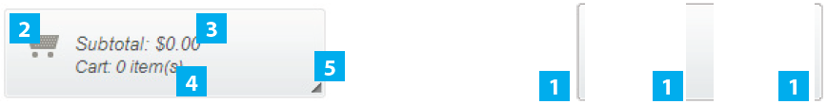
1. Background consists of three images
Left Image: images/colors/color1/widget_minishopcart/minishopcart_left_border.png
Center Image: images/colors/color1/widget_minishopcart/minishopcart_tile_bg.png
Right Image: images/colors/color1/widget_minishopcart/minishopcart_right_border.png

2. Cart Icon
Image: images/colors/color1/widget_minishopcart/minishopcart_carticon.png

3. Subtotal Text
CSS: div#widget_minishopcart > div.content > div.info > .subtotal

4. Cart Text
CSS: div#widget_minishopcart > div.content > div.info > .cart

5. Arrow Icon
CSS: div#widget_minishopcart > div.content > div.arrow
Image: images/colors/color1/widget_minishopcart/minishopcart_arrow.png

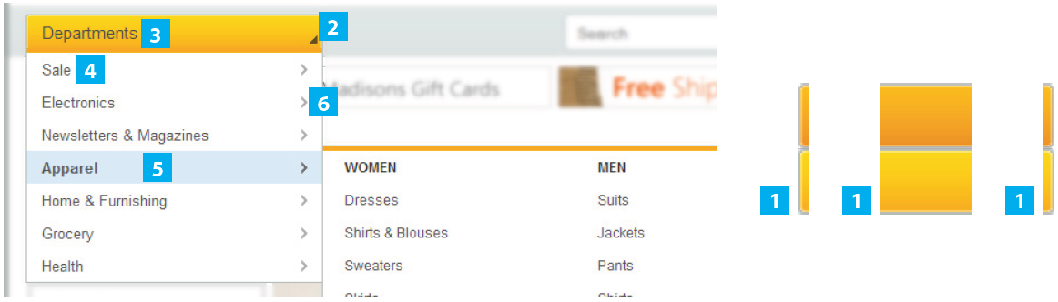
Masthead - Departments Drop-Down

1. Departments Drop-down background consists of three images
Note: Images are a sprite of default and hover states
Left Image: images/colors/color1/widget_departments/departments_left_border_sprite.png
CSS: div#widget_departments > div.left_border
Center Image: images/colors/color1/widget_departments/departments_tile_bg_sprite.png
CSS: div#widget_departments > div.content
Right Image: images/colors/color1/widget_departments/departments_right_border_sprite.png
CSS: div#widget_departments > div.right_border

2. Arrow Icon
Image: images/colors/color1/widget_departments/departments_arrow.png

3. Button Text
CSS: div#widget_departments > div.content > span.label

4. Department Element
CSS: div#widget_departments:hover > .drop_down > .middle > .left_border > .right_border > .departments

5. Department Element (4) Hover
CSS: div#widget_departments:hover > .drop_down > .middle > .left_border > .right_border > .departments > .department > .name_wrapper > .name

Footer

1. Column Header
CSS: div#footer > div.footer_element_container h1

2. List Item
CSS: div#footer > div.footer_element_container ul li

3. Divider
Note: Divider is a right-border treatment applied to the columns
CSS: div#footer > div.right_border

Carousel Widget

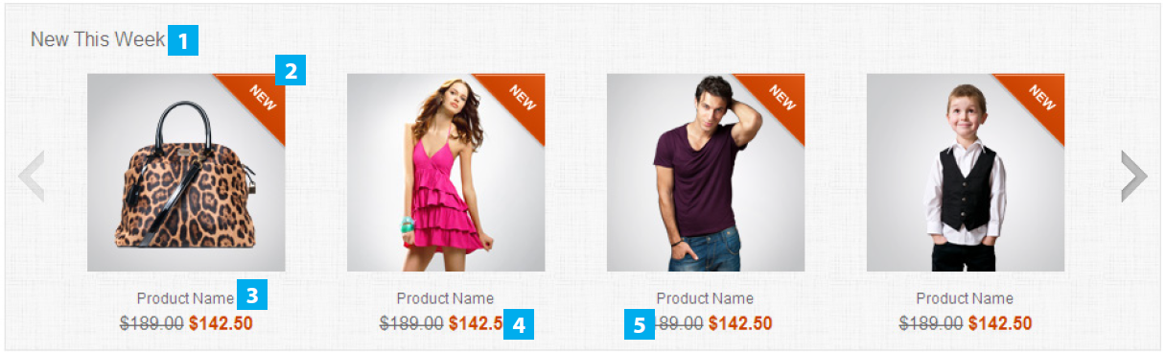
1. Widget Title
CSS: div.widget_carousel > .header

2. Product Item
Note: The following CSS class is the ‘container’ div for all the product item components.
CSS: div.widget_carousel div.product

3. Product Name
CSS: div.widget_carousel div.product > .product_info > .product_name
div.widget_carousel div.product > .product_info > .product_name a
4. Price
CSS: div.widget_carousel div.product > .product_info > .product_price

5. Old Price
CSS: div.widget_carousel div.product > .product_info > .product_price > .old_price

Breadcrumb Trail

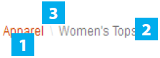
1. Trail Items
CSS: div#widget_breadcrumb > ul li a

2. Current Page
CSS: div#widget_breadcrumb > ul li.current

3. Divider
CSS: div#widget_breadcrumb > ul span.divider, div#widget_breadcrumb > ul li.divider

Product Details

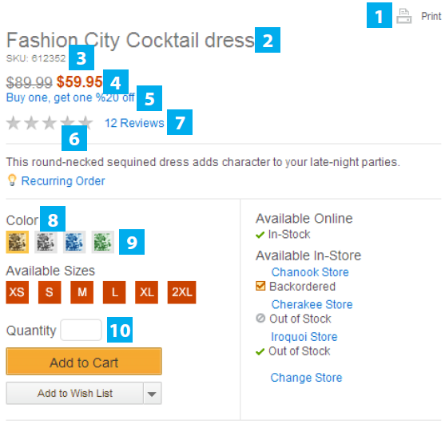
1. Print
CSS: div#widget_product_info_viewer > div.top > .print_section
Image: images/colors/color1/widget_product_info/print_icon_sprite.png

2. Product Name
CSS: div#widget_product_info_viewer > div.top > span.main_header

3. SKU
CSS: div#widget_product_info_viewer > div.top > span.sku

4. Price
CSS: div#widget_product_info_viewer > div.top > div > span.price
div#widget_product_info_viewer > div.top > div > span.old_price

5. Special Offer
CSS: div#widget_product_info_viewer > div.top .promotion
div#widget_product_info_viewer > div.top .promotion:hover

6. Star Rating
CSS: div#widget_product_info_viewer > div.top .single_star, .product_listing_container .list_mode .product > .product_info > .product_rating > div.star_ratings .single_star
div#widget_product_info_viewer > div.top .single_star:hover, .product_listing_container .list_mode .product > .product_info > .product_rating > div.star_ratings .single_star:hover

7. Reviews
CSS: div#widget_product_info_viewer > div.top > div.star_ratings > span.reviews a, .product_listing_container .list_mode .product > .product_info > .product_rating > div.star_ratings .reviews a

8. Option Title
CSS: div#widget_product_info_viewer > .product_options .color_and_size .heading, div#widget_product_info_viewer > .product_options .color_and_size .header

9. Color Swatches
CSS: div#widget_product_info_viewer > .product_options .color_and_size .color_swatch_list .color_swatch, div#widget_product_info_viewer > .product_options .color_and_size .color_swatch_list .color_swatch_disabled, div.product_listing_container .list_mode .product > .product_info > .product_color_swatches > .color_swatch_list .color_swatch, div.product_listing_container .list_mode .product > .product_info > .product_color_swatches > .color_swatch_list .color_swatch_disabled
Images: images/colors/color1/widget_product_info/color_swatch1.png (multiple swatch images)

10. Quantity Input Field
CSS: .quantity_input

Product Details

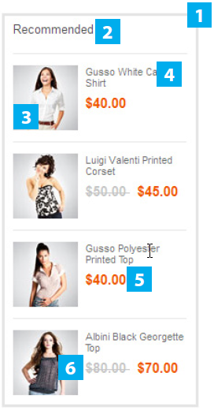
1. Border Treatment
Note: The border is divided up into 8 different parts and applied in different areas of the code.
CSS: div.widget_sidebar_container > div.top > div.left_border
div.widget_sidebar_container > div.top > div.middle
div.widget_sidebar_container > div.top > div.right_border
div.widget_sidebar_container > .left_border
div.widget_sidebar_container > .left_border > .right_border
div.widget_sidebar_container > div.bottom > div.left_border
div.widget_sidebar_container > div.bottom > div.middle
div.widget_sidebar_container > div.bottom > div.right_border

2. Widget Header
CSS: div.widget_sidebar_container > .left_border > .right_border > .content > div.header_content
div.widget_sidebar_container h1

3. Product Image
CSS: div.widget_sidebar_container > .left_border > .right_border > .content > div.item > div.left_column

4. Product Name
CSS: div.widget_sidebar_container > .left_border > .right_border > .content > div.item > div.right_column > div.item_name
div.widget_sidebar_container > .left_border > .right_border > .content > div.item > div.right_column > div.item_name a

5. Price
CSS: div.widget_sidebar_container > .left_border > .right_border > .content > div.item > div.right_column > div.item_price > .price

6. Old Price
CSS: div.widget_sidebar_container > .left_border > .right_border > .content > div.item > div.right_column > div.item_price > .old_price

Tab Container

1. Selected Tab
Text CSS: div.widget_tab_container > div.header li.selected a
CSS: div.widget_tab_container > div.header li.selected

2. Normal Tab
Text CSS: div.widget_tab_container > div.header a
CSS: div.widget_tab_container > div.header li

Shopping Cart
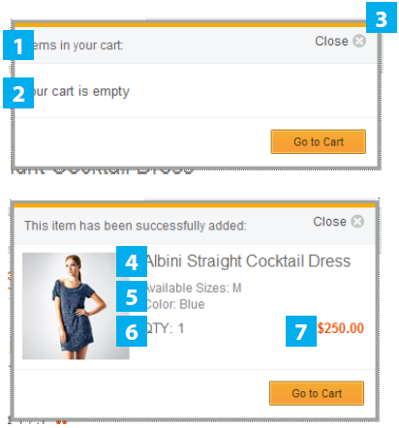
1. Notification Bar
CSS: div#widget_minishopcart_popup > .middle > .left_border > .right_border > .content > .notification, div#widget_minishopcart_popup_1 > .middle > .left_border > .right_border > .content > .notification

2. Default Text
CSS: div#widget_minishopcart_popup > .middle > .left_border > .right_border > .content > .notification, div#widget_minishopcart_popup_1 > .middle > .left_border > .right_border > .content > .notification

3. Close
CSS: div#widget_minishopcart_popup > .middle > .left_border > .right_border > .content > .close_control, div#widget_minishopcart_popup_1 > .middle > .left_border > .right_border > .content > .close_control

4. Product Name
CSS: div#widget_minishopcart_popup > .middle > .left_border > .right_border > .content > .products > .product > .product_name, div#widget_minishopcart_popup_1 > .middle > .left_border > .right_border > .content > .products > .product > .product_name

5. Product Details
CSS: div#widget_minishopcart_popup > .middle > .left_border > .right_border > .content > .products > .product > .product_color, div#widget_minishopcart_popup_1 > .middle > .left_border > .right_border > .content > .products > .product > .product_color

6. Product Quantity
CSS: div#widget_minishopcart_popup > .middle > .left_border > .right_border > .content > .products > .product > .product_quantity, div#widget_minishopcart_popup_1 > .middle > .left_border > .right_border > .content > .products > .product > .product_quantity

7. Product Price
CSS: div#widget_minishopcart_popup > .middle > .left_border > .right_border > .content > .products > .product > .product_price, div#widget_minishopcart_popup_1 > .middle > .left_border > .right_border > .content > .products > .product > .product_price

Products Grid

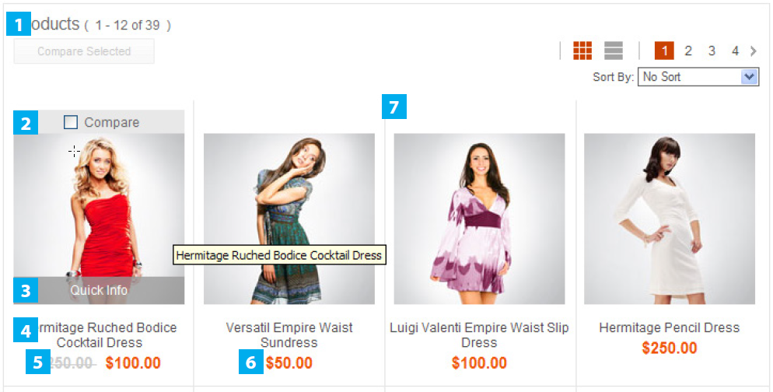
1. Grid Title
CSS: .widget_product_listing > .middle > .left_border > .right_border > .content > .header_bar > .title

2. Compare Bar
CSS: .product_listing_container .grid_mode .product > .product_image > .compare_target, .product_listing_container.list_mode .product > .product_image > .compare_target

3. Quick Info Bar
CSS: .product_listing_container .grid_mode .product > .product_image > .quick_info_toggle, .product_listing_container.list_mode .product > .product_image > .quick_info_toggle

4. Product Name
CSS: .product_listing_container .grid_mode .product > .product_info > .product_name
.product_listing_container .grid_mode .product > .product_info > .product_name a

5. Old Price
CSS: .product_listing_container .grid_mode .product > .product_info > .product_price .old_price

6. Price
CSS: .product_listing_container .grid_mode .product > .product_info > .product_price .old_price

7. Grid Background (Dividers)
CSS: .product_listing_container .grid_mode > .row

Products List

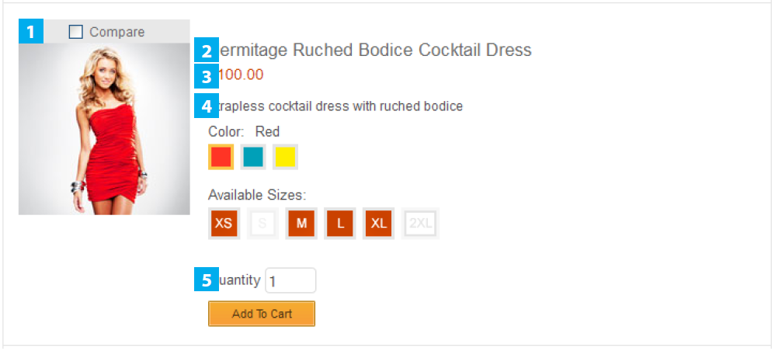
1. Compare Bar
CSS: .product_listing_container .grid_mode .product > .product_image > .compare_target, .product_listing_container.list_mode .product > .product_image > .compare_target

2. Product Name
CSS: .product_listing_container .list_mode .product > .product_info > .product_name
.product_listing_container .list_mode .product > .product_info > .product_name a

3. Product Price
CSS: .product_listing_container .list_mode .product > .product_info > .product_price

4. Description
CSS: .product_listing_container .list_mode .product > .product_info > .product_description

5. Quantity Input Field
CSS: .quantity_input
.product_listing_container .list_mode .product > .product_info > .product_quantity_addtolist > .product_quantity input

Notification Popup
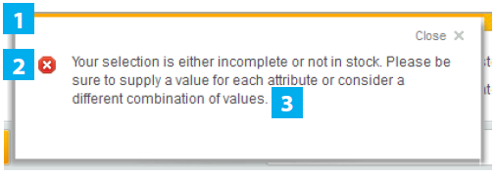
1. Overall Content
CSS: .store_message > .content

2. Notification Icon
CSS: .store_message > .content > .close

3. Notification Text
CSS: .store_message > .content > .message

Compare List

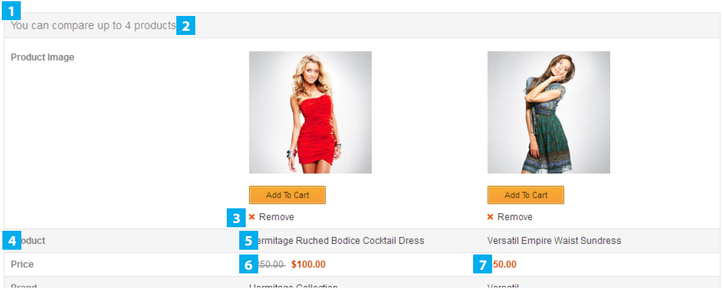
1. Table Rows
CSS: .product_listing_container .grid_mode .product > .product_image > .compare_target,
.product_listing_container.list_mode .product > .product_image > .compare_target

2. Product Name
CSS: .product_listing_container .list_mode .product > .product_info > .product_name.product_listing_container .list_mode .product > .product_info > .product_name a

3. Product Price
CSS: .product_listing_container .list_mode .product > .product_info > .product_price

4. Description
CSS: .product_listing_container .list_mode .product > .product_info > .product_description

5. Quantity Input Field
CSS: .quantity_input
.product_listing_container .list_mode .product > .product_info > .product_quantity_addtolist > .product_quantity input

