**Internet of Things in Buildings**

The Internet of Things ( IoT) is a collection of interrelated computing devices, mechanical and digital machines equipped with unique identifiers and the ability to transmit data across a network without involving human-to-human or computer-to-computer contact. Its potential excites multiple industries. The importance of IoT in the building is very vital. Modern building operations follow IoT to achieve energy savings, gain flexibility in operation, and ease in day-to-day maintenance activities. It is now starting to have a positive impact on automation and control of smart buildings. IoT offers a number of benefits for building automation including lower energy consumptions, improvements in operational efficiencies, predictive maintenance, improvements in financial planning, improvements in building performance data, and the increased use of sensors, among others.

IOT inputs the required intelligence into the basic building blocks and it helps make it smart. An IoT implemented building can be addressed as a “SMART BUILDING” which can automate and control the building operations like fire and safety, security, air conditioning, ventilation, etc. A smart building uses sensors and microchips to collect and manage data in accordance with the functions and services of a building. Such an infrastructure helps owners, operators, and facility managers boost asset efficiency and performance, reducing energy consumption, maximizing how space is used, and minimizing buildings' environmental effects. The systems must be constructed so that maintenance and adjustments can be performed.  
 **What is IoT?**

In the simplest terms, the Internet of Things is a network of sensors, meters, appliances and other devices that are capable of sending and receiving data.

**What IOT is not?**

There are multiple reasons why most of the buildings adopt IoT solutions.

1. **Comprehensive building intelligence::-**  
    The majority of the Building Automation Systems (BAS) are inept to support trending and advanced analytics for optimal use of sensor data. The IoT's native cloud-computing architecture provides a layer of intelligence over the BAS. The integrated IoT system is capable of retrieving data from an existing BAS, gathering data from various IoT sensors and unconnected devices and equipment in a house, and unifying it in the cloud. This will allow for a comprehensive view of the building operation. Real-time dashboards offer high-level views, alerts, and updates, and will provide access to data that can help with automated decisions and strategic decisions. IoT is also ready today for integration into ERPs, asset management, and predictive analytical systems.
2. **Uplift Building Performance:-** Large volumes of data from linked products are generated and used to automate decision-making and the resulting actions in real time. The analytics can be checked real time and take actions accordingly , thus the building can reduce energy costs, increase the productivity of the facility staff, improve building operations, support sustainability efforts and enhance decision-making across the organization. With the aim of creating smart buildings that are more efficient and comfortable while being easier to manage, the IoT equates to the networking of systems and devices in buildings like Heating, HVAC, Security and Access control etc.
3. **Tenant Satisfaction and retention:-**   
     
    IoT use in buildings provides a competitive advantage and will drive increased rental and property value and recommendations from occupants and tenants. Energy consumption of buildings due to the behavior of their occupants can be enabled via IoT. The HVAC and lighting can be adjusted according to user preferences based on the comfort conditions. The conventional BAS programs can be overridden by the IoT thus the tenant satisfactions improves and holds them back in the building for a longer period.
4. **Simple monitoring and maintenance:-**

Buildings are faced with the challenge of ensuring that their critical systems and other equipment operate as efficiently as possible and must also ensure that all customer service requests are meticulously addressed. IoT provides the necessary insight into the performance of the various systems in the building. IoT has the capability to provide a single view of sensor's data from multiple sources . This helps to monitor the entire group of facilities from a single location. This helps to monitor the entire group of facilities from a single location.

1. **Efficient Waste Management:-** Building Waste Management can be made smarter by introducing smart garbage containers with a sensor to determine the level of waste in the container. Waste containers can transmit this data to the IoT, which can automatically guide the waste collection trucks to the full garbage container. By this, the Basic Waste Management System will be converted to an optimized system based on real-time data resulting in much better efficiency in the overall process.
2. **Reduce Cost :-**  
     
    Continuous monitoring and predictive capability of IoT-enabled buildings can enable a building manager to take appropriate corrective action from all of the data they receive as well as control capability so they can fine-tune processes to lower energy and maintenance costs.  
     
   In conclusion, IoT brings performance in building operations by allowing integration and collaboration between devices in a way that most other systems do not. Paying attention to every detail and gathering data from every movement or rotation ensures the accuracy and applicability of building performance data. IoT products accelerate the time to resolution of maintenance issues. Remote monitoring also improves the customer service experience since customers are sent automated notifications about service issues.

17th June 2020

**Get Started with Smart Building Technology**

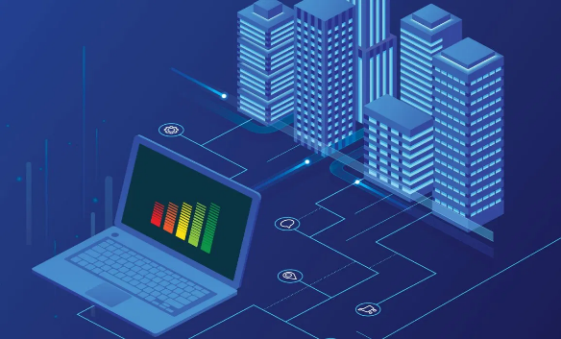

Using IoT data to make better decisions to improve tenant, employee, and management experiences. Smarter buildings can streamline business processes and expand profits with asset optimisation, better facilities management and occupant safety. The key to implementing a smart building technology program inside the facility is a successful installation and setup plan. Start small – say, track the efficiency of one air handling unit or lighting energy usage on one floor – and scale up as you get accustomed to using the device. Begin with areas that almost instantly yield a payback and make use of the savings to extend the IoT implementation.

An initial IoT implementation may be as small as a wireless monitor connected to an existing meter to gather data. Starting with only a few devices keeps operating costs down and makes it easier for the facilities workers to get the hang of understanding and acting on the data before extending the program. Determine when you are ready to extend what the next logical step is based on the data you have already collected and what other knowledge you need to obtain the insight you want.The method which works best is to create information layers and multiple discovery steps

**Additional Applications of IoT**

IoT devices and other types of smart building technology are already well established for applications such as lighting and HVAC controls, but were you aware that IoT could be incorporated in some capacity by just about every device with an on-off switch? Explore these lesser-known IoT applications and see if any of them in your facility could be of help.

1. **Wayfinding**IoT devices are tailor-made to make navigation simple.Conceptual wayfinding depends on having accurate indoor maps and open architecture wayfinding software that is capable of collecting and interpreting data from diverse IoT devices.Wayfinding is dependent on having accurate indoor maps and wayfinding software with an open architecture that is able to collect and interpret data from IoT devices. A connected IoT ecosystem is made up of four distinct components which are Devices, Local Network, Internet and Service Platform.

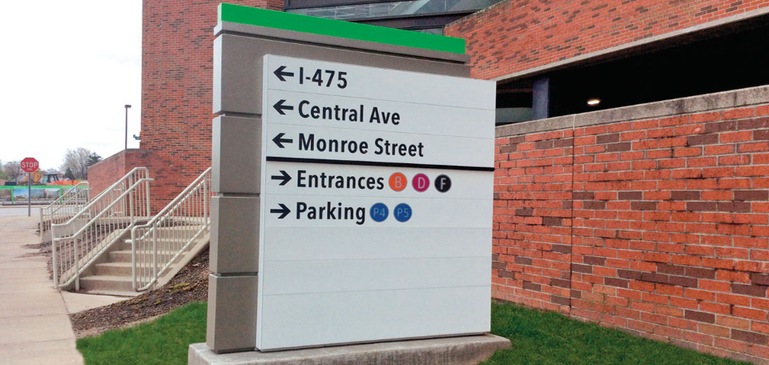

The IoT has unlocked a world of wayfinding possibilities, and is crucial to eliminating daily friction. Location-aware technologies are revolutionizing the local experience and expecting that more companies will implement wayfinding solutions through their businesses, as the IoT industry expands in the coming years.

1. **Asset Tracking, Inventory and Order Fulfillment**IoT asset tracking is a fast-growing phenomenon across a number of industries.Visualize static assets and moving objects by integrating data from Indoor Positioning Systems (IPS) to view and monitor their position and movement on high fidelity indoor maps. With our app, you can also view and easily navigate attribute information to properties.Warehouses are a great fit to technology for smart building. If you keep a considerable number of parts on site, consider making the warehouse one of your first IoT apps. Amazon uses robots to pick you up and make the product's warehouse change position automatically overnight so that they are ready for distribution.  
     
   Assets to be tracked are affixed with sensors, which continuously or periodically broadcast their location information over the internet; the software then displays that information for you to see. The various types of IoT asset tracking systems differ in the way in which the location information is transmitted, usually via GPS, Wi-Fi, or cellular networks. With sensor technology having advanced to the point where the costs are quite low, the biggest expense now associated with IoT asset tracking is Internet connectivity—an area that continues to develop and will likely drive even bigger growth as more lower-cost options arise.  
     
   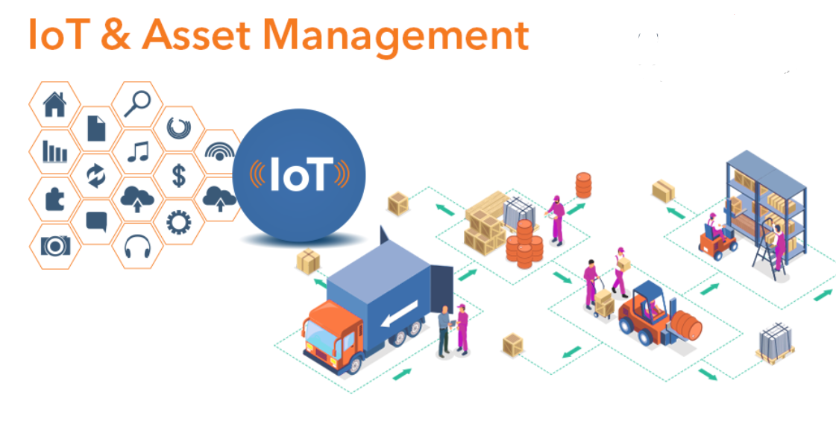
2. **Air Quality Monitoring**The most efficient air Quality Monitoring can be done using the IoT devices for Smart Buildings. Air quality sensors on top of houses, industrial areas, traffic and residential areas are mounted in the targeted area. To monitor the network of sensors these sensors are linked to a microcontroller. The data the microcontroller collects is forwarded for analysis to the cloud. How it works is that wireless sensors placed at strategic locations sense the air concentration of particles of dust, carbon dioxide , carbon monoxide, nitrogen dioxide, and sulfur dioxide. This information is transmitted via cellular or WiFi contact to a gateway which will forward it to a cloud database. The data is analyzed in the cloud to provide information about the air quality.Every year the polluted environment results in death and increases in health problems as people are exposed to poor air quality. Contaminated air awareness helps society to take precautionary steps. It will also provide for remedial action by the appropriate authority.

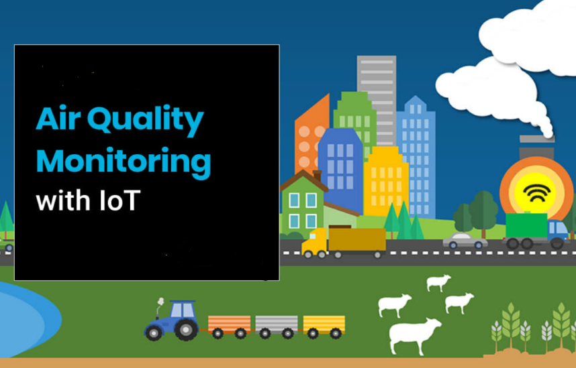

1. **Space Management**Now we will check for how the IoT can do Space Management. What IoT provides is an unparalleled level of visibility in space use – a key component of Smart Building facility management. Imagine how difficult and impractical, if not impossible at all, it is to make workers monitor office occupancy data manually during the day. Keeping this challenge in mind, you probably miss the big picture of how your offices are really being used. Incorporate IoT devices into meeting rooms and other common spaces to track occupancy and space utilization. Smart wireless technology-enabled occupancy sensors can automatically capture and communicate the utilization levels of each room or desk. Organizations will draw actionable insights by marrying IoT sensor data with an advanced analytics system to save costs and improve daily operations.  
     
   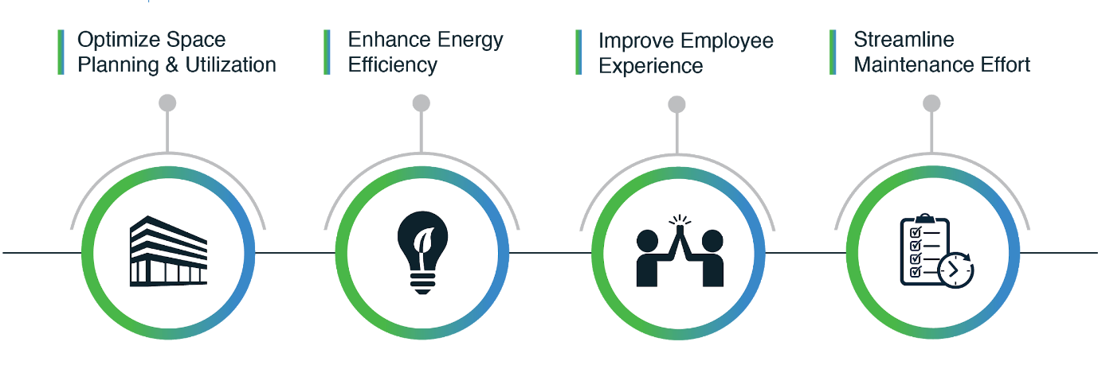
2. **Optimize Space Planning and Utilization :**- High-traffic space can be expanded and better equipped, while space that is underused can be reduced or repurposed accordingly. As such, managers might customize the optimal mix to promote collaboration , creativity and efficiency between open, co-working areas and individual zones.They can simultaneously track whether each room 's capacity is aligned with current usage.Detailed insights into space utilization additionally allow for effective allocation of office resources to different teams and departments
3. **Enhance Energy Efficiency** :- The conservation of energy is another important benefit when it comes to tracking the use of workspace.You can effectively detect waste sources throughout your building facilities to streamline consumption and maximize efficiency by monitoring the occupancy and the corresponding energy use.
4. **Improve Employee Experience** :- From the perspective of the workers, occupancy sensing will help them improve productivity and satisfaction in their day-to-day job. Sensor data, connected to room reservation systems, will help to warn when a meeting room is booked and left empty. In the same way, workers can quickly find out if there are spaces open in certain work areas or if the cafeteria is already overcrowded.
5. **Streamline Facility Management and Maintenance** :- Knowing the usage patterns of various office zones allows facility managers to schedule demand-based cleaning activities. By aligning priority and frequency cleaning with the traffic of each room, managers can ensure proper sanitation in the building is maintained. It, in effect, would have a significant influence on the betterment and happiness of the workers.

**5. Security using IoT** The Internet of Things ( IoT) helps to create safer cities, homes, and businesses by providing smart security and surveillance solutions for both private and public organizations to monitor facilities and public spaces securely and remotely in real-time. In surveillance cameras, smart locks, badge readers and other physical security tools, IoT technologies can be incorporated. Also applicable to IoT-enabled locks and access tracking may be the same geofencing barriers app developers use to target customers at certain locations. An invisible barrier that warns you about breaches helps the security personnel to respond much faster.The applications of the Internet of Things are known as the most effective technologies to be used in the design of security systems. The drones which are nowadays designed for safety are designed based on IoT solutions. More and more IoT-based apps will be used in smart ecosystems, smart cities , smart building  
 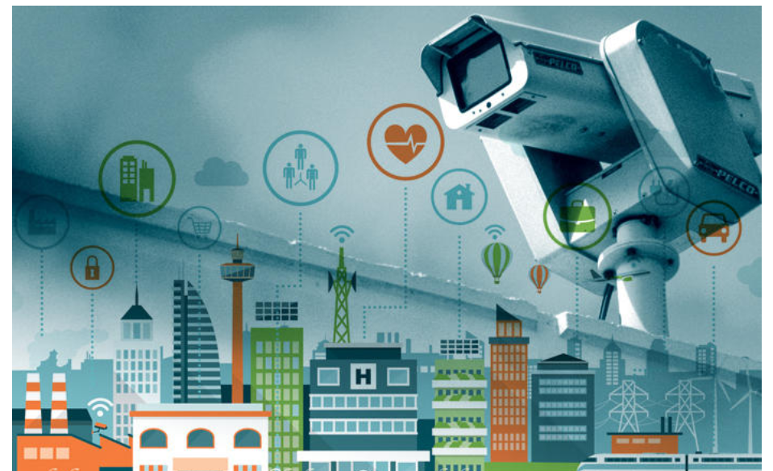

**6.Fire and Life Safety**

IoT devices linked to your emergency alarm and mass notification system can temporarily disable lighting controls that would otherwise shut off the lights, allowing people to evacuate safely. IoT powered fire safety doesn’t just have to keep us informed – it can play an active role in keeping us safe. Technology like Google’s Nest smart home system can already link a fire alarm or carbon monoxide detector with home appliances, such as the boiler or oven. If the system detects a fire or carbon monoxide, it can automatically shut off these ignition sources. Many buildings have sprinkler systems, which function on the basis that office equipment is generally cheaper to replace than an entire building. Gas and chemical solutions are also available, which minimise damages but are unsuitable for populated areas. What the IoT could offer is more targeted firefighting capabilities, helping to put out small fires and stem the tide until emergency crews arrive.By sensing exactly where the fire is, the nature of the fire and whether there are any occupants in the room, a smart IoT enabled fire system could deploy different measures to specific rooms, minimising damage to the broader facility. In future, it’s even possible that drones or robots could be released autonomously, and sent to help fight the fire in lieu of real people. As with many hyped technology, the IoT has died down in public conversations – but this shouldn’t be mistaken for it having gone away. The potential of inter-connected devices and data analysis is too great to ignore, and the benefits to fire safety and the protection of lives should bring it to a building near you soon.

The same principles applied to fire safety open up numerous possibilities for entirely new ways of fighting fires. Temperature sensors are currently configured to detect temperatures in normal ranges, but special heatproof sensors could detect the temperature of fires. This would not only detect fires before they emit smoke, but could also give firefighters a clue as to the intensity of fires, allowing them to alter their equipment and approach.Knowing where in a building a fire is taking place is also invaluable. At present, you may have an idea of where detectors were set off or where an alarm was pulled, and you might get some witness testimony. But IoT sensors could confirm this beyond all doubt, showing you not just where a fire started but where it is spreading, and how quickly.All of this information could be transmitted automatically to fire crews, even happening alongside the emergency call. In the future, it’s entirely possible that calls will be automated by the BMS, with the system forwarding vital data to the local fire department’s computer systems, which could then organise their own proportionate response. A voice alarm system could also inform evacuating employees of the best escape routes, based on the path of the fire.

**7. Vibration Sensing**

IoT vibration monitoring sensors can be used to reduce noise during construction expansion or monitor fan and other machinery health. Accelerometers are widely used in applications such as condition measurement, motion tracking and vehicle monitoring.Most handheld smart devices employ accelerometers for motion tracking, such as smartphones and tablets. These devices' size constraints have provided the impetus for developing accurate, affordable, lightweight, and power-efficient accelerometers. Microelectromechanical systems (MEMS) accelerometers follow these strict criteria and therefore justify their wide-ranging acceptance in the smart device industry.The that cost-performance ratio of modern MEMS accelerometers, especially in terms of precision and bandwidth, allows for their use in challenging measurement applications. This work presents an accelerometer, battery-powered open source Internet of Things MEMS

**How Smart Building Technology is Changing Facilities Management?**The question is precisely the broad range of possibilities that IoT provides for many facility managers. It can be tough to know where to start with smart building technology because almost every building system has IoT applications. Building automation is no replacement for the ability of a facility manager to direct a team or build smart maintenance strategies. Through keeping an eye on results and pointing out potential problems that would be difficult (and in some cases impossible) to spot with traditional hands-on management, it helps to make the job more convenient.Flexibility and serviceability are the chief advantages of setting IoT systems apart from other smart building technology. To recognize the importance of these values, consider the monthly energy bill that you receive at home. It is a crucial decision to choose which IoT provider to partner with when implementing smart building technology. Think about what you would like to do with your initial IoT investment when you explore providers and smart building solutions and ask yourself questions like these. Look for a manufacturer with scalability expertise so that after your initial achievements you can extend to other floors, building systems or facilities in your portfolio.   
  
**(i)** **What are you trying to solve?** Possibly understand where the finish line is, before you start the race. For example , if you start with lighting, do you need a system that only monitors energy use and turns off lighting in unoccupied areas, or would you also like to adjust the temperature of the color? Could you benefit from the addition of ability to detect and diagnose faults?

**(ii) Is IoT the answer to solving my problem?**If you have been talking about phasing in an IoT solution as your legacy infrastructure approaches the end of its existence, search for opportunities to begin the transition into an IoT-based approach. Often people need to upgrade their energy management system or replace lighting, and instead of using that opportunity to pivot into an IoT solution, they fall on the path of continuing to do more traditional methods. If legacy equipment is involved, find an IoT vendor who is experienced in integrating new technologies with legacy solutions.

**(iii) How much can this save me compared to the investment?**

A good IoT solution should have no recurring charges and should enable a quick payback.First asking if you have a solution that’s holistic in nature. Start there and then worry about the specific IoT technology you want to select. Make sure the platform is generalized so you can include data from any kind of IoT device.  
  
An IoT deployment problem is that there is still a great deal of distinction between hardware and software and you might need a number of hardware vendors and software to implement IoT. Look for vendors that can completely collaborate with each other and you won't be left trying to bring together the pieces on your own.

---------------------------------------------------------------------------------------------------------

18th June 2020