Experiment No. 3

Aim: Implementation of all the dimensions and the fact table for the ‘Hospital Management’

Theory:

Star Schema:
A star schema is a type of data warehouse schema that consists of a central fact table connected to multiple dimension tables.
It is optimized for query performance and simplicity, especially for OLAP (Online Analytical Processing).

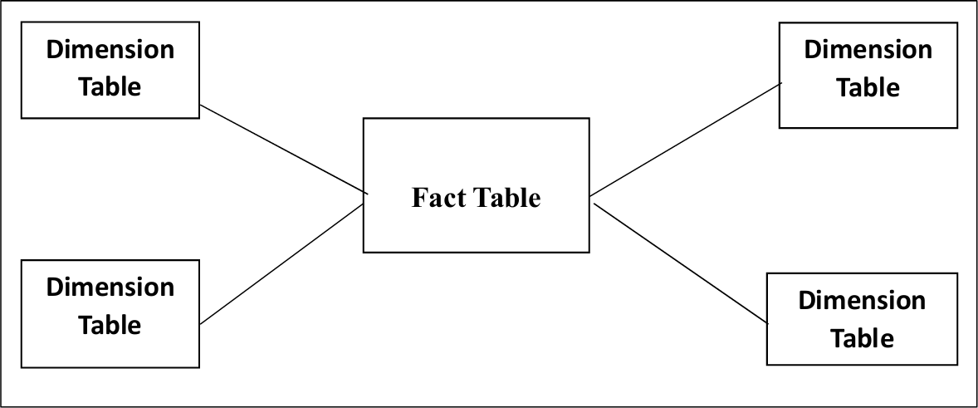

Snowflake Schema:
A Snowflake Schema is a more normalized version of the Star Schema used in data warehouse design.
It reduces data redundancy by splitting dimension tables into additional related tables.

Structure:
Fact Table: Still sits at the center and contains numerical facts (e.g., amount paid, medicine cost) and foreign keys to dimension tables.

Dimensions Table: Unlike the denormalized Star Schema, Snowflake Schema normalizes dimensions by organizing them into multiple related tables (sub-dimensions).

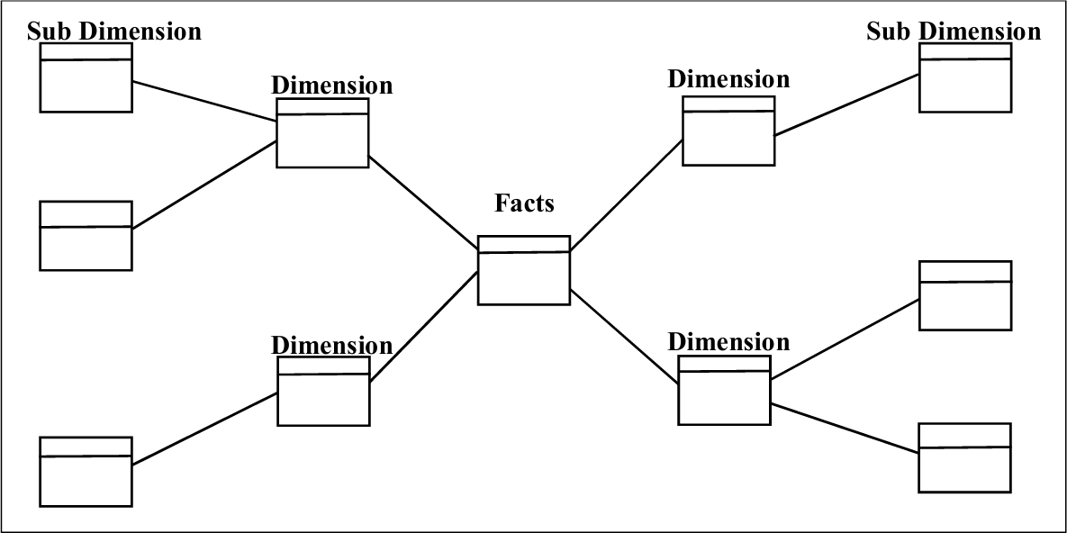

Dimension Table:
- Surround the fact table and are linked via Foreign Keys.
- Store descriptive attributes of entities (e.g., patient, doctor, time, department).
- Each dimension table has a Primary Key (e.g., patient_id, time_id).
- Attributes are usually textual or categorical (e.g., name, gender, category).
- Help in slicing and dicing the fact table for analysis.
- Usually denormalized for faster access and simplicity.
- Examples:
Time_Period: day, week, month, quarter
Patient: patient_id, name, age
Doctor: doctor_id, speciaity, license_number
Department: department_id, name, HOD

Fact Table:
- Central table in the star schema.
- Stores measurable, quantitative data (e.g., Medicine Cost, visit counts).
- Contains Foreign Keys (FK) to each related dimension table.
- Has a Primary Key (PK) — usually a surrogate key or composite key.
- Includes facts/measures like: Amount billed, Insurance coverage, etc.
- Used for aggregation, filtering, and analysis.
- Populated during the ETL process after transforming raw data.

Output:

Creating Database:

CREATE DATABASE hospital;
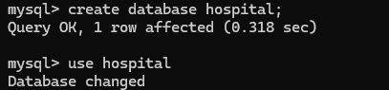

Dimension Tables

1.dimtime

Create table dimtime;

Desc dimtime;
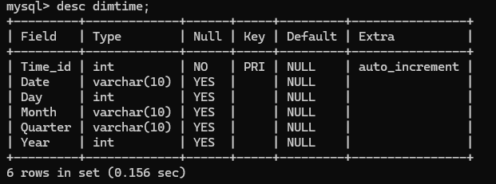

Insert into dimtime values;
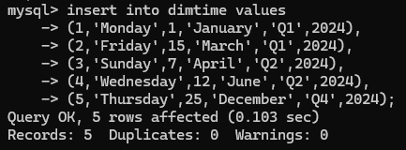

Select * from dimtime;
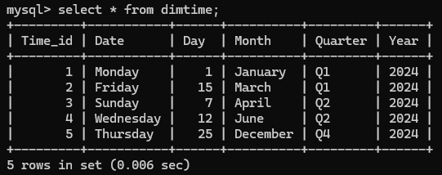

2.dimpatient

Create table dimpatient;

Desc dimpatient;
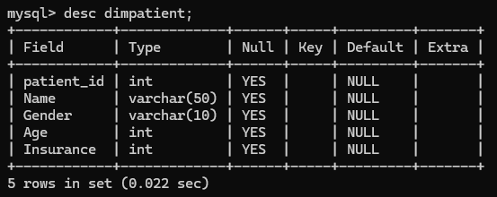

Insert into dimpatient values;
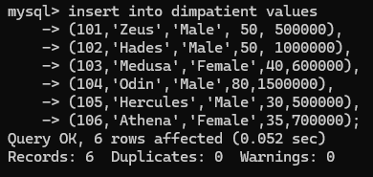

Select * from dimpatient;
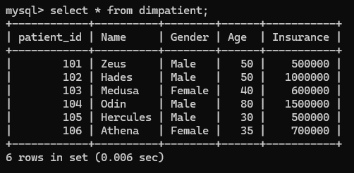

3.dimdoctor

Create table dimdoctor;

Desc dimdoctor;
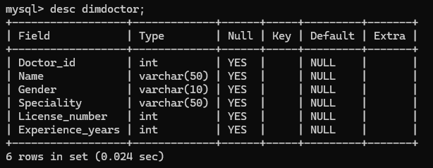

Insert into dimdoctor patient;
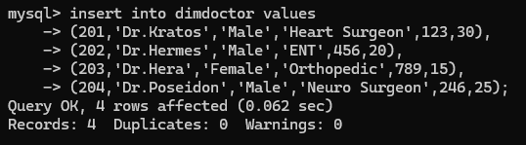

Select * from dimdoctor;
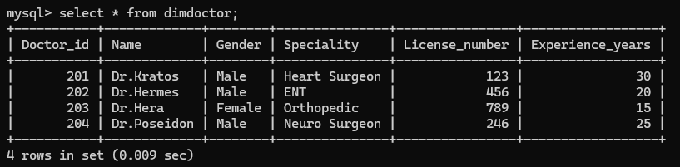

4.dimdepartment

Create table dimdepartment;

Desc dimdepartment;
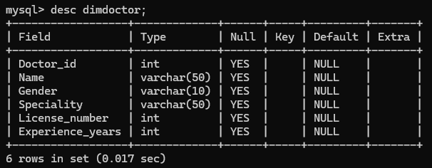

Insert into dimdepartment values;
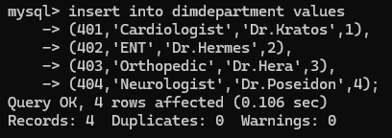

Select * from dimdepartment
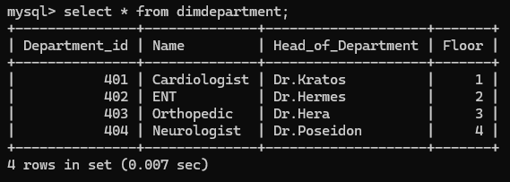

Fact table:

Create table hospitalfact;
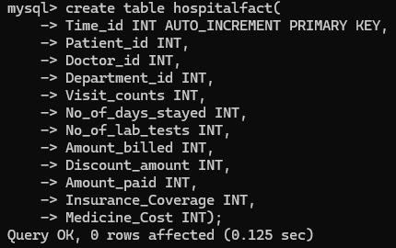

Desc hospitalfact;
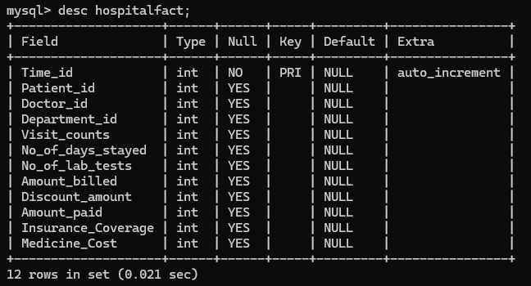

Insert into hospitalfact values;
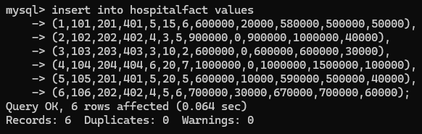

Select * from hospitalfact;
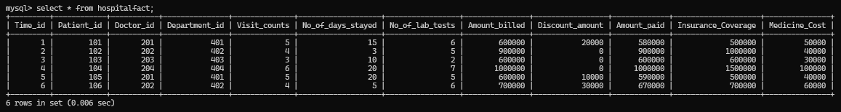

Conclusion:
We understood how to implement a Star Schema of an Insurance Claims System for which, we first implemented the dimension tables individually then we joined the central fact table using primary keys of the dimension tables as foreign key, this completes the implementation of the entire Star Schema, now we can easily perform slicing and dicing operations, this makes the fact table ready for OLAP queries of the user.

