Anara Health — Website Edit Brief
Current subtext:
Anara brings world-class healthcare to your employees - on-site and on-demand. From blood tests and preventive health checks to specialist teleconsults, we make it easy for your team to stay healthy without leaving the building.

2. STATS BAR (three numbers under hero)
85% participation rates with Anara healthcare services
9 out of 10 average satisfaction score
130+ clinic partners across India
Based on enrolled employee usage across active Anara corporate accounts, trailing 12 months to April 2026.

3

Trained & Partnered with:
Apollo Hospitals · Harvard Medical School · AIIMS · Indian Armed Forces
[Delete “OUR CREDENTIALS” section]

4. PARTICIPATION GAP SECTION
Your benefits programme is strong. Your participation isn't.

5. SERVICES SECTION
"Everything your workforce needs. One unified programme."
Box 1: On-Site Health Checks
- On-site blood tests and health checks, with trusted, consistent doctors and nurses
- Screening for chronic conditions, cancer early detection, urgent problems, and mental wellbeing
- Digital health record access to diagnostics results and consultation reports.
Box 2 — Ongoing Care & On-Demand Telehealth
- Follow up clinic days with doctors who know your workforce
- On Demand Telehealth consultations for employee and family
- Off-site master health checks and additional diagnostic testing available
Box 3 — Parents & Elderly Care
- Dedicated care managers for employees' parents and elderly family members
- Weekly home visits available across service cities
- Medication management, hospital accompaniment, lab coordination
PLUS
- Executive Health
- Specialty Clinics
- Women's Health
- Vaccines
- Workplace Wellness

6. HOW IT WORKS SECTION
"Up and running in 2 weeks. No IT integration required."
Keep this headline — it's working well.
Update the four step labels and descriptions:
Step 1 — Discovery Call
- 30 minutes to understand your workforce and existing benefits. We return with a tailored proposal.
Step 2 — Welcome & Onboard
- We handle scheduling, employee communications, app setup, and on-site orientation.
- We build trust with Lenovo team leaders
Step 3 — On-Site Blood Tests & Health Check
- Anara arrives on-site on the agreed schedule with everything set up - physicians, equipment, and lab logistics.
- Every employee receives follow-up personalised to their results.
Step 4 — Continuous Care
- Keep existing copy about monthly aggregate health reports and quarterly HR reviews.
- Monthly check-ins for chronic condition employees, on demand telehealth, follow up clinics, annual population health report delivered to your HR

7. PILOT SECTION

Change to: "Start with 100 employees. Scale when you're ready."
Change to: "Minimum 100 employees from a workforce of 200+"

8. CARE TEAM SECTION ("Real people, not an org chart")
Doctor card
Current: "MBBS and MD physicians trained in preventive care. Available on-site for clinic days and on WhatsApp for follow-up. Not teleconsultation operators — doctors who know your workforce."
Care Manager card
Retired Indian Armed Forces personnel, nurses, and trained caregivers for your employees and their families. They do home visits, manage hospital accompaniment, and handle logistics — so your employees don't have to."
HR Relationship Leads card:
Change to: "HR Liaison"
Update body copy to: "Your single point of contact. Scheduling, communications, reports, escalations all handled."
Add a care manager photos section below the four role cards:
Add a new sub-section titled: "Meet some of our care team"
With a brief intro line: "A dedicated staff of care managers, many with a background in the Indian Armed Forces, deployed to your workforce."

9. QUARTERLY REPORT / CHRO SECTION
Current subheading under the sample report:
" Built so HR can show global leadership a healthier, more engaged workforce without disclosing any individual employee's data."

10. 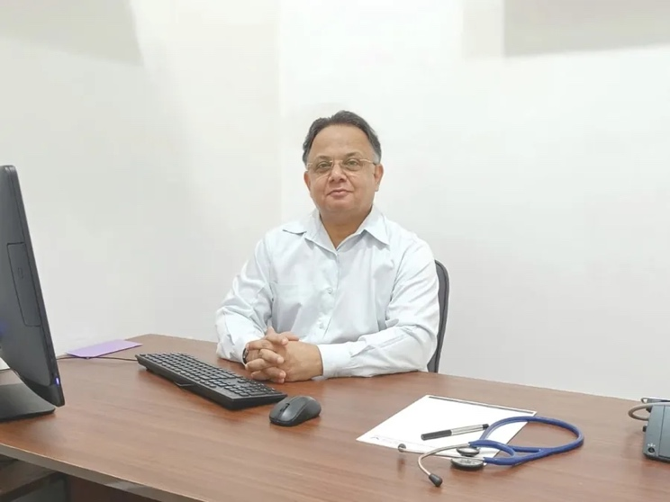
instead, replace with:
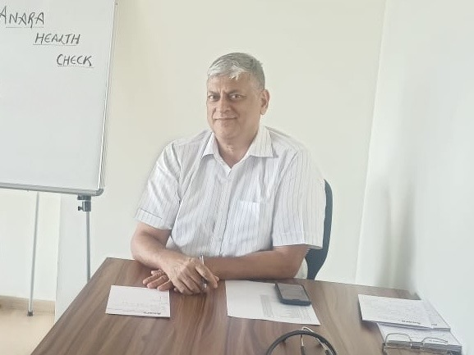

11. LEADERSHIP TEAM SECTION

12. TESTIMONIALS / QUOTES SECTION
Rahul's founder quote: We will supply updated copy. Please keep the layout but hold it for revised text from us.
Three anonymous HR testimonials: We have edits to the language on these. We will supply the revised versions within 24 hours. Please hold the layout.

