Name: Vivek Kumar

Application: Todo

Test Case

1. **Add a new Todo**

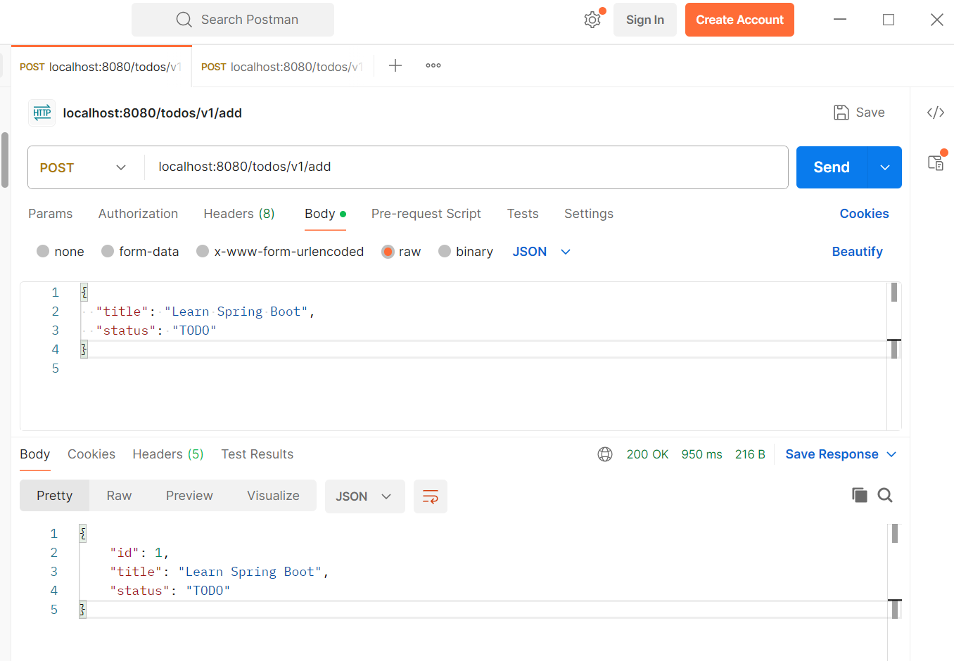

Second entry

Input wrong validation

1. Get All

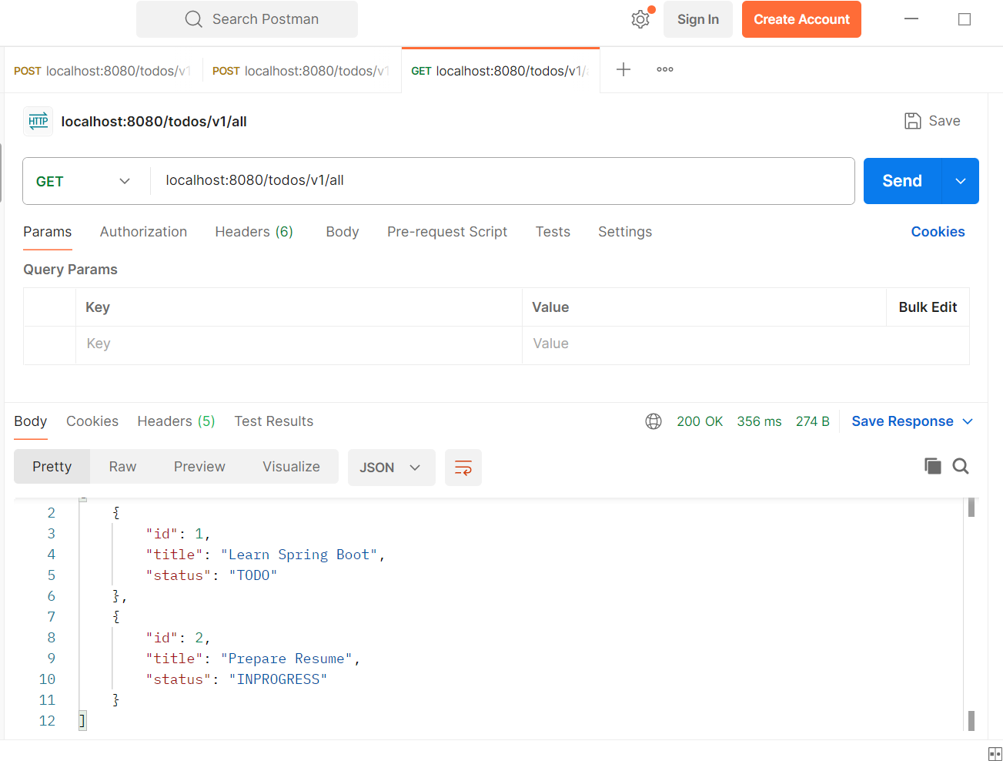

DB

1. Update a Todo

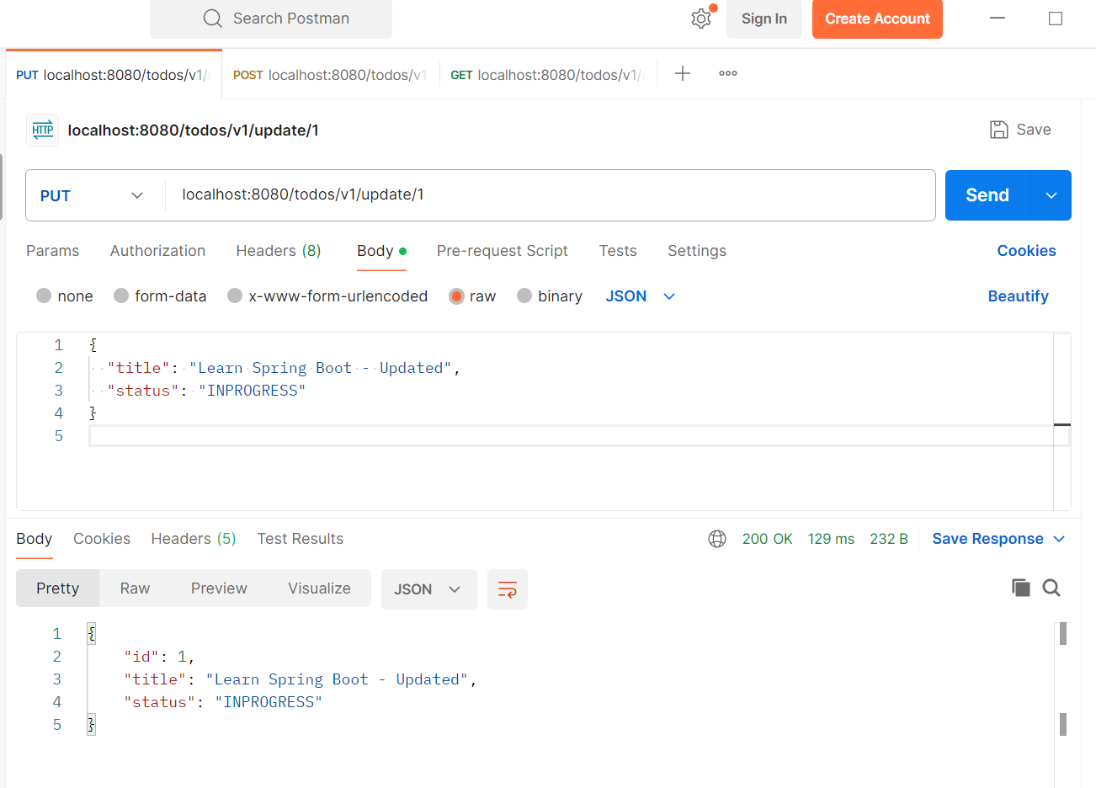

DB

1. Filter and sort

DB

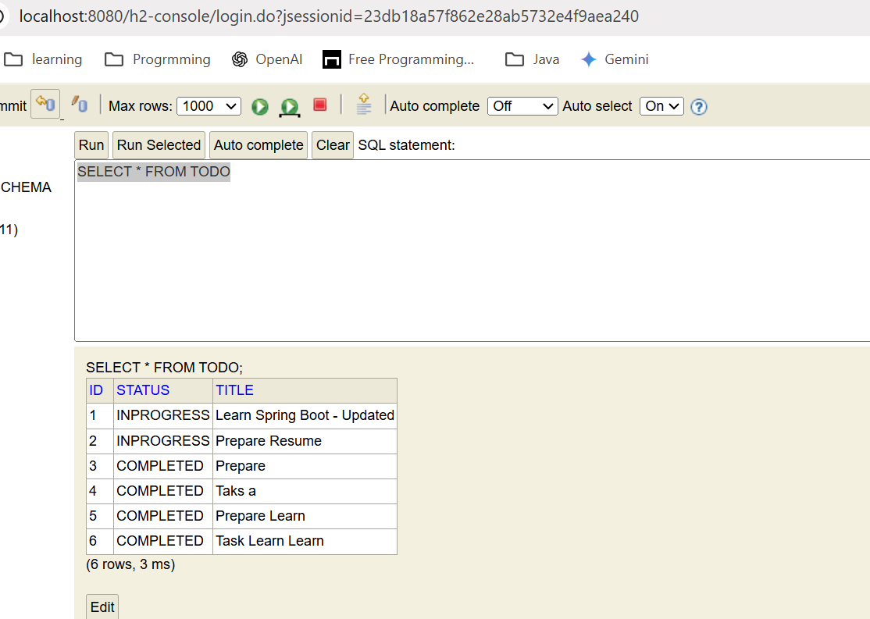

1. Delete by id

