**INTERNSHIP PROJECT INTERIM REPORT - 2**

**Internship Project Title: TCS iON RIO-125:** Forecasting System - Project Demand of Products at a Retail Outlet Based on Historical Data

**Name of the Company:** TCS iON

**Name of the Industry Mentor:** Debashish Roy

**Name of the Institute:** Viswakarma University

**Project Environment:**

**Programming Language:** Python

Tools: Jupyter Notebook, Pandas, NumPy, Matplotlib, Scikit-learn

Dataset: Retail Outlet Historical Sales Data

**Milestone #2 -** Advanced Forecasting and EDA Enhancement

**TABLE OF CONTENT**

**Acknowledgements**

**Objective**

The primary objective of this internship project is to develop an accurate demand forecasting system for retail products based on historical data. This system will help optimize inventory management and ensure product availability while minimizing overstocking and understocking issues.

**Introduction / Description of Internship**

This internship involves working with TCS iON on their RIO-125 project. The project focuses on forecasting product demand at a retail outlet, leveraging historical sales data and advanced forecasting models.

**Internship Activities**

Data Collection and Preprocessing

Exploratory Data Analysis (EDA)

Basic Forecasting Models Implementation

Advanced Forecasting Models Implementation

Model Evaluation and Fine-tuning

Project Documentation

Weekly Progress Reports

**Approach / Methodology**

**The project follows a structured approach:**

Data collection and cleaning.

Initial EDA to understand data patterns.

Implementing basic forecasting models (e.g., moving averages).

Enhancing EDA to uncover deeper insights.

Implementing advanced forecasting models (e.g., SARIMA, ETS).

Evaluating model performance and fine-tuning.

**Assumptions**

The historical sales data is representative of future sales patterns.

External factors like economic changes are stable during the forecast period.

**Exceptions / Exclusions**

The project does not consider external factors such as sudden economic crises.

It assumes that the historical data accurately represents future trends.

**Charts, Table, Diagrams:  
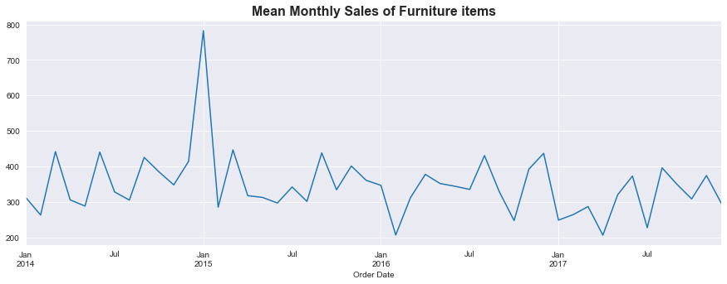**

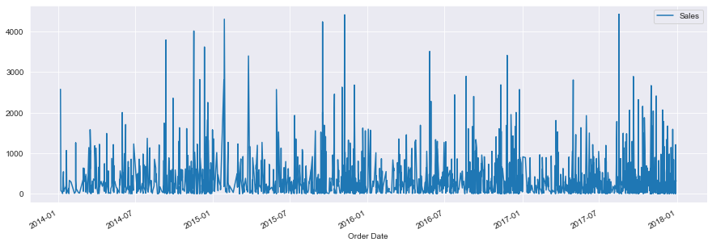

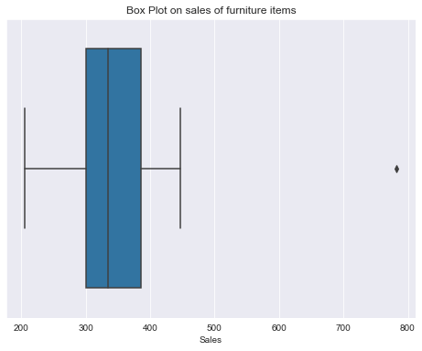

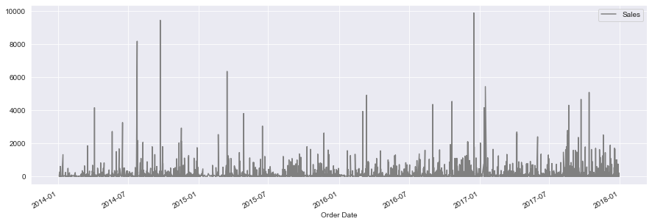

Various visualizations showing data distributions, correlations, and forecast results.

Tables displaying model performance metrics.

Algorithms

Moving Averages

Exponential Smoothing (ETS)

Seasonal Autoregressive Integrated Moving Average (SARIMA)

Challenges & Opportunities

Challenges include fine-tuning SARIMA models.

Opportunities lie in improving forecasting accuracy through model enhancements.

**Risk Vs Reward**

Risk: Forecast inaccuracies may lead to inventory issues.

Reward: Improved inventory management and cost reduction.

Reflections on the Internship

The internship provided valuable hands-on experience in data analysis and forecasting.

Collaborating with industry experts enhanced knowledge.

Recommendations

Further explore machine learning-based forecasting techniques.

Consider external factors for more robust forecasts.

**Outcome / Conclusion**

Preliminary results show promising improvements in forecasting accuracy.

Further refinement and evaluation are ongoing.

Enhancement Scope

Incorporate machine learning models for demand forecasting.

Develop a user-friendly dashboard for real-time insights.

Link to code and executable file

**GitHub Repository:**https://github.com/vivek-kumar85/Forecasting_System.git

**Research questions and responses**

Q: Can machine learning models outperform traditional time series models in demand forecasting?

A: Initial results indicate the potential for ML models to improve forecasting accuracy.

This interim report highlights the progress made in the TCS iON RIO-125 project, focusing on advanced forecasting and EDA enhancements. The project is on track, with opportunities for further improvement and exploration.