**TCS iON RIO-125: Forecasting System - Project Demand of Products at a Retail Outlet Based on Historical Data**

**Name of the Company:** TCS iON

**Name of the Industry Mentor:** Sreekathiayini Ruthraiyah

**Name of the Institute:** Viswakarma University

**Project Environment:** Python, Jupyter Notebook

**Tools used:** Python libraries (NumPy, Pandas, Matplotlib, Scikit-Learn), Visual Studio Code, Git

**Milestone 1:** Project Kick-off and Data Collection

**TABLE OF CONTENT**

**Acknowledgements**

I would like to express my gratitude to my industry mentor, Ms. Sreekathiayini Ruthraiyah, for her invaluable guidance and support throughout this internship project. I also thank my institute, Viswakarma University, for providing me with this opportunity.

**Objective**

The objective of this internship project is to develop a demand forecasting system for retail outlets based on historical sales data. The system aims to improve inventory management and optimize product availability.

**Introduction / Description of Internship**

This internship with TCS iON involves working on a real-world data science project. The project involves developing a machine learning model to predict product demand at retail outlets. By accurately forecasting demand, we aim to reduce stockouts and overstock situations.

Internship Activities

My internship activities included self-learning Python programming, studying relevant forecasting literature, collaborating with the project team, and working on data preprocessing and model development.

**Approach / Methodology**

The project follows a data-driven approach, starting with data collection and preprocessing. We are exploring various forecasting algorithms such as ARIMA, Exponential Smoothing, and machine learning models. Model evaluation and selection are key components of our methodology.

Assumptions

We assume that historical sales data is a reliable indicator of future demand. We also assume that external factors affecting demand, such as seasonality and promotions, can be incorporated into the model.

**Exceptions / Exclusions**

The project does not consider factors that are difficult to quantify or predict, such as sudden market disruptions or major economic events.

**Charts, Table, Diagrams**

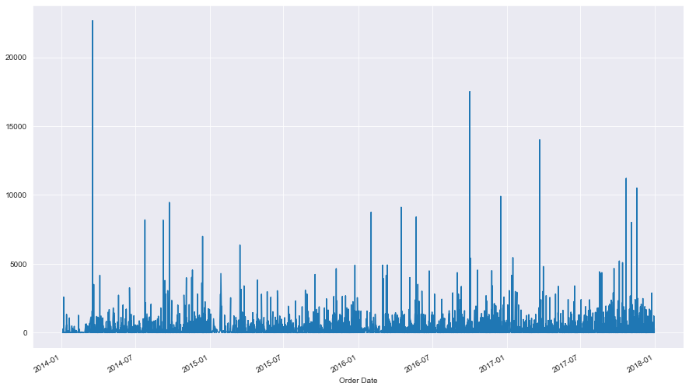

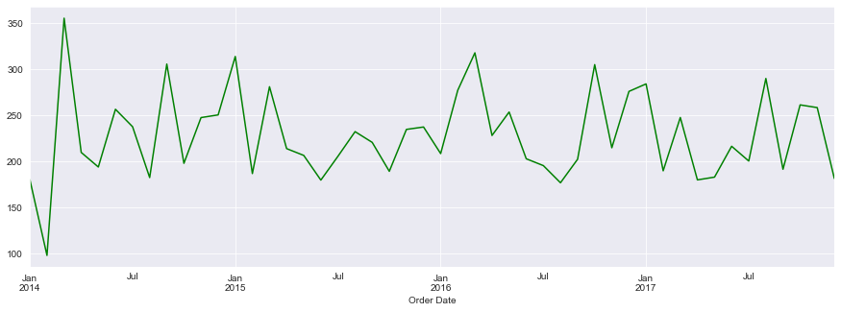

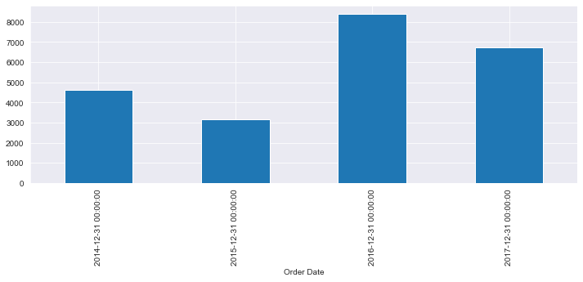

**Algorithms**

We are exploring the following algorithms for demand forecasting:

ARIMA (AutoRegressive Integrated Moving Average)

Exponential Smoothing

Machine learning models (e.g., Random Forest, XGBoost)

**Challenges & Opportunities**

Challenges include data quality issues, selecting the most suitable forecasting algorithm, and understanding complex demand patterns. Opportunities include improving inventory management and enhancing customer satisfaction.

**Risk Vs Reward**

The project's risks include potential model inaccuracies and uncertainties in demand forecasting. The reward is the potential for significant cost savings and improved retail operations.

Reflections on the Internship

This internship has been a valuable learning experience. I have gained hands-on experience in data preprocessing, machine learning, and project collaboration. It has also deepened my understanding of the retail industry.

**Recommendations**

Based on my experience, I recommend that the company invest in further data quality improvements and consider exploring more advanced machine learning techniques for demand forecasting.

**Outcome / Conclusion**

The project is ongoing, but we have made significant progress in data preprocessing and algorithm selection. We anticipate that the developed system will lead to improved demand forecasting and inventory management.

**Enhancement Scope**

Future enhancements may include incorporating external data sources (e.g., weather data) for better demand prediction and real-time demand monitoring.

**Link to code and executable file**

<https://colab.research.google.com/drive/1SlY4dVYWrw5FY1rmTefj0Fyo-Pm7YMAB?usp=sharing>