Client-Side Technologies (HTML/CSS/JavaScript/Ajax)

Tuesday 26th November

**Instructions:**

Time allowed 1hr 50 mins. Upload a .zip of the folder containing all your files to Moodle.

**NB**: For maximum marks, keep HTML, CSS and JavaScript in separate files.

1. Use the file called index.html available on Moodle and create a .css file to give the following layout using the information below.
2. The divisions for the page are shown here:

footer

section

header

nav

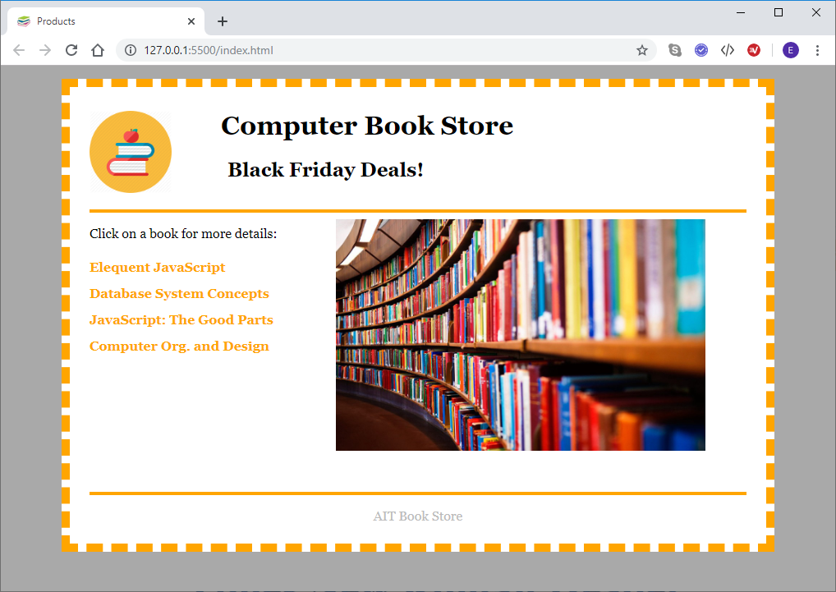

1. The background color is darkgrey.
2. The page body width is 800 pixels. It uses Georgia font family, has background color of white with a 10-pixel dashed orange border. Padding is 0.5em on top and bottom and 1.5em on left and right. Margin is 1em on top and bottom and auto on left and right (to center the division).
3. The header division is 120px high, with a 4px solid orange border at the bottom.
4. The header division contains an image, a h1 and a h2 element. The h1 font-size is 200% of the default, with a left margin of 5em. The h2 has a font-size of 150% of the default with a left margin of 7em.
5. The nav division is 300px wide by 340px high.
6. The section division has 0.5em padding at the top.
7. The links (and visited links) should be bold, orange in color with the text-decoration removed.
8. The links should change to green when the mouse moves (hovers) over them.
9. The ul in the nav division should have padding on the left set to 0. The list style for the list elements should be set to none, and the list elements should have a line-height of 2.
10. The footer has a margin at the top of 1em, and a border at the top of 4px solid orange.
11. The text in the footer is aligned to the center and has color #bbb.
12. Use appropriate floats to get the layout as shown in the picture above.
13. The details for each file are stored **as XML files** (i.e. name, author, year, pages and imageName). You need to write an XML file for each book.
14. When a link is clicked, use ajax to fetch the details, and display the book details in the section division as shown below:

Note: The image width should be set to 150px for each book.

**Book 1 details:**

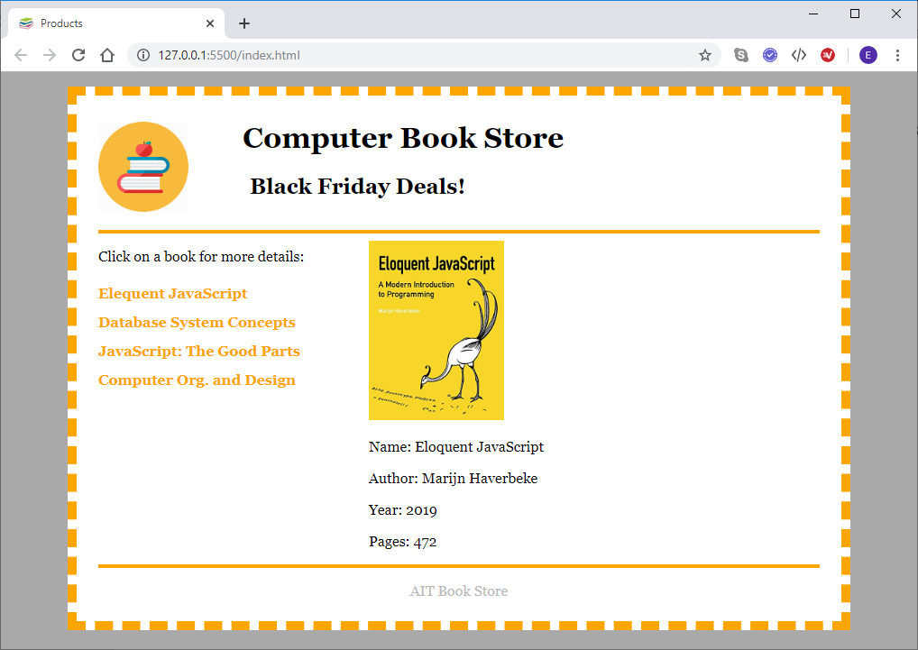

**Book 2 details:**

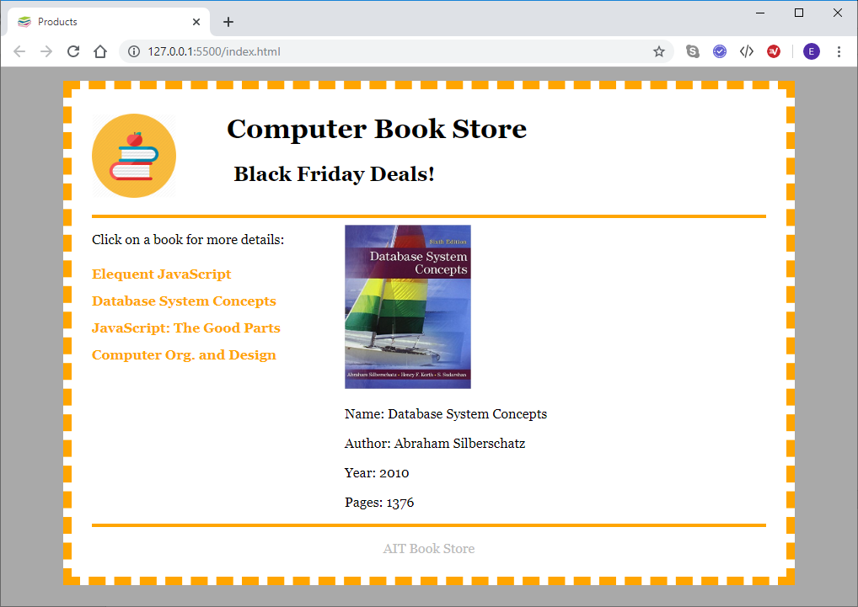

**Book 3 details:**

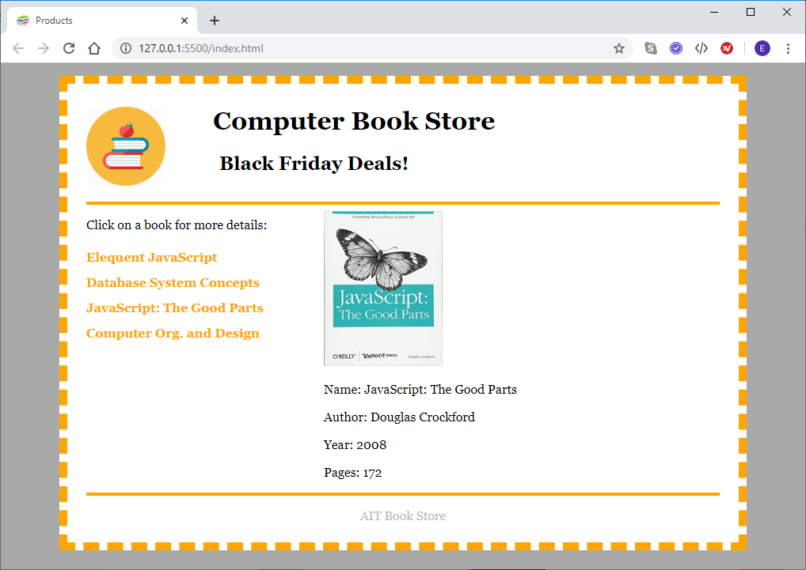

**Book 4 details:**

