Client-Side Technologies (HTML/CSS/JavaScript/JSON)

Wednesday 27th November

**Instructions:**

Time allowed 1hr 50mins. Upload a .zip of the folder containing all your files to Moodle.

**NB**: For maximum marks, keep HTML, CSS and JavaScript in separate files.

1. Use the file called index.html available on Moodle and create a .css file to give the following layout using information below.

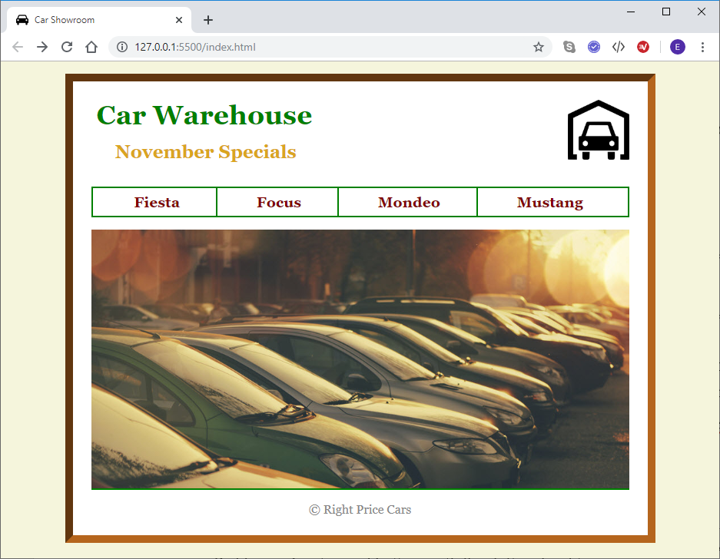

Footer

Nav

Header

Section

1. The background color is beige.
2. The body width is 700 pixels. It uses Georgia font family, has background color white with a 10-pixel inset border with color #B5651D.
3. Padding on the body is 1.5em, and it has a margin of 1em on top and bottom and auto on left and right (to center the division).
4. The header division has a margin at the bottom of 2em.
5. The header division contains an image, a h1 and a h2 element. The h1 is color green, its font-size is 220% of the default, with a margin of 0.2em.

The h2 has a margin of 0.6em on top and bottom and 1.3em on the left and right. It’s color is ‘goldenrod’.

1. The nav division has a bottom margin of 1em, font size is 120%, font-weight is bold and the nav division has a 2 px solid border which is green in color. Padding is 7px.
2. The links within the nav division have padding 7px top and bottom and 47px left and right. Use text-decoration property to remove the underline from the links. Link color is maroon.
3. The first 3 links have a right border of 2px green (class=”border” is already set in the HTML). Also, the link color should change to green when the mouse hovers on the link.
4. The footer has a margin at the top of 1em, and a border at the top of 2px solid green.
5. The footer text is center aligned with color #888. The footer <p> tag should have the bottom margin set to 0.
6. The section division has a font-size of 120% of the default.
7. Use appropriate floats to get the layout depicted in the figures shown.
8. The details for each car are stored **as JSON files** (attributes: name, color, style, price and image). You need to write the json files.
9. When a link is clicked, use AJAX to fetch the details, and display the product details in the section division as shown. Use img and p elements to display the data.

**Screenshot of page when ‘Fiesta’ is clicked:**

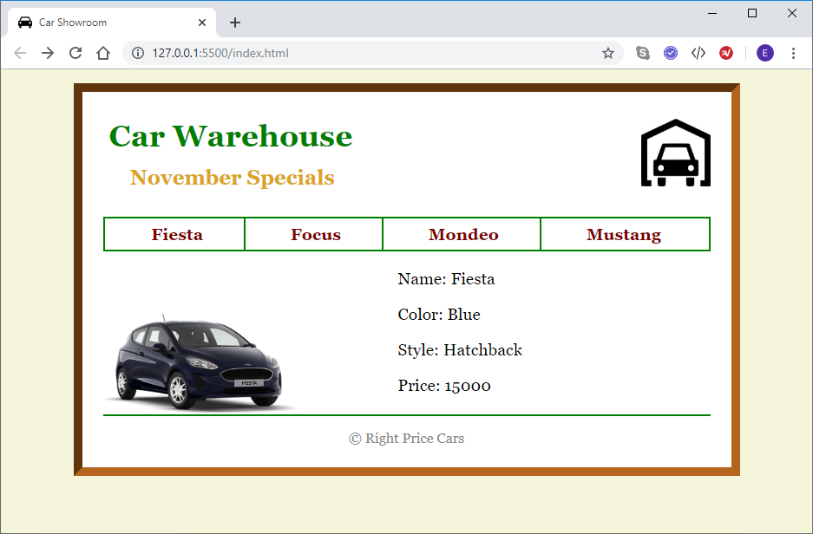

**Screenshot of page when ‘Focus’ is clicked:**

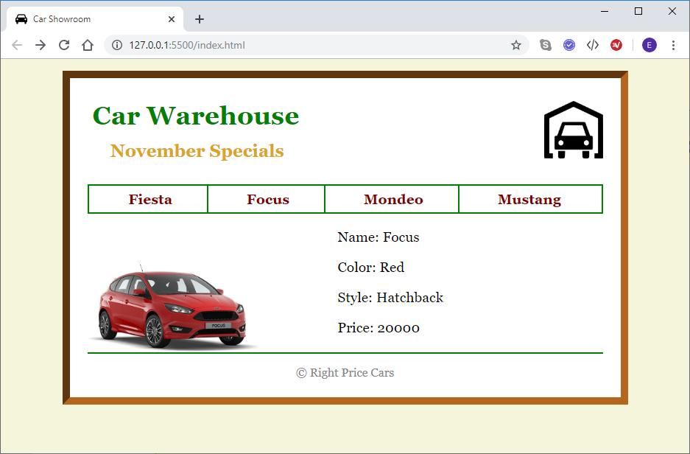

**Screenshot of page when ‘Mondeo’ is clicked:**

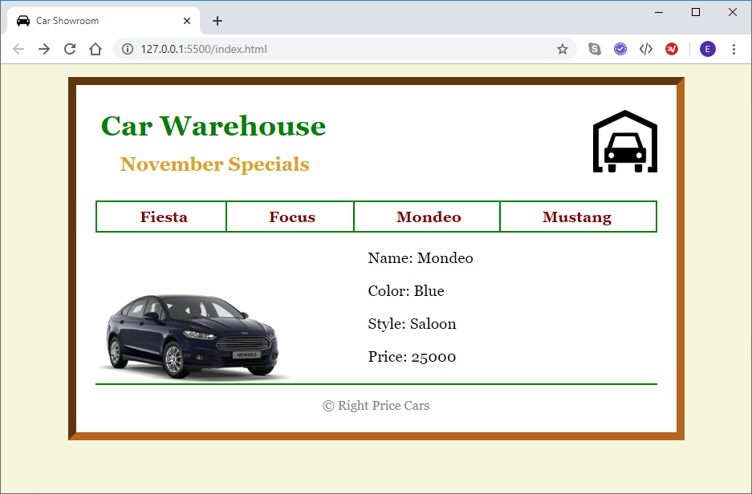

**Screenshot of page when ‘Mustang’ is clicked:**

