**JDBC Assignment**

Vivek Modi (A00268807)

**Description**

I decided to make Stock management system which is basically designed and coded to enable customers to order, store, track, and control inventory of different types of products where the users have previously stashed their orders. This system consists of 5 tables.

1. Customer
2. Login
3. Employee
4. Item
5. Order

I have used the following concepts of Database Management Systems.

1. Create
2. Insert
3. Update
4. Delete
5. Triggers
6. Joins
7. Store Procedures
8. Views

**Graphical View of Project**

1. **Login Page**

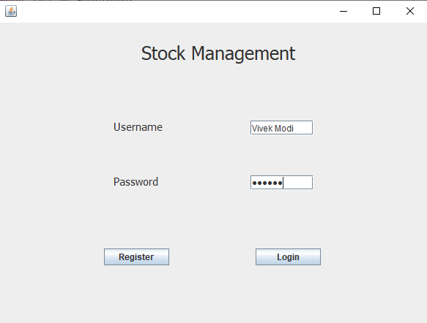

This is login page, the initial page that will greet a user trying to enter the system. It serves a security purpose, where if we login as an employee we get all the functionalities in the system and if you’re a customer, it will only let you buy a product or track it.

1. **Employee Screen**

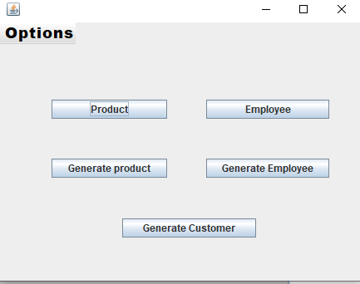

This is the main page of the application; it has 5 major functionalities needed for this project which are:

1. Product.
2. Employee.
3. Generate Product to csv file.
4. Generate Employee to csv file.
5. Generate Customer to csv file.
6. **Add product**

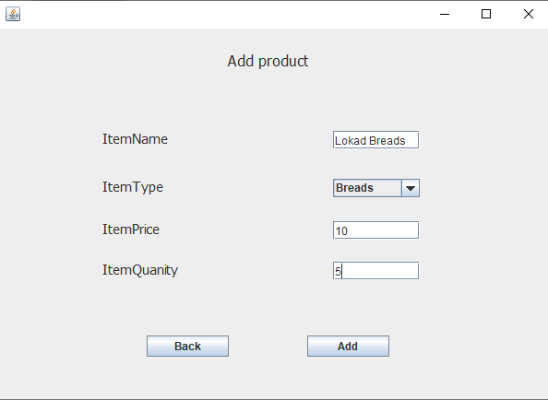

This page allows to add products in the system and add price and quantity to it.

1. **Generate Employee**

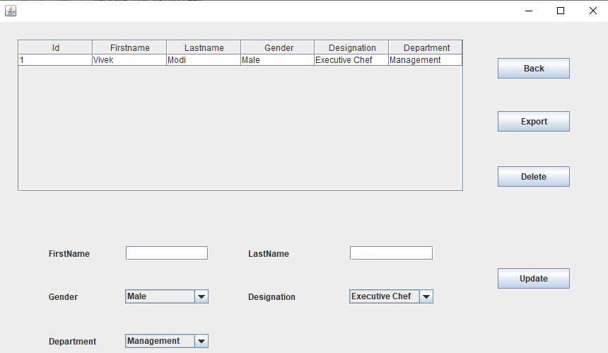

This page is Multipurpose and for a good reason. First the Export Button is used to export all the details of current Employees into a csv file. Second, we are able to delete the employee details by clicking on jtable row and then selecting the delete button to get the job done. Finally but most importantly, we have the ability to update the employee details by clicking on jtable row which automatically fills up the text-fields with the corresponding ID, and we can easily update. This was Included to make the work easier and hassle-free for the Third Party.

**First Image of Export into CSV File**

- 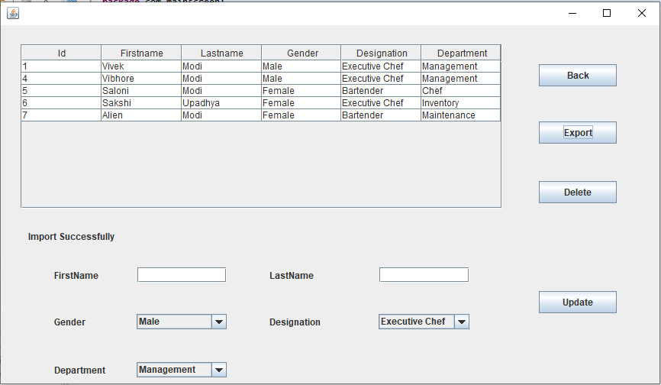

**Employee.csv**

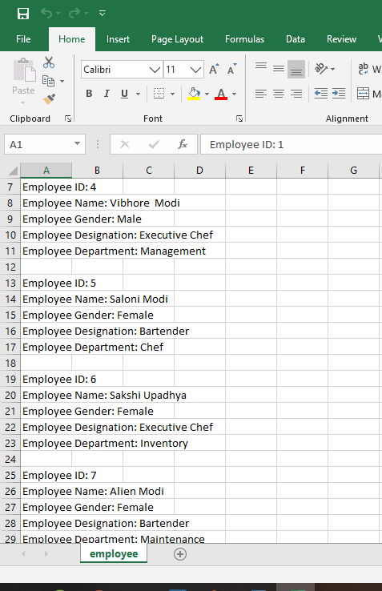

**Second delete options**

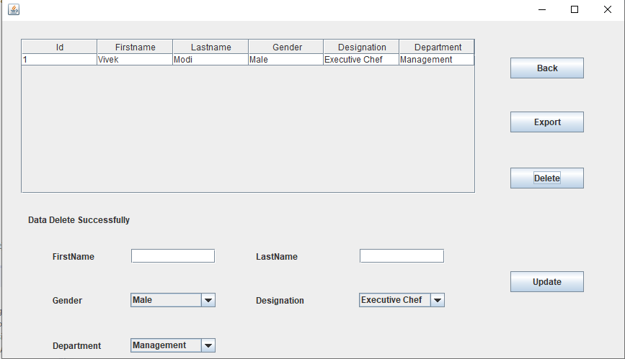

**Third to Update the employee details**

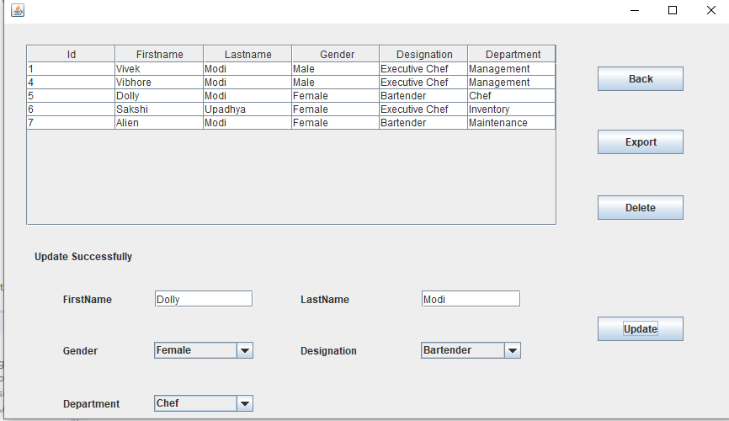

**5.Customer Screen**

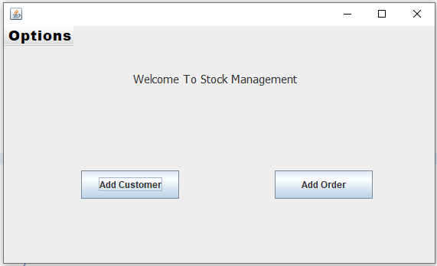

This on the other hand is the first screen that greats the customer when they choose to login and you can order and add customer.

**Add customer**

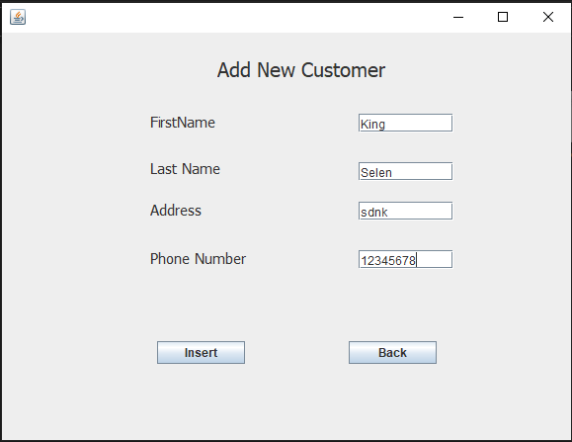

With the click of the insert button the new customer will get added to the database and it will be updated accordingly.

**Add Order**

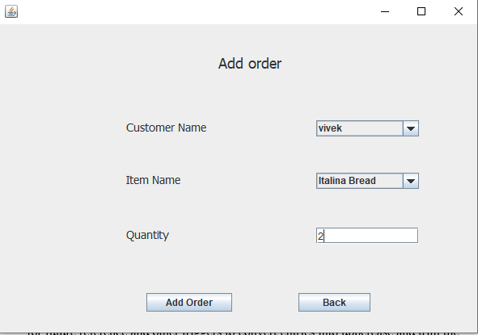

**Other Database Functionalities:**

1. **Triggers**: I created a delete trigger which saves the deleted items into a separate table for future reference and other triggers to convert entries into uppercase and trim the input

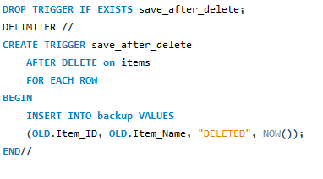

1. Stored Procedure: I created a store procedure to calculate the salary of an employee based upon the department and designation

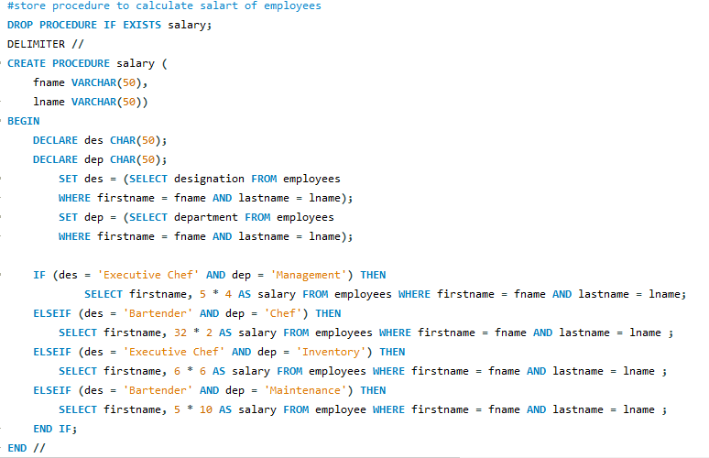

1. **Views**:

I have used view to show the stock price.

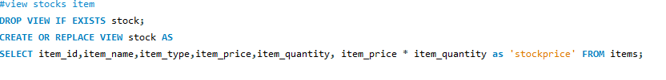

**Conclusion**

With My application it will be easy to focus on stock and maintain the employees in an overall big system. I tried to create a small prototype of what a system could work around with different inventory rather than a dedicated system.

It was a good experience creating the project and going through all the aspects of database and connecting with java to create all aspects on an application. I learned about using stored procedures and making extensive use of views which would have been impossible without this project. I would like to work more on these technologies and will implement these learnings into future projects that I will work on.