# Name: Vivek Mote

**Roll Number :20141229. Experiment Number – 1 1.Caesar Cipher**

# // Caesar Cipher Encryption

# #include <iostream>

# using namespace std;

# int main() {

# cout << "Caesar Cipher program for encryption\n\n";

# cout << "20141229 Vivek Mote Exp-1. A\n\n";

# string s, t;

# int key;

# 

# cout << "Enter the key: ";

# cin >> key;

# 

# cout << "Enter the message: ";

# cin.ignore(); // Clear the newline character left in the input buffer

# getline(cin, s); // Read a full line of input

# 

# for (int i = 0; i < s.size(); i++) {

# char originalChar = s[i];

# t.push_back(((originalChar + key) + 128) % 128);

# }

# 

# cout << "\n\nEncrypted message is " << t << '\n';

# 

# return 0;

}

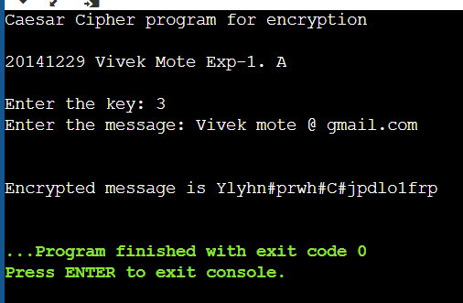

// Caesar Cipher Decryption #include <iostream>

using namespace std;

int main() {

cout << "Caesar Cipher program for decryption\n\n";

cout << "20141229 Vivek Mote Exp-1. A\n\n";

string s, t;

int key;

cout << "Enter the key: ";

cin >> key;

cout << "Enter the message to decrypt: ";

cin.ignore(); // Clear the newline character left in the input buffer

getline(cin, s); // Read a full line of input

for (int i = 0; i < s.size(); i++) {

char originalChar = s[i];

t += ((originalChar - key) + 128) % 128;

}

cout << "\n\nDecrypted message is " << t << '\n';

return 0;

}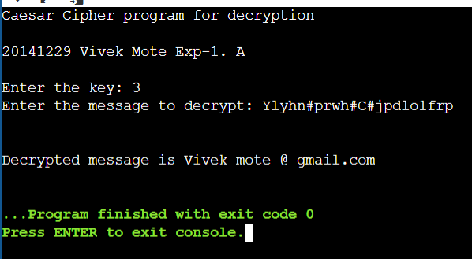

# B. Playfair Cipher Encryption

#include<bits/stdc++.h> using namespace std; int main(){

cout<<"20141229 Vivek Mote Exp-1. B\n\n"; int i,j,k,n;

cout<<"Enter the message"<<endl; string s,origin;

getline(cin,origin); cout<<"Enter the key"<<endl; string key;

cin>>key; for(i=0;i<origin.size();i++){

if(origin[i]!=' ') s+= origin[i];

}

vector<vector<char> > a(5,vector<char>(5,' ')); n=5;

map<char,int> mp; k=0;

int pi,pj; for(i=0;i<n;i++){

for(j=0;j<n;j++){ while(mp[key[k]]>0&&k<key.size()){

k++;

}

if(k<key.size()){

a[i][j]=key[k];

mp[key[k]]++; pi=i;

pj=j;

}

if(k==key.size()) break;

}

if(k==key.size()) break;

}

k=0;

for(;i<n;i++){

for(;j<n;j++){ while(mp[char(k+'a')]>0&&k<26){

k++;

}

if(char(k+'a')=='j'){ j--;

k++;

continue;

}

if(k<26){ a[i][j]=char(k+'a');

mp[char(k+'a')]++;

}

}

j=0;

}

string ans; if(s.size()%2==1)

s+="x";

for(i=0;i<s.size()-1;i++){ if(s[i]==s[i+1])

s[i+1]='x';

}

map<char,pair<int,int> > mp2; for(i=0;i<n;i++){

for(j=0;j<n;j++){

mp2[a[i][j]] = make_pair(i,j);

}

}

for(i=0;i<s.size()-1;i+=2){ int y1 = mp2[s[i]].first; int x1 = mp2[s[i]].second; int y2 = mp2[s[i+1]].first;

int x2 = mp2[s[i+1]].second; if(y1==y2){

ans+=a[y1][(x1+1)%5];

ans+=a[y1][(x2+1)%5];

}

else if(x1==x2){ ans+=a[(y1+1)%5][x1];

ans+=a[(y2+1)%5][x2];

} else { ans+=a[y1][x2];

ans+=a[y2][x1];

} }

cout<<"Encrypted message is "; cout<<ans<<'\n';

return 0;

}

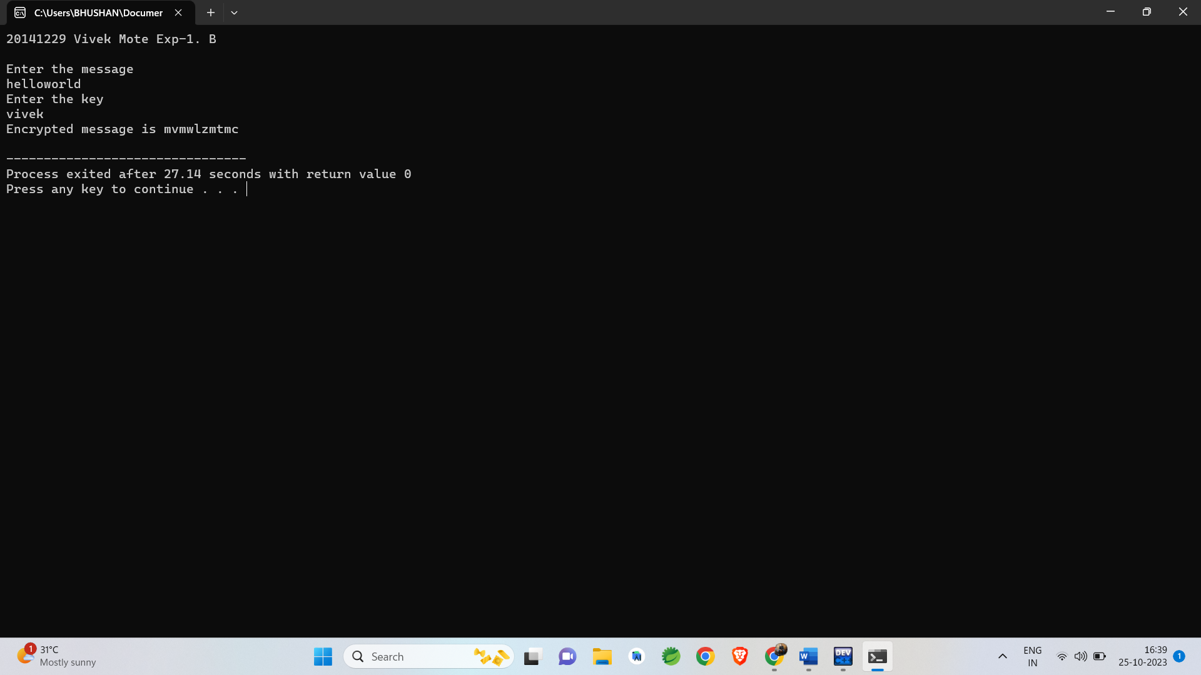

# Playfair Cipher Decryption

#include<bits/stdc++.h> using namespace std; int main(){

cout<<"Playfair cipher Decryption\n"; cout<<"20141229 Vivek Mote Exp-1. B\n\n"; cout<<"Enter the encrypted message\n";

string s; cin>>s; int i,j,k,n;

cout<<"Enter the key\n"; string key;

cin>>key;

vector<vector<char> > a(5,vector<char>(5,' ')); n=5;

map<char,int> mp; k=0;

int pi,pj; for(i=0;i<n;i++){

for(j=0;j<n;j++){ while(mp[key[k]]>0&&k<key.size()){

k++;

}

if(k<key.size()){

a[i][j]=key[k];

mp[key[k]]++; pi=i;

pj=j;

}

k=0;

}

if(k==key.size()) break;

for(;i<n;i++){

for(;j<n;j++){ while(mp[char(k+'a')]>0&&k<26){

k++;

}

if(char(k+'a')=='j'){ j--;

k++;

continue;

}

if(k<26){ a[i][j]=char(k+'a');

mp[char(k+'a')]++;

}

}

j=0;}

string ans; map<char,pair<int,int> > mp2; for(i=0;i<n;i++){

for(j=0;j<n;j++){

mp2[a[i][j]] = make_pair(i,j);

}

}

for(i=0;i<s.size()-1;i+=2){ int y1 = mp2[s[i]].first; int x1 = mp2[s[i]].second; int y2 = mp2[s[i+1]].first;

int x2 = mp2[s[i+1]].second; if(y1==y2){

ans+=a[y1][(x1-1)%5];

ans+=a[y1][(x2-1)%5];

}

else if(x1==x2){ ans+=a[(y1-1)%5][x1];

ans+=a[(y2-1)%5][x2];

}

else {

ans+=a[y1][x2];

ans+=a[y2][x1];

}

}

if(ans[ans.size()-1]=='x')

ans[ans.size()-1]='\0';

for(i=1;i<ans.size();i++){

if(ans[i]=='x')

ans[i]=ans[i-1];

}

cout<<"Decrypted message is "; cout<<ans<<'\n';

return 0;

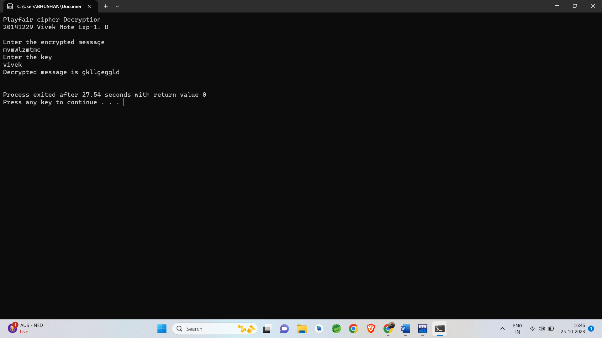}

# Hill Cipher Encryption

#include<bits/stdc++.h> using namespace std; int main(){

cout<<"Hill Cipher Encryption\n"; cout<<"Mahesh Thorat 19141227 Exp1-c \n"; int x,y,i,j,k,n;

cout<<"Enter the size of key matrix\n"; cin>>n;

cout<<"Enter the key matrix\n"; int a[n][n];

for(i=0;i<n;i++){ for(j=0;j<n;j++){

cin>>a[i][j];

} }

cout<<"Enter the message to encrypt\n"; string s;

cin>>s;

int temp = (n-s.size()%n)%n; for(i=0;i<temp;i++){

s+='x';

} k=0;

string ans=""; while(k<s.size()){

for(i=0;i<n;i++){

int sum = 0, temp = k; for(j=0;j<n;j++){

sum += (a[i][j]%26*(s[temp++]-'a')%26)%26; sum = sum%26;

}

ans+=(sum+'a');

}

k+=n;

}

cout<<ans<<'\n';

return 0;

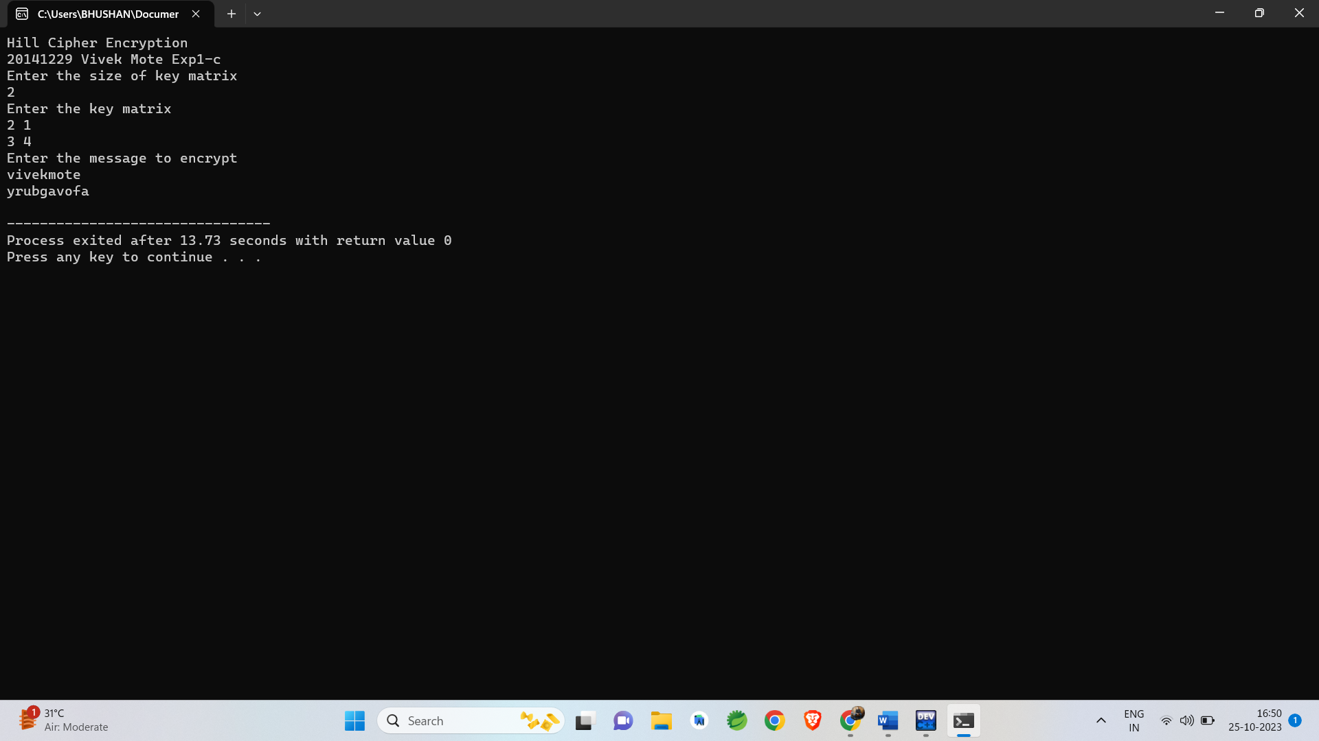}

# Hill Cipher Decryption

#include<bits/stdc++.h> using namespace std;

int modInverse(int a, int m){ a=a%m;

for(int x=-m;x<m;x++) if((a*x)%m==1)

return x;

}

void getCofactor(vector<vector<int> > &a, vector<vector<int> > &temp, int p, int q, int n){ int i=0,j=0;

for(int row=0;row<n;row++){ for(int col=0;col<n;col++){ if(row!=p&&col!=q){

temp[i][j++] = a[row][col]; if (j==n-1){

j=0; i++;

} } } } }

int determinant(vector<vector<int> > &a, int n, int N){ int D = 0;

if(n==1)

return a[0][0];

vector<vector<int> > temp(N, vector<int>(N)); int sign = 1;

for(int f=0;f<n;f++){ getCofactor(a, temp, 0, f, n);

D += sign * a[0][f] * determinant(temp, n - 1, N); sign = -sign;

} return D; }

void adjoint(vector<vector<int> > &a,vector<vector<int> > &adj,int N){ if(N == 1){

adj[0][0] = 1;

return;

}

int sign = 1;

vector<vector<int> > temp(N, vector<int>(N)); for(int i=0;i<N;i++){

for(int j=0;j<N;j++){ getCofactor(a, temp, i, j, N); sign = ((i+j)%2==0)? 1: -1;

adj[j][i] = (sign)*(determinant(temp, N-1 , N));

} }

}

bool inverse(vector<vector<int> > &a, vector<vector<int> > &inv, int N){ int det = determinant(a, N, N);

if(det == 0){

cout << "Inverse does not exist"; return false; }

int invDet = modInverse(det,26); cout<<det%26<<' '<<invDet<<'\n'; vector<vector<int> > adj(N, vector<int>(N));

adjoint(a, adj, N); for(int i=0;i<N;i++)

for(int j=0;j<N;j++)

inv[i][j] = (adj[i][j]*invDet)%26;

return true;

}

int main(){

cout<<"Hill Cipher Decryption \n"; cout<<"20141229 Vivek Mote Exp1-C\n"; int x,y,i,j,k,n;

cout<<"Enter the size of key matrix\n"; cin>>n;

cout<<"Enter the key matrix\n";

vector<vector<int> > a(n, vector<int>(n)); vector<vector<int> > adj(n, vector<int>(n)); vector<vector<int> > inv(n, vector<int>(n)); for(i=0;i<n;i++){

for(j=0;j<n;j++){ cin>>a[i][j];

}

}

if(inverse(a,inv,n)) cout<<"Inverse exist\n";

cout<<"Enter the message to decrypt\n"; string s;

cin>>s; k=0;

string ans; while(k<s.size()){

for(i=0;i<n;i++){ int sum = 0; int temp = k;

for(j=0;j<n;j++){

sum += ((inv[i][j] + 26)%26*(s[temp++]-'a')%26)%26; sum = sum%26;

}

ans+=(sum+'a');

} k+=n;

}

int f=ans.size()-1; while(ans[f]=='x')

f--;

cout<<"Decrypted message is "; for(i=0;i<=f;i++){ cout<<ans[i]<<”\n”; } return 0;

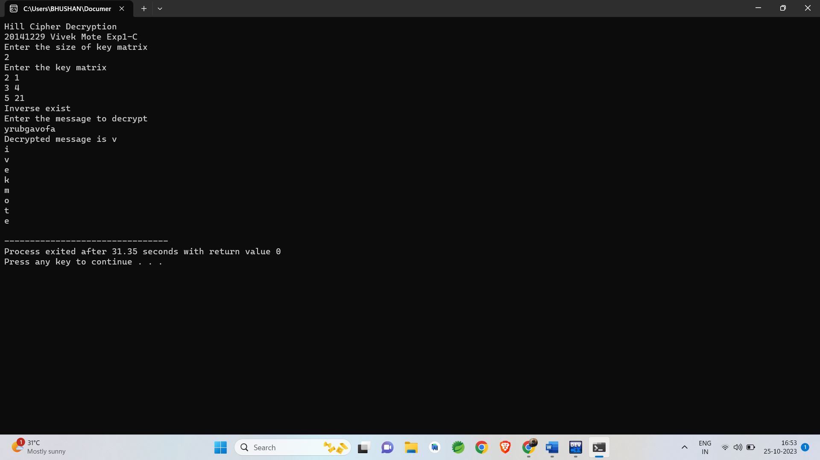}

# Vigenere Cipher Encyption

#include<bits/stdc++.h> using namespace std; int main(){

cout<<"Vigenere Cipher Encryption\n"; cout<<" 20141229 Vivek Mote Exp1-D\n"; int i,j,k,n;

vector<vector<char> > a(26,vector<char>(26)); k=0;

n=26;

for(i=0;i<n;i++){ k=i; for(j=0;j<n;j++){

a[i][j]='A'+k; k++;

if(k==26) k=0;

}

}

cout<<"Enter the message\n"; string s;

cin>>s;

cout<<"Enter the key\n"; string key;

cin>>key; k=0;

int mod = key.size(); for(i=key.size();i<s.size();i++){

key+=key[k%mod]; k++;

}

string encrypt; for(i=0;i<s.size();i++){

encrypt+= a[s[i]-'A'][key[i]-'A'];

}

cout<<"Encrypted message: "<<encrypt<<'\n'; return 0;

}

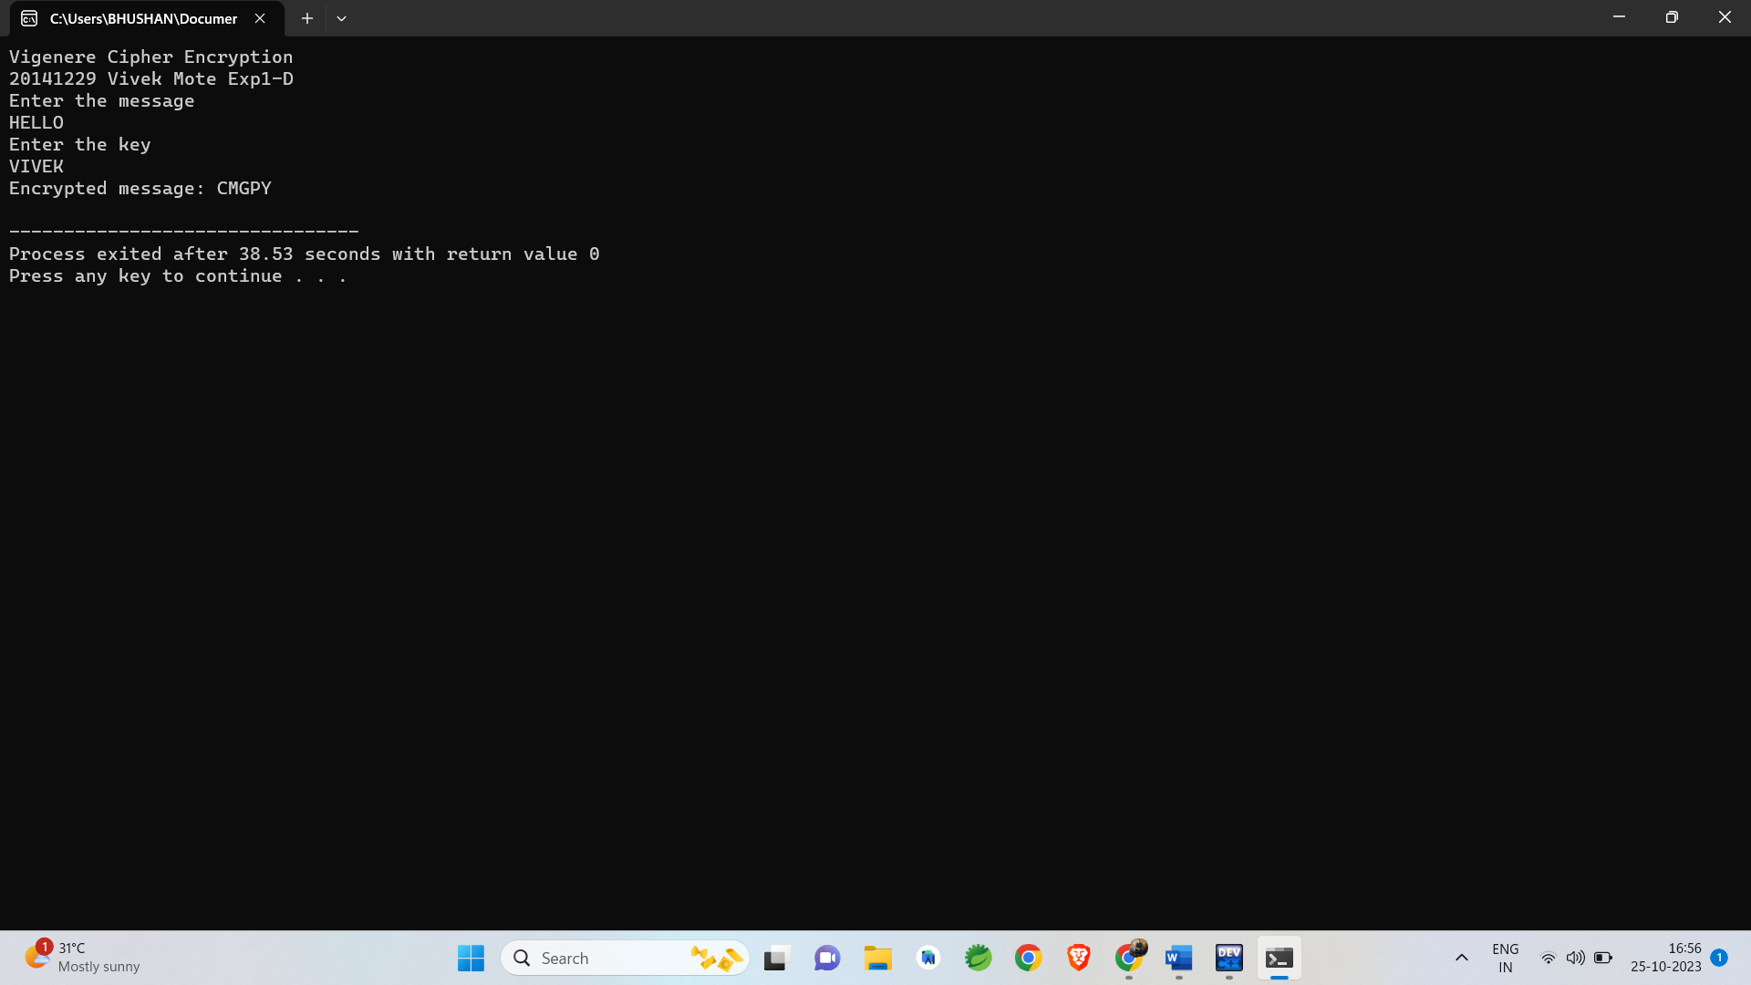

# Vigenere Cipher Decryption

#include<bits/stdc++.h> using namespace std; int main(){

cout<<"Vigenere Cipher Decryption\n"; cout<<"20141229 Vivek Mote Exp1-D\n"; int i,j,k,n;

vector<vector<char> > a(26,vector<char>(26)); k=0; n=26;

for(i=0;i<n;i++){ k=i; for(j=0;j<n;j++){

a[i][j]='A'+k; k++;

if(k==26) k=0;

} }

cout<<"Enter the encrypted message\n"; string s;

cin>>s;

cout<<"Enter the key\n"; string key;

cin>>key; k=0;

for(i=key.size();i<s.size();i++){ key+=key[k]; k++;

}

string decrypt; for(i=0;i<s.size();i++){

for(j=0;j<n;j++){ if(a[j][key[i]-'A']==s[i]){

decrypt += 'A'+j; break;

} } }

cout<<"Decrypted message: "<<decrypt<<'\n'; return 0;

}

for(i=0;i<s.size();i++){ for(j=0;j<n;j++){

if(a[j][key[i]-'A']==s[i]){ decrypt += 'A'+j; break;

} } }

cout<<"Decrypted message: "<<decrypt<<'\n'; return 0;

}

