**Integrating Graphql with Redux toolkit & React bootstrap**

**Redux Toolkit** is a library that simplifies the process of working with Redux. It provides a set of tools and best practices that make it easier to manage state in your application. With Redux Toolkit, you can easily define slices of state and write reducers to handle actions. It also comes with **built-in support for asynchronous actions**, which makes **it a great choice for applications that require complex data fetching.**

**GraphQL** is a query language that allows you to fetch data from **multiple sources in a single request**. It gives you a lot of flexibility in how you fetch data and can make your application **more efficient by reducing the number of API requests**. GraphQL is a great choice for **large-scale applications**where you need to fetch data from multiple sources.

**React-Bootstrap** is a complete re-implementation of the Bootstrap components using React. It has no dependency on either bootstrap.js or jQuery. If you have React setup and React-Bootstrap installed, you have everything you need.

1. npx create-react-app my-application --template redux-typescript
2. npm i --save @apollo/client graphql redux reselect
3. npm install -g graphql npm install -g apollo
4. npm run schema:download
5. npm run schema:generate-watch
6. npm install react-bootstrap bootstrap
7. npm i react-router-dom
8. npm i
9. npm run start

Reference:

1. <https://react-bootstrap.netlify.app/docs/getting-started/introduction>
2. <https://redux-toolkit.js.org/introduction/getting-started>
3. <https://graphql.org/learn/>
4. <https://lashanfaliq.medium.com/integrating-graphql-with-redux-toolkit-and-rtk-query-cc8040f92bd>
5. <https://medium.com/nerd-for-tech/graphql-apollo-client-in-react-build-an-app-step-by-step-2461574f16c8>
6. <https://medium.com/@diegogauna.developer/axios-graphql-and-redux-toolkit-to-fetch-data-in-a-react-typescript-application-8eed4f0248f8>
7. <https://github.com/trickjsprogram/full-stack-mern/tree/master/client>
8. <https://github.com/vercel/next.js/tree/canary/examples/with-redux>
9. <https://github.com/ranyelhousieny/GraphQL_ApolloClient_React/tree/master>
10. <https://github.com/lashanfaliq95/graphql-with-redux-toolkit-template/tree/main>

Home Screen:

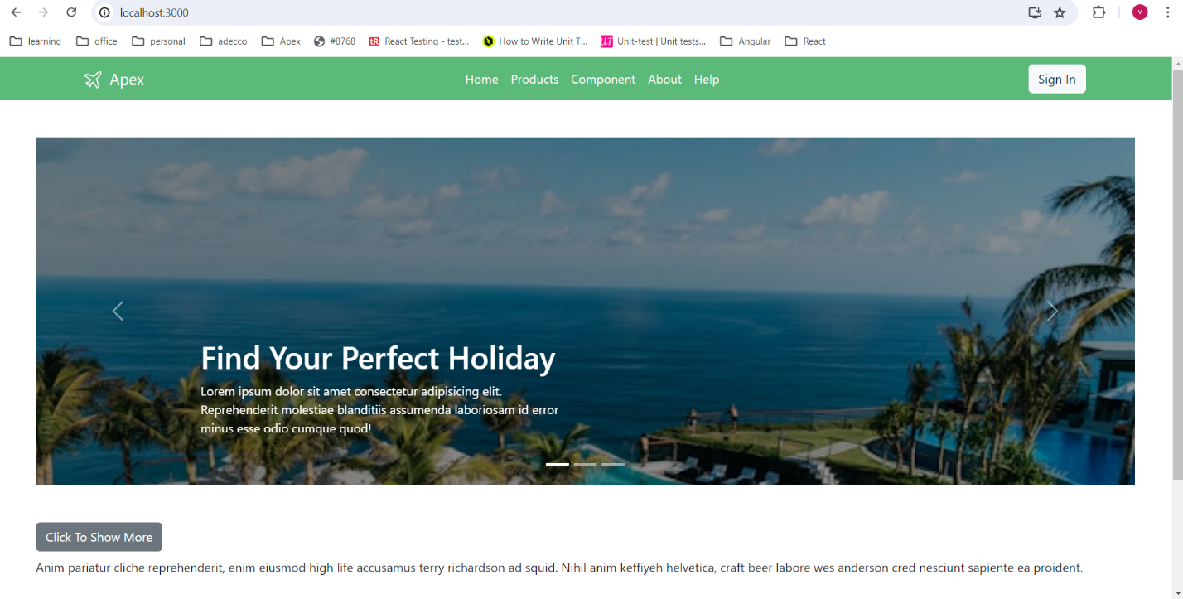

GraphQL API:

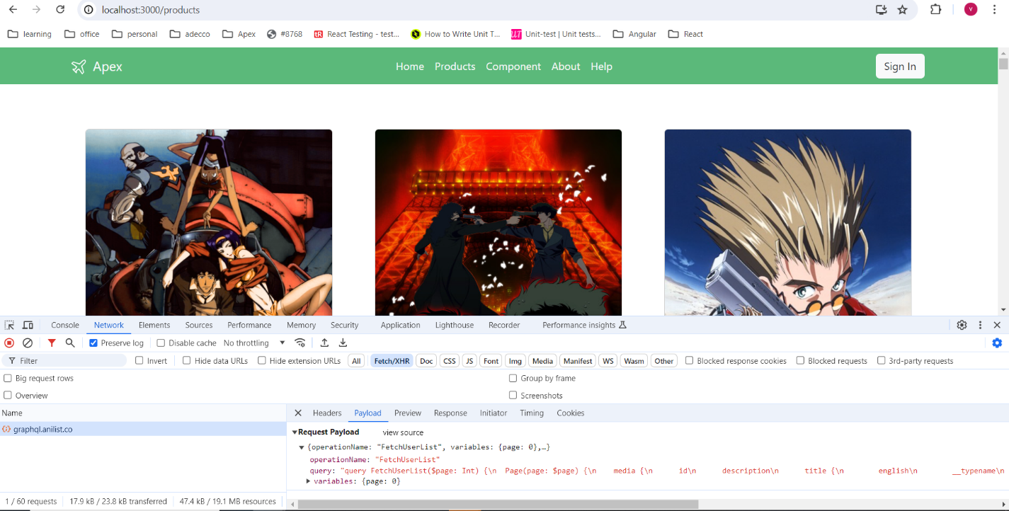

Dynamic HTML:

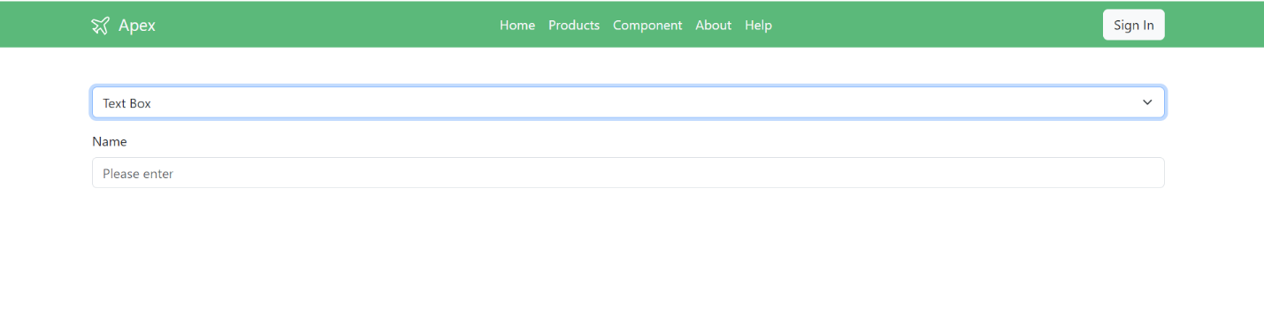

Form Save:

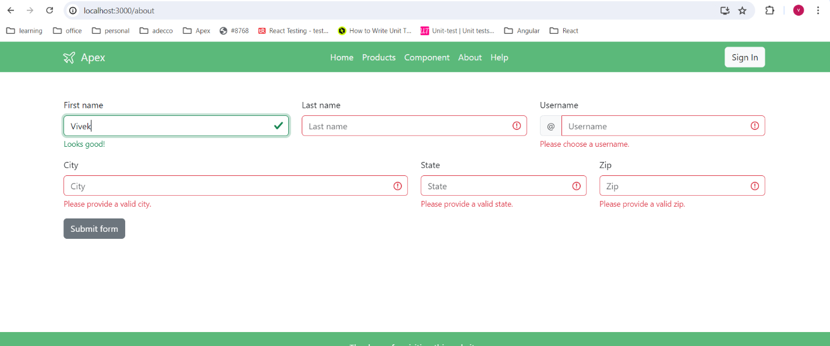

Accordion:

