Containerized microservices using Docker and Docker Compose
Step 1 – Stopping and removing existing containers
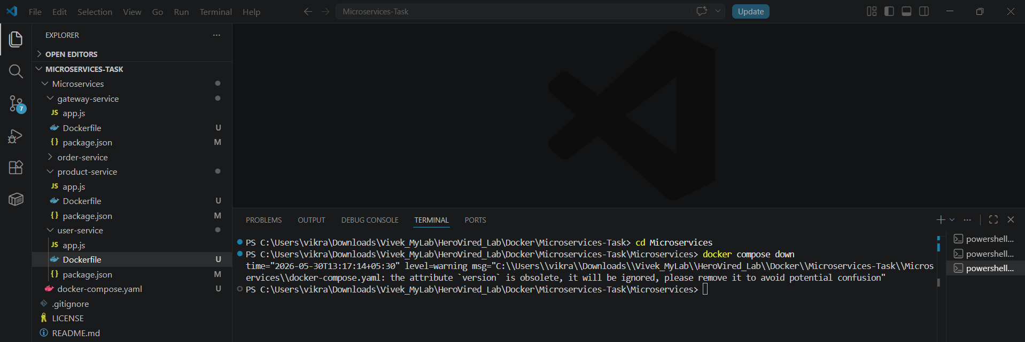
Step 2 – Initiating a fresh docker image build without cache
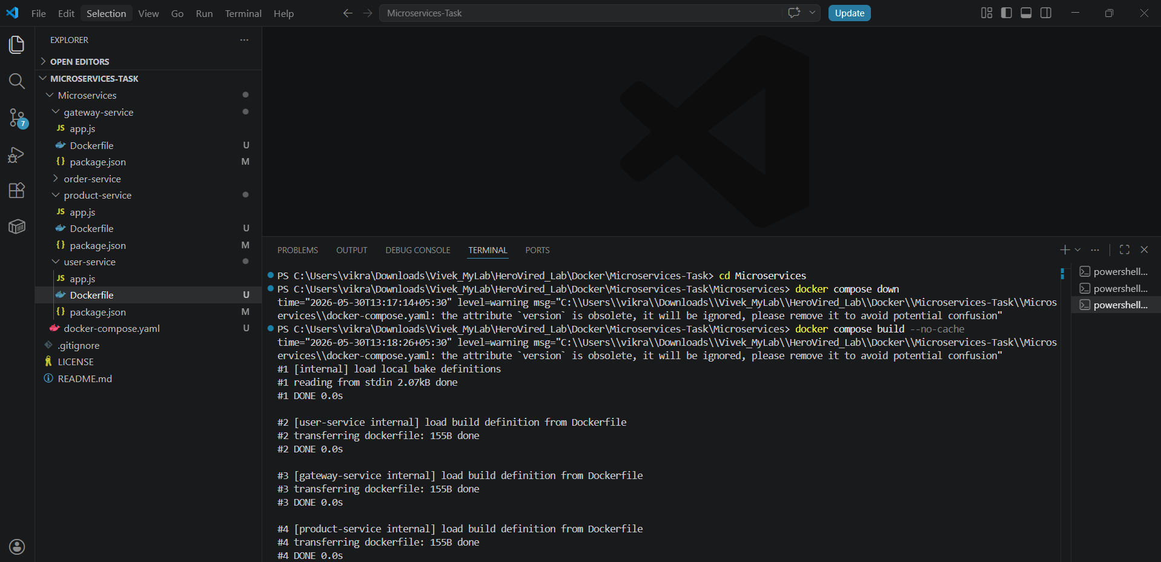
Step 3 – Completing the Docker image compilation successfully
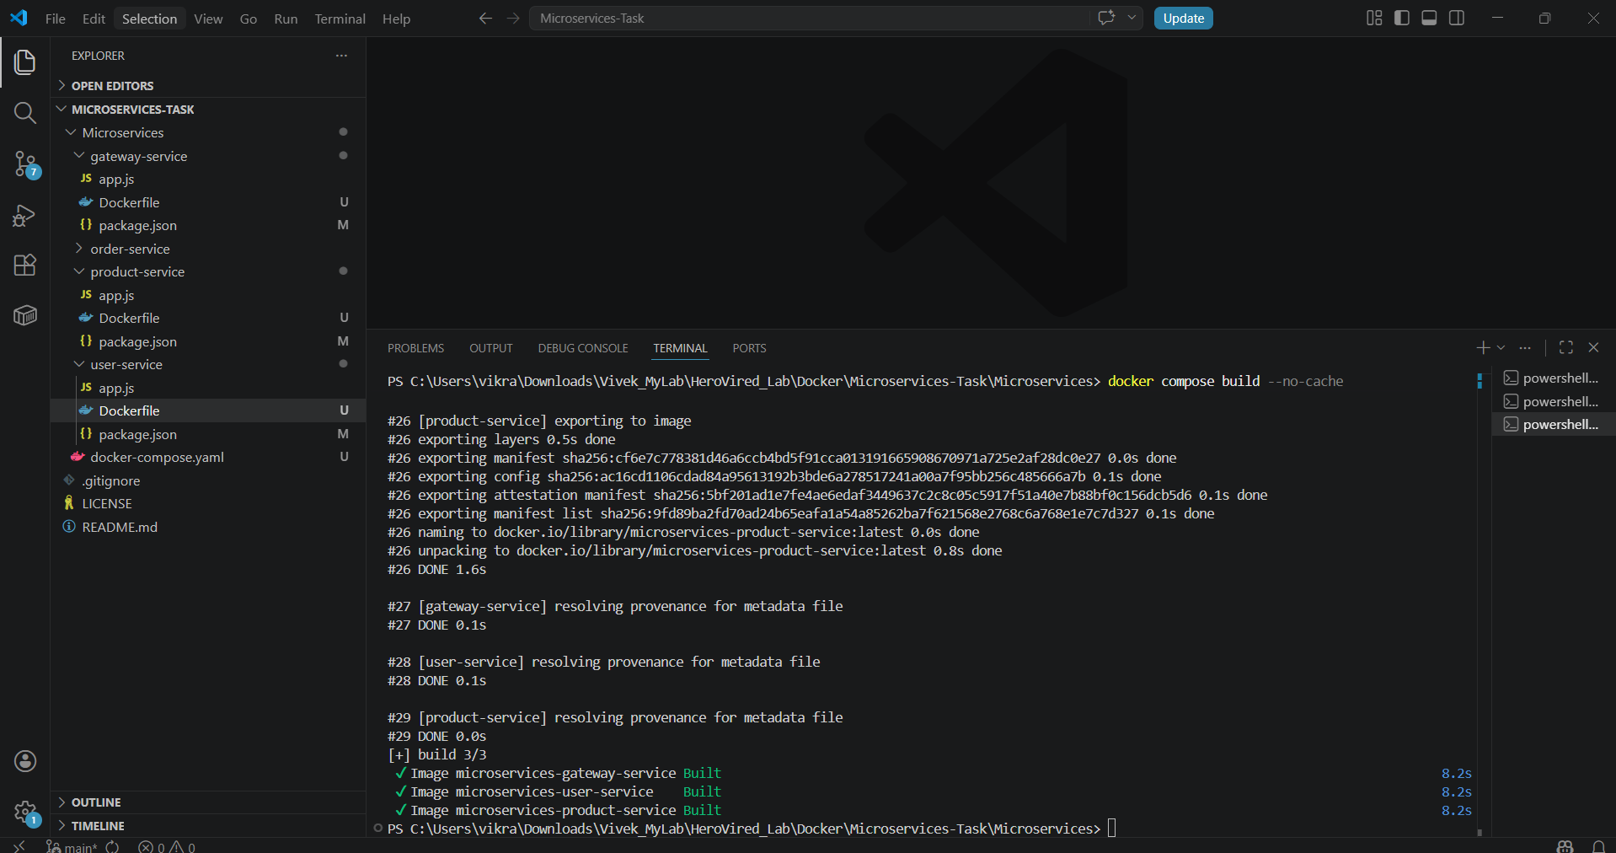
Step 4 – Initializing containers and networks
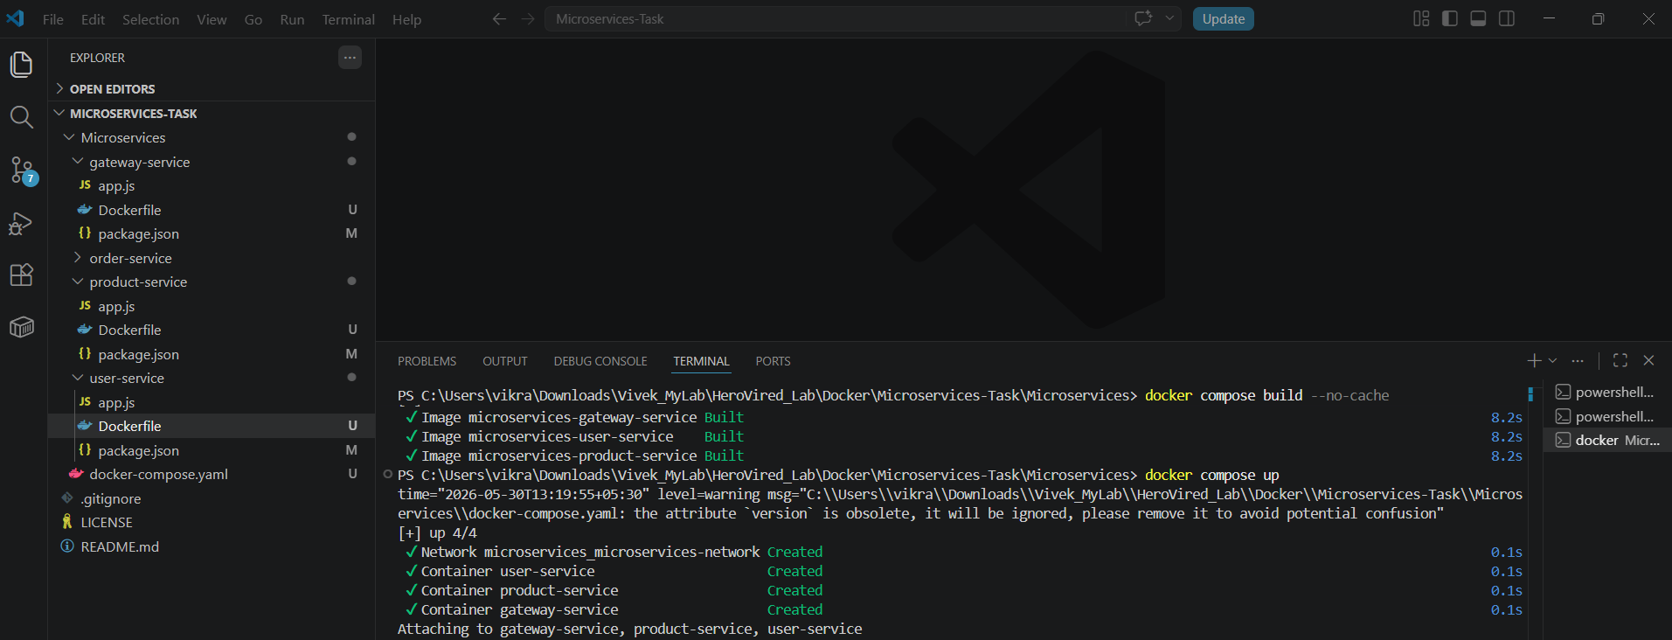
Step 5 – Monitoring application startup and log streaming in CLI
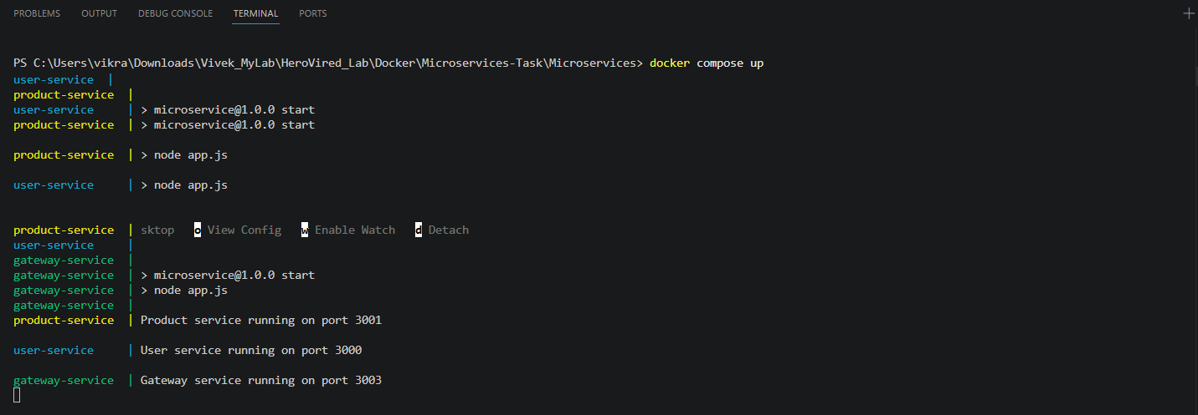
Step 6 – Verifying container status via Docker Desktop GUI
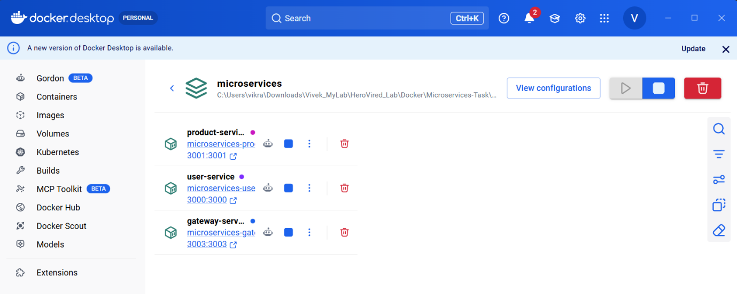
Step 7 – Listing active docker containers and port mappings via CLI
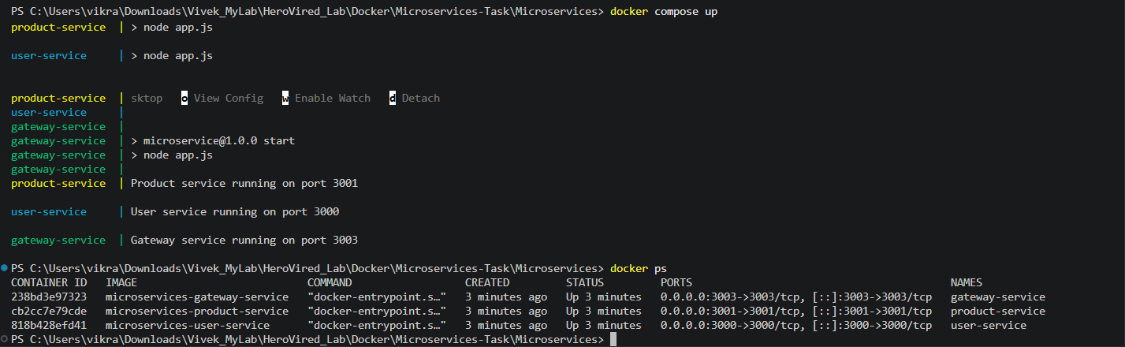
Step 8 – Verifying User Service Health Check via Browser
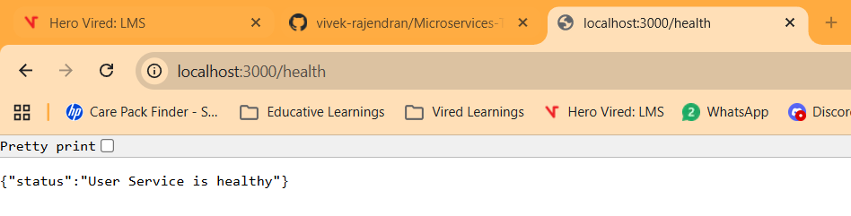
Step 9 – Testing User Service API Data Retrieval
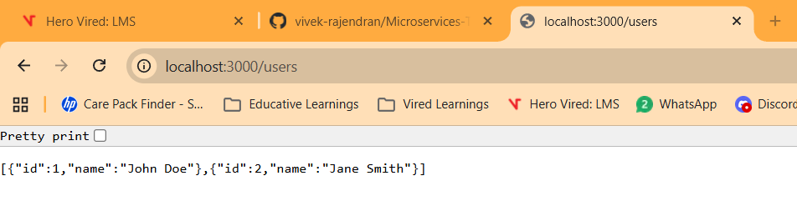
Step 10 – Verifying Product Service Health Check via Browser
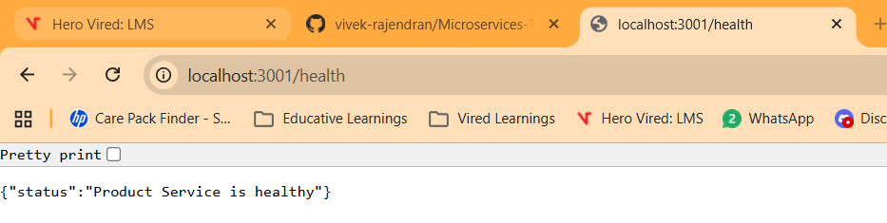

Step 11 – Testing Product Service API Data Retrieval
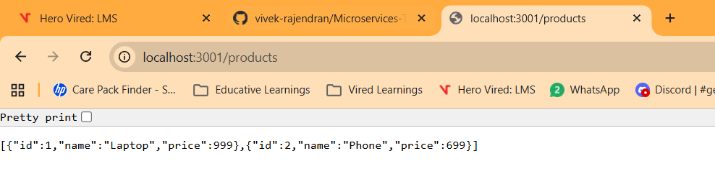

Step 12 – Verifying Gateway Service Health Check via Browser
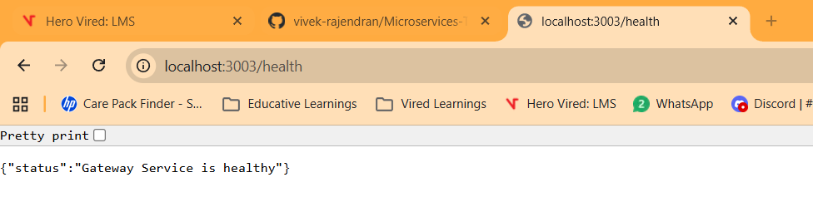
Step 13 – Testing User Service Routing via API Gateway
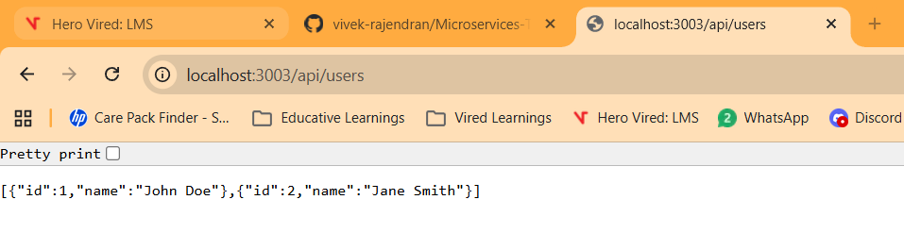

Step 14 – Testing Product Service Routing via API Gateway
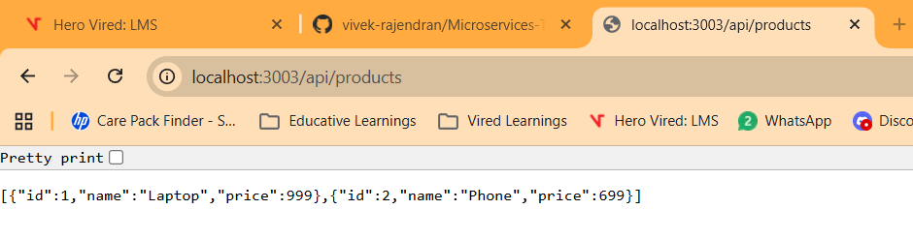
Step 15 – Stopping and Removing Application Containers via CLI
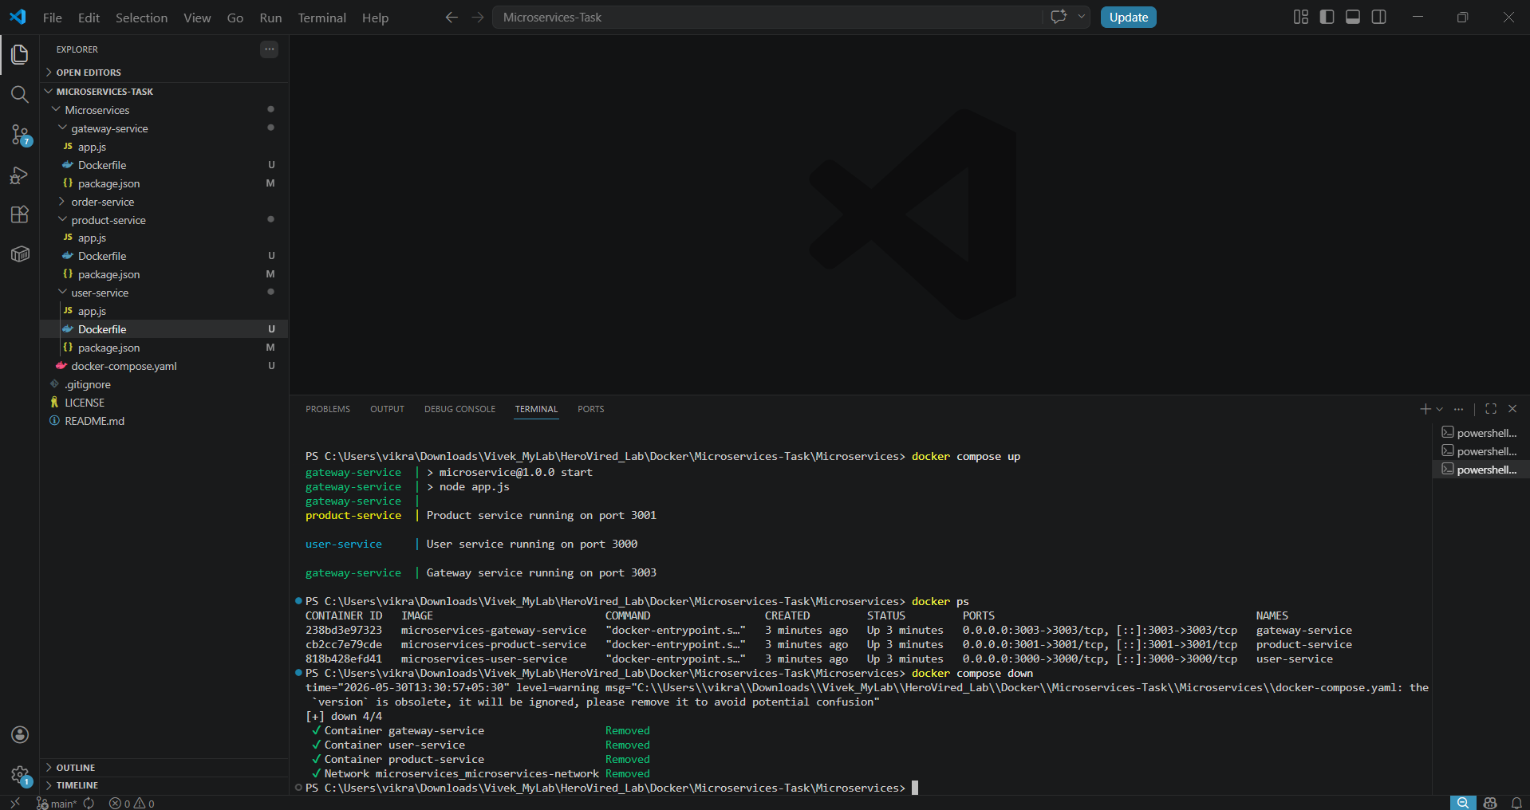
Step 16 – Verifying Containers Stopped and Cleared via Docker Desktop GUI
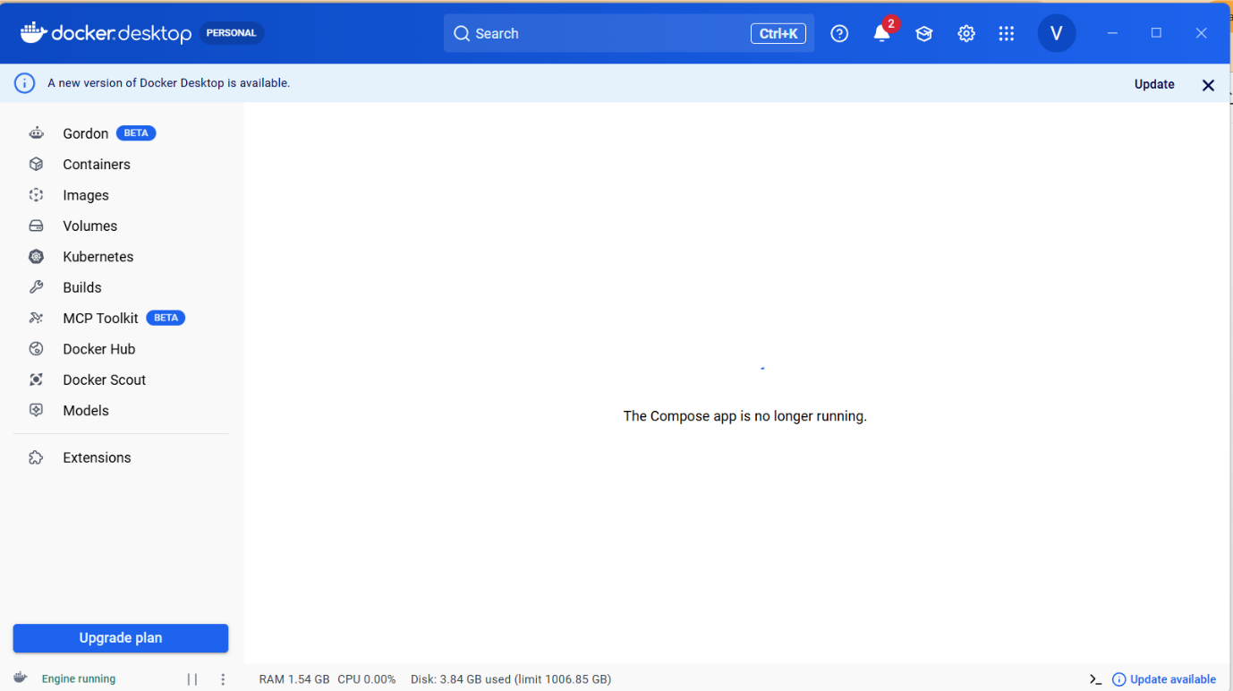
Step 17 – Modified files as part of the docker container assessment
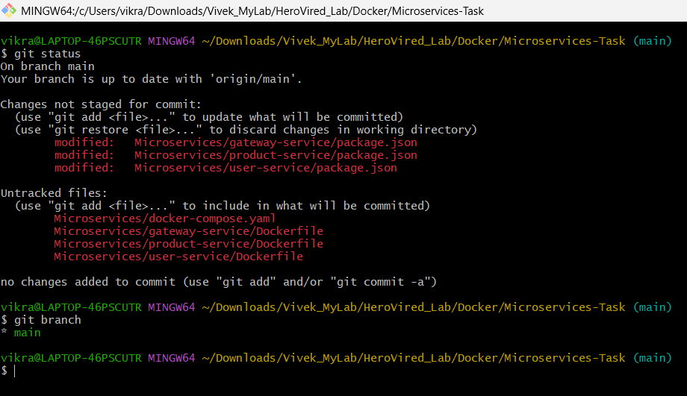

Step 18 – Pushing changes to remote git feature branch
