End-to-End MERN Microservices Orchestration & Scaling
Comprehensive Project Documentation & Implementation Guide
1. Project Overview & Architecture
This project demonstrates a production-grade MERN (MongoDB, Express, React, Node.js) microservices architecture deployed on Amazon Web Services (AWS) using containerization, automated CI/CD pipelines, Kubernetes orchestration via Amazon EKS, Helm package management, and AWS SNS ChatOps notifications.
- Component 1: Frontend: React application served via Nginx container.
- Component 2: Hello Service: Node.js backend microservice (Port 3001).
- Component 3: Profile Service: Node.js backend microservice (Port 3002) connected to MongoDB.
- Ecosystem: Infrastructure & Orchestration: GitHub, Jenkins (EC2), Amazon ECR, Amazon EKS, Helm, CloudWatch, and AWS SNS.
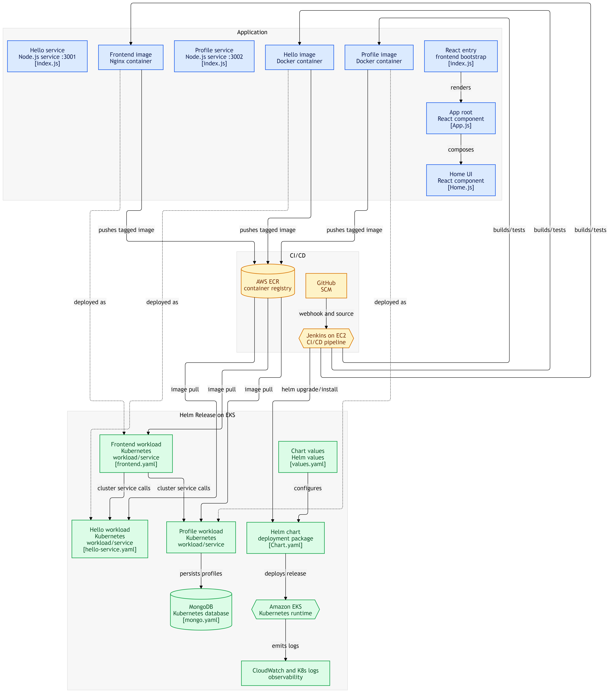
2. Step 1: Version Control with Git
Establishment and maintenance of source code version control using GitHub.
- Forking: Forking the original upstream repository (StreamingApp) into a personal GitHub account.
- Branching: Creating feature branches (e.g., feature/orchestration) for containerization and pipeline scripts.
- Maintenance: Syncing upstream updates and managing commits.
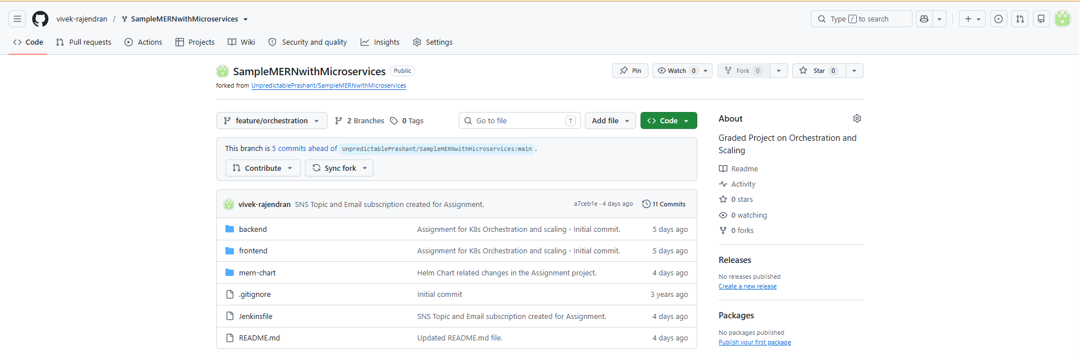
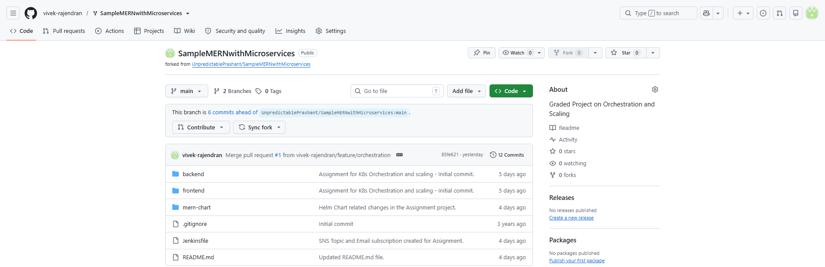

3. Step 2: Prepare the MERN Application & Containerization
Containerizing individual microservices to ensure environment consistency.
- Dockerfiles: Writing optimized Dockerfiles for the React frontend, Hello Service, and Profile Service.
- Local Build: Building container images locally and verifying multi-service interaction.
- ECR Setup: Creating private/public Amazon ECR repositories (streaming-app-frontend, streaming-app-hello-service, streaming-app-profile-service).
- Image Push: Authenticating Docker with AWS ECR, tagging images, and pushing them successfully.

Task 1 – Scale Up AWS EKS Cluster
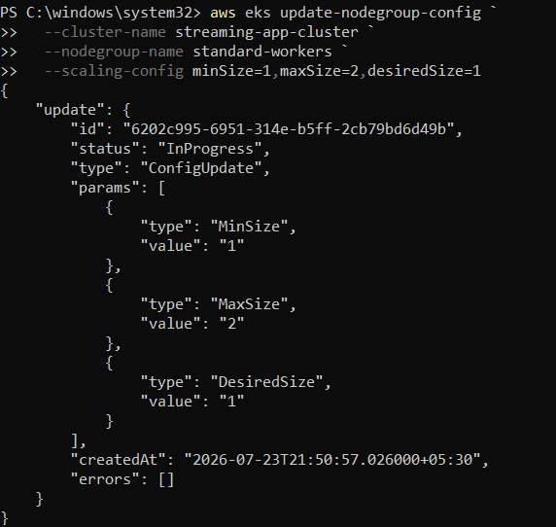

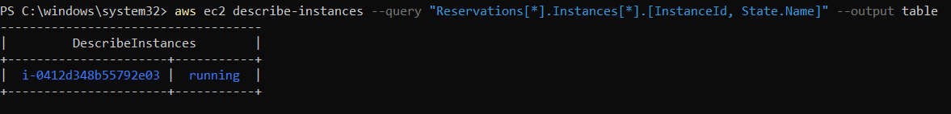

Task 2 – Dockerfiles for each service and its Local Build
- Hello Service (Port 3001)
  - Docker File for Hello Service
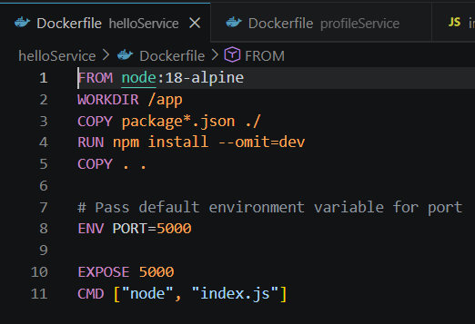
  - Docker Build for Hello Service
    - docker rm -f run-hello
    - docker build --no-cache -t test-hello .\helloService
    - docker run -d -p 3001:3001 -e PORT=3001 --name run-hello test-hello
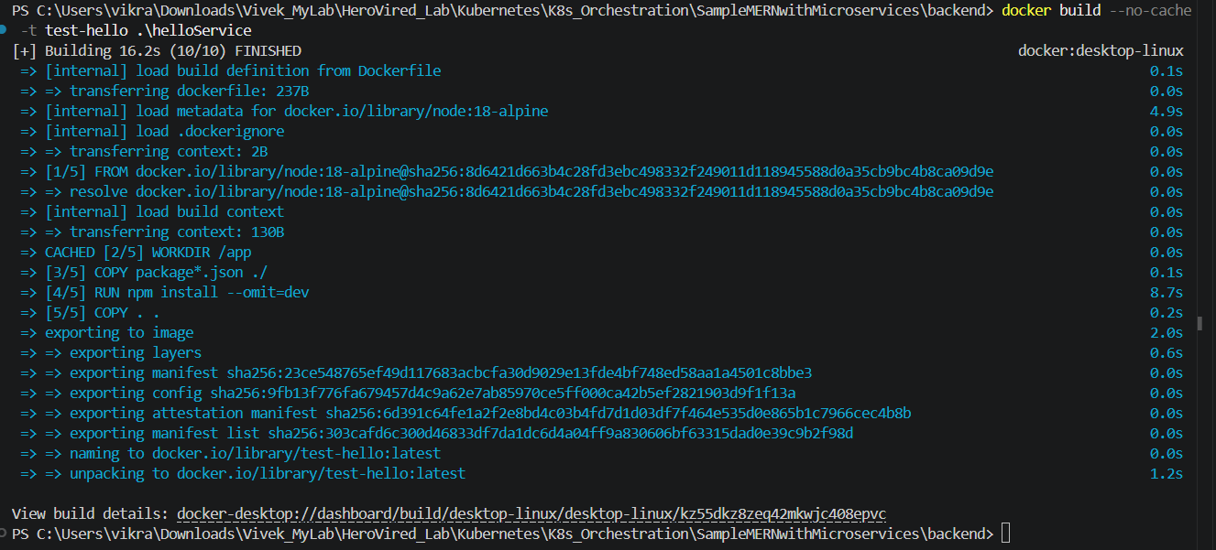

  - Docker Run for Hello Service

- Profile Service (Port 3002)
  - Docker File for Profile Service
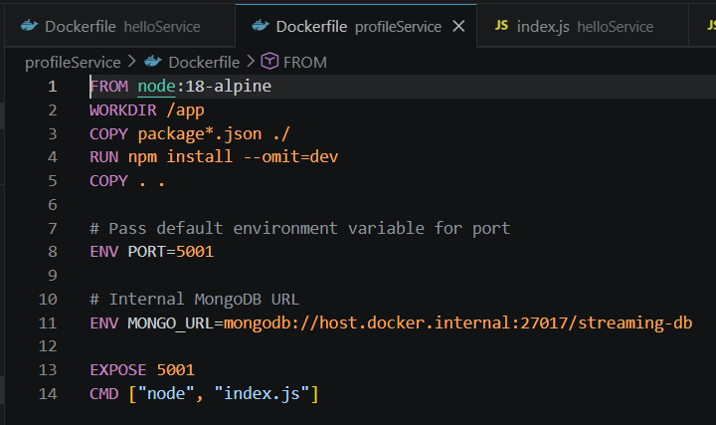
  - Docker Build for Profile Service
    - docker rm -f run-profile
    - docker build --no-cache -t test-profile .\profileService
    - docker run -d -p 3002:3002 -e PORT=3002 -e MONGO_URL="mongodb://host.docker.internal:27017/streaming-db" --name run-profile test-profile
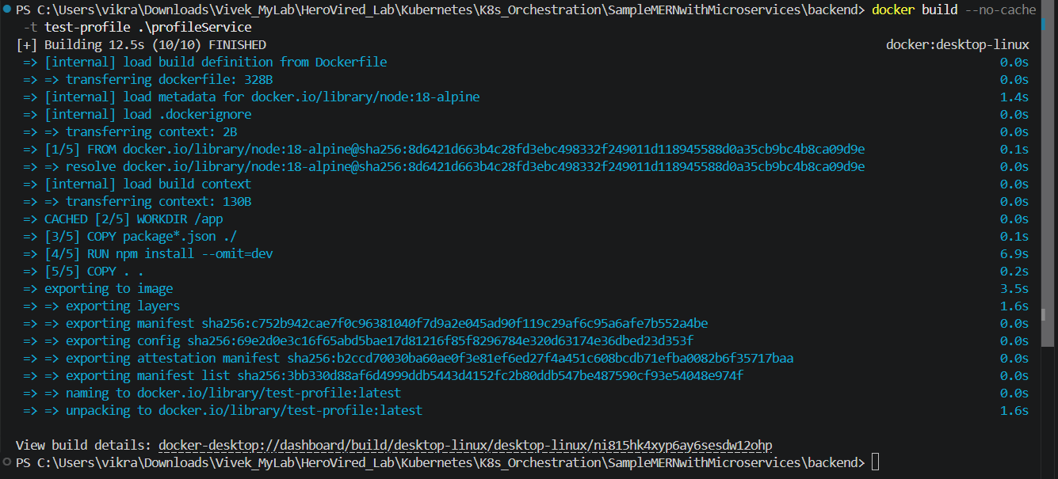

  - Docker Build for Hello Service

- Frontend Service (Port 8080)
  - Docker File for Frontend Service
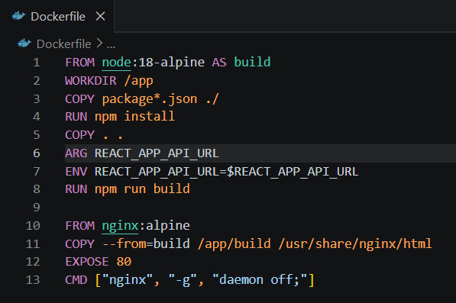
  - Docker Build for Frontend Service
    - docker rm -f run-frontend
    - docker build --no-cache -t test-frontend .\frontend
    - docker run -d -p 8080:80 --name run-frontend test-frontend
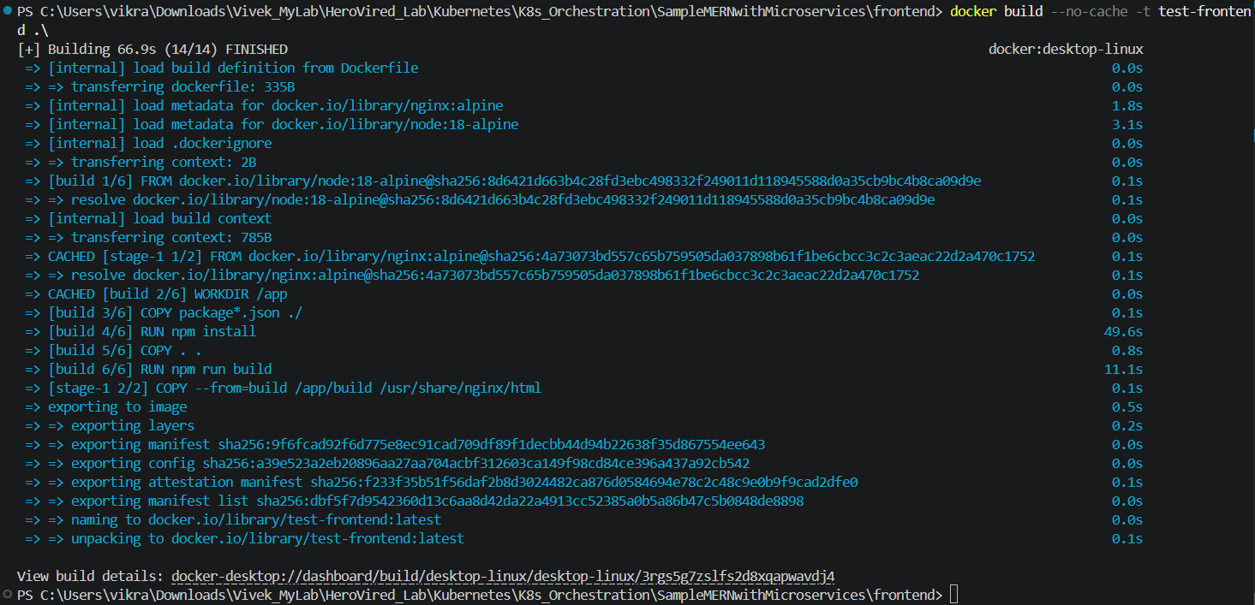
  - Docker Run for Frontend Service

Task 3 – creating AWS ECR Repositories
ECR Repository 1: aws ecr create-repository --repository-name streaming-app-hello-service --region ap-south-1
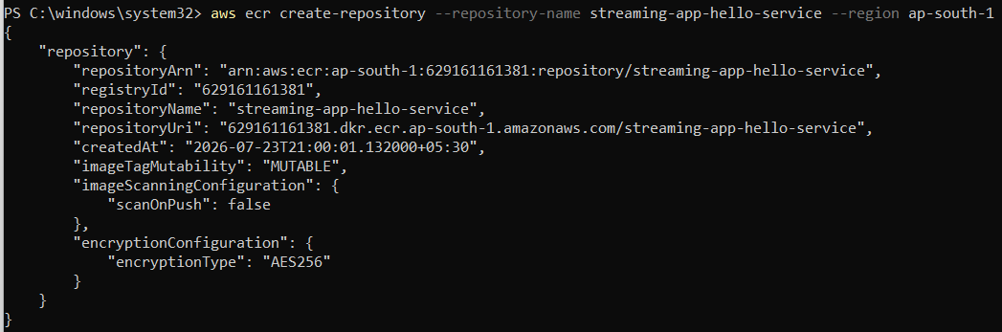

ECR Repository 2: aws ecr create-repository --repository-name streaming-app-profile-service --region ap-south-1
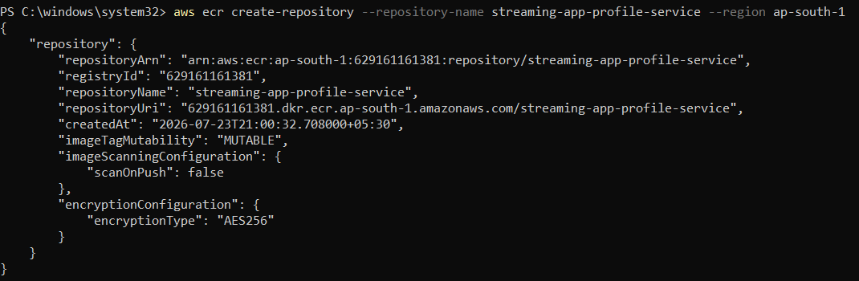

ECR Repository 3: aws ecr create-repository --repository-name streaming-app-frontend --region ap-south-1
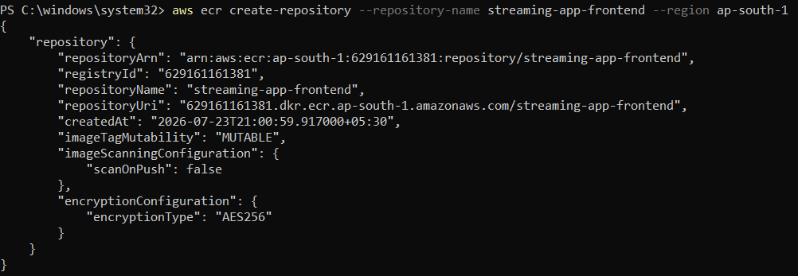

Task 4 – Docker Authentication with AWS ECR and Tagging & pushing Docker Images to ECR
- Authenticate Docker with AWS ECR:
aws ecr get-login-password --region ap-south-1 | docker login --username AWS --password-stdin 629161161381.dkr.ecr.ap-south-1.amazonaws.com

- Tag and Push Docker Images to AWS ECR:
    - Hello Service (ECR Repo Name - streaming-app-hello-service)
      - docker tag test-hello:latest 629161161381.dkr.ecr.ap-south-1.amazonaws.com/streaming-app-hello-service:latest
      - docker push 629161161381.dkr.ecr.ap-south-1.amazonaws.com/streaming-app-hello-service:latest
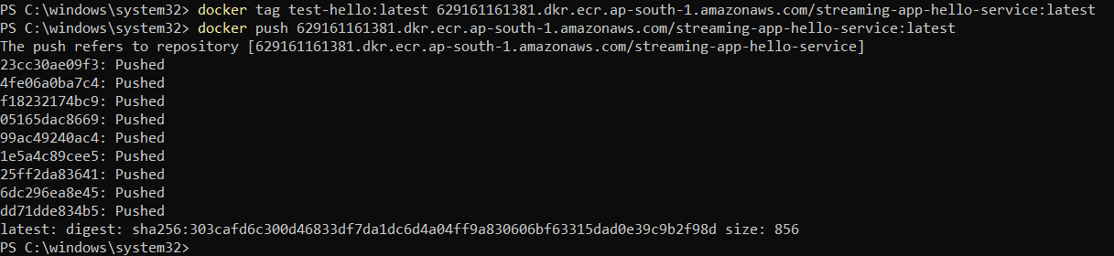
    - Profile Service (ECR Repo Name - streaming-app-profile-service)
      - docker tag test-profile:latest 629161161381.dkr.ecr.ap-south-1.amazonaws.com/streaming-app-profile-service:latest
      - docker push 629161161381.dkr.ecr.ap-south-1.amazonaws.com/streaming-app-profile-service:latest
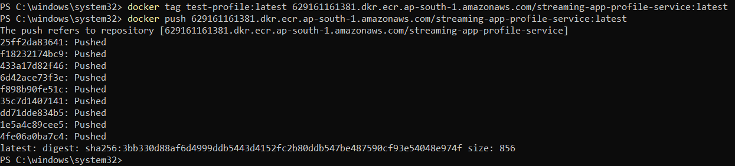
    - Frontend Service
      - docker tag test-frontend:latest 629161161381.dkr.ecr.ap-south-1.amazonaws.com/streaming-app-frontend:latest
      - docker push 629161161381.dkr.ecr.ap-south-1.amazonaws.com/streaming-app-frontend:latest
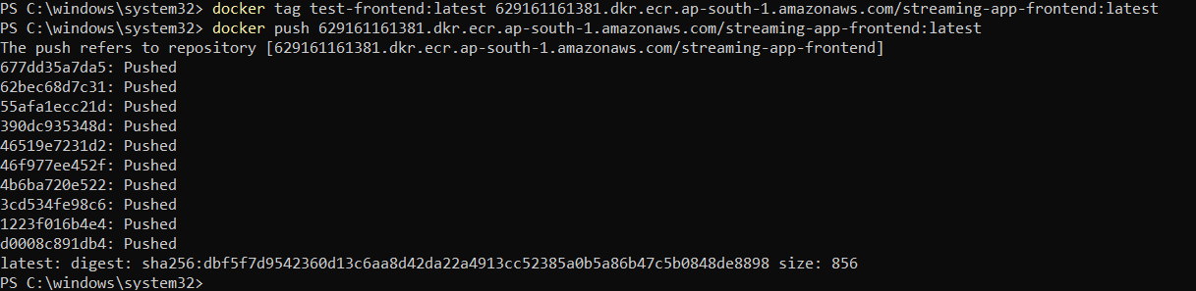

- Docker Images pushed to AWS ECR:
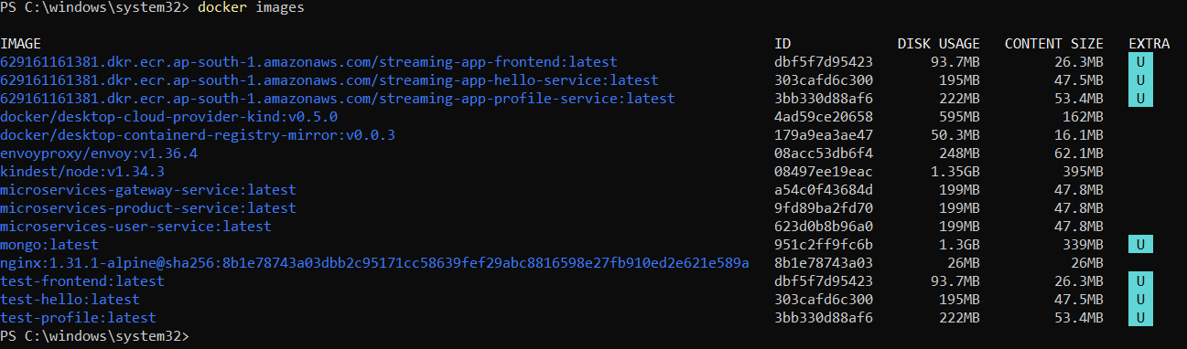
4. Step 3: AWS Environment Setup
Configuring cloud infrastructure prerequisites.
- AWS CLI: Installing and configuring the AWS CLI with secure access credentials and default region (ap-south-1).
- IAM Permissions: Configuring IAM roles and security policies for Jenkins, ECR, and EKS access.
Task 1: AWS Identity
aws sts get-caller-identity
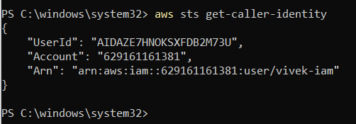

Task 2: IAM User, Roles and Policies
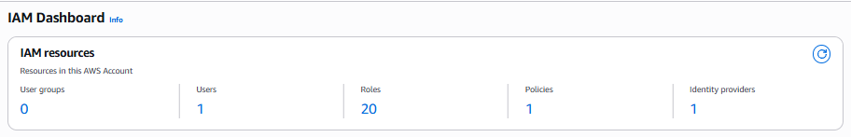
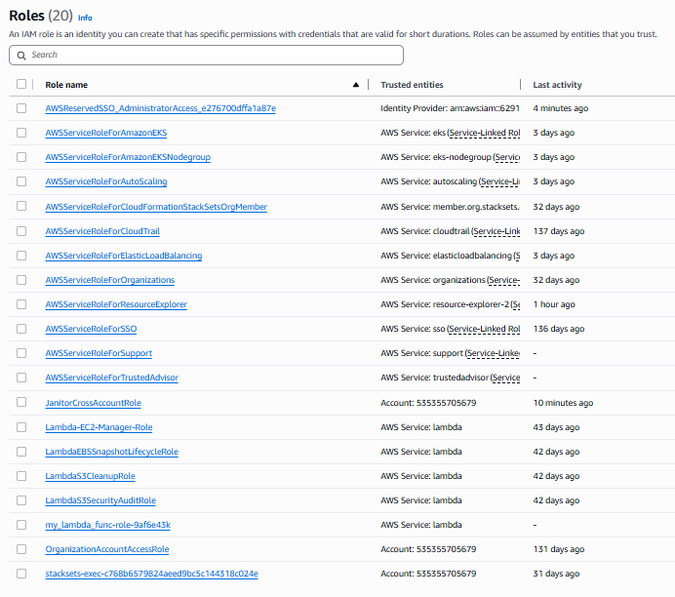
5. Step 4: Continuous Integration (CI) using Jenkins
Setting up automated build and deployment pipelines.
- Jenkins Server: Provisioning and configuring Jenkins on an Amazon EC2 instance.
- Plugin Configuration: Installing essential plugins (Docker, Kubernetes, AWS Credentials).
- Pipeline Script: Writing a declarative Jenkinsfile defining stages: Code Checkout, ECR Login, Image Build & Push, Helm Deploy, and SNS Notifications.
- Webhook Automation: Configuring GitHub Webhooks to trigger automated builds on new code commits.
Step 4.1: Log In & Configure Jenkins Credentials
- Access Jenkins UI: Go to https://jenkinsacademics.herovired.com/
- Log In Credentials:
  - Username: herovired
  - Password: herovired@123
- Add AWS Credentials:
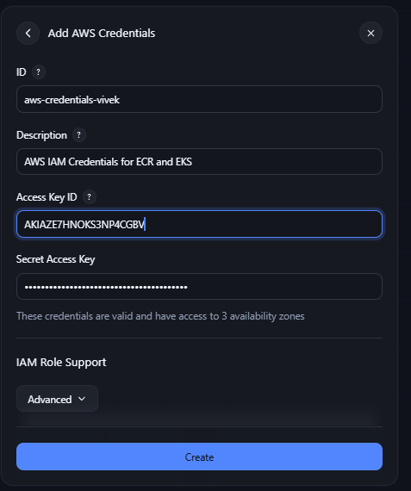
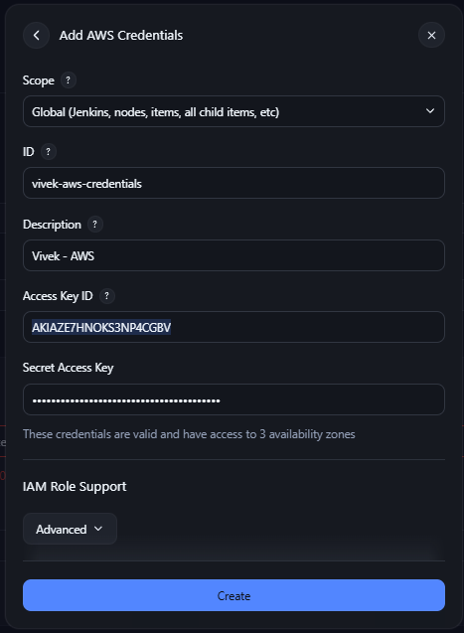
- Jenkins Pipeline creation
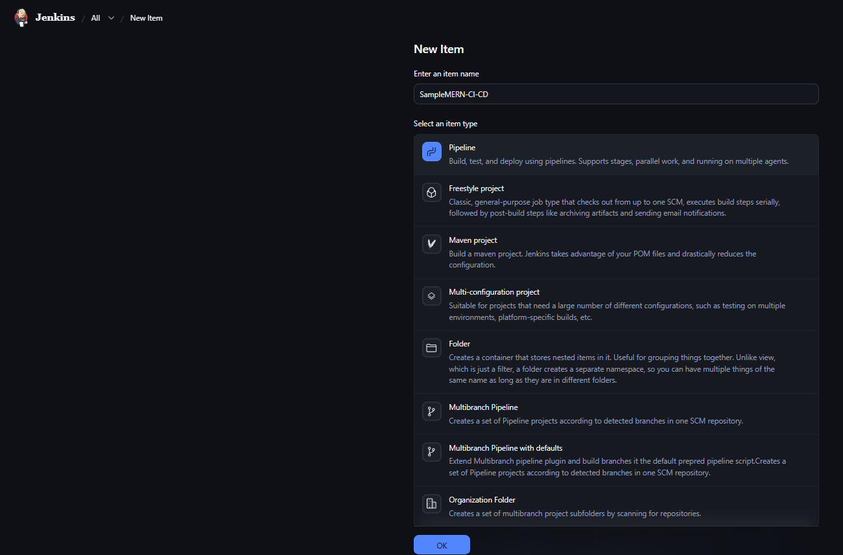

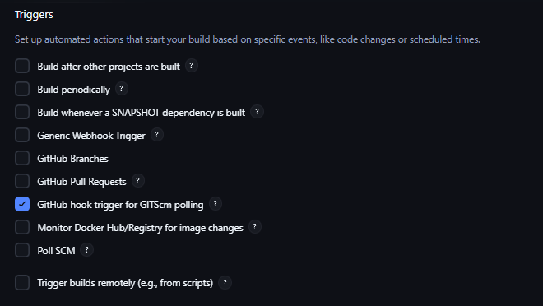
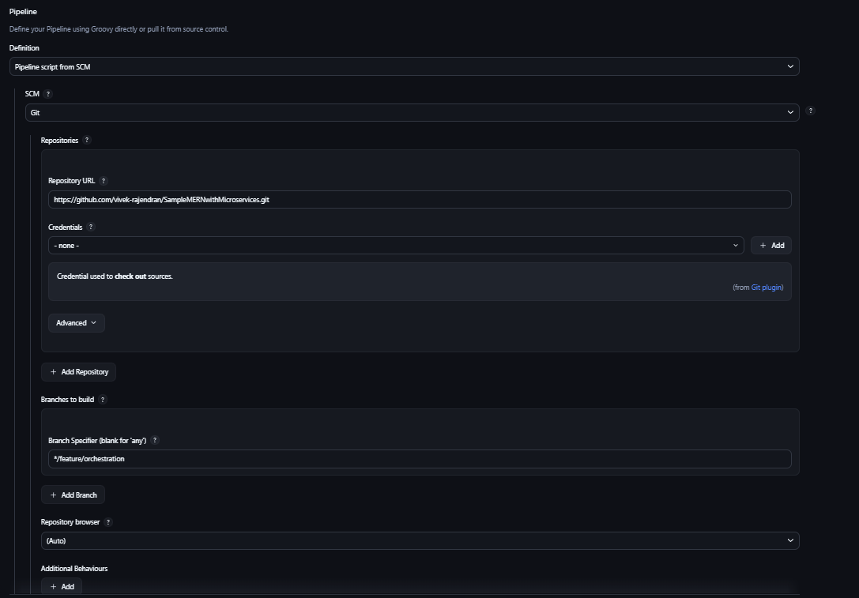
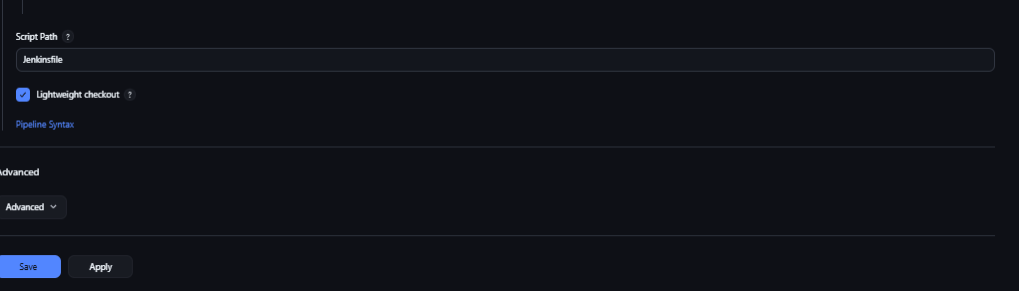
- Jenkins Stages
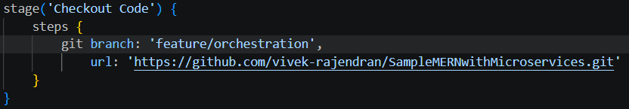

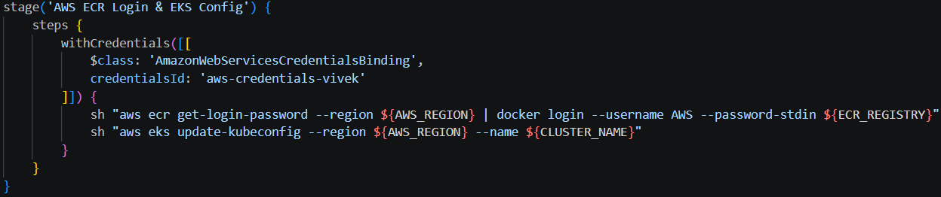

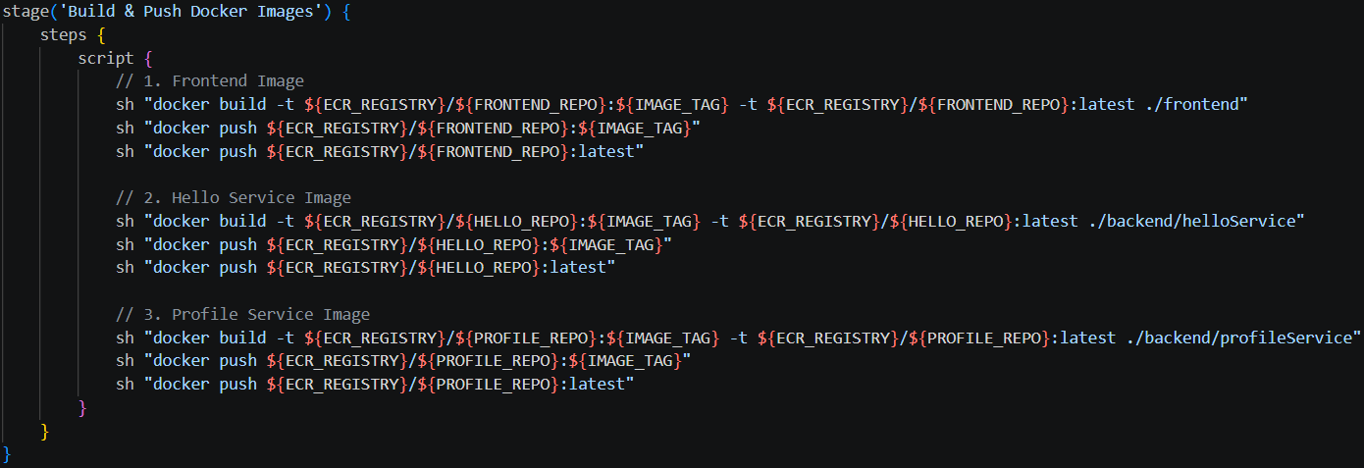

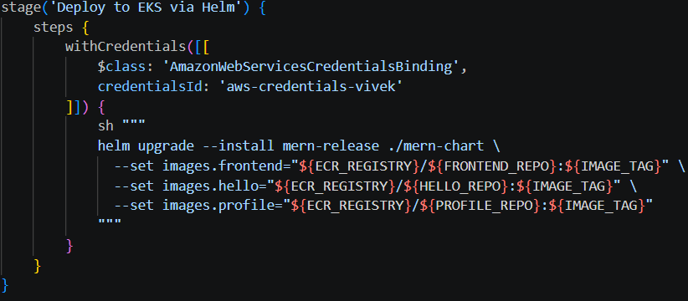
- Jenkins File
- Jenkins Build

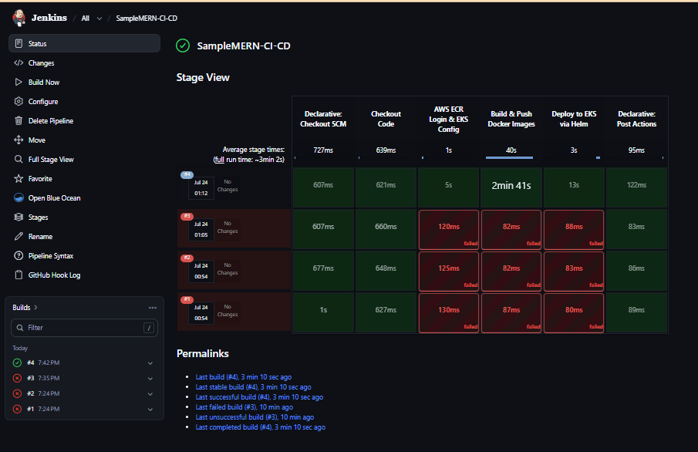
6. Step 5: Kubernetes Deployment (EKS)
Orchestrating microservices containers using Amazon EKS and Helm.
- Cluster Creation: Provisioning an Amazon EKS cluster using eksctl (node-type t3.medium).
- Kubectl Setup: Updating local kubeconfig and verifying cluster connectivity (kubectl get nodes).
- Helm Packaging: Packaging the application components into modular Helm charts (Chart.yaml, values.yaml, templates).
- Helm Deployment: Deploying the Helm release to EKS and verifying running pods and services (kubectl get pods, kubectl get svc).

Task 1: Verify EKS Access Entry / Creator IAM Principal
aws eks list-access-entries --cluster-name streaming-app-cluster --region ap-south-1
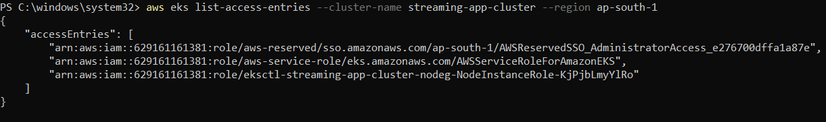

Task 2: Grant vivek-iam Access to the Cluster
- Create Access Entry for vivek-iam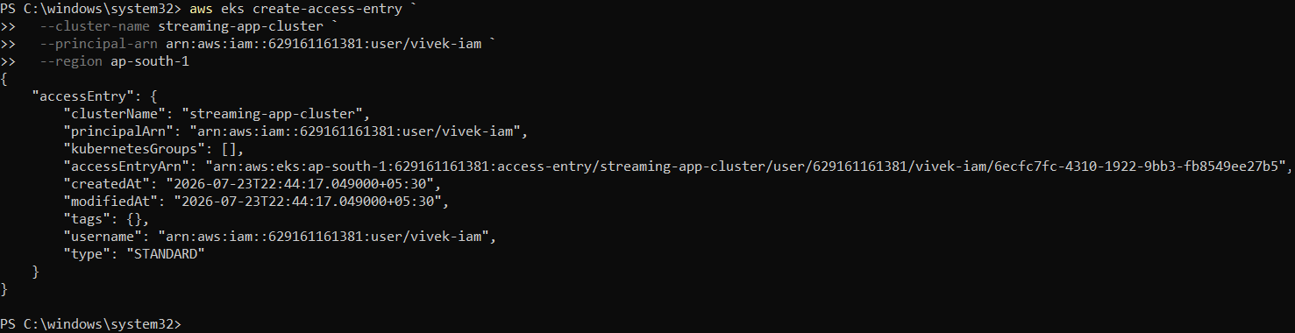

- Associate the Admin Policy
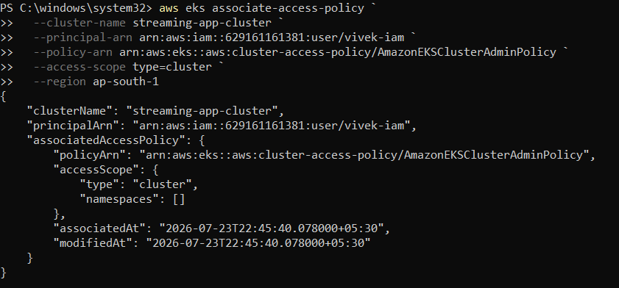

Task 3:Kubernetes Nodes
# Test cluster connectivity
kubectl get nodes
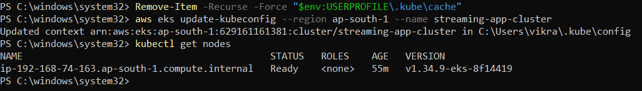

Task 4: Helm Deployment Guide for EKS
  - Lint & Install the Helm Chart on EKS

  - Dry run to verify output YAML
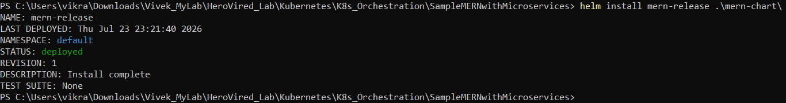

  - Verify Deployment & Obtain App URL

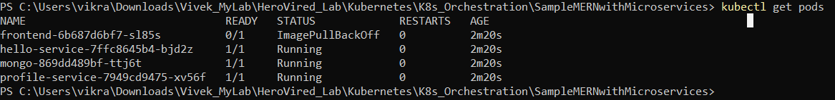
The ImagePullBackOff status on frontend-6b687d6bf7-sl85s means Kubernetes cannot pull the image specified for the frontend container.
  - kubectl describe pod frontend-6b687d6bf7-sl85s
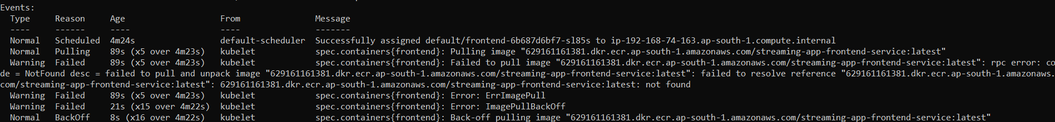
  - Update the values.yaml file with frontend service --> streaming-app-frontend instead of streaming-app-frontend-service
docker push 629161161381.dkr.ecr.ap-south-1.amazonaws.com/streaming-app-frontend:latest
  - Upgrade the Helm Release
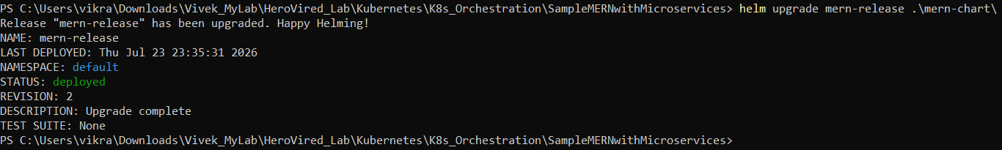
  - Clear the Failed Pod & Verify
Delete the stuck frontend pod so Kubernetes spawns a new one with the corrected image path:
# 1. Delete old pod
kubectl delete pod -l app=frontend

# 2. Check pod status
kubectl get pods
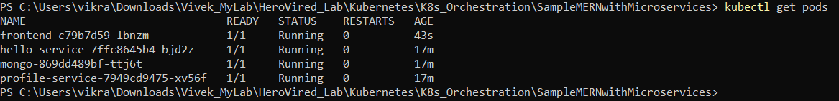

# 3. kubectl get svc frontend-service

External IP - afd6ddfaf560046288d6d662ac6d04dd-1126150939.ap-south-1.elb.amazonaws.com
http://afd6ddfaf560046288d6d662ac6d04dd-1126150939.ap-south-1.elb.amazonaws.com

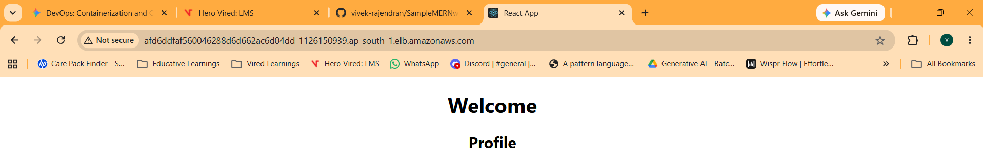
# 4. Check Pods Status:
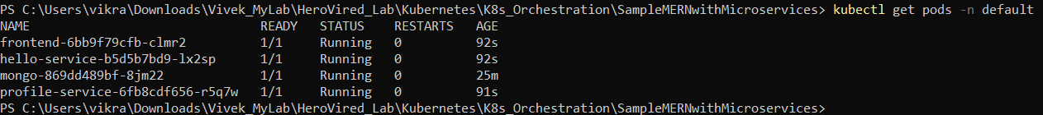

# 5. Check Services & Load Balancers:
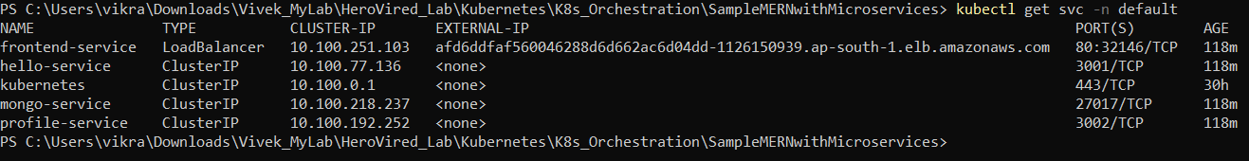
7. Step 6: Monitoring and Logging
Ensuring observability and operational health.
- CloudWatch Metrics: Configuring Amazon CloudWatch for cluster and node metrics monitoring.
- CloudWatch Alarms: Setting up metric alarms for resource utilization tracking.
- Centralized Logging: Centralizing container logs from EKS pods using CloudWatch Logs.

Task 1 – Set Up Basic CloudWatch Container Insights / Metrics:
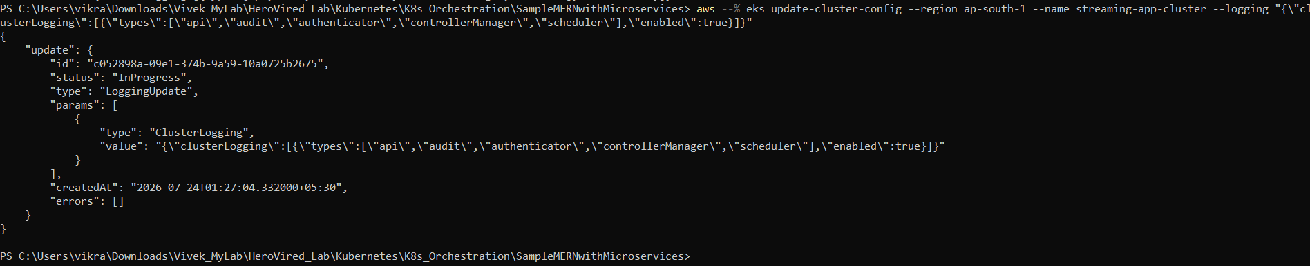

Task 2 – Verify Centralized Application Logging:
- kubectl logs -l app=streaming-app-frontend --tail=50
- kubectl logs -l app=streaming-app-hello-service --tail=50
- kubectl logs -l app=streaming-app-profile-service --tail=50

Task 3 – List All Pods and Their Labels
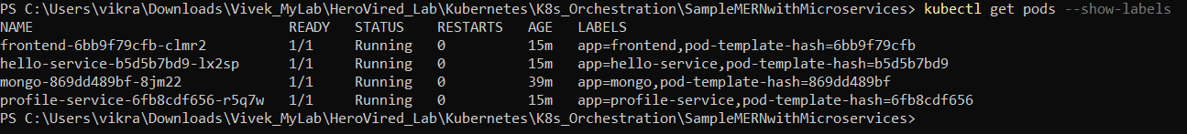

Task 4 – Fetch Logs Using Exact Pod Names
- kubectl logs frontend-6bb9f79cfb-clmr2 --tail=50
- kubectl logs hello-service-b5d5b7bd9-lx2sp --tail=50
- kubectl logs profile-service-6fb8cdf656-r5q7w --tail=5
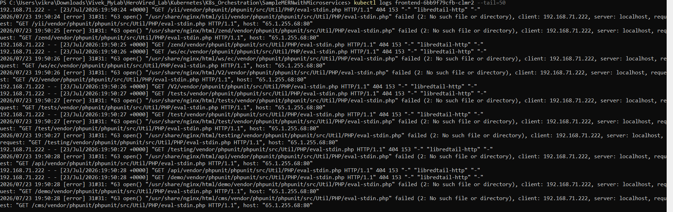
8. Step 7: Documentation & Architecture
Comprehensive recording of system architecture, configuration guides, and deployment scripts stored directly within the GitHub repository.
9. Step 8: Final Validation
Verifying end-to-end functionality and accessibility.
- Service Accessibility: Checking external LoadBalancer endpoint availability.
- Browser Validation: Validating frontend and backend microservices communication in the browser.
# Test Hello Service
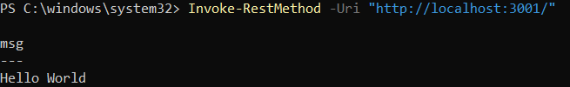

# Seed a test profile record into MongoDB via Profile Service

# Fetch profiles from MongoDB
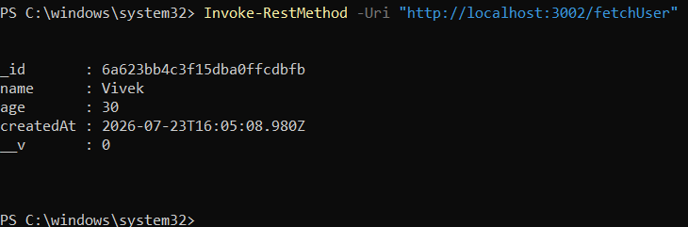

# Verify in Browser
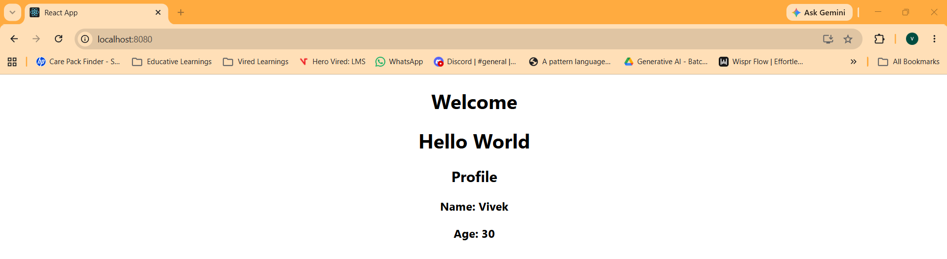
With Load Balancer
http://afd6ddfaf560046288d6d662ac6d04dd-1126150939.ap-south-1.elb.amazonaws.com


10. Step 9: Bonus — ChatOps Integration (AWS SNS)
Implementing real-time alerting mechanisms.
- SNS Topic Setup: Creating an AWS SNS Topic (mern-deployment-notifications) for deployment event reporting.
- Topic Subscriptions: Subscribing endpoints (Email / HTTPS webhook for Slack or Microsoft Teams) to the topic.
- Pipeline Integration: Integrating aws sns publish commands within the Jenkinsfile post-build block to trigger instant alerts on success or failure.
