Travel Memory Application – AWS Assignment
Application UI Screenshots
ALB URL - http://travelmemory-alb-1102129535.eu-north-1.elb.amazonaws.com
Application Home Page with existing Trip details
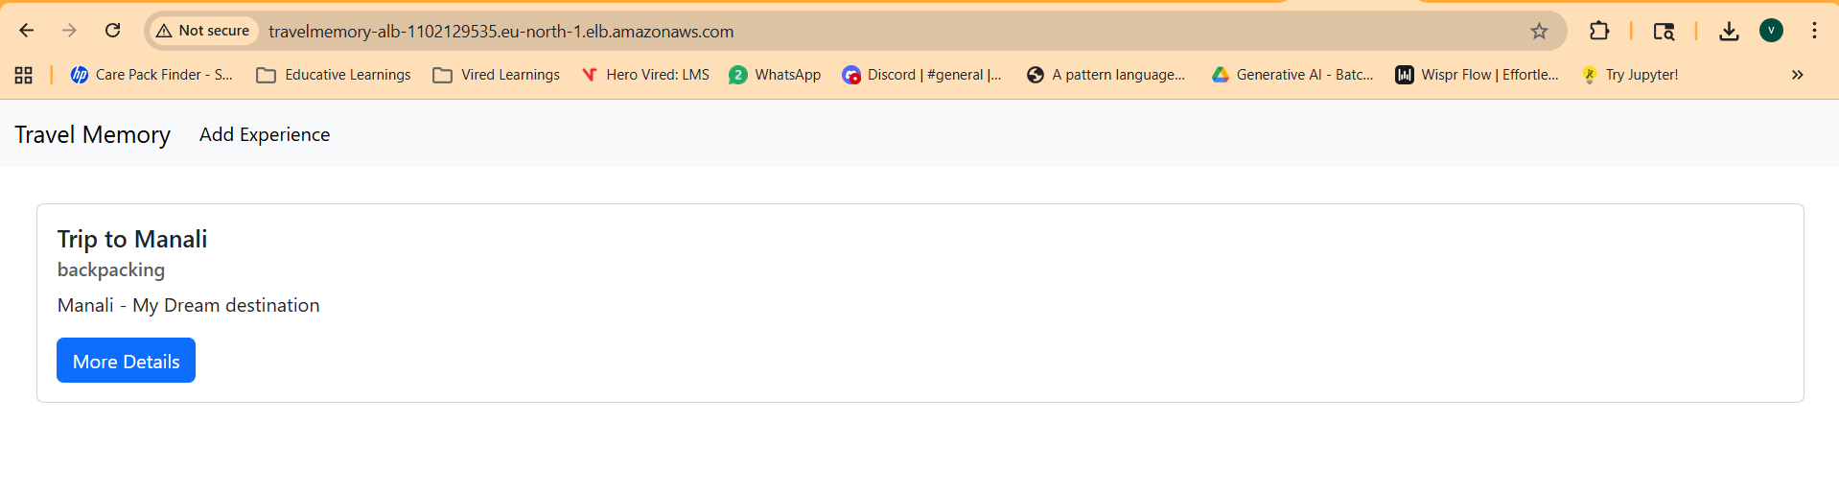
Home Page - Existing Trip details
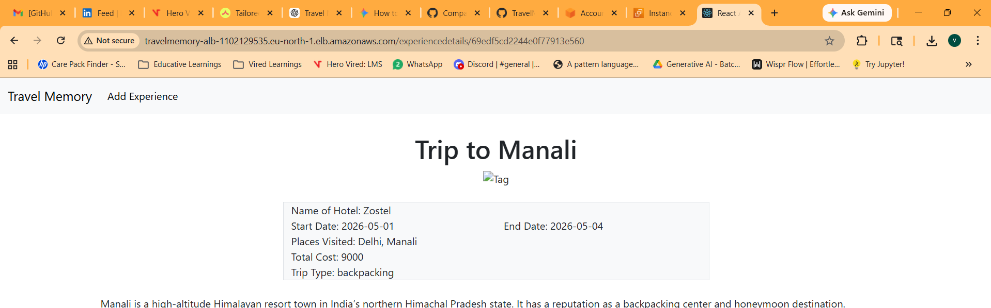
Page to Add new Trip detail
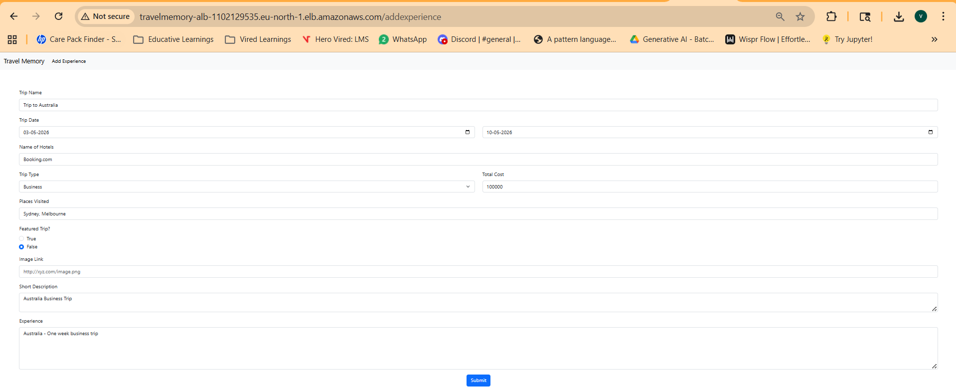

Application Home Page after added with new trip details
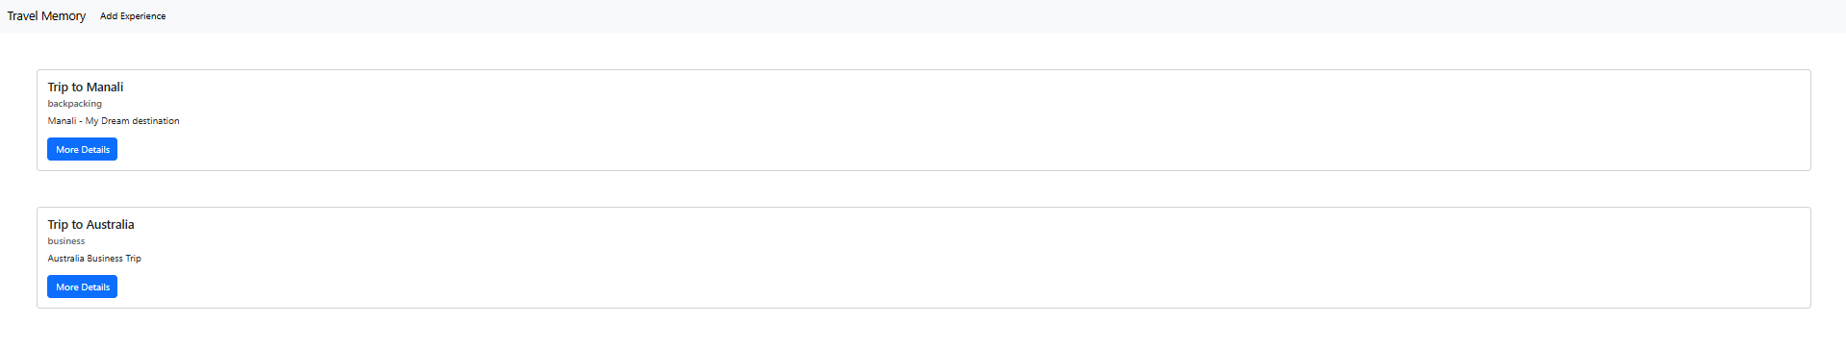
Application Home Page – New Trip details
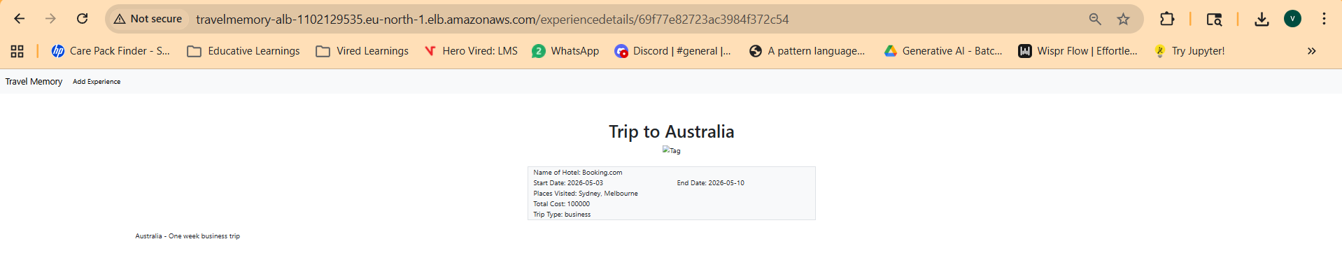

Application Backend API call screenshot with Existing and New Trip details
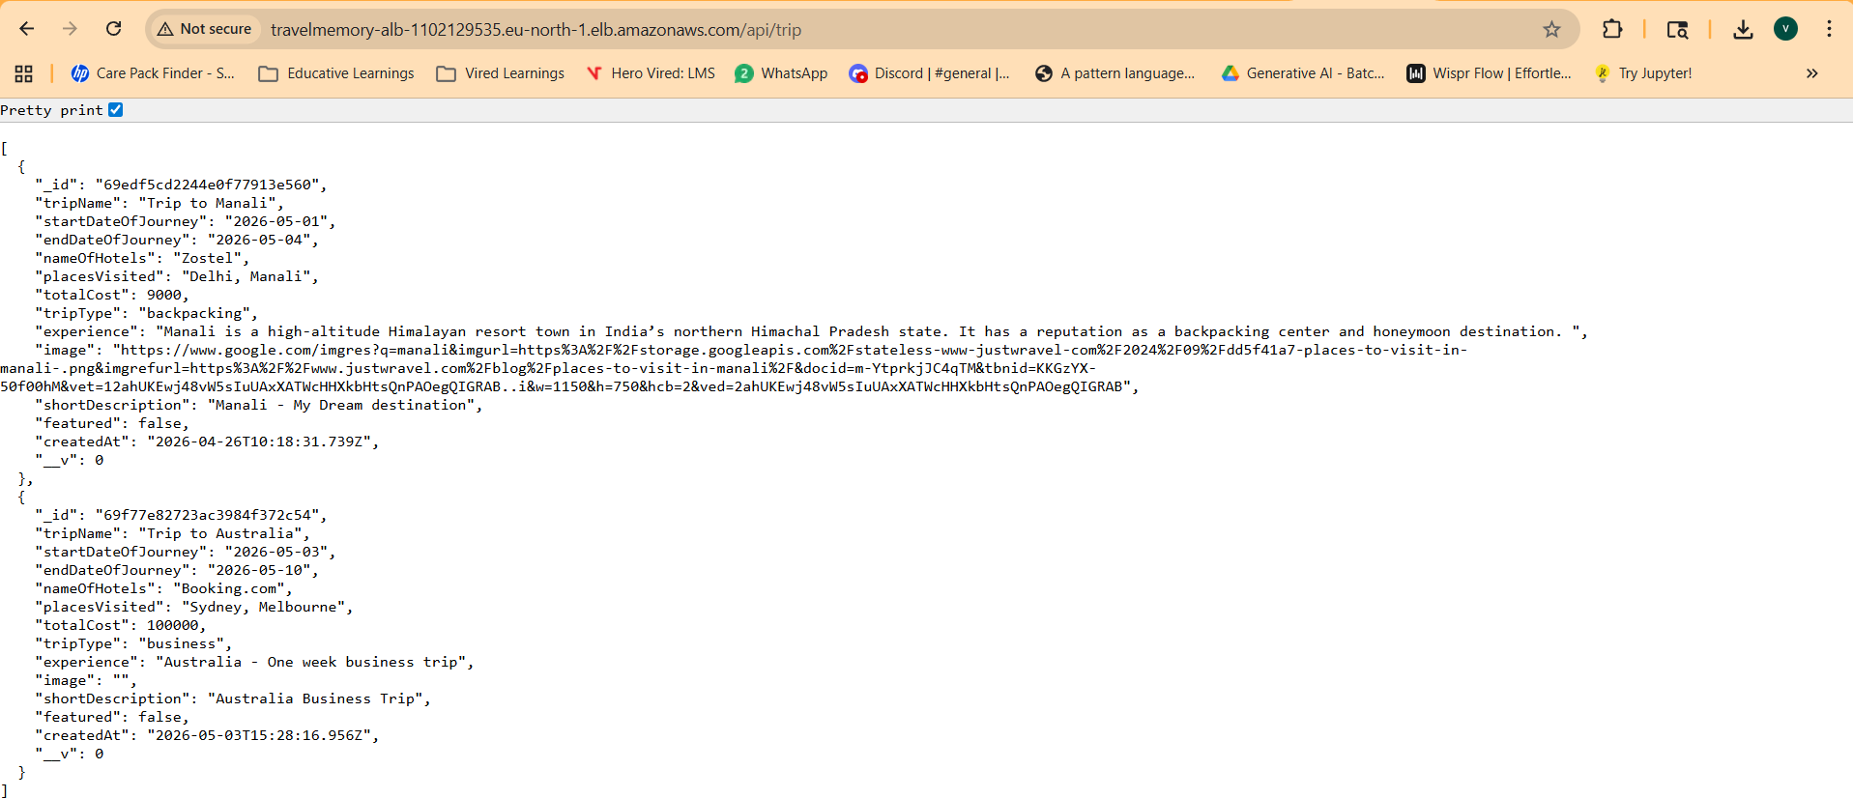

Application - Health check
ALB Health check URL - http://travelmemory-alb-1102129535.eu-north-1.elb.amazonaws.com/hello
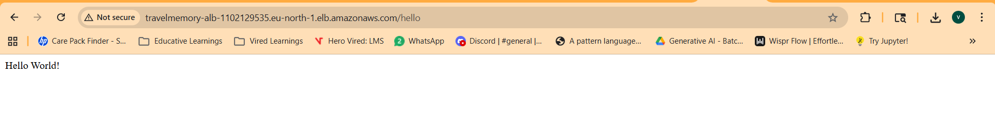

Mongo DB screenshots with Existing and New Trip details
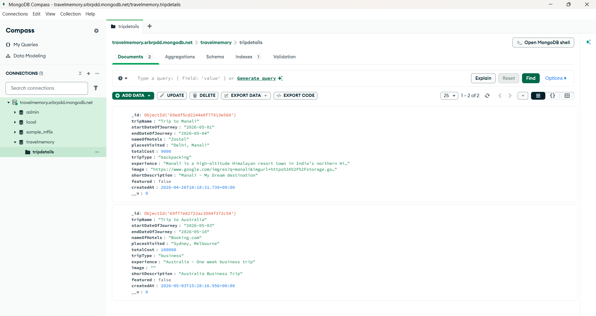

AWS – EC2 instances Screenshots
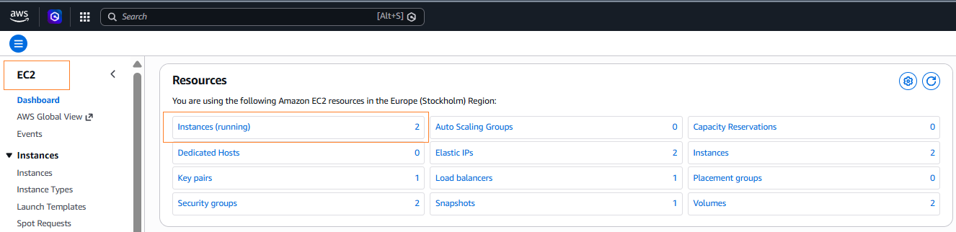
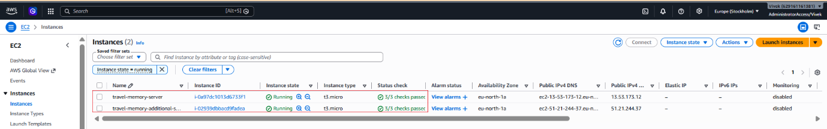
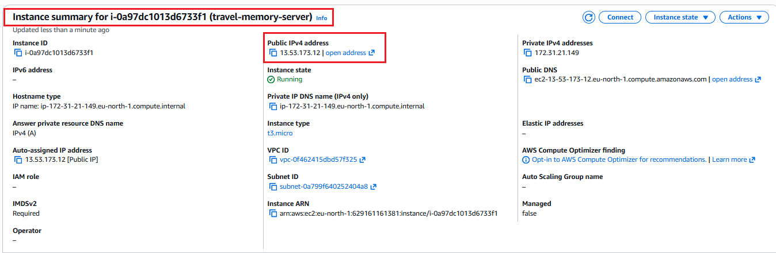
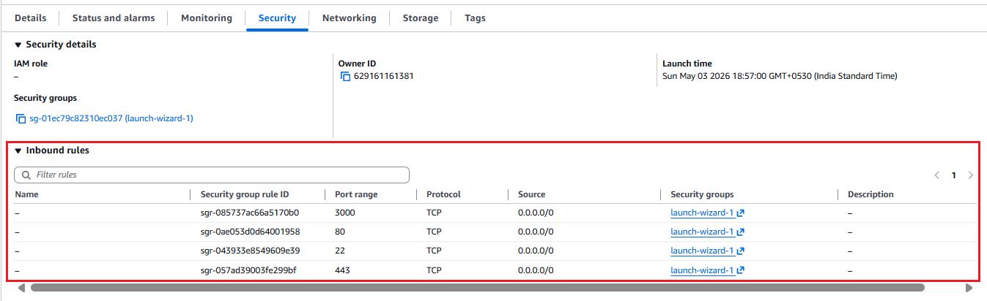
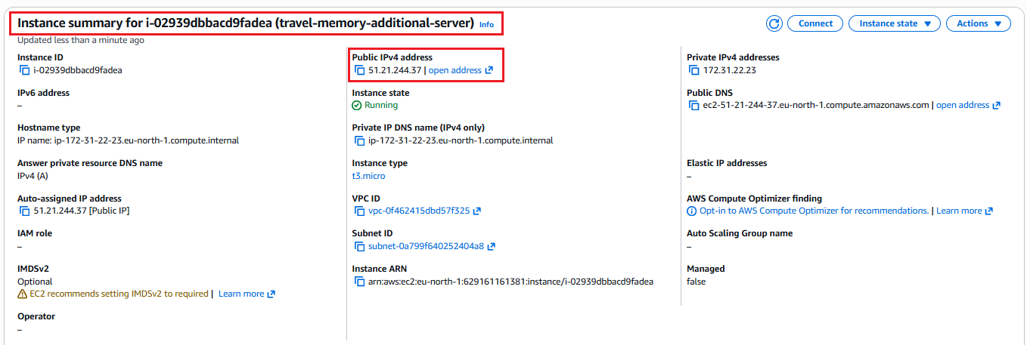
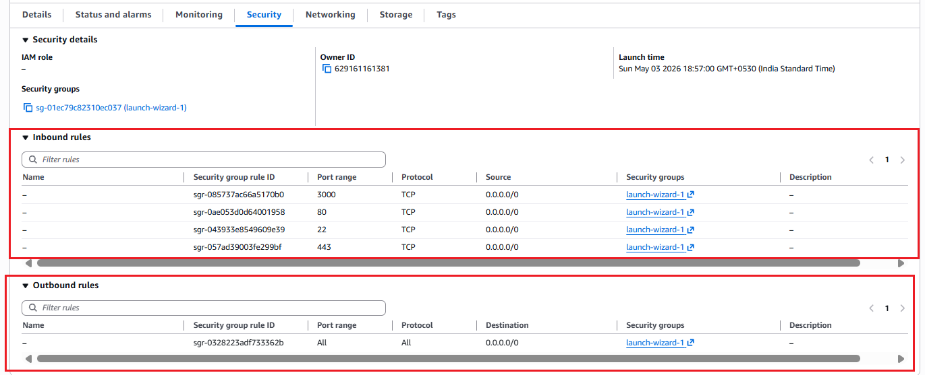
AWS – AMI screenshots
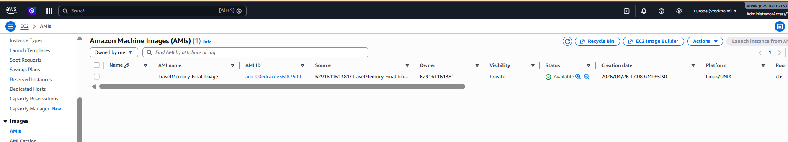

AWS - Security Groups screenshots
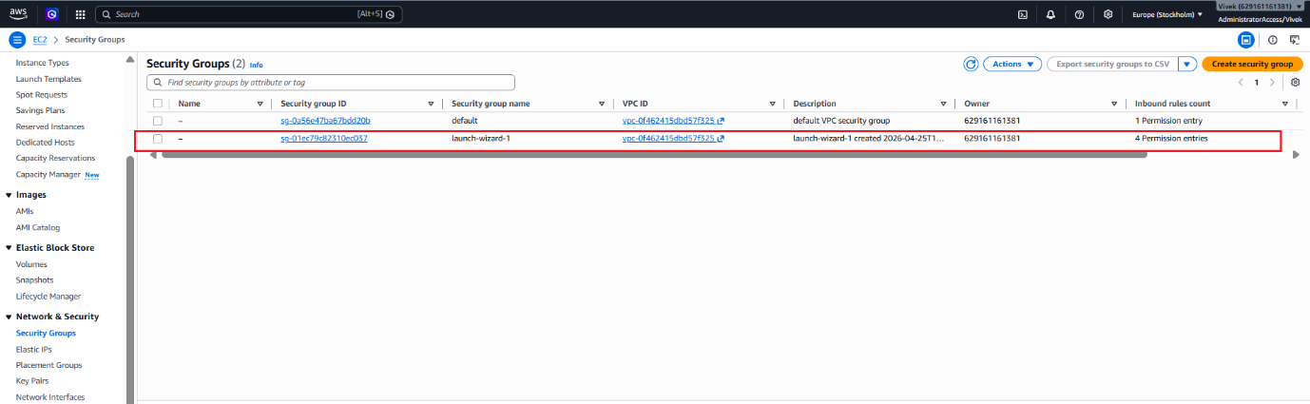
AWS – Key Pairs screenshots
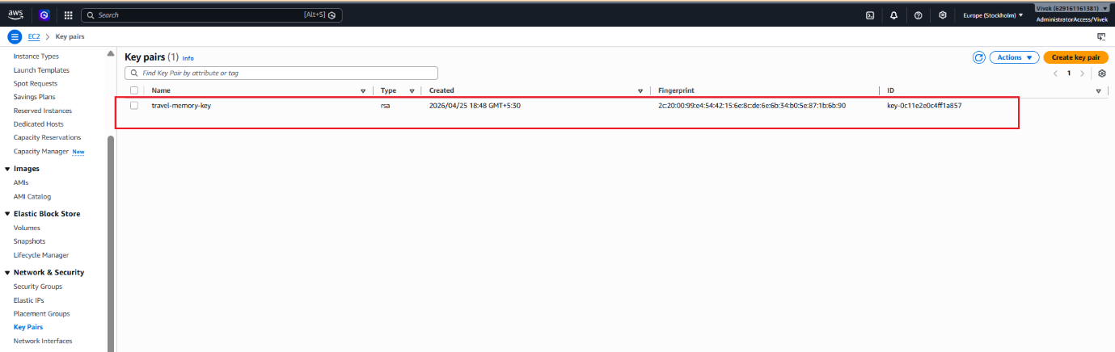
AWS – Load Balancer screenshots
DNS name - TravelMemory-ALB-1102129535.eu-north-1.elb.amazonaws.com
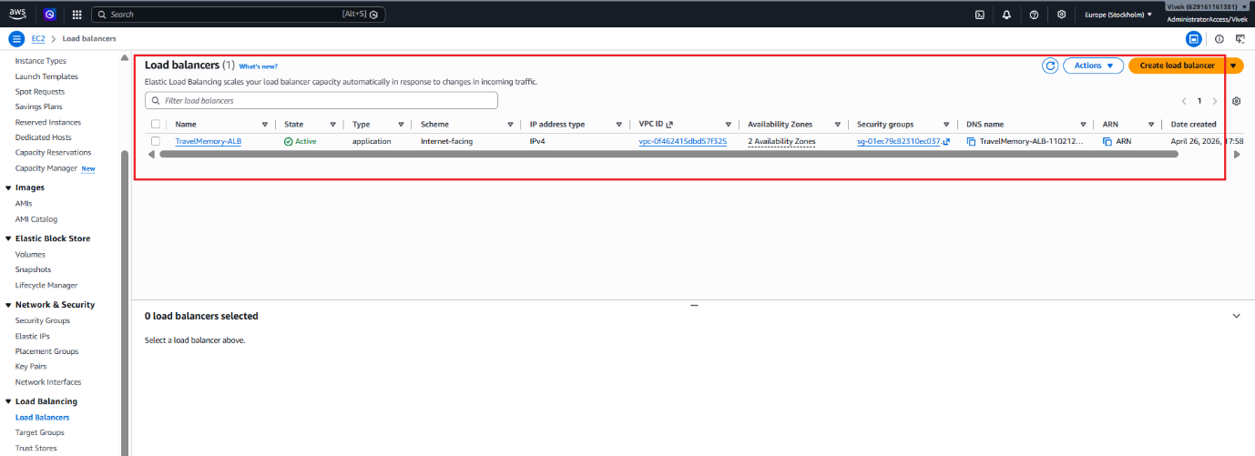
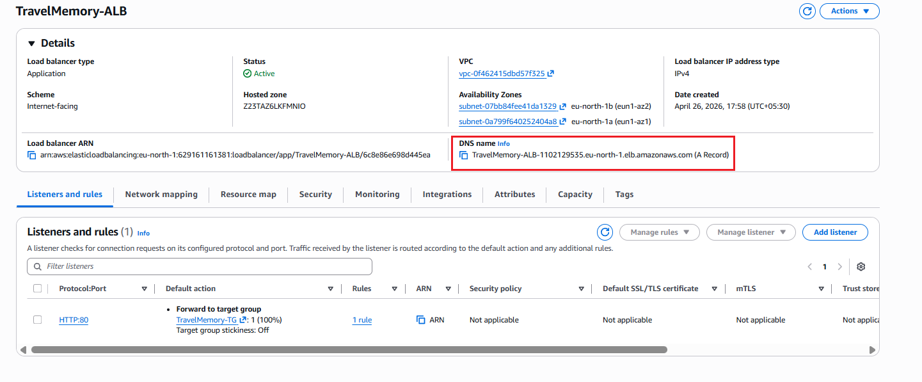
AWS – Target Groups screenshots
