Assignment 4: Automatic EBS Snapshot and Cleanup Using AWS Lambda and Boto3
Screenshot 1: Target Storage Configuration
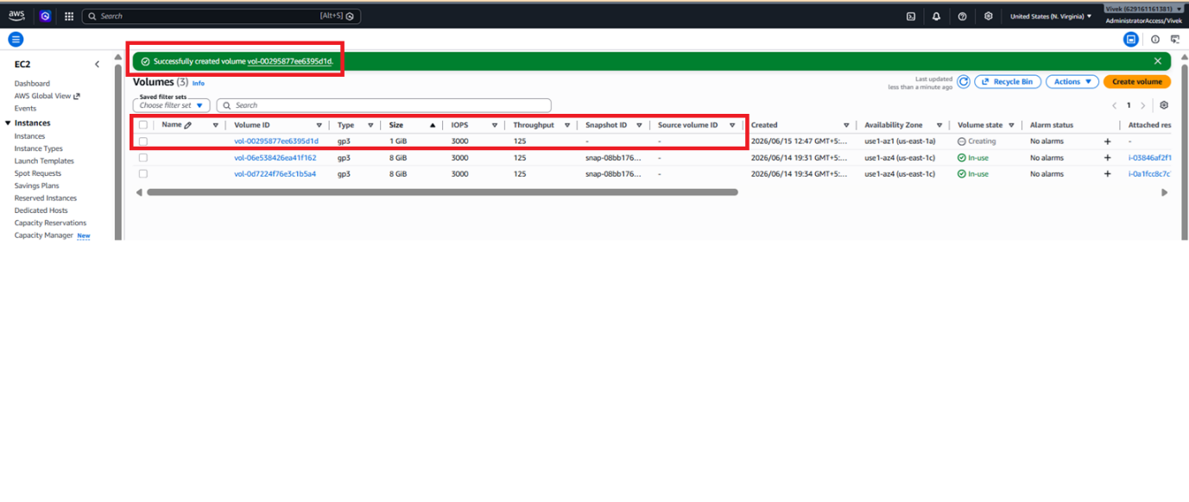
Screenshot 2: Security Profile Verification
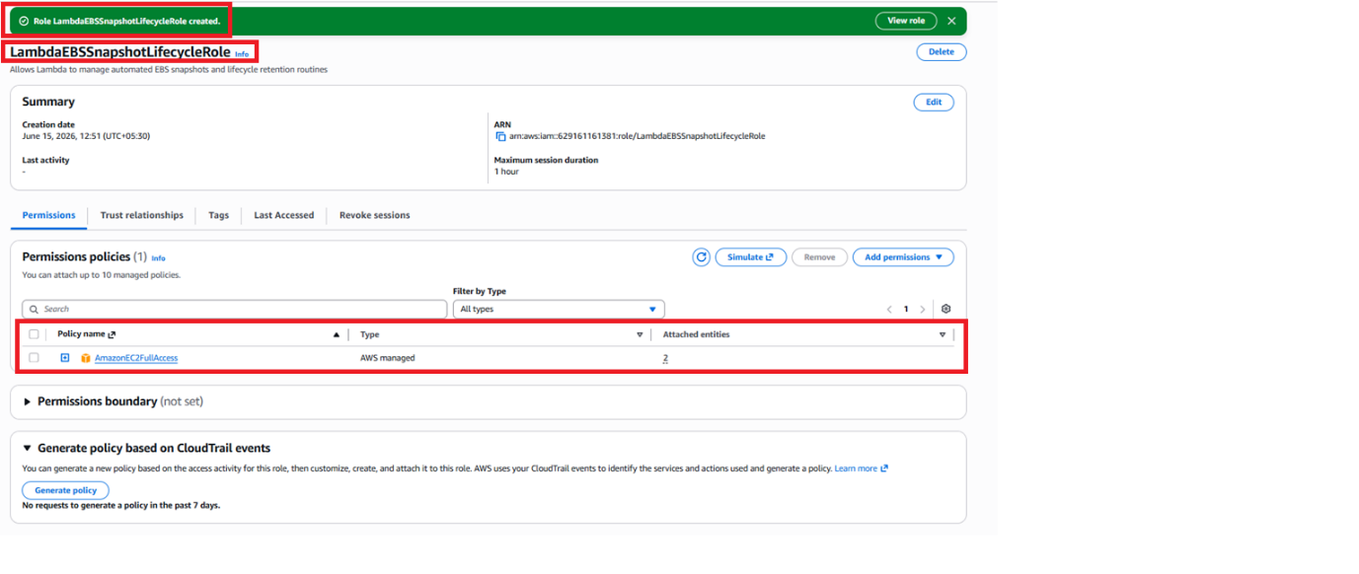
Screenshot 3: Lambda Workspace Deployment
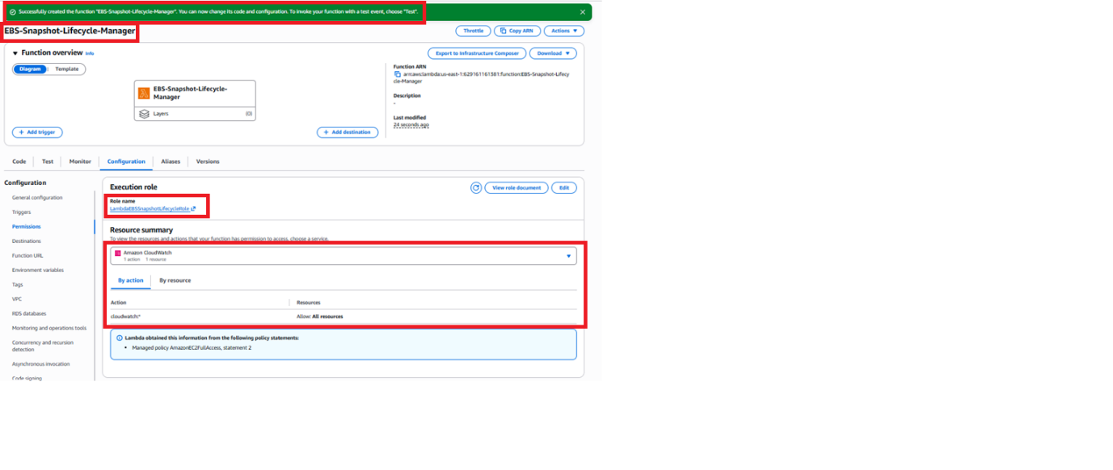
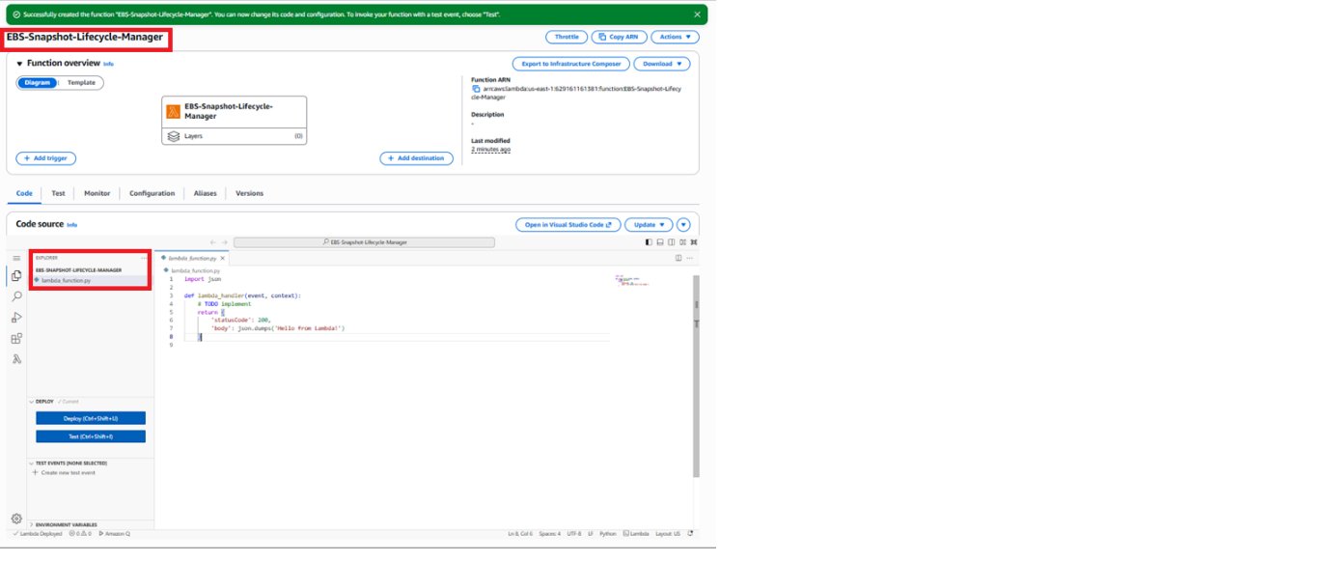
Screenshot 4: (Bonus) Cron / EventBridge Mapping
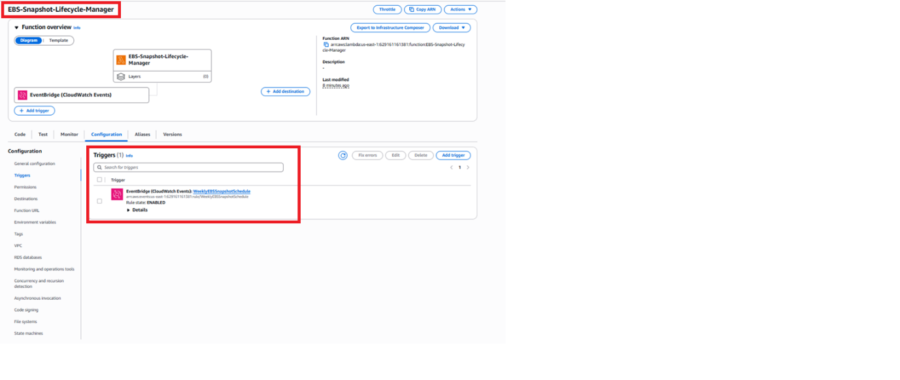
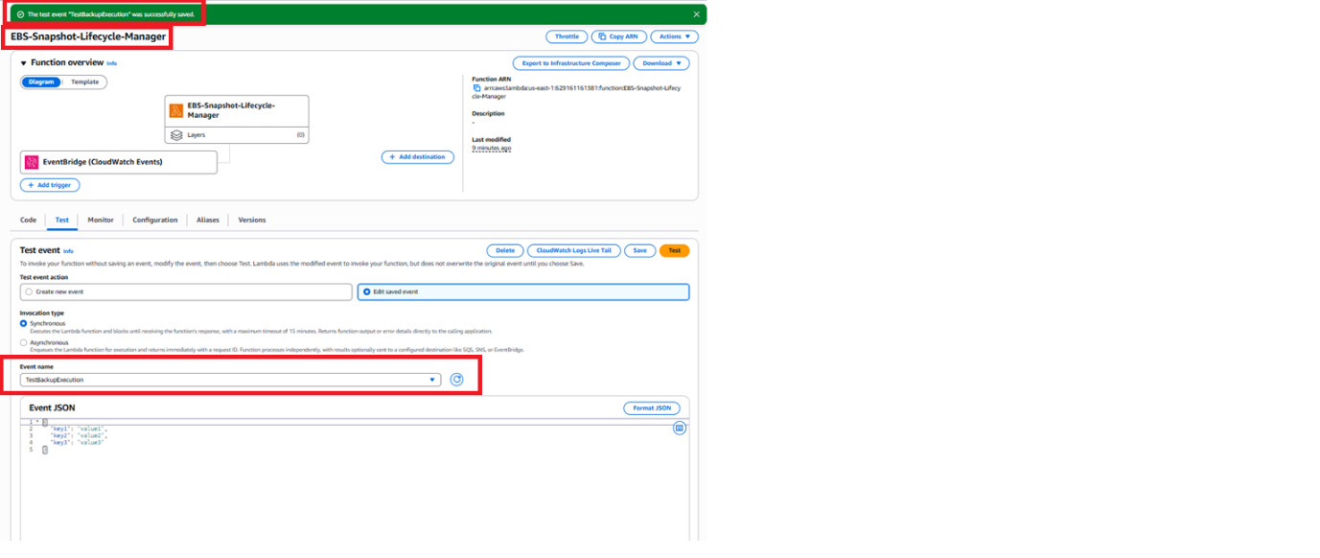
Screenshot 5: Function Execution & Live Logging Metrics
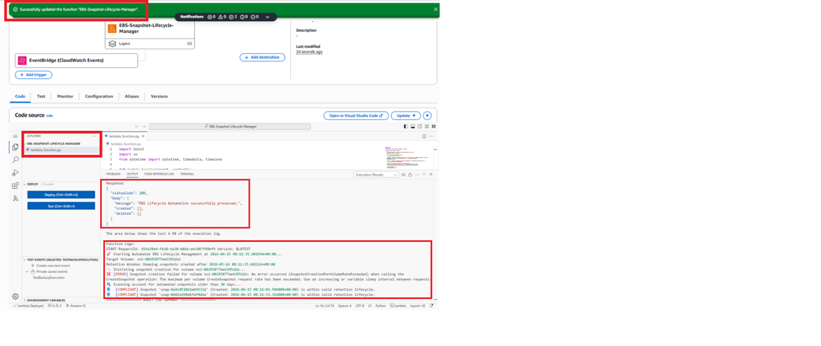
Screenshot 6: Post-Execution Architecture State
