Assignment 1: Automated Instance Management Using AWS Lambda and Boto3
Step 1 – AWS EC2 Instance starting screenshots
Auto-Stop instance running and Auto-Start instance stopped
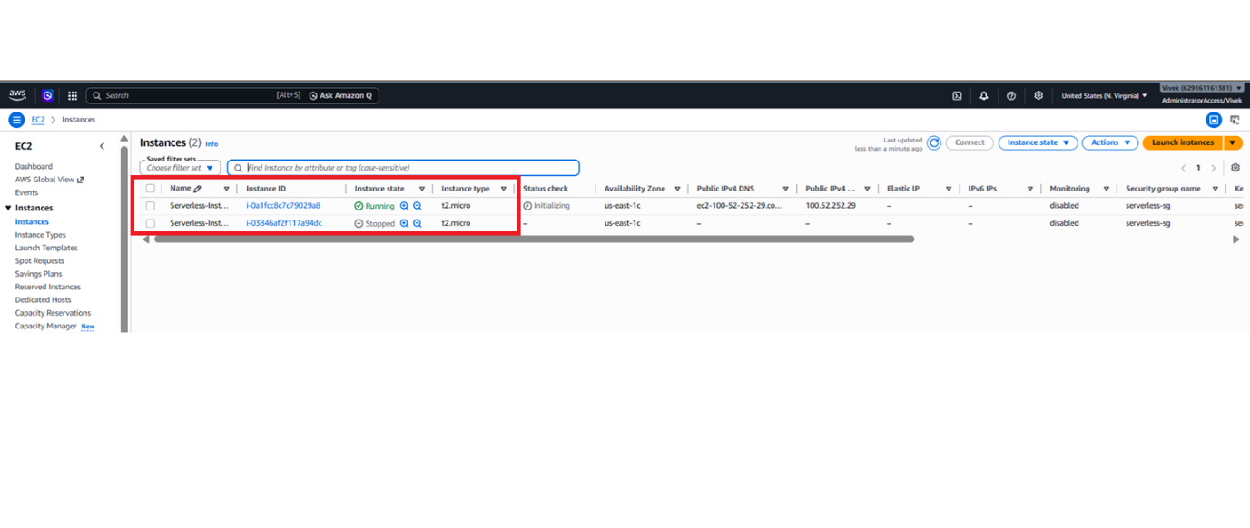
Step 1.1 – Instance 1 (i-0a1fcc8c7c79029a8) – Screenshot
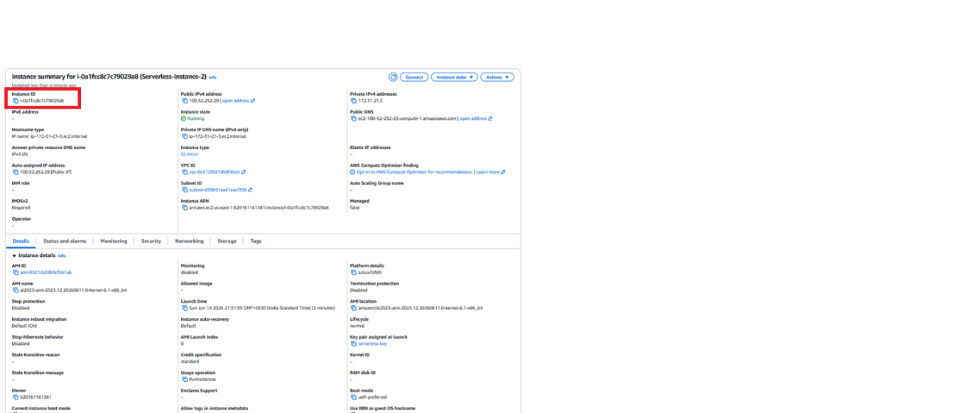

Step 1.2 – Instance 2 (i-03846af2f117a94dc) – Screenshot
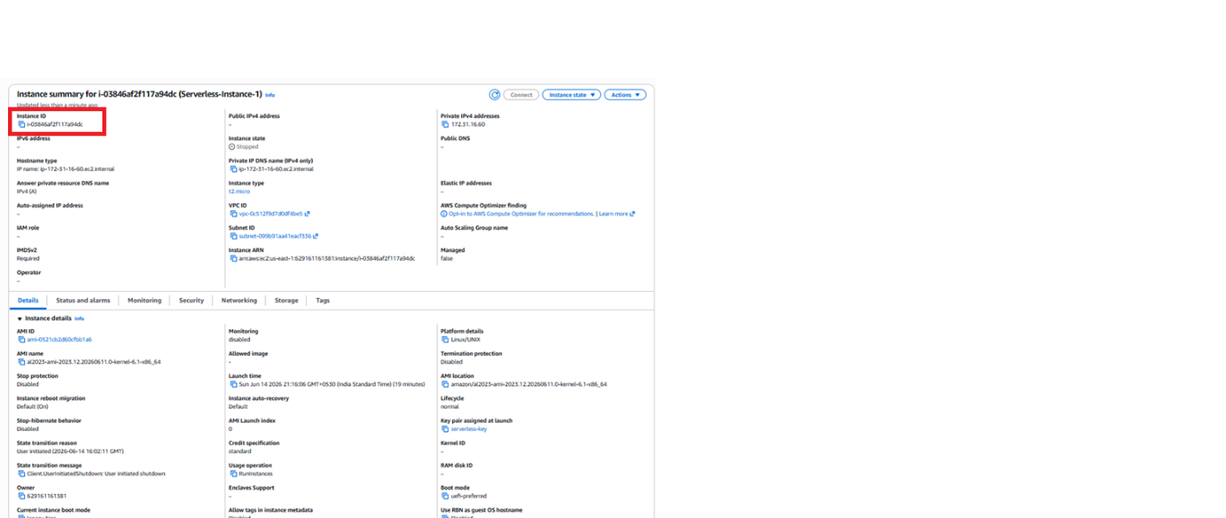
Step 1.3 – EC2 Tags Screenshot
Instance 1 (i-0a1fcc8c7c79029a8) – Tag
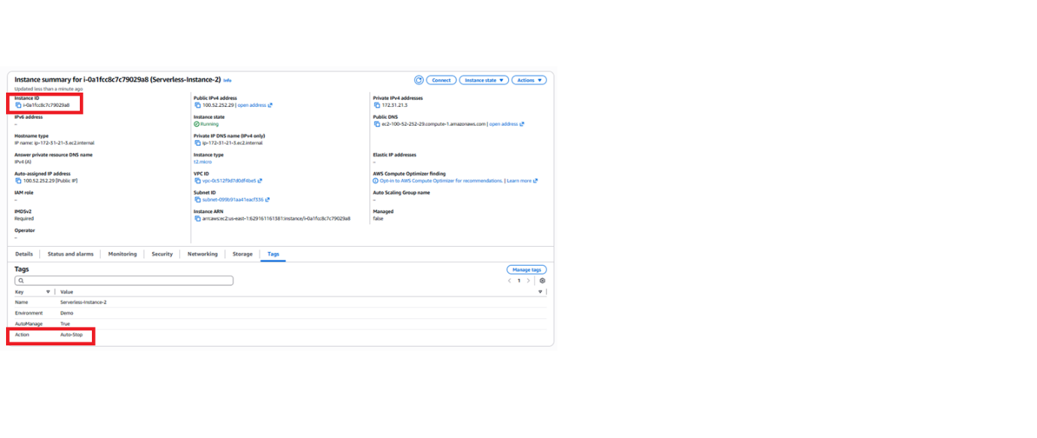
Instance 2 (i-03846af2f117a94dc) – Tag
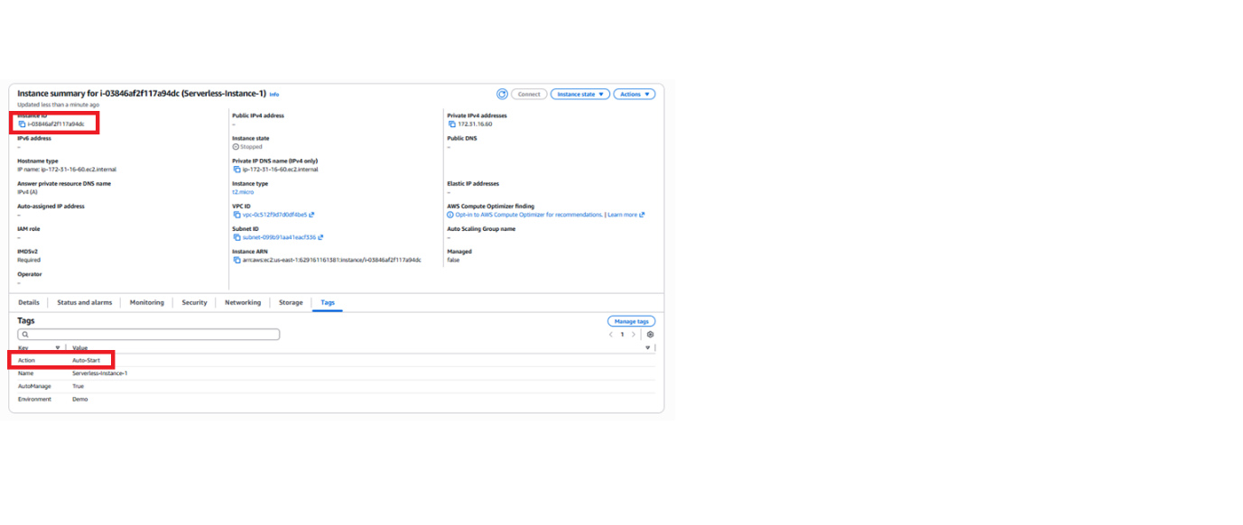
Step 2 – IAM Role screenshot
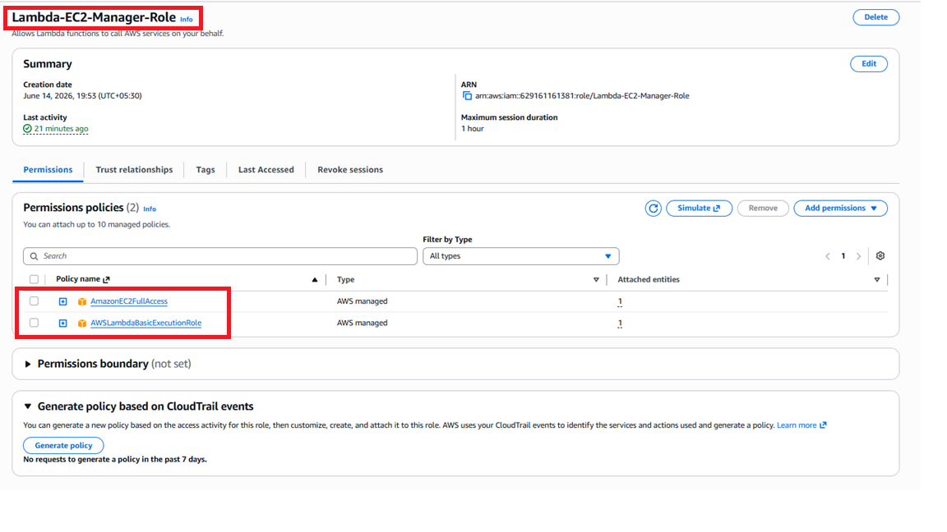
Step 3 – Lambda function screenshot
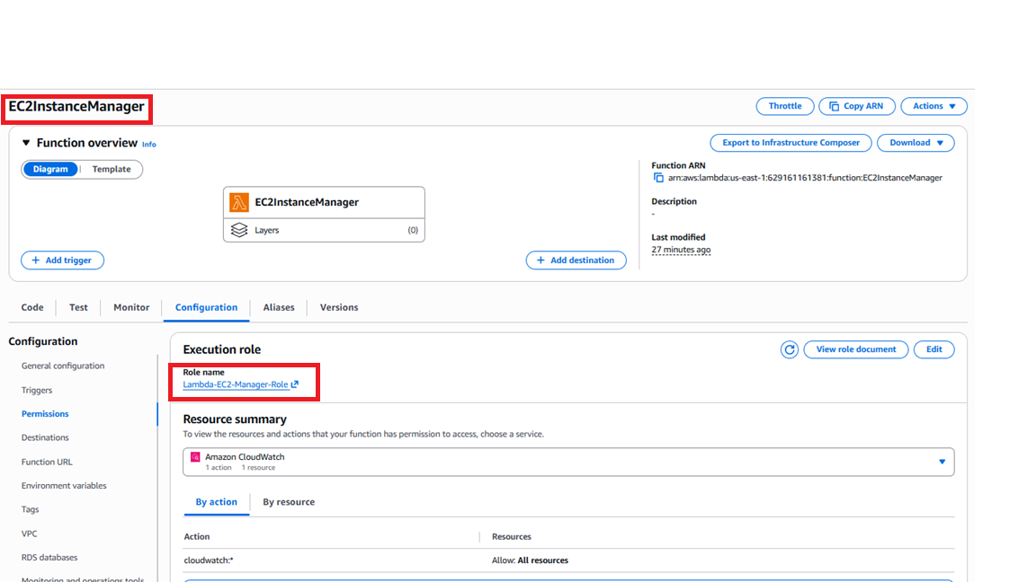
Step 4 – Lambda function code screenshot
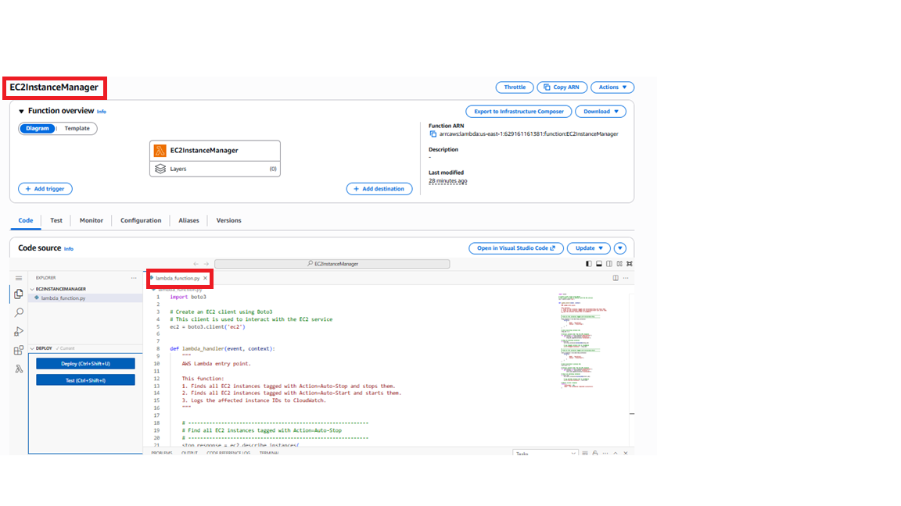
Step 4.1 – Lambda function execution 1 screenshot
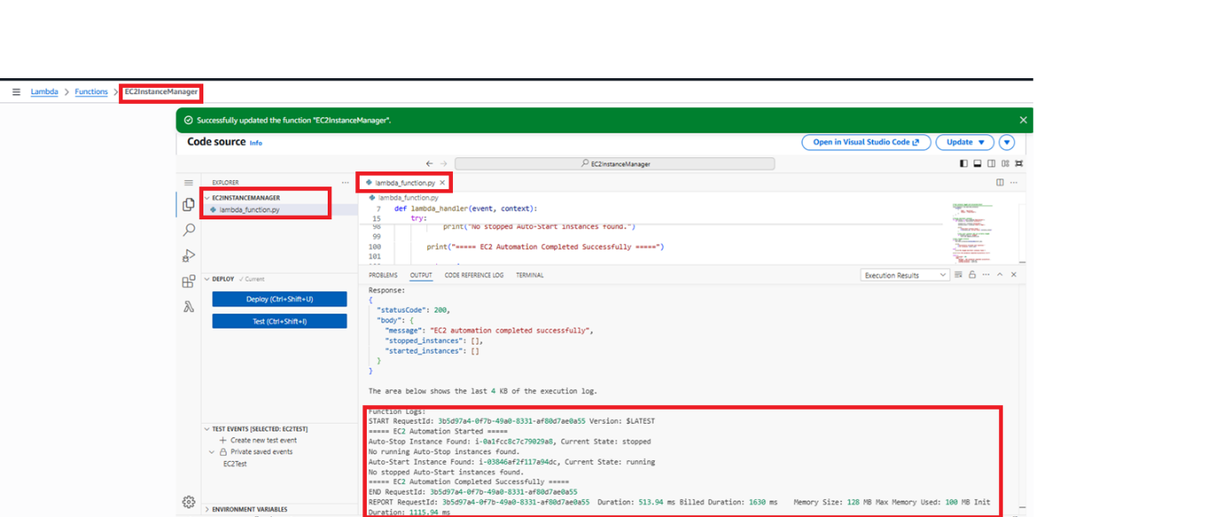
Step 4.2 – EC2 State Change Screenshot (After First Execution)
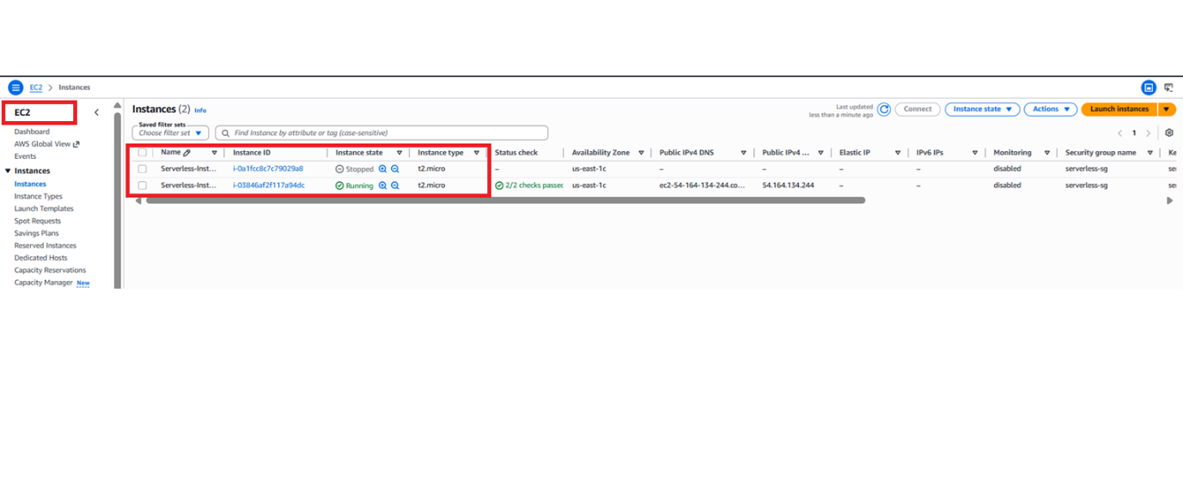
Step 4.3 Start the Auto-Stop EC2 instance and Stop the Auto-Start EC2 instance
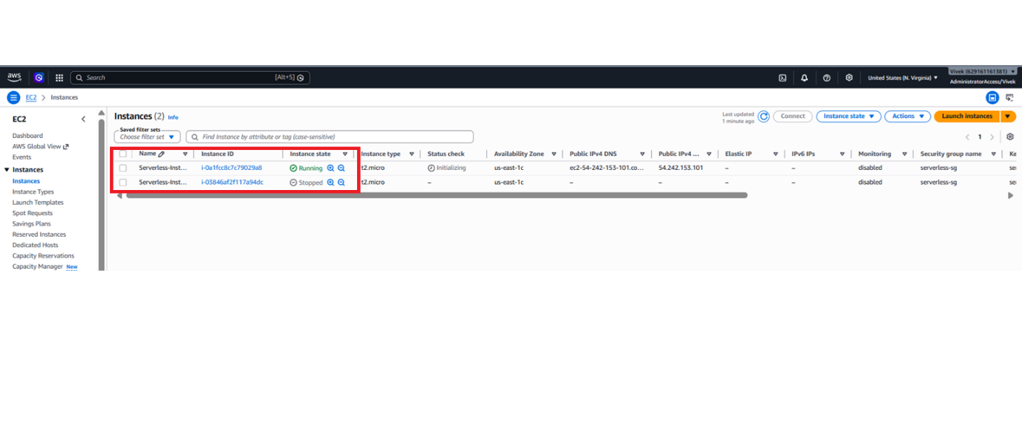
Step 4.3 – Lambda function execution 2 screenshot
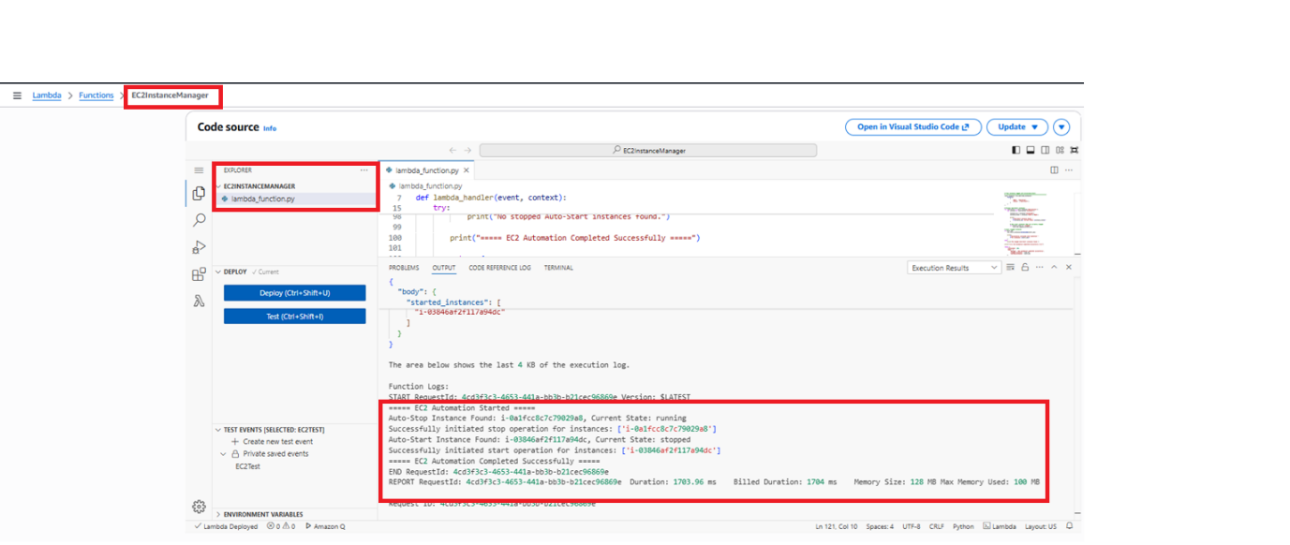
Step 4.4 – EC2 State Change Screenshot (After Second Execution)
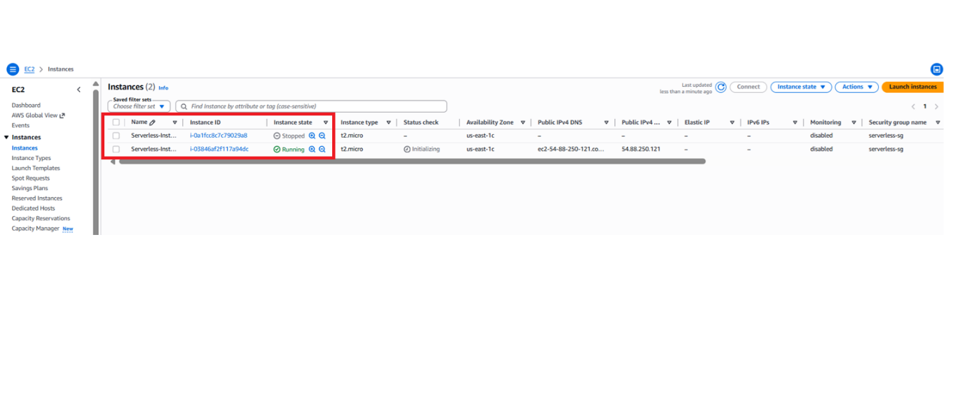
Step 5 – AWS CloudWatch Logs screenshot
