Assignment 3: Monitor Unencrypted S3 Buckets Using AWS Lambda and Boto3
Screenshot 1: The S3 Buckets List (The Target Inventory)
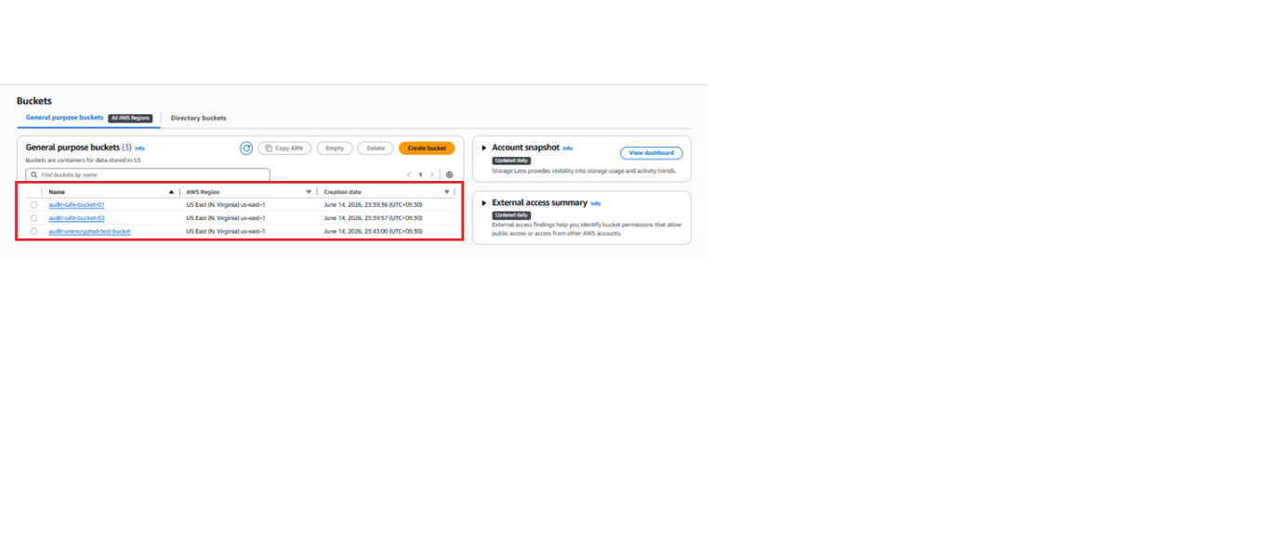
Screenshot 2: Compliant Bucket Configuration (Bucket Key Enabled)
Bucket 1 Name – audit-safe-bucket-01
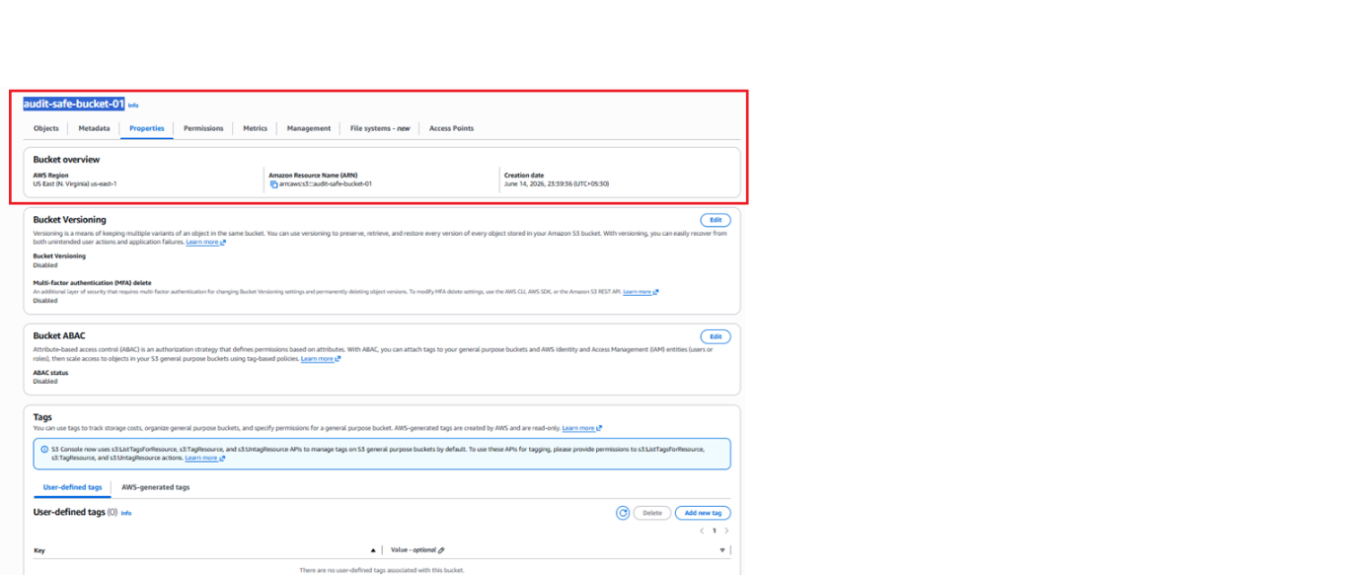
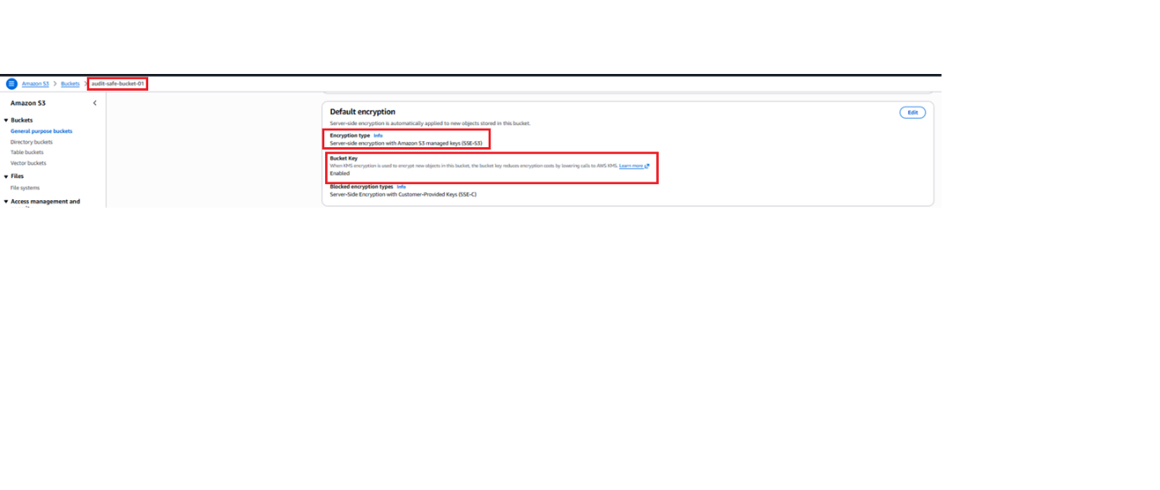
Bucket 2 Name – audit-safe-bucket-02
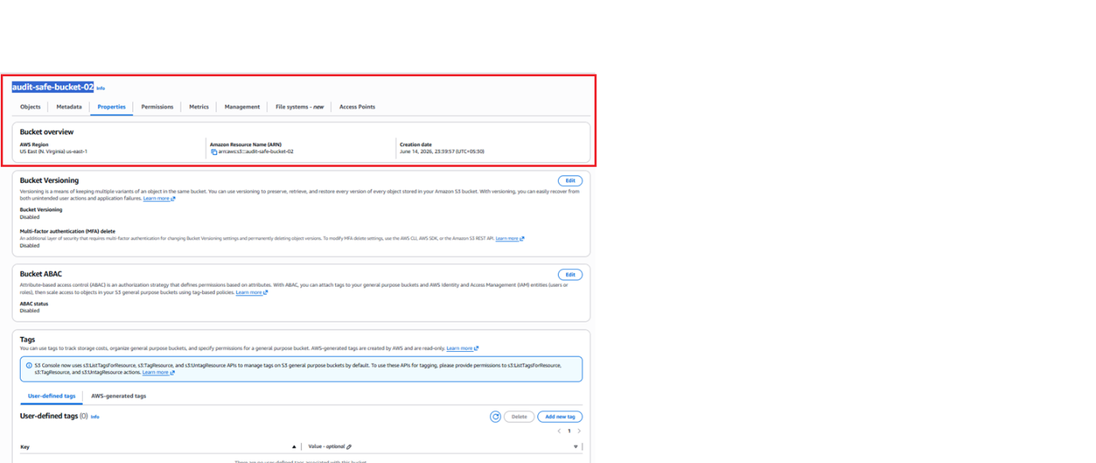
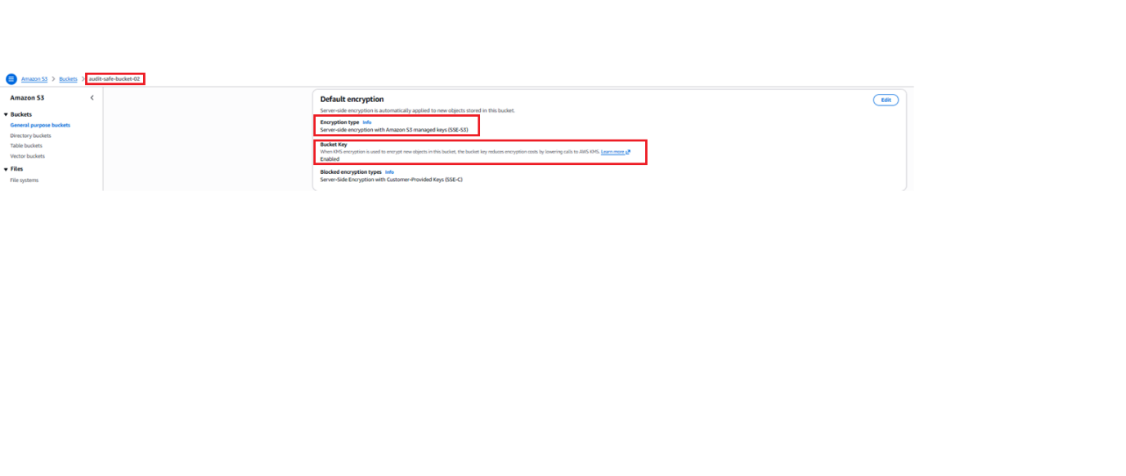
Screenshot 3: Non-Compliant/Simulated Unencrypted Bucket Configuration (Bucket Key Disabled)
Bucket 3 Name – audit-unencrypted-test-bucket
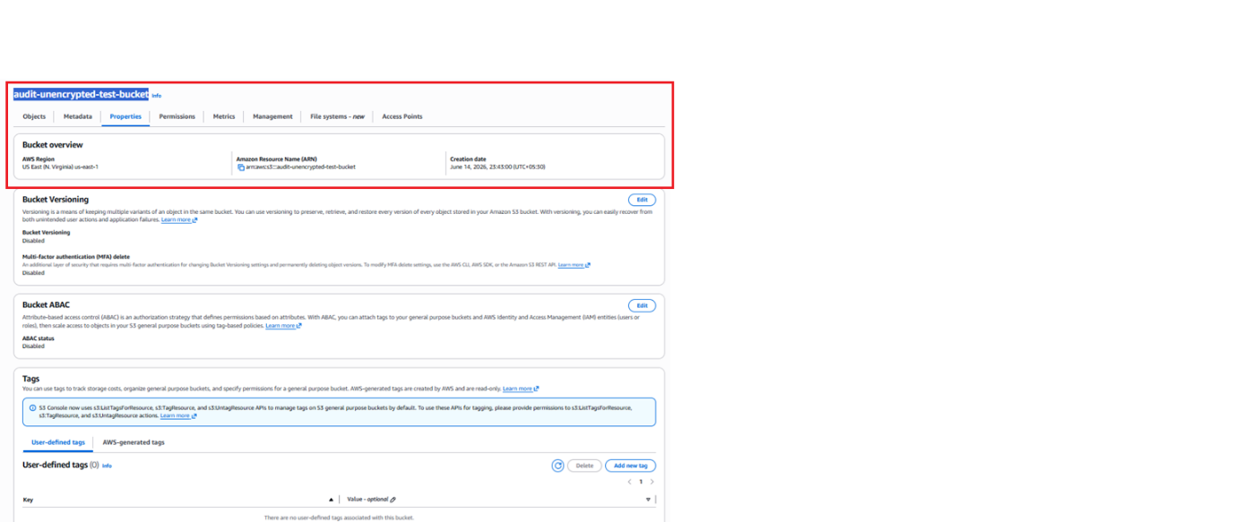
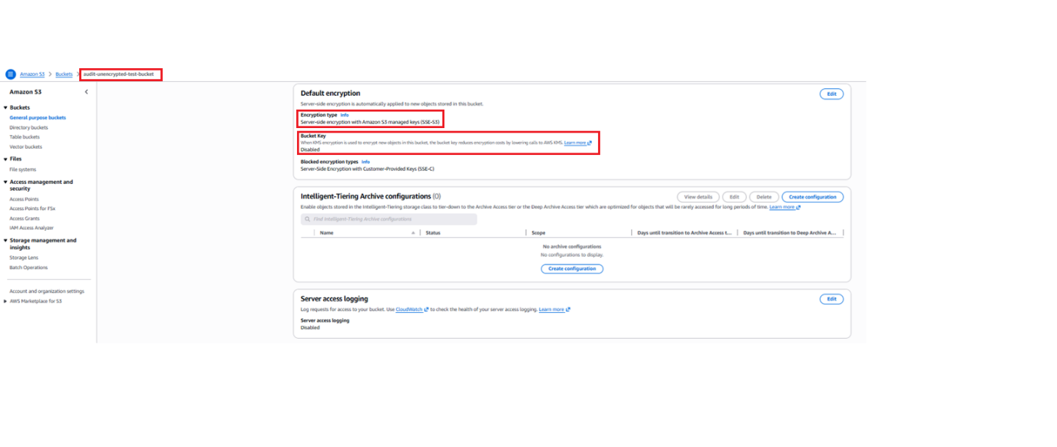
- S3 bucket properties for the non-compliant test case (audit-unencrypted-test-bucket), highlighting the disabled Bucket Key setting under Default Encryption used to simulate a vulnerable baseline fallback configuration.
Screenshot 4: IAM Role Permissions
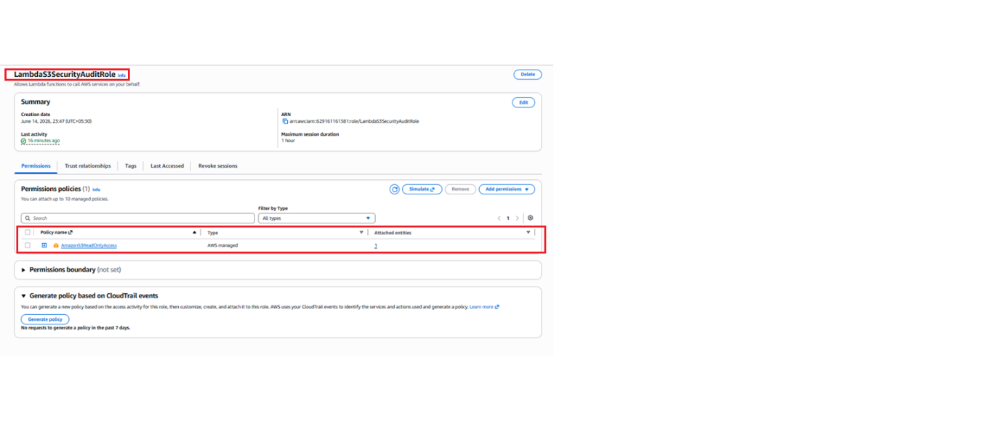
Screenshot 5: Lambda Code Workspace Environment
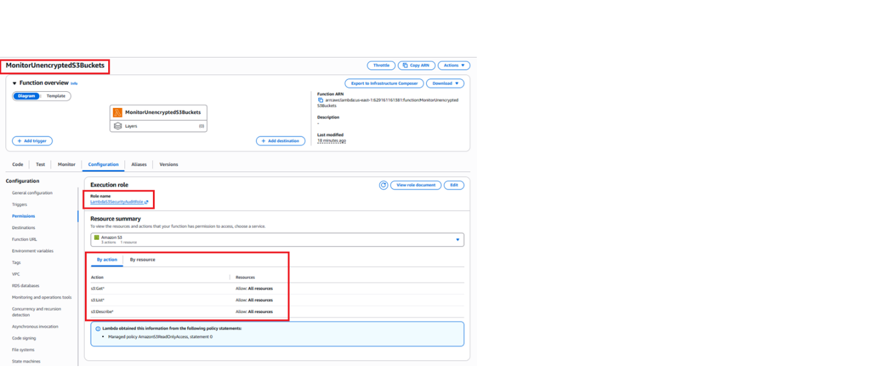
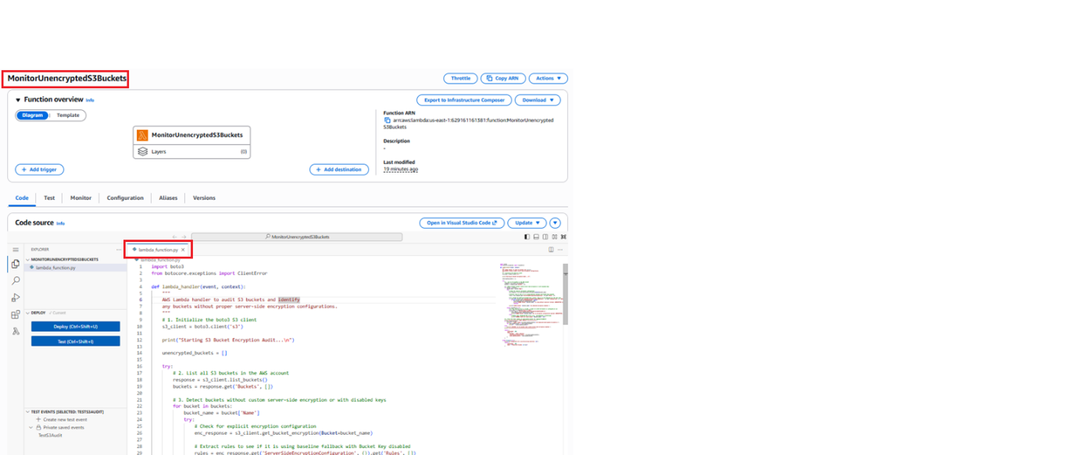
Screenshot 6: Successful Function Invocation Logs
