1. 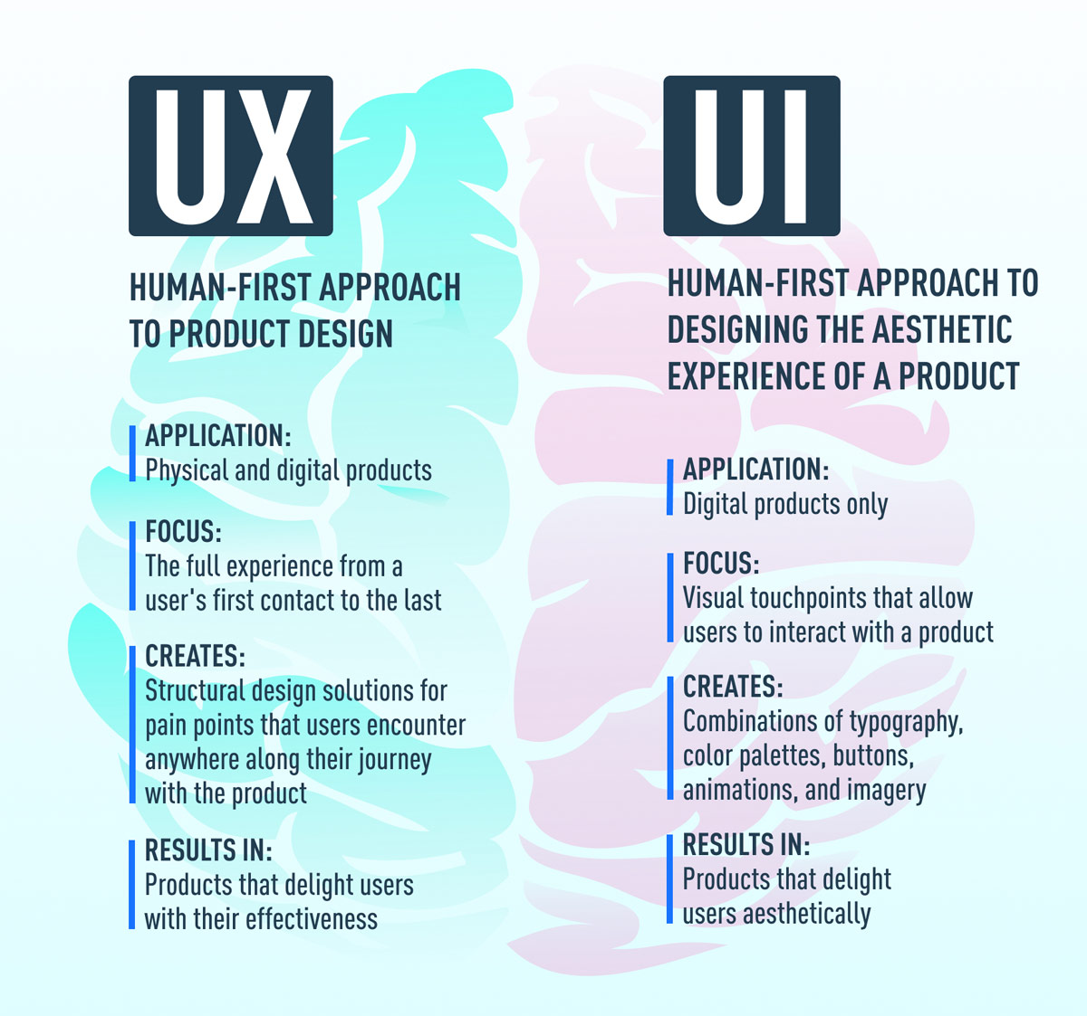What is the difference between UI and OX? Explain in your own words.
2. Who is a frontend developer? Explain the roles and responsibilities in your own words.

Ans.A Front-End Developer is responsible for developing new user-facing features, determining the structure and design of web pages, building reusable codes, optimizing page loading times, and using a variety of markup languages to create the web pages

Role

Optimizing the user experience.

Using HTML, JavaScript and CSS to bring concepts to life.

Developing and maintaining the user interface.

Implementing design on mobile websites.

Creating tools that improve site interaction regardless of the browser.

Responsibilities

Use markup languages like HTML to create user-friendly web pages

Maintain and improve website

Optimize applications for maximum speed

Design mobile-based features

Collaborate with back-end developers and web designers to improve usability

1. Who is a backend developer? Explain the roles and responsibilities in your own words.

Ans Back-end developers are the experts who build and maintain the mechanisms that process data and perform actions on websites. Unlike front-end developers, who control everything you can see on a website, back-end developers are involved in data storage, security, and other server-side functions that you cannot see.

Responsibilities

Build and maintain websites

Write high-quality code

Perform quality assurance (QA) testing

Assess efficiency and speed

1. Create your own GitHub & Linkedln accounts. Share the screenshot of both of your accounts and share your profile links of GitHub & Linkedln in the solution.

Ans Yes, you can add it as a custom website under contact info.
Go to your profile on LinkedIn > Contact Info > Websites > Choose website type “Other”, and type in the next textbot “GitHub”. Enter your GitHub profile URL in the URL box. Save.
Have you tried this?
go to your LinkedIn profile page
click on on “Add profile section” below your name, position and location information
click the + next to projects
fill out the form with your GitHub information, including a Project url to go to your profile
give yourself a high 5
No.5 is particularly important

1. Write your first blog on your favorite platform and share the link to the blog. (You can choose anytopic for writing your 1st blog)

Ans

Step 1: Plan your blog post by choosing a topic, creating an outline, conducting research, and checking facts.

Step 2: Craft a headline that is both informative and will capture readers’ attentions.

Step 3: Write your post, either writing a draft in a single session or gradually word on parts of it.

Step 4: Use images to enhance your post, improve its flow, add humor, and explain complex topics.

Step 5: Edit your blog post. Make sure to avoid repetition, read your post aloud to check its flow, have someone else read it and provide feedback, keep sentences and paragraphs short, don’t be a perfectionist, don’t be afraid to cut out text or adapt your writing last minute.

