––

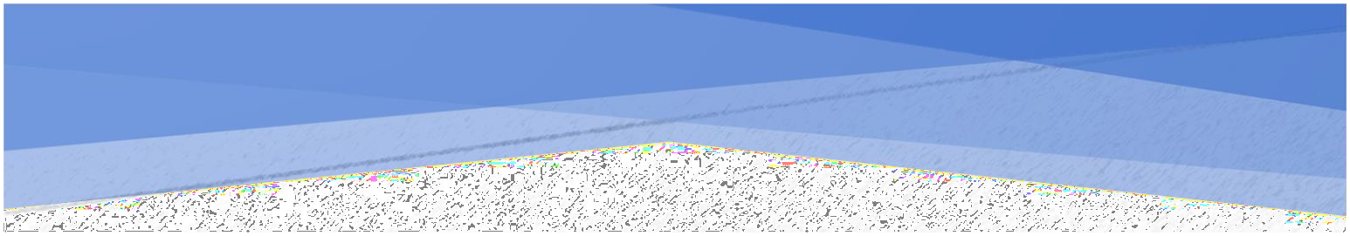A PROJECT REPORT ON



Kamani Science Collage & Prataprai Arts Collage



### Bhatti Prince Maheshbhai (Enrollment No. = 3303225422) Bhatti Darshan Girishbhai (Enrollment No. = 3303225421) Chauhan Jenil Arvindbhai (Enrollment No. = 3303225427)



P**rof**. D**hruvita** S**avaliya**



2024-25

Saurashtra University – Rajkot



1



2



3

Preface

The main objective of any computer science student is to get practical knowledge as possible. Being able to have a practical knowledge by developing a project is a lifetime experience. As practical knowledge is important as theoretical knowledge we are thankful of having a project.

Through the development of the project we had a great experience of various strategies that can be applied in development of the project. This project is the stepping stone for our career.

We are pleased to present this project report. Proper case has been taken while organizing the report so that it is easy to comprehend. Also, various software engineering concepts have been implemented.

4

Acknowledgment

We are student of BCA sem-5 Studying in the Kamani Science College Amreli. We Thanks to the entire person who has given their Support in shaping of the system.

We thank Prof. Dhruvita Savaliya for giving us guidance and co-operation in understanding the system. We also thanks them for their unconditional help in making of this project.

We have great deal of gratitude towards our head of department who encourages in taking up this activity. We thank all faculties and administrative staffs of the institute.

I am also thankful to all those friends who have helped me in this endeavor either of indirectly & especially my family.

Thanks to all!!

**Bhatti Prince M. Bhatti Darshan G. Chauhan Jenil A.**

5

Abstract

The online Freelance Marketplace is a Web Portal on which freelancers and Employers interact with each other in this platform, an employer usually post a project and many freelancers bid on that project, the most efficient bid. In this way the employer gets his job done and the freelancers earn money.

This project aims to develop a freelance marketplace where not only an employer could post a project for bidding but freelancers could also offers his/her services for buyers.

Freelancers and client both can be benefited from this bidding. Client who wish to hire internationally can take advantage of favorable overseas exchange rates , resulting in work being done for 50-90% less than if the project where done in country and also given access to a huge pool of potential work and have the ability to work independently from their homes rather than for a company.

6

## SDLC

Software development life cycle (SDLC) is a structured process that is used to design , develop , and test good-quality software .

SDLC , or software development life cycle , is a methodology that defines the entire procedure of software development step-by-step.

The software development lifecycle (SDLC) outlines several tasks required to build a software application.

Requirement Analysis

Maintenance

Defining

Deployment

Designing

Testing

Coding

7

## INTRODUCTION OF PROJECT

In the rapidly evolving real estate industry, the digital transformation has revolutionized the way properties are rented and managed. Our project, the "Online House & Apartment Rental System," aims to bridge the gap between property owners and potential renters by offering an integrated platform for renting various types of properties, including houses and apartments.

In this project people can book their favourite house & apartments after a few steps. This system has two modules namely Admin and User. Admin can also add the property details for house & apartment. User needs to register and then login just by using credentials.

Developed using PHP and MySQL, this project not only showcases advanced web development techniques but also emphasizes user experience, security, and efficiency. The system is designed to be scalable, ensuring it can handle multiple users and properties simultaneously, making it suitable for both small-scale property owners and large rental agencies.

Key features of this systems is User-Friendly Interface, Comprehensive Property Listings, Owner Management Dashboard and Secure Booking System.

8

Requirement Gathering

### Q-1: What types of properties will be listed?

* Ans: House and apartments.

### Q-2: What information should be included in each property listing?

* Ans: Location, price, size (sq ft), number of bedrooms, number of bathrooms, description, availability date and photos.

### Q-3: What amenities should be available for search functionality?

* Ans: Pool, Gym, Parking space, Furnished, Balcony, etc.

### Q-4: What is the target audience for the project?

* Ans: Students, professionals, families, etc.

### Q-5: How will search functionality work?

* Ans: Location , price range , property type.

### Q-6: What is the monthly rent for different types of properties?

* Ans: Monthly rent starts from 4000rs and higher rent as properties.

### Q-7 What information will be required for property listings?

-Ans: Photos , description , pricing , amenities.

9

### Q-8: What are the key features you want to include?

-Ans: Property listings , Search functionality , booking and payment processing , user-profiles.

### Q-9: What information will be required for property listings?

-Ans: photos , description , pricing , amenities.

### Q-10: Should users be able to schedule property viewings online?

-Ans: Yes , through a calendar booking system

### Q-11:How will search functionality work?

-Ans: Location , price range , property type.

### Q-12:What are the key features you want to include?

-Ans: Property listing , search functionality , booking and payment processing , user-profiles.

10

## PROJECT PROFILE

* **Project Name :** Online House & Apartment Rental System
* **Developed By :** Bhatti Prince ,

Bhatti Darshan , Chauhan Jenil .

* **Front-end Tool :** PHP , HTML , CSS
* **Back-end Tool :** MySQL
* **Operating System :** Microsoft Windows 10
* **Computing System :** i5 , RAM-4GB
* **Project Details :** In this rental system, people can

Choose their favorite House and people can book it after seeing all the facilities of their favorite house.

* **Completion Time :** 3 Months
* **Guided by :** Prof . Dhruvita Savaliya

11

## HARDWARE REQUIREMENT

* 4 GB Of RAM
* Multimedia keaboard And Mouse
* 1.0+ GHz Processor
* Monitor
* Printer

## SOFTWARE REQUIREMENT

* **Operating system** : Microsoft windows 10 & window11
* **Front End Tools** : PHP , JavaScript , CSS ,HTML
* **Back End Tools** : PHP MySQL
* **Documentation Tool** : Microsoft word
* **Browser Specification** : Google Chrome

12

Time Line Chart

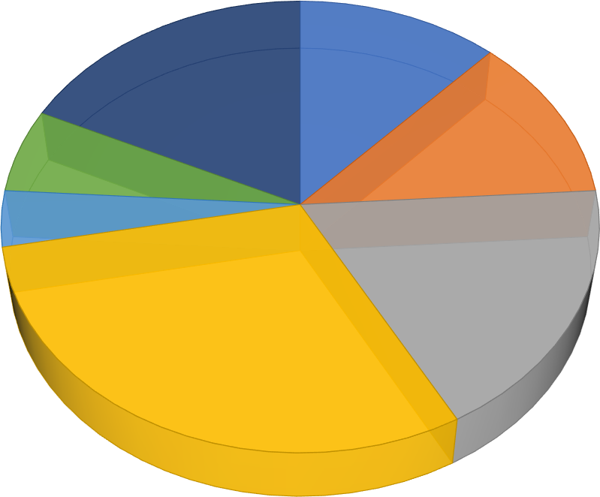

Coding, 30%

System Design, 18%

Testing, 4%

Implementation, 6%

System Analysis, 12%

Maintenance, 18%

Preliminary Investigation, 12%

Preliminary Investigation  10 Days

System Analysis  10 Days

System Design  15 Days

Coding  28 Days

Testing  05 Days

Implementation  07 Days

Maintenance  15 Days

13

Project Page Structure

# Admin Side :

House & Apartment



Management

System

Admin Side

Login

Manage Property

Manage Payment

Logout

Manage User

Manage Feedback

Manage Tenants

14

# User Side :

House & Apartment



Management System

Client Side

Login

View Property Details

Pay Payments

Logout

View property

Send Feedback

View Profile

15

Data Dictionary

The data Dictionary is a set of table. MySQL uses it to maintain information about this own database.

* **Database Name** : project_db

### Tables :

* 1. Admin :

This table is used to store users information.

|  |  |  |  |
| --- | --- | --- | --- |
| Field | Type | Size | Attributes |
| **a_id** | Int | 30 | - |
| **a_username** | Varchar | 255 | - |
| **a_password** | Varchar | 255 | - |

* 1. Registration :

This table is used to store user registration information.

|  |  |  |  |
| --- | --- | --- | --- |
| **Field** | **Type** | **Size** | **Attributes** |
| **id** | Int | 30 | Primary key |
| **username** | Varchar | 255 | - |
| **password** | Varchar | 255 | - |
| **email** | Varchar | 255 | - |

16

* 1. Property :

This table is used to store property information.

|  |  |  |  |
| --- | --- | --- | --- |
| **Field** | **Type** | **Size** | **Attributes** |
| **id** | Int | 30 | Primary key |
| **name** | Varchar | 255 | - |
| **description** | Text | - | - |
| **address** | Varchar | 255 | - |
| **property_type** | Enum | - | - |
| **price** | Int | - | - |
| **bedrooms** | Int | - | - |
| **bathrooms** | Int | - | - |
| **area** | Float | - | - |
| **availability** | Enum | - | - |
| **image_1** | Varchar | 255 | - |
| **image_2** | Varchar | 255 | - |
| **image_3** | Varchar | 255 | - |
| **image_4** | varchar | 255 | - |

* 1. Tenants :

This table is used to store tenants information.

|  |  |  |  |
| --- | --- | --- | --- |
| **Field** | **Type** | **Size** | **Attributes** |
| **tenant_id** | Int | 30 | Primary key |
| **user_id** | Int | - | Foreign key |
| **property_id** | Int | - | Foreign key |
| **date_from** | Date | - | - |
| **date_end** | Date | - | - |
| **firstname** | Varchar | 255 | - |
| **lastname** | varchar | 255 | - |

17

* 1. Wishlist :

This table is used to favorite property details.

|  |  |  |  |
| --- | --- | --- | --- |
| **Field** | **Type** | **Size** | **Attributes** |
| **wishlist_id** | Int | 30 | Primary key |
| **user_id** | Int | - | Foreign key |
| **property_id** | Int | - | Foreign key |
| **date_added** | date | - | Current timestamp |

* 1. Payment :

This table is used to store payments information.

|  |  |  |  |
| --- | --- | --- | --- |
| **Field** | **Type** | **Size** | **Attributes** |
| **payment_id** | Int | 30 | Primary key |
| **tenant_id** | Int | - | Foreign key |
| **t_amount** | Int | 30 | - |
| **payment_date** | Date | - | - |
| **card_number** | Int | - | - |
| **email** | varchar | 255 | - |
|  | 7.BookedProperties: | |  |
| Field | Type | Size | Attributes |
| booking_id | int | 30 | Primary key |
| tenant_id | int | - | Foreign key |
| property_id | int | - | Foreign key |
| booking_date | date | - | - |
| rent_start_date | date | - | - |
| rent_end_date | date | - | - |
| rent_amount | int | - | - |

18

8.Contact_us :

This table is used to store contact information.

|  |  |  |  |
| --- | --- | --- | --- |
| **Field** | **Type** | **Size** | **Attributes** |
| **tenant_id** | Int | 30 | Primary key |
| **user_id** | Int | - | Foreign key |
| **name** | varchar | 255 | - |
| **email** | Varchar | 255 | - |
| **subject** | Varchar | 255 | - |
| **message** | Text | - | - |
| **contact_date** | date | - | - |

19

Data Flow Diagram

The DFD gives brief idea on how the designed system is working. It also suggests to us the type of users who using this system and the process involved in the system.

Represent Data Flow

Represent a Entity

Represent a Data Table

Represent a Processing

20

0 level Diagram

Register form

Verify



Store register

Admin

**0.0**

Online House & Apartment Rental System

User

Login successfully

21

1st level Diagram

# Admin:

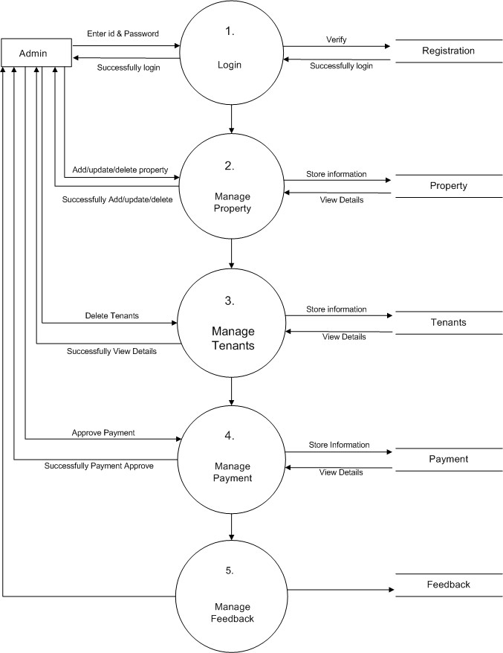

22

* **User:**

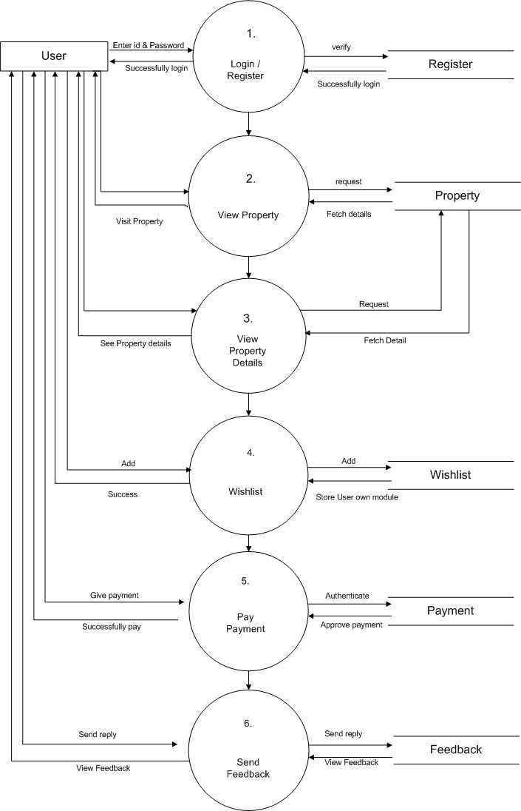

23

ER-Diagram

Username

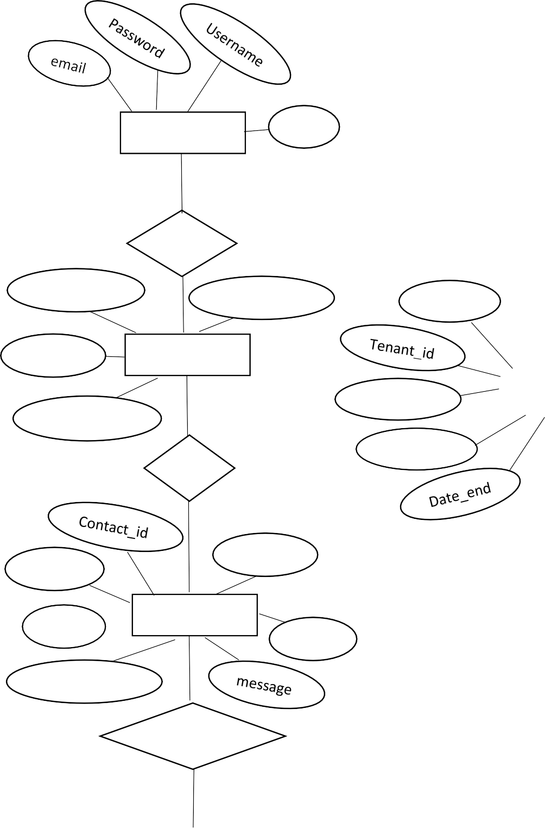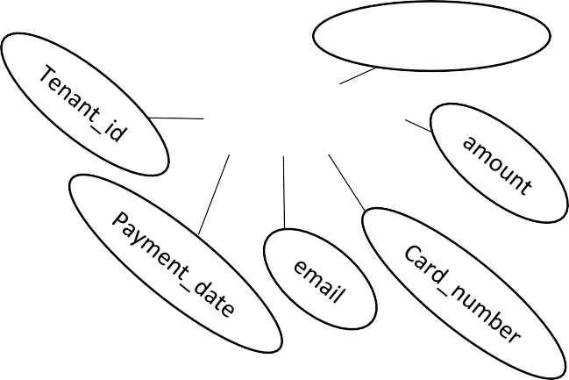

Name

Users id id

Admin

1

1

has

Wishlist_id Date_added

user_id

Manag

M

Property_id

User_id

Property_id

Wishlist

M

Firstname

Lastname

email

Date_from

Tenants

has

subject

email

User_id

Contact us

name

has

M

Payment_id

Payments

Contact_date

Send reply

24

Use case Diagram

Register



Login

Manage Property

Manage User

fManage Payment

Pay Payment

User

Manage Tenants View Property

Admin

View Property Details

View Profile

Feedback

Logout

25

Activity Diagram

### Admin Side:

Login



Check Id &

Password

Manage Payment

Manage Property

Manage Tenants

View User

Logout

26

### User Side:

Login



Check Id &

Password

Register/ Sign Up

View Property

View Property Details

Pay Payment

Logout

27

Sequence Diagram

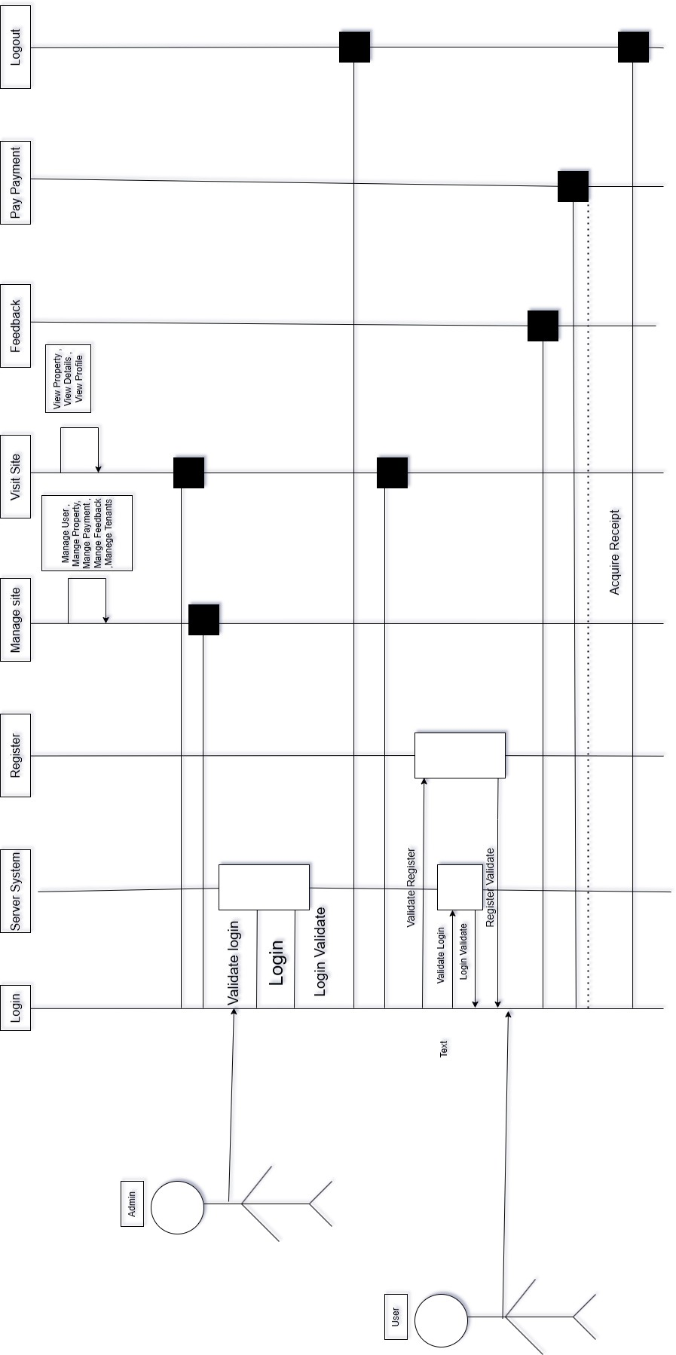

28

Screen Shots:

Front Website

* Home Page :

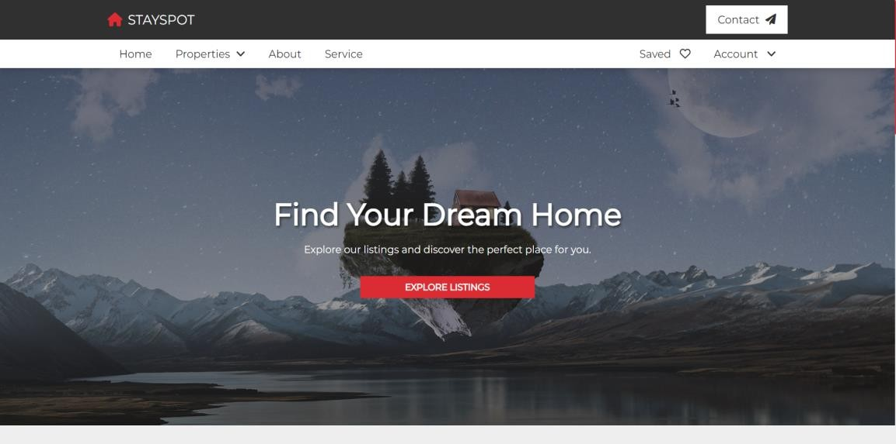

* Home Page :

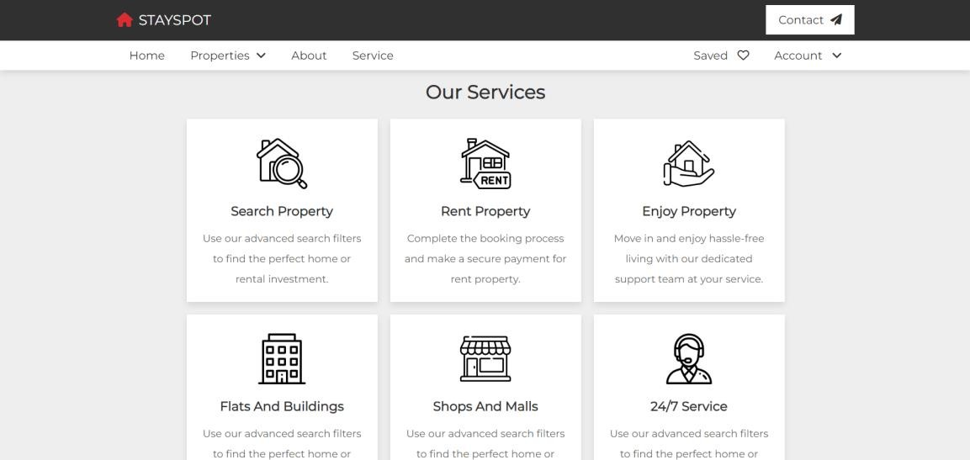

29

* Home Page :

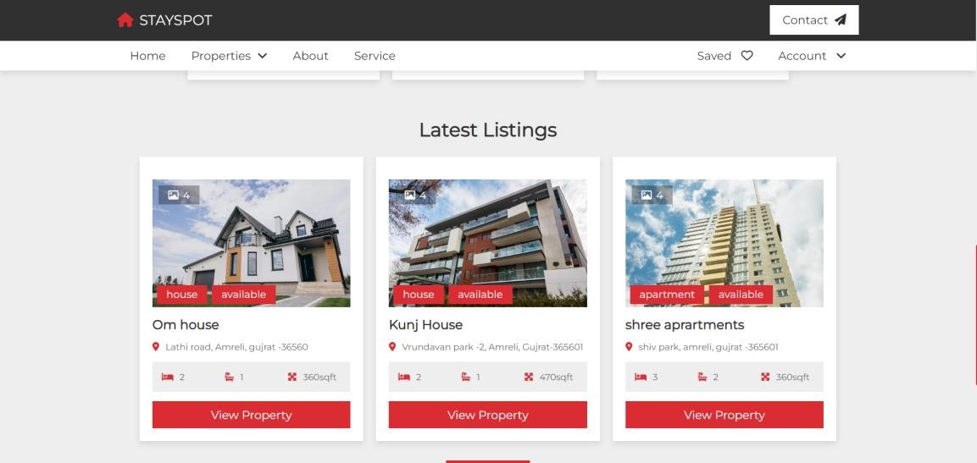

* Login Page :

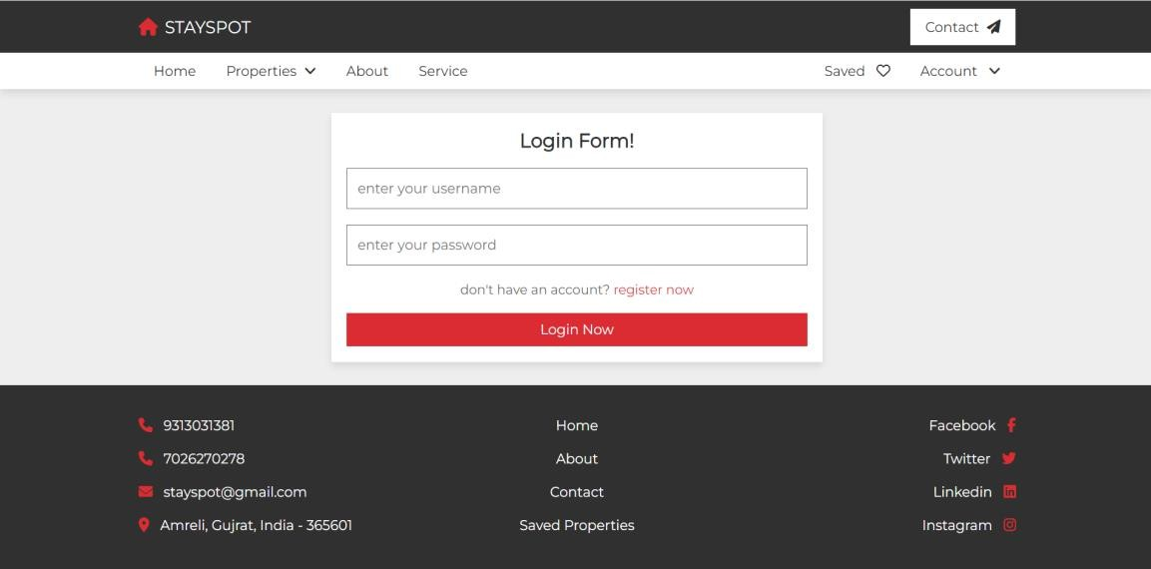

30

* Register Form :

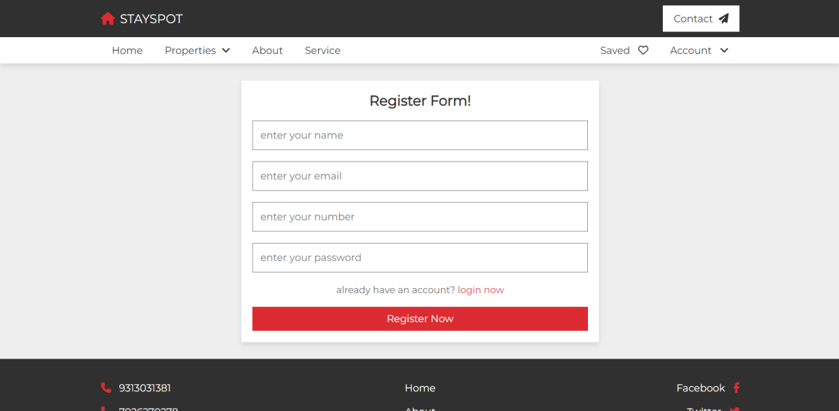

* Availability of House :

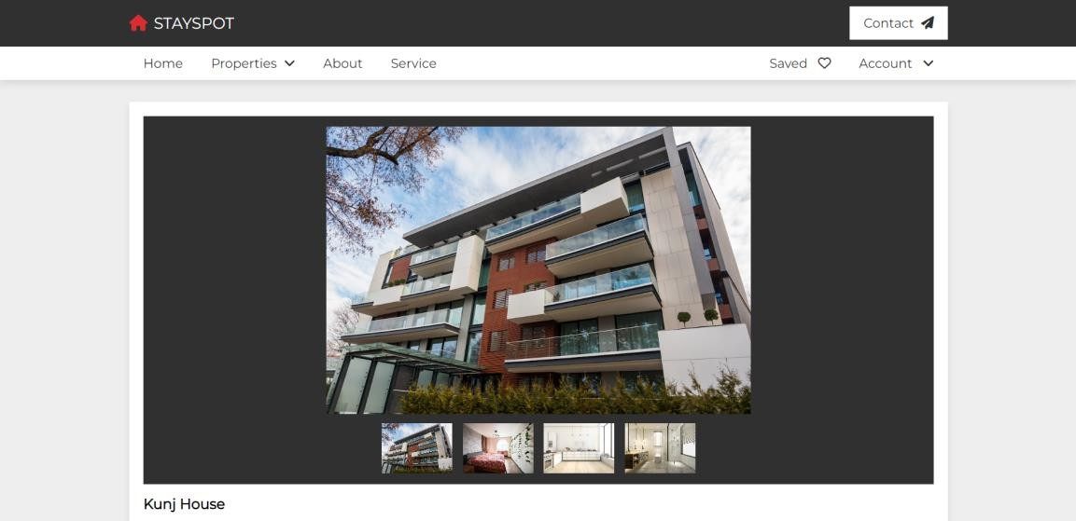

31

* Availability of Flat :

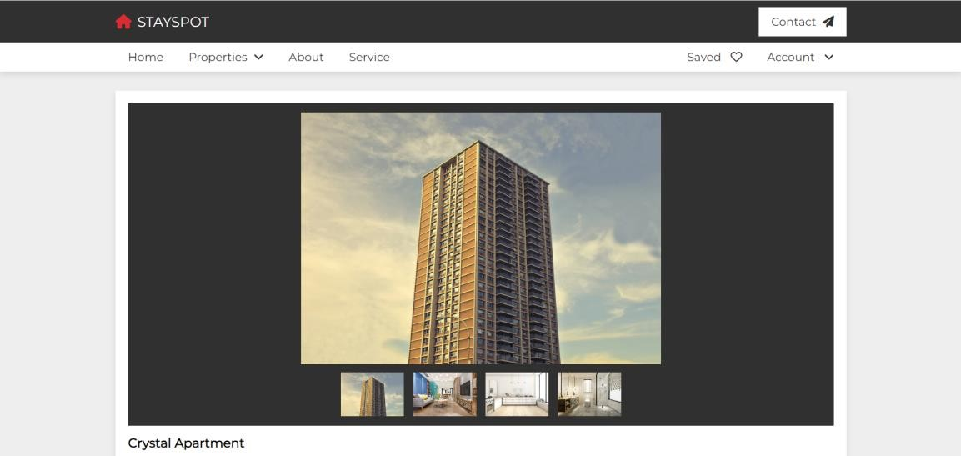

* View Flat :

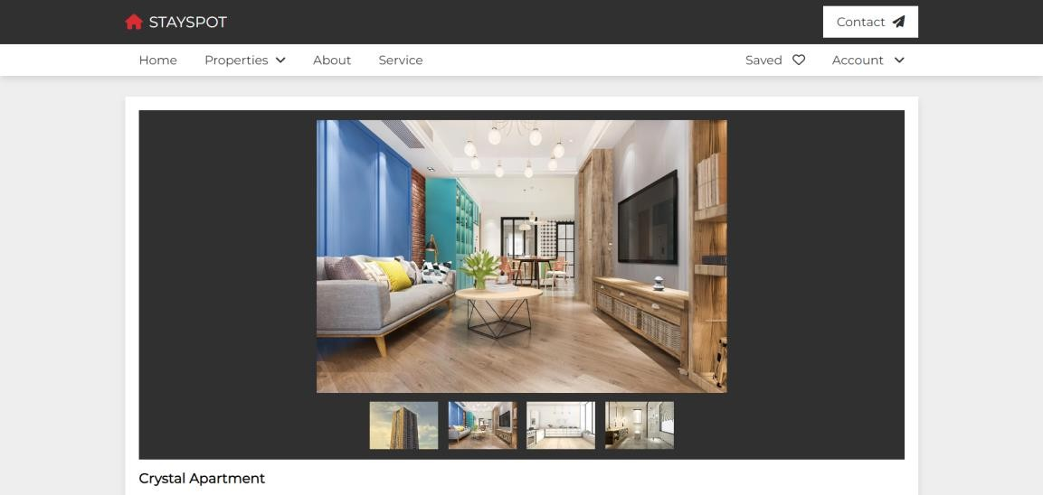

32

* House Details :

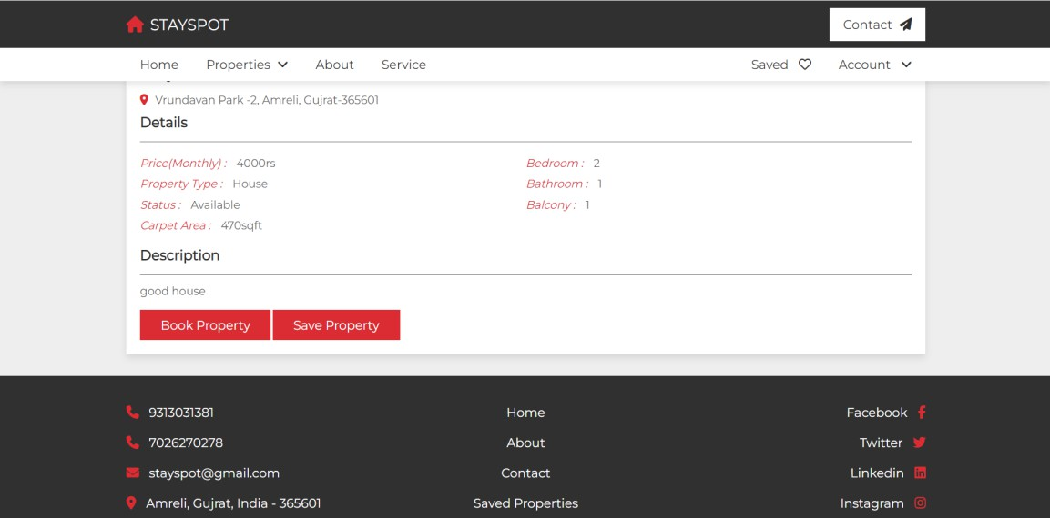

* About :

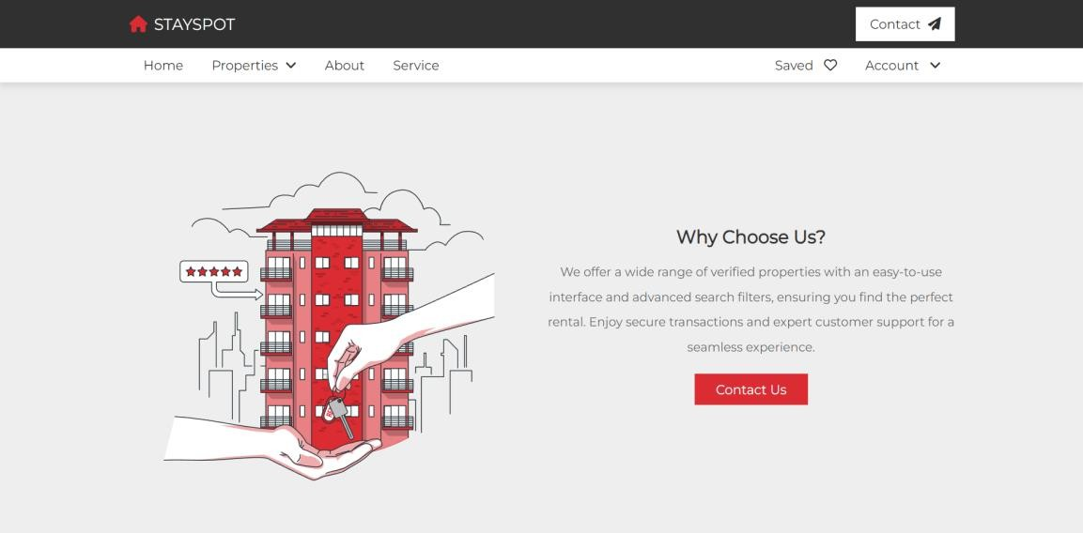

33

* Contact – us :

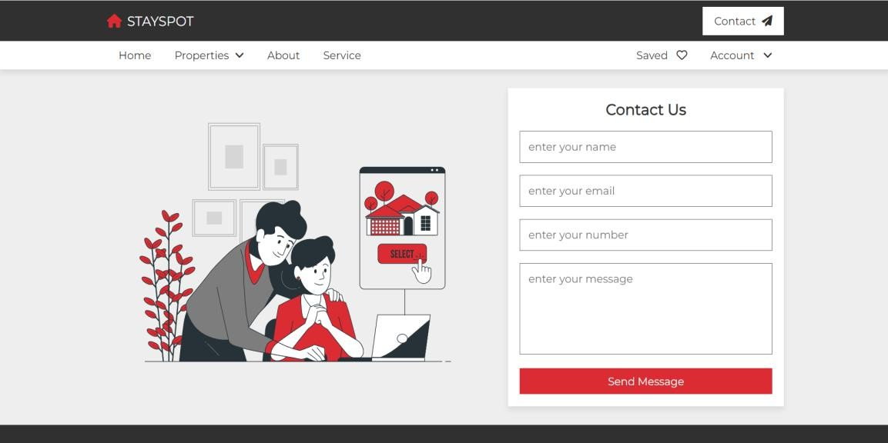

* Saved Page :

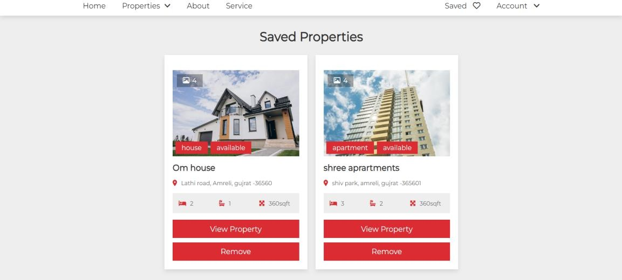

34

* Profile Page :

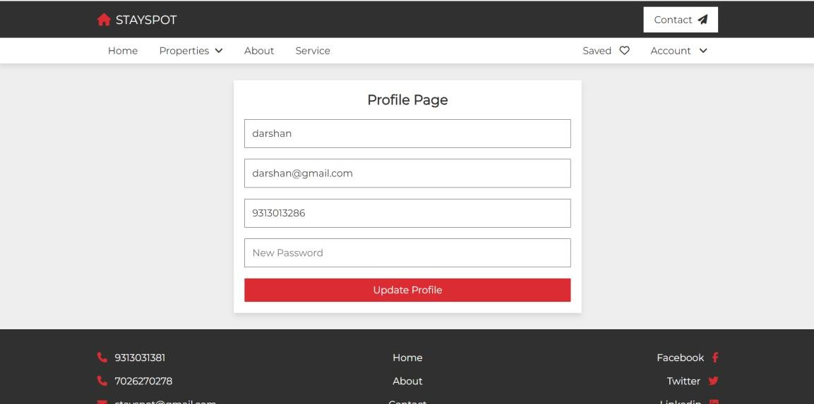

* Confirm Booking Page :

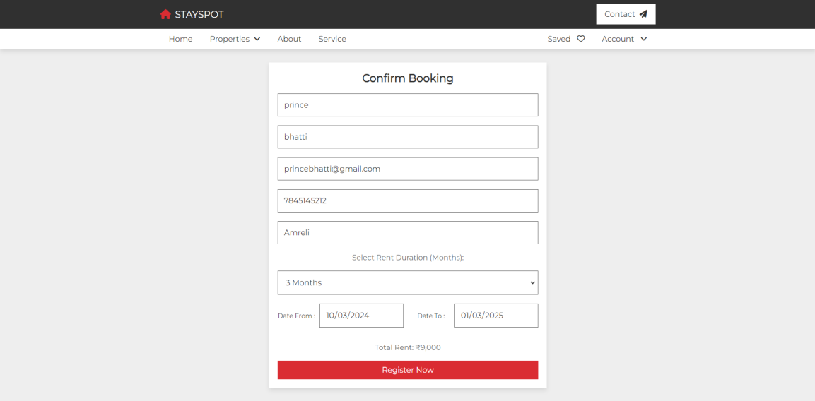

35

* Payment Page :

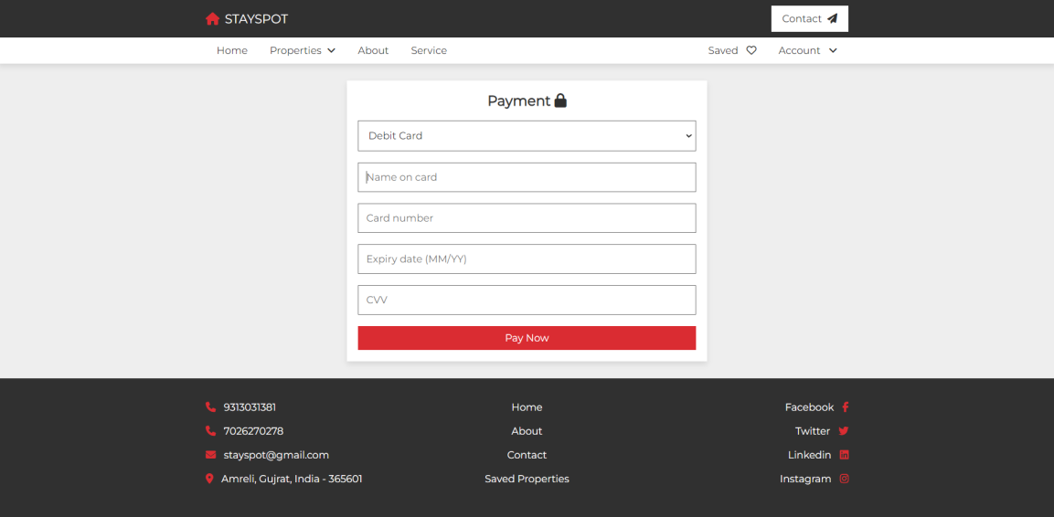

* Success Message :

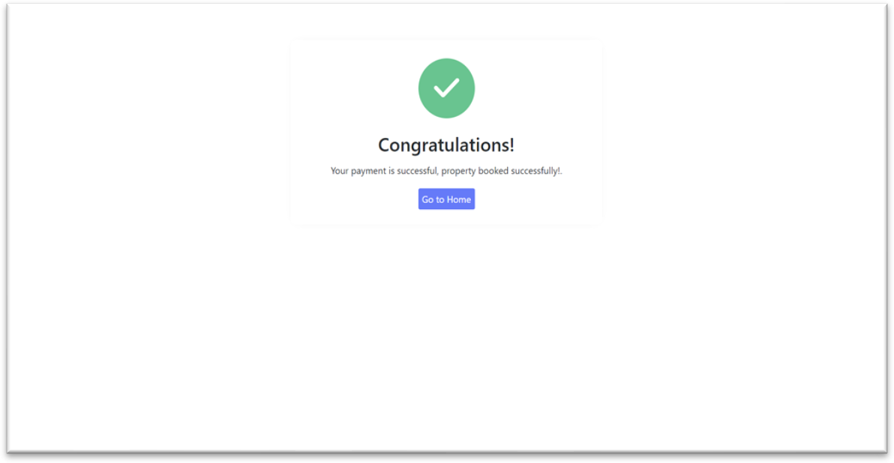

36

* Admin Login Page :

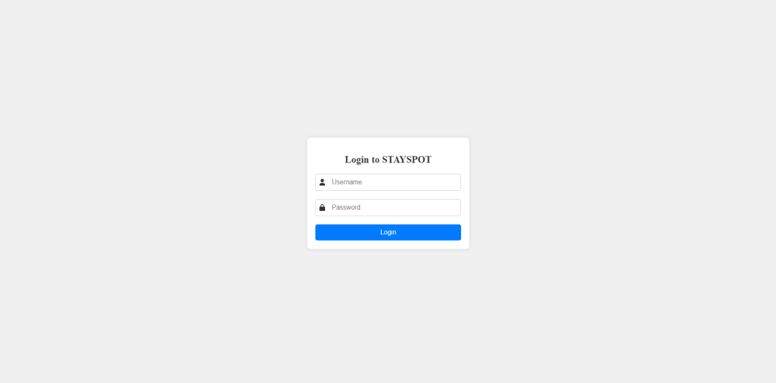

* Dashboard Page :

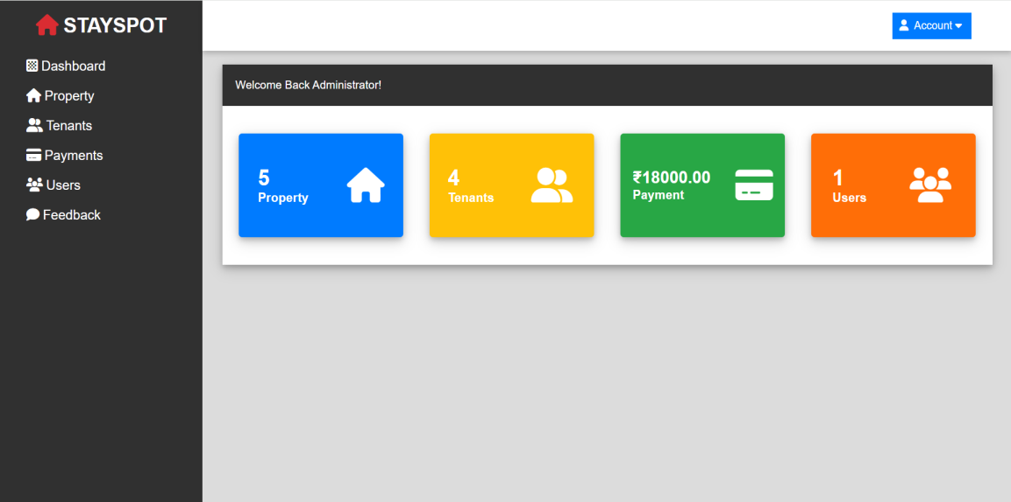

37

* Categories page :

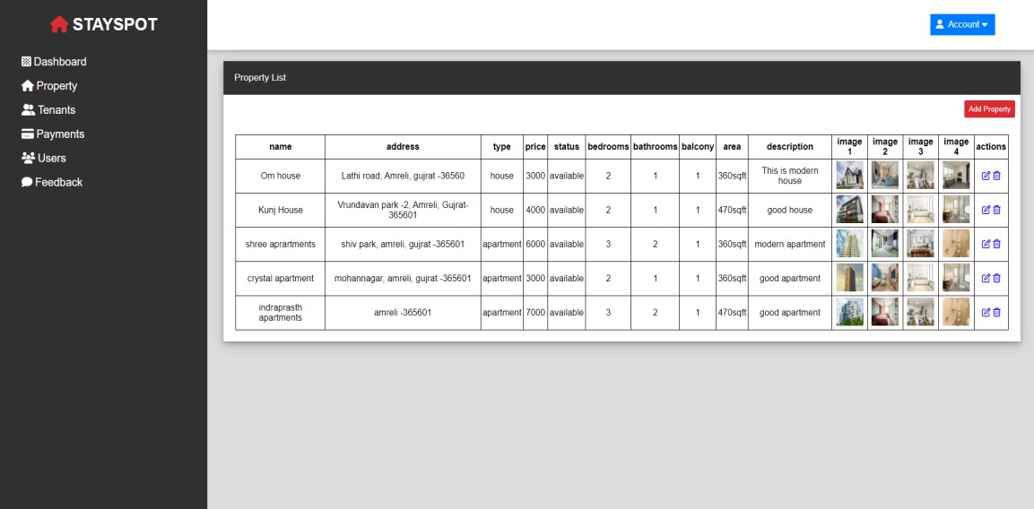

* Add House-Apartment Form :

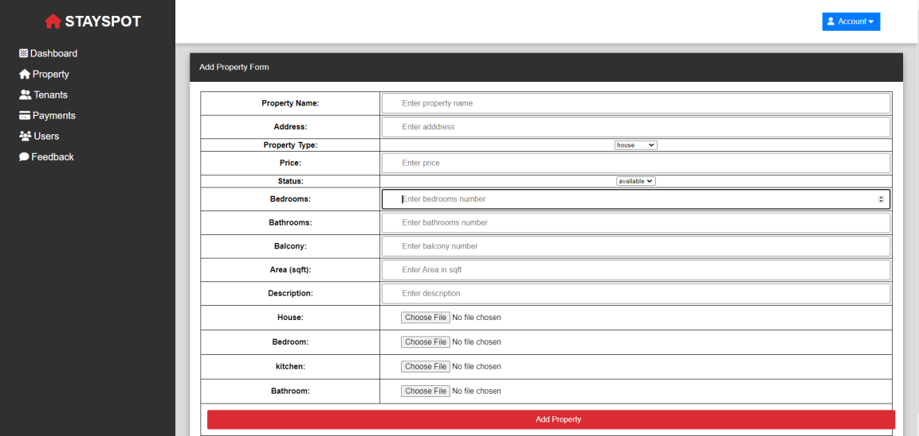

38

* Contact info page :

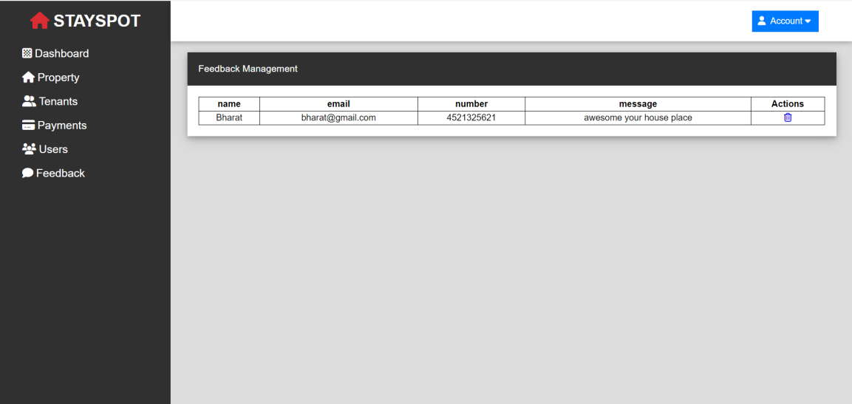

* Payment page :

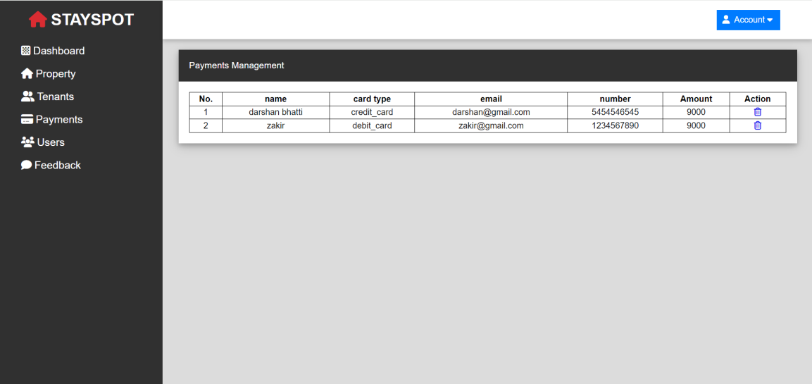

39

* Tenants Page :

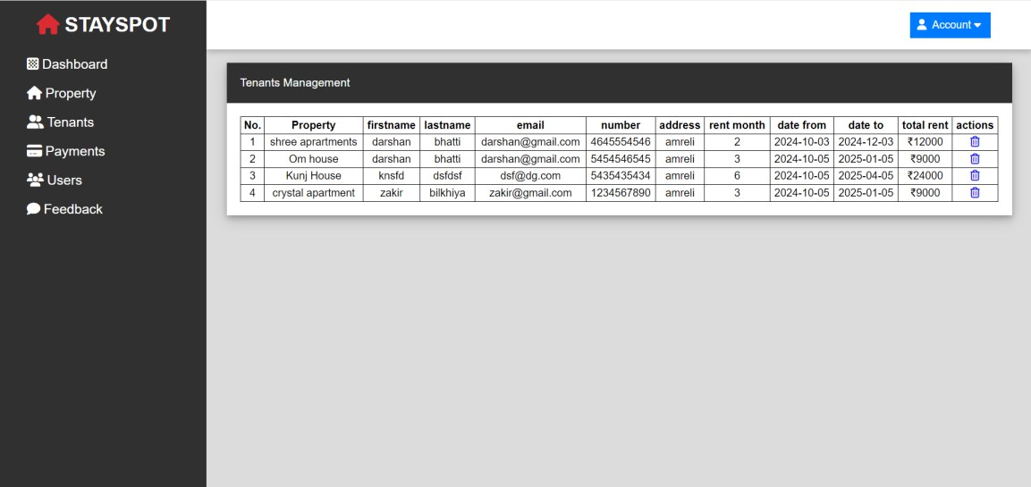

40

Test Case

Test Objective : Login Page

|  |  |  |  |  |  |
| --- | --- | --- | --- | --- | --- |
| Test Case ID | Test Step | Input data | Expected result | Actual result | Exception result |
| To_Login  - 01 | To check username and password click login button. | Enter valid username and password | User should be go home page. | User login successfully. | Successfull |
| To_Login  - 02 | To check username and password  click login button. | Enter invalid username and password | User should not go on home page. | User not login | Unsuccessfull |

41

Future Scope

Every person wants his house should be best in a location with all facilities. Apartment should be a near to market and product unit near to row material and marketplace.

Generate companies concentrate on its product and infrastructure are brought from real estate companies.

Bibliography

1. [www.google.com](http://www.google.com/)
2. You Tube

This documentation is created by

Bhatti Darshan Bhatti Prince Chauhan Jenil

42

## CD/DVD

Below items are included in cd/dvd.

* Project
* Database
* Documentation
* Screenshots

43



44