––

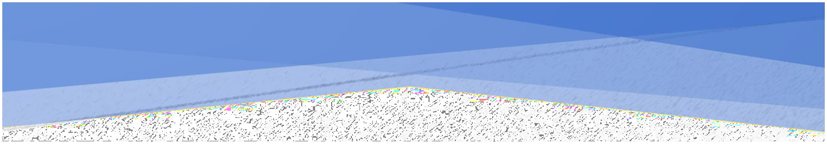APROJECTREPORTON



KamaniScienceCollage&PratapraiArtsCollage



### Bhatti PrinceMaheshbhai (EnrollmentNo. = 3303225422) BhattiDarshanGirishbhai(EnrollmentNo.=3303225421) ChauhanJenilArvindbhai(EnrollmentNo.=3303225427)



P**rof**.D**hruvita**S**avaliya**



2024-25

SaurashtraUniversity–Rajkot

1

2

3

Preface

The main objective of any computer science student is to get practical knowledge as possible. Being able to have a practicalknowledgebydevelopingaprojectisalifetimeexperience. Aspracticalknowledgeisimportantastheoreticalknowledgeweare thankful of having a project.

Through the development of the project we had a great experienceofvariousstrategiesthatcanbeappliedindevelopment of the project. This project is the stepping stone for our career.

Wearepleasedtopresentthisprojectreport.Propercase has been taken while organizing the report so that it is easy to comprehend. Also, various software engineering concepts have been implemented.

4

Acknowledgment

WearestudentofBCAsem-5StudyingintheKamaniScience CollegeAmreli.WeThankstotheentirepersonwhohasgiventheir Support in shaping of the system.

We thank Prof. Dhruvita Savaliyafor giving us guidance and co-operationinunderstandingthesystem.Wealsothanksthemfor their unconditional help in making of this project.

Wehavegreatdealofgratitudetowardsourheadofdepartment whoencouragesintakingupthisactivity.Wethankallfacultiesand administrative staffs of the institute.

I am also thankful to all those friends who have helped me in this endeavor either of indirectly & especially my family.

Thankstoall!!

**Bhatti Prince M. BhattiDarshanG. Chauhan Jenil A.**

5

Abstract

The online Freelance Marketplace is a Web Portal on which freelancers and Employers interactwith eachother inthisplatform, anemployerusuallypostaprojectandmanyfreelancersbidonthat project, the most efficient bid. In this way the employer gets his job done and the freelancers earn money.

This project aims to develop a freelance marketplace where notonlyanemployercouldpostaprojectforbiddingbutfreelancers could also offers his/her services for buyers.

Freelancersandclientbothcanbebenefitedfromthisbidding. Client who wish to hire internationally can take advantage of favorable overseas exchange rates , resulting in work being done for 50-90% less than if the project where done in country and also givenaccesstoahugepoolofpotentialworkandhavetheabilityto work independently from their homes rather than for a company.

6

## SDLC

Softwaredevelopmentlifecycle(SDLC)isastructuredprocessthat is used to design , develop , and test good-quality software .

SDLC , or software development life cycle , is a methodology that definestheentireprocedureofsoftwaredevelopmentstep-by-step.

Thesoftwaredevelopmentlifecycle(SDLC)outlinesseveraltasks required to build a software application.

Requirement Analysis

Maintenance

Defining

Deployment

Designing

Testing

Coding

7

## INTRODUCTIONOFPROJECT

Intherapidlyevolvingrealestateindustry,thedigitaltransformation hasrevolutionizedthewaypropertiesarerentedandmanaged.Our project, the "Online House & Apartment Rental System," aims to bridge the gap between property owners and potential renters by offering an integrated platform for renting various types of properties, including houses and apartments.

In this project people can book their favourite house & apartments after afew steps.Thissystem hastwomodules namely Adminand User. Admin can also add the property details for house & apartment. User needs to register and then login just by using credentials.

DevelopedusingPHPandMySQL,thisprojectnotonlyshowcases advanced web development techniques but also emphasizes user experience, security, and efficiency. The system is designed to be scalable, ensuring it can handle multiple users and properties simultaneously, making it suitable for both small-scale property owners and large rental agencies.

Key features of this systems is User-Friendly Interface, Comprehensive Property Listings, Owner Management Dashboard and Secure Booking System.

8

RequirementGathering

### Q-1:Whattypesofpropertieswillbelisted?

* Ans:Houseandapartments.

### Q-2:Whatinformationshouldbeincludedin eachproperty listing?

* Ans:Location,price,size(sqft),numberof bedrooms,numberof bathrooms, description, availability date and photos.

### Q-3: What amenities should be available for search functionality?

* Ans:Pool,Gym,Parkingspace,Furnished,Balcony,etc.

### Q-4:Whatisthetargetaudiencefortheproject?

* Ans:Students,professionals,families,etc.

### Q-5:Howwillsearchfunctionalitywork?

* Ans:Location,pricerange,propertytype.

### Q-6:Whatisthemonthlyrentfordifferenttypesofproperties?

* Ans:Monthlyrentstartsfrom4000rsandhigherrentasproperties.

### Q-7Whatinformationwillberequiredforpropertylistings?

-Ans:Photos,description,pricing,amenities.

9

### Q-8:Whatarethekeyfeaturesyouwantto include?

-Ans:Propertylistings,Searchfunctionality,bookingandpayment processing , user-profiles.

### Q-9:Whatinformationwillberequiredforpropertylistings?

-Ans:photos,description,pricing,amenities.

### Q-10:Shouldusersbeabletoschedulepropertyviewings online?

-Ans:Yes,throughacalendarbookingsystem

### Q-11:Howwillsearchfunctionalitywork?

-Ans:Location,pricerange,propertytype.

### Q-12:Whatarethekeyfeaturesyouwanttoinclude?

-Ans: Property listing , search functionality , booking and payment processing , user-profiles.

10

## PROJECTPROFILE

* **Project Name :** OnlineHouse&ApartmentRental System
* **DevelopedBy :** BhattiPrince,

BhattiDarshan, Chauhan Jenil .

* **Front-endTool :**PHP,HTML,CSS
* **Back-endTool :** MySQL
* **OperatingSystem :**MicrosoftWindows10
* **ComputingSystem :**i5,RAM-4GB
* **ProjectDetails :**Inthisrentalsystem,peoplecan

Choose their favorite House and people can book it after seeing all thefacilitiesoftheirfavoritehouse.

* **CompletionTime :**3 Months
* **Guided by :**Prof.DhruvitaSavaliya

11

## HARDWAREREQUIREMENT

* 4GBOfRAM
* MultimediakeaboardAndMouse
* 1.0+GHzProcessor
* Monitor
* Printer

## SOFTWAREREQUIREMENT

* **Operatingsystem** : Microsoftwindows10&window11
* **FrontEndTools** : PHP,JavaScript,CSS,HTML
* **BackEndTools** : PHPMySQL
* **DocumentationTool** : Microsoftword
* **BrowserSpecification**: GoogleChrome

12

TimeLineChart

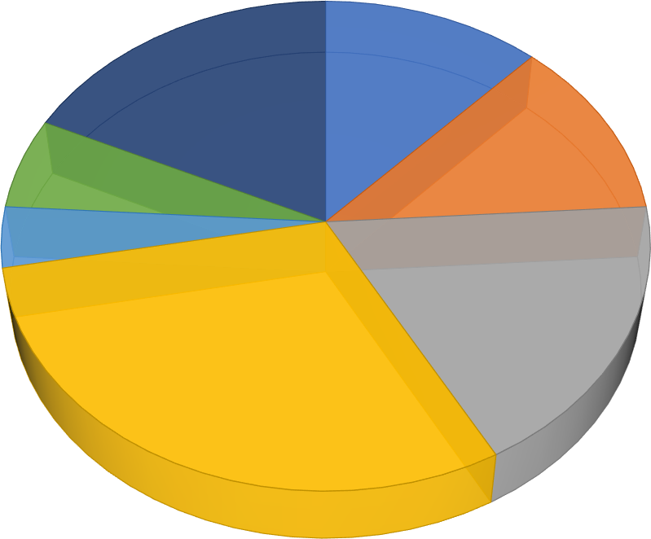

Coding,30%

SystemDesign,18%

Testing,4%

Implementation,6%

SystemAnalysis, 12%

Maintenance,18%

Preliminary Investigation,12%

PreliminaryInvestigation  10Days

SystemAnalysis  10Days

SystemDesign  15Days

Coding  28Days

Testing  05Days

Implementation  07Days

Maintenance  15Days

13

ProjectPageStructure

# AdminSide:

House&Apartment



Management

System

AdminSide

Login

Manage Property

Manage Payment

Logout

Manage User

Manage Feedback

Manage Tenants

14

# UserSide:

House&Apartment



Management System

ClientSide

Login

View Property Details

Pay Payments

Logout

View property

Send Feedback

View Profile

DataDictionary

ThedataDictionaryisasetoftable.MySQLusesittomaintain information about this own database.

* **DatabaseName**: jenish_sheladiya

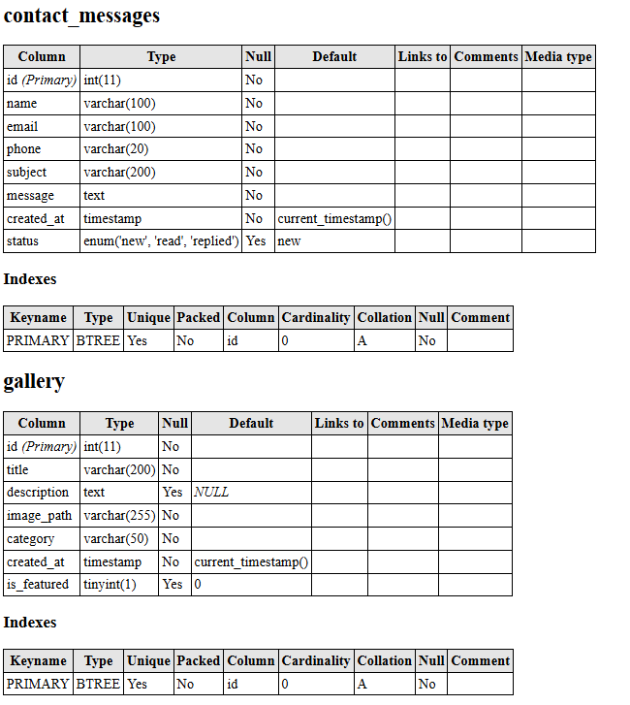

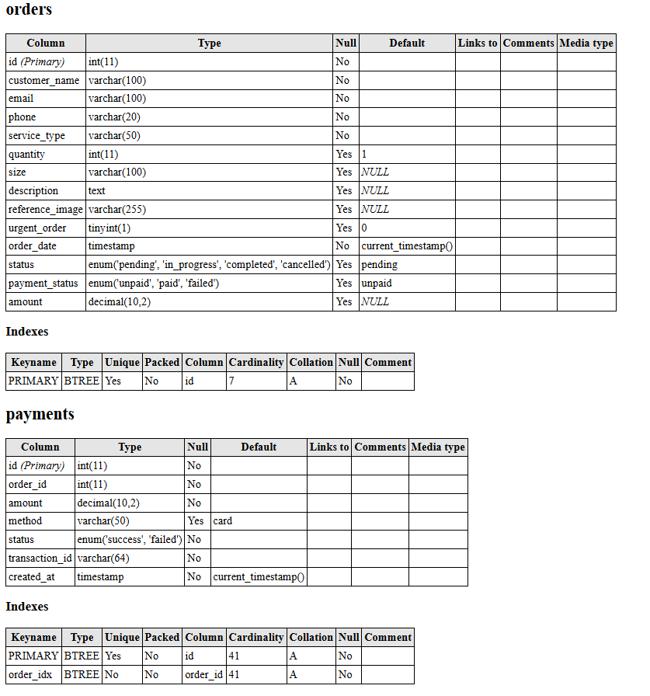

19

DataFlowDiagram

The DFD gives brief idea on how the designed system is working. It also suggests to us the type of users who using this system and the process involved in the system.

RepresentDataFlow

RepresentaEntity

RepresentaDataTable

Representa Processing

20

0levelDiagram

Registerform

Verify



Storeregister

Admin

**0.0**

Online House & Apartment RentalSystem

User

Loginsuccessfully

21

1stlevelDiagram

# Admin:

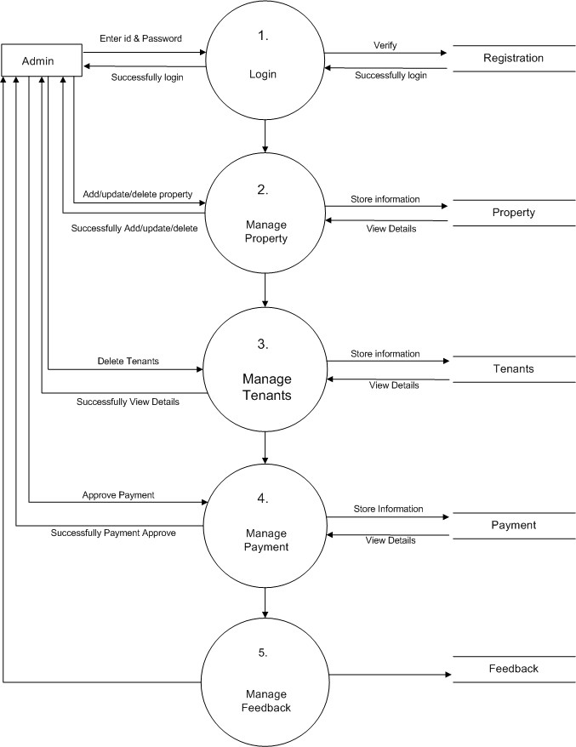

22

* **User:**

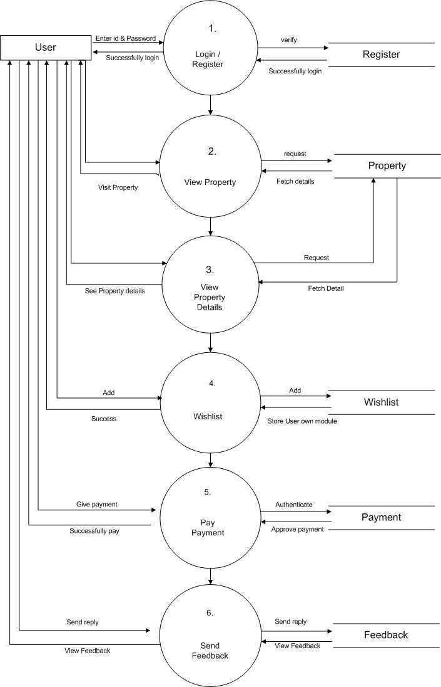

23

ER-Diagram

Username

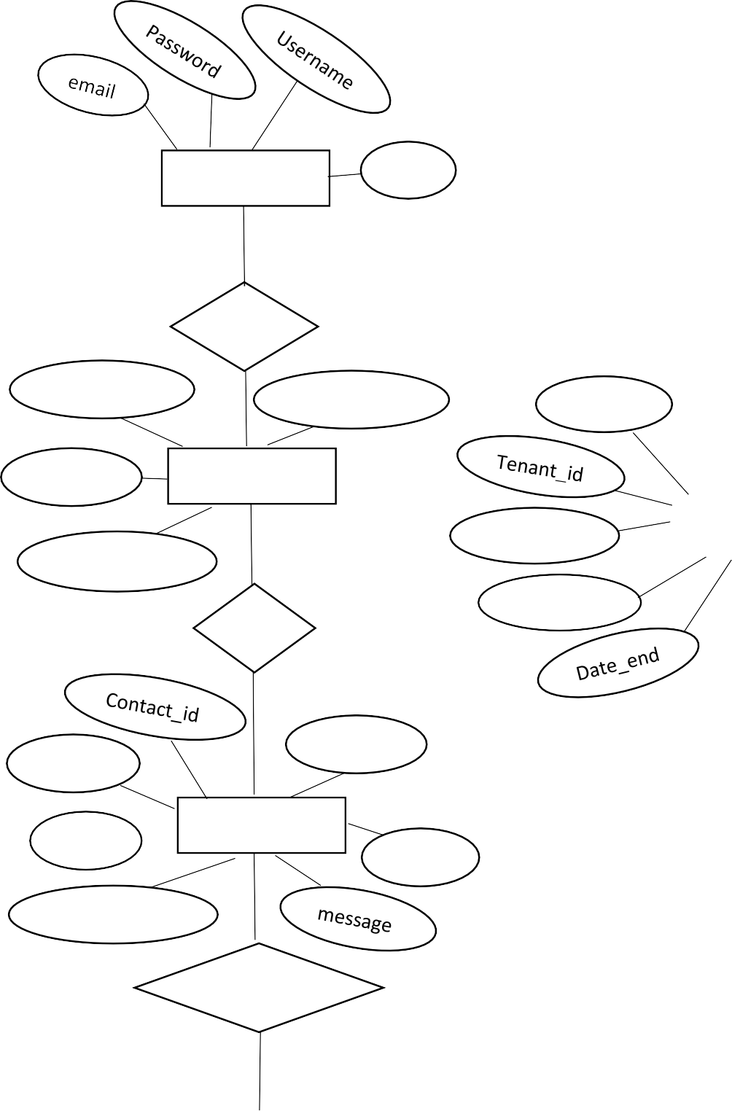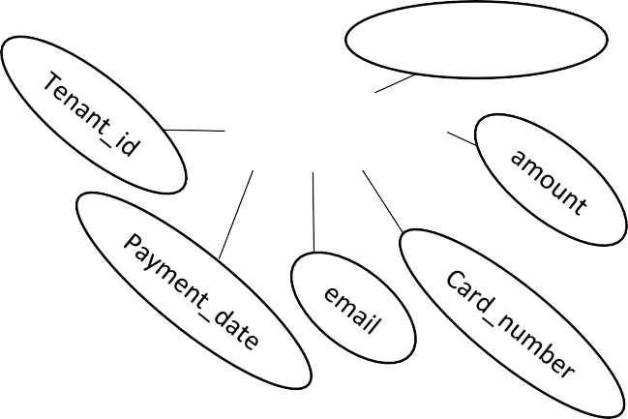

Name

Users id id

Admin

1

1

has

Wishlist_id Date_added

user_id

Manag

M

Property_id

User_id

Property_id

Wishlist

M

Firstname

Lastname

email

Date_from

Tenants

has

subject

email

User_id

Contactus

name

has

M

Payment_id

Payments

Contact_date

Sendreply

24

UsecaseDiagram

Register



Login

ManageProperty

ManageUser

fManagePayment

PayPayment

User

ManageTenants View Property

Admin

ViewPropertyDetails

ViewProfile

Feedback

Logout

25

ActivityDiagram

### AdminSide:

Login



CheckId&

Password

Manage Payment

Manage Property

Manage Tenants

View User

Logout

26

### UserSide:

Login



CheckId&

Password

Register/ Sign Up

View Property

View Property Details

Pay Payment

Logout

27

SequenceDiagram

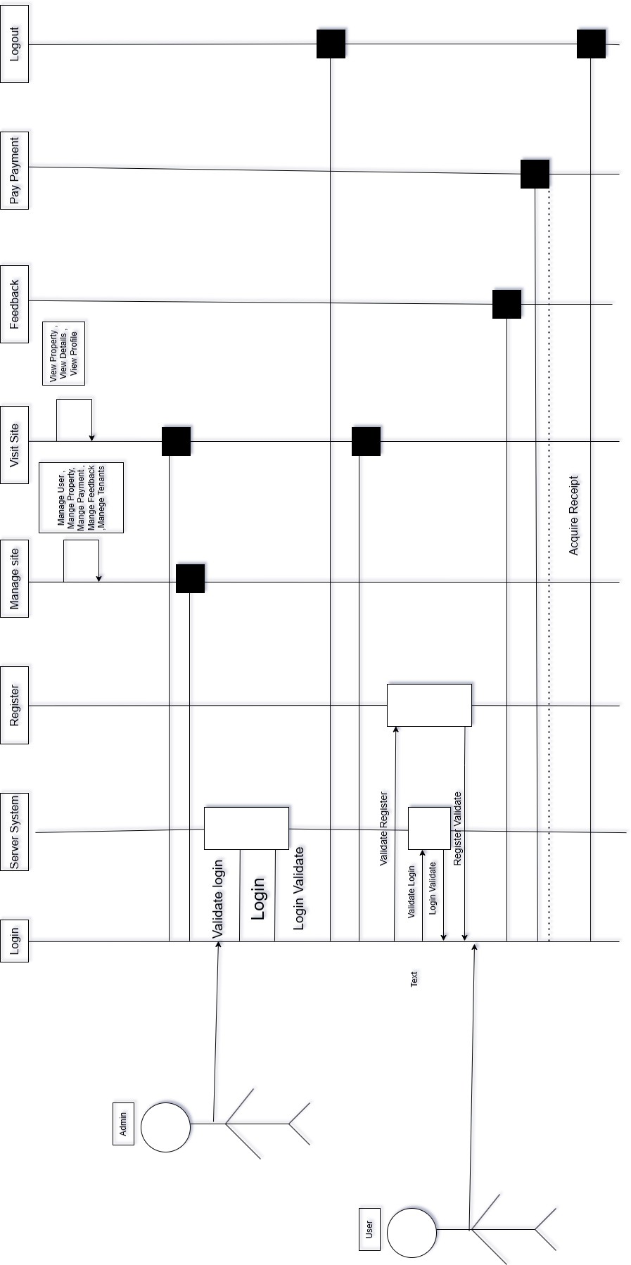

28

ScreenShots:

Front Website

* HomePage :

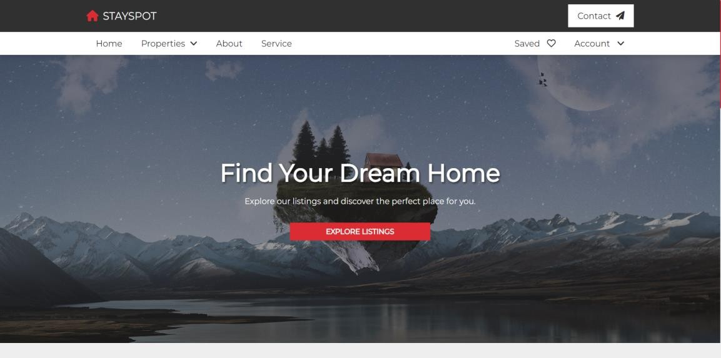

* HomePage :

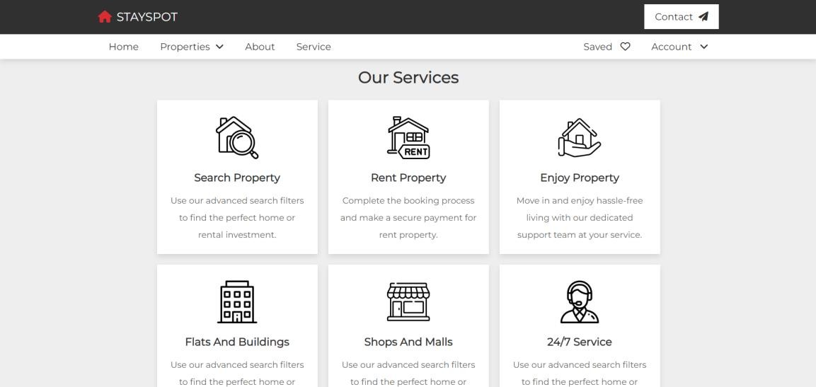

29

* HomePage :

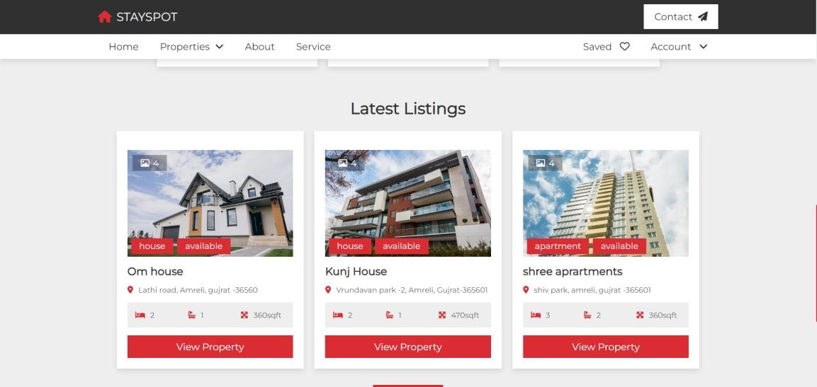

* LoginPage:

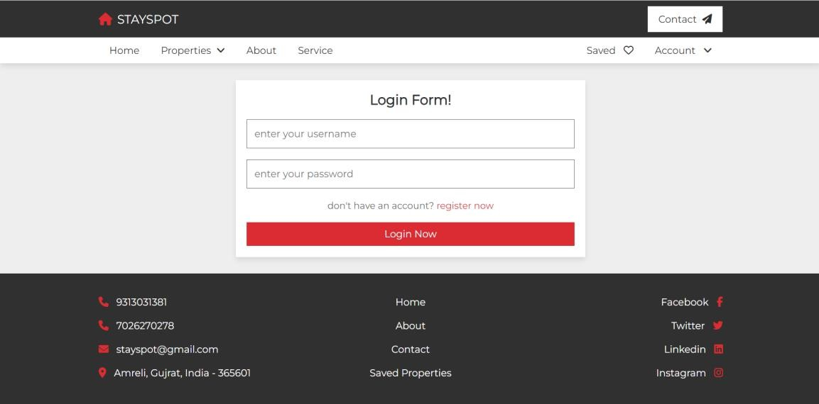

30

* RegisterForm:

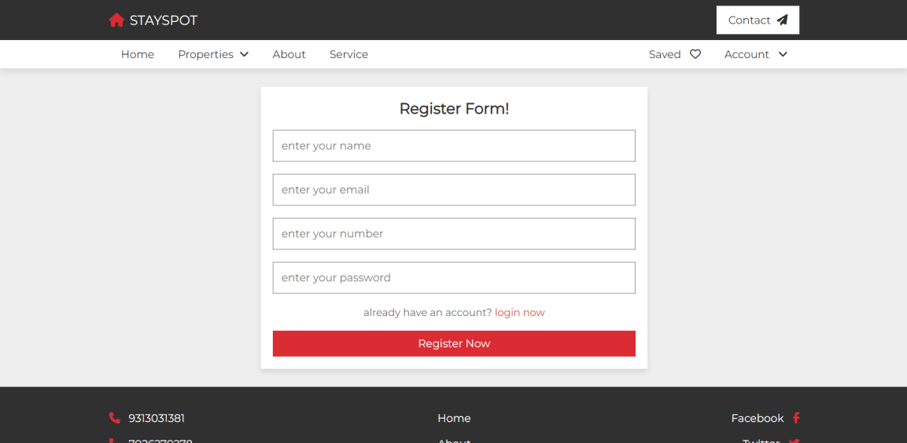

* AvailabilityofHouse:

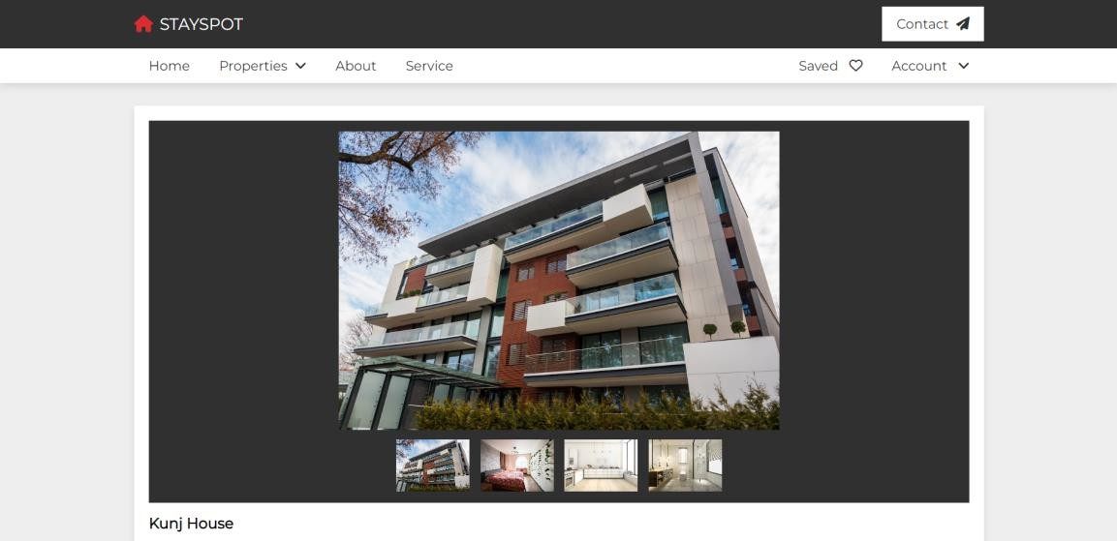

31

* AvailabilityofFlat:

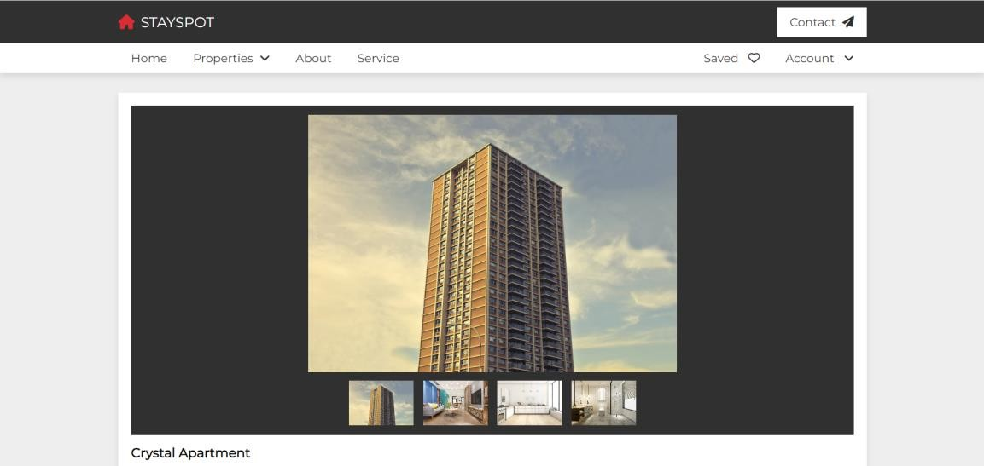

* ViewFlat:

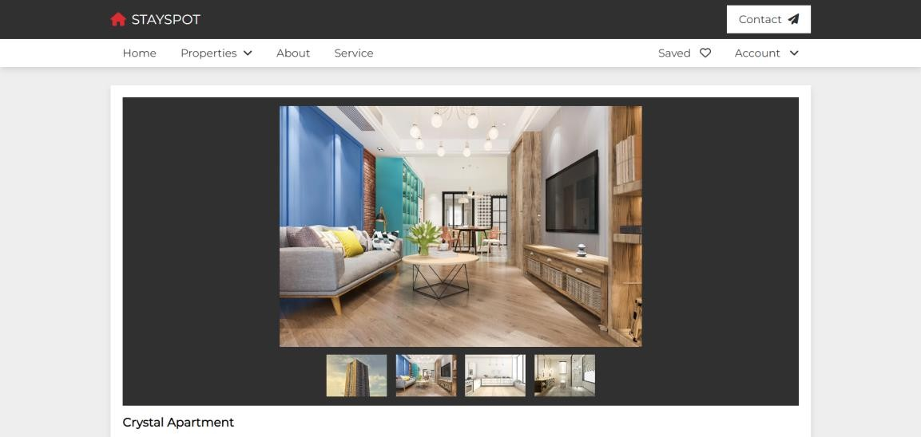

32

* HouseDetails:

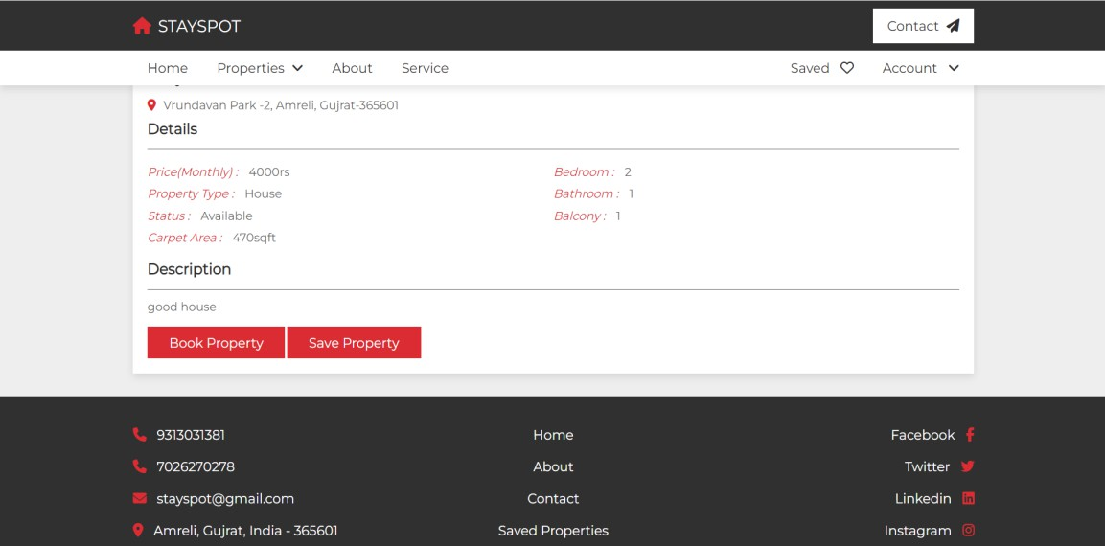

* About:

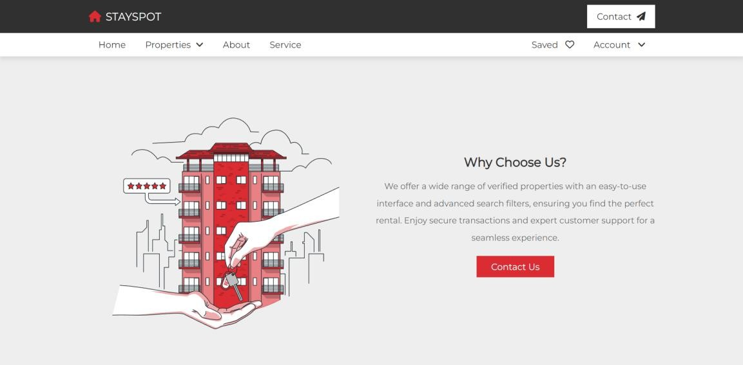

33

* Contact–us:

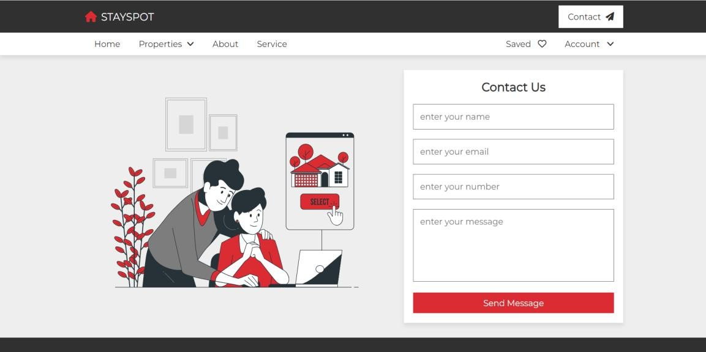

* SavedPage:

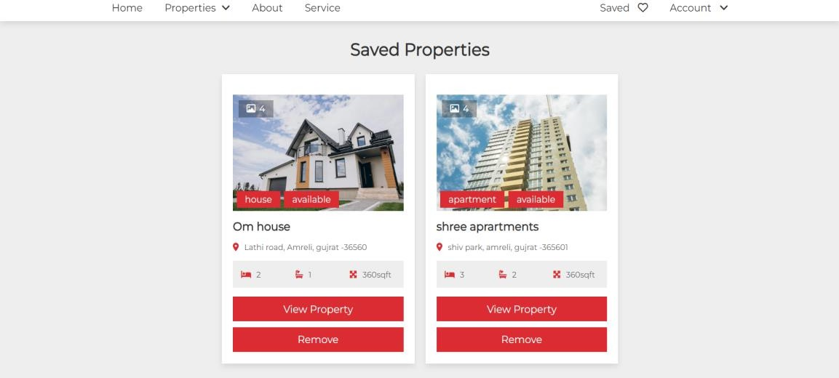

34

* ProfilePage:

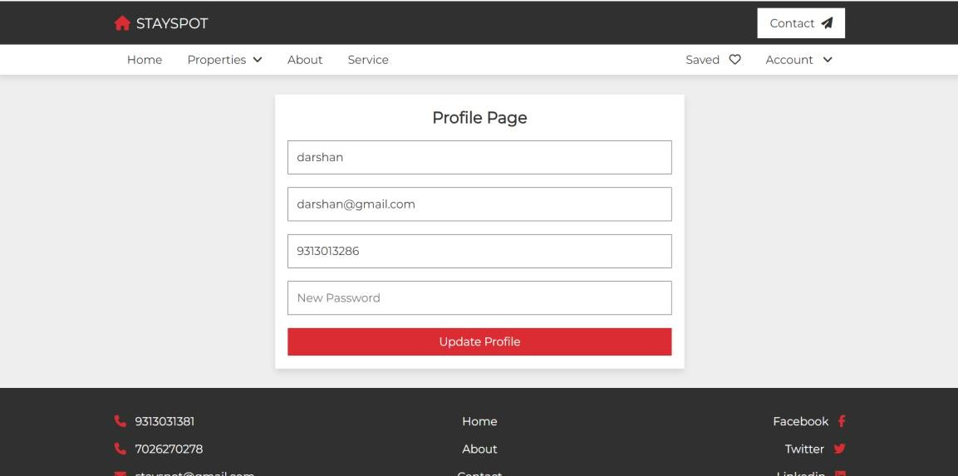

* ConfirmBookingPage:

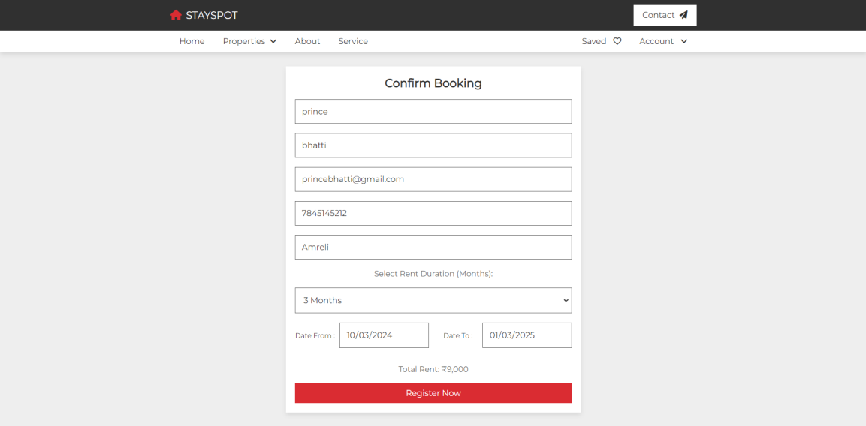

35

* PaymentPage:

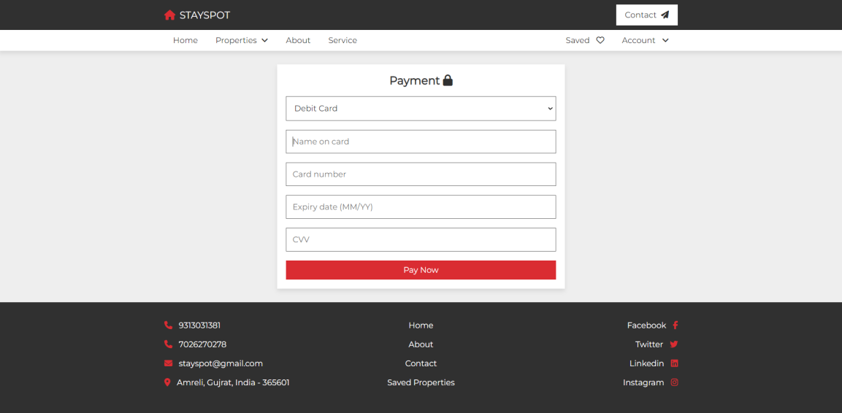

* SuccessMessage:

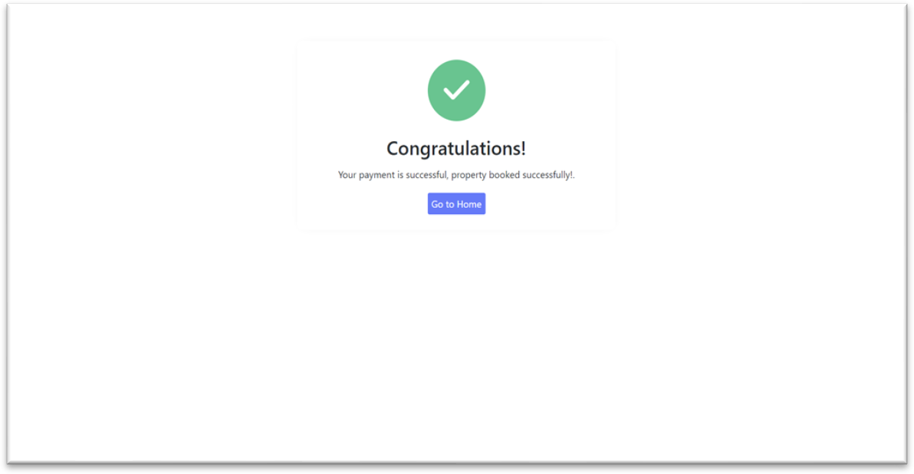

36

* AdminLoginPage:

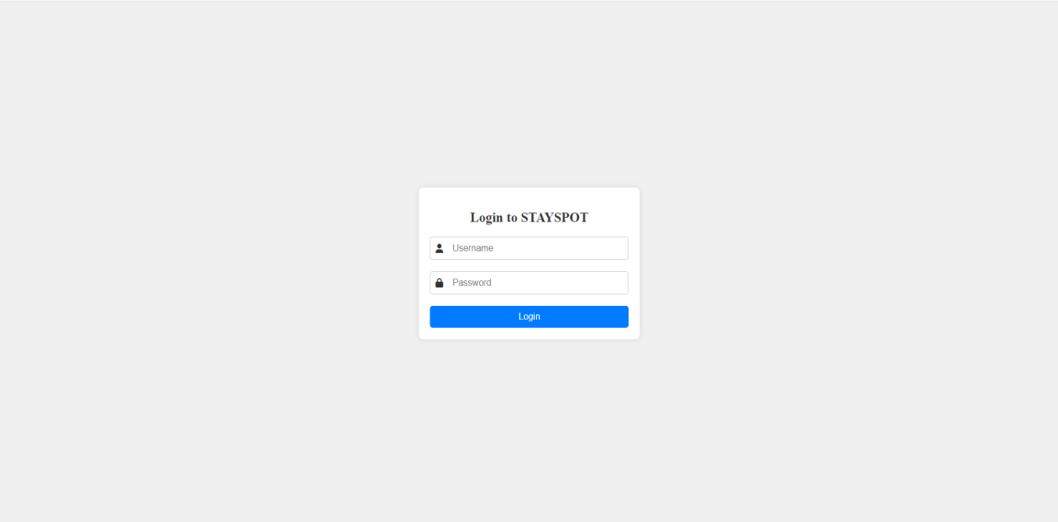

* DashboardPage:

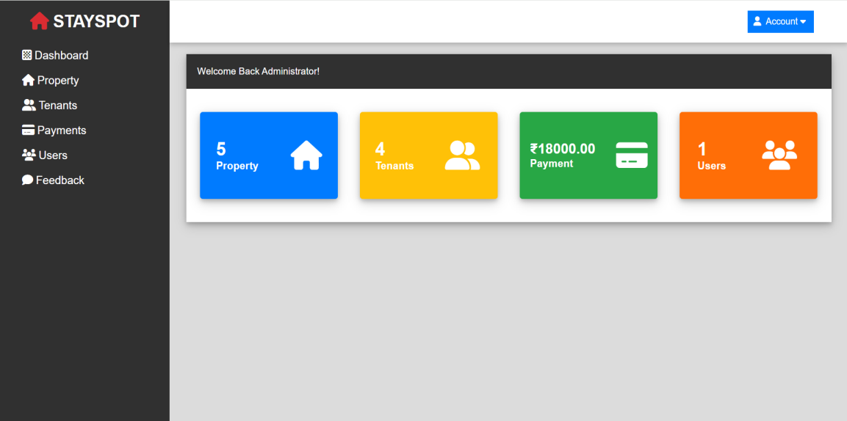

37

* Categoriespage:

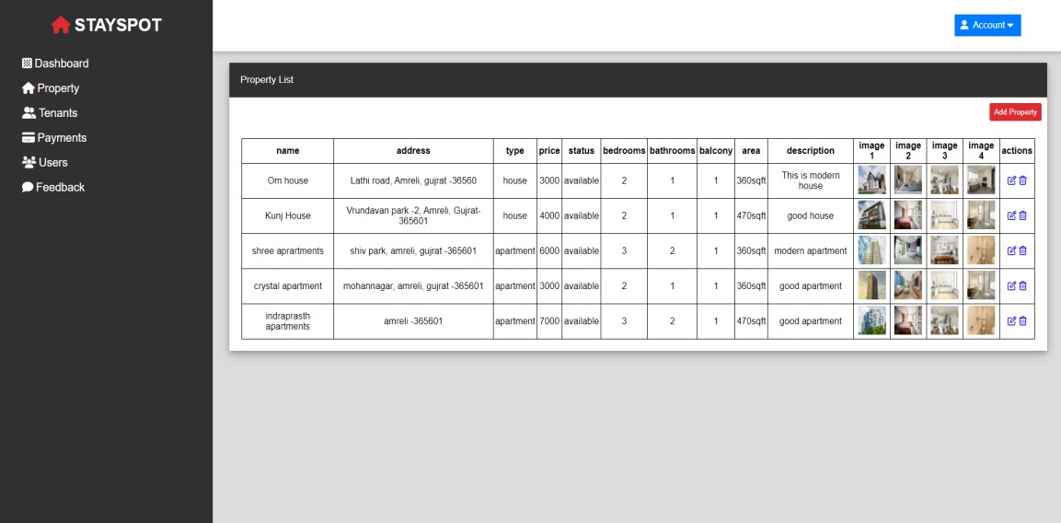

* AddHouse-ApartmentForm:

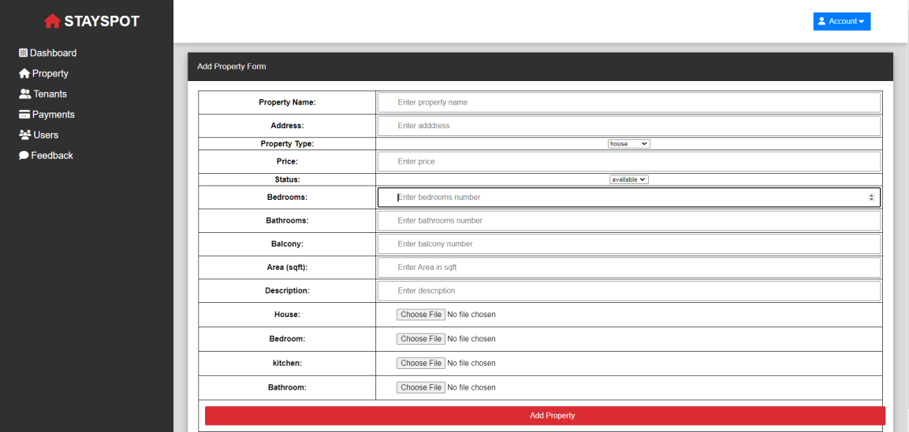

38

* Contactinfopage:

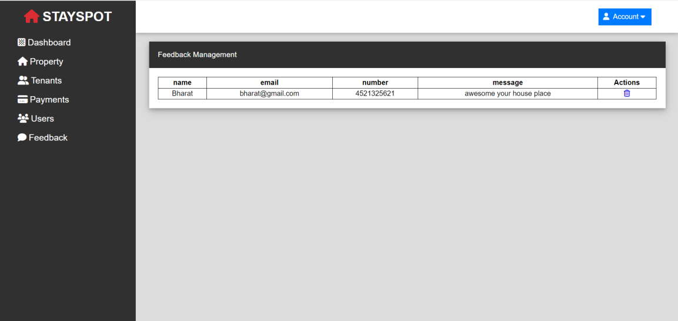

* Paymentpage :

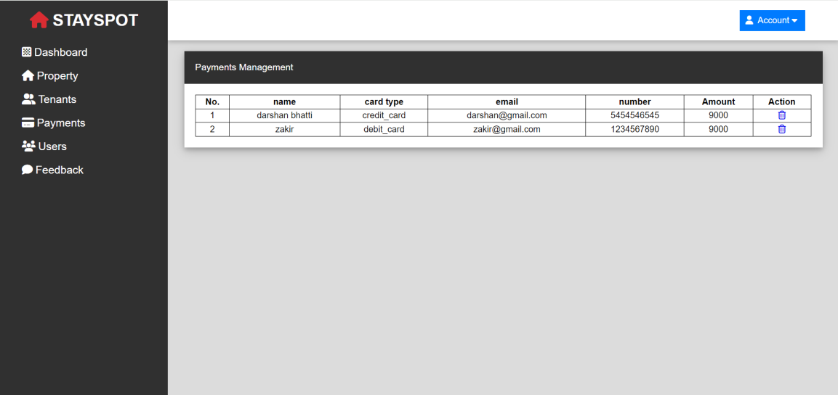

39

* TenantsPage :

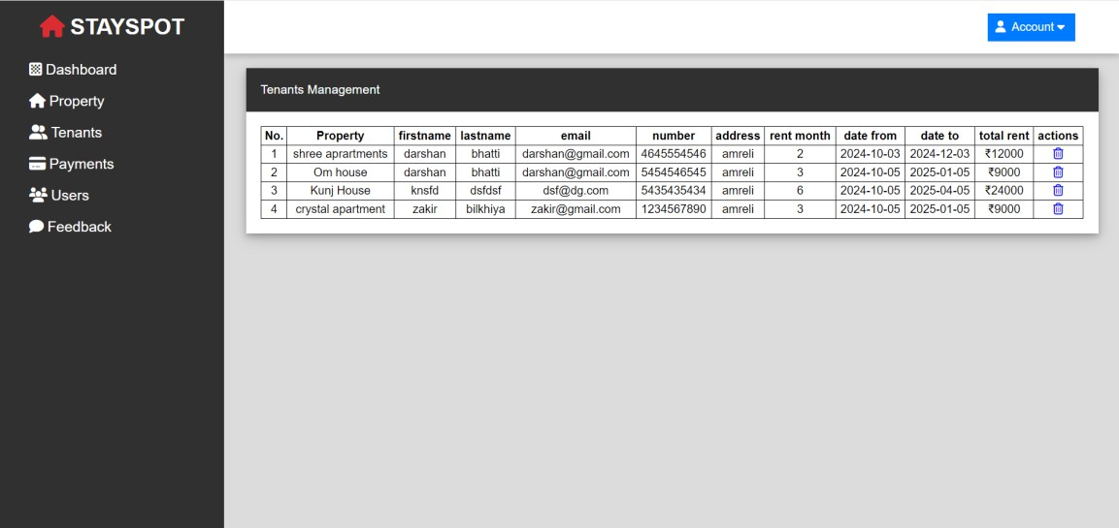

40

TestCase

TestObjective:LoginPage

|  |  |  |  |  |  |
| --- | --- | --- | --- | --- | --- |
| Test Case ID | Test Step | Input data | Expected result | Actual result | Exception result |
| To_Login  -01 | To check username and password clicklogin button. | Enter valid username and password | Usershould begohome page. | User login successfully. | Successfull |
| To_Login  -02 | To check username and password  clicklogin button. | Enter invalid username and password | Usershould notgo on homepage. | Usernot login | Unsuccessfull |

41

FutureScope

Every person wants his house should be best in a location with all facilities. Apartment should be a near to market and product unit near to row material and marketplace.

Generate companies concentrate on its product and infrastructure are brought from real estate companies.

Bibliography

1. [www.google.com](http://www.google.com/)
2. YouTube

Thisdocumentationiscreatedby

BhattiDarshan Bhatti Prince Chauhan Jenil

42

## CD/DVD

Belowitemsareincludedincd/dvd.

* Project
* Database
* Documentation
* Screenshots

43



44