bgvfbtg

bhnv

Preface

The main objective of any computer science student is to get practical knowledge as possible. Being able to have a practicalknowledgebydevelopingaprojectisalifetimeexperience. Aspracticalknowledgeisimportantastheoreticalknowledgeweare thankful of having a project.

Through the development of the project we had a great experienceofvariousstrategiesthatcanbeappliedindevelopment of the project. This project is the stepping stone for our career.

Wearepleasedtopresentthisprojectreport.Propercase has been taken while organizing the report so that it is easy to comprehend. Also, various software engineering concepts have been implemented.

Acknowledgment

WearestudentofBCAsem-5StudyingintheKamaniScience CollegeAmreli.WeThankstotheentirepersonwhohasgiventheir Support in shaping of the system.

We thank Prof. Dhruvita Savaliyafor giving us guidance and co-operationinunderstandingthesystem.Wealsothanksthemfor their unconditional help in making of this project.

Wehavegreatdealofgratitudetowardsourheadofdepartment whoencouragesintakingupthisactivity.Wethankallfacultiesand administrative staffs of the institute.

I am also thankful to all those friends who have helped me in this endeavor either of indirectly & especially my family.

Thankstoall!!

Preface

The main objective of any computer science student is to get practical knowledge as possible. Being able to have a practicalknowledgebydevelopingaprojectisalifetimeexperience. Aspracticalknowledgeisimportantastheoreticalknowledgeweare thankful of having a project.

Through the development of the project we had a great experienceofvariousstrategiesthatcanbeappliedindevelopment of the project. This project is the stepping stone for our career.

Wearepleasedtopresentthisprojectreport.Propercase has been taken while organizing the report so that it is easy to comprehend. Also, various software engineering concepts have been implemented.

Acknowledgment

WearestudentofBCAsem-5StudyingintheKamaniScience CollegeAmreli.WeThankstotheentirepersonwhohasgiventheir Support in shaping of the system.

We thank Prof. Dhruvita Savaliyafor giving us guidance and co-operationinunderstandingthesystem.Wealsothanksthemfor their unconditional help in making of this project.

Wehavegreatdealofgratitudetowardsourheadofdepartment whoencouragesintakingupthisactivity.Wethankallfacultiesand administrative staffs of the institute.

I am also thankful to all those friends who have helped me in this endeavor either of indirectly & especially my family.

Abstract

The online Freelance Marketplace is a Web Portal on which freelancers and Employers interactwith eachother inthisplatform, anemployerusuallypostaprojectandmanyfreelancersbidonthat project, the most efficient bid. In this way the employer gets his job done and the freelancers earn money.

This project aims to develop a freelance marketplace where notonlyanemployercouldpostaprojectforbiddingbutfreelancers could also offers his/her services for buyers.

Freelancersandclientbothcanbebenefitedfromthisbidding. Client who wish to hire internationally can take advantage of favorable overseas exchange rates , resulting in work being done for 50-90% less than if the project where done in country and also givenaccesstoahugepoolofpotentialworkandhavetheabilityto work independently from their homes rather than for a company.

## SDLC

Softwaredevelopmentlifecycle(SDLC)isastructuredprocessthat is used to design , develop , and test good-quality software .

SDLC , or software development life cycle , is a methodology that definestheentireprocedureofsoftwaredevelopmentstep-by-step.

Thesoftwaredevelopmentlifecycle(SDLC)outlinesseveraltasks required to build a software application.

Requirement Analysis

Maintenance

Defining

Deployment

Designing

Testing

Coding

Data Dictionary

The data Dictionary is a set of table .MySQL uses it to maintain information about this own database.

* **DatabaseName** : jenish_sheladiya

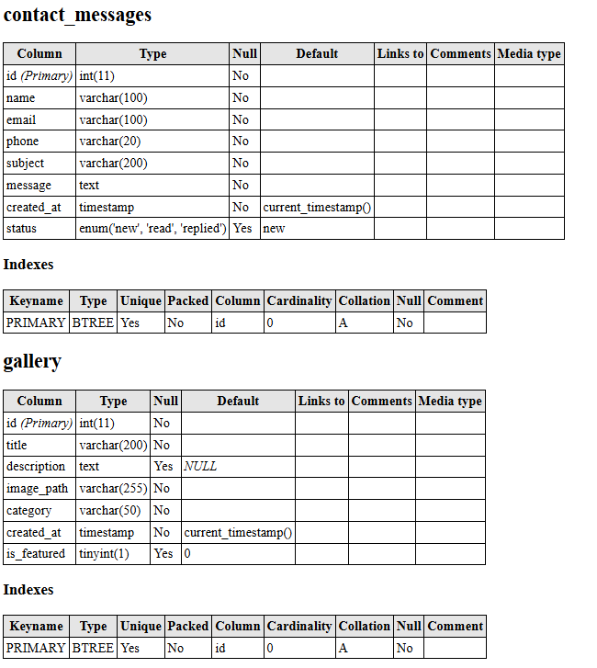

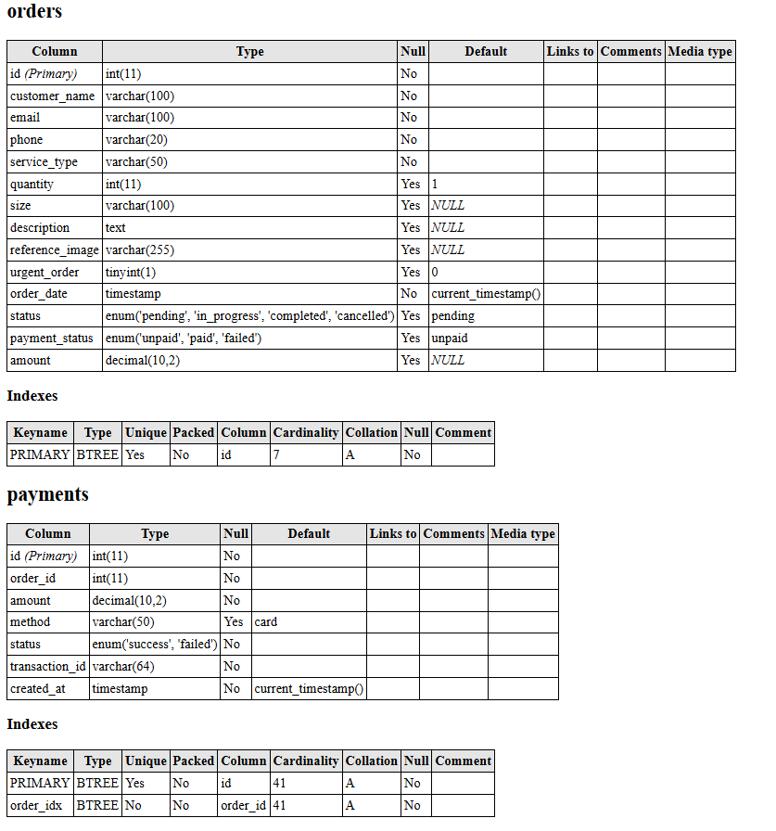

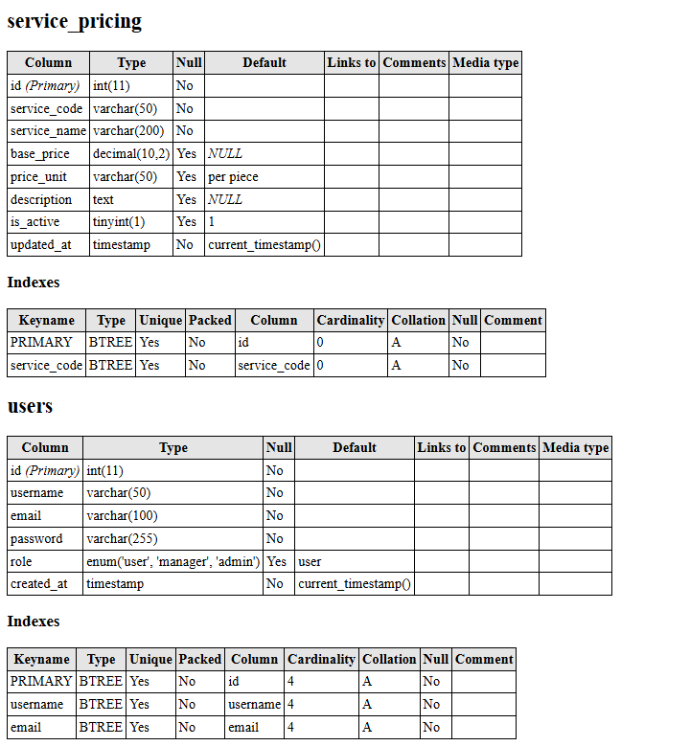

DataFlowDiagram

The DFD gives brief idea on how the designed system is working. It also suggests to us the type of users who using this system and the process involved in the system.

RepresentDataFlow

RepresentaEntity

Represent a DataTable

Representa Processing

ScreenShots:

Front Website

* HomePage :

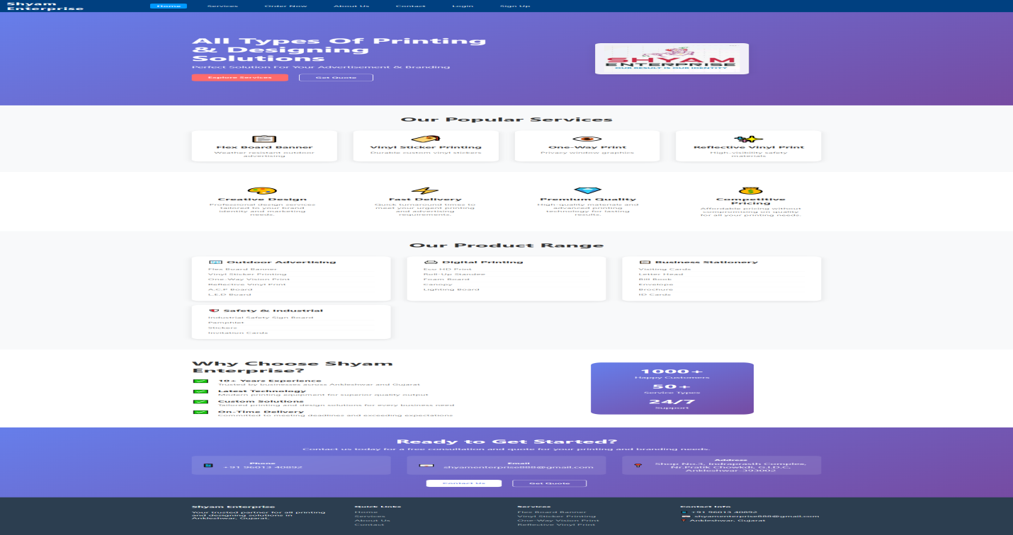

* LoginPage:

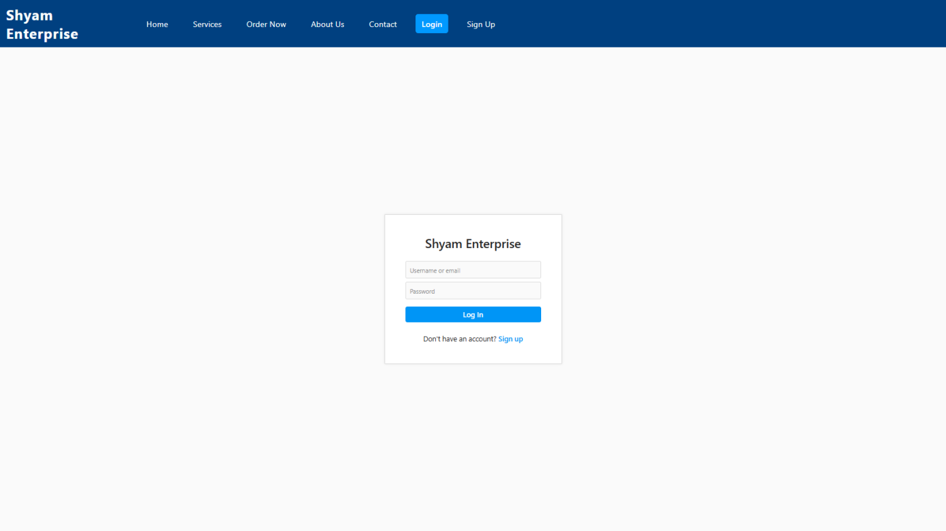

* RegisterForm:

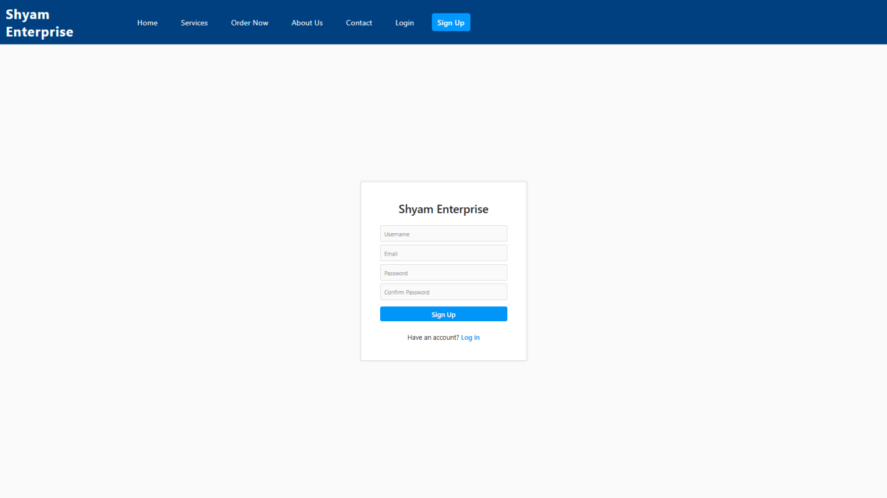

* Services:
* 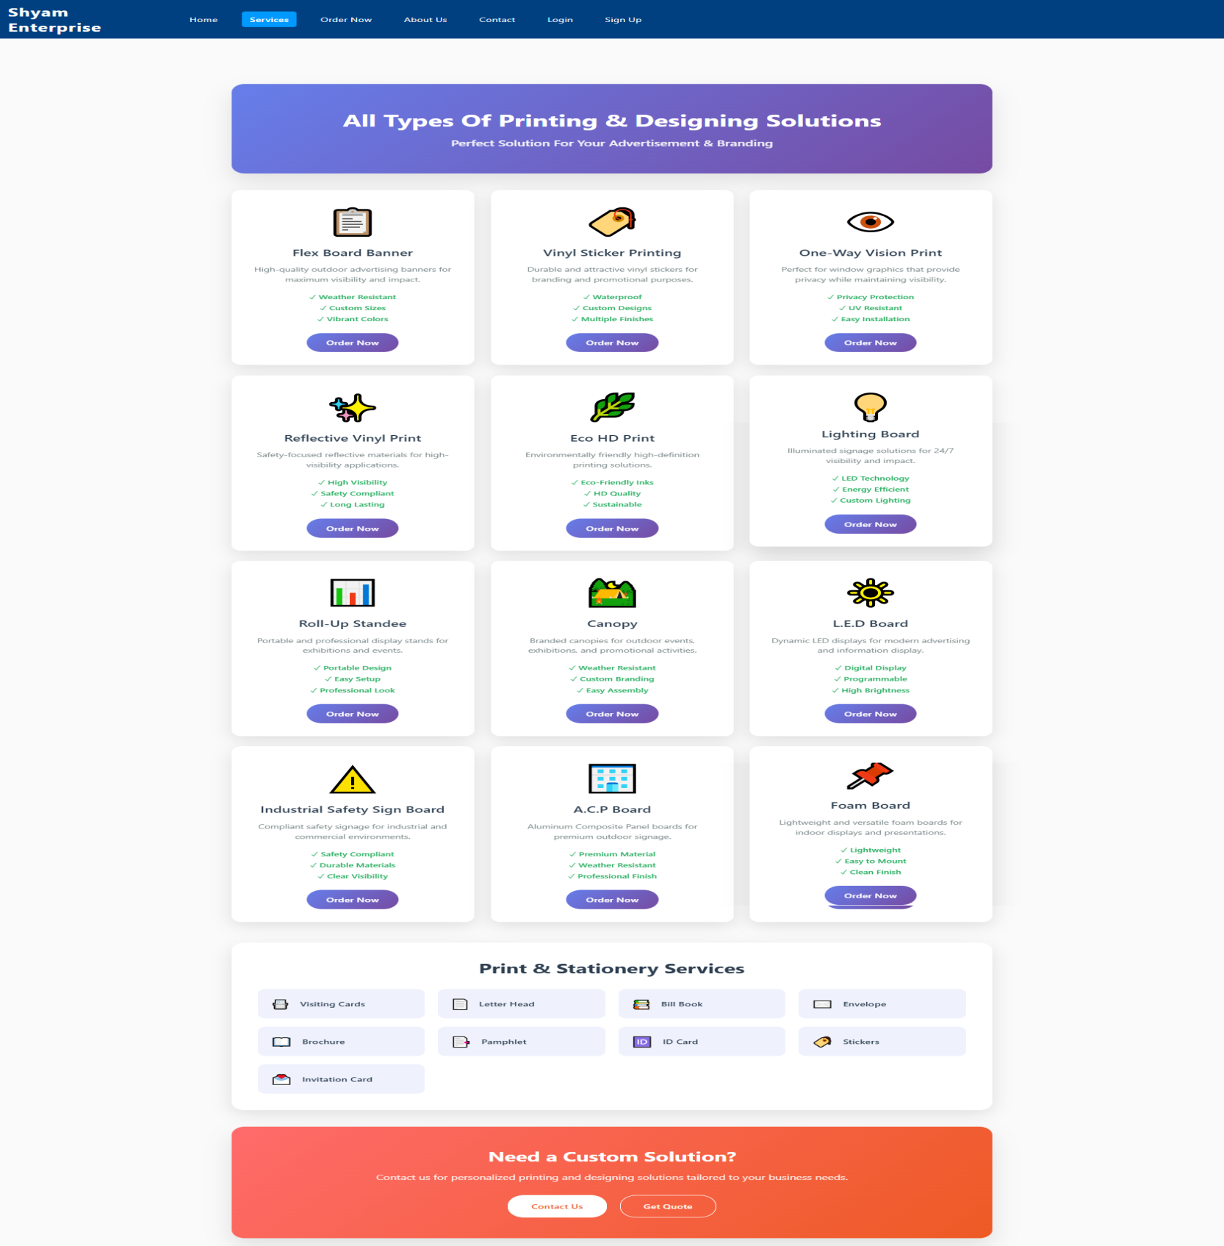
* Order Now:

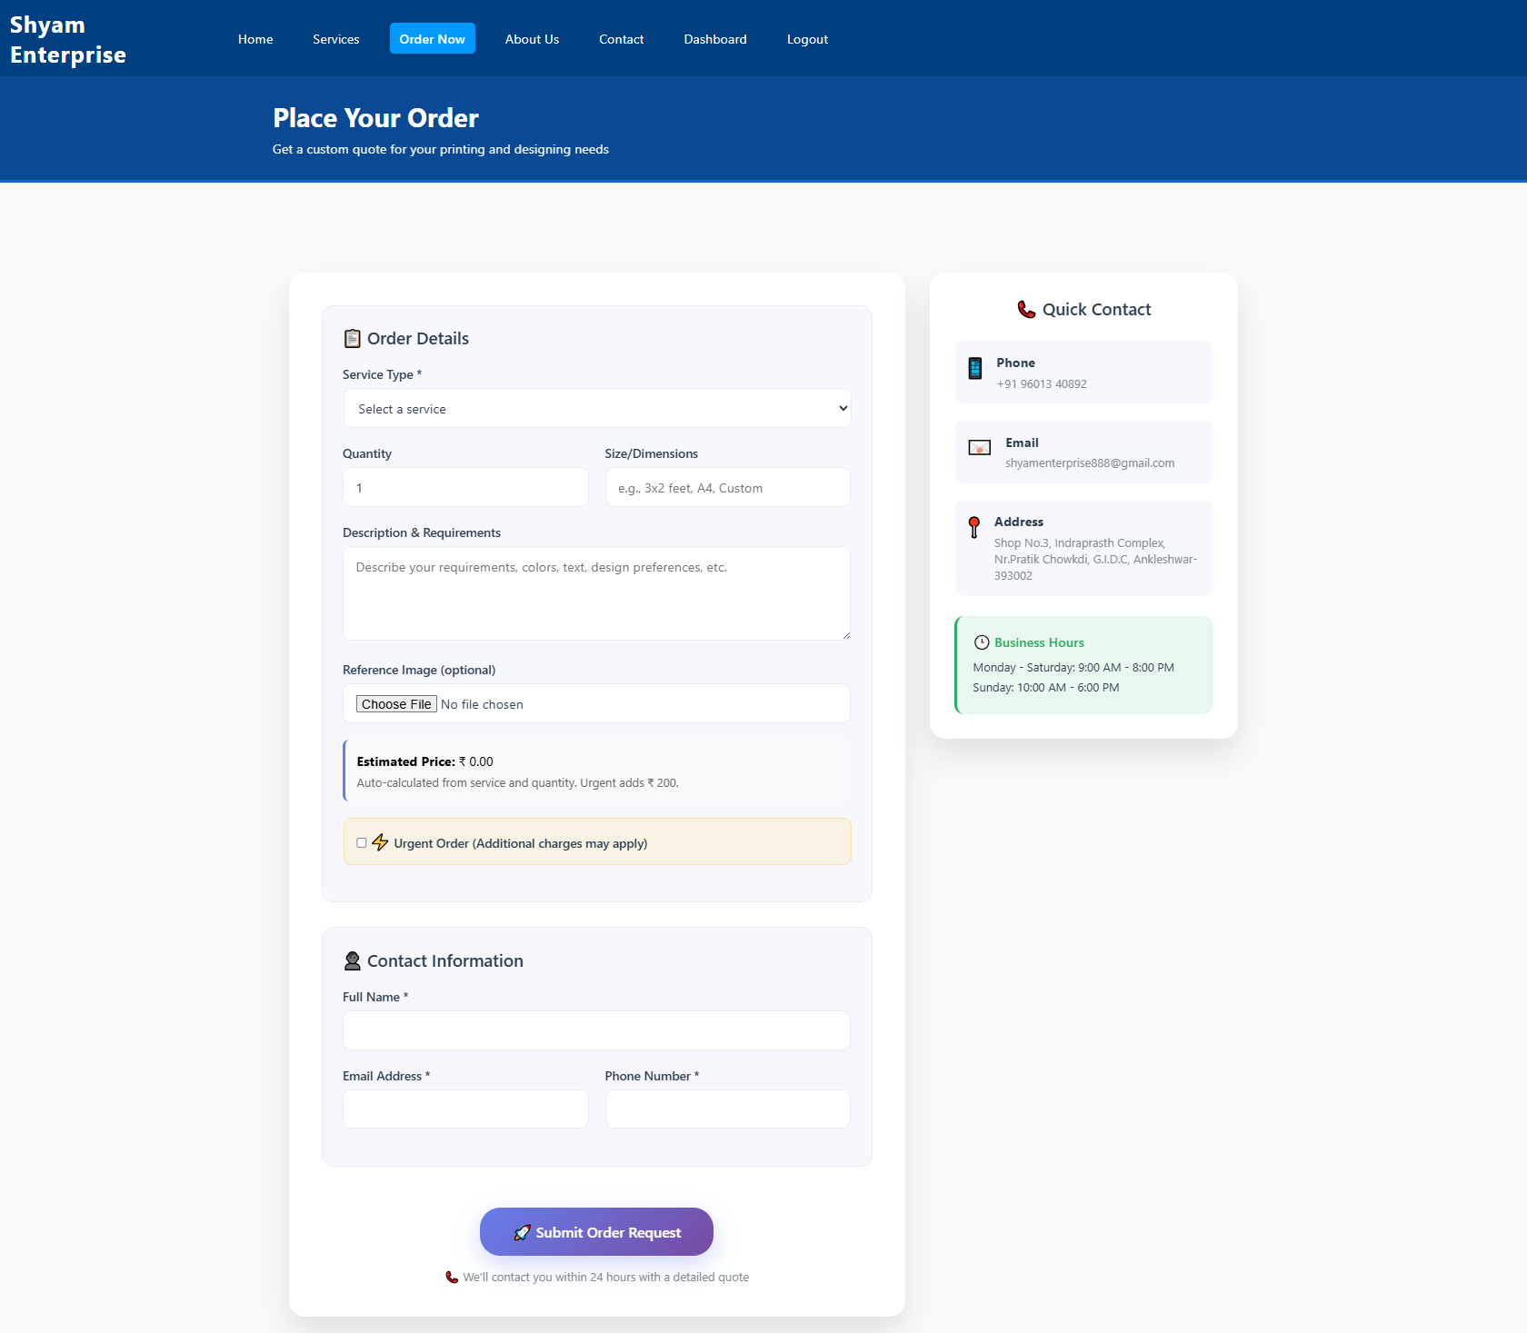

* 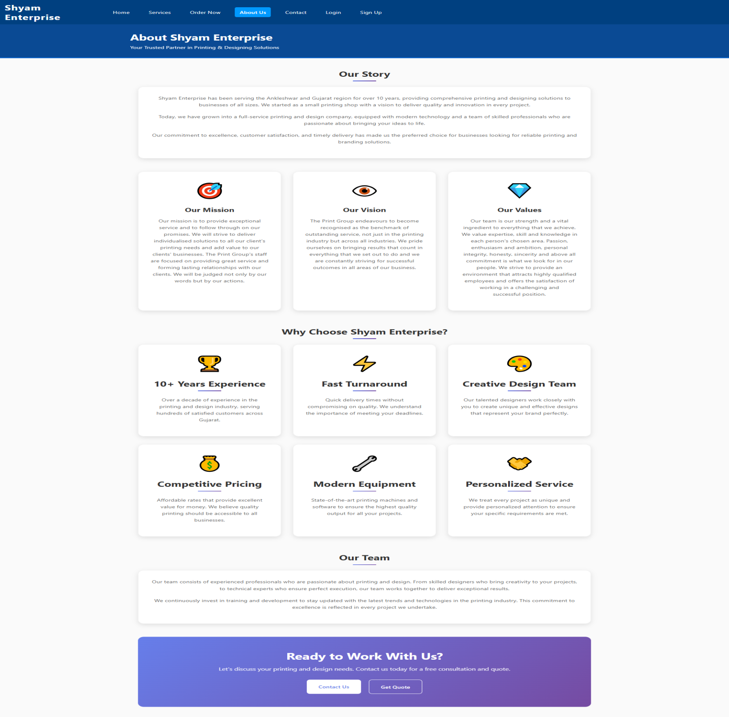About Us: