**Test Strategy Overview**

This Cypress automation project for [**SauceDemo**](https://www.saucedemo.com) is designed to simulate real-world QA practices with a focus on **functionality**, **usability**, **browser compatibility**, and **session behavior**.

### **Test Objective**

To test through Cypress the fundamental user flows of this SauceDemo eCommerce site to make sure that the site behaves properly with respect to different scenarios and browsers.

### **Scope of Testing**

**Functional Coverage:**

* Login (positive and negative scenarios)
* Product sorting (Name A–Z, Z–A, Price Low–High, High–Low)
* Add/remove multiple products to/from cart
* Cart behavior and product details validation
* Continue Shopping button redirection
* Post-logout browser back button restrictions

**Cross Browser Coverage:**

* Validation of login page rendering across Chrome, Firefox, and Edge

**UI Validation:**

* Fields visible and correctly labeled
* Page title

**Session Handling:**

* Do not allow to go back to secure pages after logout

### **Project technologies:**

### JavaScript as programming language

### Node.js as runtime environment

### Cypress as automation framework for web applications

### Google Chrome as test browser

### **Assumptions:**

* Consider the application under test (https://www.saucedemo.com) as a stable demo environment for test automation practice.
* Valid credentials (standard_user / secret_sauce) always get users logged in except for environment change scenarios.
* Product listings, sorting behavior, and cart actions remain static and consistent between sessions.

### **Limitations:**

* No API-level testing will be performed (only UI automation with Cypress will be done).
* No performance/load testing is considered.
* It is a static test demo — Hence, some edge cases from the real world (i.e., payment flows or user registration) are not possible or testable.
* It is assumed that the tests are in English language setup, and test scenario cases for responsiveness or internationalization are not considered.
* In case of any unexpected change in the structure or behavior of the demo site, the tests will likely break.

### **Security & Session Tests**:

* Session Timeout Handling - Simulate session expiration and test auto-redirection to login.

**Project Structure:**

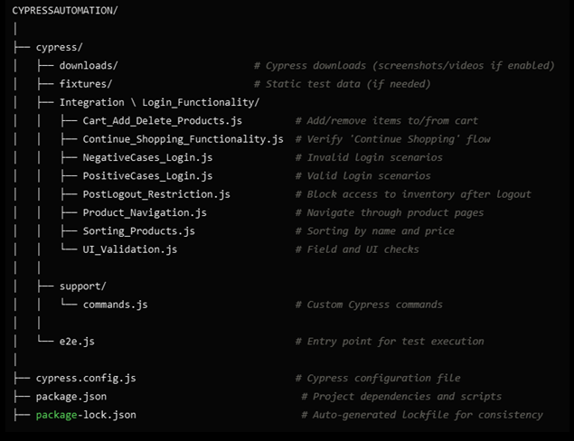

**My Goals with This Project:**

Build assurance when using modern testing tools such as Cypress. – Incorporate relevant industry testing parameters such as sorting validation, field masking, and session security. – Create a logical and scalable testing structure with organized folders and files. – Give a complete and professional-looking automation suite that adheres to the QA processes and standards. – This project demonstrates the passion I have for QA as well as the efforts I am making to evolve as a Test Automation Engineer.