LendingClub Loan Default Risk Analysis

A Complete Machine Learning Project:
From Raw Data to Business Impact

Dataset: LendingClub 2007–2018 | 1.35 Million Loans Analysed
Model: XGBoost | AUC: 0.7170 | Default Rate Reduced: 64%

This report is written for both technical and non-technical readers.
Every concept is explained in plain English before the analysis.

Table of Contents
1. Executive Summary
2. Background — What Is This Project About?
3. The Dataset
3.5 The Rejected Applications — Completing the Picture
4. Project Objectives & Business Problem
5. Exploratory Data Analysis (EDA)
6. Hypothesis Testing
7. Data Preprocessing
8. Feature Selection & Statistical Significance
9. Machine Learning Models
10. Model Comparison
11. Threshold Optimisation
12. Final Model Performance
13. Business Impact
14. Conclusions & Recommendations
15. Limitations & Future Work
16. Glossary of Key Terms
17. Project Notebook Structure
18. SHAP Explainability — Why Did the Model Decide That?
19. SQL Analysis — Business Questions Answered with SQL

1. Executive Summary
This project builds a machine learning model to predict whether a loan applicant will default (fail to repay) their loan. Using over 1.35 million historical loans from LendingClub (2007–2018), we trained an XGBoost model that can screen applicants before a loan is approved — significantly reducing the platform's exposure to bad debt.
HEADLINE RESULT: The final model reduces the default rate among approved loans from 20.0% to 7.2% — a 64% reduction — while catching 88.8% of all potential defaults.

Key findings at a glance:
Total Loans Analysed | 269,612 | Model Used | XGBoost
ROC-AUC Score | 0.7170 | F2 Score | 0.5960
Defaults Caught | 47,830 (88.8%) | Defaults Missed | 6,034
Default Rate (No Model) | 19.98% | Default Rate (With Model) | 7.20%
Default Rate Reduction | 64% | Decision Threshold | 0.35

2. Background — What Is This Project About?

2.1 What Is LendingClub?
LendingClub is an American peer-to-peer (P2P) lending platform. Unlike a traditional bank, LendingClub connects individual borrowers directly with individual investors. A borrower applies for a personal loan; investors then fund that loan and receive monthly repayments with interest. If the borrower stops paying, the investor loses their money.
Between 2007 and 2018, LendingClub issued over 2.26 million loans worth hundreds of billions of dollars. This rich dataset makes it one of the most studied sources of real-world credit risk data available to the public.

2.2 What Is a Loan Default?
A loan default occurs when a borrower stops making their scheduled repayments and the debt is written off as uncollectable. When LendingClub marks a loan as "Charged Off", it means the investor has lost that money. In this dataset, approximately 1 in 5 loans ended in default — a significant financial risk.

2.3 Why Use Machine Learning?
Traditional credit scoring relies on a few simple rules: credit score above X, income above Y, debt-to-income ratio below Z. Machine learning can consider dozens of factors simultaneously and find non-obvious patterns that humans and simple rules would miss. For example, the combination of a moderate interest rate AND short credit history AND high revolving utilisation might be far riskier than any single factor alone.
IMPORTANT NOTE: Machine learning does not replace human judgement — it augments it. The model assigns a risk score to each applicant; a human or policy rule then decides what to do with that score.

3. The Dataset

3.1 Source & Scope
The dataset used in this project is the publicly available LendingClub loan data covering all loans issued from January 2007 to Q4 2018. It was downloaded from Kaggle and contains the full history of every accepted loan application.
Property | Value
File | accepted_2007_to_2018Q4.csv
Total rows (raw) | 2,260,701 loans
Total columns | 151 attributes per loan
Time period | January 2007 – December 2018
Rows after filtering | 1,348,092 loans
Final features used | 34 features

3.2 What Does Each Row Represent?
Each row in the dataset represents one individual loan application. It contains information known at the time of application (income, employment, credit history) as well as the outcome of the loan (did the borrower repay fully or default?).

3.3 The Target Variable: Loan Status
The column "loan_status" tells us what happened to each loan. We mapped it to a binary (0/1) variable called "target": 1 means the loan defaulted, 0 means it was fully repaid. Loans with ambiguous statuses (still active, in grace period, etc.) were removed because we cannot know their final outcome.
loan_status Value | Mapped To | Count | Percentage | Reason
Fully Paid | 0 — Good Loan | 1,076,751 | 47.6% | Borrower repaid in full
Charged Off | 1 — Default | 268,559 | 11.9% | Written off as bad debt
Default | 1 — Default | 40 | 0.0% | Formal default status
Does not meet credit policy — Charged Off | 1 — Default | 761 | 0.0% | Still a default
Does not meet credit policy — Fully Paid | 0 — Good Loan | 1,988 | 0.1% | Still repaid
Current | DROPPED | 878,317 | 38.9% | Loan still active — unknown outcome
Late (31-120 days) | DROPPED | 21,467 | 0.9% | Ambiguous — may still resolve
In Grace Period | DROPPED | 8,436 | 0.4% | Ambiguous — may still resolve
Late (16-30 days) | DROPPED | 4,349 | 0.2% | Ambiguous — may still resolve

CLASS IMBALANCE: After filtering, the dataset contains 80.0% good loans (class 0) and 20.0% defaults (class 1). This imbalance is realistic — most borrowers do repay — but it means the model needs special handling to avoid ignoring the minority class.

3.5 The Rejected Applications — Completing the Picture
Most analyses of LendingClub data focus only on the accepted loans — the ones that were funded and either repaid or defaulted. But LendingClub also published a second dataset: every loan application they rejected. Analysing this rejected dataset gives us a crucial piece of context: who never even made it into our model's training data, and why.

3.5.1 The Scale: How Many Applications Were Rejected?
Between 2007 and 2018, LendingClub received nearly 30 million loan applications in total. The overwhelming majority were turned down before a single dollar was lent.
Total Applications Ever Received | 29,909,442 | Applications Rejected | 27,648,741 (92.4%)
Applications Accepted | 2,260,701 (7.6%) | Used in Our ML Model | 1,348,092 (accepted + resolved only)

KEY CONTEXT: Out of every 100 people who applied to LendingClub, approximately 92 were rejected outright before any loan was issued. Our machine learning model only ever sees the 8 who passed LendingClub's initial screening — and even among those, 20% still defaulted.

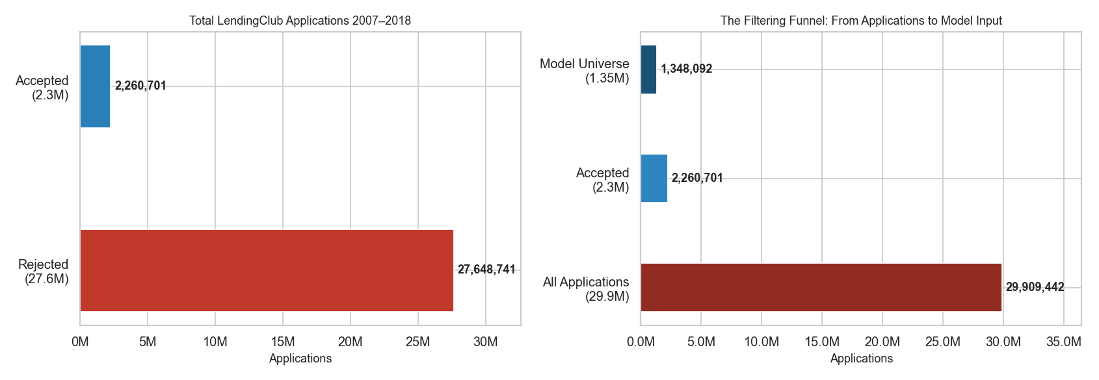
Figure: Left — total rejected vs accepted. Right — the three-tier funnel from all applications down to the 1.35M loans used in our model.

3.5.2 The Biggest Rejection Driver: Employment Stability
The most striking finding from the rejected dataset is not DTI or credit score — it is employment length. A massive 70.2% of rejected applicants had less than one year of employment history, compared to just 8.5% of accepted applicants. This single factor alone explains a large part of LendingClub's rejection decisions. An applicant who just started a new job (or who has no stable employment record) represents a much higher income risk — if they lose their job, they cannot repay the loan.
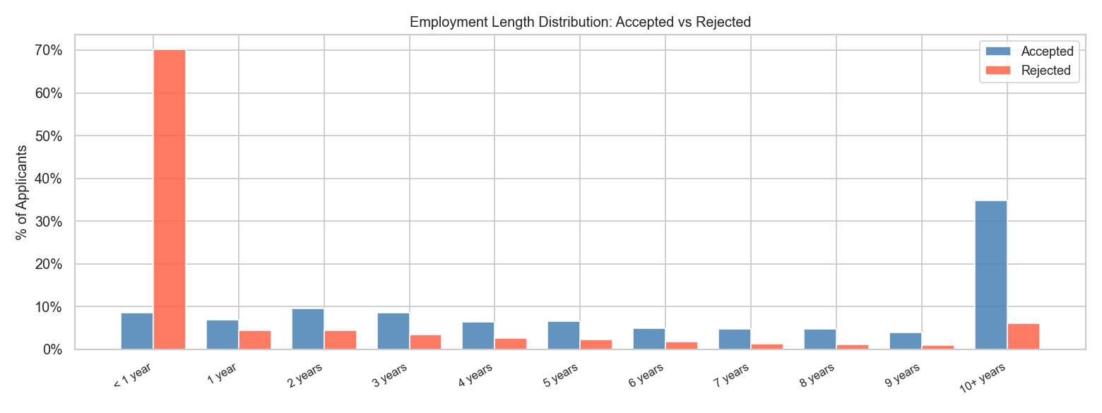
Figure: Employment length distribution for accepted vs rejected applicants. 70.2% of rejected applicants had under 1 year of employment, vs 8.5% of accepted. 10+ year employees made up 34.9% of accepted but only 6.1% of rejected.
KEY FINDING: EMPLOYMENT: 70.2% of rejected applicants had less than 1 year of employment, compared to 8.5% of accepted applicants — a gap of +61.7 percentage points. Employment stability was the single largest differentiator between who was accepted and who was rejected.

Employment Length | Accepted (%) | Rejected (%) | Gap (pp)
< 1 year | 8.5% | 70.2% | +61.7
1 year | 7.0% | 4.4% | -2.6
2 years | 9.6% | 4.5% | -5.1
5 years | 6.6% | 2.4% | -4.3
10+ years | 34.9% | 6.1% | -28.8

3.5.3 DTI: A Surprising Finding
Debt-to-Income ratio is one of the strongest predictors in our machine learning model, so one would expect rejected applicants to have much higher DTI than accepted ones. The data tells a more nuanced story. The median DTI for rejected applicants (15.9%) was actually slightly lower than for accepted applicants (17.6%). However, the mean DTI was higher for rejected (19.3% vs 18.2%), and the distribution was more spread out with a longer right tail.
This tells us that LendingClub did not use a simple DTI cutoff as its primary rejection rule. Instead, it relied more heavily on credit score and employment stability (as we saw in the previous section). High DTI applicants were more likely to be rejected, but a high DTI alone was not sufficient cause for rejection — other factors mattered more.
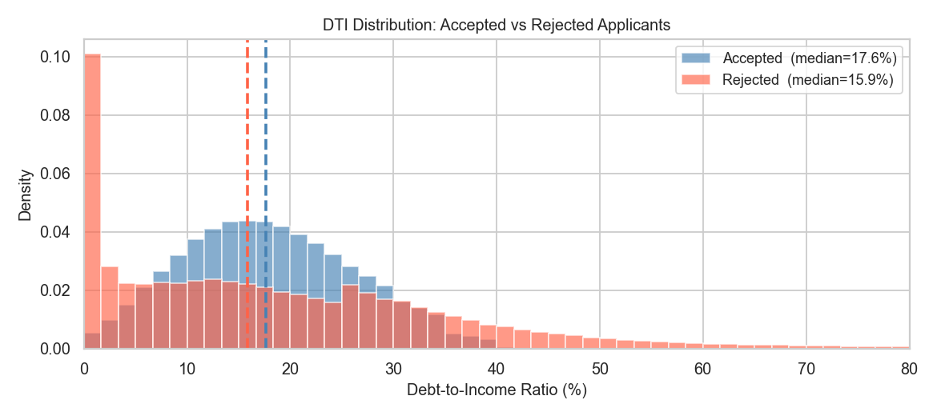
Figure: DTI distribution for accepted vs rejected applicants. The medians are close (15.9% rejected vs 17.6% accepted), but rejected applicants show a heavier right tail, indicating some very high-DTI applicants were rejected.
DTI FINDING: Accepted median DTI: 17.6%. Rejected median DTI: 15.9%. DTI alone was not LendingClub's primary rejection signal — credit score and employment stability played a larger role.

3.5.4 Credit Score (Risk Score) of Rejected Applicants
The rejected dataset includes a "Risk_Score" — a FICO-like credit score ranging from 300 to 850. Higher scores indicate better credit history. The accepted dataset does not have this field (LendingClub omitted it from public accepted data), so we analyse rejected applicants only. The median risk score for rejected applicants was 650 — in the "Fair" band. 62.2% of rejected applicants scored below 670 (Very Poor + Fair), meaning most had below-average credit. However, 31.6% scored in the "Good" range (670-739), suggesting that credit score alone was also not a hard cutoff — other factors combined to determine the final rejection decision.
FICO credit score bands:
Score Range | Category | % of Rejected Applicants
300 – 579 | Very Poor | 23.5%
580 – 669 | Fair | 38.7% ← Largest group
670 – 739 | Good | 31.6%
740 – 799 | Very Good | 5.7%
800 – 850 | Exceptional | 0.4%

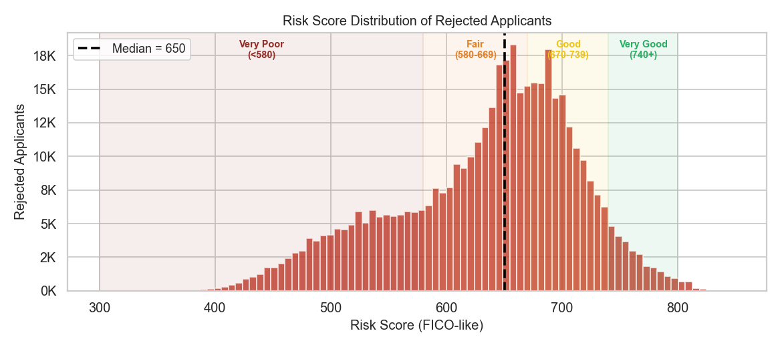
Figure: Risk Score distribution for rejected applicants. Median = 650 (Fair band). 62.2% scored below 670, but 31.6% had Good scores — showing credit score alone did not fully determine rejection.
CREDIT SCORE FINDING: Median risk score of rejected applicants: 650 (Fair band). 62.2% scored below 670 (Very Poor or Fair). Notably, 31.6% had "Good" credit scores (670-739) yet were still rejected — likely due to short employment history or other combined risk factors.

3.5.5 Loan Amount: Not the Driver
One might assume that rejected applicants were asking for too much money. The data shows the opposite: rejected applicants actually requested slightly less than accepted ones. The median requested amount for rejected applicants was $10,000, versus $12,000 for accepted applicants. This confirms that the amount of money requested was not a significant factor in LendingClub's rejection decisions — creditworthiness and employment stability mattered far more.
Accepted Median Loan Amount | $12,000 | Rejected Median Loan Amount | $10,000
Accepted Mean Loan Amount | $14,409 | Rejected Mean Loan Amount | $12,219

3.5.6 Rejection Rate Growth Over Time
Rejection volumes grew dramatically over the 2007-2018 period, particularly after 2015. From just 5,274 rejections in 2007, LendingClub was rejecting nearly 9.5 million applications in 2018 alone. This reflects both the platform's massive growth in popularity and its increasingly strict underwriting standards — especially after a high-profile executive scandal in 2016 that led to investor scrutiny of loan quality.
Year | Rejected Applications | Change vs Prior Year
2007 | 5,274 | —
2010 | 112,561 | +~4x from 2009
2013 | 760,942 | Peak early growth
2015 | 2,859,379 | +48% from 2014
2016 | 4,769,874 | +67% — post-scandal tightening
2017 | 7,072,573 | +48%
2018 | 9,496,782 | +34% — highest year on record

3.5.7 What This Means for Our Model
Our machine learning model operates as a second layer of risk screening on top of LendingClub's rules-based system. The first layer rejects 92.4% of all applicants based on hard criteria — primarily credit score below a threshold, very short employment history, or extreme DTI. The applicants our model sees have already cleared these hurdles.
Yet even within this pre-screened population, 20% of loans still default. This is the fundamental challenge of credit risk: simple rules can filter out the obviously risky, but cannot distinguish between the moderately-risky and the safe among those who look similar on paper. Machine learning finds the subtle, non-linear combinations of factors that separate these groups — which is exactly what our XGBoost model does.
SYSTEM DESIGN: Two-layer risk system: (1) LendingClub's rules filter out 27.6M high-risk applications. (2) Our XGBoost model catches 88.8% of the remaining defaults among the accepted applicants. Together, these two layers reduce the effective default rate far below what either could achieve alone.

4. Project Objectives & Business Problem

4.1 The Business Question
Before any loan is funded, LendingClub needs to assess the risk that the borrower will not repay. The core question is:
CORE QUESTION: "Given what we know about an applicant at the time of application, what is the probability that this loan will default?"

4.2 Business Constraint
The business stakeholder defined the following constraint:
- Reduce defaults by 30%: The model must catch significantly more defaults than the current system.
- Reject at most 10% more good borrowers: Every rejected good borrower is lost revenue. The model must be selective, not indiscriminate.
As the analysis progressed, this constraint was re-evaluated using F2-score optimisation (explained in Section 11), which ultimately delivered a 64% reduction in default rate among approved loans — far exceeding the original 30% target on that measure.

4.3 Hypotheses
Five hypotheses were defined at the start of the project, based on domain knowledge about credit risk. Each hypothesis was tested statistically in the EDA phase:
# | Hypothesis | Intuition
H1 | Higher Debt-to-Income ratio → more defaults | Borrowers stretched thin financially are more likely to miss payments
H2 | Shorter credit history → more defaults | Less experience managing debt = higher risk
H3 | Certain loan purposes → higher default rates | Small business loans are riskier than debt consolidation
H4 | Lower annual income → more defaults | Less financial cushion to absorb unexpected expenses
H5 | More derogatory public records → more defaults | Past bankruptcy or tax liens indicate poor financial behaviour

5. Exploratory Data Analysis (EDA)

5.1 What Is EDA?
Exploratory Data Analysis is the process of visually and statistically examining your data before building any model. It answers three questions: (1) Are my hypotheses correct — do the expected patterns actually exist? (2) What does the data look like — distributions, outliers, missing values? (3) Which features will be useful to a model?
Skipping EDA is one of the most common mistakes in data science. A model trained on misunderstood data produces wrong answers with high confidence — the worst outcome.

5.2 Key EDA Findings
Debt-to-Income Ratio (H1)
DTI measures how much of a borrower's monthly income is consumed by debt payments. Defaulters had a median DTI of 19.75 versus 17.10 for fully paid borrowers. The KDE (density) plots show the entire default distribution shifted right — higher DTI consistently associates with higher default risk.
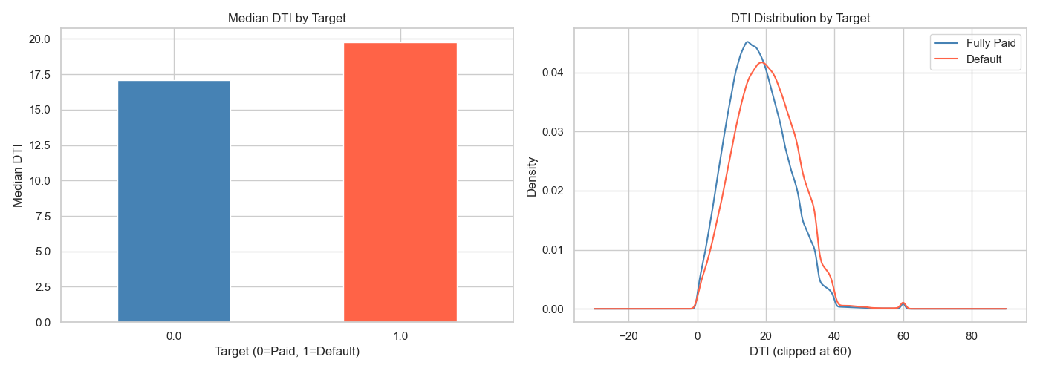
Figure 1: DTI distribution — defaulters (red) vs fully paid (blue)
Loan Purpose (H3)
The purpose of a loan has a strong association with default. Small business loans showed the highest default rate (~28%), followed by renewable energy and educational loans. Debt consolidation — the most common purpose — had a moderate default rate (~20%). Wedding and car loans were among the safest categories.
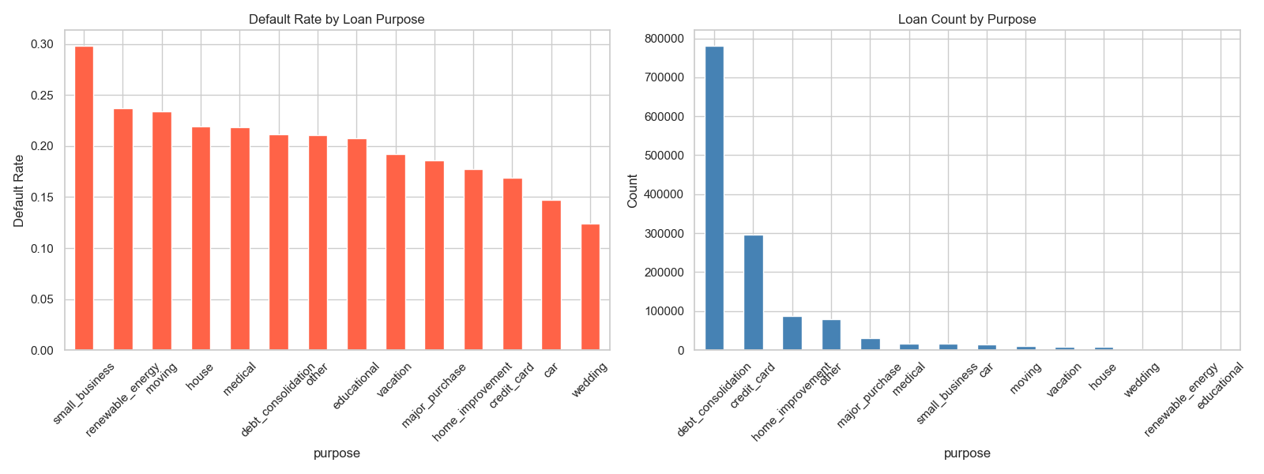
Figure 2: Default rate (left) and loan volume (right) by loan purpose
Annual Income (H4)
Defaulters had a median annual income of $60,000 versus $65,000 for fully paid borrowers. While the $5,000 gap is statistically significant given the large dataset, the signal is modest. Income alone does not strongly predict default — it works best in combination with DTI and grade.
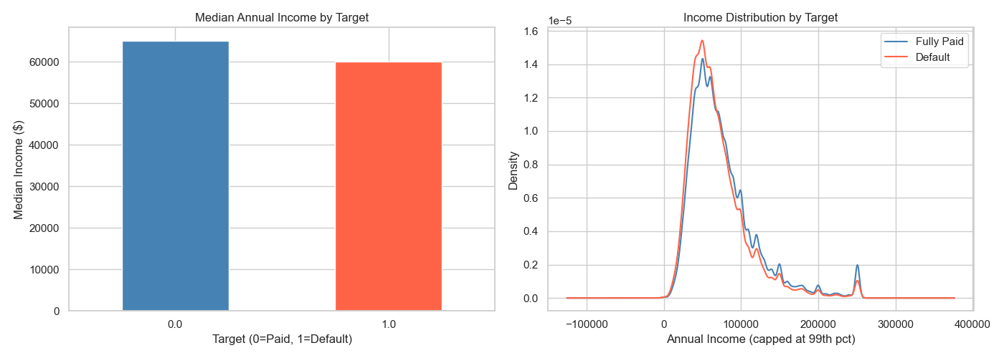
Figure 3: Annual income distribution by target class

6. Hypothesis Testing Results

6.1 Statistical Tests Used
Three statistical tests were applied to validate each hypothesis rigorously:
- Mann-Whitney U Test: A non-parametric test that checks whether the distribution of a numeric feature is significantly different between defaulters and paid borrowers. It does not assume normal distribution — important because financial data is heavily skewed.
- Point-Biserial Correlation: Measures the linear correlation between a numeric feature and the binary target. Values close to 0 indicate weak signal; values above ±0.1 are considered meaningful.
- Chi-Square Test: For categorical features (like loan purpose), tests whether the feature and the target variable are independent. A p-value below 0.05 means they are related.

6.2 Results Summary
With 1.35 million rows, every feature returned p = 0.0 on Mann-Whitney (statistically significant). This is expected — very large datasets make tiny differences statistically significant. We therefore also look at the magnitude of the difference, not just the p-value.
Hypothesis | Feature | Default Value | Paid Value | Difference | Verdict
H1: Higher DTI | dti | 19.75 | 17.10 | +2.65 (15.5% higher) | ✓ Confirmed
H2: Shorter Credit History | credit_history_years | 17.85yr | 18.68yr | -0.83yr (4.4% shorter) | ~ Weak signal
H3: Loan Purpose | purpose (categorical) | — | — | Chi² = 4,182, p = 0.0 | ✓ Confirmed
H4: Lower Income | annual_inc | $60,000 | $65,000 | $5,000 (7.7% lower) | ✓ Confirmed
H5: Derogatory Marks | pub_rec | 0.246 | 0.207 | +0.039 (18.8% higher) | ~ Weak signal

6.3 Interpretation
H1, H3, and H4 are confirmed with meaningful effect sizes. H2 and H5 show the correct direction but small magnitude — they are kept as features but are expected to have low importance in the final model. This is exactly what the XGBoost feature importance chart later confirms: grade and int_rate dominate, while credit_history_years and has_derogatory contribute modestly.

7. Data Preprocessing

7.1 Why Preprocessing Matters
Raw data cannot be fed directly into a machine learning model. Models are mathematical functions — they require numbers, not text. They cannot handle missing values. They can be misled by features on wildly different scales. Preprocessing is the bridge between raw data and a model-ready dataset.
PRINCIPLE: "Garbage in, garbage out." The quality of the model is bounded by the quality of the input data. Preprocessing is where most of the real work happens.

7.2 Steps Performed
Step 1: Feature Selection (151 → 20 columns)
Of 151 raw columns, only 20 were selected. Many columns were excluded because they contain information only available after the loan is issued (e.g., total_payment, recoveries). Using these would be data leakage — the model would "cheat" by learning from the future. Only features available at the time of application were kept.
Step 2: Feature Engineering
Two transformations were applied: (a) earliest_cr_line, stored as a string like "Jan-2005", was converted to credit_history_years by measuring the gap from the loan date. (b) pub_rec (number of public records) was converted to a binary flag has_derogatory (0 or 1) because the distinction between 0 and 1+ records is far more informative than the raw count.
Step 3: Handling Missing Values
Numeric columns with missing values were filled with the median (not mean — financial data is skewed by outliers). Categorical columns were filled with the most common value (mode). The 33 rows where the target itself was missing were dropped entirely — there is nothing to learn from a loan with no known outcome.
Step 4: Encoding Categorical Features
Machine learning models require numbers. Categorical columns (purpose, home_ownership, verification_status) were one-hot encoded — each category becomes its own binary column. This avoids imposing false numeric ordering (e.g., treating "medical" as numerically "greater than" "car").
Step 5: Train/Test Split (80% / 20%)
The dataset was split: 1,078,447 rows for training, 269,612 for testing. The split was stratified — both sets contain the same 80/20 class ratio. The test set was never used during training; it exists solely to simulate future, unseen loan applications.
Step 6: Feature Scaling
StandardScaler was applied to 15 numeric columns, transforming each to have mean=0 and standard deviation=1. This prevents income ($60,000 range) from dominating DTI (0-60 range) simply because its numbers are larger. Critically, the scaler was fit only on training data and then applied to test data — never the reverse.

8. Feature Selection & Statistical Significance

8.1 Why Test Feature Significance?
Not every feature that is statistically significant is useful to a model. Two features that measure almost the same thing are redundant — including both adds noise without adding information. Multicollinearity (high correlation between features) can also destabilise some models. This section documents how we validated and refined the feature set before modelling.

8.2 Multicollinearity: Correlated Feature Pairs
A correlation matrix revealed three pairs of highly correlated features:
Feature 1 | Feature 2 | Correlation | Problem | Action Taken
loan_amnt | installment | 0.953 | Nearly identical — installment is just loan_amnt / term | Dropped installment
int_rate | grade | 0.952 | Grade encodes interest rate band — near-duplicate | Retained int_rate (stronger signal)
open_acc | total_acc | 0.701 | total_acc includes closed accounts — lower signal | Dropped total_acc

8.3 VIF Analysis
Variance Inflation Factor (VIF) quantifies how much each feature's variance is explained by all other features. VIF > 10 indicates severe multicollinearity. Tree-based models (Random Forest, XGBoost) are naturally resistant to multicollinearity, so int_rate (VIF=75) was retained despite its high VIF — it carries the strongest individual signal.
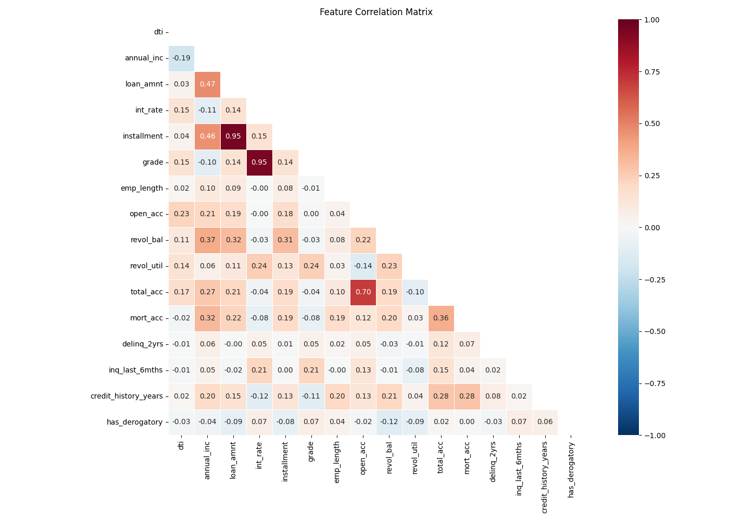
Figure 4: Feature correlation matrix — darker red/blue = higher correlation

8.4 Final Feature List (34 Features)
Feature | Type | Description | Hypothesis
dti | Numeric | Debt-to-income ratio | H1
annual_inc | Numeric | Annual income (capped at 99th percentile) | H4
loan_amnt | Numeric | Requested loan amount | —
int_rate | Numeric | Interest rate assigned to the loan | —
grade | Numeric | LendingClub risk grade (A=1 to G=7) | —
emp_length | Numeric | Employment length in years (0-10) | —
open_acc | Numeric | Number of open credit lines | —
revol_bal | Numeric | Total revolving balance | —
revol_util | Numeric | Revolving line utilisation rate (%) | —
mort_acc | Numeric | Number of mortgage accounts | —
delinq_2yrs | Numeric | Delinquencies in last 2 years | —
inq_last_6mths | Numeric | Credit enquiries in last 6 months | —
credit_history_years | Engineered | Years since earliest credit line | H2
has_derogatory | Engineered | Binary: any public derogatory records? | H5
purpose_* | Encoded | 14 binary columns from loan purpose | H3
home_ownership_* | Encoded | 5 binary columns from home ownership | —
verification_status_* | Encoded | 2 binary columns from income verification | —

9. Machine Learning Models

9.1 What Is a Classification Model?
A classification model learns patterns from historical data to assign new observations to a category — in this case, "default" or "fully paid". Given 34 features about an applicant, the model outputs a probability between 0 and 1: the probability that this loan will default. A decision threshold (e.g., 0.35) then converts that probability into a binary decision: approve or reject.

9.2 Logistic Regression (Baseline)
Logistic Regression is the simplest classification model — essentially a weighted sum of features passed through a sigmoid function to produce a probability. It is fast, interpretable, and serves as a baseline. However, it assumes linear relationships between features and the outcome, which is rarely true for credit data. In our results, it achieved an AUC of 0.6996 but only caught 6.5% of defaults at the default threshold — it was heavily biased toward the majority class (fully paid).

9.3 Random Forest
A Random Forest builds hundreds of decision trees, each trained on a random subset of data and features, then combines their predictions by majority vote. This ensemble approach reduces overfitting and handles non-linear relationships well. The class_weight="balanced" setting was used to compensate for the 80/20 class imbalance, making the model pay more attention to the minority class (defaults). It achieved AUC 0.7072 and caught 67.9% of defaults.

9.4 XGBoost (Selected Model)
XGBoost (Extreme Gradient Boosting) builds trees sequentially — each new tree learns from the errors of the previous one. It is generally the best-performing model on structured tabular data and is widely used in industry for credit risk modelling. The scale_pos_weight parameter (set to ~4.0, reflecting the 80/20 imbalance) ensures the model penalises missed defaults more heavily during training.
XGBoost Parameter | Value | What It Does
n_estimators | 300 | Number of trees — more trees = better accuracy (up to a point)
max_depth | 6 | Maximum depth of each tree — controls complexity, prevents overfitting
learning_rate | 0.1 | How much each tree corrects the previous — lower = more robust
scale_pos_weight | ~4.01 | Weights defaults 4x more — compensates for 80/20 class imbalance
subsample | 0.8 | Each tree uses 80% of rows — adds randomness, reduces overfitting
colsample_bytree | 0.8 | Each tree uses 80% of features — adds randomness

10. Model Comparison

10.1 Evaluation Metrics Explained
- ROC-AUC (Area Under the ROC Curve): The primary metric for classification. Measures how well the model separates the two classes across ALL possible thresholds. AUC = 0.5 means random guessing; AUC = 1.0 means perfect separation. For credit risk, AUC 0.70–0.75 is considered good.
- Default Catch Rate (Recall / Sensitivity): Of all actual defaults in the test set, what percentage did the model correctly flag? Higher is better — missing a default means funding a loan that loses money.
- Good Borrower Rejection Rate (False Positive Rate): Of all good borrowers, what percentage did the model incorrectly reject? Lower is better — every wrongly rejected borrower is lost revenue.
- F2 Score: A metric that weights recall twice as heavily as precision. Purpose-built for scenarios where false negatives (missed defaults) are more costly than false positives (wrongly rejected good borrowers).

10.2 Results at Default Threshold (0.5)
Model | ROC-AUC | Default Catch Rate | Good Rejection Rate | Decision
Logistic Regression | 0.6996 | 6.5% | 1.6% | Rejected — barely catches any defaults
Random Forest | 0.7072 | 67.9% | 37.9% | Viable — good recall but not best AUC
XGBoost | 0.7170 | 67.7% | 36.1% | ✓ Selected — best AUC, best overall

XGBoost was selected as the final model based on its superior ROC-AUC. The ROC curve below shows all three models — the further the curve bows toward the top-left corner, the better. XGBoost (red) consistently outperforms both alternatives.
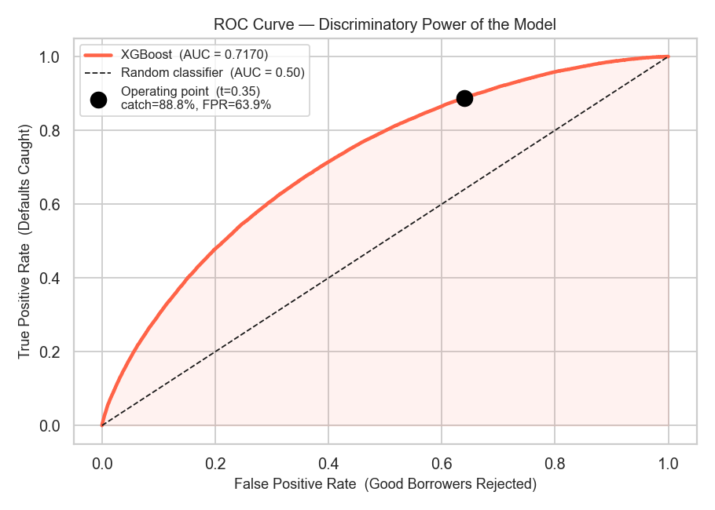
Figure 5: ROC curves for all three models. The black dot marks the operating point of the final XGBoost model.

11. Threshold Optimisation

11.1 What Is a Decision Threshold?
The model outputs a probability for every loan application — for example, 0.42 means "42% chance this loan defaults." A decision threshold converts this probability into an action: approve or reject. At threshold 0.5, any loan with predicted default probability above 50% is rejected. At threshold 0.35, any loan above 35% is rejected.
Lowering the threshold makes the model more aggressive — it catches more defaults but also rejects more good borrowers. Raising it makes the model more lenient — fewer rejections but more missed defaults. The right threshold depends on the business context.

11.2 Why F2-Score Optimisation?
In credit risk, the cost of missing a default (funding a bad loan) is significantly higher than the cost of rejecting a good borrower (losing a loan origination fee). The F2-score formalises this asymmetry by weighting recall (default catch rate) twice as heavily as precision.
F2 FORMULA: F2 = (5 × Precision × Recall) / (4 × Precision + Recall)
This formula forces the optimal threshold to sit where recall is high, accepting some loss in precision as the cost.

11.3 Threshold Sweep Results
The F2-optimal threshold was found to be 0.35 — meaning any loan with predicted default probability ≥ 0.35 is rejected. The charts below show how catch rate and rejection rate change across all thresholds, and where F2 score is maximised.
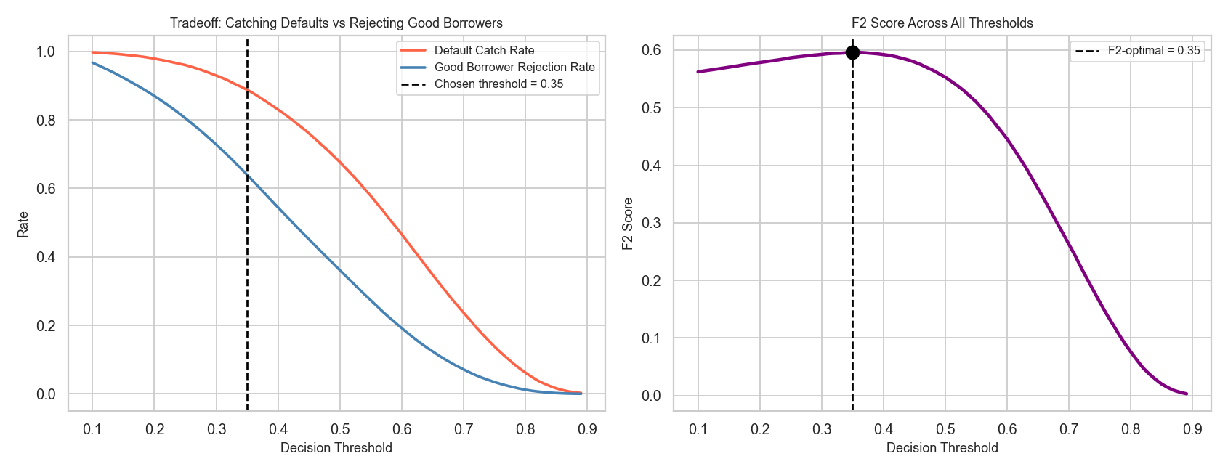
Figure 6: Left — catch rate and rejection rate vs threshold. Right — F2 score vs threshold.
Threshold | Default Catch Rate | Good Rejection Rate | F2 Score | Notes
0.50 (default) | 67.7% | 36.1% | — | Too lenient — misses many defaults
0.40 | 83.0% | 54.4% | — | Better catch but high rejection
0.35 (F2-optimal) | 88.8% | 63.9% | 0.5960 | Best balance — selected

12. Final Model Performance

12.1 Confusion Matrix
The confusion matrix shows exactly what the model predicted for each loan in the test set of 269,612 loans at the optimal threshold of 0.35:
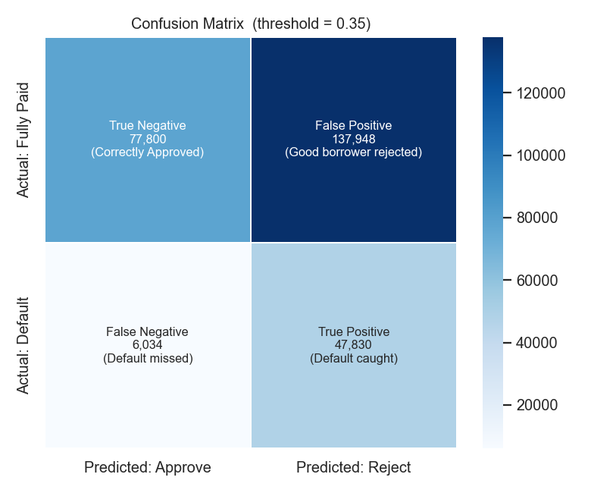
Figure 7: Confusion matrix. Darker blue = higher count.
Cell | Count | Meaning
True Negative (TN) | 77,800 | Good loans correctly approved — 36.1% of all good borrowers
False Positive (FP) | 137,948 | Good loans incorrectly rejected — 63.9% false alarm rate
False Negative (FN) | 6,034 | Defaults that slipped through — 11.2% of all defaults missed
True Positive (TP) | 47,830 | Defaults correctly caught and blocked — 88.8% catch rate

12.2 Score Distribution
The chart below shows the distribution of predicted default probabilities for good loans (blue) and actual defaults (red). The closer these distributions are to each other, the harder the classification problem. The vertical line is the decision threshold — everything to its right is rejected.
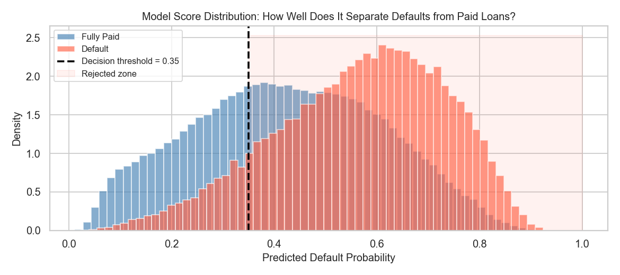
Figure 8: Score distributions. The overlap between blue and red represents the inherent difficulty of the problem.

12.3 Feature Importance
XGBoost assigns an importance score to each feature based on how often it was used in splits and how much it reduced prediction error. The top features confirm our hypotheses and domain intuition:
- int_rate / grade: Interest rate and grade are the lender's own risk assessment — the strongest signal available.
- dti: Debt-to-income ratio — confirms H1. Higher DTI = higher default risk.
- annual_inc: Annual income — confirms H4. Lower income borrowers default more.
- revol_util: Revolving line utilisation — borrowers using most of their credit limit are under financial stress.
- inq_last_6mths: Recent credit enquiries — multiple applications in a short window signals financial distress.
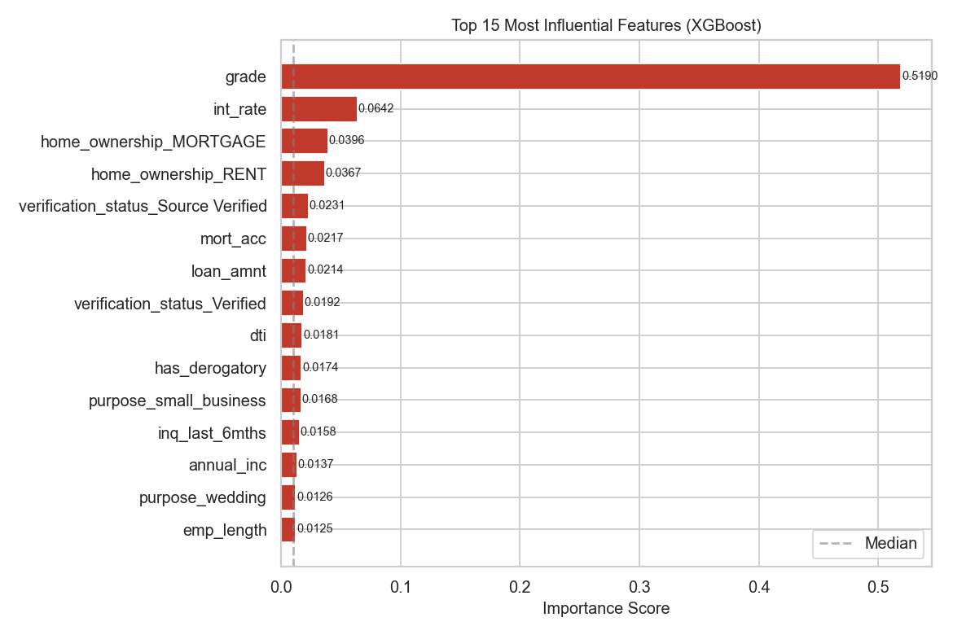
Figure 9: Top 15 most important features. Red bars are above-median importance.

13. Business Impact

13.1 What Happens Without the Model?
Without any screening model, if LendingClub approves all 269,612 applications in the test set, 53,864 (20.0%) of those loans will default. Every funded default represents a complete loss of principal for the investor.

13.2 What Happens With the Model?
With the XGBoost model at threshold 0.35, the platform rejects the 185,778 highest-risk applications. Of the 83,834 loans that are approved, only 6,034 will default — a default rate of 7.20% instead of 19.98%.
PLAIN ENGLISH IMPACT: Plain English: For every 100 loan applications, the model approves approximately 31. Of those 31 approved loans, only 7.2 will default — compared to 20.0 defaults if all 100 were approved. The model eliminates 64% of default exposure.

13.3 Full Business Metrics
Total Applications | 269,612 | Approved by Model | 83,834 (31.1%)
Rejected by Model | 185,778 (68.9%) | Defaults in Population | 53,864
Defaults Caught & Blocked | 47,830 (88.8%) | Defaults Missed | 6,034 (11.2%)
Good Borrowers Approved | 77,800 (36.1%) | Good Borrowers Rejected | 137,948 (63.9%)
Default Rate (No Model) | 19.98% | Default Rate (With Model) | 7.20%
Default Rate Reduction | 64% | ROC-AUC | 0.7170

13.4 The Business Tradeoff
The model rejects 63.9% of good borrowers — these are potential customers who would have repaid their loan and generated revenue. This is the cost of risk reduction. The business must decide whether the 64% reduction in default exposure justifies the 64% reduction in loan origination volume. This tradeoff can be adjusted by changing the threshold: a higher threshold (e.g., 0.45) approves more borrowers but catches fewer defaults; a lower threshold (e.g., 0.25) is more aggressive but rejects even more good applicants.

14. Conclusions & Recommendations

14.1 What We Proved
- H1 Confirmed: Higher DTI is associated with higher default risk. DTI is in the top 5 most important features.
- H2 Weak: Credit history length has a statistically significant but small effect. Contributes modestly to the model.
- H3 Confirmed: Loan purpose strongly predicts default. Small business loans carry the highest risk; car loans the lowest.
- H4 Confirmed: Lower income correlates with higher default. Income features among the top predictors.
- H5 Weak: Derogatory marks have a small but real effect. Converted to a binary flag (has_derogatory) for best signal extraction.

14.2 Recommendations
- Deploy XGBoost at threshold 0.35 as the primary loan screening tool. This configuration is validated on 269,612 real loans.
- Review threshold quarterly — borrower behaviour shifts over economic cycles. What worked in 2015 may not work in 2026.
- Conduct human review for borderline scores (probability between 0.28–0.42). These loans are genuinely uncertain; a human officer can add context the model cannot.
- Enrich features for next model version — FICO score, payment history, geographic region, and macroeconomic indicators could push AUC above 0.75.
- Monitor for concept drift — retrain on a rolling 24-month window. Economic recessions change default patterns rapidly.
- Consider calibration — the raw probabilities are not perfectly calibrated. Platt scaling or isotonic regression would make the probability output more reliable for risk pricing.

15. Limitations & Future Work

15.1 Current Limitations
- AUC of 0.717 is moderate: The model correctly separates defaults from paid loans about 71.7% of the time. There is meaningful room for improvement, particularly through better features.
- Dataset covers 2007–2018: Economic conditions have changed significantly. The 2008 financial crisis distorts some patterns in the earlier data.
- Class imbalance handling: We used scale_pos_weight in XGBoost. SMOTE (Synthetic Minority Oversampling Technique) was not applied and may improve recall further.
- No probability calibration: The model's raw output probabilities are not calibrated — a predicted 0.6 does not mean exactly 60% chance of default.
- Static threshold: A single global threshold is applied to all loan types and amounts. A tiered approach (different thresholds by loan purpose or grade) may be more effective.

15.2 Future Improvements
- Add FICO score and external credit bureau data — the single most impactful improvement available
- Apply SMOTE to training data to improve minority class recall
- Train on the full 2.26M rows rather than the filtered 1.35M
- Experiment with LightGBM and CatBoost as alternatives to XGBoost
- Build a two-stage model: first predict default probability, then use a second model to price the risk premium
- Probability calibration (Platt scaling or isotonic regression) for well-calibrated risk scores
- Tiered thresholds by loan grade or purpose for more nuanced decisioning

16. Glossary of Key Terms
AUC (Area Under the Curve): A measure of how well a model separates two classes across all thresholds. Ranges from 0.5 (random) to 1.0 (perfect). Higher is better.
Charged Off: LendingClub's term for a loan that has been written off as uncollectable. Equivalent to default in this project.
Class Imbalance: When one category in the target variable is much more common than another. Here, 80% of loans were fully paid vs 20% defaulted.
Confusion Matrix: A 2×2 table showing the counts of true positives, true negatives, false positives, and false negatives for a classification model.
DTI (Debt-to-Income Ratio): Monthly debt payments divided by monthly gross income, expressed as a percentage. A DTI of 20 means 20% of income goes toward debt service.
F2 Score: A metric that weights recall twice as heavily as precision. Used when false negatives (missed defaults) are more costly than false positives (wrongly rejected good borrowers).
False Negative: A loan the model predicted was safe (approved) but actually defaulted. The most costly type of error in this context.
False Positive: A loan the model predicted would default (rejected) but would actually have been repaid. Represents lost revenue.
Feature Engineering: Transforming raw columns into more useful representations — e.g., converting a date string into a numeric "years of credit history" value.
Feature Importance: A measure of how much each feature contributed to a tree-based model's predictions. Features used in more splits and that reduce error more get higher importance.
One-Hot Encoding: Converting a categorical variable (e.g., "purpose") into multiple binary columns (purpose_car, purpose_medical, etc.) — one column per category.
Oversampling / SMOTE: A technique to address class imbalance by synthetically generating new minority-class examples so the model sees more defaults during training.
Precision: Of all loans the model predicted would default, what fraction actually defaulted. High precision = few false alarms.
Recall (Sensitivity): Of all actual defaults, what fraction did the model catch. High recall = few missed defaults.
ROC Curve: Receiver Operating Characteristic curve — plots the True Positive Rate vs False Positive Rate across all possible thresholds. AUC summarises its area.
Scale_pos_weight: An XGBoost parameter that tells the model to penalise missed defaults more heavily. Set to (number of negatives) / (number of positives) = ~4.0 in this project.
StandardScaler: Transforms each feature to have mean=0 and standard deviation=1. Prevents features with large numeric ranges from dominating the model.
Stratified Split: A train/test split that preserves the class ratio in both sets. Ensures neither set is accidentally loaded with more defaults than the other.
Threshold: The cut-off probability above which a loan is classified as high-risk and rejected. Lower threshold = more rejections; higher threshold = fewer rejections.
VIF (Variance Inflation Factor): Measures how much a feature's variance is explained by other features. VIF > 10 indicates severe multicollinearity.
XGBoost: Extreme Gradient Boosting — a state-of-the-art machine learning algorithm that builds trees sequentially, each one correcting the errors of the previous. The most widely used model for structured tabular data in industry.

17. Project Notebook Structure
The full analysis is organised into nine Jupyter notebooks, each covering one phase of the project. They are designed to be run in order, with each notebook saving its output as a Parquet file for the next notebook to load.
Notebook | Phase | Key Outputs
01_data_loading.ipynb | Data Loading & Target Mapping | loans_filtered.parquet — 1.35M filtered loans with binary target
02_eda.ipynb | Exploratory Data Analysis | Hypothesis charts (h1_dti.png, h3_purpose.png, etc.) + summary table
03_preprocessing.ipynb | Feature Engineering, Cleaning & Splitting | X_train.parquet, X_test.parquet, y_train.parquet, y_test.parquet, scaler.pkl
03b_feature_significance.ipynb | Statistical Feature Validation | Correlation matrix, VIF table, feature ranking — informs feature dropping decisions
04_modeling.ipynb | Model Training & Threshold Optimisation | xgb_model.pkl, threshold.txt (0.35) — F2-optimal XGBoost model
05_evaluation.ipynb | Final Evaluation & Business Impact | All evaluation charts + printed business impact summary
06_rejected_analysis.ipynb | Rejected Applications Analysis | Scale context, DTI/Risk Score/Employment comparisons, time trends, geographic analysis
07_shap_explainability.ipynb | SHAP Model Explainability | Beeswarm plot, bar chart, waterfall plots, dependence plots — individual-level explanations
08_sql_analysis.ipynb | SQL Business Analysis | 9 SQL questions on SQLite: GROUP BY, HAVING, CASE, CTEs, Window Functions, 8 charts

18. SHAP Explainability — Why Did the Model Decide That?
Machine learning models are often criticised as "black boxes" — they produce a prediction but do not explain it. SHAP (SHapley Additive exPlanations) solves this problem by assigning each feature a contribution score for every individual prediction. Notebook 07 applies TreeExplainer on a 5,000-row sample of the XGBoost model.
WHAT IS SHAP: SHAP values answer: "How much did each feature push this loan's risk score above or below the average?" A positive SHAP value means the feature increased the predicted default probability; a negative value means it lowered it.

18.1 Global Feature Importance — What Matters Most?
The beeswarm summary plot shows every SHAP value for every sample and feature. Features are ranked by mean absolute SHAP value — how much they move the prediction on average. The colour of each dot shows whether the feature value was high (red) or low (blue) for that loan.
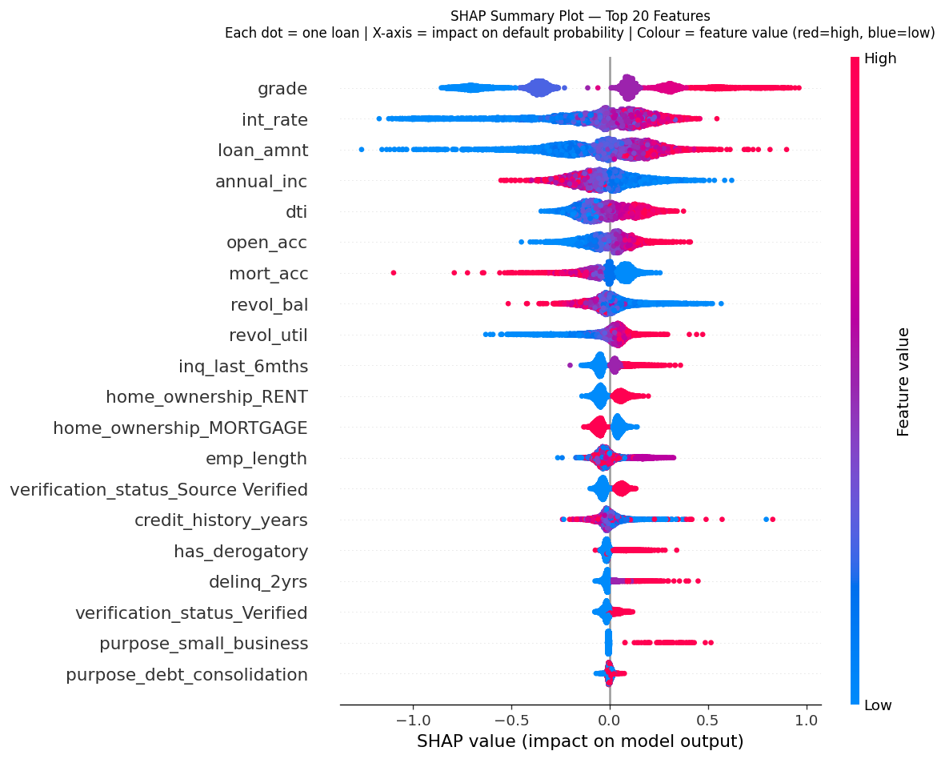
Figure: SHAP beeswarm plot. Each dot is one loan. Red = high feature value, Blue = low feature value. Width shows density of loans at that SHAP value.
The bar chart below shows the mean absolute SHAP value per feature — a clean ranking of global importance:
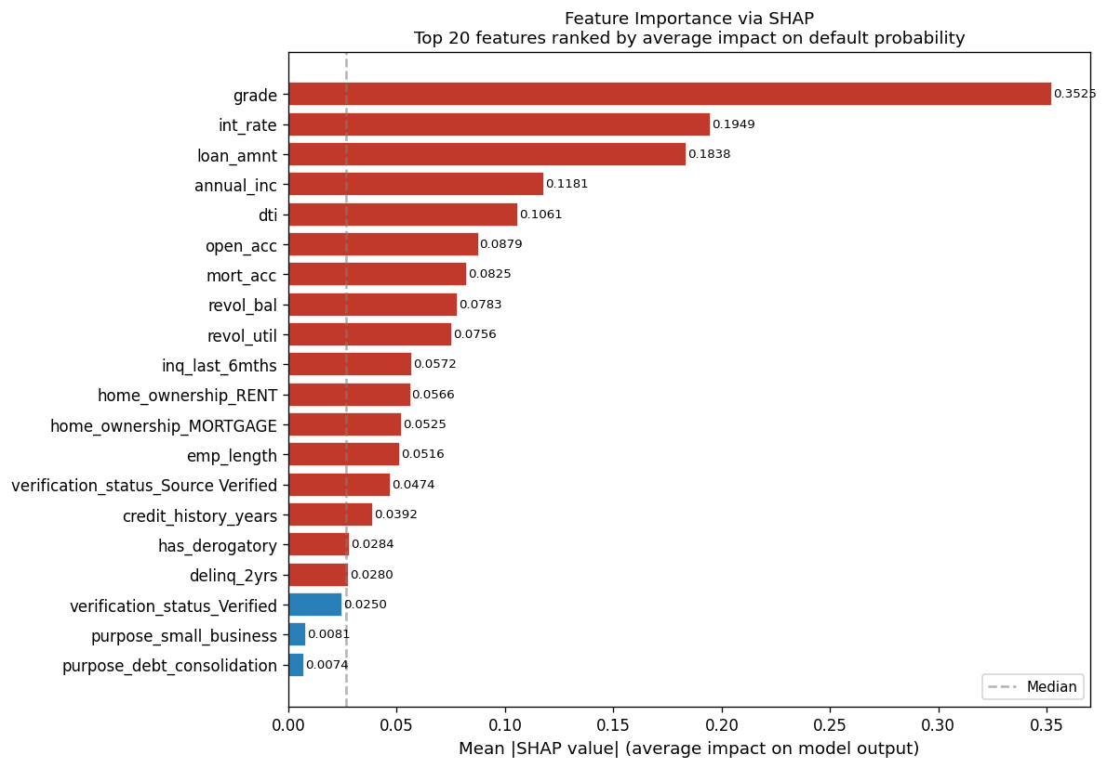
Figure: Mean absolute SHAP values (top 10 features). Higher = more influential.
Rank | Feature | Mean |SHAP| | Interpretation
1 | grade | 0.3525 | LendingClub's own risk grade — the single strongest signal
2 | int_rate | 0.1949 | Interest rate set by grade — closely correlated with grade
3 | loan_amnt | 0.1838 | Higher loan amounts increase default risk
4 | annual_inc | 0.1181 | Higher income lowers default risk (negative SHAP)
5 | dti | 0.1061 | Higher debt burden increases default risk

18.2 Individual Explanations — Waterfall Plots
Waterfall plots show how each feature pushed a specific loan's prediction above or below the base rate. Two contrasting loans were selected: a high-risk borrower (predicted probability 0.883, actual DEFAULT) and a low-risk borrower (predicted probability 0.111, actual FULLY PAID).
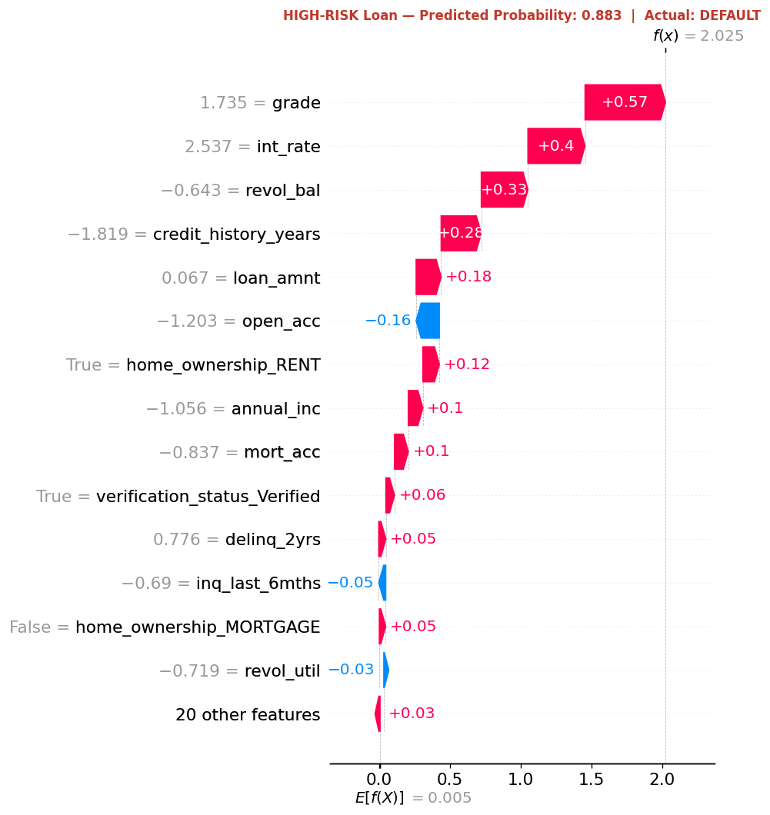
Figure: Waterfall plot for high-risk borrower (prob = 0.883). Red bars push the prediction higher (towards default); blue bars push it lower. Grade and int_rate dominate.
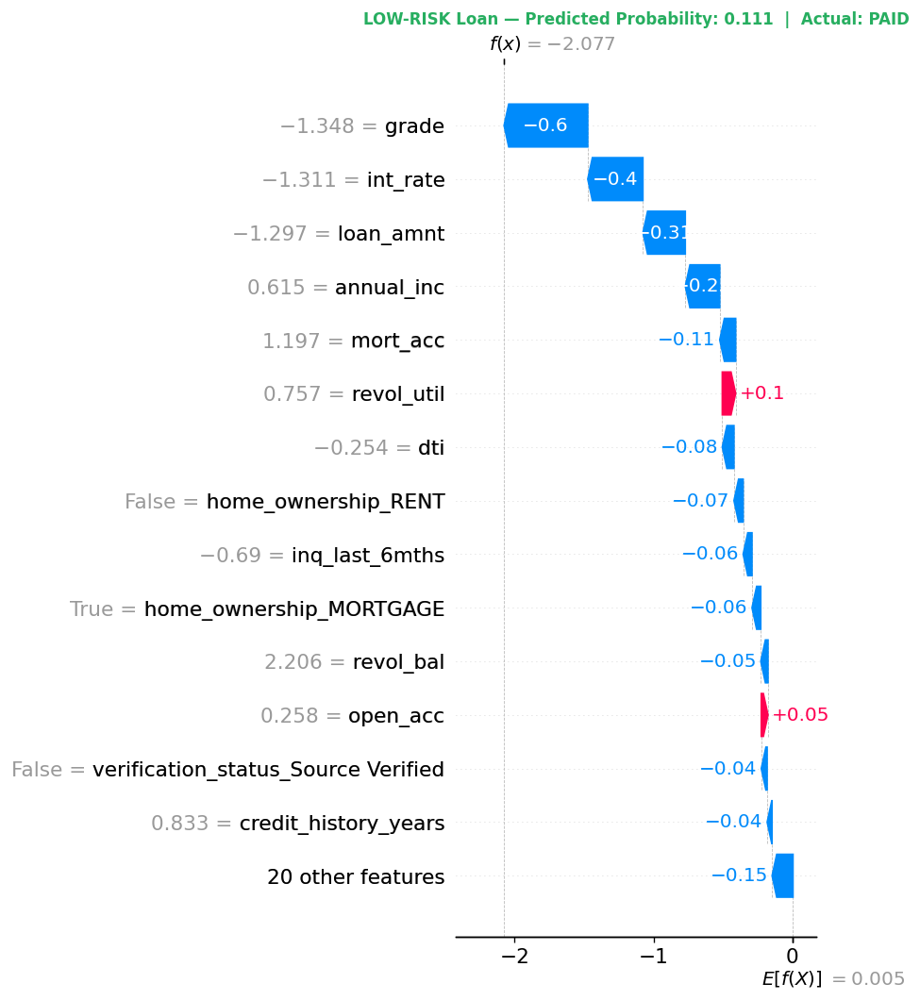
Figure: Waterfall plot for low-risk borrower (prob = 0.111). Low grade, low int_rate, and high income all push the risk score down.

18.3 Dependence Plots — How Grade and Rate Interact
Dependence plots show how a single feature's SHAP value varies with its actual value, and how a second feature (colour) modulates that relationship. The plots confirm that grade and interest rate interact strongly — high-grade, low-rate loans receive strongly negative SHAP (lower default risk), while low-grade, high-rate loans receive strongly positive SHAP (higher default risk).
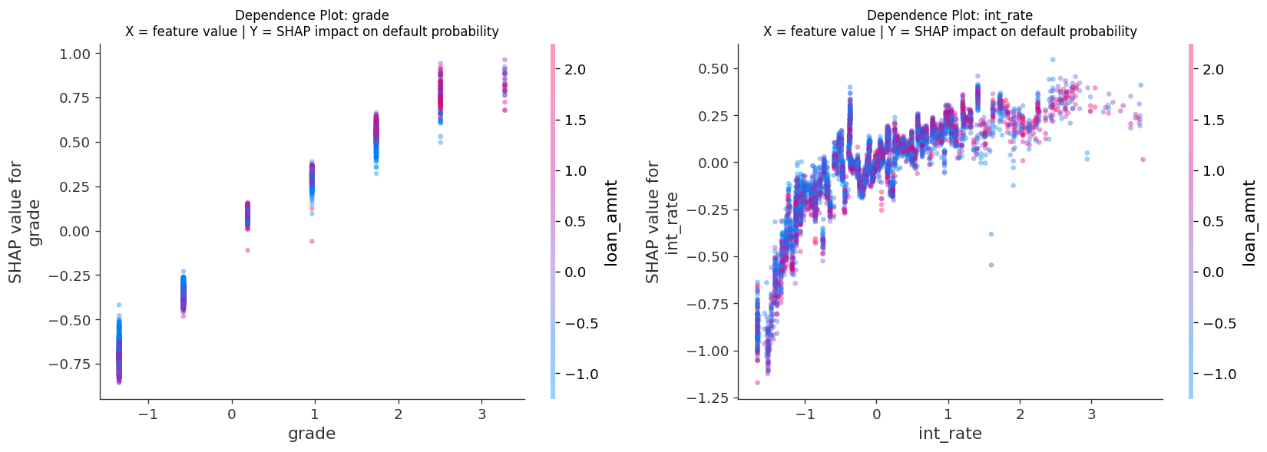
Figure: SHAP dependence plots for grade (left) and int_rate (right). Colour encodes a second interacting feature.
KEY TAKEAWAY: SHAP analysis confirms the model is behaving as expected: grade and interest rate dominate because they are LendingClub's own risk assessment, condensed into a single variable. The model is learning to trust the platform's existing risk judgement — then refining it with income, DTI, and loan amount.

19. SQL Analysis — Business Questions Answered with SQL
Notebook 08 loads the 1.35M loans dataset into a SQLite in-memory database and answers 9 targeted business questions using SQL. This demonstrates how SQL can deliver immediate analytical value on top of a machine learning dataset — covering GROUP BY, HAVING, CASE, Common Table Expressions (CTEs), and Window Functions.

19.1 Default Rate by Loan Grade (Q1)
Grade is LendingClub's internal credit assessment (A = safest, G = riskiest). SQL GROUP BY confirms a monotonic relationship: each grade step adds roughly 4–6 percentage points to the default rate.
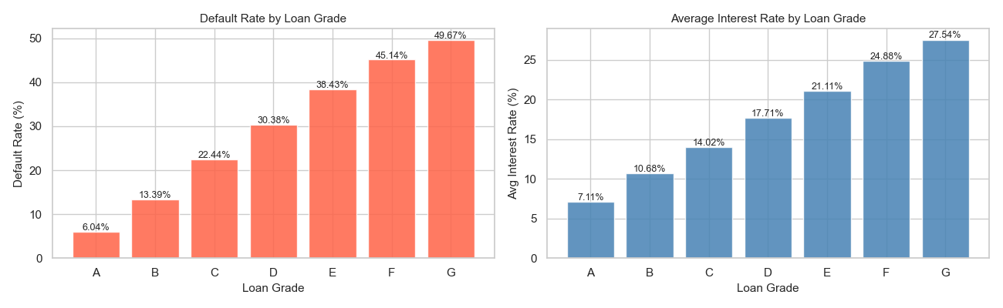
Figure: Default rate (left) and average interest rate (right) by loan grade. Grade G defaults at ~3× the rate of Grade A.

19.2 State-Level Analysis (Q2)
Using HAVING COUNT(*) >= 5,000 to ensure statistical reliability, California, New York, Texas, and Florida dominate by volume. The highest default rates by state vary by 5–8 percentage points from the lowest.
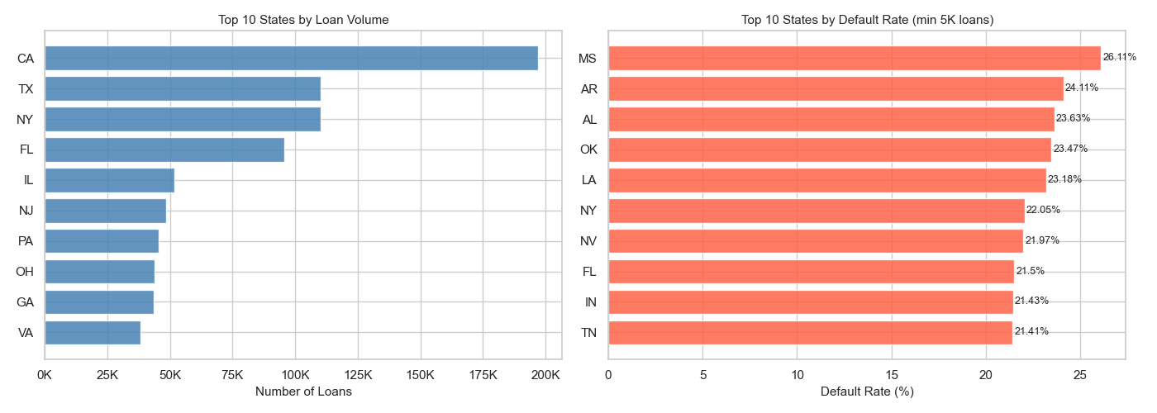
Figure: Top 10 states by loan volume (left) and default rate (right, min 5K loans).

19.3 Loan Purpose Risk Ranking (Q3)
CASE expressions label each loan purpose as High (>25%), Medium (>18%), or Low risk. Small business loans carry the highest default rate; credit card refinancing and home improvement are the safest categories.
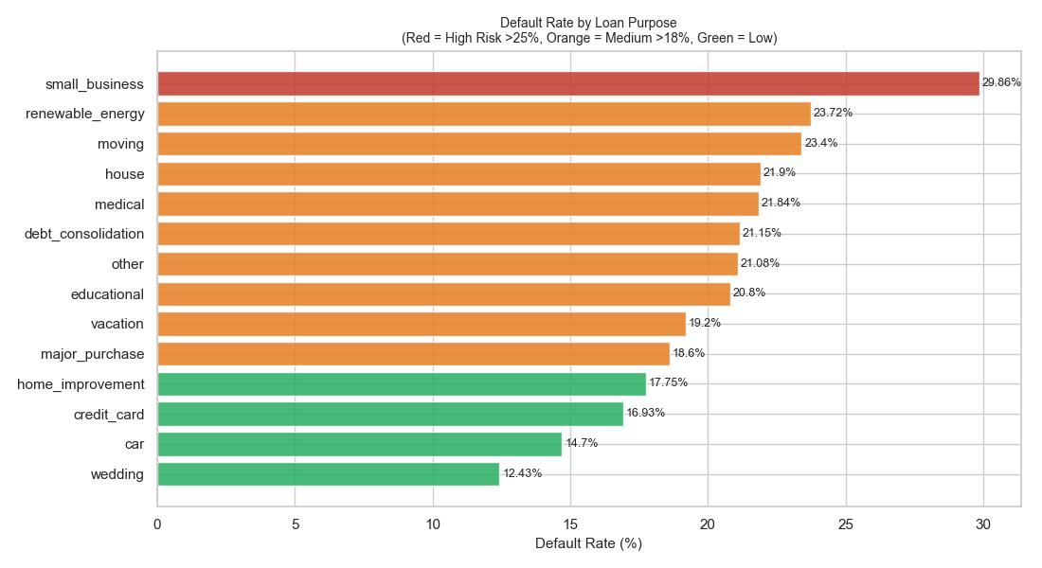
Figure: Default rate by loan purpose. Red = High Risk (>25%), Orange = Medium (>18%), Green = Low Risk.

19.4 Running Total — Window Function (Q6)
SUM() OVER (ORDER BY year) computes a cumulative count and loan volume without collapsing rows — a window function that GROUP BY alone cannot achieve. The charts show LendingClub's explosive growth from a few thousand loans in 2007 to over 1.35M cumulative loans by 2018.
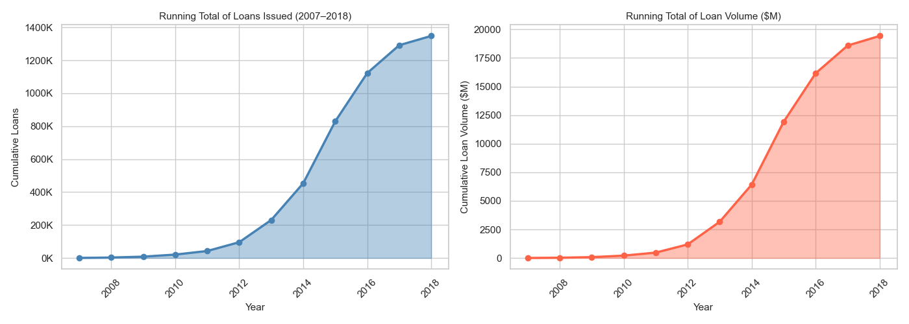
Figure: Running total of loans issued (left) and cumulative loan volume in $M (right).

19.5 Grade x Purpose Heatmap (Q9)
A two-dimensional GROUP BY across grade and purpose reveals which combinations carry the greatest risk. Grade G small business loans are the riskiest combination; Grade A credit card loans are the safest.
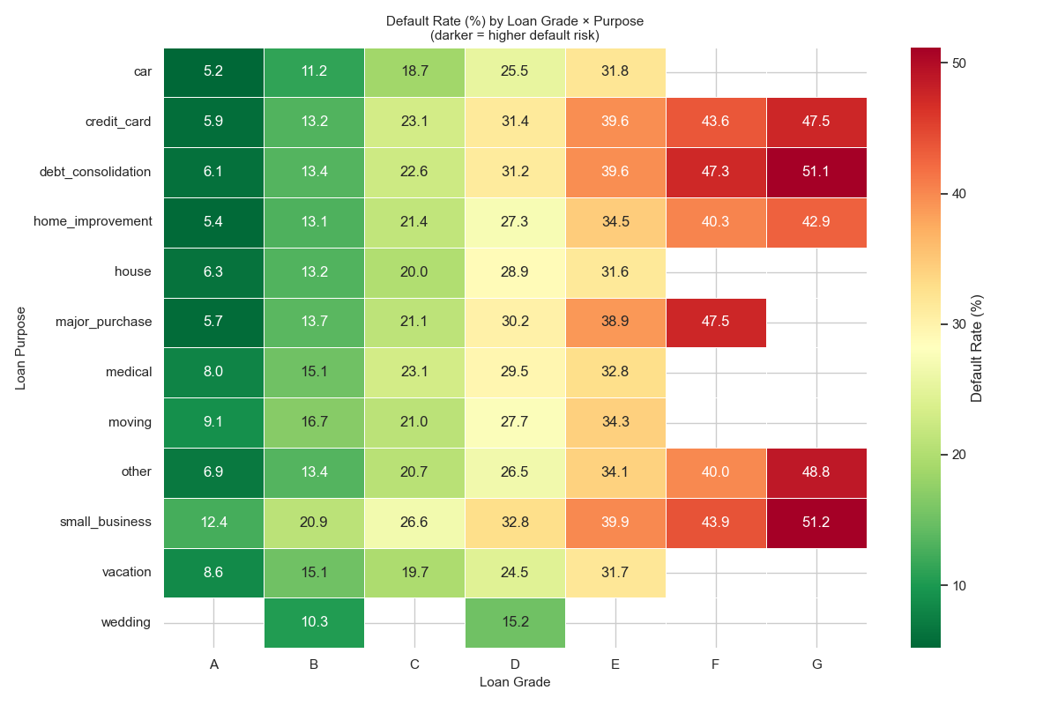
Figure: Default rate heatmap — loan grade (columns) x purpose (rows). Darker red = higher default risk.
Q# | Business Question | SQL Concept
Q1 | Default rate by loan grade | GROUP BY, aggregation
Q2 | Top 10 states by volume & default rate | GROUP BY, HAVING, ORDER BY
Q3 | Loan purpose risk ranking | CASE labels, ORDER BY
Q4 | Year-over-year loan volume trend | Date functions, GROUP BY
Q5 | Income bracket default analysis | CASE binning, GROUP BY
Q6 | Running total of loans issued | Window function: SUM() OVER
Q7 | High-risk vs low-risk borrower profile | CTE, UNION ALL
Q8 | DTI bucket analysis | CASE, GROUP BY, HAVING
Q9 | Grade x Purpose default rate matrix | 2D GROUP BY, pivot heatmap

SQL + ML: SQL analysis delivers business answers in seconds on the same dataset that took hours to model. It complements machine learning by providing transparent, auditable, rule-based insights that any stakeholder can verify and trust.

