USER MANUAL FOR ASSISTANT REGISTAR (PROJECT)
Receipt

- whenever PCE will submit receipt you will get notification of receipt.
- it will view as follows

screen shot – 01
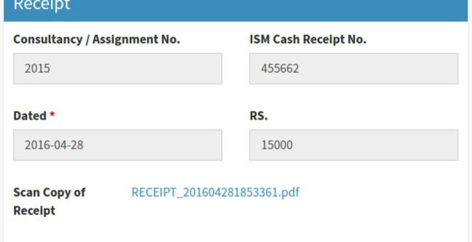

Approval of Disbursement Sheet.

- When PCE forward disbursement sheet.
- A notification will come to you .
- you have two option either forward or reject
- Approve:
  - after clicking forward button a confirmation button will added which will asked
are you sure.
II) after clicking “Are You Sure To Approve” the file will move to PCE. III) now you have to fill account project

screen shot – 02
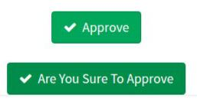

5.reject:
I)after clicking reject a remark text area and “Are You Sure To Reject” button will added. II) remark will be optional it should contain why are you form has been rejected.

III) after clicking ““Are You Sure To Reject” file will move again to CI. IV) a notifiacation will send to CI to fill again.
screen shot – 03
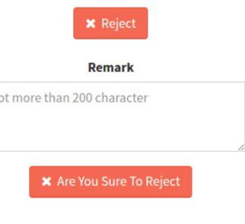

Filling of Account Project Form.

Step 1: Detail of receipt.
- all the details are auto filled form consultant estmate form

- for the detail click link in red

screen shot – 04
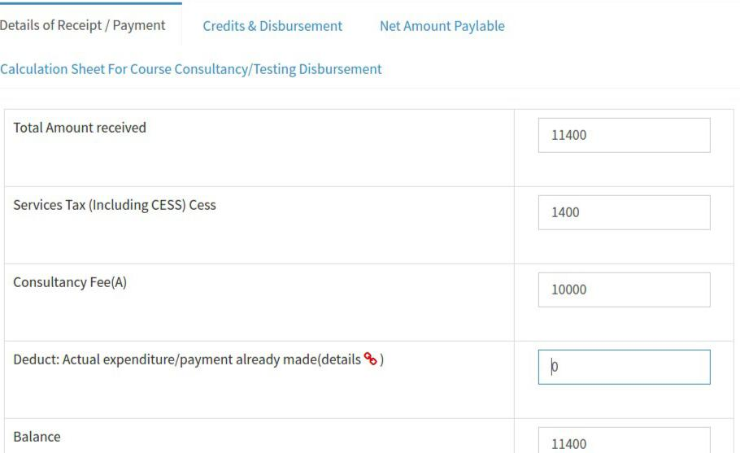

Step 2: Credit and disbursement
1. how are distributing the money .
2.most of data are auto filled from previous form.

3. grand total should be sum of all the data.

Step 3: Net amount Payable
1. if you have filled all the data in previous step all three row will automatically filled

Step 4: Calculation sheet for course consultancy/ testing disbursement
- it will contain all the emp which are present in consultancy ( faculty or non faculty)
- bank account no will auto fill if it is present in database.
- else fill it.
- fill the income tax and net amount paylable..

screen shot – 23
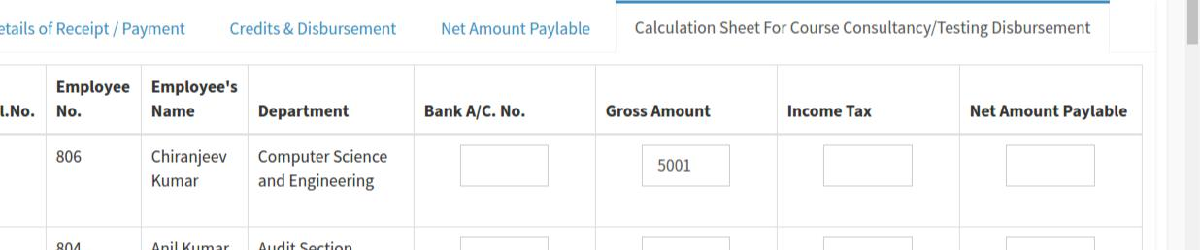

Viewing of Consultancy File.

→ You can track you file through following
- click view consultancy form in header
- click link in action column
- A pop up window will open which will show the status of your file andall process it gone through.

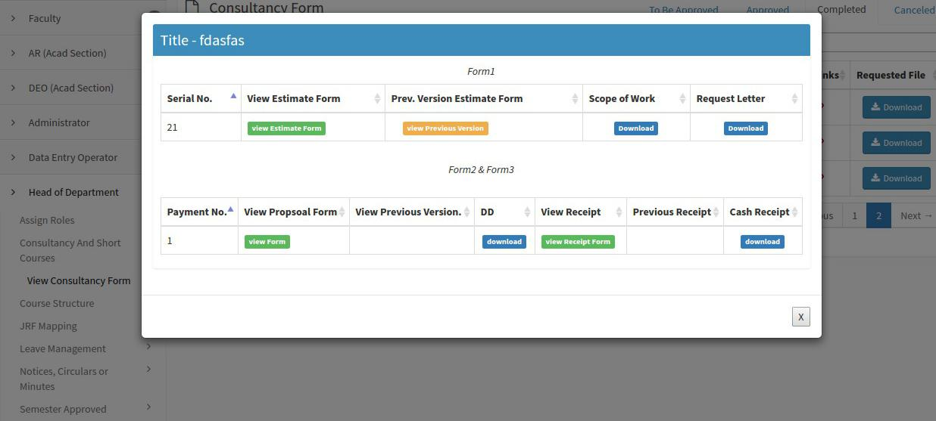
screen shot – 03

