USER MANUAL FOR DIRECTOR
Approval of of Estimate Form

- When PCE forwarded you will get a notification approve
- A notification will come to you..
- you have two option either approve or reject
- approve:
  - after clicking approve button a confirmation button and remark will added which will asked are you sure.
II) after clicking “Are You Sure To Approve” the file will move to PCE.
III) a notification will send to PCE to assign link up no and page no.

screen shot – 01
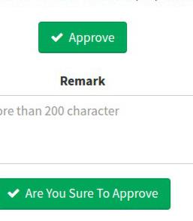

5.reject:
I)after clicking reject a remark text area and “Are You Sure To Reject” button will added. II) remark will be optional it should contain why are you form has been rejected.

III) after clicking ““Are You Sure To Reject” file will move again to CI. IV) a notification will send to CI to fill again.

screen shot – 02
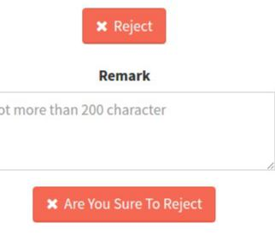
Approving and sanctioning of Project Account Form.

- When PCE recommend project account.
- A notification will come to you for approve if total amount is greater than 200000.
- you have two option either approve or reject
- Approve:
  - after clicking forward button a confirmation button will added which will asked are you sure.
II) after clicking “Are You Sure To Approve” (it's completion of this consultancy). III) a notification will send to CI.
5.reject:
I)after clicking reject a remark text area and “Are You Sure To Reject” button will added. II) remark will be optional it should contain why are you form has been rejected.

III) after clicking ““Are You Sure To Reject” file will move again to Ar project. IV) a notifiacation will send to Ar project. to fill again.
*** reject is same as estimate form.

Viewing of Consultancy File.

→ You can track you file through following
- click view consultancy form in header
- click link in action column
- A pop up window will open which will show the status of your file andall process it gone through.

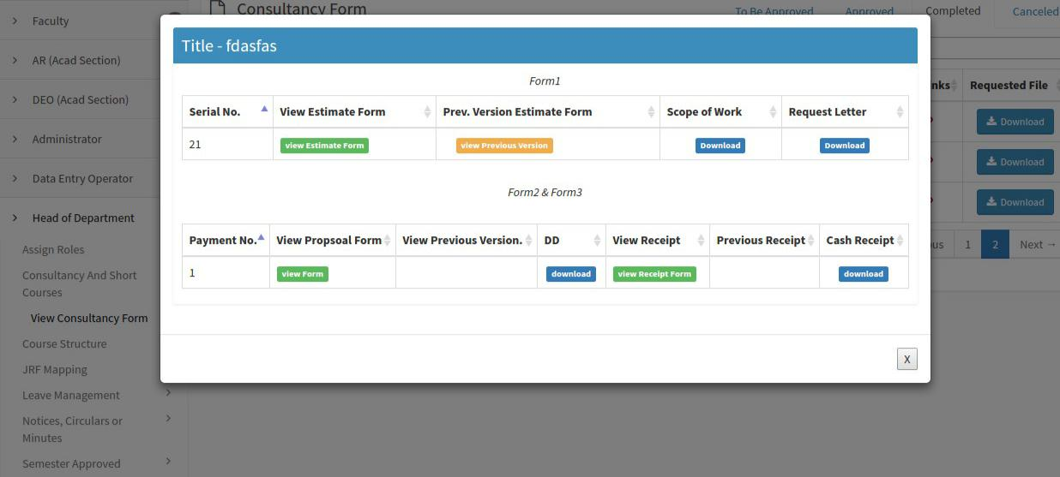
screen shot – 03

