Module : Consultancy and Short Courses

USER MANUAL FOR CONSULTANCY IN CHARGE

PRIMARY DETAIL
1. Title : It will contain the title name of consultancy e.g FOUR WEEK ADVANCE COURSE
2. Scope of Work: it will have pdf which will contains what type of work this consultancy is doing
3. Letter of request from client/ approval letter from Director :
if this estimate form is for consultancy then you should upload the letter of request from client
else if this is short courses then you should upload the approval letter from Director

DETAILS OF CONSULTANCY INCHARGE
4. filling of member of this Consultancy and their share
1) first row' details will of consultancy in-charge that are added by default in the first row .whosoever is applying the consultancy must be consultancy in-charge details are added from login details
2) we have to fill the share and click add button unless the data will not shaved in the table

screen shot – 02
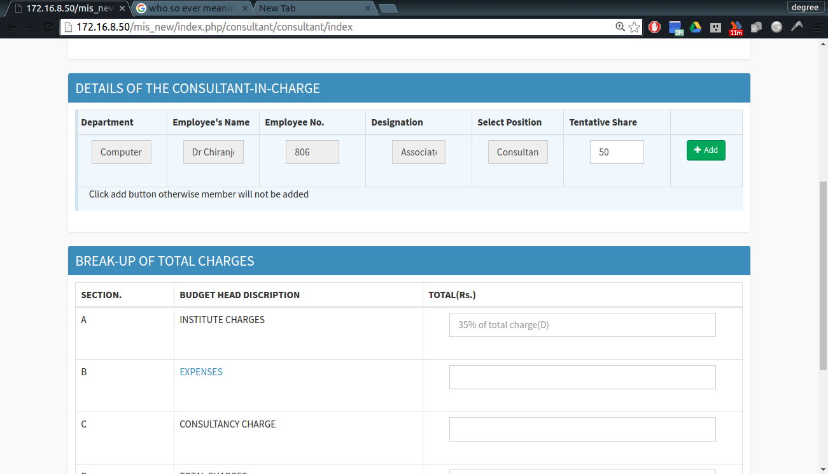
3) after click , new row will added like this under the previous member
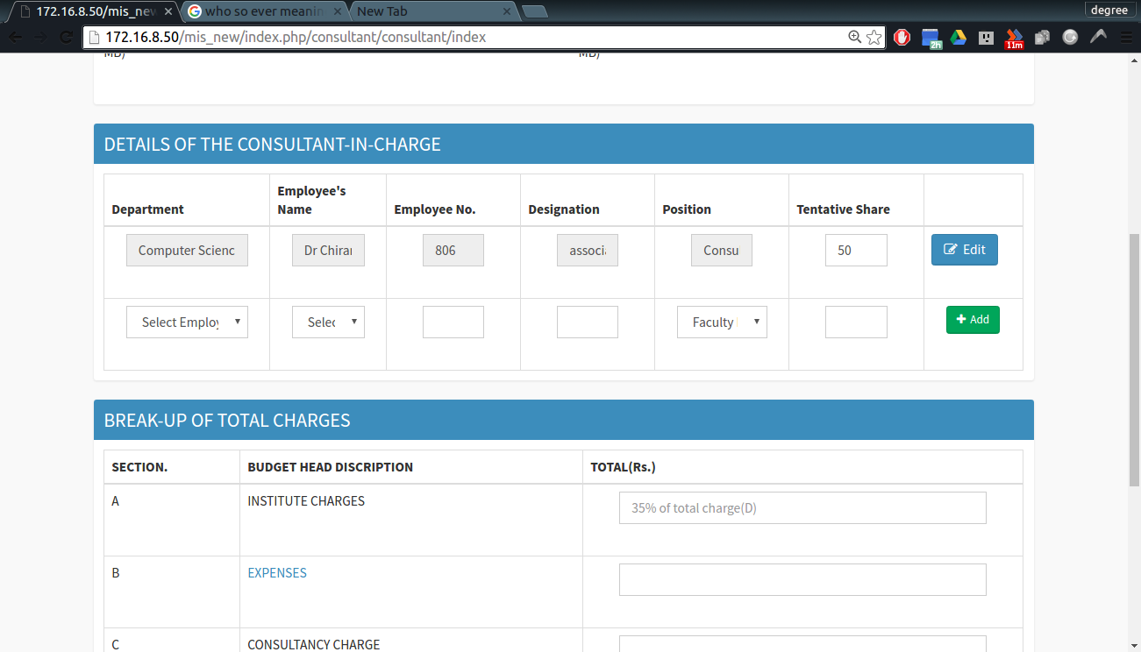
screen shot – 03
4) fill the member' details as follows
i)select employee's department in first column through drop down.
screen shot – 04
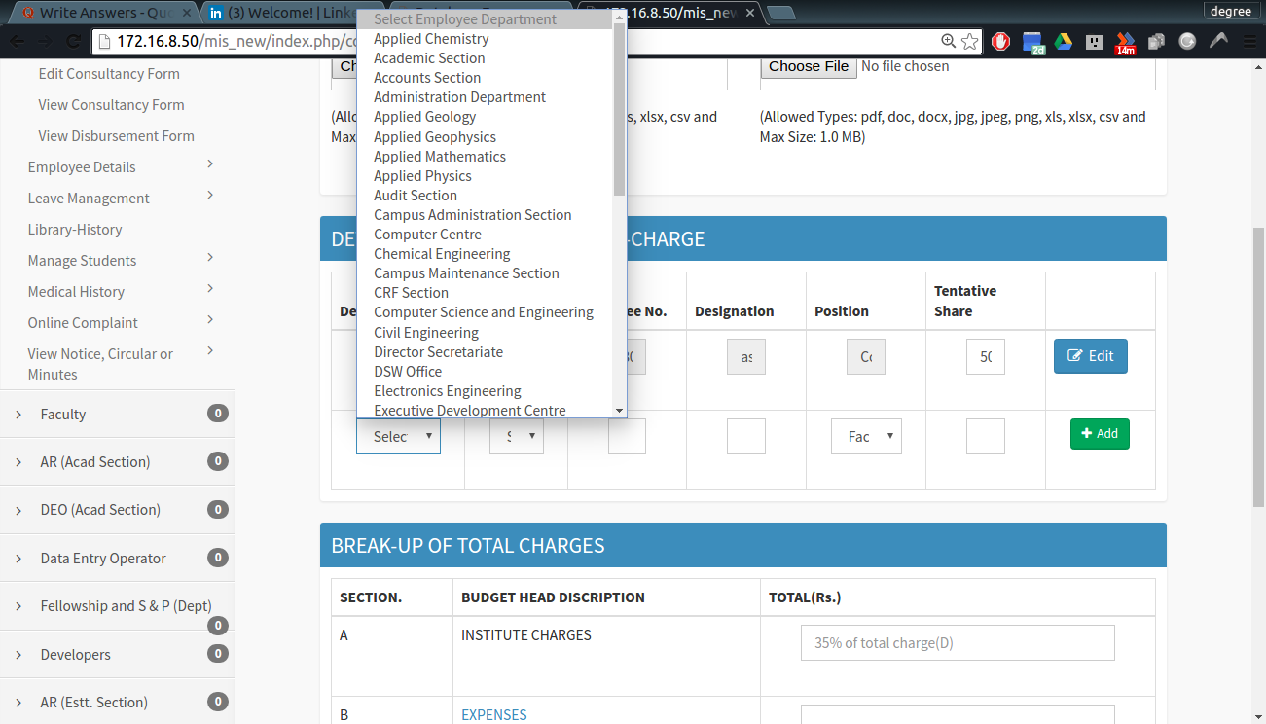
screen shot – 05
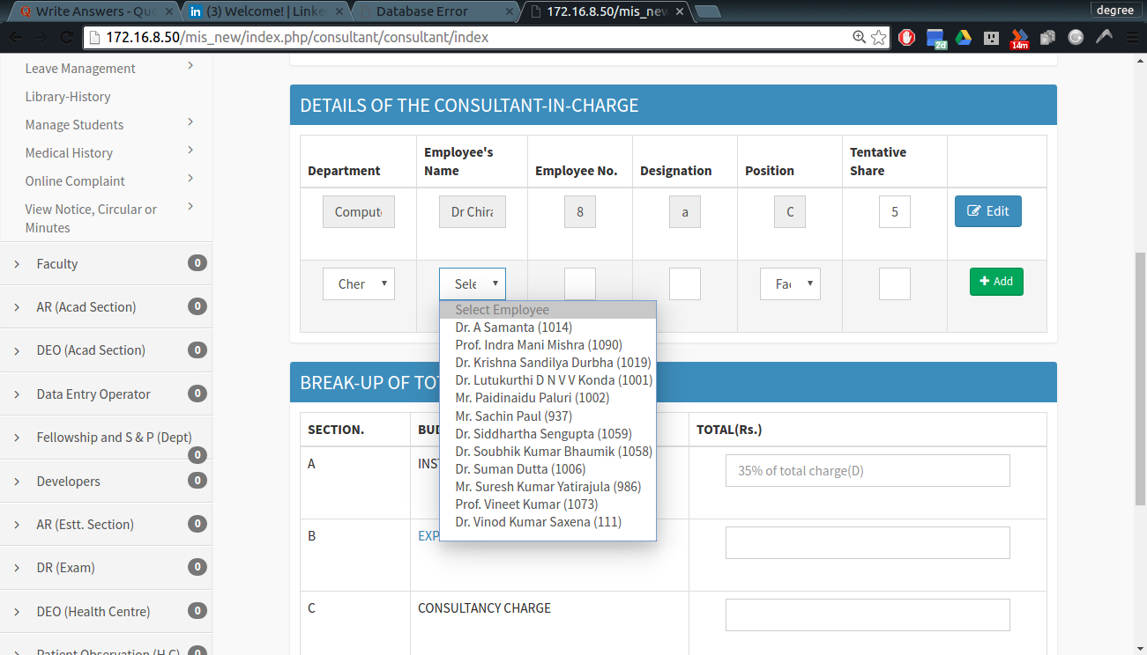
ii) select employee' s name in second column though drop down. iii)designation and position will be auto filled.
iv)select position of employee in this consultancy .
There are two options a) Co consultancy in-charge
b) faculty member
v) fill the tentative share (sum of share of
all the member should be 100)
vi)click add button to add this member which we have filled
(note : without clicking add the member will not be added)

screen shot – 06

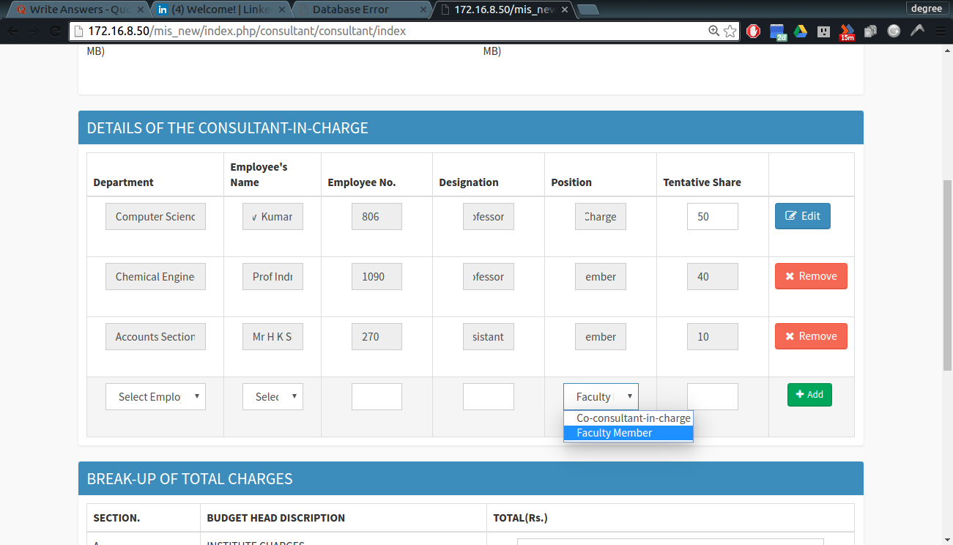
5. a)you can remove any member but CI by clicking remove except CI
b) you can only change the share of CI by first changing the share and clicking edit.
screen shot – 07
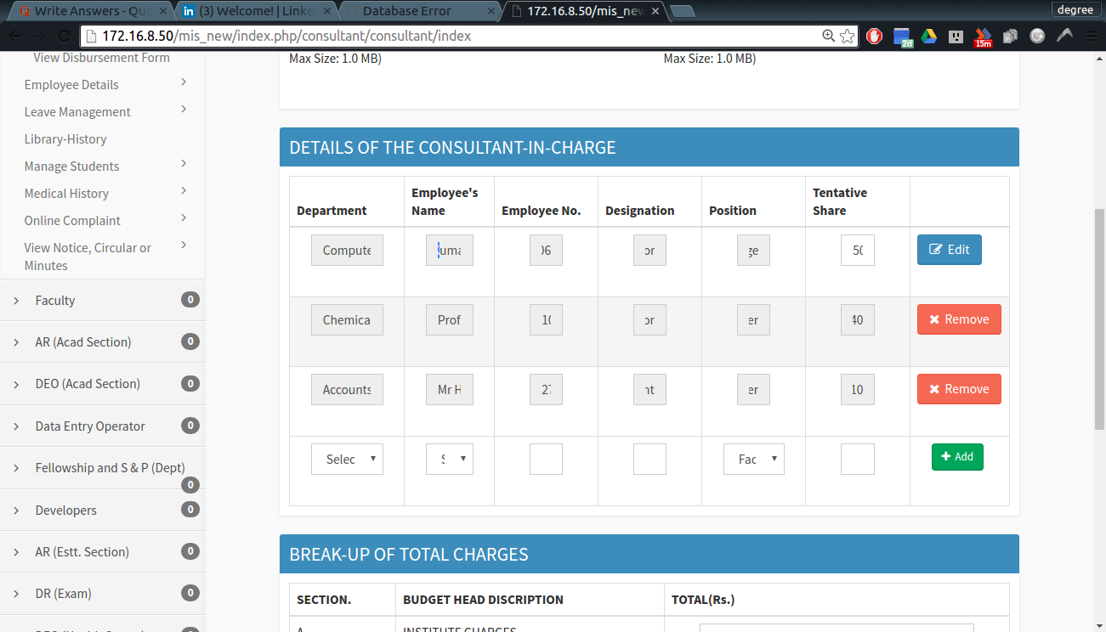
BREAK-UP OF TOTAL CHARGES

6. here CI has to enter all the charges for consultancy. This form has a script which auto fill the some column which is dependent upon the order in which you fill it.
I) fill the gross amount, service tax, total charges and institute charges will be auto fill.
II) fill either consultancy charges or expense other will be auto fill
screen shot – 08
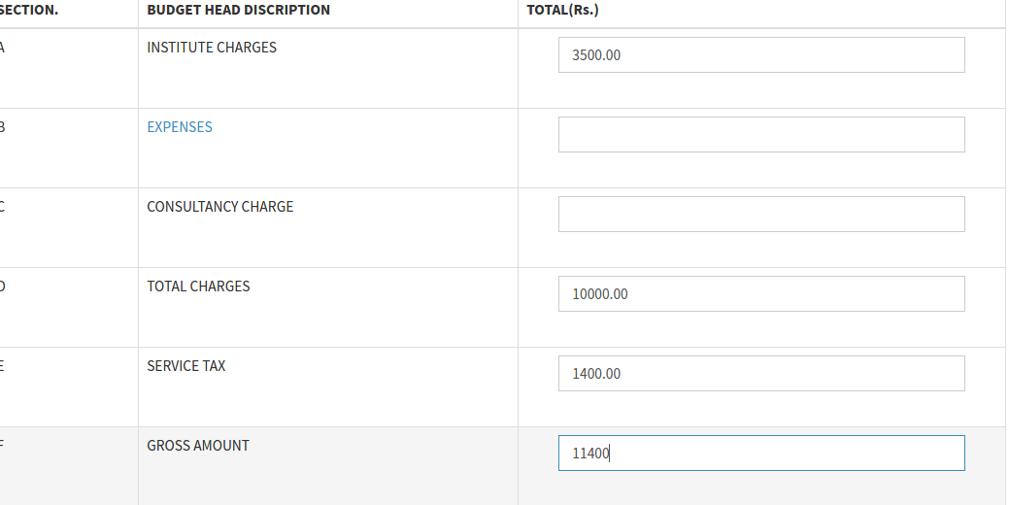
screen shot – 09
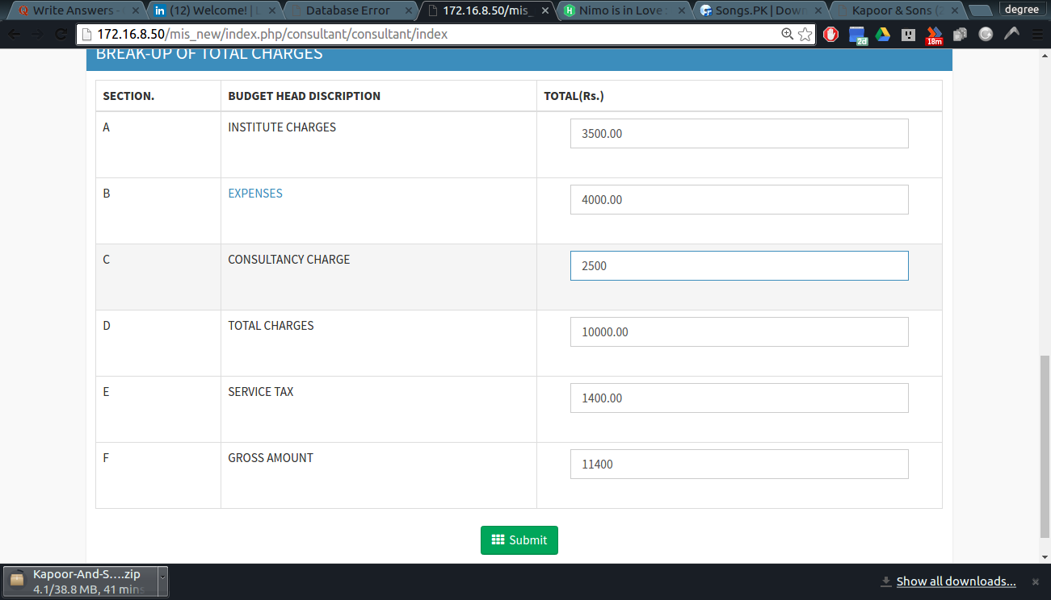

III) click EXPENSES a form for all expenses will open , fill it sum of all expenses should be equal to t he sum filled in EXPENSES input.

screen shot – 10
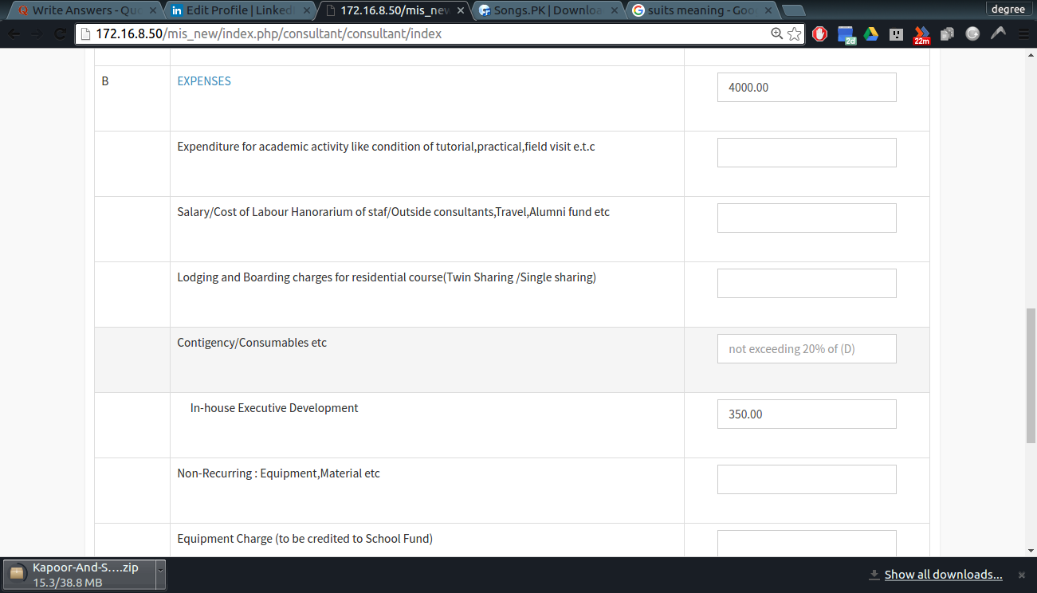
click submit , this form will be send to HOD for approval .
→ You will get notification after every event
→ You can track you file through following
1) click view consultancy form in header
2) click link in action column
3) A pop up window will open which will show the status of your file andall process it gone through.

screen shot – 11n shot – 10R
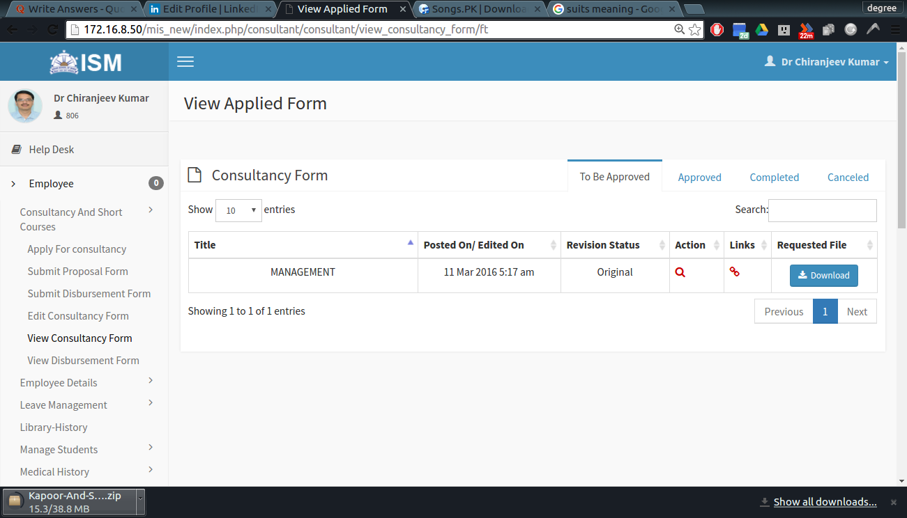

After this estimate form approved by Director pce will generate assingn
link up no and page no.
after that you will notify that you can now proposal form

screen shot – 12
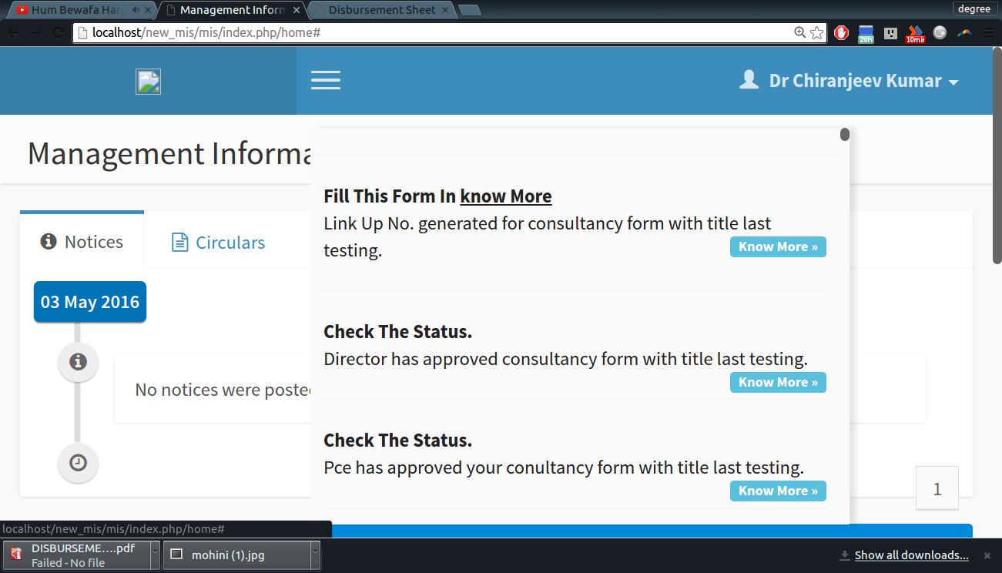

screen shot – 13
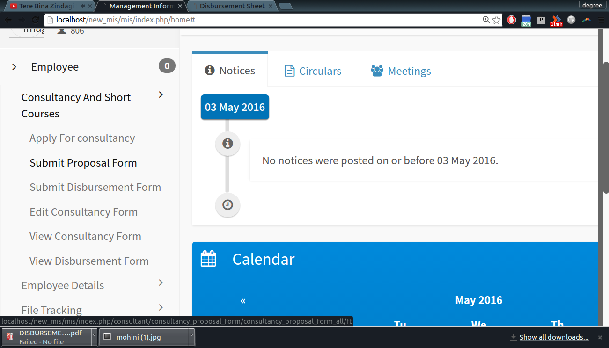
FILLING OF PROPOSAL FORM

Step 1:Click the submit proposal form in header.

Step 2:it will redirect to a table which contains all the consultancy where proposal can be applied.

screen shot – 14
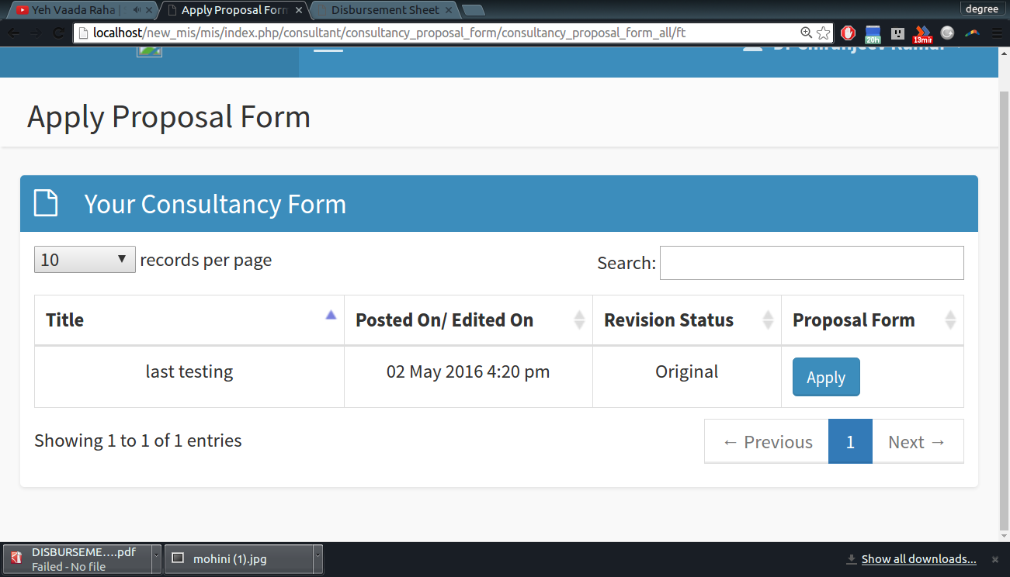
Steps 3:
Click apply on corresponding consultancy.

Step 4:
You will redirected to choice of payment that
is you have detail of payment or it is with screen shot – 15
You will fill next payment for that consultancy.
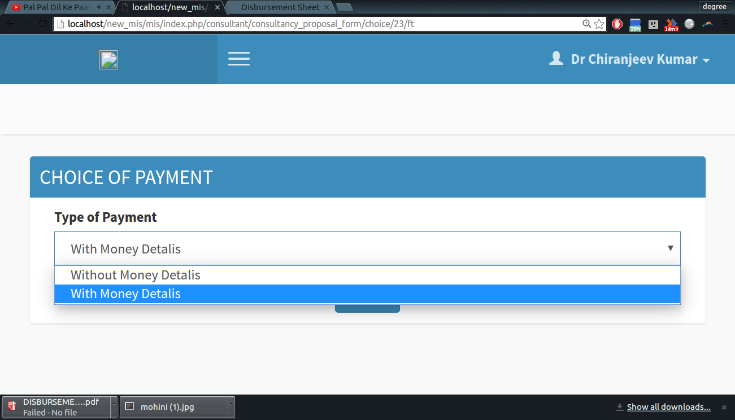
project account (case of on line transaction)

Step 5:
Select type of payment and click submit
you will redirected to proposal form

Step 6:
1.Fill the detail of expected time schedule.
2. time period of project in form of __year__month__week__days
3. fill the starting date of project.

screen shot – 16
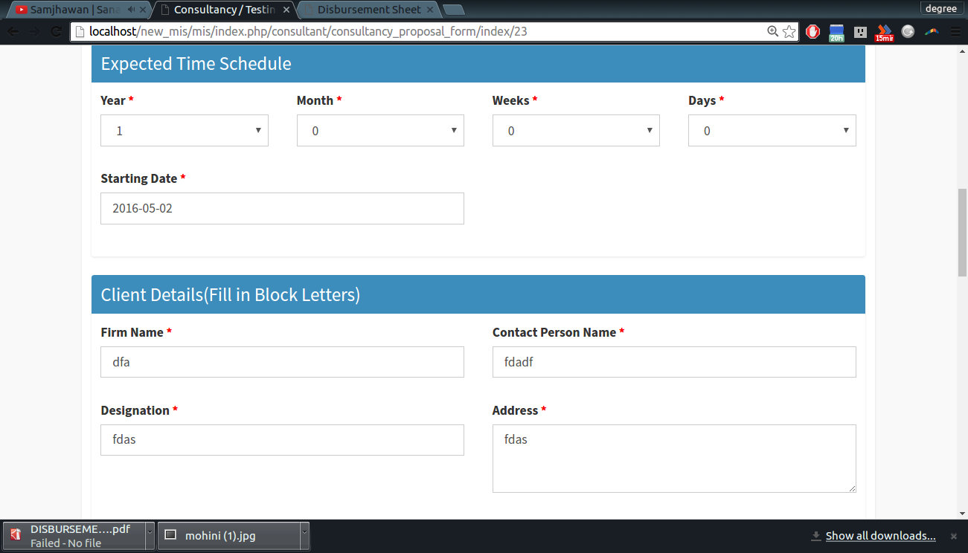

Step 7:
1. fill all the details of client
2. all details are general

screen shot – 17
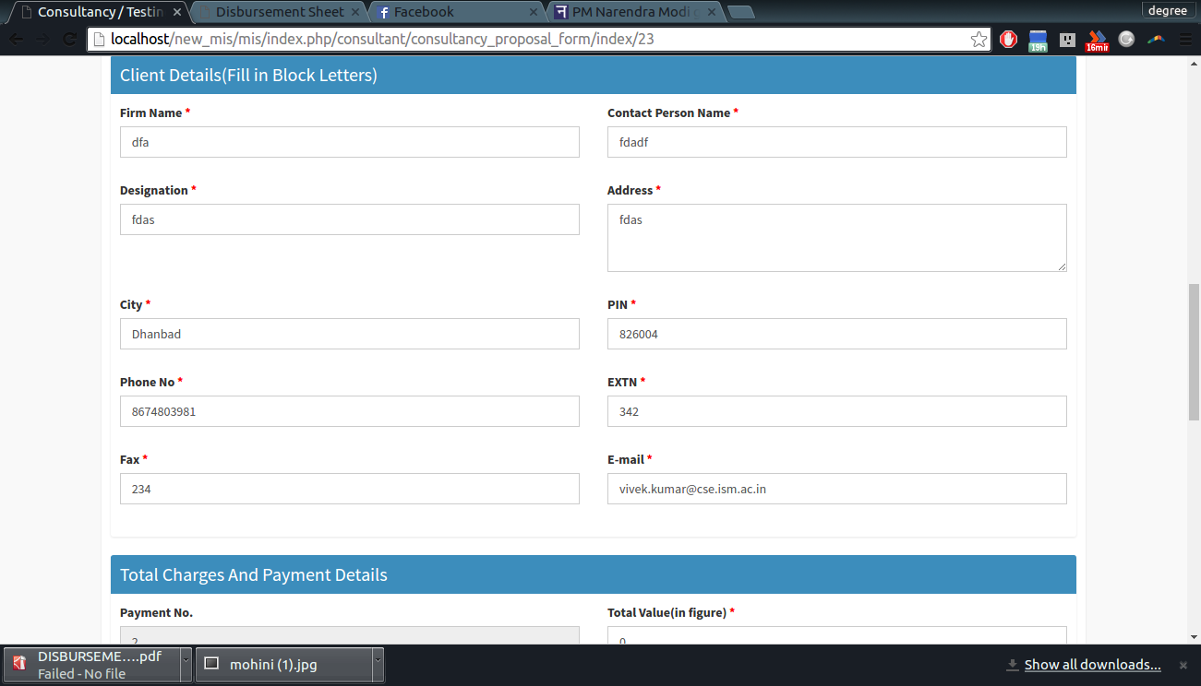

Step 8:
1.Fill total charge and break up
2.Not required if choice chosen at first is without.
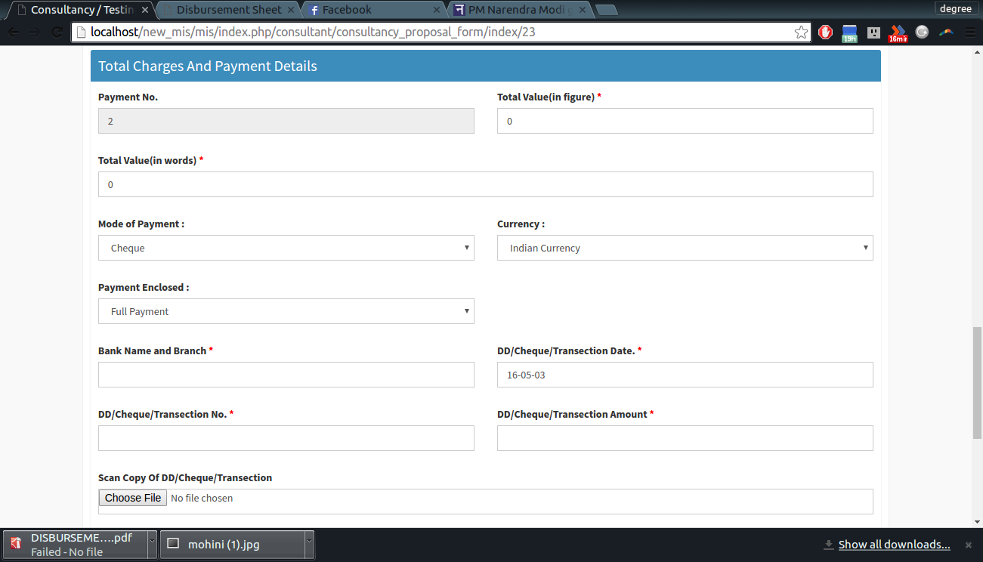
screen shot – 18

3.Total value( in fig) is total amount that client has
to pay. He can pay partwise. But here he have to screen shot – 19
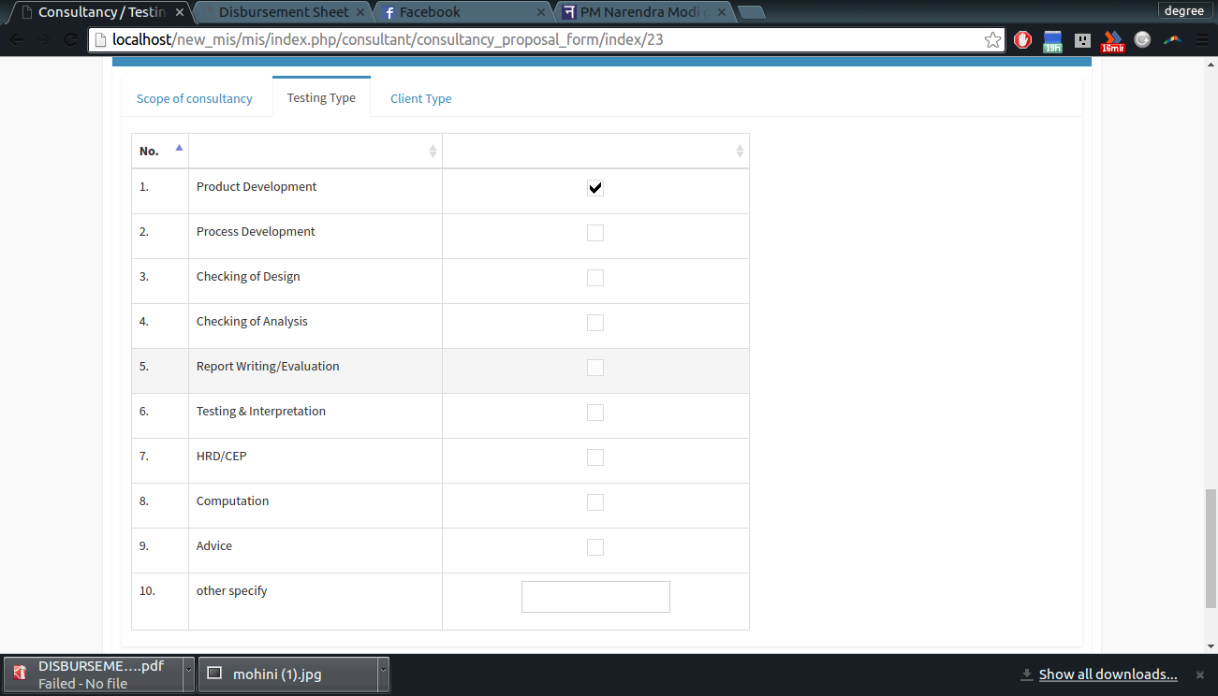
mentioned to about complete amount .
4.currency is indian or foreign
5. if foreign you have to mention name of
currency in box appear below.
6. all other input are detail of payment
and mode.
7. also insert the scan copy.

Step 8: upload the scope of consultancy
(I.e area of consultancy)

Step 9:
1. tick the testing type (which type of testing )
2. you can tick multiple checkbox

screen shot – 20
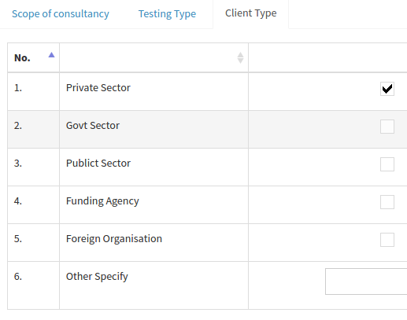
Step 10:

1. tick the client type
(which type of client )
2. you can tick multiple checkbox

Step 10:
correspondence with client
if yes
click yes
else
click no.

You can view all the file for a consultancy by clicking links symbol in view consultancy for that consultancy. A pop up window will open as follow.

screen shot – 21
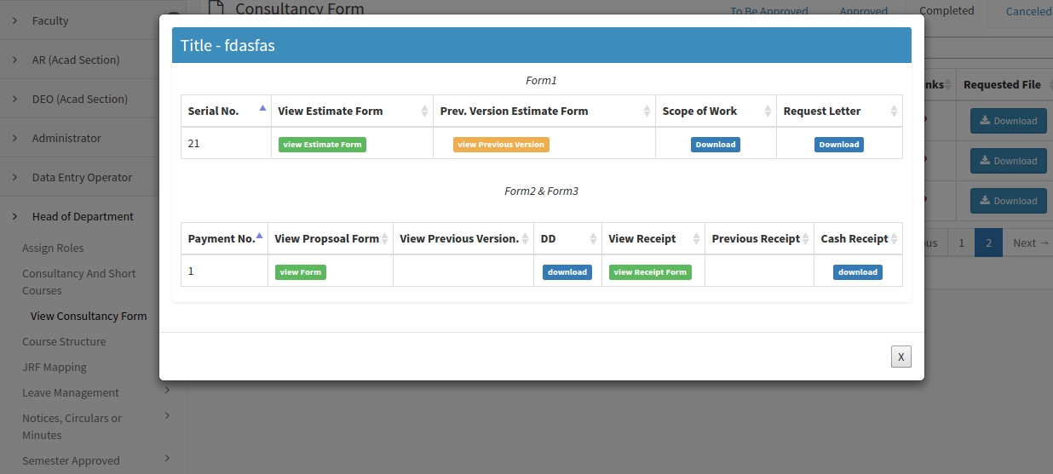
after PCE confirmed by clicking done, you are ready to fill the disbursement sheet.
FILLING OF DISBURSEMENT SHEET.

Step 1: Detail of receipt.

1. all the details are auto filled form consultant estmate form
2. for the detail click link in red
3. Its mandatory for you to upload the statement of expenditure.

screen shot – 22
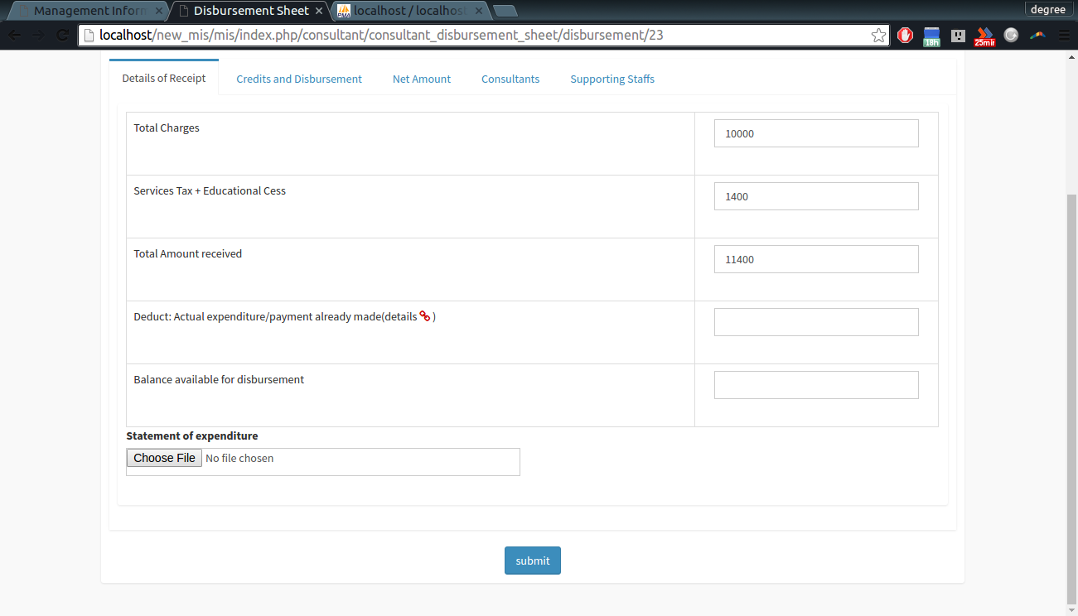

Step 2: Credit and disbursement
1. how are distributing the money .
2.most of data are auto filled from previous form.
3. total credit should be sum of all the data.

Step 3: Net amount
1. if you have filled all the data in previous step first three row will automatically filled
2. once you filled fifth , other three will als filled.

Step 4: Consultant
1. it will contain details of consultant and facutly member and amount received by them
2. first a input will appear and asking no of person.
3. fill the number of person including consultancy incharge.
4. click enter next to input.
screen shot – 23
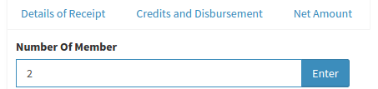

4. click enter next to input.
5. number of row will inserted which will be equal to number of member you have entered.
6. first row will of consultancy in charge so it will be already filled you only had to enter gross amount.
7.other row you have to select each employee as I have guided in estimate form .

screen shot – 24
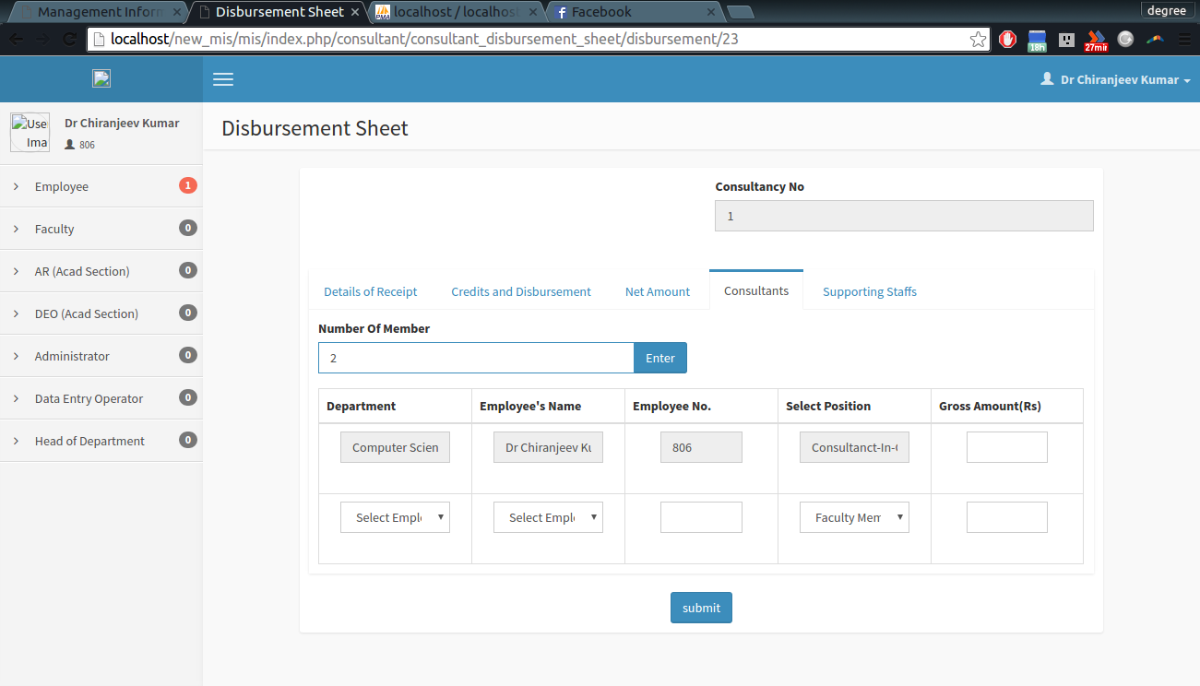

Step 5: Supporting staffs
1. it will contain details of staff and amount received by them
2. first a input will appear and asking no of staff. (sane as step 4)
3. fill the number of staff
4. click enter next to input.

screen shot – 25
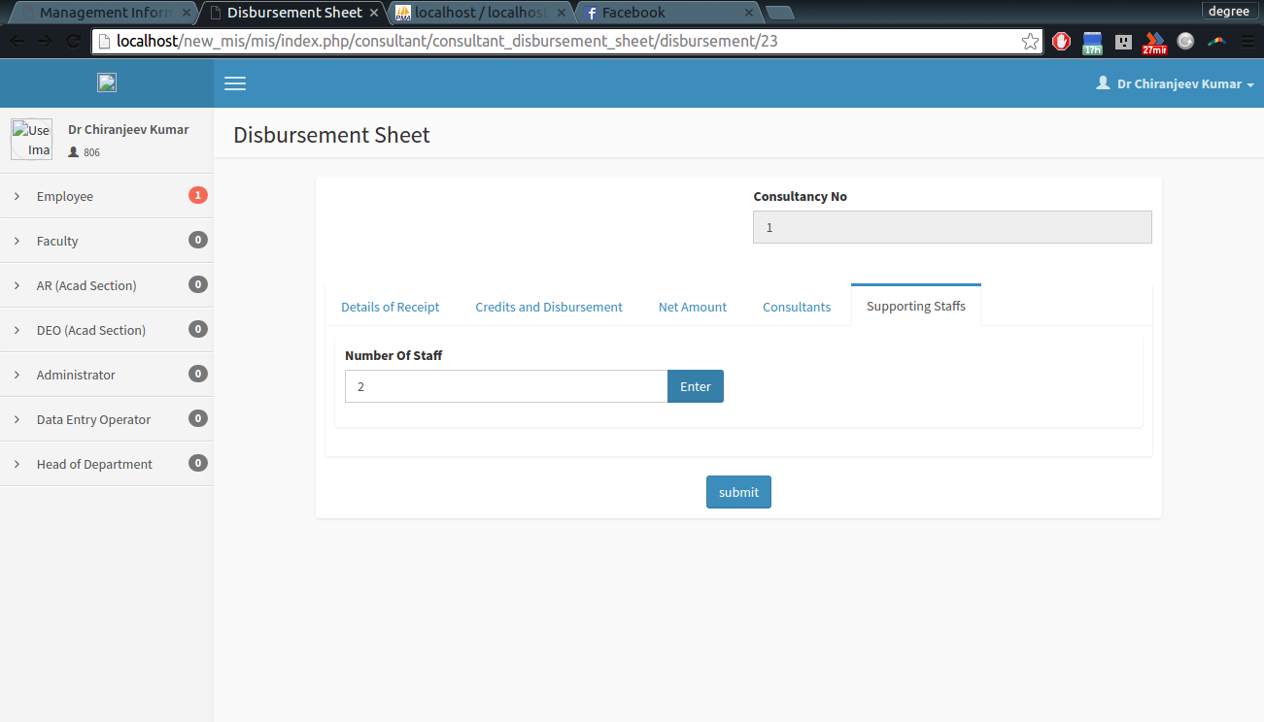

5. other will be same as step 4

