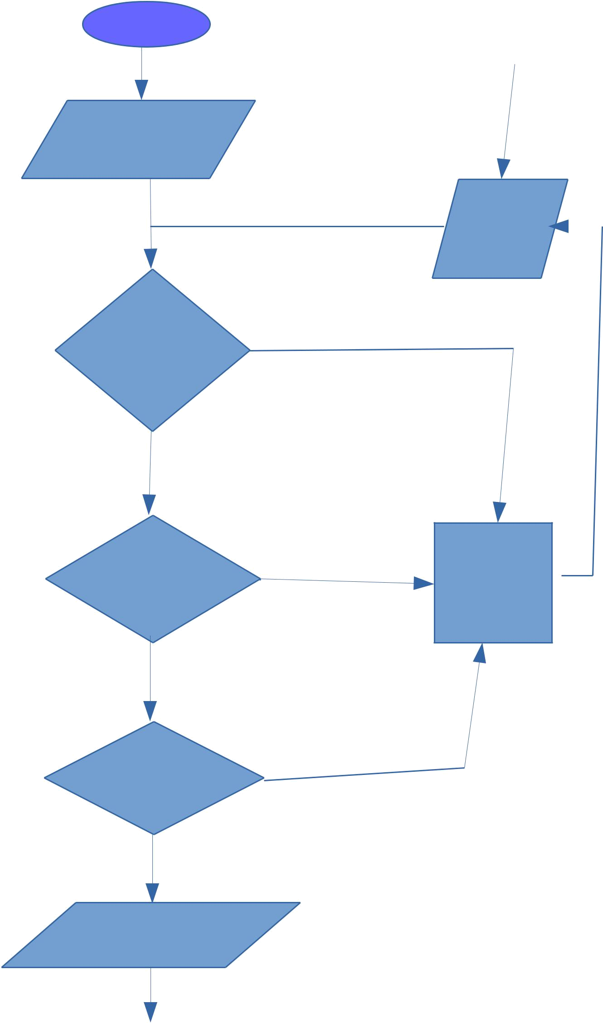
START

Estimate form applied by CI

Forwarded By HOD | NO
Of Department of CI

YES

NO

Forwarded By PCE

YES

NO

Approved By Director

YES

Can be edited
By CI

Estimate Form |  | TO
Edited by CI |  | CI
 | N
 | O
 | T
 | I
 | F
 | I
 | C
 | A
 | T
 | I
 | O
 | N

REJECTED

Assign Link Up No and Page No

Can be edited
By CI

Proposal Form
Of This Payment No

Are Edited

REJECTED

Apply Proposal Form
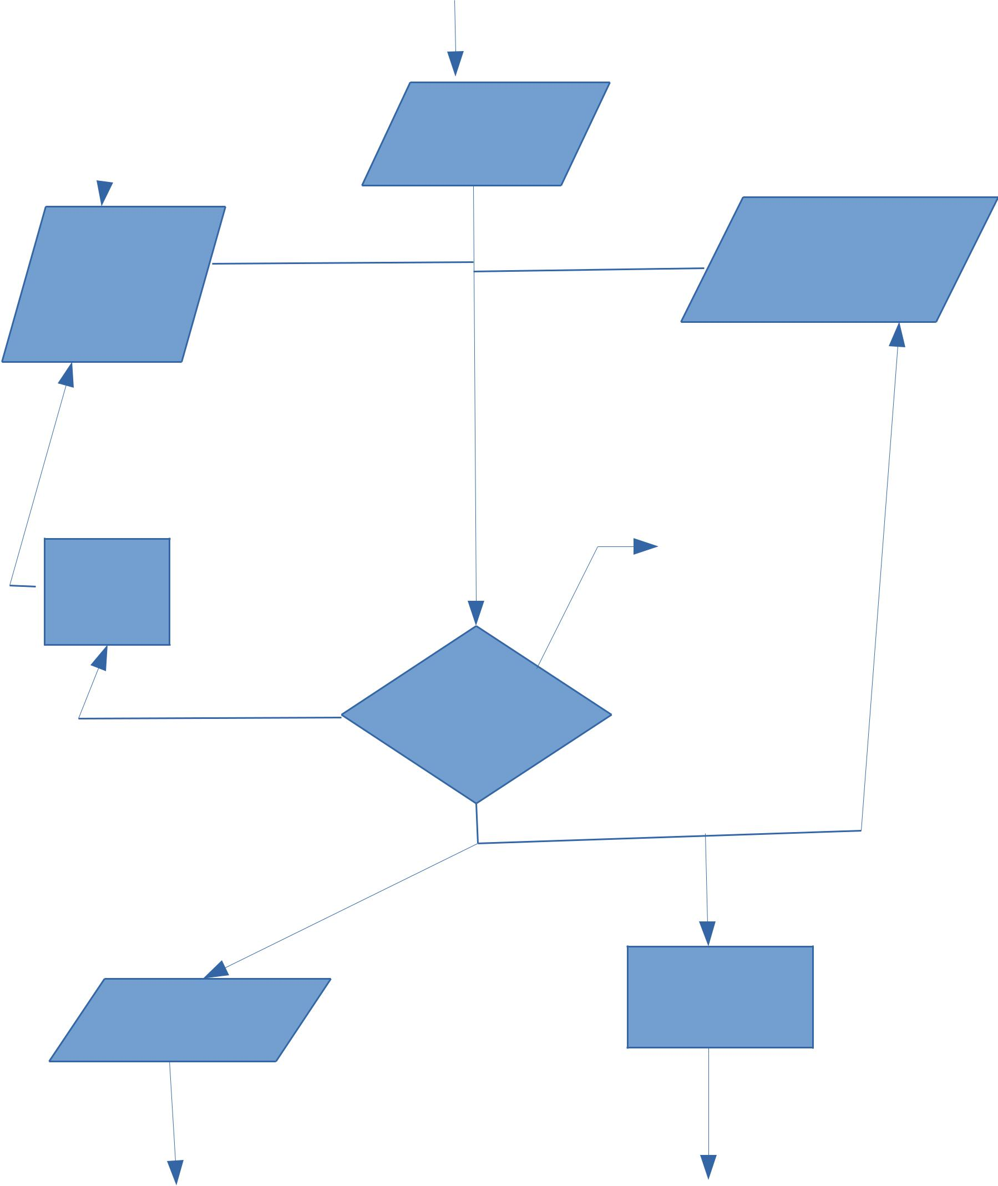
With Payment No 1
BY CI

NO
Approved By PCE

YES

Apply next proposal Form

With Payment No =
Current Payment No.+1

 | N | TO
 | O | CI
 | T
 | I
For payment | F
No. 1 Assign | I
Consultancy no. | C
 | A
 | T
 | I
 | O
 | N

PCE Has
Submitted the Receipt

Send the receipt to CI
And Ar_prj

Exit the loop If PCE
Has Clicked 'DONE'

Disbursement Sheet will generated

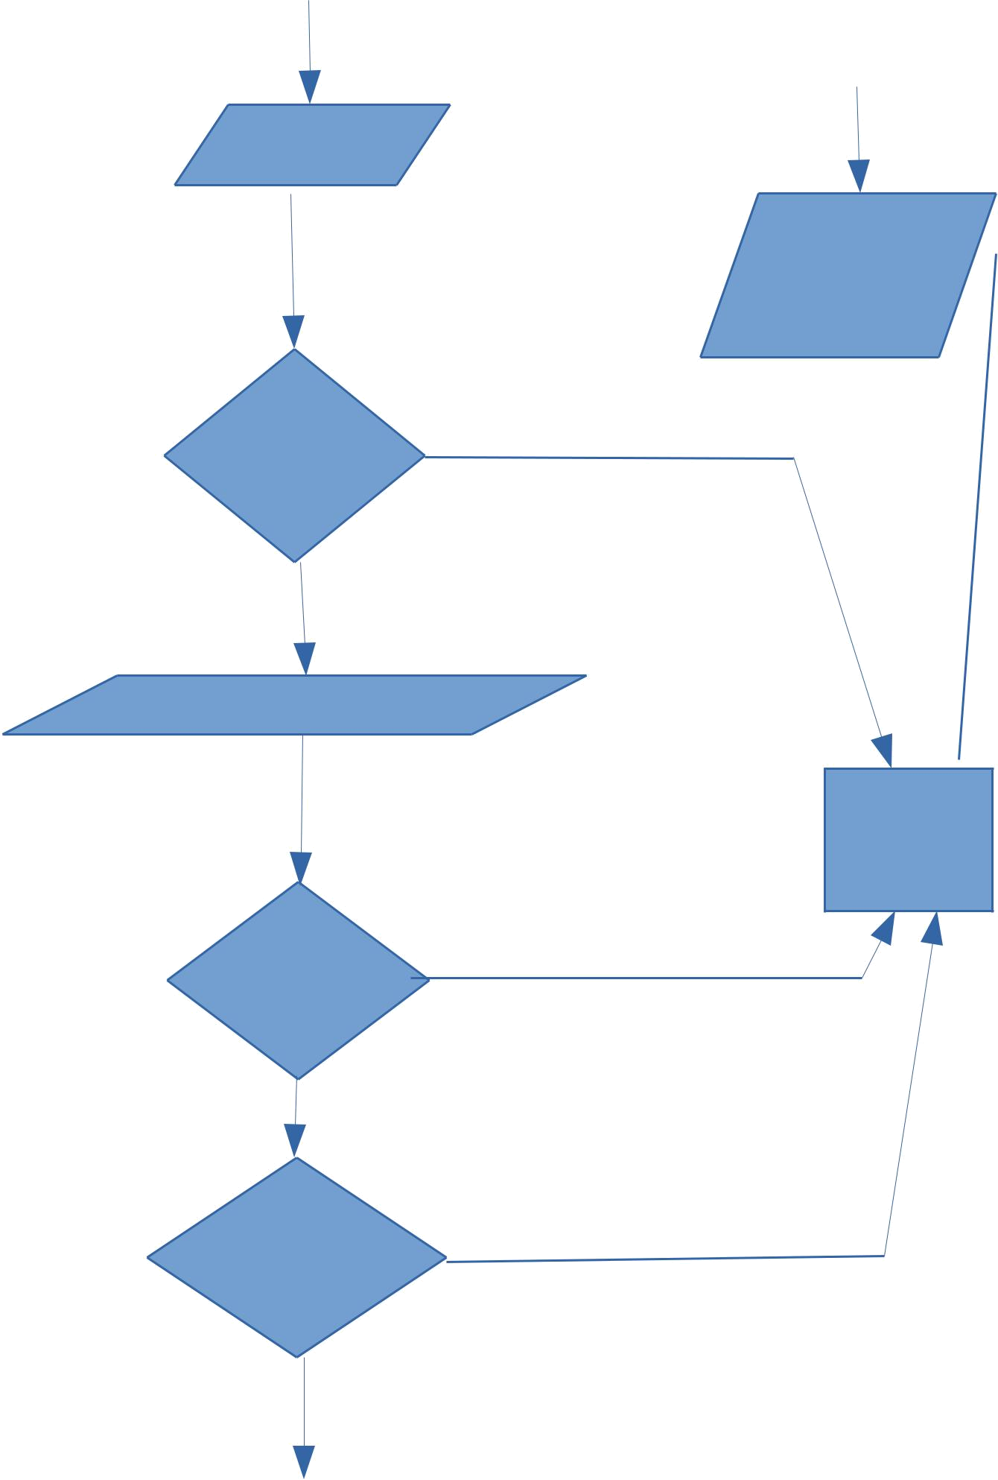
Can be edited
By CI

CI has submitted The disbursement

Disbursement Form

Edited by CI

Forwarded by HOD

NO

YES

Memo filled By PCE

REJECTED

NO

Forwarded By PCE

YES

NO

Approved by
Assistant Registar
Project

YES

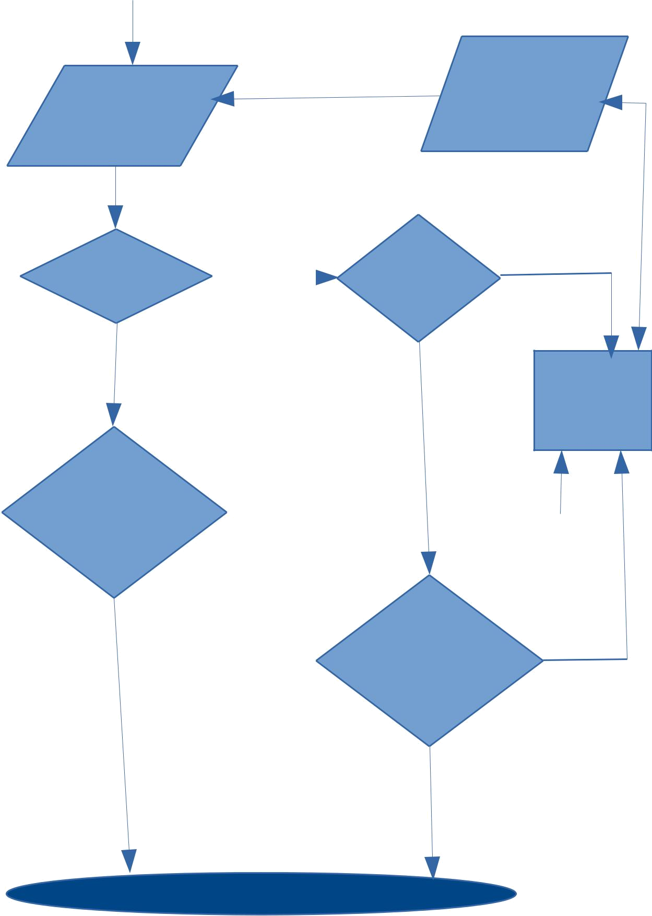
Project Account
Ar Project applied Form edited by

Project Account Ar Prj

Form

Gross Amount | YES | Recommed to | NO
>= 200000 |  | Director by PCE

No
^{YES} REJECTED

Approved And Senctioned | NO
By PCE

YES | Approved And Senctioned | NO
 | By Director

YES

END

