USER MANUAL FOR HEAD OF DEPARTMENT/ HEAD OF
SECTION
Forwarding of Estimate Form

- When consultancy in charge submits estimate form.
- A notification will come to you if the consultancy in charge belong to your department.
- you have two option either forward or reject
- forward to pce:
- after clicking forward button a confirmation button will added which will asked are you sure.
II) after clicking “Are You Sure To Forward” the file will move to PCE.
III) a notification will send to PCE to approve or reject.
screen shot – 01
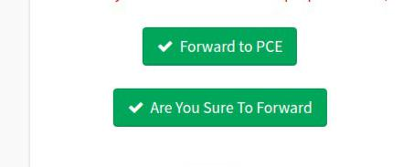

5.reject:
I)after clicking reject a remark text area and “Are You Sure To Reject” button will added. II) remark will be optional it should contain why are you form has been rejected.

III) after clicking ““Are You Sure To Reject” file will move again to CI. IV) a notifiacation will send to CI to fill again.

screen shot – 02
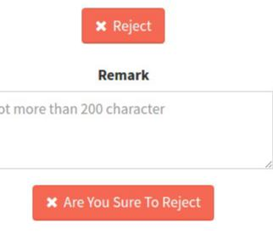
Forwarding of Disbursement Sheet.

- When consultancy in charge submits disbursement sheet.
- A notification will come to you if the consultancy in charge belong to your department.
- you have two option either forward or reject
- forward to pce:
  - after clicking forward button a confirmation button will added which will asked are you sure.
II) after clicking “Are You Sure To Forward” the file will move to PCE. III) a notification will send to PCE to approve or reject.
5.reject:
I)after clicking reject a remark text area and “Are You Sure To Reject” button will added. II) remark will be optional it should contain why are you form has been rejected.

III) after clicking ““Are You Sure To Reject” file will move again to CI. IV) a notifiacation will send to CI to fill again.

*** it is similar to consultancy estimate form.
Viewing of Consultancy File.

→ You can track you file through following
- click view consultancy form in header
- click link in action column
- A pop up window will open which will show the status of your file andall process it gone through.

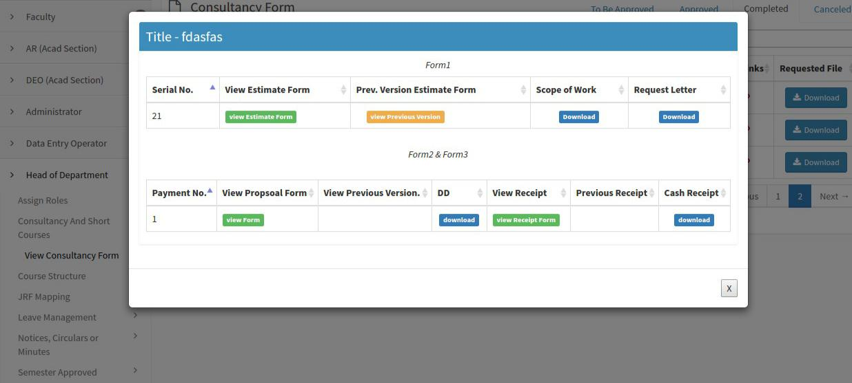
screen shot – 03

