USER MANUAL FOR PROFESSOR OF CONTINUING EDUCATION (PCE)
Forwarding of Estimate Form

- When HOD/HOS forwarded you will get a notification to forward
- A notification will come to you..
- you have two option either forward or reject
- forward to director:
- after clicking forward button a confirmation button will added which will asked are you sure.
II) after clicking “Are You Sure To Forward” the file will move to PCE.
III) a notification will send to Director to approve or reject.
screen shot – 01
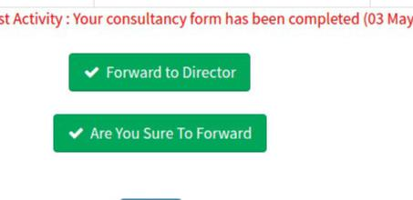

5.reject:
I)after clicking reject a remark text area and “Are You Sure To Reject” button will added. II) remark will be optional it should contain why are you form has been rejected.

III) after clicking ““Are You Sure To Reject” file will move again to CI. IV) a notification will send to CI to fill again.

screen shot – 02
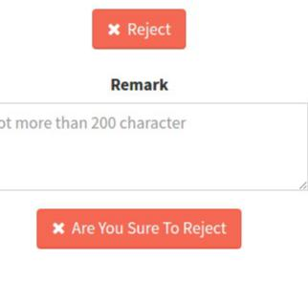

Filling of Link up no and page no.

1.After Director approved the estimate form.
2.you will get a notification for assigning link up no and page no.
- fill this form and submit.
- after that CI will get a notification to fill proposal form.

screen shot – 03
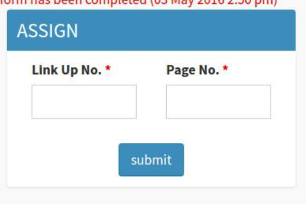

Approving of Proposal Form

- after CI will fill a proposal form a notification will come to you..
- you have two option either forward or reject
- Approve:
  - after clicking forward button a confirmation button will added which will asked
are you sure.
II) after clicking “Are You Sure To Approve” the file will move to PCE. III) a notification will send to Director to approve or reject.
screen shot – 04
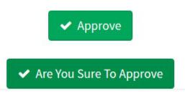

4.reject:
I)after clicking reject a remark text area and “Are You Sure To Reject” button will added. II) remark will be optional it should contain why are you form has been rejected.

III) after clicking ““Are You Sure To Reject” file will move again to CI. IV) a notifiacation will send to CI to fill again.
*** reject is same as estimate form.
Submission of Receipt screen shot – 05

1.click send receipt in header
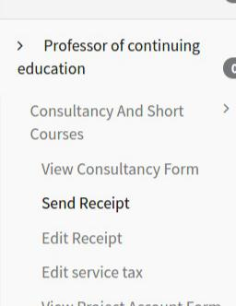
- a table will be open which contain all proposal for which a receipt can be generated.

- click you proposal form.

- upload the scan copy of receipt which has been cash section
- fill the proposal form .

- click submit

screen shot – 06
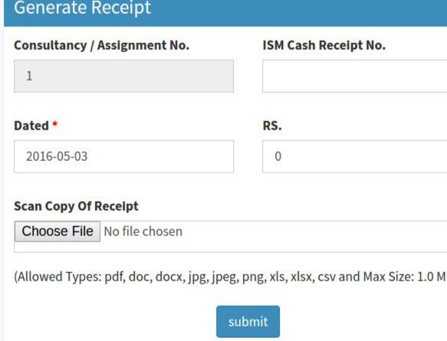

Completion of Payment
1.when you think that all the payment has been made and disbursement sheet can generate.
2.chick done corresponding consultancy in approve tab consultancy form table.
- when you click done a confirmation alert will added.
- clicking ok the status of this consultancy will change to 7.
- a notification will send to CI to fill disbursement sheet.
- you can do it by clicking link.

screen shot – 07

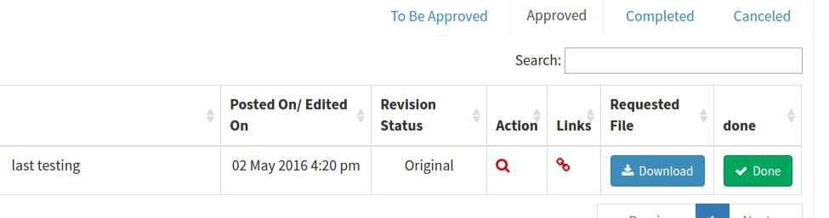

Forwarding of Disbursement Sheet.

- When consultancy in charge submits disbursement sheet.
- A notification will come to you .
- you have two option either forward or reject
- forward to pce:
  - after clicking forward button a confirmation button will added which will asked are you sure.
II) after clicking “Are You Sure To Forward” the file will move to PCE. III) a notification will send to PCE to approve or reject.
5.reject:
I)after clicking reject a remark text area and “Are You Sure To Reject” button will added. II) remark will be optional it should contain why are you form has been rejected.

III) after clicking ““Are You Sure To Reject” file will move again to CI. IV) a notifiacation will send to CI to fill again.
*** it is similar to consultancy estimate form.

Recommending of Project Account Form.

- When assistant project fill project account.
- A notification will come to you for forward if total amount is greater than 200000.
- A notification will come to you..
- you have two option either recommend or reject
- recommend to director:
  - after clicking recommend button a confirmation button will added which will asked

are you sure.
II) after clicking “Are You Sure To Recommend” the file will move to PCE. III) a notification will send to Director to approve or reject.
5.reject:
I)after clicking reject a remark text area and “Are You Sure To Reject” button will added. II) remark will be optional it should contain why are you form has been rejected.

III) after clicking ““Are You Sure To Reject” file will move again to Ar Prj. IV) a notification will send to CI to fill again.

Approving and sanctioning of Project Account Form.

- When assistant project fill project account.
- A notification will come to you for forward if total amount is less than 200000.
- you have two option either approve or reject
- Approve:
  - after clicking forward button a confirmation button will added which will asked are you sure.
II) after clicking “Are You Sure To Approve” the file will move to PCE. III) a notification will send to CI
5.reject:
I)after clicking reject a remark text area and “Are You Sure To Reject” button will added. II) remark will be optional it should contain why are you form has been rejected.

III) after clicking ““Are You Sure To Reject” file will move again to Ar project. IV) a notifiacation will send to Ar project. to fill again.
*** reject is same as estimate form.

Viewing of Consultancy File.

→ You can track you file through following
- click view consultancy form in header
- click link in action column
- A pop up window will open which will show the status of your file andall process it gone through.

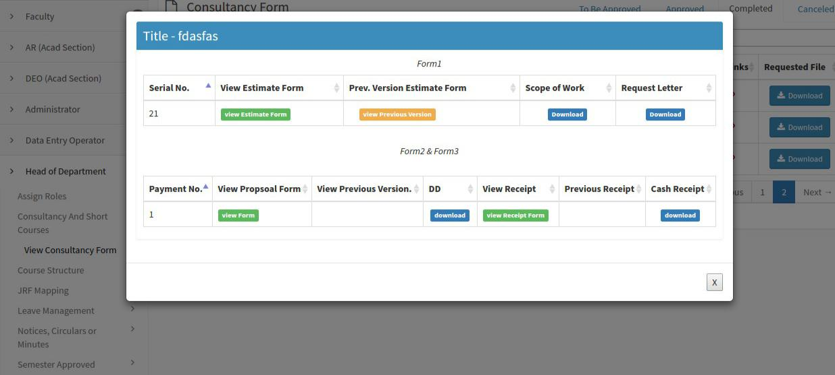
screen shot – 03

