1.Additional Cipher

#include<bits/stdc++.h>
int encrypt(int p)
{
return (2*p+3)%26;
}
using namespace std;
int main()
{
char c[101];
char p[101];
cin>>p;
int i=0;
for(i=0;p[i]!='\0';i++ ) {
c[i]=encrypt(p[i]-'A');
c[i]+='A';
}
c[i]='\0';
cout<<c<<endl;
}

input-output:

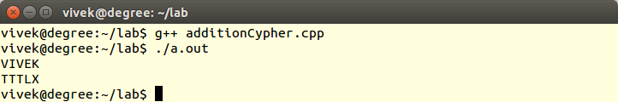

2.Brute Force Attack On Additive Cipher
#include<bits/stdc++.h>
using namespace std;
int encrypt(int p,int b)
{
return ((p-b+26)%26);
}
int main()
{
char c[101],p[101];
cin>>p;
int i=0, b,n=strlen(p);
for(i=0;i<n;i++ ) hash[p[i]-'A']++;
int maxindex=0,max=0;
for(int i=0;i<26;i++ ) if(hash[i]>max) max=hash[i]; maxindex=i;
for(int J=0;J<26;J++) {
b=(maxindex-J)%26;
for(i=0;i<n;i++ ) c[i]=encrypt(p[i]-'A',b)+'A';
c[i]='\0';
cout<<(char)(J+'A')<<" "<<c<<endl; }

}
input-output:
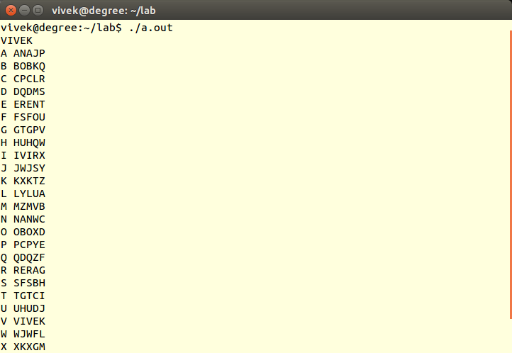
3.Statical Attack on Additive cipher

#include <iostream>
#include <limits.h>

using namespace std;
int main() {
string str,strOutput;
int hash[26] = {0};
int i;
for(i = 0; i < str.size(); i++) hash[str[i] - 'A']++;
int maxIndex = INT_MIN, maxValue = INT_MIN;
for(i = 0; i < 26; i++){
if(maxValue < hash[i]) {
maxValue = hash[i];
maxIndex = i;
}
}
int b = maxIndex - 4;
if(b < 0) b += 26;
for(i = 0; i < str.size(); i++) {
char ch = (str[i] - 'A' - b) % 26 + 'A';
if(ch < 'A') ch += 26;
strOutput.push_back(ch);
}
cout << "The output string is " << strOutput<<endl;
return 0;
}

input-output:

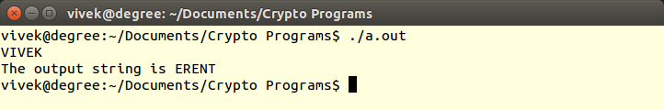

4.Multiplicative Cipher
#include <iostream>
using namespace std;
int main() {
string str;
cin >> str;
cout << "Enter the key: ";
int b;
cin >> b;
if(b % 13 == 0 || b % 2 == 0) {
cout << "Not a valid Key";
} else {
for(int i = 0; i < str.size(); i++) {
str[i] = ((str[i] - 'A') * b) % 26 + 'A';
}
cout << "Ciphertext " << str<<endl;
}
return 0;
}

input-output:

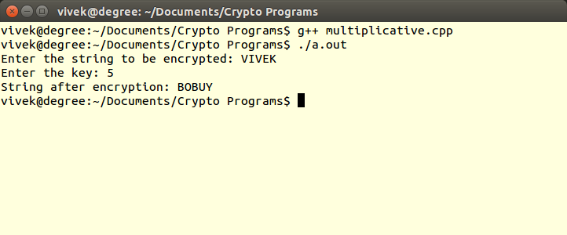

5.Affine Cipher
#include<bits/stdc++.h>
int encrypt(int p,int ainv,int b)
{
return (((ainv*(p-b+26)))%26);
}
using namespace std;
int hash[26];
int main()
{

char c[101] , p[101];
cin>>c;
int a,b;
cout<<"Enter the decription key";
cin>>a>>b;
int ainv;
for(int i=0;i<26;i++) {
if((i*a)%26==1) {
ainv=i;
break;
}
}
int i=0, n=strlen(c);
for(i=0;i<n;i++ )
p[i]=encrypt(c[i]-'A',ainv,b)+'A';
p[i]='\0';
cout<<p<<endl;
}

input-output:

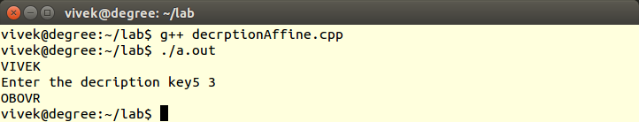
6.Play Fair Cipher

#include<stdio.h>
#include<string.h>
char Table[5][5]={{'L','G','D','B','A'},{'Q','M','H','E','C'},{'U','R','N','I','F'},{'X','V','S','O','K'},{'Z','Y','W','T','P'}};
void findTable(char p,int *a ,int *b)
{
int i,j;
for(i=0;i<5;i++) {
for(j=0;j<5;j++) {
if(Table[i][j]==p) {
*(a)=i;
*(b)=j;
return;
}
}
}
}
void findcord(char *p,char *q,char a,char b)
{
int i,j,r,s;
findTable(a,&i,&j);
findTable(b,&r,&s);
int x,y,k,l;
if(i==r) {
x=i; y=j+1; y%=5; k=r; l=s+1; l%=5;
}
else if(j==s)
{
x=i+1; x%=5; y=j; k=r+1;
k%=5;
l=s;
}
else
{
x=i;
y=s;
k=r;
l=j;
}
*(p)=Table[x][y];
*(q)=Table[k][l];
}
int main()
{
printf("Enter the plain text!n");
char plaintext[101];
char ciphertext[102];
scanf("%s",plaintext);
int n=strlen(plaintext);
char p,q;
char a,b;
int i;
for(i=0;i<n;i++)
{
a=plaintext[i++];
if(i==n)
{
b='A';
}
else
b=plaintext[i];
findcord(&p,&q,a,b);
ciphertext[i-1]=p;
ciphertext[i]=q;
}
ciphertext[i]='';
printf("Cipher text is %sn",ciphertext);
}

input-output:

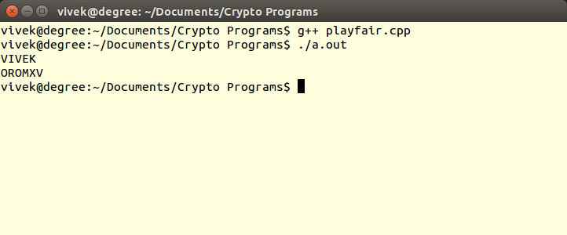
7.Hill Cipher
#include<stdio.h>
#include<string.h>
#include<stdlib.h>
int keyTable[3][3]={{3,5,7},{9,11,15},{17,19,21}};
int main()
{
int j;
printf("Enter the plain text!n");
char plaintext[101];
char ciphertext[102];
scanf("%s",plaintext);
int n=strlen(plaintext);
int *sol[3];
int *result[3];
int m=n/3+(n%3!=0);
char p,q;
char a,b;
int i;
int temp;
for(i=0;i<3;i++)
sol[i]=(int*)malloc(m*sizeof(int));
for(i=0;i<3;i++)
result[i]=(int*)malloc(m*sizeof(int));
int k=0;
for(i=0;i<3;i++)
{
for(j=0;j<m;j++)
{
if(k<n)
{
sol[i][j]=plaintext[k]-'A';
k++;
}
else
{
sol[i][j]=2;
}
}
}
for(i=0;i<3;i++)
{
for(j=0;j<m;j++)
{
int ans=0;
for(k=0;k<3;k++)
{
ans+=keyTable[i][k]*sol[k][j];
}
ans%=26;
result[i][j]=ans;
}
}
k=0;
for(i=0;i<3;i++)
{
for(j=0;j<m;j++)
{
ciphertext[k++]=result[i][j]+'A';
if(k>=n)
break;
}
if(k>=n)
break;
}
ciphertext[k]='';
printf("Cipher text is %sn",ciphertext);
}

input-output:

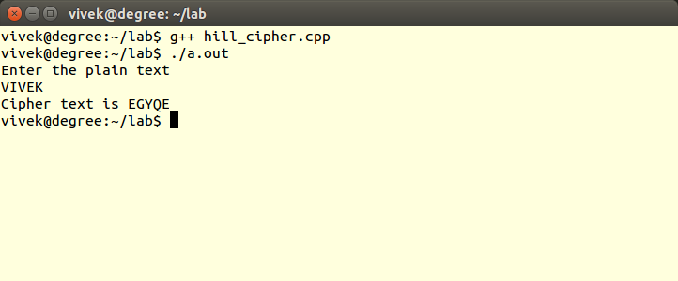

8.Vigenere Cipher
#include<stdio.h>
#include<string.h>
int key[5]={15,0,18,2,11};
int main()
{
int j;
printf("Enter the plain text!n");
char plaintext[101];
char ciphertext[102];
scanf("%s",plaintext);
int n=strlen(plaintext);
char p,q;
char a,b;
int i;
int temp;
for(i=0;i<n;)
{
for(j=0;j<5;j++)
{
temp=plaintext[i]-'A'+key[j];
temp%=26;
printf("%dn",j);
ciphertext[i]=temp+'A';
i++;
if(i>=n) break;
}
}
ciphertext[i]='';
printf("Cipher text is %sn",ciphertext);
}

input-output:

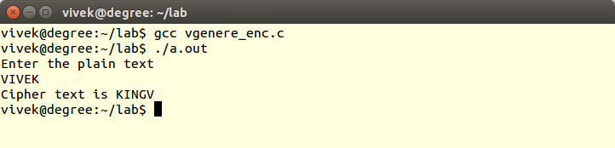
9.DES
#include<bits/stdc++.h>
using namespace std;
int IP[] = {58, 50, 42, 34,26, 18, 10, 2, 60, 52, 44, 36, 28, 20, 12, 4, 62, 54, 46, 38, 30, 22, 14, 6, 64, 56, 48, 40, 32, 24, 16, 8, 57, 49, 41, 33, 25, 17, 9, 1, 59, 51, 43, 35, 27, 19, 11, 3,
61, 53, 45, 37, 29, 21, 13, 5, 63, 55, 47, 39, 31, 23, 15, 7};
int FP[] = {40, 8, 48, 16, 56, 24, 64, 32, 39, 7, 47, 15, 55, 23, 63, 31, 38, 6, 46, 14, 54, 22, 62, 30,
37, 5, 45, 13, 53, 21, 61, 29, 36, 4, 44, 12, 52, 20, 60, 28, 35, 3, 43, 11, 51, 19, 59, 27,
34, 2, 42, 10, 50, 18, 58, 26, 33, 1, 41, 9, 49, 17, 57, 25};
int expension[] = { 32, 1, 2, 3, 4, 5, 4, 5, 6, 7, 8, 9, 8, 9, 10, 11, 12, 13, 16, 17, 18, 19, 20, 21,
24, 25, 26, 27, 28, 29, 28, 29, 31, 31, 32, 1};
int parity[] = {57, 49, 41, 33, 25, 17, 9, 1, 58, 50, 42, 34, 26, 18, 10, 2, 59, 51, 43, 35, 27,
19, 11, 3, 60, 52, 44, 36, 63, 55, 47, 39, 31, 23, 15, 7, 62, 54, 46, 38, 30, 22,
14, 6, 61, 53, 45, 37, 29, 21, 13, 5, 28, 20, 12, 4};
int cmpress[] = {14, 17, 11, 24, 1, 5, 3, 28, 15, 6, 21, 10, 23, 19, 12, 4, 26, 8, 16, 7, 27, 20, 13, 2,
41, 52, 31, 37, 47, 55, 30, 40, 51, 45, 33, 48, 44, 49, 39, 56, 34, 53,
46, 42, 50, 36, 29, 32};
int strtperm[] = {16, 7, 20, 21, 29, 12, 28, 17, 1, 15, 23, 26, 5, 18, 31, 10, 2, 8, 24, 14, 32, 27, 3, 9,
19, 13, 30, 6, 22, 11, 4, 25 };
int s1[][16] = {{14, 4, 13, 1, 2, 15, 11, 8, 3, 10, 6, 12, 5, 9, 0, 7},
{0, 15, 7, 4, 14, 2, 13, 1, 10, 6, 12, 11, 9, 5, 3, 8},
{4, 1, 14, 8, 13, 6, 2, 11, 15, 12, 9, 7, 3, 10, 5, 0},
{15, 12, 8, 2, 4, 9, 1, 7, 5, 11, 3, 14, 10, 0, 6, 13}};
int s2[][16] = {{15, 1, 8, 14, 6, 11, 3, 4, 9, 7, 2, 13, 12, 0, 5, 10},
{3, 13, 4, 7, 15, 2, 8, 14, 12, 0, 1, 10, 6, 9, 11, 5},
{0, 14, 7, 11, 10, 4, 13, 1, 5, 8, 12, 6, 9, 3, 2, 15},
{13, 8, 10, 1, 3, 15, 4, 2, 11, 6, 7, 12, 0, 5, 14, 9}};
int s3[][16] = {{10, 0, 9, 14, 6, 3, 15, 5, 1, 13, 12, 7, 11, 4, 2, 8},
{13, 7, 0, 9, 3, 4, 6, 10, 2, 8, 5, 14, 12, 11, 15, 1},
{13, 6, 4, 9, 8, 15, 3, 0, 11, 1, 2, 12, 5, 10, 14, 7},
{1, 10, 13, 0, 6, 9, 8, 7, 4, 15, 14, 3, 11, 5, 2, 12} };
int s4[][16] = {{7, 13, 14, 3, 0, 6, 9, 10, 1, 2, 8, 5, 11, 12, 4, 15},
{13, 8, 11, 5, 6, 15, 0, 3, 4, 7, 2, 12, 1, 10, 14, 9},
{10, 6, 9, 0, 12, 11, 7, 13, 15, 1, 3, 14, 5, 2, 8, 4},
{3, 15, 0, 6, 10, 1, 13, 8, 9, 4, 5, 11, 12, 7, 2, 14} };
int s5[][16] = {{2, 12, 4, 1, 7, 10, 11, 6, 8, 5, 3, 15, 13, 0, 14, 9},
{14, 11, 2, 12, 4, 7, 13, 1, 5, 0, 15, 10, 3, 9, 8, 6},
{4, 2, 1, 11, 10, 13, 7, 8, 15, 9, 12, 5, 6, 3, 0, 14},
{11, 8, 12, 7, 1, 14, 2, 13, 6, 15, 0, 9, 10, 4, 5, 3} };
int s6[][16] = {{12, 1, 10, 15, 9, 2, 6, 8, 0, 13, 3, 4, 14, 7, 5, 11},
{10, 15, 4, 2, 7, 12, 9, 5, 6, 1, 13, 14, 0, 11, 3, 8},
{9, 14, 15, 5, 2, 8, 12, 3, 7, 0, 4, 10, 1, 13, 11, 6},
{4, 3, 2, 12, 9, 5, 15, 10, 11, 14, 1, 7, 6, 0, 8, 13} };
int s7[][16] = {{4, 11, 2, 14, 15, 0, 8, 13, 3, 12, 9, 7, 5, 10, 6, 1},
{13, 0, 11, 7, 4, 9, 1, 10, 14, 3, 5, 12, 2, 15, 8, 6},
{1, 4, 11, 13, 12, 3, 7, 14, 10, 15, 6, 8, 0, 5, 9, 2},
{6, 11, 13, 8, 1, 4, 10, 7, 9, 5, 0, 15, 14, 2, 3, 12} };
int s8[][16] = {{13, 2, 8, 4, 6, 15, 11, 1, 10, 9, 3, 14, 5, 0, 12, 7},
{1, 15, 13, 8, 10, 3, 7, 4, 12, 5, 6, 11, 0, 14, 9, 2},
{7, 11, 4, 1, 9, 12, 14, 2, 0, 6, 10, 13, 15, 3, 5, 8},
{ 2, 1, 14, 7, 4, 10, 8, 13, 15, 12, 9, 0, 3, 5, 6, 11}};

void getIp(char *binr, char *ipr)
{
int i;
for(i=0; i<64; i++) ipr[i] = binr[IP[i]-1];
}
void getParity(char *ipr, char *party)
{
int i;
for(i=0; i<56; i++) party[i] = ipr[parity[i]-1];
}
void getLeft(char *party, char *left)
{
int i;
for(i=0; i<28; i++) left[i] = party[i];
}
void getRight(char *party, char *right)
{
int i;
for(i=28; i<56; i++) right[i-28] = party[i];
}
void leftShift(char *arr)
{
int i;
char ch = arr[0];
for(i=0; i<27; i++) arr[i] = arr[i+1];
arr[i] = ch;
}
void hexToBin(string str, char binr[])
{
int i = 0,len = str.size();
while(i<len) {
int t;
if(str[i]>='0' && str[i]<='9') t = str[i]-'0';
if(str[i]=='a' || str[i] == 'A') t = 10;
if(str[i]=='b' || str[i] == 'B') t = 11;
if(str[i] == 'c' || str[i] == 'C') t = 12;
if(str[i]=='d' || str[i] == 'D') t = 13;
if(str[i] == 'e' || str[i] == 'E') t =14;
if(str[i] == 'f' || str[i] == 'F') t = 15;
int k = 3;
while(k>=0)
{
char ch = '0'+t%2;
binr[i*4+k] = ch; k--; t = t/2;
}
i++;
} }
void expensionptr(char str[], char expnr[])
{
int i;
for(i=0; i<48; i++) expnr[i] = str[expension[i]-1];
}
void xorr(char str[], char ptr[])
{
int i;
for(i=0; i<48; i++)
if(str[i]==ptr[i])
str[i] = '0';
else
str[i] = '1';
}
void placeBit(char str[], int num, int t)
{
int k =3;
while(k>=0) {
char ch = '0'+num%2; str[4*t+k] = ch; num = num/2;
k--;
}
}
void getRC(char expnr[], int i, int &r, int &c)
{
r = (expnr[i]-'0')*2+(expnr[i+5]-'0');
c = (expnr[i+1]-'0')*8+(expnr[i+2]-'0')*4+(expnr[i+3]-'0')*2+(expnr[i+4]-'0');
}
void getStrS(char expnr[], char str[])
{
int i, j, r, c;
getRC(expnr, 0, r, c);
int num, t = 0;
num = s1[r][c];
placeBit(str, num, t); getRC(expnr, 6, r, c); num = s2[r][c]; t++;
placeBit(str, num, t); t++; getRC(expnr, 12, r, c); num = s3[r][c];
placeBit(str, num, t); t++; getRC(expnr, 18, r, c); num = s4[r][c];
placeBit(str, num, t); t++; getRC(expnr, 24, r, c); num = s5[r][c];
placeBit(str, num, t); t++; getRC(expnr, 30, r, c); num = s6[r][c];
placeBit(str, num, t); t++; getRC(expnr, 36, r, c); num = s5[r][c];
placeBit(str, num, t); t++; getRC(expnr, 42, r, c); num = s6[r][c];
placeBit(str, num, t); t++;

}
void straightD(char str[], char right[])
{
int i;
for(i=0; i<32; i++) right[i] = str[strtperm[i]-1];
}
void getFP(char str[], char fp[])
{
int i;
for(i=0; i<64; i++) {
fp[i] = str[FP[i]-1]; cout<<fp[i];
}
}
int main()
{
char binr[64];
string str = "123456abcd132536",key = "AABB09182736CCDD";
int len = str.size(), i = 0, k;
hexToBin(key, binr);
char ipr[64], party[56];
getIp(binr, ipr); getParity(ipr, party);
char left[30], right[30];
getLeft(party, left); getRight(party, right);
char keyr[17][49]; i=1;
while(i<=16) {
if(i==1 || i==2 || i==9 || i==16) {
leftShift(left); leftShift(right);
}
else {
leftShift(left); leftShift(left);
leftShift(right);leftShift(right);
}
for(k=0; k<48; k++) {
if(cmpress[k]>27)
keyr[i][k] = right[cmpress[k]-28];
else
keyr[i][k] = left[cmpress[k]];
}
i++;
}
char bstr[65];
hexToBin(str, bstr);
char leftp[33], rightp[33];
for(i=0; i<32; i++) leftp[i] = bstr[i];
leftp[32] = '\0';
for(i=0; i<32; i++) ightp[i] = bstr[i+32];
rightp[64] = '\0';
i = 1;
while(i<=16) {
char expnr[49], strs[33];
expensionptr(rightp, expnr);
xorr(expnr, keyr[i]); getStrS(expnr, strs); straightD(strs, rightp);
char temp[33]; strcpy(temp, rightp); temp[32] = '\0';
strcpy(rightp, leftp); rightp[32] = '\0'; strcpy(leftp, temp); leftp[32] = '\0';
i++; }
char finp[66]; leftp[32] = '\0'; rightp[64] = '\0';
strcpy(finp, left); strcat(finp, rightp);
cout<<finp<<endl;
char fp[65]; cout<<"Final Result: ";
getFP(finp, fp); cout<<endl;
return 0;
}

input-output:
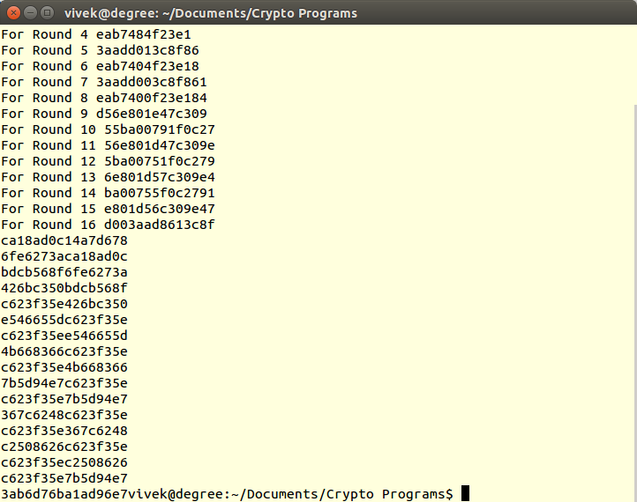

10.AES
#include<stdio.h>
#include<string.h>
#include<stdlib.h>
int sbox[256] ={ 0x63, 0x7c, 0x77, 0x7b, 0xf2, 0x6b, 0x6f, 0xc5, 0x30, 0x01, 0x67, 0x2b, 0xfe, 0xd7, 0xab, 0x76,\0xca, 0x82, 0xc9, 0x7d, 0xfa, 0x59, 0x47, 0xf0, 0xad, 0xd4, 0xa2, 0xaf, 0x9c, 0xa4, 0x72, 0xc0, 0xb7, 0xfd, 0x93, 0x26, 0x36, 0x3f, 0xf7, 0xcc, 0x34, 0xa5, 0xe5, 0xf1, 0x71, 0xd8, 0x31, 0x15, 0x04, 0xc7, 0x23, 0xc3, 0x18, 0x96, 0x05, 0x9a, 0x07, 0x12, 0x80, 0xe2, 0xeb, 0x27, 0xb2, 0x75, 0x09, 0x83, 0x2c, 0x1a, 0x1b, 0x6e, 0x5a, 0xa0, 0x52, 0x3b, 0xd6, 0xb3, 0x29, 0xe3, 0x2f, 0x84, 0x53, 0xd1, 0x00, 0xed, 0x20, 0xfc, 0xb1, 0x5b, 0x6a, 0xcb, 0xbe, 0x39, 0x4a, 0x4c, 0x58, 0xcf, 0xd0, 0xef, 0xaa, 0xfb, 0x43, 0x4d, 0x33, 0x85, 0x45, 0xf9, 0x02, 0x7f, 0x50, 0x3c, 0x9f, 0xa8,0x51, 0xa3, 0x40, 0x8f, 0x92, 0x9d, 0x38, 0xf5, 0xbc, 0xb6, 0xda, 0x21, 0x10, 0xff, 0xf3, 0xd2,0xcd, 0x0c, 0x13, 0xec, 0x5f, 0x97, 0x44, 0x17, 0xc4, 0xa7, 0x7e, 0x3d, 0x64, 0x5d, 0x19, 0x73, 0x60, 0x81, 0x4f, 0xdc, 0x22, 0x2a, 0x90, 0x88, 0x46, 0xee, 0xb8, 0x14, 0xde, 0x5e, 0x0b, 0xdb, 0xe0, 0x32, 0x3a, 0x0a, 0x49, 0x06, 0x24, 0x5c, 0xc2, 0xd3, 0xac, 0x62, 0x91, 0x95, 0xe4, 0x79,0xe7, 0xc8, 0x37, 0x6d, 0x8d, 0xd5, 0x4e, 0xa9, 0x6c, 0x56, 0xf4, 0xea, 0x65, 0x7a, 0xae, 0x08,0xba, 0x78, 0x25, 0x2e, 0x1c, 0xa6, 0xb4, 0xc6, 0xe8, 0xdd, 0x74, 0x1f, 0x4b, 0xbd, 0x8b, 0x8a, 0x70, 0x3e, 0xb5, 0x66, 0x48, 0x03, 0xf6, 0x0e, 0x61, 0x35, 0x57, 0xb9, 0x86, 0xc1, 0x1d, 0x9e, 0xe1, 0xf8, 0x98, 0x11, 0x69, 0xd9, 0x8e, 0x94, 0x9b, 0x1e, 0x87, 0xe9, 0xce, 0x55, 0x28, 0xdf,0x8c, 0xa1, 0x89, 0x0d, 0xbf, 0xe6, 0x42, 0x68, 0x41, 0x99, 0x2d, 0x0f, 0xb0, 0x54, 0xbb, 0x16};
char RC[10][8] = {{'0','0','0','0','0','0','0','1'}, {'0','0','0','0','0','0','1','0'}, {'0','0','0','0','0','1','0','0'},
{'0','0','0','0','1','0','0','0'}, {'0','0','0','1','0','0','0','0'}, {'0','0','1','0','0','0','0','0'},
{'0','1','0','0','0','0','0','0'}, {'1','0','0','0','0','0','0','0'}, {'0','0','0','1','1','0','1','1'},
{'0','0','1','1','0','1','1','0'} };
char getHexDigit(char a,char b,char c,char d)
{
char ar[4]; ar[0]=a; ar[1]=b; ar[2]=c; ar[3]=d;
if(strcmp(ar,"0000")==0) return '0';
else if(strcmp(ar,"0001")==0) return '1';
else if(strcmp(ar,"0010")==0) return '2';
else if(strcmp(ar,"0011")==0) return '3';
else if(strcmp(ar,"0100")==0) return '4';
else if(strcmp(ar,"0101")==0) return '5';
else if(strcmp(ar,"0110")==0) return '6';
else if(strcmp(ar,"0111")==0) return '7';
else if(strcmp(ar,"1000")==0) return '8';
else if(strcmp(ar,"1001")==0) return '9';
else if(strcmp(ar,"1010")==0) return 'A';
else if(strcmp(ar,"1011")==0) return 'B';
else if(strcmp(ar,"1100")==0) return 'C';
else if(strcmp(ar,"1101")==0) return 'D';
else if(strcmp(ar,"1110")==0) return 'E';
else return 'F';
}
char xor(char x,char y)
{
if(x==y) return '0';
else return '1';
}
void xorArr(char a[],char b[],char c[],int n)
{
int i=0;
for(i=0;i<n;i++) c[i]=xor(a[i],b[i]);
}
char ** keygeneration(char str[])
{
char **word;
word=(char**)malloc(4*sizeof(char*));
int i,j;
for(i=0;i<4;i++) word[i]=(char*)malloc(32*sizeof(char));
for(i=0;i<4;i++)
for(j=0;j<32;j++)
word[i][j]=str[i*32+j];
return word;
}
void intToString(int n,char V[])
{
int i;
for(i=7;i>=0;i--) \V[i]=(char)(n%2+'0'); n/=2;
}
void S(char V1[])
{
int index=stringToInt(V1,8),x=sbox[index];
intToString(x,V1);
}
void delta(char A[],char B[],int round)
{
char V[4][8];
int i,j;
for(i=0;i<4;i++) for(j=0;j<8;j++) V[(i-1+4)%4][j]=A[i*8+j];
S(V[0]); S(V[1]); S(V[2]); S(V[3]);
xorArr(V[0],RC[round],V[0],8);
for(i=0;i<4;i++) for(j=0;j<8;j++) B[8*i+j]=V[i][j];
}
\void schedule(char **word,char **temp,int round)
{
char deltaVal[32];
delta(word[3],deltaVal,round);
xorArr(word[0],deltaVal,temp[0],32); xorArr(temp[0],word[1] ,temp[1],32);
xorArr(temp[1],word[2] ,temp[2],32); xorArr(temp[2],word[3] ,temp[3],32);
}

int main()
{
char input[128];
scanf("%s",input);
char **word,**temp;
word=keygeneration(input);
int i,j,k;
for( i=0;i<4;i++) \printf("%s\n",word[i]);
temp=(char**)malloc(4*sizeof(char*));
for(i=0;i<4;i++) temp[i]=(char*)malloc(32*sizeof(char));
for(k=0;k<10;k++) {
printf("Round %d\n",k+1);
schedule(word,temp,k);
for(i=0;i<4;i++) {
for(j=0;j<8;j++)
printf("%c",getHexDigit(temp[i][j*4+0],temp[i][j*4+1],temp[i][j*4+2],temp[i][j*4+3]));
strcpy(word[i],temp[i]);
} }
return 0;
}

input-output:

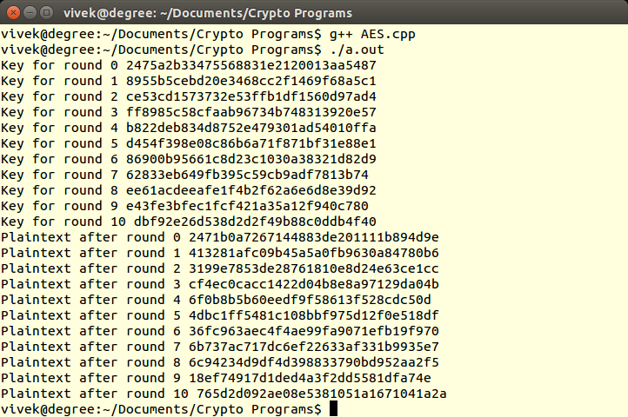

11.RSA
#include<bits/stdc++.h>
using namespace std;
int power1(int a,int b,int mod)
{
long long int x=a,y=1;
while(b) {
if(b&1) y=(y*x)%mod;
x=(x*x)%mod; b>>=1;
}
return (int)y;
}
int modInverse(int a, int m) {
a %= m;
for(int x = 1; x < m; x++) if((a*x) % m == 1) return x;
}
void keyGenerationAlgorithm(int &e,int &d,int &n)
{
int p,q,phi_n;
cin>>p>>q;
n=p*q; phi_n=(p-1)*(q-1);
cin>>e;
d=modInverse(e,phi_n);
return;
}
int RsaEncryption(int p,int e,int n)
{
return power1(p,e,n);
}
string inttostring(int number)
{
string A="";
while(number) {
int temp=number%100; A=(char)(temp+'a')+A; number/=100;
}
return A;
}
int RsaDecryption(int c,int d,int n)
{
return (power1(c,d,n));
}
int stringtoint(string A)
{
int n=A.size(),int number=0;
for(int i=0;i<n;i++) {
int temp=(A[i]-'a'); number=number*100+temp;

}
return number; }
int main()
{
int e,d,n;
e=0,d=0,n=1;
keyGenerationAlgorithm(e,d,n);
string plaintext;
cin>>plaintext;
int C=RsaEncryption(stringtoint(plaintext),e,n);
int t=RsaDecryption(C,d,n);
cout<<inttostring(t)<<endl;

}

input-output:

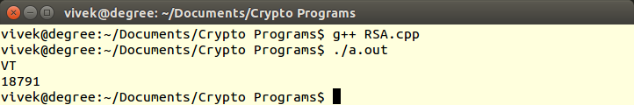

12.Elgamal Cipher
#include<bits/stdc++.h>
using namespace std;
int modPower(int a, int p, int n)
{
int ans = 1;
while(p) {
if(p&1) ans = (ans*a)%n;
a = (a*a)%n; p = p/2;
}
return ans;
}
int primitive(int n)
{
for(int a=2;a<n; a++) {
int count = 0;
for(int i=1; i<n; i++) {
if(modPower(a, i, n)==1) count++;
}
if(count==1) return a;
}
}
int main()
{
int p,d;
cin>>p;
int e1 = primitive(p);
srand(time(NULL));
while(1) {
d = rand()%p;
if(d>0 && d<p-1) break;
}
int e2 = modPower(e1, d, p);
int r = rand()%p;
int c1 = modPower(e1, r, p);
int msg;
cin>>msg;
int z = modPower(e2, r, p);
int c2 = (msg*z)%p;
cout<<"Encrypttion: ";
cout<<c1<<" "<<c2<<endl;
cout<<"Decryption: ";
int cr = modPower(c1, d, p);
int cz = 1;
while(1)
{
if((cz*cr-1)%p==0)
break;
cz++;
}
int msz = c2*cz%p;
cout<<msz<<endl;
return 0;
}

input-output:

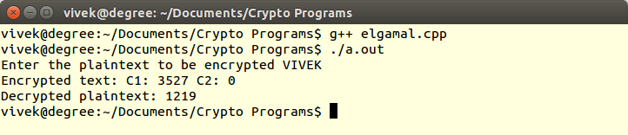

13.Elegmal Digital Signature:
#include<bits/stdc++.h>
using namespace std;

int modPower(int a, int p, int n)
{
int ans = 1;
while(p) {
if(p&1) ans = (ans*a)%n;
a = (a*a)%n; p = p/2;
}
return ans;
}

int primitive(int n)
{
for(int a=2;a<n; a++) {
int count = 0;
for(int i=1; i<n; i++) {
if(modPower(a, i, n)==1) count++;
}
if(count==1) return a;
}
}
bool isVerify(int e1, int e2, int s1, int s2, int msg, int p)
{
int res = modPower(e2, s1, p);
int v2 = (res*modPower(s1, s2, p))%p;
int v1 = modPower(e1, msg, p);
if(v1==v2) return true;
return false;
}

int main()
{
int p;
cin>>p;
int e1 = primitive(p);
int msg;
cin>>msg;
srand(time(NULL));
int r = 307; //rand()%p;
int d = 127;
while(1) {
d = rand()%p;
if(d>0 && d<p-1) break;
}

int e2 = modPower(e1, d, p);
int s1 = modPower(e1, r, p);
int s2 = (msg-d*s1);
int inv = 1;
while(1) {
if((inv*r-1)%(p-1)==0) break;
inv++;
}
s2 = (s2*inv)%(p-1);
if(s2<0) s2+=(p-1);
if(isVerify(e1, e2, s1, s2, msg, p))
cout<<"Verified"<<endl;
else
cout<<"Not Verified"<<endl;
return 0;
}

input-output:

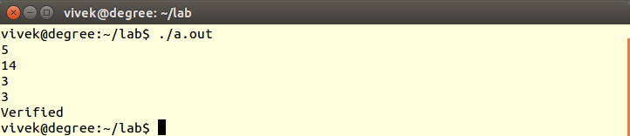

14. SHA
#include <bits/stdc++.h>
using namespace std;
typedef unsigned int uint;
vector<uint> plaintext;
vector<uint> words;
uint H0 = 0x67452301, H1 = 0xefcdab89, H2 = 0x98badcfe, H3 = 10325476, H4 = 0xc3d2e1f0,k
uint leftShift(uint x, int n) {
if(n > 32) n %= 32;
uint y = (x << n) | (x >> (32 - n));
return y;
}
void createWords() {
int i;
for(i = 0; i < plaintext.size(); i++)
words.push_back(plaintext[i]);
for(i = 16; i < 80; i++) {
uint wordT = leftShift(words[i - 3] ^ words[i - 8] ^ words[i - 14] ^ words[i - 16], 1);
words.push_back(wordT);
}
}
uint functionT(uint B, uint C, uint D, int t) {
if(t < 20) {
k = 0x5a827999;
return (B & C) | (~(B) & D);
} else if(t < 40) {
k = 0x6ed9eba1;
return B ^ C ^ D;
} else if(t < 60) {
k = 0x8f1bbcdc;
return (B & C) | (B & D) | (C & D);
} else {
k = 0xca6261d6;
return B ^ C ^ D;
}
}
void performHash() {
uint A = H0, B = H1, C = H2, D = H3, E = H4;
int i;
for(i = 0; i < 80; i++) {
uint t = leftShift(A, 5) + functionT(B, C, D, i) + E + words[i] + k;
E = D; D = C; C = leftShift(B, 30);
B = A; A = t;
}
H0 = H0 + A; H1 = H1 + B;
H2 = H2 + C; H3 = H3 + D;
H4 = H4 + E;
}

uint convertToHex(char ch) {
if(ch >= '0' && ch <= '9')
return 0x0 + ch - '0';
else
return 0xa + ch - 'a';
}
int main() {
string str = "aaaaaaaaaaaaaaaaaaaabbbbbbbbbbbbbbbbbbbbcccccccccc";
int i , length = 0;
uint t;
for(i = 0; i < str.size(); i += 8) {
t = convertToHex(str[i]);
length += 4;
int flag = 0;
if(i + 1 < str.size()) {
t <<= 4;
t |= convertToHex(str[i + 1]);
length += 4;
}
if(i + 2 < str.size()) {
t <<= 4;
t |= convertToHex(str[i + 2]);
length += 4;
}
if(i + 3 < str.size()) {
t <<= 4;
t |= convertToHex(str[i + 3]);
length += 4;
}
if(i + 1 < str.size()) {
t <<= 4;
t |= convertToHex(str[i + 1]);
length += 4;
}
if(i + 2 < str.size()) {
t <<= 4;
t |= convertToHex(str[i + 2]);
length += 4;
}
if(i + 3 < str.size()) {
t <<= 4;
t |= convertToHex(str[i + 3]);
length += 4;
}
if(flag)
plaintext.push_back(t);
}
int size = length;
if(length < 448) {
if(length % 32 == 8) {
t <<= 24;
t |= (1 << 24);
length += 24;
plaintext.push_back(t);
} else if(length % 32 == 16) {
t <<= 16;
t |= (1 << 16);
length += 16;
plaintext.push_back(t);
} else if(length % 32 == 24) {
t <<= 8;
t |= (1 << 8);
length += 8;
plaintext.push_back(t);
}
}
for(; length < 448; length += 4) {
plaintext.push_back(0);
}
plaintext.push_back(0);
plaintext.push_back(size);
for(i = 0; i < plaintext.size(); i++) {
cout << hex << plaintext[i] << endl;
}
createWords();
performHash();
cout << "The hashed value is ";
cout << hex << H0 << H1 << H2 << H3 << H4 << endl;
return 0;
}

input-output:

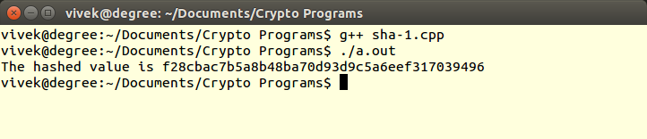

15.Chosen Ciphertext Attack on RSA
#include <bits/stdc++.h>
using namespace std;
bool isPrime(int a) {
for (int i = 2; i * i <= a; ++i) if (a % i == 0) return false;
return true;
}
vector<int> getMeTuple(int a) {
vector<int> primes (2, 0);
for (int i = 2; i <= a; ++i)
if (a % i == 0 && isPrime(i) && isPrime(a / i)) {
primes[0] = i; primes[1] = a / i;
}
return primes;
}
int fastExpo(int a, int b, int MOD) {
if (b == 0) return 1;
int result = fastExpo(a, b >> 1, MOD); result = (result * result) % MOD;
if (b & 1) result = (result * (a % MOD)) % MOD;
return result;
}
int inverse(int e, int MOD) {
int result = 0;
while (true) {
if ((e * result) % MOD == 1) return result;
++result;
}
return result;
}
int main() {
int p, e, n, c;
cin >> p >> c >> e >> n;
vector<int> myPQ = getMeTuple(n);
int d = inverse(e, (myPQ[0] - 1) * (myPQ[1] - 1));
int decrypted = fastExpo(c, d, n);
cout << (decrypted == p) << endl;
cout << decrypted << endl;
return 0;
}

input-output:

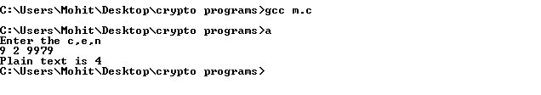
16.Common Modulas Attack on RSA
#include <iostream>
using namespace std;
long long int e, f, n,cffs, cffb;
void calcInverse(long long int a, long long int b) {
long long int newa = b, newb = a % b;
if(newa % newb == 0) {
cffs = (a / b) * (-1);
cffb = 1;
return;
}
calcInverse(b, a % b);
long long int store = cffs;
cffs = cffb - (a / b) * (cffs);
cffb = store;
}
long long int power(long long int plaintext, long long int e) {
long long int ans = 1;
while(e) {
if(e & 1)
ans = (ans * plaintext) % n;
plaintext = (plaintext * plaintext) % n;
e = e >> 1;
}
return ans;
}
long long int convertToNum(string str) {
int i;
long long int ans = 0;
for(i = 0; i < str.size(); i++) ans = (ans * 26 + str[i] - 65) % n;
return ans;
}
int main() {
cin >> n,e,f;
string cipher1, cipher2;
string ans = "";
long long cipherNum1, cipherNum2, plaintext;
cin >> cipher1>>cipher2;
cipherNum1 = convertToNum(cipher1);
cipherNum2 = convertToNum(cipher2);
//cout << cipherNum1 << " " << cipherNum2 << endl;
long long int x, y;
if(e < f) {
calcInverse(f, e);
y = cffb; x = cffs;
x = x % n; y = y % n;
if(x < 0) x += f;
if(y < 0) y += e;

else {
calcInverse(e, f);
y = cffs; x = cffb;

}
if(y < 0) {
calcInverse(n, cipherNum2);
plaintext = (power(cipherNum1, x) * power(cffs, -y)) % n;
} else if(x < 0) {
calcInverse(n, cipherNum1);
plaintext = (power(cffs, -x) * power(cipherNum2, y)) % n;
}
while(plaintext) {
int rem = plaintext % 26; string s = "";
s.push_back(rem + 65);
ans = s + ans; plaintext /= 26;
}
cout << ans << endl;
return 0;
}

input-output:

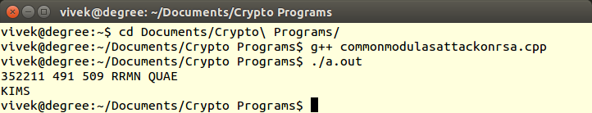

17.Elliptical Cryptosystem
#include <bits/stdc++.h>
using namespace std;
typedef pair<int,int> point;
int a = 2, b = 3;
int p = 67;

int inverse(int v) {
//cout<<"INv "<<v<<endl;
if(v < 0)
v += p;
int i = 1;
while(i<p) {
if( (v*i) %p ==1 )
return i;
i++;
}
}

point multiply(point e1, int d) {
point p1 = e1;
point p2 = e1;

for(int i=0;i<d-1;i++) {
int x1 = p1.first;
int y1 = p1.second;
int x2 = p2.first;
int y2 = p2.second;

if(x1 == x2 && y1 == -1*y2)
cout<<"here\n";
else if(x1 == x2 && y1 == y2) {
int lamda =( (3*x1*x1 + a)*inverse( (2*y1)%p ) )%p ;
p2.first = ((lamda*lamda - x1 - x2 )%p )%p ;
p2.second = ((lamda*(x1 - p2.first) - y1)%p )%p;
} else {
int t = x2 - y1;
if(t < 0)
t+=p;
int t1 = y2 - y1;
if(t1 < 0)
t1 += p;
int lamda = ( (t1)*inverse(t) )%p;
p2.first = (( lamda*lamda - x1 - x2 )%p )%p ;
p2.second = (( lamda*(x1-p2.first) -y1 )%p )%p;
}

cout<<i<<" "<<x1<<" "<<y1<<" "<<p2.first<<" "<<p2.second<<endl;
}

return p2;
}

int main() {

point e1 = make_pair(2,22);
int d = 4;
point e2 = multiply(e1,d);
cout<<e2.first<<" "<<e2.second;

return 0;
}

input-output:

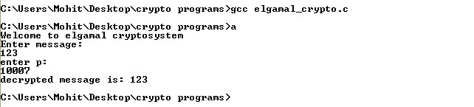

18.RSA Digital Signature
#include<bits/stdc++.h>
using namespace std;
int modPower(int a, int p, int mod)
{
long long ans = 1;
while(p) {
if(p&1) ans = (ans*a)%mod;
a = (a*a)%mod;
p = p/2;
}
return (int)ans;
}
int main()
{
int p, q, e; cin>>p>>q>>e;
int msg; cin>>msg;
int phi = (p-1)*(q-1);
int n = p*q, d = 1;
while(1) {
if(((d*e)-1)%phi==0)
break;
d++;
}
int y = modPower(msg, d, n), z = modPower(y, e, n);
if(msg == z)
cout<<"Verified";
else
cout<<"Not Verified";

return 0;
}

input-output:

