VLSI Design and Testing Laboratory Manual



**DEPARTMENTS OF COMPUTER SCIENCE AND ENGINEERING**

**NAME :** VIVEK KUMAR

**ADM. NO:** 2012JE0739

**SESSION : 2015-16**

# **ADDITIVE CIPHER**

**CODE:**

// Additive Cipher C Program

#include <stdio.h>

#include <string.h>

int main()

{

// String input

char a[35];

printf("Enter the string: ");

scanf("%s",a);

// KEy input

printf("Enter the additive key\n");

int k;

scanf("%d",&k);

if(k < 0) {

k += 26;

}

for(int i = 0; i < strlen(a); i++)

{

a[i] = (a[i] - 'A' + k) % 26 + 'A';

}

// Printing the encryption

printf("After Encryption the string is : %s\n",a);

return 0;

}

**OUTPUT:**

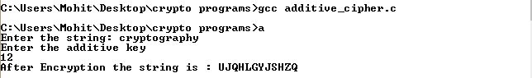

Figure: Output Additive Cipher

# **BRUTE FORCE ATTACK ON ADDITIVE CIPHER**

**CODE:**

// Additive Cipher Brute Force Attack C Program

#include <iostream>

#include <stdio.h>

using namespace std;

int main() {

string pt;

string ct;

cin >> pt;

int k = 1;

while(k < 26) {

ct = "";

int i;

for(i = 0; i < pt.size(); i++) {

char ch = (pt[i] - 'A' - k)%26;

ch += 'A';

if(ch < 'A') {

ch += 26;

}

ct.push_back(ch);

}

cout << "String after taking key = " << k << " is " << ct << endl;

k++;

}

return 0;

}

**OUTPUT:**

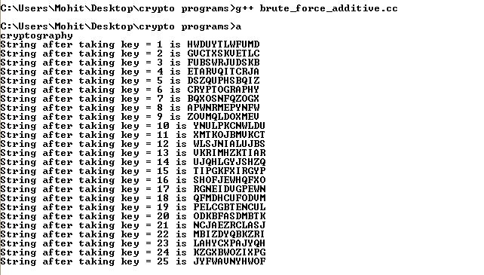

Figure: Brute Force Attack on Additive Cipher(Key 6 makes sense)

# **STATISTICAL ATTACK ON ADDITIVE CIPHER**

**CODE:**

// Additive Cipher Statistical Attack C Program

#include <stdio.h>

#include <limits.h>

#include<string.h>

int main() {

char a[100] = "XLILSYWIMWRSAJSVWEPIJSVJSYVQMPPMSRHSPPEVWMXMWASVXLQSVILYVVCFIJSVIXLIWIPPIVVIGIMZIWQSVISJJIVW";

int hash[26] = {0},k=0;

char ct[100];

int i;

for(i = 0; i < strlen(a); i++) {

hash[a[i] - 'A']++;

}

int maxIndex = INT_MIN, maxValue = INT_MIN;

for(i = 0; i < 26; i++) {

if(maxValue < hash[i]) {

maxValue = hash[i];

maxIndex = i;

}

}

int b = maxIndex - 4;

if(b < 0) {

b += 26;

}

for(i = 0; i < strlen(a); i++) {

char ch = (a[i] - 'A' - b) % 26 + 'A';

if(ch < 'A') {

ch += 26;

}

ct[k++]=ch;

}

printf("Encrypted string is %s\n",ct);

return 0;

}

**OUTPUT:**

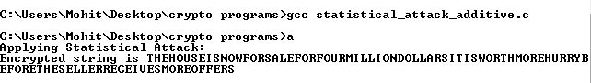

Figure: Statistical Attack on Additive Cipher

# **MULTIPLICATIVE CIPHER**

**CODE:**

// Multiplicative Cipher C Program

#include <iostream>

#include <stdio.h>

using namespace std;

int main() {

string pt;

cout << "Enter the string to be encrypted: ";

cin >> pt;

cout << "Enter the key: ";

int key;

cin >> key;

if(key % 13 == 0 || key % 2 == 0) {

cout << "Not a valid Key";

} else {

for(int i = 0; i < pt.size(); i++) {

pt[i] = ((pt[i] - 'A') * key) % 26 + 'A';

}

cout << "String after encryption: " << pt;

}

return 0;

}  
**OUTPUT:**

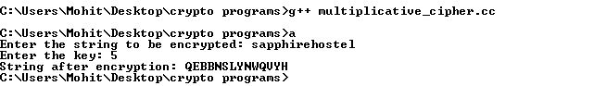

Figure: Output Multiplicative Cipher using key 5

# **AFFINE CIPHER**

**CODE:**

// Affine Cipher C Program

#include <stdio.h>

#include <string.h>

int main()

{

char str[30];

int keym,keya,i;

printf("Enter plaintext\n");

scanf("%s",str);

int len=strlen(str);

printf("Enter the additive key\n");

scanf("%d",&keya);

printf("Enter the multiplicative key\n");

scanf("%d",&keym);

for(i=0;i<len;i++)

{

int t = str[i]-'a';

t=(t*keym+keya);

t=t%26;

str[i]=(char)(t+'a');

}

printf("Cipher Text is \n%s\n",str);

return 0;

}

**OUTPUT:**

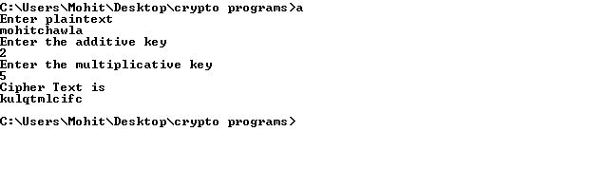

Figure: Output Affine Cipher

# **PLAYFAIR CIPHER**

**CODE:**

// Playfair Cipher C Program

#include <stdio.h>

#include <conio.h>

#include <string.h>

int main() {

char v,w,ch,string[100],arr[5][5],key[10],a,b,enc[100];

int temp,i,j,k,l,r1,r2,c1,c2,t,var;

FILE * fp;

fp=fopen("playfair_ip.txt","r");

//keep message in sk.txt (e.g. jamia)

printf("Enter the key\n");

fflush(stdin);

scanf("%s",&key);

l=0;

while(1) {

ch=fgetc(fp);

if(ch!=EOF) {

string[l++]=ch;

}

if(ch==EOF)

break;

}

string[l]='\0';

puts(string);

for (i=0;key[i]!='\0';i++) {

for (j=i+1;key[j]!='\0';j++) {

if(key[i]==key[j]) {

temp=1;

break;

}

}

}

if(temp==1)

printf("invalid key"); else {

k=0;

a='a';

//printf("%c",b);

for (i=0;i<5;i++) {

for (j=0;j<5;j++) {

if(k<strlen(key))

arr[i][j]=key[k]; else if(k==strlen(key)) {

b:

for (l=0;l<strlen(key);l++) {

if(key[l]==a) {

a++;

goto b;

}

}

arr[i][j]=a;

if(a=='i')

a=a+2; else

a++;

}

if(k<strlen(key))

k++;

}

}

printf("\n");

printf("The matrix is\n");

for (i=0;i<5;i++) {

for (j=0;j<5;j++) {

printf("%c",arr[i][j]);

}

printf("\n");

}

t=0;

if(strlen(string)%2!=0)

var=strlen(string)-1;

for (i=0;i<var;) {

v=string[i++];

w=string[i++];

if(v==w) {

enc[t++]=v;

enc[t++]='$';

} else {

for (l=0;l<5;l++) {

for (k=0;k<5;k++) {

if(arr[l][k]==v||v=='j'&&arr[l][k]=='i') {

r1=l;

c1=k;

}

if(arr[l][k]==w||w=='j'&&arr[l][k]=='i') {

r2=l;

c2=k;

}

}

}

if(c1==c2) {

r1++;

r2++;

if(r1==5||r2==5) {

r1=0;

r2=0;

}

} else if(r1==r2) {

c1++;

c2++;

if(c1==5||c2==5) {

c1=0;

c2=0;

}

} else {

temp=r1;

r1=r2;

r2=temp;

}

enc[t++]=arr[r1][c1];

enc[t++]=arr[r2][c2];

}

}

if(strlen(string)%2!=0)

enc[t++]=string[var];

enc[t]='\0';

}

printf("The encrypted text is\n");

puts(enc);

return 0;

}

**OUTPUT:**

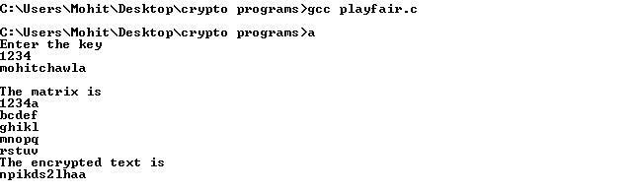

Figure: Output Playfair Cipher

# **VIGENERE CIPHER**

**CODE:**

#include <iostream>

using namespace std;

int main() {

        string str, strOutput = "";

        cin >> str;

        int n;

        int array[26];

        int i;

        cout << "Enter private key size: ";

        cin >> n;

        cout << "Enter the private key: ";

        for(i = 0; i < n; i++) {

                cin >> array[i];

        }

        int k = 0;

        for(i = 0; i < str.size(); i++) {

                if(k % n == 0) {

                        k = 0;

                }

                char ch = (str[i] + array[k++] - 'A') % 26 + 'A';

                strOutput.push_back(ch);

        }

        cout << "Cipher Text: " << strOutput << endl;

        return 0;

}

**OUTPUT:**

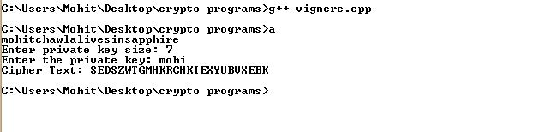

Figure: Output of Vigenere Cipher

# **HILL CIPHER**

**CODE:**

#include <iostream>

using namespace std;

int matrix[4][4] = {{9, 7, 11, 13}, {4, 7, 5, 6}, {2, 21, 14, 9}, {3, 23, 21, 8}};

int decr[4][4] = {{2, 15, 22, 3}, {15, 0, 19, 3}, {9, 9, 3, 11}, {17, 0, 4, 7}};

int mult[100][4];

int createMatrix(string temp) {

int cnt = 0, i;

int row = 0;

for(i = 0; i < temp.size(); i++) {

mult[row][cnt % 4] = temp[i] - 'a';

cnt++;

if(cnt % 4 == 0) {

row++;

}

}

while(cnt % 4 != 0) {

mult[row][cnt % 4] = 'z' - 'a';

cnt++;

if(cnt % 4 == 0)

row++;

}

row--;

return row;

}

string encrypt(string temp) {

int i, j, k;

string ret = "";

int finalMat[100][4];

int rows = createMatrix(temp);

for(i = 0; i <= rows; i++) {

for(j = 0; j < 4; j++) {

finalMat[i][j] = 0;

for(k = 0; k < 4; k++) {

finalMat[i][j] = (finalMat[i][j] + mult[i][k] * matrix[k][j]) % 26;

}

}

}

for(i = 0; i <= rows; i++) {

for(j = 0; j < 4; j++) {

ret.push_back('a' + finalMat[i][j]);

}

}

return ret;

}

string decrypt(string temp1) {

int i, j, k;

string ret = "";

int finalMat[100][4];

int rows = createMatrix(temp1);

for(i = 0; i <= rows; i++) {

for(j = 0; j < 4; j++) {

finalMat[i][j] = 0;

for(k = 0; k < 4; k++) {

finalMat[i][j] = (finalMat[i][j] + mult[i][k] * decr[k][j]) % 26;

}

}

}

for(i = 0; i <= rows; i++) {

for(j = 0; j < 4; j++) {

ret.push_back('a' + finalMat[i][j]);

}

}

return ret;

}

int main() {

string str, strOutput = "", decrypted = "";

cout << "Enter the string to be encrypted: ";

cin >> str;

strOutput = encrypt(str);

cout << "Encrypted text " << strOutput << endl;

decrypted = decrypt(strOutput);

cout << "Decrypted text " << decrypted;

return 0;

}

**OUTPUT:**

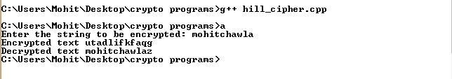

Figure: Output of Hill Cipher

# **DES**

**CODE:**

// DES C Program

#include <stdio.h>

void left_shift(int *a)

{

int i,tmp=a[0];

for(i=0;i<27;i++)

a[i]=a[i+1];

a[27]=tmp;

}

int main()

{

int i,j;

int p[64]={0,0,0,1,0,0,1,0,0,0,1,1,0,1,0,0,0,1,0,1,0,1,1,0,1,0,1,0,1,0,1,1,1,1,0,0,1,1,0,1,0,0,0,1,0,0,1,1,0,0,1,0,0,1,0,1,0,0,1,1,0,1,1,0};

int key[64]={1,0,1,0,1,0,1,0,1,0,1,1,1,0,1,1,0,0,0,0,1,0,0,1,0,0,0,1,1,0,0,0,0,0,1,0,0,1,1,1,0,0,1,1,0,1,1,0,1,1,0,0,1,1,0,0,1,1,0,1,1,1,0,1};

//parity drop

int parity_drop[8][7]={{57,49,41,33,25,17,9},

{1,58,50,42,34,26,18},

{10,2,59,51,43,35,27},

{19,11,3,60,52,44,36},

{63,55,47,39,31,23,15},

{7,62,54,46,38,30,22},

{14,6,61,53,45,37,29},

{21,13,5,28,20,12,4}};

int key_comp[8][6]={{14,17,11,24,1,5},

{3,28,15,6,21,10},

{23,19,12,4,26,8},

{16,7,27,20,13,2},

{41,52,31,37,47,55},

{30,40,51,45,33,48},

{44,49,39,56,34,53},

{46,42,50,36,29,32}};

int key_parity[56];

int z=0;

for(i=0;i<8;i++)

{

for(j=0;j<7;j++)

key_parity[z++]=key[parity_drop[i][j]-1];

}

// for(i=0;i<56;i++)

// printf("%d",key_parity[i]);

int k1[28],k2[28];

for(i=0;i<56;i++)

{

if(i<28)

k1[i]=key_parity[i];

else

k2[i-28]=key_parity[i];

}

int round=1,shift;

while(round<=16)

{

printf("key for round %d:\n",round);

if(round==1 || round==2 || round==9 ||round==16)

shift=1;

else

shift=2;

while(shift--)

{

left_shift(k1);

left_shift(k2);

}

for(i=0;i<8;i++)

{

for(j=0;j<6;j++)

{

if(key_comp[i][j]<=28)

printf("%d",k1[key_comp[i][j]-1]);

else

printf("%d",k2[key_comp[i][j]-29]);

}

}

printf("\n");

round++;

}

return 0;

}

**OUTPUT:**

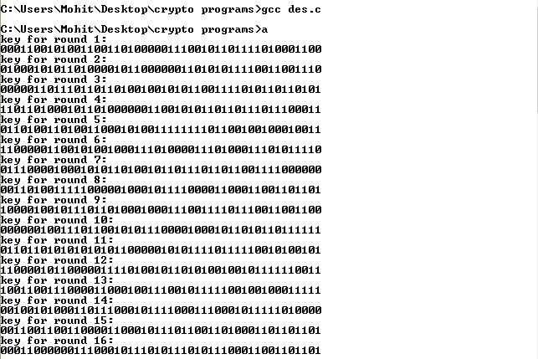

Figure: Output DES

# **AES**

**CODE:**

// AES C Program

#include <stdio.h>

#include <stdlib.h>

int sbox[256] = {

//0 1 2 3 4 5 6 7 8 9 A B C D E F

0x63, 0x7c, 0x77, 0x7b, 0xf2, 0x6b, 0x6f, 0xc5, 0x30, 0x01, 0x67, 0x2b, 0xfe, 0xd7, 0xab, 0x76, //0

0xca, 0x82, 0xc9, 0x7d, 0xfa, 0x59, 0x47, 0xf0, 0xad, 0xd4, 0xa2, 0xaf, 0x9c, 0xa4, 0x72, 0xc0, //1

0xb7, 0xfd, 0x93, 0x26, 0x36, 0x3f, 0xf7, 0xcc, 0x34, 0xa5, 0xe5, 0xf1, 0x71, 0xd8, 0x31, 0x15, //2

0x04, 0xc7, 0x23, 0xc3, 0x18, 0x96, 0x05, 0x9a, 0x07, 0x12, 0x80, 0xe2, 0xeb, 0x27, 0xb2, 0x75, //3

0x09, 0x83, 0x2c, 0x1a, 0x1b, 0x6e, 0x5a, 0xa0, 0x52, 0x3b, 0xd6, 0xb3, 0x29, 0xe3, 0x2f, 0x84, //4

0x53, 0xd1, 0x00, 0xed, 0x20, 0xfc, 0xb1, 0x5b, 0x6a, 0xcb, 0xbe, 0x39, 0x4a, 0x4c, 0x58, 0xcf, //5

0xd0, 0xef, 0xaa, 0xfb, 0x43, 0x4d, 0x33, 0x85, 0x45, 0xf9, 0x02, 0x7f, 0x50, 0x3c, 0x9f, 0xa8, //6

0x51, 0xa3, 0x40, 0x8f, 0x92, 0x9d, 0x38, 0xf5, 0xbc, 0xb6, 0xda, 0x21, 0x10, 0xff, 0xf3, 0xd2, //7

0xcd, 0x0c, 0x13, 0xec, 0x5f, 0x97, 0x44, 0x17, 0xc4, 0xa7, 0x7e, 0x3d, 0x64, 0x5d, 0x19, 0x73, //8

0x60, 0x81, 0x4f, 0xdc, 0x22, 0x2a, 0x90, 0x88, 0x46, 0xee, 0xb8, 0x14, 0xde, 0x5e, 0x0b, 0xdb, //9

0xe0, 0x32, 0x3a, 0x0a, 0x49, 0x06, 0x24, 0x5c, 0xc2, 0xd3, 0xac, 0x62, 0x91, 0x95, 0xe4, 0x79, //A

0xe7, 0xc8, 0x37, 0x6d, 0x8d, 0xd5, 0x4e, 0xa9, 0x6c, 0x56, 0xf4, 0xea, 0x65, 0x7a, 0xae, 0x08, //B

0xba, 0x78, 0x25, 0x2e, 0x1c, 0xa6, 0xb4, 0xc6, 0xe8, 0xdd, 0x74, 0x1f, 0x4b, 0xbd, 0x8b, 0x8a, //C

0x70, 0x3e, 0xb5, 0x66, 0x48, 0x03, 0xf6, 0x0e, 0x61, 0x35, 0x57, 0xb9, 0x86, 0xc1, 0x1d, 0x9e, //D

0xe1, 0xf8, 0x98, 0x11, 0x69, 0xd9, 0x8e, 0x94, 0x9b, 0x1e, 0x87, 0xe9, 0xce, 0x55, 0x28, 0xdf, //E

0x8c, 0xa1, 0x89, 0x0d, 0xbf, 0xe6, 0x42, 0x68, 0x41, 0x99, 0x2d, 0x0f, 0xb0, 0x54, 0xbb, 0x16 }; //F

int round[10]={0x01,0x02,0x04,0x08,0x10,0x20,0x40,0x80,0x1b,0x36};

int find(int a)

{

return sbox[a];

}

int * calculate_delta(int *key,int r)

{

int *t = (int *)malloc(4*sizeof(int));

t[0]=key[13];

t[1]=key[14];

t[2]=key[15];

t[3]=key[12];

t[0]=find(t[0])^round[r];

t[1]=find(t[1]);

t[2]=find(t[2]);

t[3]=find(t[3]);

return t;

}

int *find_xor(int *a,int s,int *b,int s1)

{

int *t = (int *)malloc(4*sizeof(int));

int i;

for(i=0;i<4;i++)

{

t[i]=a[s+i]^b[s1+i];

}

return t;

}

void overwrite(int *a,int s,int *b)

{

int i;

for(i=0;i<4;i++)

a[s+i]=b[i];

}

void fn(int *key)

{

int i;

int *temp = (int *)malloc(4*sizeof(int));

for(i=0;i<10;i++)

{

int *delta = calculate_delta(key,i);

int *temp = find_xor(key,0,delta,0);

overwrite(key,0,temp);

temp = find_xor(key,0,key,4);

overwrite(key,4,temp);

temp = find_xor(key,4,key,8);

overwrite(key,8,temp);

temp = find_xor(key,8,key,12);

overwrite(key,12,temp);

int j;

char strr[100];

printf("KEY %d : " ,i+1);

for(j=0;j<16;j++)

{

itoa(key[j],strr,16);

printf("%s ",strr);

}

printf("\n");

}

}

int main()

{

int key[]={0x24, 0x75 ,0xA2 ,0xB3 ,0x34 ,0x75 ,0x56 ,0x88 ,0x31 ,0xE2 ,0x12 ,0x00 ,0x13 ,0xAA ,0x54 ,0x87};

fn(key);

return 0;

}

**OUTPUT:**

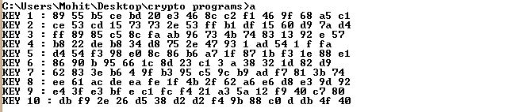

Figure: Output AES

# **RSA**

**CODE:**

#include <stdio.h>

int powmod(int n,int m,int d)

{

int ans=1;

while(d--)

ans=(ans*m)%n;

return ans;

}

int main()

{

int p,q,n,d,e;

printf("Enter the value of p:\n");

scanf("%d",&p);

printf("Enter the value of q:\n");

scanf("%d",&q);

printf("Enter the value of d:\n");

scanf("%d",&d);

printf("Enter the value of e:\n");

scanf("%d",&e);

n=p*q;

int phi=(p-1)*(q-1);

int m=46;

m=m%n;

int s=powmod(n,m,d);

int v=powmod(n,s,e);

if(v==m)

printf("message is accepted\n");

else

printf("message is rejected\n");

return 0;

}

**OUTPUT:**

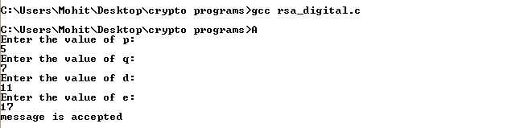

Figure: Output RSA

# **CHOSEN CIPHERTEXT ATTACK ON RSA**

**CODE:**

#include <bits/stdc++.h>

using namespace std;

bool isPrime(int a) {

for (int i = 2; i * i <= a; ++i) {

if (a % i == 0) return false;

}

return true;

}

vector<int> getMeTuple(int a) {

vector<int> primes (2, 0);

for (int i = 2; i <= a; ++i) {

if (a % i == 0 && isPrime(i) && isPrime(a / i)) {

primes[0] = i;

primes[1] = a / i;

}

}

return primes;

}

int fastExpo(int a, int b, int MOD) {

if (b == 0) return 1;

int result = fastExpo(a, b >> 1, MOD);

result = (result * result) % MOD;

if (b & 1) result = (result * (a % MOD)) % MOD;

return result;

}

int inverse(int e, int MOD) {

int result = 0;

while (true) {

if ((e * result) % MOD == 1) return result;

++result;

}

return result;

}

int main() {

int p, e, n, c;

cin >> p >> c >> e >> n;

vector<int> myPQ = getMeTuple(n);

int d = inverse(e, (myPQ[0] - 1) * (myPQ[1] - 1));

int decrypted = fastExpo(c, d, n);

cout << (decrypted == p) << endl;

cout << decrypted << endl;

return 0;

}

**OUTPUT:**

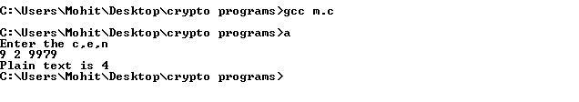

Figure: Chosen Ciphertext Attack on RSA

# **COMMON MODULUS ATTACK ON RSA**

**CODE:**

#include <iostream>

using namespace std;

long long int e, f;

long long int n;

long long int cffs, cffb;

void calcInverse(long long int a, long long int b) {

long long int newa = b;

long long int newb = a % b;

if(newa % newb == 0) {

cffs = (a / b) * (-1);

cffb = 1;

//cout << cffb << " " << cffs << endl;

return;

}

calcInverse(b, a % b);

long long int store = cffs;

cffs = cffb - (a / b) * (cffs);

cffb = store;

//cout << cffb << " " << cffs << endl;

}

long long int power(long long int plaintext, long long int e) {

long long int ans = 1;

while(e) {

if(e & 1) {

ans = (ans * plaintext) % n;

}

plaintext = (plaintext * plaintext) % n;

e = e >> 1;

//cout << plaintext;

}

return ans;

}

long long int convertToNum(string str) {

int i;

long long int ans = 0;

for(i = 0; i < str.size(); i++) {

ans = (ans * 26 + str[i] - 65) % n;

}

return ans;

}

int main() {

cout<<"Enter common modulus"<<endl;

cin >> n;

cout<<"Enter public key1:"<<endl;

cin >> e;

cout<<"Enter public key2"<<endl;

cin >> f;

string cipher1;

string cipher2;

string ans = "";

long long cipherNum1, cipherNum2;

long long int plaintext;

cout<<"Enter cipher text for key 1:"<<endl;

cin >> cipher1;

cout<<"Enter cipher text for key 2:"<<endl;

cin >> cipher2;

cipherNum1 = convertToNum(cipher1);

cipherNum2 = convertToNum(cipher2);

//cout << cipherNum1 << " " << cipherNum2 << endl;

long long int x, y;

if(e < f) {

calcInverse(f, e);

y = cffb;

x = cffs;

// cout << x << " " << y << endl;

/*x = x % n;

y = y % n;

if(x < 0) {

x += f;

}

if(y < 0) {

y += e;

}*/

} else {

calcInverse(e, f);

y = cffs;

x = cffb;

/*x = x % f;

y = y % e;

if(x < 0) {

x += f;

}

if(y < 0) {

y += e;

}*/

}

//cout << x << " " << y << endl;

//cout << power(cipherNum1, x) << " " << power(cipherNum2, y) << endl;

if(y < 0) {

calcInverse(n, cipherNum2);

//cout << cffs << endl;

plaintext = (power(cipherNum1, x) * power(cffs, -y)) % n;

} else if(x < 0) {

calcInverse(n, cipherNum1);

//cout << cffs << endl;

plaintext = (power(cffs, -x) * power(cipherNum2, y)) % n;

}

//plaintext = (power(cipherNum1, x) * power(cipherNum2, y)) % n;

while(plaintext) {

int rem = plaintext % 26;

string s = "";

s.push_back(rem + 65);

ans = s + ans;

plaintext /= 26;

}

cout<< "The plaintext is:"<<endl;

cout << ans << endl;

return 0;

}

**OUTPUT:**

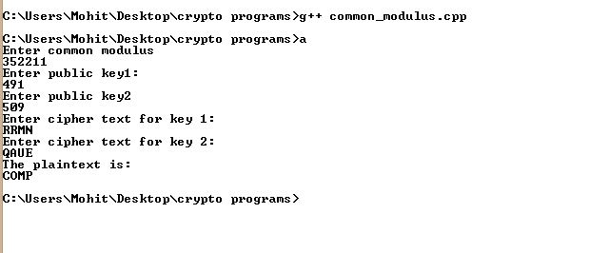

Figure: Common Modulus Attack on RSA

# **ELGAMAL DIGITAL SIGNATURE**

**CODE:**

#include<stdio.h>

int powmod(int a,int b,int m)

{

int ans=1;

int d=a;

while(b)

{

if(b&1)

ans=(ans*d)%m;

d=(d*d)%m;

b>>=1;

}

return ans;

}

int premitive_root(int p)

{

int i,a;

for(a=2;a<p;a++)

{

for(i=2;i<p;i++)

{

if(powmod(a,i,p)==1 && i==p-1)

return a;

else if(powmod(a,i,p)==1 && i!=p-1)

break;

}

}

}

int inverse(int a,int b)

{

int inv=1;

while((inv*b-1)%a!=0)

inv++;

return inv;

}

int main()

{

int m,p,d,r;

//User enter a large prime number, say 123

printf("Enter message:\n");

scanf("%d",&m);

//Simulation: 3119,127,307

printf("enter p,d and r:\n");

scanf("%d %d %d",&p,&d,&r);

// int e1=2;

// printf("debug");

int e1=premitive_root(p);

int e2=powmod(e1,d,p);

// printf("e1=%d e2=%d",e1,e2);

// signature generation

int s1=powmod(e1,r,p);

int cal1=(m-d*s1);

cal1=cal1%(p-1)+p-1;

cal1=cal1%(p-1);

int cal2=inverse(p-1,r);

int s2=(cal1*cal2)%(p-1);

// signature verification

int v1= powmod(e1,m,p);

int v2= (powmod(e2,s1,p)*powmod(s1,s2,p))%p;

// printf("ca1=%d cal2=%d\nv1=%d v2=%d\ns1=%d s2=%d\n",cal1,cal2,v1,v2,s1,s2);

printf("Using Elgaml Digital Signature Technique... \nVerfying Signature... \n");

if(v1==v2)

printf("signature verified\n");

else

printf("signature rejected\n");

return 0;

}

**OUTPUT:**

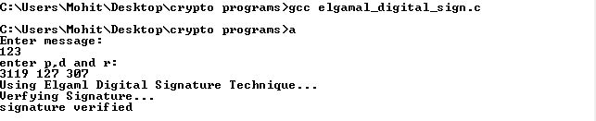

Figure: El Gamal Digital Signature

# **SHA**

**CODE:**

#include <stdio.h>

#include <string.h>

#include <stdlib.h>

/*

Output should be:

a9993e364706816aba3e25717850c26c9cd0d89d

84983e441c3bd26ebaae4aa1f95129e5e54670f1

34aa973cd4c4daa4f61eeb2bdbad27316534016f

*/

// Signed variables are for wimps

#define uchar unsigned char

#define uint unsigned int

// DBL_INT_ADD treats two unsigned ints a and b as one 64-bit integer and adds c to it

//Define left rotation with wrapping

#define ROTLEFT(a,b) ((a << b) | (a >> (32-b)))

//Define addition modulo 2^w

#define DBL_INT_ADD(a,b,c) if (a > 0xffffffff - c) ++b; a += c;

typedef struct {

uchar data[64];

uint datalen;

uint bitlen[2];

uint state[5];

uint k[4];

} SHA1_CTX;

void sha1_transform(SHA1_CTX *ctx, uchar data[])

{

uint a,b,c,d,e,i,j,t,m[80];

for (i=0,j=0; i < 16; ++i, j += 4)

m[i] = (data[j] << 24) + (data[j+1] << 16) + (data[j+2] << 8) + (data[j+3]);

for ( ; i < 80; ++i) {

m[i] = (m[i-3] ^ m[i-8] ^ m[i-14] ^ m[i-16]);

m[i] = (m[i] << 1) | (m[i] >> 31);

}

//Define the 5 variables

a = ctx->state[0];

b = ctx->state[1];

c = ctx->state[2];

d = ctx->state[3];

e = ctx->state[4];

for (i=0; i < 20; ++i) {

t = ROTLEFT(a,5) + ((b & c) ^ (~b & d)) + e + ctx->k[0] + m[i];

e = d;

d = c;

c = ROTLEFT(b,30);

b = a;

a = t;

}

for ( ; i < 40; ++i) {

t = ROTLEFT(a,5) + (b ^ c ^ d) + e + ctx->k[1] + m[i];

e = d;

d = c;

c = ROTLEFT(b,30);

b = a;

a = t;

}

for ( ; i < 60; ++i) {

t = ROTLEFT(a,5) + ((b & c) ^ (b & d) ^ (c & d)) + e + ctx->k[2] + m[i];

e = d;

d = c;

c = ROTLEFT(b,30);

b = a;

a = t;

}

for ( ; i < 80; ++i) {

t = ROTLEFT(a,5) + (b ^ c ^ d) + e + ctx->k[3] + m[i];

e = d;

d = c;

c = ROTLEFT(b,30);

b = a;

a = t;

}

ctx->state[0] += a;

ctx->state[1] += b;

ctx->state[2] += c;

ctx->state[3] += d;

ctx->state[4] += e;

}

void sha1_init(SHA1_CTX *ctx)

{

ctx->datalen = 0;

ctx->bitlen[0] = 0;

ctx->bitlen[1] = 0;

ctx->state[0] = 0x67452301;

ctx->state[1] = 0xEFCDAB89;

ctx->state[2] = 0x98BADCFE;

ctx->state[3] = 0x10325476;

ctx->state[4] = 0xc3d2e1f0;

ctx->k[0] = 0x5a827999;

ctx->k[1] = 0x6ed9eba1;

ctx->k[2] = 0x8f1bbcdc;

ctx->k[3] = 0xca62c1d6;

}

void sha1_update(SHA1_CTX *ctx, uchar data[], uint len)

{

uint t,i;

for (i=0; i < len; ++i) {

ctx->data[ctx->datalen] = data[i];

ctx->datalen++;

if (ctx->datalen == 64) {

sha1_transform(ctx,ctx->data);

DBL_INT_ADD(ctx->bitlen[0],ctx->bitlen[1],512);

ctx->datalen = 0;

}

}

}

void sha1_final(SHA1_CTX *ctx, uchar hash[])

{

uint i;

i = ctx->datalen;

// Pad whatever data is left in the buffer.

if (ctx->datalen < 56) {

ctx->data[i++] = 0x80;

while (i < 56)

ctx->data[i++] = 0x00;

}

else {

ctx->data[i++] = 0x80;

while (i < 64)

ctx->data[i++] = 0x00;

sha1_transform(ctx,ctx->data);

memset(ctx->data,0,56);

}

// Append to the padding the total message's length in bits and transform.

DBL_INT_ADD(ctx->bitlen[0],ctx->bitlen[1],8 * ctx->datalen);

ctx->data[63] = ctx->bitlen[0];

ctx->data[62] = ctx->bitlen[0] >> 8;

ctx->data[61] = ctx->bitlen[0] >> 16;

ctx->data[60] = ctx->bitlen[0] >> 24;

ctx->data[59] = ctx->bitlen[1];

ctx->data[58] = ctx->bitlen[1] >> 8;

ctx->data[57] = ctx->bitlen[1] >> 16;

ctx->data[56] = ctx->bitlen[1] >> 24;

sha1_transform(ctx,ctx->data);

// Since this implementation uses little endian byte ordering and MD uses big endian,

// reverse all the bytes when copying the final state to the output hash.

for (i=0; i < 4; ++i) {

hash[i] = (ctx->state[0] >> (24-i*8)) & 0x000000ff;

hash[i+4] = (ctx->state[1] >> (24-i*8)) & 0x000000ff;

hash[i+8] = (ctx->state[2] >> (24-i*8)) & 0x000000ff;

hash[i+12] = (ctx->state[3] >> (24-i*8)) & 0x000000ff;

hash[i+16] = (ctx->state[4] >> (24-i*8)) & 0x000000ff;

}

}

void print_hash(unsigned char hash[])

{

int idx;

for (idx=0; idx < 20; idx++)

printf("%02x",hash[idx]);

printf("\n");

}

int main()

{

unsigned char text1[]={"abc"},

text2[]={"abcdbcdecdefdefgefghfghighijhijkijkljklmklmnlmnomnopnopq"},

text3[]={"aaaaaaaaaa"},

hash[20];

int idx;

SHA1_CTX ctx;

printf("Printing final hash output: \n\n");

// Hash one

sha1_init(&ctx);

sha1_update(&ctx,text1,strlen(text1));

sha1_final(&ctx,hash);

print_hash(hash);

// Hash two

sha1_init(&ctx);

sha1_update(&ctx,text2,strlen(text2));

sha1_final(&ctx,hash);

print_hash(hash);

// Hash three

sha1_init(&ctx);

for (idx=0; idx < 100000; ++idx)

sha1_update(&ctx,text3,strlen(text3));

sha1_final(&ctx,hash);

print_hash(hash);

getchar();

return 0;

}

**OUTPUT:**

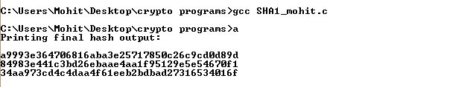

Figure: SHA

# **ELLIPTIC CURVE CRYPTOSYSTEM**

**CODE:**

//El Gamal Cryptosystem

#include<stdio.h>

int powmod(int a,int b,int m)

{

int ans=1;

int d=a;

while(b)

{

if(b&1)

ans=(ans*d)%m;

d=(d*d)%m;

b>>=1;

}

return ans;

}

int premitive_root(int p)

{

int i,a;

for(a=2;a<p;a++)

{

for(i=2;i<p;i++)

{

if(powmod(a,i,p)==1)

return a;

}

}

}

int main()

{

printf("Welcome to elgamal cryptosystem\n");

int m,p;

//User enter a large prime number, say 10007

printf("Enter message:\n");

//USer enters a msg in form of a number, say 123

scanf("%d",&m);

printf("enter p:\n");

scanf("%d",&p);

int e1=premitive_root(p);

int d=p/2,r=7;

int e2=powmod(e1,d,p);

int c1=powmod(e1,r,p);

int c2=(m%p*powmod(e2,r,p))%p;

int decrypt=(c2*powmod(powmod(c1,d,p),p-2,p))%p;

printf("decrypted message is: %d\n",decrypt);

return 0;

}

**OUTPUT:**

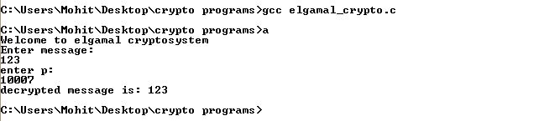

Figure: Output El Gamal Cryptosystem