DETAILED ARCHITECTURE
Aegis-V
Design and Verification of a RISC-V Secure Edge Node SoC with
Hardware SHA-256 Engine, High-Precision PWM, and Windowed Watchdog
Architecture Baseline: RV32I 32-bit RISC-V • 3-stage pipeline • AXI4 32-bit • 2 AXI4 masters (CPU + DMA) • 9 AXI4 slaves • AXI4 interconnect • Verilog/SystemVerilog RTL

Document purpose
This is the main architecture document for RTL design, verification, integration, firmware planning, and agentic-AI/Kiro consumption. It supersedes the previous single-level top-level block-diagram presentation by defining the top-level hierarchy, sub-block decomposition, control path, data path, error/fault model, interrupt model, applications, signals, registers, and verification mapping.

Document item | Value
Project | Aegis-V Secure Edge Node SoC
Core | 32-bit RV32I RISC-V processor core; 3-stage execution pipeline
Interconnect | AXI4 master interface → AXI4 interconnect → AXI4 interconnect → AMBA AXI4 AXI4 peripheral fabric
Mandatory base peripherals | UART, 32-bit System Timer, 16-bit GPIO
Custom IP #1 | Hardware SHA-256 Engine
Custom IP #2 | 4-Channel High-Precision PWM Generator
Custom IP #3 | Windowed Watchdog (W-WDT)
Primary application | Secure edge actuation + cryptographic integrity verification
RTL / verification | Verilog HDL / SystemVerilog layered testbenches
Status convention | Source-defined items are normative; implementation-defined items are explicitly tagged.

Source basis: Aegis-V_Detailed_Architecture.docx, Aegis_V_Project_Abstract(1).pdf, Aegis_V_Signal_List(1).pdf, Aegis_V_SoC_Architecture_Document(1).pdf, plus the supplied block diagram image. The supplied architecture establishes the 19-page detailed baseline and the signal/register specifications; this document expands that baseline without silently changing defined addresses, interfaces, or behaviors.

Document Map
Section | Contents
1 | Introduction and Architecture Scope
2 | System Architecture and New Hierarchical Block Diagram
3 | Module / IP Inventory and Address Map
4 | CPU and Memory Subsystem Architecture
5 | AMBA AXI4 AXI4 Interconnect Architecture
6 | Control Path Architecture
7 | Data Path Architecture
8 | Detailed Peripheral and Custom-IP Internal Architectures
9 | Interrupt and NMI Architecture
10 | Error Conditions, Fault Handling, and Recovery
11 | Clock, Reset, and System Control
12 | End-to-End Firmware and Operational Flow
13 | Applications and Deployment Mapping
14 | Verification Architecture and Test Mapping
15 | Agentic-AI / Kiro Implementation Specification
16 | Architecture Traceability and Open Items
Appendix A | Complete Register Map
Appendix B | Complete Signal List
Appendix C | State Machines and Invariants
Appendix D | Kiro-Ready Component Manifest

How to use this document
Use Sections 2–11 as the hardware architecture baseline; Sections 12–14 as system/verification behavior; Section 15 and Appendix D as agentic-AI/Kiro implementation guidance. Any statement marked IMPLEMENTATION-DEFINED or OPEN ITEM requires confirmation against RTL before sign-off.

1. Introduction

1.1 Architecture Overview
Aegis-V is an RTL-level secure edge node controller centered on a 32-bit RV32I RISC-V processor. The architecture combines a CPU, split Instruction/Data memory, two AXI4 master paths (CPU M0 + DMA M1) feeding a 32-bit AXI4 interconnect and nine AXI4 slaves, three mandatory base peripherals, three custom IPs, and clock/reset/system-control infrastructure.
The architectural intent is to keep cryptographic integrity checking, deterministic actuation timing, and execution-supervision hardware off the CPU's timing-critical software path. The supplied baseline specifies a hardware SHA-256 engine that processes a 512-bit block in 66 cycles, a four-channel PWM generator with 16-bit configuration and dead-time support, and a windowed watchdog that detects both early and late servicing.

1.2 Problem Statement and Motivation
The source architecture identifies three main engineering problems: software SHA-256 can consume roughly 4,200 optimized RV32I CPU cycles per 512-bit block; software-polled PWM introduces timing jitter and interrupt overhead; and a conventional single-threshold watchdog does not detect a system that is still executing but servicing the watchdog too early.
- Cryptographic bottleneck: hardware offload reduces the stated hash transformation cost to 66 cycles and frees CPU bandwidth for control, monitoring, and logging.
- Actuation determinism: PWM timing is generated autonomously after configuration, using a free-running timebase, four duty comparators, and dead-time logic.
- Timing-integrity supervision: W-WDT enforces a valid service interval [WDT_WIN_LOW, WDT_WIN_HIGH], rather than only a maximum timeout.
- The CPU-facing interconnect uses AXI4 for a standard, scalable master interface. Register-mapped peripherals are implemented as AXI4 slaves with a uniform 32-bit AXI4 register/data interface.
- Memory separation: Instruction Memory and Data Memory are kept separate to avoid fetch/load-store contention.

1.3 Design Goals
- Provide a FIPS 180-4-compliant hardware SHA-256 accelerator interface with explicit BUSY, DONE, and ERR status.
- Provide four independent 16-bit PWM duty channels with edge/center alignment, inversion, and programmable dead-time.
- Detect watchdog early-kick and late/timeout conditions and route them to NMI or direct reset according to WDT_CTRL.RST_ACTION.
- Maintain deterministic AXI4 VALID/READY channel behavior and deterministic AXI4 VALID/READY handshakes, response ordering, burst accounting, and error propagation.
- Keep all defined peripheral windows 4 KB aligned for simple address decoding.
- Provide explicit error, interrupt, reset-cause, and verification hooks.

1.4 Scope and Boundary
In scope are the processor-facing AXI4 interfaces, on-chip memories, AXI4 interconnect and address decoder, UART, 32-bit timer, 16-bit GPIO, SHA-256 accelerator, 4-channel PWM, windowed watchdog, system control/status, clock/reset distribution, interrupt/NMI paths, fault handling, and the complete external I/O boundary. The architecture uses a single AXI4 interconnect and contains no protocol-conversion interconnect.

1.5 Source-of-Truth Rules
Tag | Meaning | Use
[NORMATIVE] | Explicitly defined by the supplied architecture/signal/register documents. | Do not change without architecture review.
[DECOMPOSITION] | Internal sub-block breakdown added to make RTL structure explicit. | Use as an implementation structure; confirm against RTL.
[IMPLEMENTATION-DEFINED] | Behavior explicitly left open by the source documents. | Must be fixed before verification sign-off.
[OPEN] | A capability is mentioned but the required register/signal is not defined. | Do not invent an interface; raise an architecture item.
[VERIFY] | Property or test obligation derived directly from the architecture. | Must map to a test/check/assertion.

2. System Architecture and New Hierarchical Block Diagram

2.1 New Top-Level Architecture
The revised baseline is an AXI4-only SoC interconnect. The CPU and DMA controller are the two AXI4 masters (M0 and M1). The AXI4 interconnect performs address decoding, read/write channel routing, transaction-ID handling, burst accounting, and response routing to nine AXI4 slaves: Instruction Memory, Data Memory, UART, Timer, GPIO, SHA-256, PWM, W-WDT, and System Control. Instruction Memory and Data Memory remain dedicated CPU memory paths.

Figure 2.1 — Detailed Internal Architecture of Aegis-V SoC (AXI4-Based with CPU and DMA Masters).
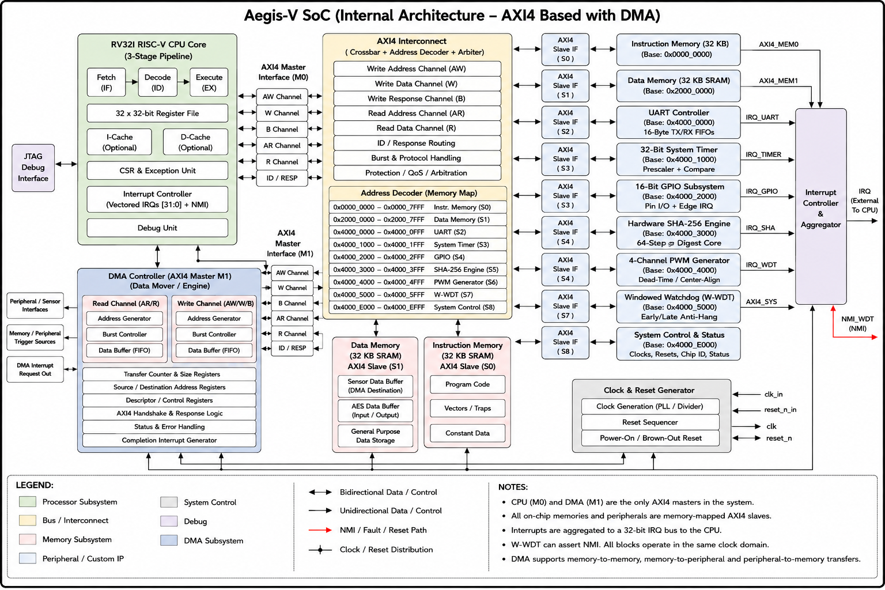

Architecture rule [NORMATIVE]
The CPU and DMA controller are the two AXI4 masters (M0 and M1). The AXI4 interconnect arbitrates both masters and routes transactions to the nine AXI4 slaves. Instruction Memory and Data Memory remain separate paths. Peripheral MMIO crosses the AXI4 interconnect, AXI4 interconnect, and AXI4 decoder. Interrupts return from peripherals to the CPU; W-WDT additionally has NMI and direct-reset paths.

2.2 Top-Level Hierarchy
Hierarchy ID | Block | Sub-blocks | Primary Interfaces
A0 | Aegis-V SoC Top | CPU, memories, AXI4, base peripherals, custom IPs, system control | HCLK/ACLK, reset, external I/O
A1 | RV32I CPU | Fetch, Decode/Control, ALU/Execute, RegFile, CSR/Exception, Interrupt Controller, LSU | IMEM, DMEM, AXI4 master, IRQ/NMI
A2 | Memory subsystem | 32 KB Instruction Memory, 32 KB Data SRAM | imem_addr/rdata, dmem_addr/wdata/rdata
A3 | AXI4 front-end + AXI4 interconnect + AXI4 fabric | Master arbitration, address decoder, target_select generation, ID tracking, response mux | AWADDR/ARADDR, WDATA, RDATA, READY, SLVERR
A4 | Mandatory peripherals | UART, Timer, GPIO | AXI4 + external I/O + IRQ
A5 | Custom IPs | SHA-256, 4-CH PWM, W-WDT | AXI4 + outputs + IRQ/NMI/reset
A6 | System infrastructure | Clock/Reset Controller, System Control & Status | HCLK/ACLK, HRESETn/ARESETn, reset cause

2.3 Application/Data, Interrupt, and Safety Paths
- Application/data path: external UART/GPIO ingress → CPU firmware → AXI4 MMIO → SHA-256 → digest validation → AXI4 PWM configuration → actuator outputs. MMIO path: CPU LSU → AXI4 read/write channels → AXI4 address decoder → one selected AXI4 slave → AXI4 R/B response → CPU. Interrupt path: UART, Timer, GPIO, SHA-256, PWM and WDT events → irq_vec[5:0]. NMI path: W-WDT fault → irq_wdt_nmi → nmi_in when RST_ACTION=0. Reset path: W-WDT fault → wdt_rst_out → Clock & Reset Controller → HRESETn when RST_ACTION=1.
- Peripheral MMIO path: CPU LSU → AXI4 transaction → AXI4 interconnect → one selected AXI4 slave → AXI4 response → AXI4 response → CPU.
- Interrupt path: UART, Timer, GPIO, SHA-256, PWM and WDT-related vectored events → irq_vec[5:0].
- NMI path: W-WDT fault → irq_wdt_nmi → nmi_in when RST_ACTION=0.
- Reset path: W-WDT fault → wdt_rst_out → Clock & Reset Controller → HRESETn/ARESETn when RST_ACTION=1.
- Supervisory service path: CPU writes WDT_KICK with 0x55AA followed by 0xAA55 within the valid window.

2.4 Diagram-to-RTL Mapping
Diagram block | Expected RTL responsibility | Verification focus
RV32I CPU | Execute RV32I instructions; generate IMEM/DMEM/MMIO accesses; handle IRQ/NMI | Instruction execution, traps, MMIO sequencing, interrupt entry
AXI4 interconnect + AXI4 / AXI4 interconnect + AXI4 / AXI4 decoder | Generate AXI4 VALID/READY handshakes, one-hot target_select, burst/ID state, and read/write responses | Protocol assertions, address decode, back-to-back transfers
UART | Serialize/deserialize, FIFO buffering, status and IRQ generation | FIFO boundaries, baud timing, parity error
Timer | Prescaler, counter, compare, optional auto-reload, IRQ | Match timing, rollover, enable/disable
GPIO | Input/output direction, data latches, edge detection/mask, IRQ | Direction masking, edge event, interrupt mask
SHA-256 | Input registers, INIT/START, 64 rounds, digest latch, BUSY/DONE/ERR | NIST vectors, cycle count, illegal access while BUSY
PWM | Prescaler, timebase, four comparators, gating, dead-time | Period/duty/dead-time and mode correctness
W-WDT | Counter, window comparators, key sequence detector, fault routing | Early/late/malformed key and reset/NMI behavior
Clock/reset/system | Clock enables, reset generation, reset cause, chip ID | Reset sequencing, cause capture, clock gating

3. Module / IP Inventory and Address Map

3.1 Complete Module Inventory
ID | Category | Module | Base | Size | Role
IP-CPU | Core | RV32I CPU | — | — | Fetch/decode/execute, AXI4 master, vectored IRQ[5:0] + NMI
IP-IMEM | Memory | Instruction Memory | 0x0000_0000 | 32 KB | Boot vector, firmware, program code
IP-DMEM | Memory | Data Memory | 0x2000_0000 | 32 KB | Stack, heap, runtime data
IP-UART | Base | UART Controller | 0x4000_0000 | 4 KB | Full-duplex serial, 16-byte TX/RX FIFOs, baud divider, IRQs
IP-TIMER | Base | 32-bit System Timer | 0x4000_1000 | 4 KB | Free-running/auto-reload counter, compare IRQ
IP-GPIO | Base | 16-bit GPIO | 0x4000_2000 | 4 KB | Bidirectional pins, direction, edge IRQ
IP-SHA | Custom #1 | Hardware SHA-256 | 0x4000_3000 | 4 KB | 512-bit block → 256-bit digest, 66-cycle transformation
IP-PWM | Custom #2 | 4-Channel PWM | 0x4000_4000 | 4 KB | 4 independent 16-bit channels, alignment, dead-time
IP-WDT | Custom #3 | Windowed WDT | 0x4000_5000 | 4 KB | Early/late service supervision; NMI/reset
IP-SYS | Infrastructure | System Control & Status | 0x4000_E000 | 4 KB | Reset cause, clock gates, chip ID
IP-CLK | Infrastructure | Clock & Reset Controller | — | — | HCLK/ACLK and HRESETn/ARESETn generation

3.2 Memory Map
Region | Base | End | Size | Access | Function
Instruction Memory | 0x0000_0000 | 0x0000_7FFF | 32 KB | R/W/X | Boot vector, C runtime, program code
Data Memory | 0x2000_0000 | 0x2000_7FFF | 32 KB | R/W | Stack, heap, runtime variables
Reserved | 0x2000_8000 | 0x3FFF_FFFF | ~512 MB | — | Reserved for system expansion
UART | 0x4000_0000 | 0x4000_0FFF | 4 KB | R/W | Serial I/O
Timer | 0x4000_1000 | 0x4000_1FFF | 4 KB | R/W | Timing
GPIO | 0x4000_2000 | 0x4000_2FFF | 4 KB | R/W | Digital I/O
SHA-256 | 0x4000_3000 | 0x4000_3FFF | 4 KB | R/W | Cryptographic accelerator
PWM | 0x4000_4000 | 0x4000_4FFF | 4 KB | R/W | Actuation timing
W-WDT | 0x4000_5000 | 0x4000_5FFF | 4 KB | R/W | Supervision
System Control | 0x4000_E000 | 0x4000_EFFF | 4 KB | R/W | System status/control

3.3 Address Decode Rule
AXI4 address routing uses the defined 4-KB-aligned peripheral windows. The AXI4 interconnect decodes the target from AWADDR for writes and ARADDR for reads. Exactly one AXI4 slave target is selected for each valid transaction. Unmapped addresses return DECERR. AXI4 burst transfers must remain inside a legal target window or be rejected according to the architecture-defined boundary/error policy.
For the defined peripheral region, the AXI4 decoder can use the 4 KB alignment of the address map, specifically the peripheral page encoded by AWADDR[15:12] / ARADDR[15:12]. Exactly one target_select must be asserted for a valid transfer. Any address not belonging to a defined window must produce the architecture's illegal/unmapped-address error response.
Architecture revision constraint [NORMATIVE]
The baseline contains two AXI4 masters (CPU and DMA controller) and one AXI4 interconnect, which is the sole AXI4 master for the peripheral fabric. Do not add a second AXI4 master, DMA master, second AXI fabric, cache, or additional peripheral window unless the architecture is formally revised.

4. CPU and Memory Subsystem Architecture

4.1 RV32I CPU Architecture

Figure 4.1 — CPU internal architecture and AXI4 system-facing interfaces.
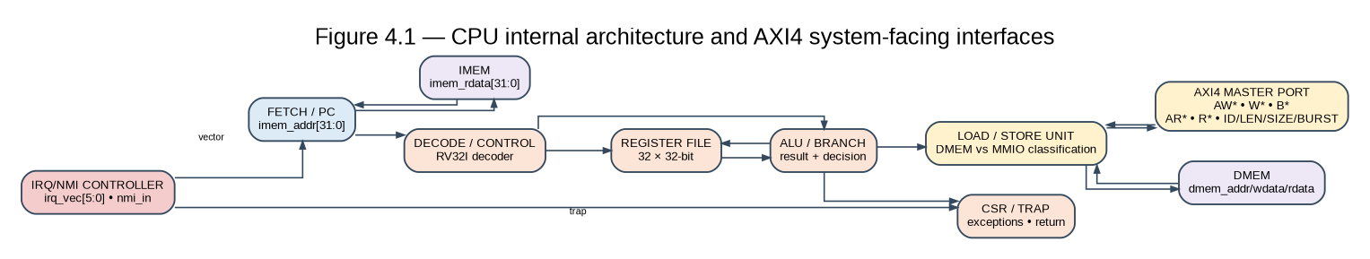

The supplied architecture defines a 32-bit RV32I processor with a 3-stage execution pipeline. Its explicit internal blocks are Fetch/Decode/ALU, a 32×32-bit register file, CSR & Exception Unit, Interrupt Controller, and Load/Store Unit. The figure adds a structural decomposition for RTL planning; exact forwarding, hazard, branch, and stage-register implementation is not specified by the supplied documents and is therefore implementation-defined.

4.2 CPU Control Responsibilities
- Generate the program counter and instruction-memory address; decode RV32I instructions; select ALU, branch, register-file and LSU controls; generate data-memory transactions for the Data Memory region; generate AXI4 MMIO transactions for peripheral accesses; hold dependent operations until the required AXI4 R/B response is accepted; enter interrupt/exception handlers; and give nmi_in precedence over maskable vectored interrupts.
- Decode RV32I instructions and select ALU/register/LSU controls.
- Perform register-file write-back only when the decoded instruction requires it.
- Generate data-memory transactions for addresses in the Data Memory region.
- Generate AXI4 MMIO transactions for peripheral accesses and accept AXI4 completion responses.
- Hold the dependent CPU transaction until the AXI4 interconnect reports completion; the interconnect tracks VALID/READY handshakes and holds transaction context until the selected slave completes.
- Enter the appropriate interrupt or exception handler when enabled conditions occur.
- Give nmi_in precedence over maskable vectored interrupts.

4.3 Instruction Memory
Instruction Memory is a 32 KB ROM/RAM region at 0x0000_0000–0x0000_7FFF. It contains the boot vector and compiled firmware. The CPU accesses it through imem_addr/imem_rdata. The architecture uses this memory as the executable code store; the exact ROM versus RAM implementation is a build-level choice consistent with the source description.

4.4 Data Memory
Data Memory is a 32 KB synchronous SRAM region at 0x2000_0000–0x2000_7FFF. It holds the stack, heap, and runtime variables. The CPU accesses it through dmem_addr, dmem_wdata, and dmem_rdata. The split memory organization gives separate instruction and data paths and avoids structural contention for these two on-chip memories.

4.5 CPU/Memory Invariants
- [VERIFY] Instruction fetch addresses remain within the executable memory map for valid program execution.
- [VERIFY] Data-memory writes never select an AXI4 peripheral.
- [VERIFY] AXI4 MMIO accesses do not corrupt Instruction Memory or Data Memory.
- [VERIFY] A READY-low AXI4 transfer stalls the AXI4 interconnect; the CPU transaction completes only after an AXI4 response or architecture-defined error.
- [VERIFY] Reset establishes the CPU and memory interfaces in their defined inactive states.

5. AXI4 Interconnect and DMA Architecture

5.1 AXI4 Interconnect, Master Arbitration, and Slave Fabric
The CPU is AXI4 master M0; DMA is AXI4 master M1. The AXI4 interconnect routes each decoded address to one selected AXI4 slave. The interconnect routes AXI4 read/write transactions directly to the selected AXI4 slave and returns the AXI4 R/B response with the original transaction ID. AXI4 peripherals remain register-mapped AXI4 slaves.
AXI4 Signal | Width | Direction | Function
AWADDR | 32 | Master → Interconnect | Write address
AWVALID / AWREADY | 1 / 1 | Master ↔ Interconnect | Write-address handshake
WDATA | 32 | Master → Interconnect | Write data
WSTRB | 4 | Master → Interconnect | Byte write strobes
WVALID / WREADY | 1 / 1 | Master ↔ Interconnect | Write-data handshake
BRESP | 2 | Interconnect → Master | Write response
BVALID / BREADY | 1 / 1 | Interconnect ↔ Master | Write response handshake
ARADDR | 32 | Master → Interconnect | Read address
ARVALID / ARREADY | 1 / 1 | Master ↔ Interconnect | Read-address handshake
RDATA | 32 | Interconnect → Master | Read data
RRESP | 2 | Interconnect → Master | Read response
RVALID / RREADY | 1 / 1 | Interconnect ↔ Master | Read-data handshake

Figure 5.1 — AXI4 interconnect, address decoder, channels, and nine AXI4 slaves.
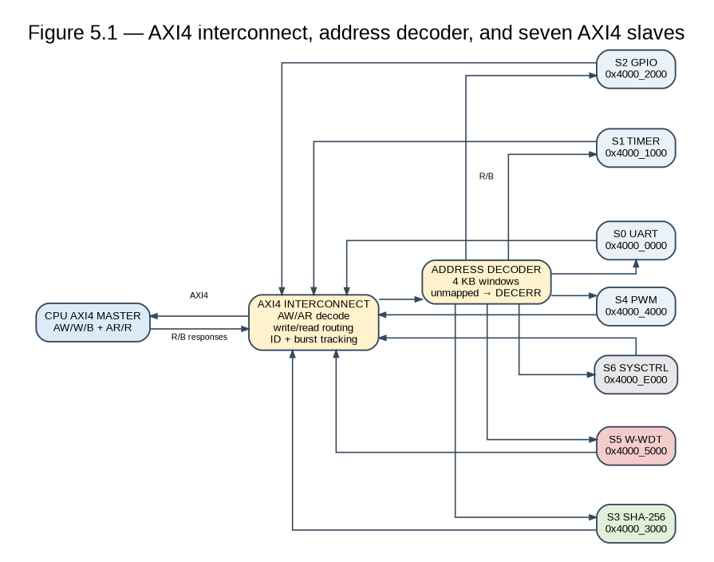

The AXI4 interconnect is the CPU-facing transaction-routing point. The AXI4 interconnect performs address decode, arbitration, channel routing, burst tracking, ID tracking, and AXI4 R/B response routing. There is no protocol-conversion state machine.

5.2 Transfer State Machine
State | target_select | AXI4 VALID/READY | Required behavior
IDLE | 0 | 0 | No transfer in progress.
SETUP | One selected slave | 0 | One-cycle setup; drive AWADDR/ARADDR and write data.
ACCESS | One selected slave | 1 | Wait for READY; complete on rising edge when READY=1.

ACCESS self-loops while READY=0. If a new transfer is queued, ACCESS can transition directly to SETUP for back-to-back transfers; otherwise it returns to IDLE.

5.4 AXI4 Peripheral-Side Signal Contract
Signal | Width | Direction | Architecture meaning
ACLK | 1 | Master → slaves | Peripheral bus clock
ARESETn | 1 | Master → slaves | Active-low peripheral reset
AWADDR[31:0]/ARADDR[31:0] | 32 | Master → slaves | Decoded peripheral address
target_select | 1 per slave | Decoder → slave | One-hot slave selection
AXI4 VALID/READY | 1 | Master → slaves | AXI4 VALID/READY handshake
AW/W or AR channel | 1 | Master → slaves | 1=write, 0=read
WDATA[31:0] | 32 | Master → slaves | Write payload
RDATA[31:0] | 32 | Slave → master | Read payload
READY | 1 | Slave → master | Transfer completion / wait state
SLVERR | 1 | Slave → master | Illegal/access/hardware error response

5.4 AXI4 Read and Write Data Rules
- For writes, the selected slave accepts the address and write-data channels independently, applies WSTRB byte enables, and generates exactly one B response for the completed write transaction. For reads, the selected slave returns RDATA with an RRESP and asserts RLAST on the final beat. Unsupported accesses return SLVERR; unmapped accesses return DECERR. Response IDs must match the originating transaction IDs.
- Read: the selected slave supplies RDATA so it is valid when READY asserts.
- Non-selected slaves must not corrupt the shared RDATA response.
- A write to a read-only register or read from a write-only register is an access violation and should assert SLVERR.
- An unmapped address selects no valid slave and must be reported as an illegal-address fault.

6. Control Path Architecture

Figure 6.1 — Detailed AXI4 control path across CPU, interconnect, peripherals, interrupts, and safety supervision.
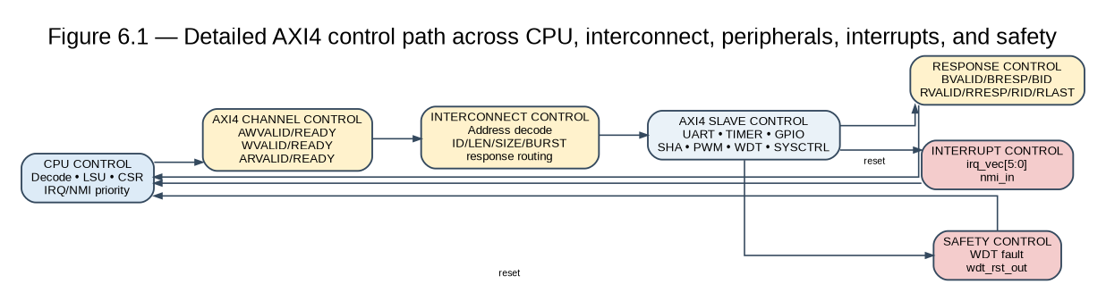

6.1 CPU Control Layer
The CPU control path comprises the Fetch/Decode/ALU control unit, register-file write-enable logic, CSR/exception logic, interrupt controller, and LSU control. A memory-mapped access to an address at or above 0x4000_0000 is treated as peripheral MMIO and is converted into AXI4 control signals.

6.2 AXI4 Control Layer and AXI4 Translation
The AXI4 control logic accepts read/write VALID/READY handshakes, while the AXI4 interconnect governs peripheral selection and translated transfer completion. This layer is intentionally simple: address decode, one-hot selection, setup/access timing, wait-state support, and response/error return.

6.3 Peripheral CSR Control Layer
Every peripheral exposes a small register bank that controls or reports its internal datapath. The CSR layer is therefore the software-to-hardware control boundary. The CPU writes configuration, trigger, or key registers and reads status/result registers.

6.4 UART Control
- UART_INT_EN[1:0] gates RX-data-available and TX-complete interrupt sources.
- UART_STATUS reports TX_FULL, TX_EMPTY, RX_FULL, RX_VALID, and PERR.
- UART_BAUD_DIV configures the internal baud timing relation Div = fACLK / (16 × Baud).

6.5 Timer Control
- TIMER_CTRL[0] enables the timer.
- TIMER_CTRL[1] enables auto-reload behavior.
- TIMER_CTRL[2] enables compare-match IRQ generation.
- TIMER_CMP is continuously compared with TIMER_COUNT.

6.6 GPIO Control
- GPIO_DIR selects input versus output operation per pin.
- GPIO_INT_MASK enables edge detection per pin.
- The OR-reduced edge event produces irq_gpio.

6.7 SHA-256 Control
- SHA_CTRL[0] START triggers the compression operation.
- SHA_CTRL[1] INIT loads the standard initial digest state.
- SHA_CTRL[2] IRQ_EN gates irq_sha.
- SHA_STATUS.BUSY prevents conflicting writes during the 66-cycle operation.
- SHA_STATUS.DONE marks completion and SHA_STATUS.ERR reports misuse such as illegal writes while BUSY.

6.8 PWM Control
- PWM_CTRL[3:0] enables channels.
- PWM_CTRL[4] selects edge-aligned versus center-aligned operation.
- PWM_CTRL[5] selects output inversion.
- PWM_PRESCALER and PWM_PERIOD establish the timebase and PWM frequency.
- PWM_DEADTIME controls non-overlap duration.

6.9 W-WDT Control
- WDT_CTRL[0] is a write-once ENABLE latch until hardware reset.
- WDT_CTRL[1] selects NMI versus direct-reset fault response.
- WDT_KICK accepts the exact ordered 0x55AA → 0xAA55 service sequence.
- WDT_WIN_LOW and WDT_WIN_HIGH define the valid servicing window.
- Early or late service is a safety fault.

7. Data Path Architecture

Figure 7.1 — Detailed AXI4 instruction, data-memory, MMIO, cryptographic, and actuation data paths.
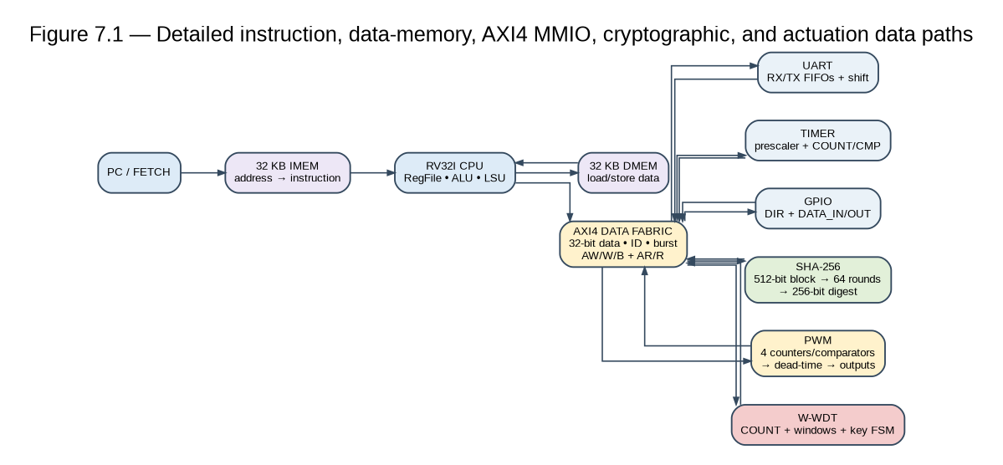

7.1 CPU Data Path
The CPU fetches instructions through imem_addr/imem_rdata, executes them through the register file and ALU, and uses the LSU for data-memory or MMIO operations. The separate Instruction and Data Memory ports preserve the intended Harvard-style separation.

7.2 AXI4 Data Path
The AXI4 data path contains two masters: CPU M0 and DMA M1. CPU M0 performs software-driven loads/stores and MMIO control; DMA M1 performs autonomous burst reads and writes for high-speed memory and SHA-256 data movement. Arbitration, burst accounting, ID tracking, and response routing are centralized in the single AXI4 interconnect.
All peripheral register writes use WDATA[31:0], while reads return through RDATA[31:0]. target_select identifies the target slave. READY determines the completion edge, and SLVERR carries an error response.

7.3 SHA-256 Data Path
One 512-bit block is supplied as sixteen 32-bit SHA_DATA_IN words. On START, the block feeds the message-schedule and 64-round compression datapath. The resulting 256-bit digest is held in eight 32-bit SHA_DIGEST registers for CPU read-back.

7.4 PWM Data Path
The PWM data path is autonomous after configuration: prescaled ACLK → counter/timebase → four duty comparators → channel gating/polarity → dead-time insertion → pwm_out[3:0]. In edge-aligned mode the counter advances to PERIOD; in center-aligned mode it counts up/down.

7.5 W-WDT Data Path
WDT_COUNT is driven by a prescaled clock. Window comparators continuously evaluate the count against LOW and HIGH bounds. The CPU contributes only the service-key sequence during normal operation. A valid sequence inside the window resets the count; an early or late condition produces the configured fault response.

7.6 UART, Timer, GPIO Data Paths
- UART RX: uart_rxd → RX bit timing → RX shift register → 16-byte RX FIFO → UART_DATA → AXI4 → AXI4 → CPU.
- UART TX: CPU → AXI4 → AXI4 → UART_DATA → 16-byte TX FIFO → TX shift register → uart_txd.
- Timer: prescaler → TIMER_COUNT → comparator with TIMER_CMP → optional reload + irq_timer.
- GPIO input: gpio_pins → GPIO_DATA_IN → AXI4 → AXI4 → CPU; GPIO output: CPU → AXI4 → AXI4 → GPIO_DATA_OUT → pads according to GPIO_DIR.

7.7 End-to-End Application Data Flow
- Receive command or telemetry bytes through UART and/or GPIO events.
- Assemble a 512-bit payload block in firmware.
- Write sixteen 32-bit words to SHA_DATA_IN and assert START.
- Wait for irq_sha or poll DONE; compare SHA_DIGEST with the expected/transmitted digest.
- Only after validation, update PWM_DUTY_CH[0:3] with the desired actuator setpoints.
- Service W-WDT with 0x55AA followed by 0xAA55 inside the configured timing window.

8. Detailed Peripheral and Custom-IP Internal Architectures

8.1 UART Controller

Figure 8.1 — UART internal architecture.
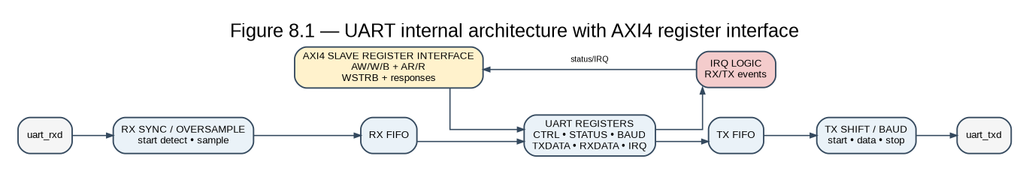

The UART is a full-duplex serial interface with 16-byte TX and RX FIFOs and a programmable baud divider. The supplied signal list defines external uart_rxd/uart_txd, the DATA/STATUS/BAUD_DIV/INT_EN registers, and RX/TX interrupt outputs.
Register | Offset | Access | Defined fields / meaning
UART_DATA | 0x00 | R/W | 8-bit TX/RX FIFO data register
UART_STATUS | 0x04 | RO | [0] TX_FULL, [1] TX_EMPTY, [2] RX_FULL, [3] RX_VALID, [4] PERR
UART_BAUD_DIV | 0x08 | R/W | 16-bit baud divider
UART_INT_EN | 0x0C | R/W | [0] RX IRQ enable, [1] TX IRQ enable

UART implementation-defined points
The source defines TX-complete as an event when the FIFO empties below a threshold or fully empties, per implementation. Parity-error handling retains the byte in the RX FIFO per the supplied architecture's implementation-dependent wording. These details must be fixed in RTL and captured in the verification plan.

8.2 32-bit System Timer

Figure 8.2 — 32-bit system timer internal architecture.
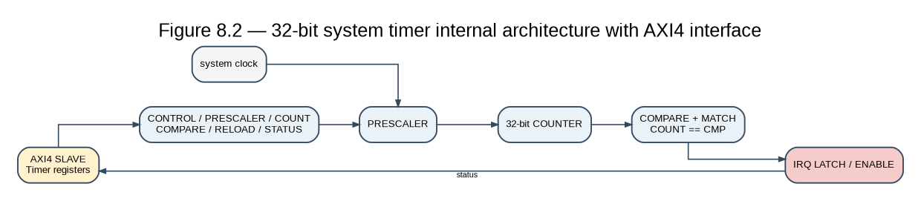

Register | Offset | Access | Defined fields / meaning
TIMER_CTRL | 0x00 | R/W | [0] Enable, [1] Auto-Reload, [2] Match IRQ Enable
TIMER_COUNT | 0x04 | R/W | 32-bit free-running/up-counting value
TIMER_CMP | 0x08 | R/W | 32-bit compare target; equality generates irq_timer when enabled

The timer is intended to provide the deterministic control-loop scheduling tick. When auto-reload is enabled, a compare event can reload the count to zero; otherwise the counter can continue to run.

8.3 16-bit GPIO Subsystem

Figure 8.3 — 16-bit GPIO internal architecture.
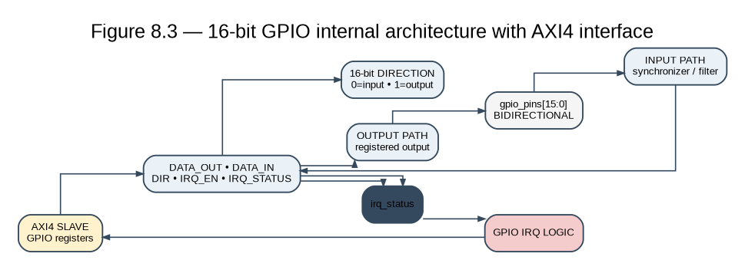
Register | Offset | Access | Defined fields / meaning
GPIO_DATA_IN | 0x00 | RO | External pin logical levels
GPIO_DATA_OUT | 0x04 | R/W | Output drive latch
GPIO_DIR | 0x08 | R/W | 0=input, 1=output
GPIO_INT_MASK | 0x0C | R/W | Per-pin interrupt mask for edge detection

GPIO open item
The proposal mentions configurable input filtering, but the supplied signal/register list does not define a filter register or filter signal. Therefore filtering must be treated as [OPEN] until an RTL interface is explicitly specified; do not assume a hidden filter block.

8.4 Hardware SHA-256 Engine

Figure 8.4 — SHA-256 internal architecture and RTL decomposition.
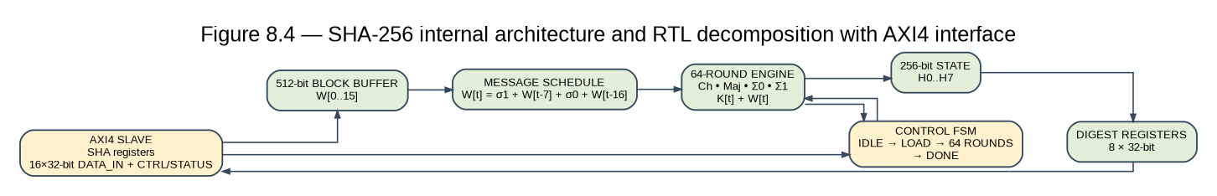

The source defines a 512-bit input buffer (16 × 32-bit words), a 64-round digest transformation, a 256-bit output digest (8 × 32-bit words), BUSY/DONE/ERR status, and a 66-cycle transformation. The diagram decomposes the engine into input buffer, message schedule, working variables, round counter/FSM, hash state, and digest latch. The Σ0/Σ1/Ch/Maj/K[t] functional labels are a FIPS-180-4-consistent internal decomposition; the exact combinational sharing or pipeline structure is implementation-defined.
Register | Offset | Access | Reset | Meaning
SHA_CTRL | 0x00 | R/W | 0 | [0] START, [1] INIT, [2] IRQ_EN
SHA_STATUS | 0x04 | RO | 0 | [0] BUSY, [1] DONE, [2] ERR
SHA_DATA_IN[0:15] | 0x08–0x44 | WO | 0 | 16 × 32-bit words = one 512-bit message block
SHA_DIGEST[0:7] | 0x48–0x64 | RO | 0 | 8 × 32-bit words = 256-bit digest

8.4.1 SHA-256 Processing Sequence
- INIT: load the standard SHA-256 initial hash constants into H0…H7.
- LOAD: firmware writes the 16 input words.
- START: assert the start control and enter BUSY state.
- SCHEDULE/COMPRESS: process W[0:63] and the eight working variables a…h for 64 rounds.
- FINALIZE: update/latch the digest state and clear BUSY.
- DONE: set DONE and optionally pulse irq_sha if IRQ_EN is enabled.
- IDLE: wait for the next INIT/START sequence.
SHA sequencing rule [VERIFY]
The source explicitly calls out START without prior INIT as a functional error because the chain state may be undefined/previous. Verification must include this case even though no explicit hardware error flag is defined for it.

8.5 4-Channel High-Precision PWM Generator

Figure 8.5 — PWM internal architecture.
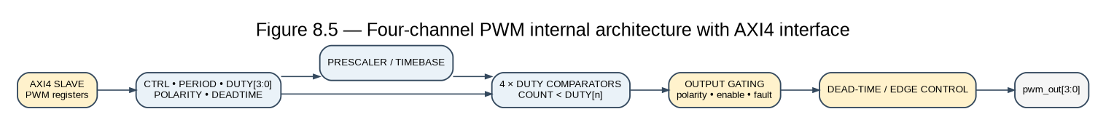

Register | Offset | Access | Defined fields / meaning
PWM_CTRL | 0x00 | R/W | [3:0] CH_EN, [4] ALIGN_MODE, [5] INVERT
PWM_PRESCALER | 0x04 | R/W | 16-bit prescaler; f_cnt = f_ACLK/(PRESCALER+1)
PWM_PERIOD | 0x08 | R/W | 16-bit top threshold; f_PWM = f_cnt/(PERIOD+1)
PWM_DUTY_CH[0:3] | 0x0C–0x18 | R/W | 16-bit duty compare thresholds
PWM_DEADTIME | 0x1C | R/W | 8-bit non-overlap duration counter

For edge-aligned operation, the timebase counts upward to PWM_PERIOD. For center-aligned operation, it counts up and down. Each duty comparator is independently gated by CH_EN[i]. The dead-time logic prevents overlap between complementary transitions where the system integration requires it.
PWM implementation-defined points
The supplied architecture permits irq_pwm period/fault behavior to be implementation-defined. The source also describes double-buffering at the reload boundary as the mitigation for configuration writes near a period boundary. The exact internal buffering and fault-input interface must be fixed before sign-off.

8.6 Windowed Watchdog (W-WDT)

Figure 8.6 — Windowed watchdog internal architecture.
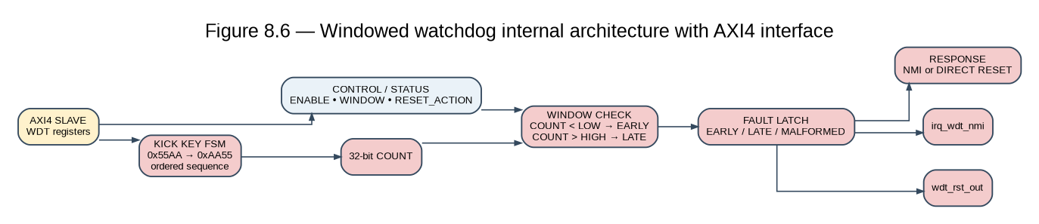

Register | Offset | Access | Defined fields / meaning
WDT_CTRL | 0x00 | R/W | [0] ENABLE write-once; [1] RST_ACTION (0=NMI, 1=direct reset)
WDT_KICK | 0x04 | WO | Exact sequence 0x55AA then 0xAA55
WDT_WIN_LOW | 0x08 | R/W | Minimum valid service boundary
WDT_WIN_HIGH | 0x0C | R/W | Maximum service boundary
WDT_COUNT | 0x10 | RO | 32-bit prescaled real-time count

8.6.1 Watchdog State Model
- DISABLED/RESET: watchdog inactive after reset.
- ENABLED: software sets ENABLE once; the block becomes permanently enabled until hardware reset.
- COUNTING: WDT_COUNT advances from the prescaled clock.
- KEY_WAIT: the first key word 0x55AA has been accepted; the detector expects 0xAA55.
- VALID_KICK: the ordered key sequence completed while LOW ≤ COUNT < HIGH; COUNT is reset.
- EARLY_FAULT: a valid sequence completes while COUNT < LOW.
- LATE_FAULT: COUNT reaches HIGH before a valid sequence.
- FAULT_RESPONSE: assert NMI or direct reset according to RST_ACTION.

8.7 DMA Controller / Data-Movement Engine
The DMA controller is the second AXI4 master (M1). It autonomously moves data between the 32 KB Data Memory and the SHA-256 accelerator data interface, reducing CPU load for high-throughput sensor/telemetry and cryptographic transfers. CPU M0 and DMA M1 share the same AXI4 interconnect; the interconnect arbitrates requests and routes each transaction to exactly one of the nine AXI4 slaves.
DMA internal blocks include source/destination address generators, transfer-length counter, burst controller, AXI4 read and write channel controllers, data buffer/pipeline, handshake manager, response/error handler, and completion/interrupt logic. The DMA is configured through System Control using the dma_cfg_* sideband interface; it does not create a second AXI4 fabric.
DMA control/status signals: dma_cfg_start, dma_cfg_src_addr[31:0], dma_cfg_dst_addr[31:0], dma_cfg_len[31:0], dma_cfg_ctrl, dma_status_busy, dma_status_done, dma_status_err, dma_irq, and dma_fault. Exact System Control register offsets remain implementation-defined until RTL register allocation is frozen.
Figure 8.7 — DMA controller internal architecture and AXI4 master data-movement path.
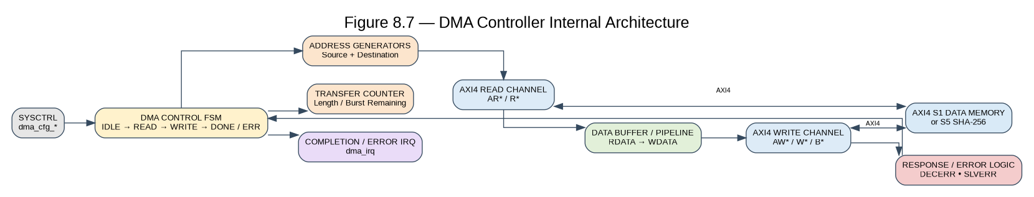

9. Interrupt and NMI Architecture

Figure 9.1 — Complete vectored interrupt and watchdog NMI topology.
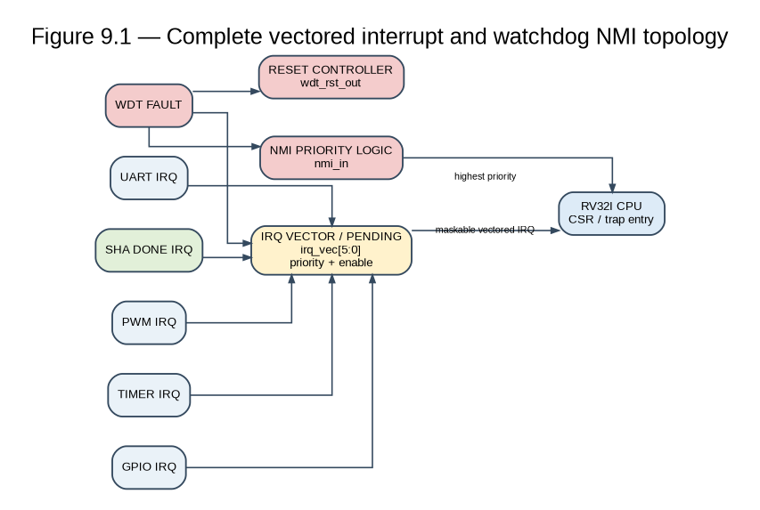

9.1 Interrupt Source Map
Vector | Signal | Source | Trigger | Local enable
IRQ[0] | irq_uart_rx / irq_uart_tx | UART | RX data available / TX complete | UART_INT_EN[1:0]
IRQ[1] | irq_timer | Timer | TIMER_COUNT == TIMER_CMP / periodic tick | TIMER_CTRL[2]
IRQ[2] | irq_gpio | GPIO | Any unmasked pin edge | GPIO_INT_MASK[15:0]
IRQ[3] | irq_sha | SHA-256 | 66-cycle transformation completes | SHA_CTRL[2] IRQ_EN
IRQ[4] | irq_pwm | PWM | Period/fault event | Implementation-defined extension
IRQ[5] | irq_wdt_nmi | W-WDT | Early/late fault if vectored routing selected | WDT_CTRL[1]
NMI | nmi_in | W-WDT | Early/late fault when RST_ACTION=0 | Not maskable

9.2 Detailed Interrupt Behavior
- UART RX: asserted when RX data becomes available and RX interrupt enable is set; firmware drains UART_DATA.
- UART TX: asserted on TX-complete according to the implementation-defined completion threshold; firmware may queue additional data.
- Timer: compare-match event; used as the primary scheduling heartbeat for the deterministic control loop.
- GPIO: OR-reduced unmasked pin-edge event; firmware reads GPIO_DATA_IN and any implementation-defined status latch to identify the source pin if needed.
- SHA: asserted once at completion, coincident with DONE and valid digest registers.
- PWM: typically period-rollover synchronization and/or implementation-defined fault event.
- WDT NMI: highest-priority safety event; it bypasses maskable interrupt enables.
- WDT direct reset: hardware reset path, not a software interrupt.

9.3 Priority and Arbitration
The source architecture states that nmi_in has absolute priority. For the vectored sources, the CPU interrupt controller resolves arbitration. The intended safety-relevant ordering is NMI (WDT) > SHA completion > Timer tick > UART > GPIO > PWM. The exact fixed-priority versus round-robin implementation is not defined by the supplied documents and must be captured as an implementation decision.

9.4 Interrupt Verification Obligations
- [VERIFY] Each local enable gates only its intended interrupt source.
- [VERIFY] No maskable IRQ can block or delay a WDT NMI.
- [VERIFY] SHA completion IRQ occurs at the defined completion point.
- [VERIFY] GPIO interrupt is suppressed for masked pins.
- [VERIFY] UART FIFO boundary events are handled without silent data corruption beyond documented overflow behavior.
- [VERIFY] Multiple simultaneous IRQs are arbitrated deterministically according to the selected CPU implementation policy.

10. Error Conditions, Fault Handling, and Recovery

Figure 10.1 — Error/fault architecture and response paths.
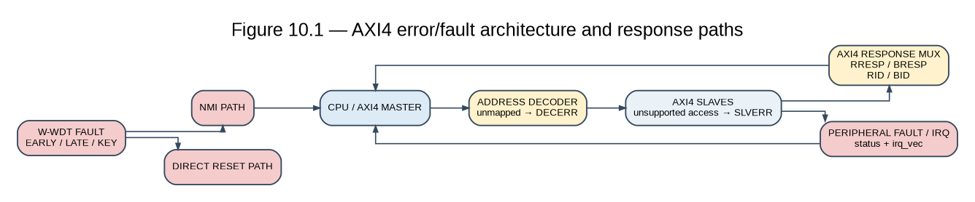

10.1 AXI4 Bus-Level Errors
Error | Trigger | Response
Illegal/unmapped address | Address not in defined AXI4 target window | DECERR; CPU access-fault path
Unsupported access | Unsupported register/transfer type | SLVERR; transaction rejected
Write response error | Peripheral detects hardware/register error | BRESP=SLVERR
Read response error | Peripheral cannot provide legal data | RRESP=SLVERR
Back-pressure | READY remains low | Transaction remains pending; no payload loss
Burst boundary violation | Burst crosses illegal target boundary | Reject or terminate per defined AXI4 error policy
ID mismatch | Returned BID/RID differs from originating ID | Verification failure / protocol assertion

10.2 SHA-256 Errors
Condition | Flag/effect | Required handling
Write to SHA_DATA_IN or SHA_CTRL while BUSY | SHA_STATUS.ERR; write ignored | Firmware waits for completion / clears sequencing state
Read digest before DONE | Stale/undefined architectural result; no SLVERR | Firmware must gate digest reads on DONE
START without INIT | No explicit hardware flag; chain state may be wrong | Verification must cover; firmware must initialize correctly

10.3 PWM Error / Hazard Conditions
Condition | Effect / risk | Handling
DUTY >= PERIOD | Channel can become effectively 100% active | Firmware bounds-check; fault reporting is implementation-defined
Insufficient dead-time | External half-interconnect shoot-through risk | Board/firmware integration constraint
PRESCALER/PERIOD left at zero | Degenerate/high switching rate | Firmware initialization must configure safe values
Configuration change at active boundary | Potential single-cycle glitch | Use reload-boundary/double-buffer strategy as defined by implementation

10.4 W-WDT Fault Classes
Fault | Condition | Detection | Response
Early kick | Kick completes while COUNT < LOW | LOW comparator | NMI or reset
Late/timeout | COUNT reaches HIGH before valid kick | HIGH comparator | NMI or reset
Malformed key | Sequence is not 0x55AA → 0xAA55 | Sequence detector | Rejected; escalation is implementation-defined
Disable/re-lock attempt | ENABLE is cleared after being set | Write-once latch | Write ignored; supervision remains enabled

10.5 UART Error Conditions
Error | Indicator | Effect
Parity error | UART_STATUS.PERR | Byte may remain in RX FIFO; firmware must validate
RX FIFO overflow | RX_FULL | Data loss can occur; firmware must service RX promptly
TX FIFO overflow | TX_FULL | Write is discarded; no SLVERR per supplied architecture

10.6 Error-Handling Summary
Layer | Reported by | Handled by
Bus protocol | SLVERR | CPU exception path
SHA misuse | SHA_STATUS.ERR | Firmware polling / irq_sha handler
PWM misconfiguration | Firmware validation / implementation-defined irq_pwm | Firmware and integration constraints
Watchdog timing fault | irq_wdt_nmi or wdt_rst_out | NMI handler or hardware reset
UART data integrity | PERR / RX_FULL / TX_FULL | Firmware polling / UART handlers

Safety principle
W-WDT is the only block with a separate non-maskable CPU input and a direct reset request. This is intentional: the architecture must remain able to react when software itself is suspected to be corrupted or executing at the wrong time.

11. Clock, Reset, and System Control

11.1 Clock & Reset Controller
The Clock & Reset Controller generates HCLK/core_clk and ACLK, distributes HRESETn to the CPU, and distributes ARESETn to the AXI4/interconnect, AXI4 interconnect, and AXI4 peripheral logic. The supplied signal list also defines SYS_CLK_GATE as a programmable set of per-peripheral clock-gate enables.
Signal | Width | Role
HCLK / core_clk | 1 | Core and AXI4 clock
HRESETn | 1 | Active-low core/AXI4 reset
SYS_CLK_GATE | N | Per-peripheral clock-gating enables

11.2 System Control & Status
Register | Offset/base | Access | Meaning
SYS_RESET_CAUSE | 0x4000_E000 + implementation-defined offset | RO | Indicates last reset source, including WDT
SYS_CLK_GATE | 0x4000_E000 + implementation-defined offset | R/W | Per-peripheral clock gate controls
SYS_CHIP_ID | 0x4000_E000 + implementation-defined offset | RO | Fixed chip/revision identifier

Register-offset status
The supplied signal list names SYS_RESET_CAUSE, SYS_CLK_GATE, and SYS_CHIP_ID but does not provide their offsets inside the 0x4000_E000 window. Treat these offsets as [OPEN] and do not invent them. The base address and functional meanings are normative.

11.3 Reset Causes and Post-Mortem Flow
- A reset source asserts the reset path.
- Clock & Reset Controller regenerates HRESETn/ARESETn.
- CPU and peripherals return to reset values.
- On the next boot, firmware reads SYS_RESET_CAUSE.
- If the source was W-WDT, firmware can record/log the event before re-entering normal operation.

12. End-to-End Firmware and Operational Flow

Figure 12.1 — Four-phase secure edge control loop and watchdog supervision.
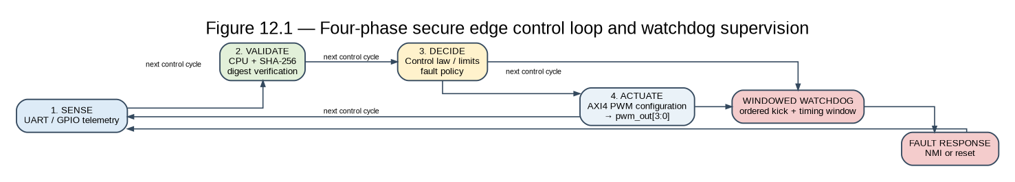

12.1 Boot / Initialization Sequence
- Reset is released and the CPU begins execution from Instruction Memory.
- Initialize UART baud divider and interrupt enables.
- Initialize Timer and configure the control-loop compare value.
- Configure GPIO directions and interrupt masks.
- Initialize SHA-256 state before first hashing operation.
- Configure PWM prescaler, period, duty values, alignment, polarity, and dead-time.
- Configure W-WDT window bounds and RST_ACTION; enable the watchdog using its write-once control.
- Enter the deterministic control loop.

12.2 Four-Phase Deterministic Control Loop
Phase | Hardware used | Firmware action | Success condition
1. Ingress & Parsing | UART, GPIO | Receive/assemble command or telemetry; build 512-bit blocks | Valid frame/payload assembled
2. Hardware Authentication | SHA-256 | Write 16 words, START, wait IRQ/DONE, compare digest | Digest matches expected value
3. Actuation & Output | PWM | Write validated setpoints to duty registers | PWM hardware produces outputs
4. Supervisory Kick | W-WDT | Write 0x55AA then 0xAA55 inside valid window | WDT_COUNT resets; no fault

12.3 Authentication Gate
The architecture should enforce a software policy that invalid or unauthenticated commands do not update PWM setpoints. The hardware SHA engine supplies the digest; the firmware performs the comparison with the expected/transmitted digest and makes the accept/reject decision.

12.4 Watchdog Timing Contract
The watchdog is not merely a liveness timer. The control loop must complete its expected work before WDT_WIN_HIGH and must not service the watchdog before WDT_WIN_LOW. Therefore the selected window must be derived from the actual control-loop execution budget and verified under worst-case interrupt and hashing activity.

12.5 Reference Pseudocode
loop:
wait_for_ingress_or_timer_event()
frame = receive_and_parse()
block = assemble_512_bit_block(frame)
SHA_INIT()
SHA_WRITE_16_WORDS(block)
SHA_START()
wait_until_SHA_DONE_or_IRQ()
digest = SHA_READ_DIGEST()
if digest == expected_digest:
PWM_UPDATE_SAFE(setpoints)
else:
reject_command_and_log()
WDT_KICK(0x55AA)
WDT_KICK(0xAA55) # both writes must complete inside [LOW, HIGH]

13. Applications and Deployment Mapping

13.1 Secure Edge Node Controller
Primary target: a cyber-physical edge controller that receives commands and telemetry over UART/GPIO, authenticates them with SHA-256, drives precision actuators through PWM, and proves correct timing to the watchdog.

13.2 Motor / Servo Drive Control with Integrity Checking
The four-channel dead-time-controlled PWM is suitable for multi-axis or power-stage control interfaces. SHA-256 provides a hardware integrity check before motion-command data is converted into physical actuation.

13.3 Secure Boot / Firmware Integrity Verification
The supplied architecture identifies a secure-boot use case in which Instruction Memory contents can be hashed and compared with an expected digest before normal operation. The exact boot ROM/root-of-trust mechanism is outside the defined RTL and should not be assumed to exist.

13.4 Safety-Instrumented / Functional-Safety Nodes
The windowed watchdog is suited to systems where a wrong-but-plausible execution period is unsafe, because it detects both early and late servicing. The architecture is a teaching/prototyping vehicle for timing-integrity supervision; it is not by itself a certification claim.

13.5 Cryptographic Payload Gateway
The hardware-offload model benefits embedded gateways that need repeated per-packet hashing without consuming a large fraction of CPU bandwidth.

13.6 Application-to-IP Mapping
Application function | Primary IPs | Secondary IPs | Critical property
Secure telemetry ingress | UART, GPIO | Timer, CPU | Integrity before actuation
Motion/actuator control | PWM | Timer, WDT | Deterministic timing + dead-time
Secure boot | SHA-256, Instruction Memory | CPU, System Control | Digest comparison before execution
Safety supervision | W-WDT | Clock/Reset, CPU NMI | Early/late timing fault response
Payload gateway | SHA-256, UART | Timer, WDT | Line-rate integrity offload

13.7 Stated System Advantages
Metric | Software-oriented baseline | Aegis-V architecture
SHA-256 512-bit block | ~4,200 optimized RV32I CPU cycles | 66-cycle dedicated RTL transformation
CPU bandwidth | Consumed by hashing | >98% freed for control/monitoring/logging, per project baseline
PWM timing | CPU polling/general timer can introduce jitter | Hardware counter/comparators after configuration
Fault coverage | Conventional watchdog detects hangs | Windowed WDT detects hangs and erratic timing

14. Verification Architecture and Test Mapping

14.1 Verification Strategy
The verification methodology is updated for the AXI4 front-end: AXI4 protocol/BFM testing, AXI4 interconnect verification, AXI4 BFM testing, IP-level unit verification, and full-chip SoC integration with compiled bare-metal firmware.

14.2 Unit-Level Verification
IP | Mandatory unit tests | Key checks
CPU | RV32I instruction/exception/IRQ smoke tests | Instruction results, CSR/trap behavior, NMI dominance
Instruction Memory | Read/write/execute access | Address range and initialization
Data Memory | Read/write and byte-address behavior | No AXI4 aliasing; synchronous timing
UART | FIFO fill/drain, baud, parity, IRQ | FULL/EMPTY/VALID/PERR and IRQ enables
Timer | Prescaler, compare, reload | Exact compare event and IRQ gating
GPIO | Direction, input/output, edge mask | Pin masking and irq_gpio
SHA-256 | NIST CAVP single/multi-block vectors | Digest correctness, 66-cycle completion, BUSY/ERR
PWM | Period/duty/mode/dead-time sweeps | Frequency formula, 16-bit thresholds, no overlap per configured behavior
W-WDT | Valid, early, late, malformed key, disable attempt | NMI/reset response and write-once enable
System Control | Reset cause, clock gate, chip ID | Reset distribution and status persistence as defined
P-AXI-01 | AXI VALID/READY handshakes complete only when VALID and READY are both high.
P-AXI-02 | AXI read/write responses correspond to the translated AXI4 transfer.
P-AXI-03 | AXI4 READY-low holds the interconnect; no premature AXI response is allowed.
P-AXI-04 | AXI4 WSTRB is mapped correctly to the 32-bit AXI4 write payload or rejected by an architecture-defined error path.
P-AXI-05 | AXI4 bursts, if supported, are decomposed into ordered AXI4 transfers and responses preserve ordering.

14.3 AXI4 Master/Interconnect and AXI4 BFM Tests
- Read/write every defined register window.
- Attempt unmapped accesses and expect SLVERR.
- Attempt reads from WO and writes to RO registers and expect SLVERR.
- Hold READY low and verify ACCESS wait-state behavior.
- Check one-hot target_select for every valid address.
- Check back-to-back transfers without an unintended idle cycle where supported.
- Inject peripheral response errors and verify CPU-side exception handling.

14.4 Full-Chip Integration Tests
- Boot compiled bare-metal firmware from Instruction Memory.
- Receive a UART frame and trigger GPIO events.
- Hash a 512-bit payload using the SHA engine.
- Compare digest and conditionally update PWM duty registers.
- Generate UART diagnostic output.
- Service the watchdog within its valid window.
- Force early/late watchdog faults and verify NMI/direct-reset paths.
- After reset, read SYS_RESET_CAUSE and confirm the watchdog-origin diagnosis.

14.5 Assertions / Properties
Property ID | Property
P-AXI-01 | VALID must not depend combinationally on READY.
P-AXI-02 | When VALID=1 and READY=0, channel payload/control remains stable.
P-AXI-03 | Every accepted write produces exactly one B response.
P-AXI-04 | Every accepted read address produces the programmed number of R beats and exactly one RLAST.
P-AXI-05 | BID/RID match the originating transaction ID.
P-AXI-06 | AWLEN/ARLEN and WLAST/RLAST are consistent.
P-AXI-07 | WSTRB controls byte-write enables correctly.
P-AXI-08 | Unmapped addresses return DECERR.
P-SHA-01 | SHA BUSY is asserted throughout the defined 66-cycle transformation.
P-SHA-02 | Writes forbidden during BUSY set ERR and do not modify protected state.
P-PWM-01 | Disabled channels do not produce an enabled PWM output.
P-WDT-01 | Kick below LOW produces a watchdog fault.
P-WDT-02 | COUNT above HIGH without a valid kick produces a watchdog fault.

14.6 Coverage Plan
- Functional coverage: every register, access type, interrupt source, error condition, alignment mode, watchdog outcome, and reset source.
- Cross coverage: interrupt source × local enable; watchdog fault × RST_ACTION; SHA BUSY × illegal access; PWM mode × duty boundary.
- Code coverage: statement, branch, toggle, FSM, and assertion coverage according to project sign-off policy.
- End-to-end coverage: ingress → hash → validation → PWM → watchdog kick.

15. Agentic-AI / Kiro Implementation Specification

15.1 Why This Architecture Is Agent-Friendly
An agentic RTL tool needs stable component names, explicit interfaces, deterministic state transitions, address ownership, error behavior, and verification obligations. This document therefore expresses the architecture as a hierarchy of components with unique IDs and machine-readable rules.

15.2 Component IDs
Component ID | RTL block | Depends on | Produces
A0 | aegis_v_soc_top | All system blocks | SoC-level interfaces
A1 | rv32i_core | IMEM/DMEM/AXI4/IRQ/NMI | Instruction and AXI4 transactions
A2 | imem_32k | CPU | Instruction words
A3 | dmem_32k | CPU | Load/store data
A4 | axi4_interconnect | CPU + AXI4 slaves | AXI4 routing and responses
A5 | uart_controller | AXI4 + clock | Serial I/O + IRQ
A6 | system_timer | AXI4 + clock | irq_timer
A7 | gpio_subsystem | AXI4 + pads | GPIO data + irq_gpio
A8 | sha256_accelerator | AXI4 + clock | Digest + irq_sha
A9 | pwm_generator | AXI4 + clock | pwm_out[3:0] + irq_pwm
A10 | windowed_watchdog | AXI4 + clock | irq_wdt_nmi + wdt_rst_out
A11 | system_control | AXI4 + clock/reset | status/reset-cause

15.3 Agent Rules
- Never change a defined base address or register offset without updating the architecture and traceability matrix.
- Use two AXI4 masters in the baseline: M0 is the CPU and M1 is the DMA controller. The AXI4 interconnect arbitrates both masters.
- Generate one-hot target_select from the defined address map.
- Treat RO/WO access violations as SLVERR where defined.
- Do not accept SHA input writes while BUSY.
- Do not clear W-WDT ENABLE in software after it is set.
- Do not allow PWM actuation to be updated from unauthenticated application data in the reference firmware flow.
- Keep WDT NMI physically separate from maskable IRQ enable logic.
- Mark every unspecified behavior as IMPLEMENTATION-DEFINED or OPEN instead of inventing it.
- Every RTL component must have a unit test and at least one integration test.

15.4 Agent-Ready Interface Contract
SOC_CLOCKS:
core_clk: HCLK
peripheral_clk: ACLK
core_reset_n: HRESETn
peripheral_reset_n: ARESETn
CPU:
irq_vec[5:0]
nmi_in
imem_addr/imem_rdata
dmem_addr/dmem_wdata/dmem_rdata
AXI4: AWADDR/AWVALID/AWREADY, WDATA/WSTRB/WVALID/WREADY
BRESP/BVALID/BREADY, ARADDR/ARVALID/ARREADY
RDATA/RRESP/RVALID/RREADY
AXI4_TO_AXI4:
AWADDR/ARADDR[31:0], target_select, AXI4 phase control, AW/W write channels
WDATA[31:0], RDATA[31:0]
READY, SLVERR
CUSTOM_IPS:
SHA: SHA_CTRL, SHA_STATUS, SHA_DATA_IN[0:15], SHA_DIGEST[0:7], irq_sha
PWM: PWM_CTRL, PWM_PRESCALER, PWM_PERIOD, PWM_DUTY_CH[0:3],
PWM_DEADTIME, pwm_out[3:0], irq_pwm
WDT: WDT_CTRL, WDT_KICK, WDT_WIN_LOW, WDT_WIN_HIGH,
WDT_COUNT, irq_wdt_nmi, wdt_rst_out

15.5 Kiro Task Decomposition
Task ID | Agent task | Acceptance criteria
K-01 | Implement clock/reset infrastructure | Clock/reset distribution and WDT reset path verified
K-02 | Implement memories | Correct address ranges and CPU interfaces
K-03 | Implement AXI4 interconnect and nine AXI4 slave interfaces | AXI4 protocol, decode, burst, ID and response tests pass
K-04 | Implement UART | Register, FIFO, IRQ and error tests pass
K-05 | Implement Timer | Compare/reload/IRQ tests pass
K-06 | Implement GPIO | Direction, input/output and IRQ tests pass
K-07 | Implement SHA-256 | FIPS 180-4 vectors, 66-cycle transformation and BUSY/DONE/ERR tests pass
K-08 | Implement PWM | Alignment, duty, inversion, dead-time and fault behavior pass
K-09 | Implement W-WDT | Early/late/timeout faults and NMI/reset paths pass
K-10 | Integrate full SoC over AXI4 | Firmware executes and all AXI4 accesses are verified

16. Architecture Traceability and Open Items

16.1 Chapter-to-Block Traceability
Architecture chapter | Primary blocks | Mapped interfaces / registers | Verification
Introduction | A0–A12 | System goals, performance claims | System-level tests
Block Diagram | A0–A12 | All top-level interfaces | Integration connectivity
Control Path | A1, A4–A12 | CSR controls, AXI4 FSM | Protocol/FSM assertions
Data Path | A1–A10 | IMEM/DMEM/AXI4/custom datapaths | Data integrity/end-to-end
Errors | A4, A5, A8, A9, A10 | SLVERR/ERR/status/fault outputs | Fault injection
Interrupts | A1, A5–A10 | irq_vec[5:0], nmi_in | IRQ/NMI tests
Applications | A0–A10 | UART/GPIO/SHA/PWM/WDT | Full-chip firmware
Verification | A0–A12 | All | Unit/BFM/full-chip

16.2 Open / Implementation-Defined Items
Item | Status | Required decision
CPU hazard/forwarding/pipeline microarchitecture | IMPLEMENTATION-DEFINED | Confirm exact 3-stage RTL timing
Vectored IRQ arbitration policy | IMPLEMENTATION-DEFINED | Fixed priority or round-robin; document result
PWM irq_pwm enable/fault inputs | IMPLEMENTATION-DEFINED | Define exact trigger and enable bit(s)
PWM configuration double-buffer implementation | IMPLEMENTATION-DEFINED | Define buffer timing and atomic update behavior
UART TX-complete threshold | IMPLEMENTATION-DEFINED | Define empty/threshold condition
UART parity handling details | IMPLEMENTATION-DEFINED | Define parity generation/checking and FIFO treatment
GPIO input filtering | OPEN | Add explicit register/signal or remove claim
System Control register offsets | OPEN | Define offsets inside 0x4000_E000
WDT malformed-key escalation | IMPLEMENTATION-DEFINED | Define whether malformed key alone asserts fault
WDT reset scope | IMPLEMENTATION-DEFINED | Define full SoC vs core-level reset semantics
Exact clock frequency | OPEN | Project must supply fACLK/fHCLK for absolute timing numbers

Sign-off rule
No item in the OPEN or IMPLEMENTATION-DEFINED list should be left ambiguous in the final RTL release. Each must become either a fixed architecture requirement, a documented RTL parameter, or an explicitly removed feature claim.

Appendix A. Complete Register Map

A.1 UART
Base | Offset | Register | Access | Fields
0x4000_0000 | 0x00 | UART_DATA | R/W | 8-bit TX/RX FIFO data
0x4000_0000 | 0x04 | UART_STATUS | RO | TX_FULL, TX_EMPTY, RX_FULL, RX_VALID, PERR
0x4000_0000 | 0x08 | UART_BAUD_DIV | R/W | 15:0 baud divider
0x4000_0000 | 0x0C | UART_INT_EN | R/W | bit0 RX IRQ, bit1 TX IRQ

A.2 Timer
Base | Offset | Register | Access | Fields
0x4000_1000 | 0x00 | TIMER_CTRL | R/W | bit0 Enable, bit1 Auto-Reload, bit2 IRQ Enable
0x4000_1000 | 0x04 | TIMER_COUNT | R/W | 31:0 count
0x4000_1000 | 0x08 | TIMER_CMP | R/W | 31:0 compare

A.3 GPIO
Base | Offset | Register | Access | Fields
0x4000_2000 | 0x00 | GPIO_DATA_IN | RO | 15:0 input levels
0x4000_2000 | 0x04 | GPIO_DATA_OUT | R/W | 15:0 output latch
0x4000_2000 | 0x08 | GPIO_DIR | R/W | 15:0 direction
0x4000_2000 | 0x0C | GPIO_INT_MASK | R/W | 15:0 edge IRQ mask

A.4 SHA-256
Base | Offset | Register | Access | Fields
0x4000_3000 | 0x00 | SHA_CTRL | R/W | bit0 START, bit1 INIT, bit2 IRQ_EN
0x4000_3000 | 0x04 | SHA_STATUS | RO | bit0 BUSY, bit1 DONE, bit2 ERR
0x4000_3000 | 0x08–0x44 | SHA_DATA_IN[0:15] | WO | 16 × 32-bit input words
0x4000_3000 | 0x48–0x64 | SHA_DIGEST[0:7] | RO | 8 × 32-bit digest words

A.5 PWM
Base | Offset | Register | Access | Fields
0x4000_4000 | 0x00 | PWM_CTRL | R/W | [3:0] CH_EN, [4] ALIGN_MODE, [5] INVERT
0x4000_4000 | 0x04 | PWM_PRESCALER | R/W | 15:0 prescaler
0x4000_4000 | 0x08 | PWM_PERIOD | R/W | 15:0 period
0x4000_4000 | 0x0C–0x18 | PWM_DUTY_CH[0:3] | R/W | 15:0 duty match per channel
0x4000_4000 | 0x1C | PWM_DEADTIME | R/W | 7:0 dead-time

A.6 W-WDT
Signal | Width | Direction | Description | Fields
AWADDR | 32 | AXI master → interconnect | Write address | bit0 ENABLE, bit1 RST_ACTION
AWVALID | 1 | AXI master → interconnect | Write address valid | 32-bit service key
AWREADY | 1 | interconnect → AXI master | Write address accepted | 31:0 minimum boundary
WDATA | 32 | AXI master → interconnect | Write data | 31:0 maximum boundary
WSTRB | 4 | AXI master → interconnect | Byte write strobes | 31:0 current count
WVALID | 1 | AXI master → interconnect | Write data valid
WREADY | 1 | interconnect → AXI master | Write data accepted
BRESP | 2 | interconnect → AXI master | Write response
BVALID | 1 | interconnect → AXI master | Write response valid
BREADY | 1 | AXI master → interconnect | Write response accepted
ARADDR | 32 | AXI master → interconnect | Read address
ARVALID | 1 | AXI master → interconnect | Read address valid
ARREADY | 1 | interconnect → AXI master | Read address accepted
RDATA | 32 | interconnect → AXI master | Read data
RRESP | 2 | interconnect → AXI master | Read response
RVALID | 1 | interconnect → AXI master | Read data valid
RREADY | 1 | AXI master → interconnect | Read data accepted

Appendix B. Complete Signal List

B.1 AXI4 Master / Interconnect Signals
Signal | Width | Direction | Description
ACLK | 1 | Input | AXI4 clock
ARESETn | 1 | Input | Active-low AXI4 reset
AWID | ID | Master→slave | Write transaction ID
AWADDR[31:0] | 32 | Master→slave | Write address
AWLEN[7:0] | 8 | Master→slave | Burst length minus one
AWSIZE[2:0] | 3 | Master→slave | Bytes per beat as 2^AWSIZE
AWBURST[1:0] | 2 | Master→slave | FIXED/INCR/WRAP burst type
AWVALID | 1 | Master→slave | Write-address valid
AWREADY | 1 | Slave→master | Write-address accepted
WDATA[31:0] | 32 | Master→slave | Write payload
WSTRB[3:0] | 4 | Master→slave | Byte write enables
WLAST | 1 | Master→slave | Last write beat
WVALID | 1 | Master→slave | Write data valid
WREADY | 1 | Slave→master | Write data accepted
BID | ID | Slave→master | Write response ID
BRESP[1:0] | 2 | Slave→master | OKAY/EXOKAY/SLVERR/DECERR
BVALID | 1 | Slave→master | Write response valid
BREADY | 1 | Master→slave | Write response accepted
ARID | ID | Master→slave | Read transaction ID
ARADDR[31:0] | 32 | Master→slave | Read address
ARLEN[7:0] | 8 | Master→slave | Burst length minus one
ARSIZE[2:0] | 3 | Master→slave | Bytes per beat as 2^ARSIZE
ARBURST[1:0] | 2 | Master→slave | FIXED/INCR/WRAP burst type
ARVALID | 1 | Master→slave | Read-address valid
ARREADY | 1 | Slave→master | Read-address accepted
RID | ID | Slave→master | Read response ID
RDATA[31:0] | 32 | Slave→master | Read payload
RRESP[1:0] | 2 | Slave→master | OKAY/EXOKAY/SLVERR/DECERR
RLAST | 1 | Slave→master | Last read beat
RVALID | 1 | Slave→master | Read data valid
RREADY | 1 | Master→slave | Read data accepted
dma_cfg_start | 1 | SYSCTRL → DMA | Start transfer
dma_cfg_src_addr[31:0] | 32 | SYSCTRL → DMA | Source address
dma_cfg_dst_addr[31:0] | 32 | SYSCTRL → DMA | Destination address
dma_cfg_len[31:0] | 32 | SYSCTRL → DMA | Transfer length
dma_status_busy | 1 | DMA → SYSCTRL | Transfer active
dma_status_done | 1 | DMA → SYSCTRL | Transfer complete
dma_status_err | 1 | DMA → SYSCTRL | Transfer error
dma_irq | 1 | DMA → IRQ Aggregator | DMA completion/error interrupt

B.2 AXI4 Interconnect-to-Slave Shared Signals
Signal | Width | Direction | Description
HCLK / core_clk | 1 | Input | CPU/core clock
HRESETn | 1 | Input | Active-low core reset
irq_vec[5:0] | 6 | Input | Vectored IRQ lines from UART, Timer, GPIO, SHA, PWM, WDT
nmi_in | 1 | Input | W-WDT non-maskable interrupt
imem_addr / imem_rdata | 32/32 | Out/In | Instruction fetch
dmem_addr/wdata/rdata | 32 each | Out/Out/In | Data memory load/store
AXI4 M_AXI AW*/W*/B* | AXI4 | Out/In | Write address/data/response channels
AXI4 M_AXI AR*/R* | AXI4 | Out/In | Read address/data channels

B.3 UART Signals
Signal | Width | Direction | Description
uart_txd | 1 | Output | External serial TX
uart_rxd | 1 | Input | External serial RX
UART_DATA[7:0] | 8 | R/W register | TX/RX FIFO data
UART_STATUS | 5 used bits | RO register | TX_FULL, TX_EMPTY, RX_FULL, RX_VALID, PERR
UART_BAUD_DIV[15:0] | 16 | R/W register | Baud divider
UART_INT_EN | 2 used bits | R/W register | RX/TX interrupt enables
irq_uart_rx / irq_uart_tx | 1/1 | Output | RX available / TX complete

B.4 Timer and GPIO Signals
Signal | Width | Direction | Description
TIMER_CTRL | 3 used bits | R/W | Enable, Auto-Reload, Match IRQ Enable
TIMER_COUNT[31:0] | 32 | R/W | Free-running/up counter
TIMER_CMP[31:0] | 32 | R/W | Compare target
irq_timer | 1 | Output | Timer compare/periodic IRQ
gpio_pins[15:0] | 16 | Bidirectional | External sensor/switch/indicator pads
GPIO_DATA_IN[15:0] | 16 | RO | External pin levels
GPIO_DATA_OUT[15:0] | 16 | R/W | Output latch
GPIO_DIR[15:0] | 16 | R/W | 0=input, 1=output
GPIO_INT_MASK[15:0] | 16 | R/W | Per-pin edge mask
irq_gpio | 1 | Output | OR-reduced unmasked edge IRQ

B.5 SHA/PWM/WDT Signals
Signal | Width | Direction | Description
SHA_CTRL | 3 used bits | R/W | START, INIT, IRQ_EN
SHA_STATUS | 3 used bits | RO | BUSY, DONE, ERR
SHA_DATA_IN[0:15] | 16×32 | WO | 512-bit input block
SHA_DIGEST[0:7] | 8×32 | RO | 256-bit digest
irq_sha | 1 | Output | SHA completion IRQ
pwm_out[3:0] | 4 | Output | External PWM outputs
PWM_CTRL | 6 used bits | R/W | CH_EN[3:0], ALIGN_MODE, INVERT
PWM_PRESCALER[15:0] | 16 | R/W | Counter divider
PWM_PERIOD[15:0] | 16 | R/W | Period threshold
PWM_DUTY_CH[0:3] | 4×16 | R/W | Duty compare values
PWM_DEADTIME[7:0] | 8 | R/W | Dead-time duration
irq_pwm | 1 | Output | Period/fault event; implementation-defined
WDT_CTRL | 2 used bits | R/W | ENABLE, RST_ACTION
WDT_KICK[31:0] | 32 | WO | 0x55AA → 0xAA55
WDT_WIN_LOW[31:0] | 32 | R/W | Minimum window boundary
WDT_WIN_HIGH[31:0] | 32 | R/W | Maximum window boundary
WDT_COUNT[31:0] | 32 | RO | Current prescaled count
irq_wdt_nmi | 1 | Output | WDT NMI
wdt_rst_out | 1 | Output | Direct reset request

B.6 System Control Signals
Signal | Width | Direction | Description
SYS_RESET_CAUSE | 8 used bits | RO | Last reset source
SYS_CLK_GATE | N implementation-defined | R/W | Per-peripheral clock gate enables
SYS_CHIP_ID | 32 | RO | Fixed chip/revision ID
HRESETn / ARESETn | 1/1 | Output | Generated core/peripheral resets

Appendix B.7. Internal RTL Signal Decomposition
This section supplements Appendix B with the internal signals implied by the architecture's explicit block decomposition and datapath descriptions. Signals marked IMPLEMENTATION-DEFINED are structural RTL planning names rather than additional normative top-level ports. Exact RTL signal names, register-stage signals, forwarding/hazard signals, and combinational sharing must be confirmed against the final RTL before verification sign-off.

B.7.1 CPU Core Internal Signals
Block | Signal | Width | Direction | Function / Meaning | Status
rv32i_core | pc[31:0] | 32 | Internal | Program counter / current fetch address | IMPLEMENTATION-DEFINED
rv32i_core | next_pc[31:0] | 32 | Internal | Next program-counter value | IMPLEMENTATION-DEFINED
rv32i_core | instruction[31:0] | 32 | Internal | Instruction word returned by IMEM | IMPLEMENTATION-DEFINED
rv32i_core | opcode[6:0] | 7 | Internal | RV32I opcode decode field | IMPLEMENTATION-DEFINED
rv32i_core | rs1_idx[4:0] / rs2_idx[4:0] / rd_idx[4:0] | 5 each | Internal | Register-file index fields | IMPLEMENTATION-DEFINED
rv32i_core | rs1_data[31:0] / rs2_data[31:0] | 32 each | Internal | Register-file read operands | IMPLEMENTATION-DEFINED
rv32i_core | rd_wdata[31:0] | 32 | Internal | Register-file write-back data | IMPLEMENTATION-DEFINED
rv32i_core | regfile_we | 1 | Internal | Register-file write enable | IMPLEMENTATION-DEFINED
rv32i_core | alu_a[31:0] / alu_b[31:0] | 32 each | Internal | ALU operands | IMPLEMENTATION-DEFINED
rv32i_core | alu_result[31:0] | 32 | Internal | ALU result | IMPLEMENTATION-DEFINED
rv32i_core | branch_taken | 1 | Internal | Branch/jump decision | IMPLEMENTATION-DEFINED
rv32i_core | lsu_addr[31:0] | 32 | Internal | Load/store effective address | IMPLEMENTATION-DEFINED
rv32i_core | lsu_wdata[31:0] / lsu_rdata[31:0] | 32 each | Internal | Load/store write/read data | IMPLEMENTATION-DEFINED
rv32i_core | mem_read / mem_write | 1 each | Internal | Data-memory access controls | IMPLEMENTATION-DEFINED
rv32i_core | mmio_req / mmio_write | 1 each | Internal | Peripheral MMIO request/control | IMPLEMENTATION-DEFINED
rv32i_core | irq_pending[5:0] | 6 | Internal | Latched/combined maskable interrupt state | IMPLEMENTATION-DEFINED
rv32i_core | irq_select[5:0] | 6 | Internal | Selected interrupt source | IMPLEMENTATION-DEFINED
rv32i_core | exception_valid | 1 | Internal | Exception/trap indication | IMPLEMENTATION-DEFINED
rv32i_core | nmi_active | 1 | Internal | NMI handling state | IMPLEMENTATION-DEFINED

B.7.2 Instruction/Data Memory Internal Signals
axi4_interconnect | axi_awaddr_q / axi_araddr_q | 32 | Internal | Latched AXI address for translated transaction | DECOMPOSITION
axi4_interconnect | axi_req | 1 | Internal | Translated AXI4 request accepted by interconnect | IMPLEMENTATION-DEFINED
imem_32k | imem_rdata[31:0] | 32 | Output | Instruction word to CPU | NORMATIVE
imem_32k | imem_en | 1 | Internal | Instruction memory enable | IMPLEMENTATION-DEFINED
imem_32k | imem_index | 15 | Internal | Word/byte address decode within 32 KB | IMPLEMENTATION-DEFINED
dmem_32k | dmem_addr[31:0] | 32 | Input | Data memory address from CPU | NORMATIVE
dmem_32k | dmem_wdata[31:0] | 32 | Input | Store data | NORMATIVE
dmem_32k | dmem_rdata[31:0] | 32 | Output | Load data | NORMATIVE
dmem_32k | dmem_we | 1 | Internal | Data SRAM write enable | IMPLEMENTATION-DEFINED
dmem_32k | dmem_re | 1 | Internal | Data SRAM read enable | IMPLEMENTATION-DEFINED
dmem_32k | dmem_index | 15 | Internal | Address within 32 KB data SRAM | IMPLEMENTATION-DEFINED
axi4_interconnect | axi_awvalid_q / axi_awready | 1 / 1 | Internal | AXI write-address handshake state | DECOMPOSITION
axi4_interconnect | axi_wdata_q[31:0] / axi_wstrb_q[3:0] | 32 / 4 | Internal | Latched AXI write payload and byte strobes | DECOMPOSITION
axi4_interconnect | axi_arvalid_q / axi_arready | 1 / 1 | Internal | AXI read-address handshake state | DECOMPOSITION
axi4_interconnect | axi_addr[31:0] | 32 | Internal | Translated AXI4 address | IMPLEMENTATION-DEFINED
axi4_interconnect | axi_state | 2+ | Internal | IDLE / SETUP / ACCESS interconnect state | DECOMPOSITION
axi4_interconnect | axi_rdata_q[31:0] | 32 | Internal | AXI4 read data captured for AXI RDATA | DECOMPOSITION
axi4_interconnect | axi_rresp_q[1:0] / axi_bresp_q[1:0] | 2 / 2 | Internal | AXI responses generated from AXI4 result | DECOMPOSITION

B.7.3 AXI4 Interconnect / Decoder Internal Signals
Block | Signal | Width | Direction | Function / Meaning | Status
axi4_interconnect | awaddr_q / araddr_q | 32 | Internal | Latched AXI addresses | DECOMPOSITION
axi4_interconnect | awid_q / arid_q | ID | Internal | Latched transaction IDs | DECOMPOSITION
axi4_interconnect | awlen_q / arlen_q | 8 | Internal | Burst lengths | DECOMPOSITION
axi4_interconnect | awsize_q / arsize_q | 3 | Internal | Beat sizes | DECOMPOSITION
axi4_interconnect | awburst_q / arburst_q | 2 | Internal | Burst types | DECOMPOSITION
axi4_interconnect | wdata_q / wstrb_q | 8.0 | Internal | Write payload and byte enables | DECOMPOSITION
axi4_interconnect | write_target[6:0] | 7 | Internal | One-hot target selection | IMPLEMENTATION-DEFINED
axi4_interconnect | read_target[6:0] | 7 | Internal | One-hot read target selection | IMPLEMENTATION-DEFINED
axi4_interconnect | write_state / read_state | N | Internal | Independent channel FSM state | IMPLEMENTATION-DEFINED
axi4_interconnect | burst_count_q | 8 | Internal | Remaining beats | IMPLEMENTATION-DEFINED
axi4_interconnect | illegal_addr | 1 | Internal | Unmapped target detection | IMPLEMENTATION-DEFINED
axi4_interconnect | slverr / decerr | 1/1 | Internal | Slave/protocol and decode error | IMPLEMENTATION-DEFINED
axi4_interconnect | rdata_q / rresp_q / rid_q | 32/2/ID | Internal | Read response pipeline | IMPLEMENTATION-DEFINED
axi4_interconnect | bresp_q / bid_q | 2/ID | Internal | Write response pipeline | IMPLEMENTATION-DEFINED

B.7.4 UART Internal Signals
Block | Signal | Width | Direction | Function / Meaning | Status
uart_controller | rx_sample_tick | 1 | Internal | Receiver bit/sample timing event | IMPLEMENTATION-DEFINED
uart_controller | tx_bit_tick | 1 | Internal | Transmitter bit timing event | IMPLEMENTATION-DEFINED
uart_controller | rx_shift_reg[7:0] | 8 | Internal | Serial-to-parallel receive shift register | DECOMPOSITION
uart_controller | tx_shift_reg[7:0] | 8 | Internal | Parallel-to-serial transmit shift register | DECOMPOSITION
uart_controller | rx_fifo_data[7:0] | 8 | Internal | RX FIFO storage data | DECOMPOSITION
uart_controller | tx_fifo_data[7:0] | 8 | Internal | TX FIFO storage data | DECOMPOSITION
uart_controller | rx_fifo_wr / rx_fifo_rd | 1 each | Internal | RX FIFO write/read controls | IMPLEMENTATION-DEFINED
uart_controller | tx_fifo_wr / tx_fifo_rd | 1 each | Internal | TX FIFO write/read controls | IMPLEMENTATION-DEFINED
uart_controller | rx_fifo_count[4:0] / tx_fifo_count[4:0] | 5 each | Internal | 16-byte FIFO occupancy tracking | IMPLEMENTATION-DEFINED
uart_controller | rx_valid / rx_full / tx_full / tx_empty | 1 each | Internal | FIFO/status conditions | DECOMPOSITION
uart_controller | parity_error | 1 | Internal | Parity-check result feeding PERR | DECOMPOSITION
uart_controller | rx_irq_cond / tx_irq_cond | 1 each | Internal | Local interrupt event conditions | IMPLEMENTATION-DEFINED

B.7.5 Timer Internal Signals
Block | Signal | Width | Direction | Function / Meaning | Status
system_timer | timer_prescale_count | N | Internal | Clock divider/prescaler state | IMPLEMENTATION-DEFINED
system_timer | timer_count_next[31:0] | 32 | Internal | Next timer counter value | IMPLEMENTATION-DEFINED
system_timer | compare_match | 1 | Internal | TIMER_COUNT == TIMER_CMP event | DECOMPOSITION
system_timer | reload_event | 1 | Internal | Auto-reload event | IMPLEMENTATION-DEFINED
system_timer | timer_enable | 1 | Internal | Decoded TIMER_CTRL[0] | DECOMPOSITION
system_timer | auto_reload_en | 1 | Internal | Decoded TIMER_CTRL[1] | DECOMPOSITION
system_timer | match_irq_en | 1 | Internal | Decoded TIMER_CTRL[2] | DECOMPOSITION
system_timer | irq_timer | 1 | Output | Timer compare/periodic interrupt | NORMATIVE

B.7.6 GPIO Internal Signals
Block | Signal | Width | Direction | Function / Meaning | Status
gpio_subsystem | gpio_in_sync[15:0] | 16 | Internal | Synchronized GPIO input levels | IMPLEMENTATION-DEFINED
gpio_subsystem | gpio_prev[15:0] | 16 | Internal | Previous sampled input state for edge detection | IMPLEMENTATION-DEFINED
gpio_subsystem | edge_rise[15:0] / edge_fall[15:0] | 16 each | Internal | Per-pin edge detection results | IMPLEMENTATION-DEFINED
gpio_subsystem | edge_event[15:0] | 16 | Internal | Combined configured edge events | DECOMPOSITION
gpio_subsystem | gpio_irq_event | 1 | Internal | OR-reduced unmasked edge event | DECOMPOSITION
gpio_subsystem | gpio_out_latch[15:0] | 16 | Internal | Output drive latch | DECOMPOSITION
gpio_subsystem | gpio_oe[15:0] | 16 | Internal | Output-enable state derived from GPIO_DIR | IMPLEMENTATION-DEFINED
gpio_subsystem | irq_gpio | 1 | Output | GPIO interrupt output | NORMATIVE

B.7.7 SHA-256 Internal Signals
Block | Signal | Width | Direction | Function / Meaning | Status
sha256_engine | msg_block[511:0] | 512 | Internal | Captured 512-bit message block | DECOMPOSITION
sha256_engine | W[0:63][31:0] | 64x32 | Internal | Expanded SHA-256 message schedule | DECOMPOSITION
sha256_engine | a,b,c,d,e,f,g,h | 32 each | Internal | Eight working variables | DECOMPOSITION
sha256_engine | H0,H1,H2,H3,H4,H5,H6,H7 | 32 each | Internal | Hash chaining state | DECOMPOSITION
sha256_engine | K[t][31:0] | 32 | Internal | Round constant selected for round t | DECOMPOSITION
sha256_engine | round_counter[5:0] | 6 | Internal | 64-round counter | DECOMPOSITION
sha256_engine | T1[31:0] / T2[31:0] | 32 each | Internal | SHA-256 round temporary values | IMPLEMENTATION-DEFINED
sha256_engine | Sigma0 / Sigma1 | 32 each | Internal | SHA-256 Σ0/Σ1 functions | DECOMPOSITION
sha256_engine | Ch / Maj | 32 each | Internal | SHA-256 choice/majority functions | DECOMPOSITION
sha256_engine | sha_fsm_state | 2+ | Internal | IDLE/LOAD/COMPRESS/DONE state | DECOMPOSITION
sha256_engine | busy_int / done_int / err_int | 1 each | Internal | Internal status state | IMPLEMENTATION-DEFINED
sha256_engine | digest_latch[255:0] | 256 | Internal | Latched final digest | DECOMPOSITION
sha256_engine | irq_sha | 1 | Output | SHA completion interrupt | NORMATIVE

B.7.8 PWM Internal Signals
Block | Signal | Width | Direction | Function / Meaning | Status
pwm4_generator | prescale_count[15:0] | 16 | Internal | PWM clock divider state | DECOMPOSITION
pwm4_generator | pwm_count[15:0] | 16 | Internal | Edge/center-aligned timebase | DECOMPOSITION
pwm4_generator | count_dir | 1 | Internal | Up/down direction for center alignment | IMPLEMENTATION-DEFINED
pwm4_generator | period_match | 1 | Internal | PWM_PERIOD boundary event | DECOMPOSITION
pwm4_generator | duty_match[3:0] | 4 | Internal | Per-channel duty comparator results | DECOMPOSITION
pwm4_generator | channel_en[3:0] | 4 | Internal | Decoded PWM_CTRL[3:0] | DECOMPOSITION
pwm4_generator | align_mode | 1 | Internal | Decoded PWM_CTRL[4] | DECOMPOSITION
pwm4_generator | invert_en | 1 | Internal | Decoded PWM_CTRL[5] | DECOMPOSITION
pwm4_generator | deadtime_count[7:0] | 8 | Internal | Dead-time/non-overlap state | DECOMPOSITION
pwm4_generator | pwm_gate[3:0] | 4 | Internal | Per-channel gated waveform | IMPLEMENTATION-DEFINED
pwm4_generator | pwm_polarity[3:0] | 4 | Internal | Output polarity control | IMPLEMENTATION-DEFINED
pwm4_generator | pwm_out[3:0] | 4 | Output | Four external PWM outputs | NORMATIVE
pwm4_generator | pwm_irq_event | 1 | Internal | Period/fault event source | IMPLEMENTATION-DEFINED
pwm4_generator | irq_pwm | 1 | Output | PWM interrupt output | NORMATIVE/implementation-defined trigger

B.7.9 Windowed Watchdog Internal Signals
Block | Signal | Width | Direction | Function / Meaning | Status
windowed_wdt | wdt_prescale_count | N | Internal | Watchdog clock-divider state | IMPLEMENTATION-DEFINED
windowed_wdt | wdt_count[31:0] | 32 | Internal | Prescaled watchdog counter | DECOMPOSITION
windowed_wdt | low_window_hit | 1 | Internal | LOW boundary comparison result | DECOMPOSITION
windowed_wdt | high_window_hit | 1 | Internal | HIGH boundary comparison result | DECOMPOSITION
windowed_wdt | key_state | 2+ | Internal | RESET/COUNTING/KEY_WAIT/fault sequencing state | DECOMPOSITION
windowed_wdt | key_first_seen | 1 | Internal | 0x55AA accepted indicator | DECOMPOSITION
windowed_wdt | key_valid | 1 | Internal | 0xAA55 completes ordered sequence | DECOMPOSITION
windowed_wdt | early_fault | 1 | Internal | Valid kick below LOW | DECOMPOSITION
windowed_wdt | late_fault | 1 | Internal | HIGH reached before valid kick | DECOMPOSITION
windowed_wdt | malformed_key | 1 | Internal | Sequence mismatch indication | DECOMPOSITION
windowed_wdt | fault_event | 1 | Internal | Combined watchdog fault | IMPLEMENTATION-DEFINED
windowed_wdt | nmi_event | 1 | Internal | Fault routed to NMI | IMPLEMENTATION-DEFINED
windowed_wdt | reset_event | 1 | Internal | Fault routed to direct reset | IMPLEMENTATION-DEFINED
windowed_wdt | irq_wdt_nmi | 1 | Output | WDT vectored/NMI source output | NORMATIVE
windowed_wdt | wdt_rst_out | 1 | Output | Direct reset request | NORMATIVE

B.7.10 Clock/Reset/System-Control Internal Signals
Block | Signal | Width | Direction | Function / Meaning | Status
clock_reset_ctrl | core_clk_int | 1 | Internal | Core clock distribution | IMPLEMENTATION-DEFINED
clock_reset_ctrl | peripheral_clk_int | 1 | Internal | Peripheral clock distribution | IMPLEMENTATION-DEFINED
clock_reset_ctrl | core_reset_int_n | 1 | Internal | Core reset generation state | IMPLEMENTATION-DEFINED
clock_reset_ctrl | peripheral_reset_int_n | 1 | Internal | Peripheral reset generation state | IMPLEMENTATION-DEFINED
clock_reset_ctrl | wdt_reset_req | 1 | Input | WDT direct-reset request | NORMATIVE
clock_reset_ctrl | reset_source_wdt | 1 | Internal | WDT reset-cause capture condition | IMPLEMENTATION-DEFINED
system_ctrl_status | reset_cause_reg[7:0] | 8 | Internal | Stored reset source | DECOMPOSITION
system_ctrl_status | clk_gate_reg[N-1:0] | N | Internal | Per-peripheral clock-gate state | IMPLEMENTATION-DEFINED
system_ctrl_status | chip_id_reg[31:0] | 32 | Internal | Fixed chip/revision ID | DECOMPOSITION
clock_reset_ctrl | HRESETn | 1 | Output | Generated core reset | NORMATIVE
clock_reset_ctrl | ARESETn | 1 | Output | Generated peripheral reset | NORMATIVE

B.8 External Signal Summary
The following table isolates signals that cross the SoC boundary or are explicitly identified as system-facing interfaces. It does not add undefined board-level PHY signals. The architecture states that external PHYs, actuator electronics, sensor electronics, board-level power stages, and physical security mechanisms are outside RTL scope.
Interface | Signal | Width | Direction | Description | Status
Clock/reset | HCLK / core_clk | 1 | Input | Core and AXI4 clock | Defined
Clock/reset | HRESETn | 1 | Input | Active-low core/AXI4 reset | Defined
UART | uart_rxd | 1 | Input | External serial RX | Defined
UART | uart_txd | 1 | Output | External serial TX | Defined
GPIO | gpio_pins[15:0] | 16 | Bidirectional | External sensor/switch/indicator pads | Defined
PWM | pwm_out[3:0] | 4 | Output | External PWM actuator-control outputs | Defined
CPU interrupt | irq_vec[5:0] | 6 | Input to CPU | Vectored peripheral events | Internal SoC connection
CPU safety | nmi_in | 1 | Input to CPU | Non-maskable WDT fault | Internal SoC connection
AXI4 master | AW*/W*/B*/AR*/R* | AXI4 | Bidirectional | CPU master interface to AXI4 interconnect | Defined

B.9 Complete Signal Connectivity Matrix
This matrix provides the intended signal-level connectivity for RTL integration. AXI4 register signals are shown as shared bus signals; peripheral register names are the architectural software interface, while the internal datapath signals above are implementation/decomposition signals.
Connection | Signals | Purpose
SoC ↔ CPU | HCLK/core_clk, HRESETn, irq_vec[5:0], nmi_in | CPU clock/reset and interrupt/safety connections
CPU ↔ IMEM | imem_addr, imem_rdata | Instruction fetch
CPU ↔ DMEM | dmem_addr, dmem_wdata, dmem_rdata | Data load/store
CPU ↔ AXI4 interconnect | AW*, W*, B*, AR*, R* | Peripheral MMIO transaction interface
AXI4 ↔ UART | Full AXI4 slave channels | UART register/data interface
AXI4 ↔ Timer | Full AXI4 slave channels | Timer register interface
AXI4 ↔ GPIO | Full AXI4 slave channels | GPIO register interface
AXI4 ↔ SHA | Full AXI4 slave channels + SHA registers | SHA accelerator interface
AXI4 ↔ PWM | Full AXI4 slave channels + PWM registers | PWM configuration interface
AXI4 ↔ WDT | Full AXI4 slave channels + WDT registers | Watchdog configuration/service interface
AXI4 ↔ System Control | Full AXI4 slave channels + system registers | ID/reset/status interface
WDT ↔ CPU | irq_wdt_nmi → irq_vec[5] and/or nmi_in; wdt_rst_out → reset controller | Safety path

B.10 Signal Naming and Sign-Off Rules
- NORMATIVE: Preserve all source-defined top-level/interface signal names and widths unless the architecture is formally revised.
- NORMATIVE: The baseline has two AXI4 masters, M0 CPU and M1 DMA, sharing one AXI4 interconnect. The interconnect arbitrates both masters and routes transactions to nine AXI4 slaves; no second bus fabric is introduced.
- NORMATIVE: Exactly one target_select is asserted for a valid AXI4 peripheral transfer.
- NORMATIVE: WDT NMI remains separate from maskable IRQ enable logic.
- IMPLEMENTATION-DEFINED: Internal signal names in Appendix B.7 may be renamed in RTL, but each must map one-to-one to the corresponding architectural function.
- OPEN: JTAG/debug signal names and widths are not defined by the supplied signal/register list; do not invent them as normative ports.
- OPEN/IMPLEMENTATION-DEFINED items already identified in Section 16 remain unresolved until RTL sign-off, including CPU pipeline details, IRQ arbitration, PWM fault/IRQ definition, UART TX-complete threshold, GPIO filtering, SYSCTL offsets, WDT malformed-key escalation, reset scope, and exact clock frequency.

Appendix C. State Machines and Invariants

C.1 AXI4 FSM
Channel/State | Condition | Next | Invariant
WRITE ADDRESS | AWVALID && AWREADY | WRITE DATA / response tracking | Capture AWID/AWADDR/AWLEN/AWSIZE/AWBURST
WRITE DATA | WVALID && WREADY && WLAST | WRITE RESPONSE | Consume final write beat
WRITE RESPONSE | BVALID && BREADY | IDLE | BID/BRESP correspond to write ID
READ ADDRESS | ARVALID && ARREADY | READ DATA | Capture ARID/ARADDR/ARLEN/ARSIZE/ARBURST
READ DATA | RVALID && RREADY && RLAST | IDLE | RID/RRESP correspond to read ID
BACKPRESSURE | VALID=1 && READY=0 | Same state | Payload/control stable until acceptance

C.2 SHA FSM
State | Entry | Action | Exit
IDLE | Reset / completion | Wait for START | START → LOAD
LOAD | START | Capture/use SHA_DATA_IN words | Next → COMPRESS
COMPRESS | Loaded block | 64 rounds | Round 63 complete → DONE
DONE | Compression complete | Latch digest, assert DONE/IRQ | → IDLE

C.3 W-WDT Logical States
State | Condition | Action
RESET | Hardware reset | Clear count; disable watchdog
ENABLED/COUNTING | ENABLE set | Increment WDT_COUNT
KEY_WAIT | 0x55AA observed | Wait for 0xAA55
VALID_KICK | Sequence valid and LOW ≤ COUNT < HIGH | Reset count
EARLY_FAULT | Kick sequence completes below LOW | NMI/reset
LATE_FAULT | COUNT reaches HIGH before valid kick | NMI/reset

C.4 Global Invariants
- Exactly one AXI4 slave is selected for a valid peripheral transfer.
- No AXI4 transaction completes before READY is asserted.
- No SHA input/control write modifies protected state while BUSY.
- A watchdog fault cannot be masked by normal interrupt-enable state.
- A software write cannot disable W-WDT after ENABLE is locked until hardware reset.
- PWM outputs are determined by hardware timing state after configuration; CPU polling is not required for each pulse.
- Instruction and Data Memory regions remain separate.
- All defined peripheral windows are 4 KB aligned and non-overlapping.

Appendix D. Kiro-Ready Component Manifest
The following compact manifest is intended as an agent handoff artifact. It uses only interfaces and behaviors established by the supplied architecture, while explicitly flagging unresolved implementation choices.
project: Aegis-V
architecture:
cpu: RV32I_32bit_3stage
axi4_masters: [M0_CPU, M1_DMA]
axi4_interconnect: AXI4_32bit_2x9
axi4_slaves:
S0_instruction_memory: {base: 0x00000000, size: 32KB}
S1_data_memory: {base: 0x20000000, size: 32KB}
S2_uart: {base: 0x40000000, size: 4KB}
S3_timer: {base: 0x40001000, size: 4KB}
S4_gpio: {base: 0x40002000, size: 4KB}
S5_sha256: {base: 0x40003000, size: 4KB}
S6_pwm4: {base: 0x40004000, size: 4KB}
S7_wwdt: {base: 0x40005000, size: 4KB}
S8_sysctl: {base: 0x4000E000, size: 4KB}
dma: {role: AXI4_MASTER, config_path: SYSCTL_dma_cfg_sideband}

Appendix D.1 Agent Completion Checklist
Check | Complete when
Architecture constants | All base addresses, sizes, widths, registers, AXI4 channel definitions and defined external signals match this document.
Connectivity | All top-level ports and internal sub-blocks map to the AXI4-only diagrams.
Control | AXI4 channel handshakes, CPU IRQ/NMI, and each peripheral FSM are explicitly implemented.
Data | Every defined input/output datapath has a corresponding RTL signal path.
Errors | DECERR, SLVERR and peripheral error conditions have detection and response points.
Interrupts | Every IRQ/NMI source has a trigger and enable rule.
Verification | Every component has unit tests; integration covers AXI4 protocol and end-to-end application flow.
Open items | No OPEN item remains unresolved at sign-off.

Document Closure
Architecture closure statement
This Detailed Architecture document is the consolidated main document for the Aegis-V project. It preserves the supplied architecture's defined CPU, memories, AXI4 front-end / AXI4 / AXI4 peripheral topology, addresses, registers, signals, interrupts, errors, firmware phases, applications, and verification strategy. The new hierarchical diagrams expose internal sub-blocks needed for RTL implementation and agentic-AI/Kiro decomposition. Where the source documents do not define an implementation detail, this document labels it rather than silently inventing a requirement.

Recommended next artifact sequence: freeze the OPEN/IMPLEMENTATION-DEFINED items → generate RTL module specifications from Appendix D → implement unit testbenches → integrate AXI4 → AXI4 → AXI4 peripherals → integrate full SoC firmware → execute fault/interrupt regression → perform final architecture/RTL traceability review.

