

Functional Safety Concept Lane Assistance

**Document Version: [Version]**

**Template Version 1.0, Released on 2017-06-21**



# 

# Document history

|  |  |  |  |
| --- | --- | --- | --- |
| Date | Version | Editor | Description |
| 23/5/2018 | 1.0 | Vivek Pathak | First Attempt |
| 25/5/2018 | 1.1 | Vivek Pathak | Second Attempt |
|  |  |  |  |
|  |  |  |  |
|  |  |  |  |

# Table of Contents

Document history

Table of Contents

Purpose of the Functional Safety Concept

Inputs to the Functional Safety Analysis

Safety goals from the Hazard Analysis and Risk Assessment

Preliminary Architecture

Description of architecture elements

Functional Safety Concept

Functional Safety Analysis

Functional Safety Requirements

Refinement of the System Architecture

Allocation of Functional Safety Requirements to Architecture Elements

Warning and Degradation Concept

# 

# Purpose of the Functional Safety Concept

Functional safety basically looks into the safety concepts without involving much into its technical concepts of the systems. As it basically concerned with the safety concepts that are accepted at the society

# Inputs to the Functional Safety Concept

## Safety goals from the Hazard Analysis and Risk Assessment

|  |  |
| --- | --- |
| **ID** | **Safety Goal** |
| Safety_Goal_01 | The oscillating steering torque from the Lane Departure Warning function shall be limited. |
| Safety_Goal_02 | The Lane Keeping Assistance function shall be time limited, and thus after lane change control should be given back to driver |

## Preliminary Architecture

### Description of architecture elements

|  |  |
| --- | --- |
| **Element** | **Description** |
| Camera Sensor | Capture images and feed them to the Camera Sensor ECU. |
| Camera Sensor ECU | Detect lane lines and position of the car with respect to lane |
| Car Display | Provide feedback to the driver displaying warnings and the Lane Departure Assistance status. |
| Car Display ECU | It controls the display unit of car and based on input the received from other inputs. |
| Driver Steering Torque Sensor | Measure the torque applied to the steering wheel by the driver. |
| Electronic Power Steering ECU | It takes input from Driver Steering Torque Sensor and camera ECU and decide on amount of torque applied on steering wheel. |
| Motor | Applies the torque indicated by the Electronic Power Steering ECU to the steering wheel. |

# Functional Safety Concept

The functional safety concept consists of:

* Functional safety analysis
* Functional safety requirements
* Functional safety architecture
* Warning and degradation concept

## Functional Safety Analysis

|  |  |  |  |
| --- | --- | --- | --- |
| **Malfunction ID** | **Main Function of the Item Related to Safety Goal Violations** | **Guidewords (NO, WRONG, EARLY, LATE, MORE, LESS)** | **Resulting Malfunction** |
| Malfunction_01 | Lane Departure Warning (LDW) function shall apply an oscillating steering torque to provide the driver a haptic feedback | MORE | The Lane Departure Warning function applies an oscillating torque with very high torque amplitude (above limit) |
| Malfunction_02 | Lane Departure Warning (LDW) function shall apply an oscillating steering torque to provide the driver a haptic feedback | MORE | The Lane Departure Warning function applies an oscillating torque with very high torque frequency (above limit) |
| Malfunction_03 | Lane Keeping Assistance (LKA) function shall apply the steering torque when active in order to stay in ego lane | NO | The Lane Keeping Assistance function is not limited in time duration which lead to misuse as an autonomous driving function. |

## Functional Safety Requirements

Lane Departure Warning (LDW) Requirements:

|  |  |  |  |  |
| --- | --- | --- | --- | --- |
| **ID** | **Functional Safety Requirement** | **ASIL** | **Fault Tolerant Time Interval** | **Safe State** |
| Functional  Safety  Requirement  01-01 | LDW shall ensure lane departure oscillating torque amplitude be below the Max_Torque_Amplitude. | C | 50 ms | Vibration torque amplitude below Max_Torque_Amplitude. |
| Functional  Safety  Requirement  01-02 | LDW shall ensure lane departure oscillating torque frequency  be below the Max_Torque_Frequency. | C | 50 ms | Vibration frequency is below Max_Torque_Frequency. |

Lane Departure Warning (LDW) Verification and Validation Acceptance Criteria:

|  |  |  |
| --- | --- | --- |
| **ID** | **Validation Acceptance**  **Criteria and Method** | **Verification Acceptance**  **Criteria and Method** |
| Functional  Safety  Requirement  01-01 | The Max_Torque_Amplitude chosen is high enough to warn driver while low enough not to cause loss of steering | Check whether systems are turned off when Max_Torque_Frequency is exceed. |
| Functional  Safety  Requirement  01-02 | The Max_Torque_Amplitude chosen is high enough to warn the driver and not cause the loss of steering. | Check whether systems are turned off when Max_Torque_Frequency is exceed. |

Lane Keeping Assistance (LKA) Requirements:

|  |  |  |  |  |
| --- | --- | --- | --- | --- |
| **ID** | **Functional Safety Requirement** | **ASIL** | **Fault Tolerant Time Interval** | **Safe State** |
| Functional  Safety  Requirement  02-01 | ECU shall ensure that the Lane Keeping Assistance torque is applied only Max_Duration. | B | 500 ms | Set LKA torque to zero |

Lane Keeping Assistance (LKA) Verification and Validation Acceptance Criteria:

|  |  |  |
| --- | --- | --- |
| **ID** | **Validation Acceptance**  **Criteria and Method** | **Verification Acceptance**  **Criteria and Method** |
| Functional  Safety  Requirement  02-01 | Validate the Max_Duration chosen not allow the driver to use the car as self-driving car. | Check whether systems are turned off if the Lane Keeping Assistance torque application exceeds Max_Duration. |

## Refinement of the System Architecture

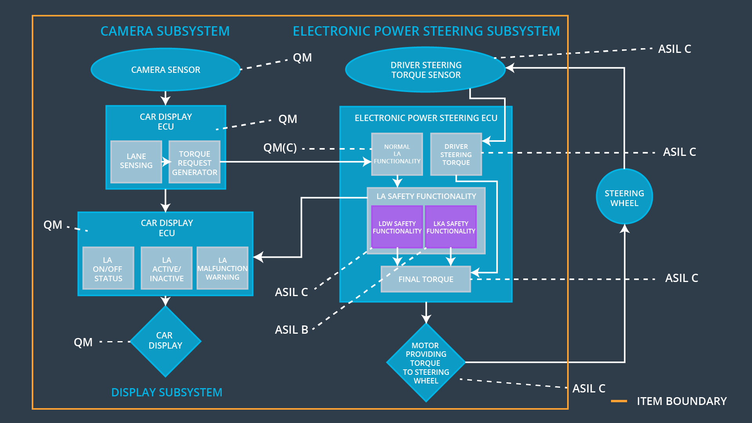

## Allocation of Functional Safety Requirements to Architecture Elements

|  |  |  |  |  |
| --- | --- | --- | --- | --- |
| **ID** | **Functional Safety Requirement** | **Electronic Power Steering ECU** | **Camera ECU** | **Car Display ECU** |
| Functiona l  Safety  Requirement  01-01 | The Lane Departure Warning item shall ensure that the lane departure oscillating torque amplitude is below Max_Torque_Amplitude. | **Responsible** | **Not Responsible** | **Not Responsible** |
| Functional  Safety  Requirement  01-02 | The Lane Departure Warning item shall ensure that the lane departure oscillating torque frequency is below Max_Torque_Frequency. | **Responsible** | **Not Responsible** | **Not Responsible** |
| Functional Safety Requirement 01-03 | The Lane Departure Warning function shall be deactivated when the camera sensor stop working. | **Responsible** | **Not Responsible** | **Not Responsible** |

## Warning and Degradation Concept

|  |  |  |  |  |
| --- | --- | --- | --- | --- |
| **ID** | **Degradation Mode** | **Trigger for Degradation Mode** | **Safe State invoked?** | **Driver Warning** |
| WDC-01 | Turn off LDW functionality | Malfunction_01,  Malfunction_02 | Yes | Light displayed on dashboard and on car as warnings |
| WDC-02 | Turn off LKA functionality | Malfunction_03,  Malfunction_05 | Yes | Light displayed on dashboard and on car as warnings |