

Technical Safety Concept Lane Assistance

**Document Version: [Version]**

**Template Version 1.0, Released on 2017-06-21**



# Document history

|  |  |  |  |
| --- | --- | --- | --- |
| Date | Version | Editor | Description |
| 24/5/2018 | 1.0 | Vivek Pathak | First Attempt |
| 25/5/2018 | 1.1 | Vivek Pathak | Second Attempt |
|  |  |  |  |
|  |  |  |  |
|  |  |  |  |

# 

# Table of Contents

Document history

Table of Contents

Purpose of the Technical Safety Concept

Inputs to the Technical Safety Concept

Functional Safety Requirements

Refined System Architecture from Functional Safety Concept

Functional overview of architecture elements

Technical Safety Concept

Technical Safety Requirements

Refinement of the System Architecture

Allocation of Technical Safety Requirements to Architecture Elements

Warning and Degradation Concept

# 

# Purpose of the Technical Safety Concept

In this document we look into technical safety of every sub-systems and we separately define safety concept for each sub-systems as according to ISO-26262 they are more specific and underlie what is happening in more deep.

# Inputs to the Technical Safety Concept

## Functional Safety Requirements

|  |  |  |  |  |
| --- | --- | --- | --- | --- |
| **ID** | **Functional Safety Requirement** | **ASIL** | **Fault Tolerant Time Interval** | **Safe State** |
| Functional  Safety  Requirement  01-01 | The Lane keeping item shall ensure that torque is below Max_Torque_Amplitude. | C | 50 ms | Vibration torque amplitude below Max_Torque_Amplitude. |
| Functional  Safety  Requirement  01-02 | The Lane keeping item shall ensure that lane departure oscillating torque frequency is below Max_Torque_Frequency. | C | 50 ms | Vibration frequency is below Max_Torque_Frequency. |
| Functional  Safety  Requirement  02-01 | LKA function shall be time limited for max_duration | B | 500 ms | Set the LKA torque to zero |

## Refined System Architecture from Functional Safety Concept

### 

### Functional overview of architecture elements

|  |  |
| --- | --- |
| **Element** | **Description** |
| Camera Sensor | Capture images and provide them to the Camera Sensor ECU. |
| Camera Sensor ECU - Lane Sensing | Detect lane line and calculate position of the car with respect to lane |
| Camera Sensor ECU - Torque request generator | Generate torque request to the car for ECU. |
| Car Display | Display status of malfunctioning of the system. |
| Car Display ECU - Lane Assistance On/Off Status | Indicate the status of the Lane Assistance functionality (On/Off.) |
| Car Display ECU - Lane Assistant Active/Inactive | Indicate if the Lane Assistance functionality is properly functioning (Active/Inactive.) |
| Car Display ECU - Lane Assistance malfunction warning | Indicate a malfunction on the Lane Assistance functionality. |
| Driver Steering Torque Sensor | Measure the torque applied to the steering wheel by the driver. |
| Electronic Power Steering (EPS) ECU - Driver Steering Torque | On receiving the driver’s torque request from the steering wheel. |
| EPS ECU - Normal Lane Assistance Functionality | On receiving the Camera Sensor ECU torque request. |
| EPS ECU - Lane Departure Warning Safety Functionality | On ensuring the torque amplitude is below Max_Torque_Amplitude and torque frequency is below Max_Torque_Frequency. |
| EPS ECU - Lane Keeping Assistant Safety Functionality | On ensuring the Lane Keeping Assistance functionality application is not activate more than Max_duration time. |
| EPS ECU - Final Torque | Combine the torque request from the Lane Keeping and Lane Departure Warning functionalities and sends them to the Motor. |
| Motor | Applies the required torque to the steering wheels. |

# Technical Safety Concept

## Technical Safety Requirements

**Lane Departure Warning (LDW) Requirements:**

Functional Safety Requirement 01-01 with its associated system elements

(derived in the functional safety concept)

|  |  |  |  |  |
| --- | --- | --- | --- | --- |
| **ID** | **Functional Safety Requirement** | **Electronic Power Steering ECU** | **Camera ECU** | **Car Display ECU** |
| Functional  Safety  Requirement  01-01 | LDW system shall ensure that the lane departure oscillating torque amplitude is below Max_Torque_Amplitude | Responsible | Not Responsible | Not Responsible |

Technical Safety Requirements related to Functional Safety Requirement 01-01 are:

|  |  |  |  |  |  |
| --- | --- | --- | --- | --- | --- |
| **ID** | **Technical Safety Requirement** | **ASIL** | **Fault Tolerant Time Interval** | **Architecture Allocation** | **Safe State** |
| Technical  Safety  Requirement  01 | The Lane Departure Warning shall ensure that the amplitude of the ‘LDW_Torque_Request’ sent to the ‘Final electronic power steering Torque’ component is below ‘Max_Torque_Amplitude.’ | C | 50 ms | LDW Safety | LDW torque shall be set to zero. |
| Technical  Safety  Requirement  02 | As soon as the Lane Departure Warning is deactivated, the ‘LDW Safety’ software module shall send a signal to the Car Display ECU to turn on a warning signal. | C | 50 ms | LDW Safety | LDW torque shall be set to zero. |
| Technical  Safety  Requirement  03 | As soon as when a failure is detected by the Lane Departure Warning functionality, it shall deactivate the Lane Departure Warning feature and set ‘LDW_Torque_Request’ to zero. | C | 50 ms | LDW Safety | LDW torque shall be set to zero. |
| Technical  Safety  Requirement  04 | The validity and integrity of the data transmission for ‘LDW_Torque_Request’ signal shall be ensured. | C | 50 ms | LDW Safety | LDW torque shall be set to zero. |
| Technical  Safety  Requirement  05 | Memory test shall be conducted at start up of the EPS ECU to check for any memory problems | A | Ignition cycle | Data Transmission Integrity Check | LDW torque shall be set to zero. |

Functional Safety Requirement 01-2 with its associated system elements

(derived in the functional safety concept)

|  |  |  |  |  |
| --- | --- | --- | --- | --- |
| **ID** | **Functional Safety Requirement** | **Electronic Power Steering ECU** | **Camera ECU** | **Car Display ECU** |
| Functional  Safety  Requirement  01-02 | The lane keeping item shall ensure that the lane departure oscillating torque frequency is below Max_Torque_Frequency | Responsible | Not Responsible | Not Responsible |

Technical Safety Requirements related to Functional Safety Requirement 01-02 are:

|  |  |  |  |  |  |
| --- | --- | --- | --- | --- | --- |
| **ID** | **Technical Safety Requirement** | **ASIL** | **Fault Tolerant Time Interval** | **Architecture Allocation** | **Safe State** |
| Technical  Safety  Requirement  01 | The Lane Departure Warning safety component shall ensure that the amplitude of the ‘LDW_Torque_Request’ sent to the ‘Final electronic power steering Torque’ component is below ‘Max_Torque_Amplitude.’ | C | 50 ms | LDW Safety | LDW torque shall be set to zero. |
| Technical  Safety  Requirement  02 | With time when the Lane Departure Warning is deactivated, the ‘LDW Safety’ software module shall send a signal to the Car Display ECU to turn on a warning signal. | C | 50 ms | LDW Safety | LDW torque shall be set to zero. |
| Technical  Safety  Requirement  03 | With time when a failure is detected by the Lane Departure Warning functionality, it shall deactivate the Lane Departure Warning feature and set ‘LDW_Torque_Request’ to zero. | C | 50 ms | LDW Safety | LDW torque shall be set to zero. |
| Technical  Safety  Requirement  04 | The validity and integrity of the data transmission for ‘LDW_Torque_Request’ signal shall be ensured. | C | 50 ms | LDW Safety | LDW torque shall be set to zero. |
| Technical  Safety  Requirement  05 | Memory test shall be conducted at start up of the EPS ECU to check for any memory problems | A | Ignition cycle | Data Transmission Integrity Check | LDW torque shall be set to zero. |

**Lane Keeping Assistance (LKA) Requirements:**

Functional Safety Requirement 02-1 with its associated system elements

(derived in the functional safety concept)

|  |  |  |  |  |
| --- | --- | --- | --- | --- |
| **ID** | **Functional Safety Requirement** | **Electronic Power Steering ECU** | **Camera ECU** | **Car Display ECU** |
| Functional  Safety  Requirement  02-01 | The lane keeping item shall ensure that the lane keeping assistance torque is applied for only Max_Duration | Responsible | Not Responsible | Not Responsible |

Technical Safety Requirements related to Functional Safety Requirement 02-01 are:

|  |  |  |  |  |  |
| --- | --- | --- | --- | --- | --- |
| **ID** | **Technical Safety Requirement** | **ASIL** | **Fault Tolerant Time Interval** | **Allocation to Architecture** | **Safe State** |
| Technical  Safety  Requirement  01 | The Lane Keeping Assistance safety component shall ensure the duration of the lane keeping assistance torque is applied for less than Max_Duration | C | 500 ms | LKA Safety | Lane Keeping Assistance torque to zero. |
| Technical  Safety  Requirement  02 | With time when the Lane Keeping Assistance function deactivates, the ‘LKA Safety’ shall send a signal to the Car Display ECU to turn on a warning light. | C | 500 ms | LKA Safety | Lane Keeping Assistance torque to zero. |
| Technical  Safety  Requirement  03 | With time when a failure is detected, the Lane Keeping Assistance function shall deactivate and the ‘LKA_Torque_Request’ shall be zero. | C | 500 ms | LKA Safety | Lane Keeping Assistance torque to zero. |
| Technical  Safety  Requirement  04 | The validity and integrity of the data transmission for ‘LKA_Torque_Request’ signal shall be ensured. | C | 500 ms | LKA Safety | Lane Keeping Assistance torque to zero. |
| Technical  Safety  Requirement  05 | Memory test shall be conducted at start up of the EPS ECU to check for any memory problems | A | Ignition cycle | Data Transmission Integrity Check | Lane Departure Warning torque to zero. |

**Lane Keeping Assistance (LKA) Verification and Validation Acceptance Criteria:**

## Refinement of the System Architecture

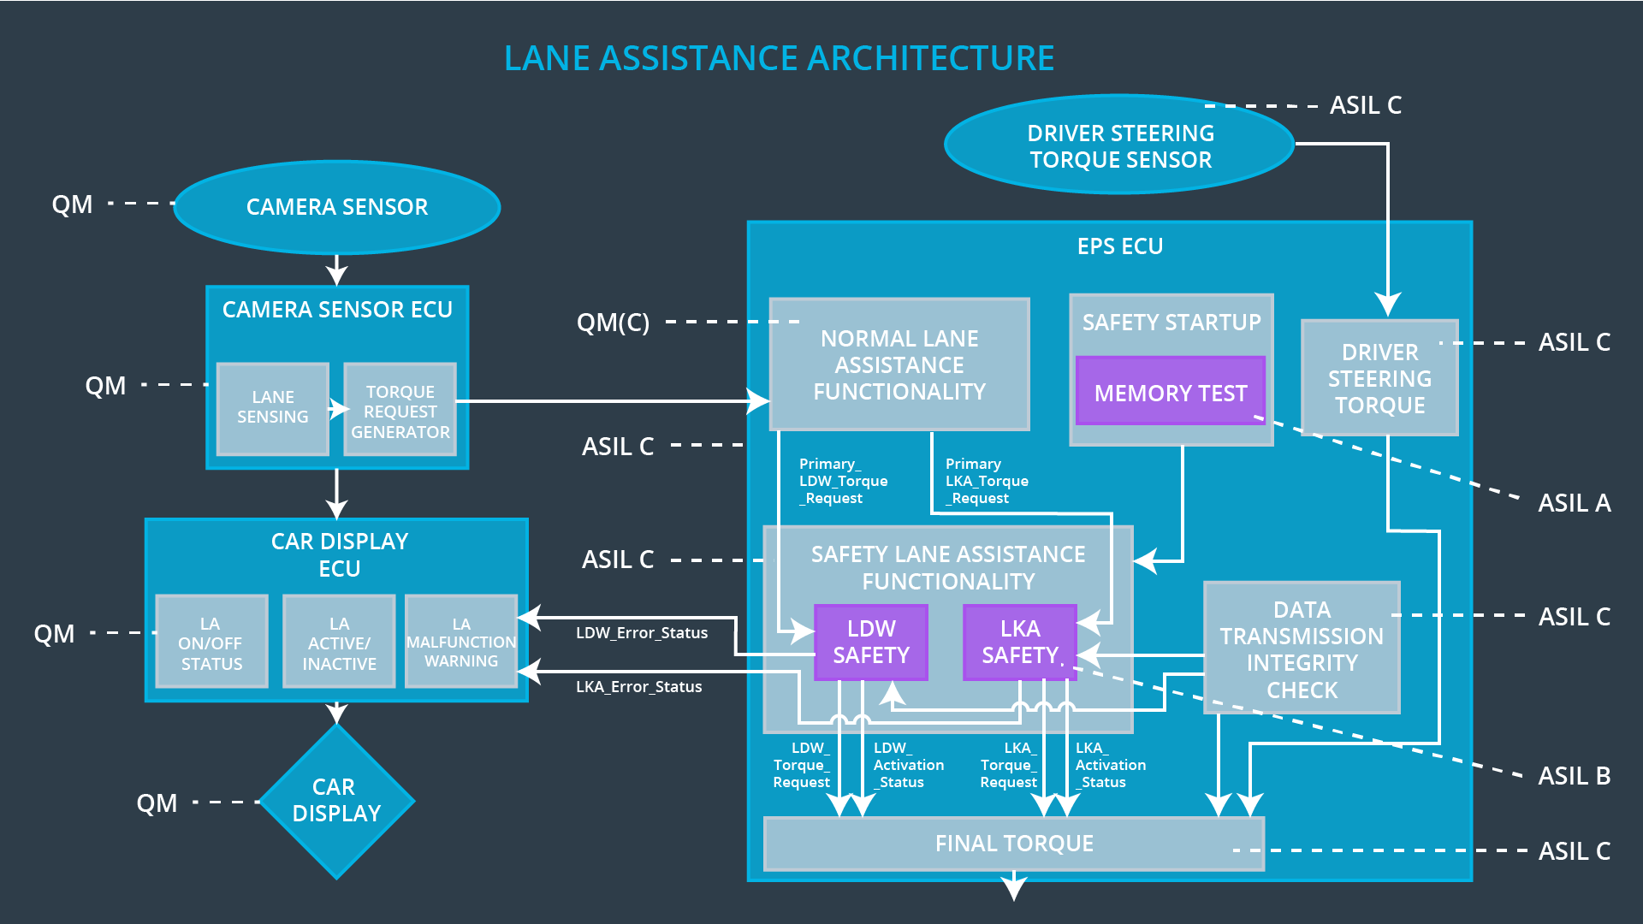

## 

## Allocation of Technical Safety Requirements to Architecture Elements

|  |  |  |  |  |
| --- | --- | --- | --- | --- |
| **ID** | **Functional Safety Requirement** | **Electronic Power Steering ECU** | **Camera ECU** | **Car Display ECU** |
| Functiona l  Safety  Requirement  01-01 | The Lane Departure Warning item shall ensure that the lane departure oscillating torque amplitude is below Max_Torque_Amplitude. | **Responsible** | **Not Responsible** | **Not Responsible** |
| Functional  Safety  Requirement  01-02 | The Lane Departure Warning item shall ensure that the lane departure oscillating torque frequency is below Max_Torque_Frequency. | **Responsible** | **Not Responsible** | **Not Responsible** |
| Functional Safety Requirement 01-03 | The Lane Departure Warning function shall be deactivated when the camera sensor stop working. | **Responsible** | **Not Responsible** | **Not Responsible** |

## Warning and Degradation Concept

|  |  |  |  |  |
| --- | --- | --- | --- | --- |
| **ID** | **Degradation Mode** | **Trigger for Degradation Mode** | **Safe State invoked?** | **Driver Warning** |
| WDC-01 | Turn off Warning functionality | Malfunction_01,  Malfunction_02 | Yes | Light displayed on dashboard and on car as warnings |
| WDC-02 | Turn off Assistance functionality | Malfunction_03 | Yes | Light displayed on dashboard and on car as warnings |