Name: Vivek Lele
Roll No: 23MCA1023
Topic: Inserting / Updating / Deleting / Records in the table – Using Transaction Control Commands – Commit, Rollback, and save point

Code:

select * from 23mca1023_student;
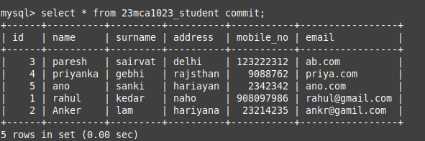
start transaction;
savepoint savepoint2;
insert into 23mca1023_student values(33, “ank”, “kase”, “ksd”, 237854, “ad”)
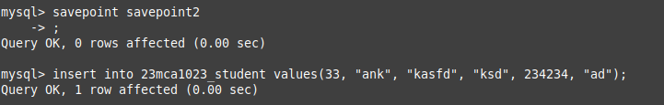

rollback to savepoint2;
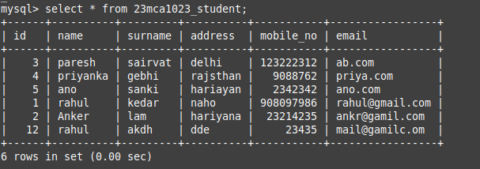

select * from 23mca1023_teacher where id in(2,4);
