Name: Vivek Lele

Roll NO: 23MCA1023

Topic: Singly Link List

Code:

**#include <stdio.h>**

**#include <stdlib.h>**

**struct Node {**

**int data;**

**struct Node *next;**

**};**

**void insertAtBeginning(struct Node **head, int data) {**

**struct Node *newNode = (struct Node *)malloc(sizeof(struct Node));**

**newNode->data = data;**

**newNode->next = *head;**

**\*head = newNode;**

**}**

**void printList(struct Node *node) {**

**while (node != NULL) {**

**printf("%d -> ", node->data);**

**node = node->next;**

**}**

**printf("NULL\n");**

**}**

**int main() {**

**struct Node *head = NULL;**

**int value, numNodes;**

**printf("Enter the number of nodes: ");**

**scanf("%d", &numNodes);**

**for (int i = 0; i < numNodes; i++) {**

**printf("Enter value for node %d: ", i + 1);**

**scanf("%d", &value);**

**insertAtBeginning(&head, value);**

**}**

**printf("Linked List: ");**

**printList(head);**

**return 0;**

**}**

Output:

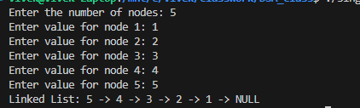x