Name: Vivek Lele

Roll No: 23MCA1023

1. Write a Java program that checks whether a given number is divisible by either 3 or 5. If it is, print "Divisible"; otherwise, print "Not divisible."

Code:

import java.util.Scanner;

public class Main

{

public static void main(String[] args) {

Scanner sc = new Scanner(System.in);

int num = sc.nextInt();

if(num % 3 || num % 5){

System.out.println("Divisible");

}

else{

System.out.println("Not divisible");

}

}

}

Output:

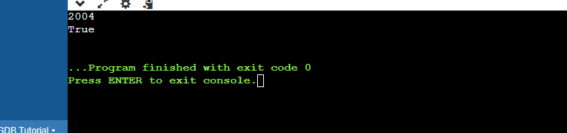

1. Create a Java program to determine if a person is eligible to vote. The eligibility age is 18. Check if the age entered by the user is either equal to or greater than 18. Print "Eligible" if true, otherwise, print "Not Eligible.

Code:

import java.util.Scanner;

public class Main

{

public static void main(String[] args) {

Scanner sc = new Scanner(System.in);

int num = sc.nextInt();

if(num > 17 || num >= 18){

System.out.println("Eligible");

}

else{

System.out.println("Not Eligible");

}

}

}

Output:

