1st page: Login

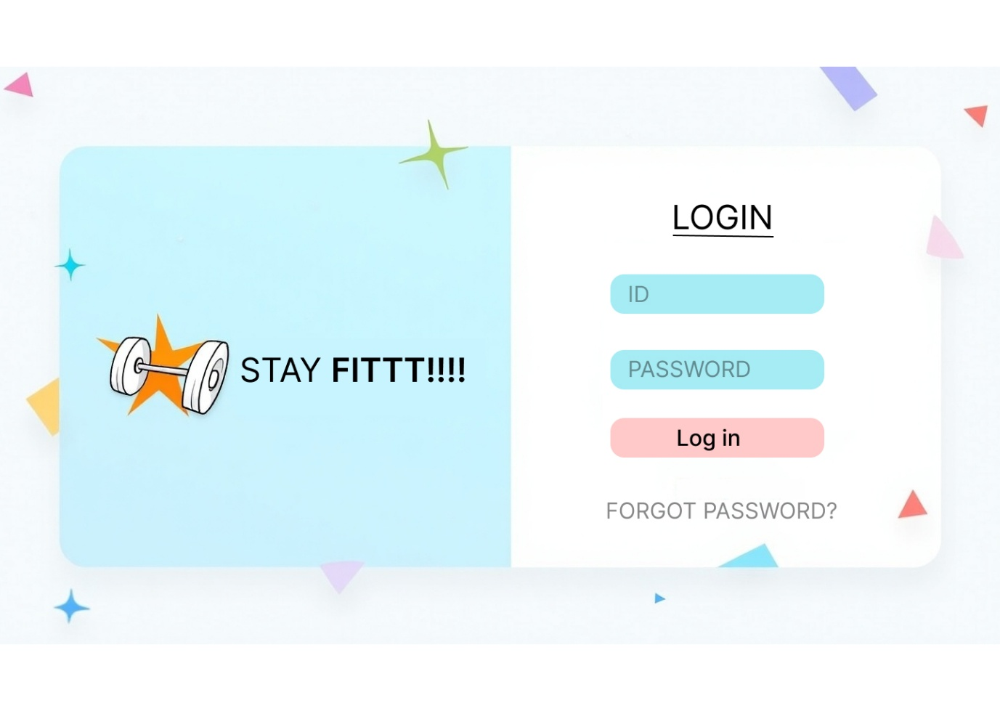

2nd page: sign up

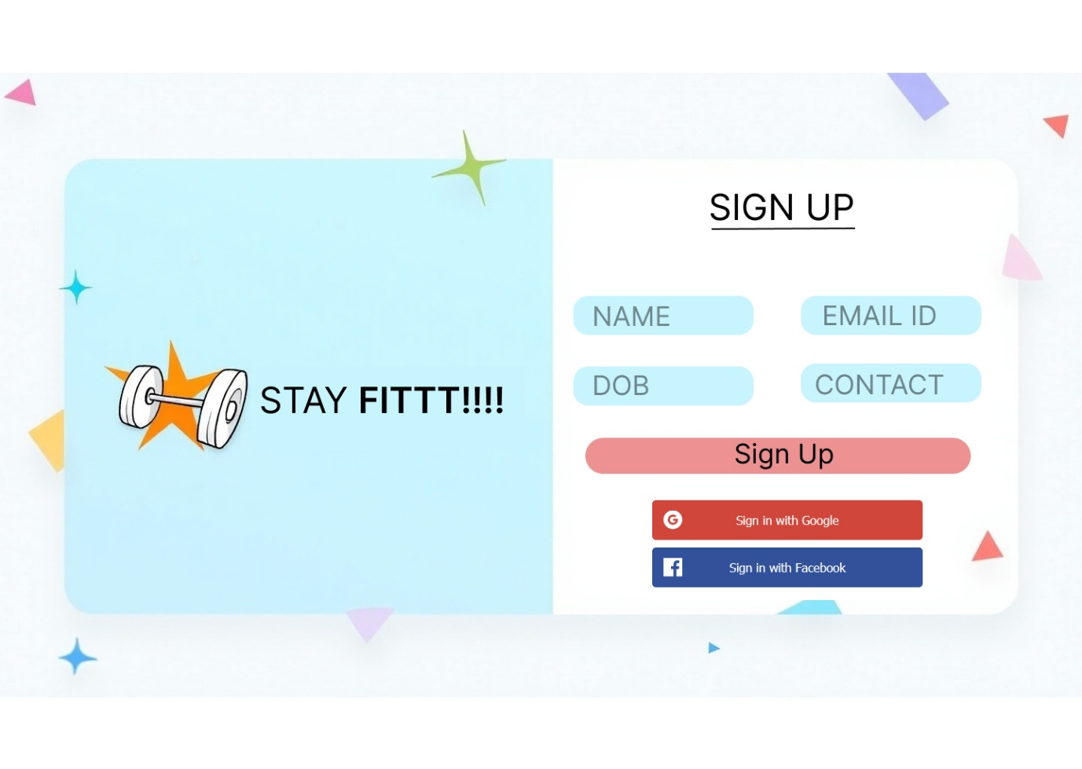

3rd page:

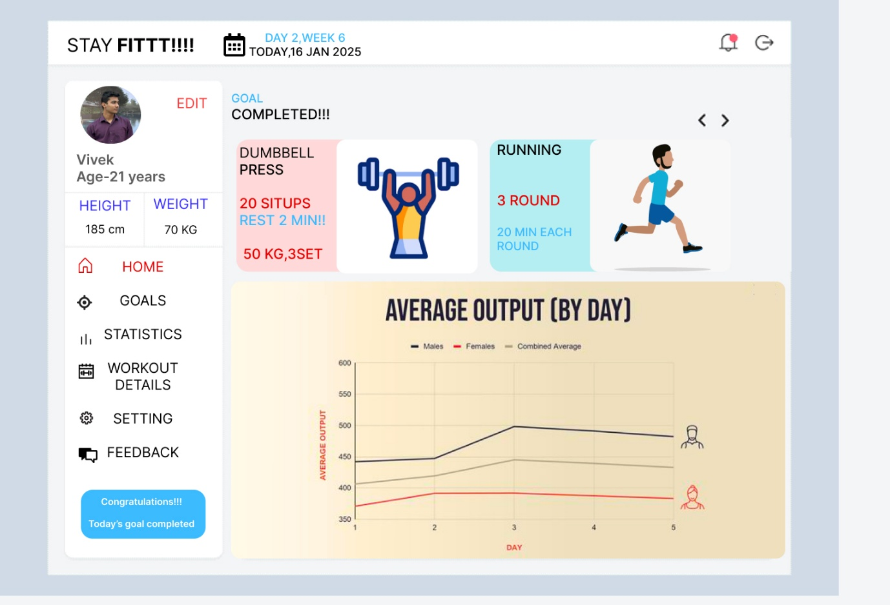

4th page:

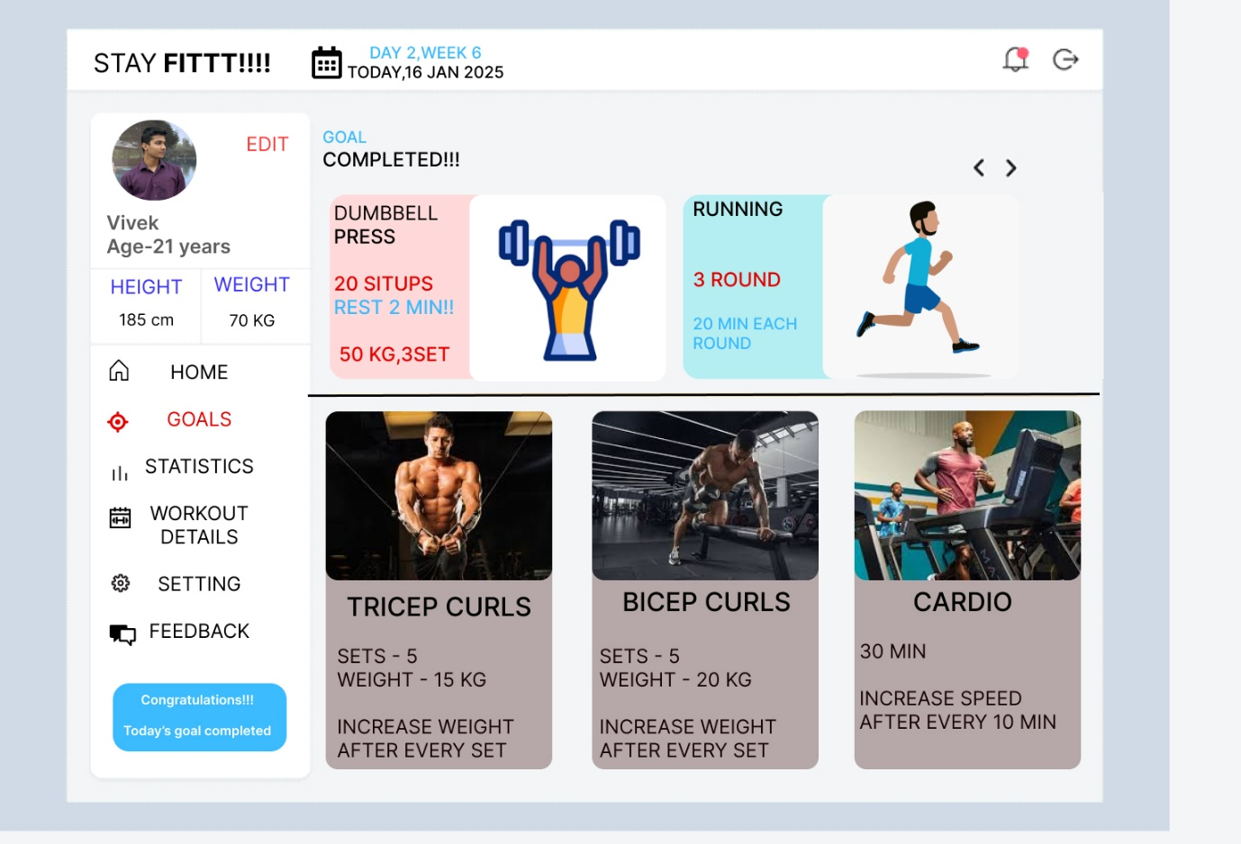

5th page:

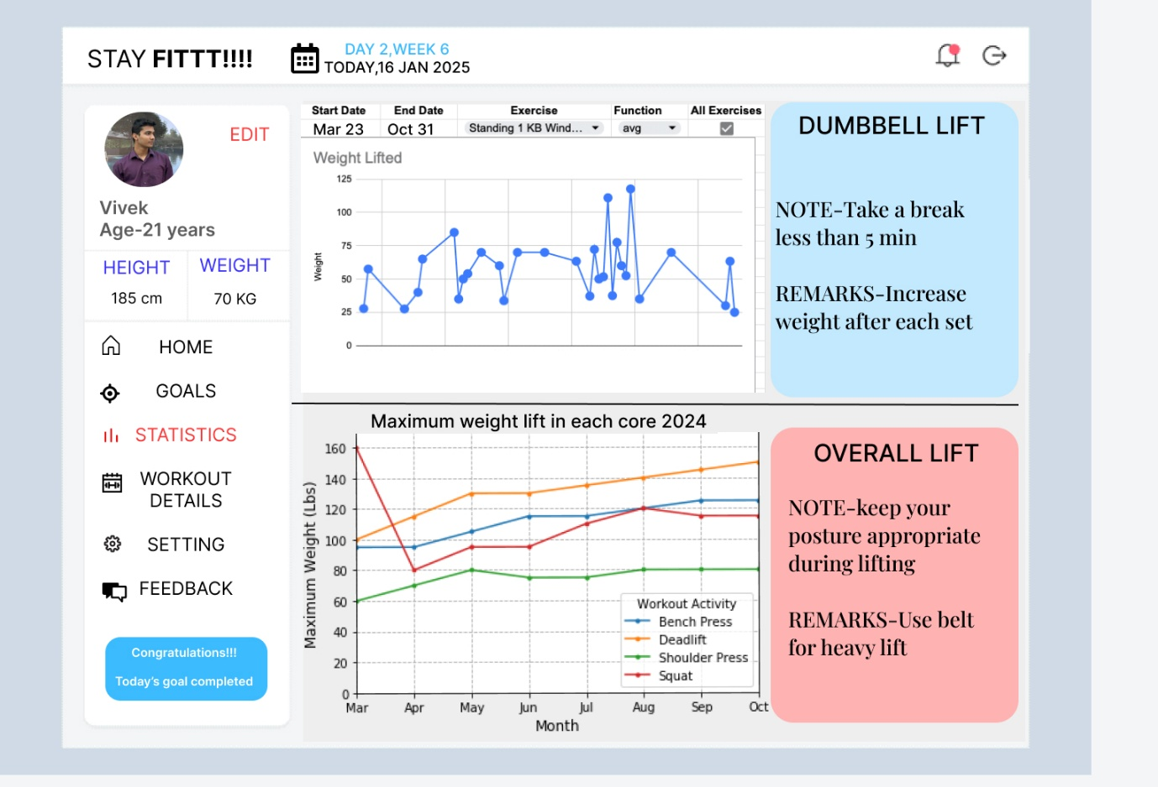

6th page:

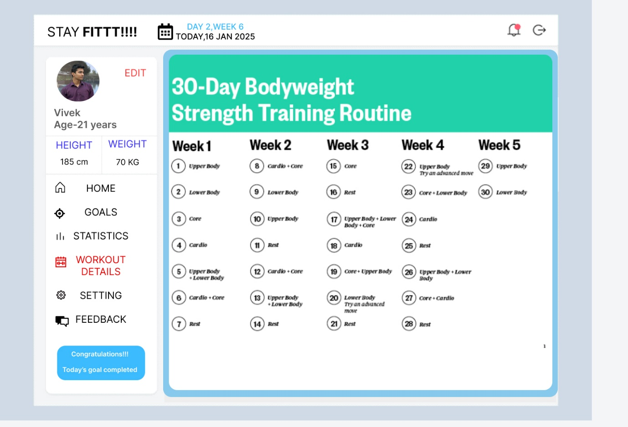

7th page:

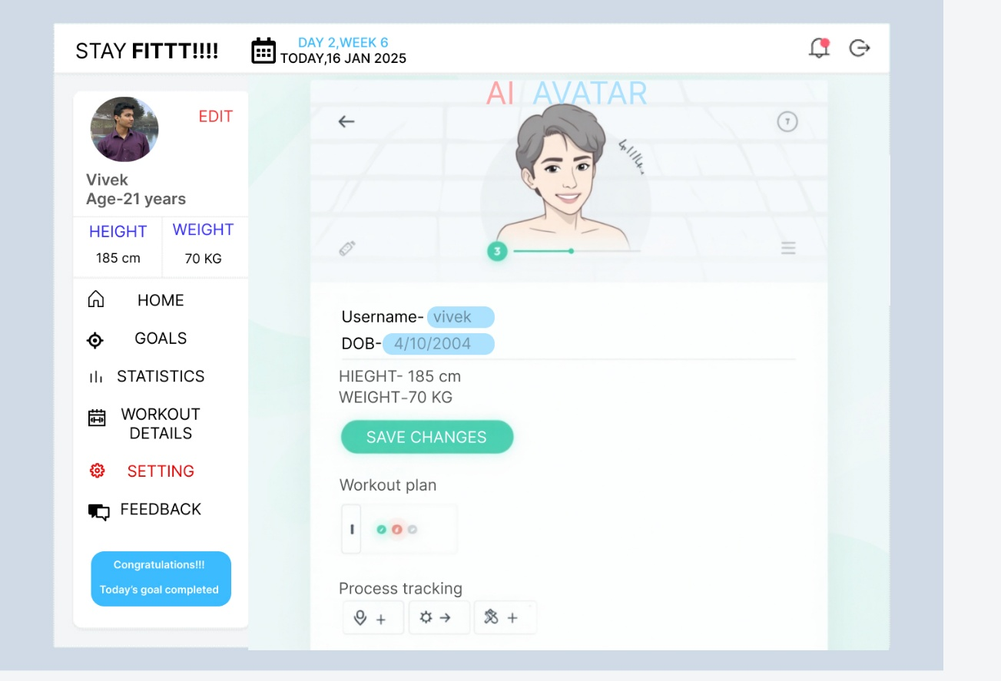

8th page:

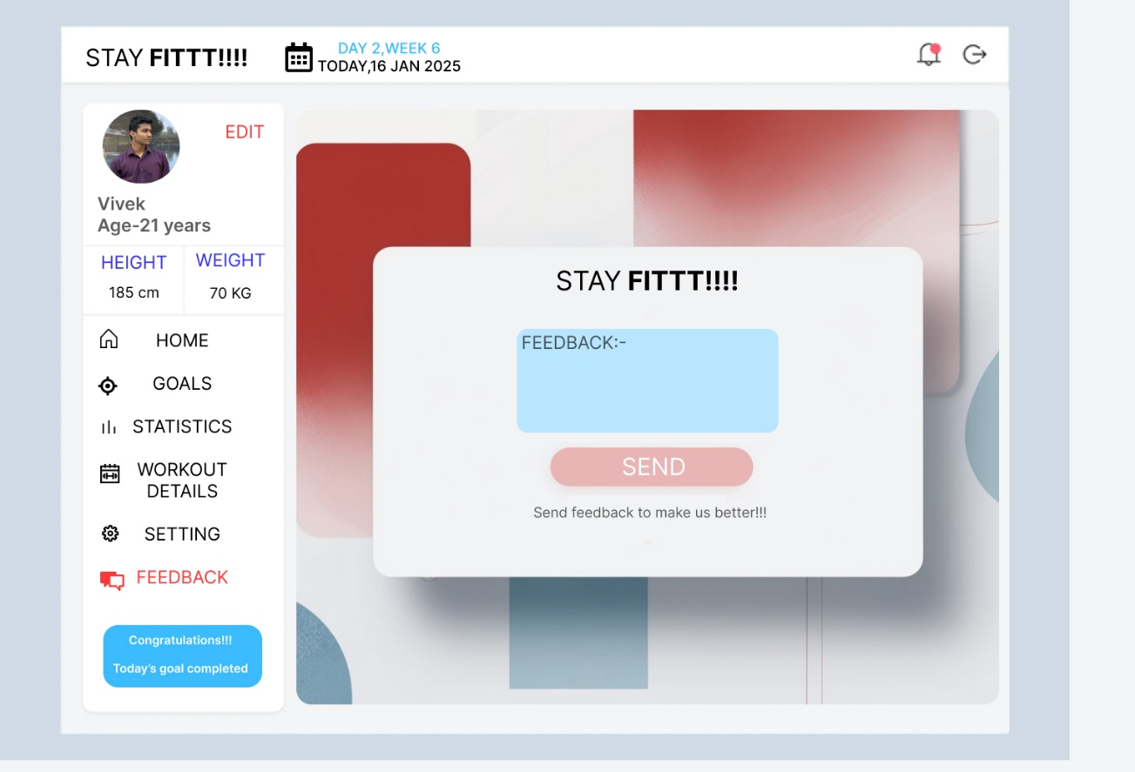

Prototype link: https://www.figma.com/proto/2ic2TiP5TVcTyeeO2vllG5/Untitled?page-id=0%3A1&node-id=1-2&p=f&viewport=563%2C69%2C0.62&t=bZWHaag50LzLHdtB-1&scaling=min-zoom&content-scaling=fixed&starting-point-node-id=1%3A2