Step 1: search git hub in your browser , and select the first link.



Step 2:click on sign in for new user.

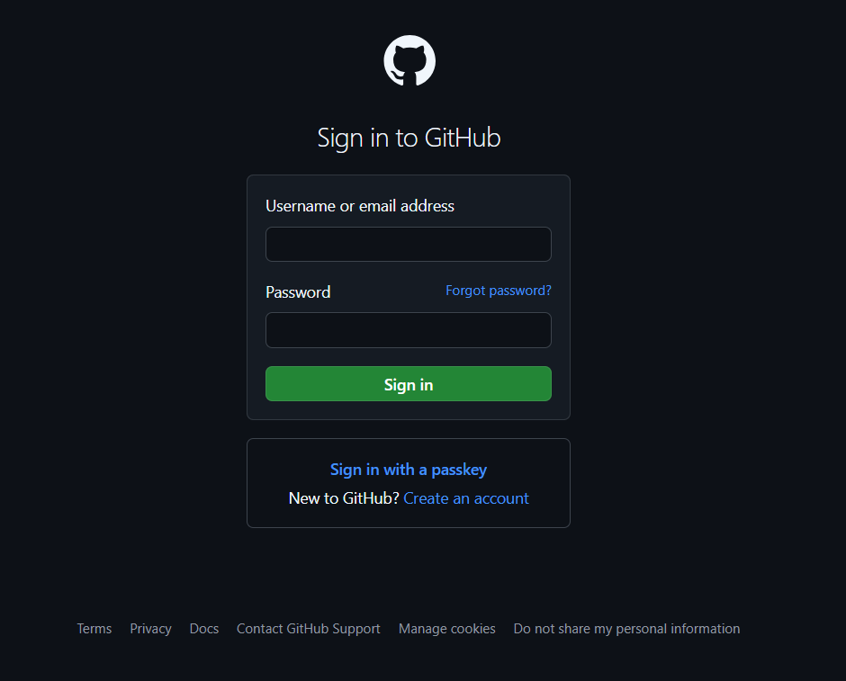

Step 3:click on create an account and fill the information.

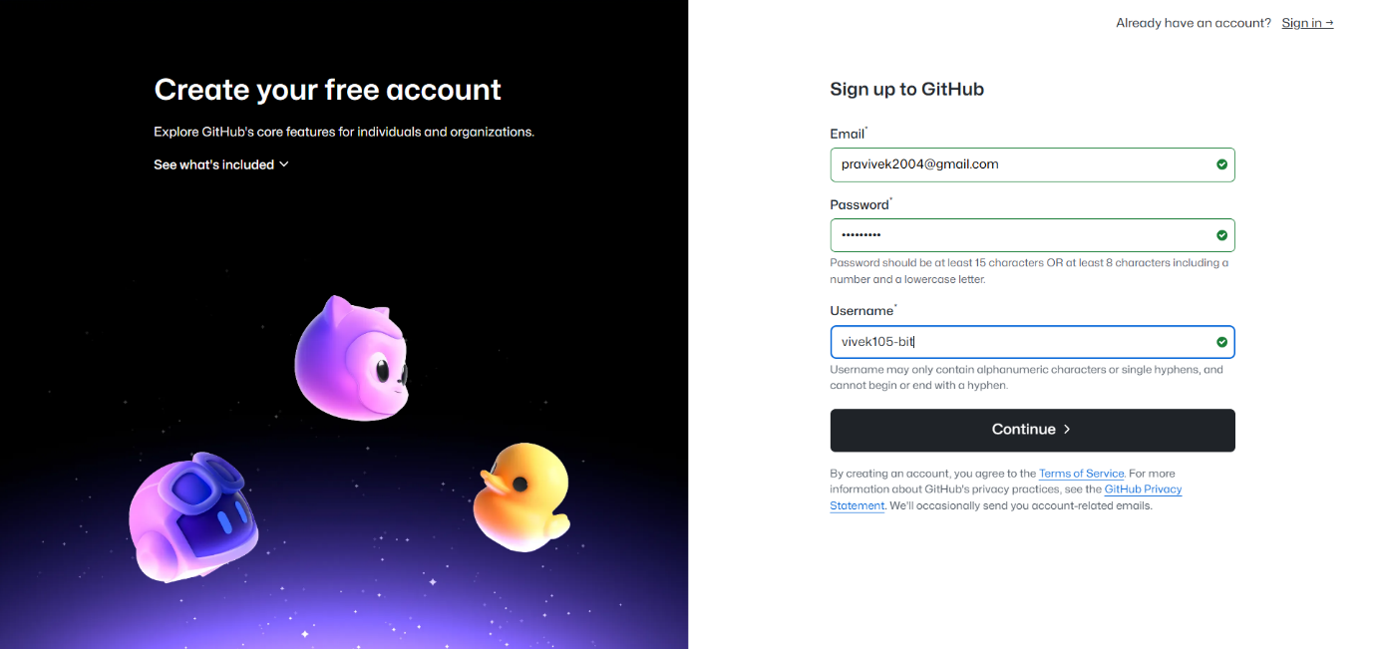

Step 4:click on continue , and the solve the puzzle.

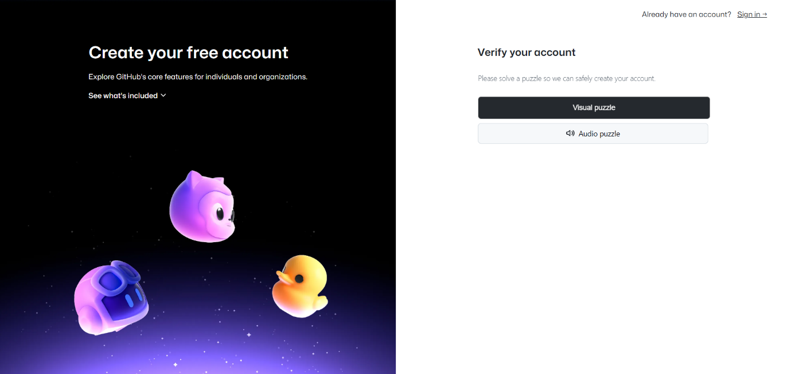

Step 5: after the solving puzzle code has been sent to your chosen email id and click on continue.

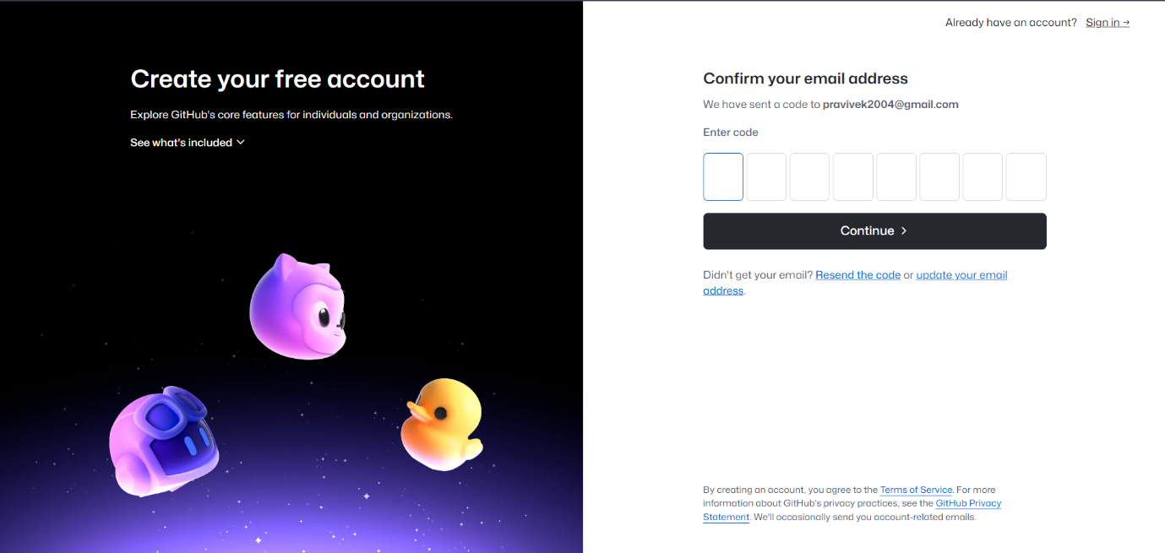

Step 6:now login with your email id and password.

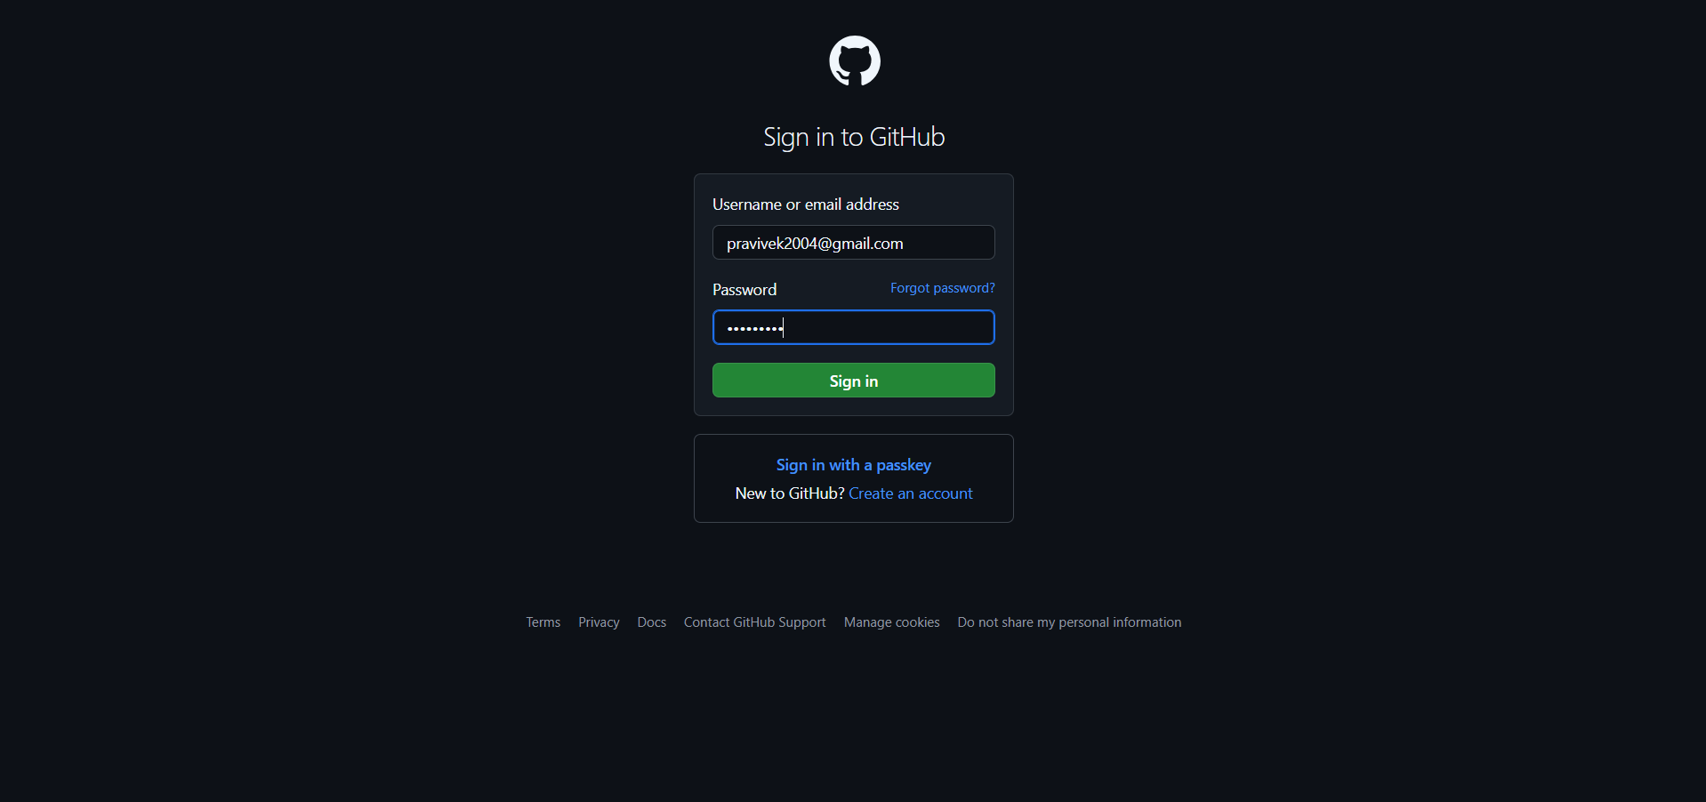

Step 7: home page of github would be opened , now click on create repository.

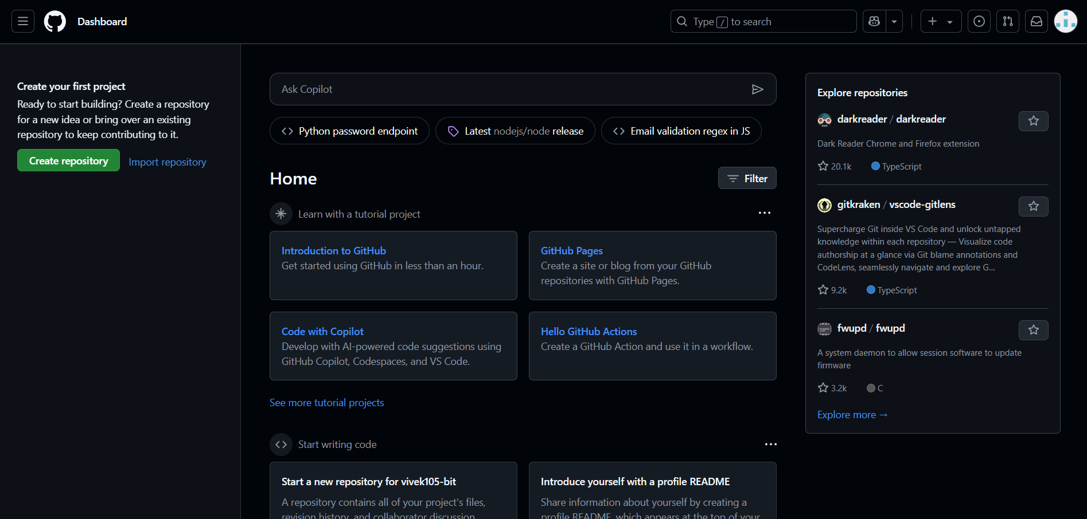

Step 8:chose the name for your repository according to your enrollment number and click on create.

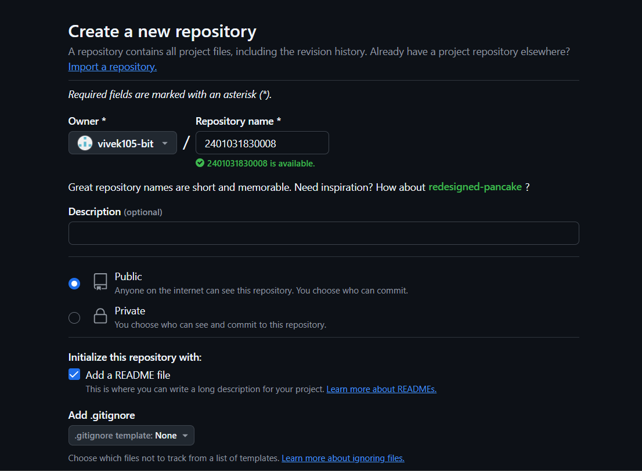

Step 9:your repository has been successfully created.

