**PROJECT REPORT ON**

***EMPLOYEE ABSENTEEISM***

**(BASED ON R AND PYTHON)**

***Presented by***

***VIVEK SHARMA***

***(***[***vickysharma199526@gmail.com***](mailto:vickysharma199526@gmail.com)***)***

December 2019

***CONTENTS***

***Page No.***

1. **INTRODUCTION……………………………………………………………………6**

**1.1.** Problem Statement………………………………………………………………………………………….6

**1.2.** Data………………………………………………………………………………………………………………….6

**2. METHODOLOGY…………………………………………………………………..9**

**2.1.** Data Exploration……………………………………………………………………………………………..9

**2.2. Preprocessing techniques……………………………………………………………………………..9**

**2.2.1.** Missing value analysis………………………………………………………………………….10

**2.2.2.** Outlier Analysis…………………………………………………………………………………….11

**2.2.3.** Feature selection………………………………………………………………………………….13

**2.2.4.** Feature scaling……………………………………………………………………………………..15

**3. MODELING…………………………………………………………………………18**

**3.1. Machine learning algorithm……………………………………………………………………….18**

**3.1.1.** Model Selection…………………………………………………………………………………..18

**3.2.1.** Decision Tree……………………………………………………………………………………….19

**3.2.2.** Random Forest…………………………………………………………………………………….19

**3.2.3.** Linear Regression…………………………………………………………………………………20

**4. MODEL EVALUATION………………………………………………………….22**

**5. Work Loss…………………………………………………………………………..23**

**6. CONCLUSION………………………………………………………………………24**

**APPENDIX– A Extra Figures……………………………………………………25**

**APPENDIX– B VIF…………………………………………………………………..27**

**APPENDIX – C Output Terms………………………………………………….28**

**REFERENCE…………………………………………………………………………….29**

***LIST OF TABLES***

Page no.

* 1. Variables Name………………………………………………………………………………..6
  2. Levels of reason for absence……………………………………………..................7
  3. Sample data (column 1:7)…………………………………………………………………8
  4. Sample data (column 8:14)……………………………………………………………….8
  5. Sample data (column 15:21)……………………………………………………………..8

**2.1**. ANOVA for categorical variable……………………………………………………….15

**3.1** Absenteeism vs. Count of employee………………………………………………..18

**3.2** Decision Tree accuracy table……………………………………………………………19

**3.3** Random Forest accuracy table…………………………………………………………20

**3.4** Linear Regression accuracy table……………………………………………………..20

**3.5** Accuracy of the models........................................................................21

**5.1** Monthly work loss…………………………………………………………………………….23

***LIST OF FIGURES***

Page no

**2.1.** Missing percentage graph…………………………………………………………………..10

**2.2.** Missing percentage graph……………………………………………………………………11

**2.3.** Missing percentage graph……………………………………………………………………11

**2.4.** Boxplots……………………………………………………………………………………………….13

**2.5.** Correlation plot……………………………………………………………………………………14

**2.6.** Normalization (Transportation expense)………………………………………………16

**2.7.** Normalization (Distance form residence)……………………………………………..16

**2.8.** Normalization (Service time)…………………………………………………………………16

**2.9.** Normalization (Weight)…………………………………………………………………………17

**2.10.** Normalization (Workload)…………………………………………………………………..17

***ABSTRACT***

Absenteeism means pattern of absence from a duty without any good reason. Absenteeism is unplanned absences from ones duty and is indicator poor individual performance which in turn leads to poor performance of the company. In this project XYZ a courier company facing a severe issue of absenteeism has shared its dataset which contains the information about the employees of that company of previous year. On the basis of the previous year dataset and observed pattern and insights we have to predict the future values and help them to know the factors which help them to reduce the number of absenteeism as well as the monthly loss company is going to face in the coming year i.e. 2011.

We are using both R and Python to build the suitable model according to the company’s problem statement. We will try different ML Algorithm and will choose the best model accordingly to help them to know the answers for the questions mentioned above.

***CHAPTER – 1***

**INTRODUCTION**

Absenteeism is the unplanned absence from the duty without any good reason. It is one of the severe issues faced by many companies. We know that human capital plays an important role in any business. Being able to predict the employee absenteeism can prevent company from severe loss. It is very important to know the cause of absenteeism among the employee. One of the best ways to make the predictions is with the help of machine learning techniques.

* 1. **PROBLEM STATEMENT**

Absenteeism leads to severe business loss. XYZ is a courier company and is facing a genuine issue of absenteeism. The aim of this project is to predict the factors to reduce the number of absenteeism and the work loss company is going to face next year if same trend of absenteeism continues. To make the predictions we used R and Python codes and algorithms.

* 1. **DATA**

According to the problem statement the given data comes under **“REGRESSION” (forecasting)** category as our target variable **“Absenteeism time in hours”** is continuous in nature. Depending on the problem statement we developed and selected algorithms for the prediction.

There are 21 predictors and 1 target variable in our dataset listed in table 1.1. These predictors are very useful in predicting the results.

**Table 1.1:** Variables name

|  |  |
| --- | --- |
| **No.** | **Variable name** |
| 1 | Individual Identification(ID) |
| 2 | Reason for absence |
| 3 | Month of absence |
| 4 | Day of the week |
| 5 | Seasons |
| 6 | Transportation expense |
| 7 | Distance from residence to work |
| 8 | Service time |
| 9 | Age |
| 10 | Work load average/day |
| 11 | Hit target |
| 12 | Disciplinary failure |
| 13 | Son |
| 14 | Pet |
| 15 | Social smoker |
| 16 | Social drinker |
| 17 | Height |
| 18 | Weight |
| 19 | Body mass index |
| 20 | Education |
| 21 | Absenteeism time in hours |

There are several categories in the variable “Reason for absence” according to International Code of Diseases (ICD) which is listed below in table 1.2.

**Table 1.2:** Levels ofReason for absence

|  |  |
| --- | --- |
| No | Reason for absence |
| I | Certain infectious and parasitic diseases. |
| II | Neoplasms. |
| III | Diseases of the blood and blood-forming organs and certain disorders involving the immune mechanism. |
| IV | Endocrine, nutritional and metabolic diseases. |
| V | Mental and behavioural disorders. |
| VI | Diseases of the nervous system. |
| VII | Diseases of the eye and adnexa. |
| VIII | Diseases of the ear and mastoid process. |
| IX | Diseases of the circulatory system. |
| X | Diseases of the respiratory system. |
| XI | Diseases of the respiratory system. |
| XII | Diseases of the skin and subcutaneous tissue. |
| XIII | Diseases of the musculoskeletal system and connective tissue. |
| IV | Diseases of the genitourinary system. |
| XV | Pregnancy, childbirth and the  puerperium. |
| XVI | Certain conditions originating in the perinatal period. |
| XVII | Congenital malformations, deformations and chromosomal abnormalities |
| XVIII | Symptoms, signs and abnormal clinical and laboratory findings, not elsewhere  Classified. |
| XIX | Injury, poisoning and certain other consequences of external causes. |
| XX | External causes of morbidity and mortality. |
| XI | Factors influencing health status and contact with health services. |

There are 7 more categories without COD and different levels in few variables like day of the week, month of absence, seasons, education, social smoker, Disciplinary failure and social drinker which are mentioned in appendix B.

Table 1.3 represents the sample of the dataset on which we applied the preprocessing techniques and algorithms for further prediction of the target class.

**Table 1.3:** Sample ofEmployee Absenteeism Dataset (Column 1 to 7)

|  |  |  |  |  |  |  |
| --- | --- | --- | --- | --- | --- | --- |
| ID | Reason for absence | Month of absence | Day of the week | Seasons | Transportation  expense | Distance from work to home |
| 11 | 26 | 7 | 3 | 1 | 289 | 36 |
| 36 | 0 | 7 | 3 | 1 | 118 | 13 |
| 3 | 23 | 7 | 4 | 1 | 179 | 31 |
| 7 | 7 | 7 | 5 | 1 | 279 | 5 |
| 11 | 23 | 7 | 5 | 1 | 289 | 36 |
| 3 | 23 | 7 | 6 | 1 | 179 | 51 |

**Table 1.4:** Sample of Employee Absenteeism Dataset (Column 8 to14)

|  |  |  |  |  |  |  |
| --- | --- | --- | --- | --- | --- | --- |
| Service time | Age | Workload | Hit target | Disciplinary  Failure | Education | Son |
| 13 | 33 | 239554 | 97 | 0 | 1 | 2 |
| 18 | 50 | 239554 | 97 | 1 | 1 | 1 |
| 18 | 38 | 239554 | 97 | 1 | 1 | 0 |
| 14 | 39 | 239554 | 97 | 1 | 1 | 2 |
| 18 | 33 | 239554 | 97 | 1 | 1 | 2 |
| 3 | 38 | 239554 | 97 | 1 | 1 | 0 |

**Table 1.5:** Sample of Employee Absenteeism Dataset (Column 15 to 21)

|  |  |  |  |  |  |  |
| --- | --- | --- | --- | --- | --- | --- |
| Social drinker | Social smoker | Pet | Weight | Height | Body mass index | Absenteeism time in hours |
| 1 | 0 | 1 | 90 | 172 | 30 | 4 |
| 1 | 0 | 0 | 98 | 178 | 31 | 0 |
| 1 | 0 | 0 | 89 | 170 | 31 | 2 |
| 1 | 1 | 0 | 68 | 168 | 24 | 4 |
| 1 | 0 | 1 | 90 | 172 | 30 | 2 |
| 1 | 0 | 4 | 89 | 170 | 31 | NA |

***CHAPTER- 2***

**METHODOLOGY**

We know that data is backbone of data science is Data. We collect data from different sources and converting data I proper format is very necessary. When any new project comes in we spend 80% time in understanding, cleaning and preparing the data as driving the data according to problem is very important. The whole data process is divided into six phases.

1. Business understanding: When any client comes in we should try to understand their problem statement first. It helps us to get proper data for better results.
2. Data understanding: In this we use many statistical techniques, Graphs and visualizations to understand the data so that we can understand the data well and can get relevant data from the client.
3. Data Preparation: This means exploring the raw data we receive from client and understanding what data speaks out. In data science 80% of our time goes in data understanding, cleaning and preparation and 20% in model development and model evaluation. If the quality of data is good the model will predict better and results in high accuracy.
4. Data modeling: There are many machine learning algorithms and we have to select the most appropriate algorithm according to our problem statement.

Evaluation: It helps us to evaluate our model. It tells us whether our model is able to accomplish the business objective or not.

1. Deployment: This is the final phase in which we deploy our model in client premises.

**2.1 Data Exploration**

In data exploration we try to understand the data. We should observe the data and understand them. Looking at data and understanding them with the help of different tools and graph and visualizations is called Exploratory Data Analysis. It is one of the very important steps as driving the data according to problem statement is very necessary and to drive the data we need to understand our data first.

In our project we check the data type dimensions, shape of the data, and count of unique values in each variable. In our dataset we have 740 observations and 21 variables. All the variables are in numeric format. Later in preprocessing technique we changed some of the variables such as reason for absence, seasons, and days of the week, months of absence, disciplinary failure, education, social smoker and social drinker into required format accordingly.

**2.2 Pre Processing techniques**

Data preprocessing is a data mining technique that involves transforming raw data into proper format. It prepares raw data for further processing. Data preprocessing includes cleaning, normalization, transformation, feature extraction and selection etc. The product of data preprocessing is final training set. Data we receive from client is messy data. If there is much irrelevant and redundant information present in our dataset it will make our model inconsistent which results in poor and low results.

**2.2.1 Missing value analysis**

Missing value is the values which are not present or missing from the dataset. Missing values appears in our dataset due to various reasons like human error, refuse to answer the questions in a survey or optional box questionnaire. The skipped or unanswered questions appear in form of missing values. Missing values can be treated either by dropping the variable or by imputing the missing values.

With the help of domain knowledge we need to understand why there is missing value in a dataset and then it is suitable to know whether to ignore or impute the missing values.

**When to ignore the missing values:** First we will create a data frame which tells us amount of missing values present in each variable. Drop the variables which consists more than 30% (according to industry standards) of missing values.

**When to impute missing values and methods of imputation:** We will impute those variables whose missing percentage is less than 30%. There are three methods to impute missing values: **a)** Fill with central statistics method i.e. mean and median for continuous variable and mode (majority minority rule) for categorical variable. **b)** Distance based or Data mining method which includes KNN imputation. **c)** The last method is prediction method which is based on ML algorithms.

**In our dataset we have 135 missing values. All the variables have less than 10% of missing values so we have imputed them using mean and median accordingly.** The graphs of missing values percentage are presented below.

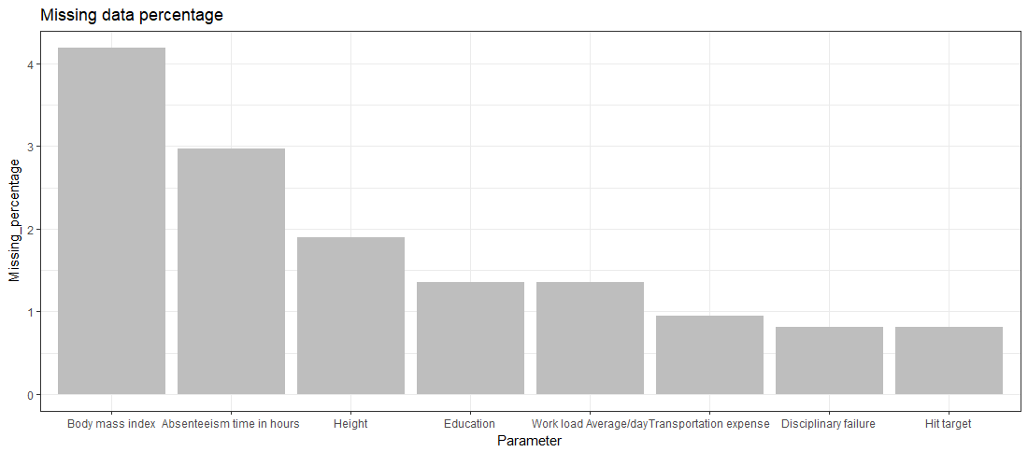

**Fig 2.1:** Missing percentage graph

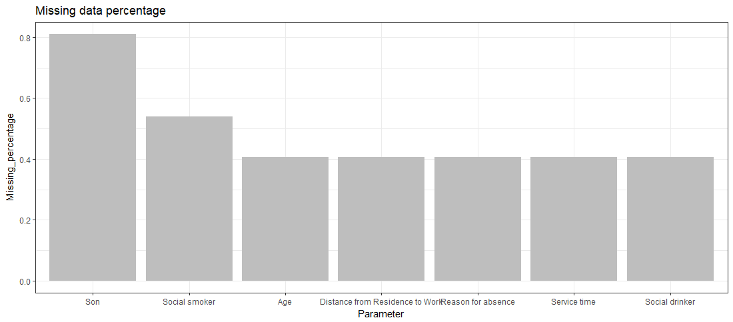

**Fig 2.2:** Missing value percentage

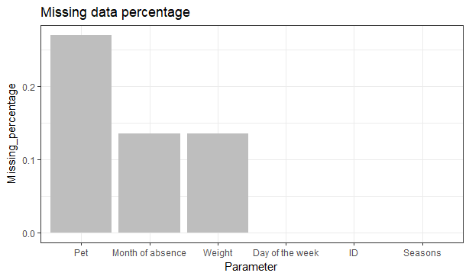

**Fig 2.3:** Missing value percentage

The graph shows all the missing values lies between 4.18% and 0.135%. The highest missing value is in Body mass index where is lowest is in month of absence and weight. Our target variable i.e. Absenteeism time in hours consists of 2.97% of missing values whereas three variables (Day of week, ID, Seasons) does not contain any missing values.

**2.2.2 Outlier Analysis**

Outlier analysis is one of the preprocessing techniques used to check for abnormal values in the data set clean them and transform the data into a proper shape. There are many different techniques like Graphical Tools (Box Plot Method), Statistical technique (Grubbs test), R Package outlier for outlier analysis and replace with NA which will be treated as missing value analysis and will be imputed using suitable method mentioned in missing value analysis. Presence of outlier in our data leads to poor data quality and contamination, low quality measurement and manual errors. The best way to look at outlier is to understand business process i.e. how data is generated and how is the business flow.

We know that outlier analysis is applicable only on numerical variable so we have converted the entire variable in their appropriate data types and separated out numerical variables for outlier analysis. We have plotted box plot for each numerical variable which is shown below.

From the boxplot almost all the variables **except “Distance from residence to work”, “Son”, “Weight” and “Body mass index”** consists of outliers. We have converted the outliers (data beyond minimum and maximum values) as NA i.e. missing values and fill them with mean and median accordingly.

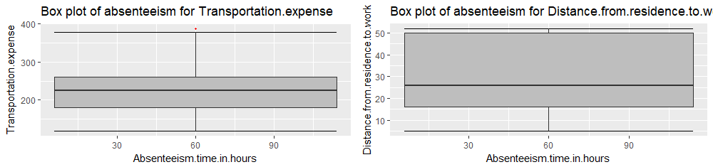

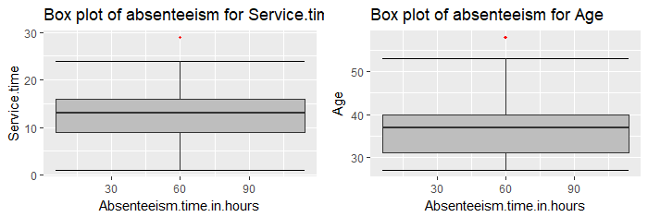

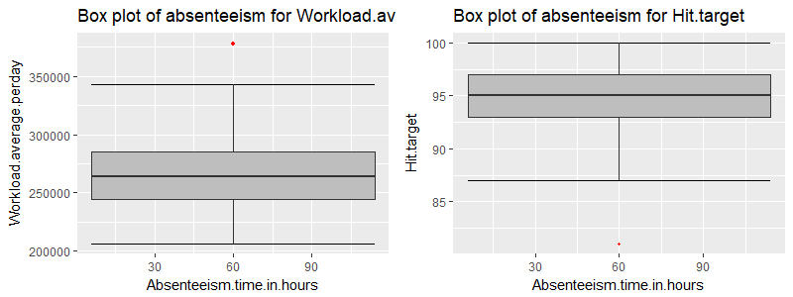

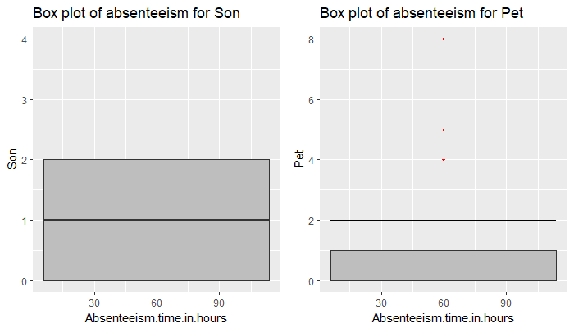

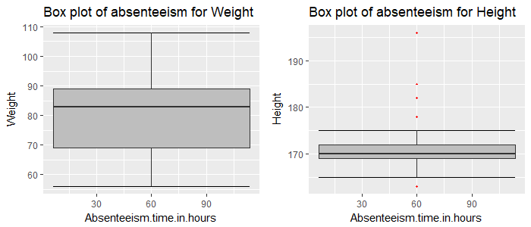

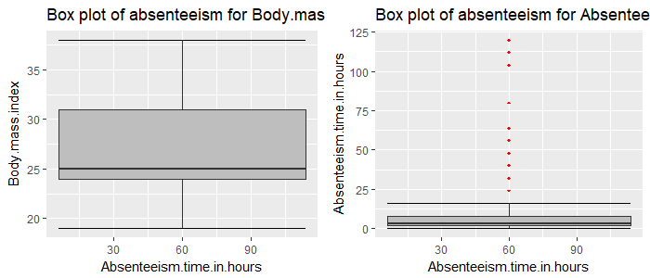

**Fig 2.4:** Box plot of predictors versus absenteeism of train data (with outliers)

**2.2.3 Feature Selection**

Selecting subset of relevant features for model construction is known as Feature Selection. When we get raw data we have multiple variables and with the help of variable selection we have to extract relevant data. We cannot use all the features because some features may be carrying the same information or irrelevant information which does not impact the business solution. To reduce complexity we adopt feature selection technique to extract meaningful features out of it. This in turn helps us to avoid the problem of multi colinearity. Correlation Analysis (for numerical variable), Chi Square Test (for both target and predictor as categorical) and other ML algorithm like Random Forest are some of the methods of feature selection.

**Correlation analysis:** It is one of the methods for feature selection technique applied only on numerical data. Correlation tells us the association between two continuous variables. It ranges for -1 to +1.

**-1: Highly negatively correlated**

**0: No correlation**

**+1: Highly positively correlated**

In correlation there is an assumption that there should be high dependency between predictor and target variable but there should be low dependency between two predictors.

**ANOVA (Analysis of Variance):** It is applied on one categorical and one continuous variable. It is a statistical technique used to compare means of two or more group. We get results in form of p values. If p value is less than 0.05 we will reject NULL HYPOTHESIS (result purely from chance) and accepts ALTERNATE HYPOTHESIS (influenced by some non-random cause).

In our project we have used Correlation plot and ANOVA to select important variables and selected the variables according to the values of correlation and ANOVA. The correlation plot and ANOVA values are given below.

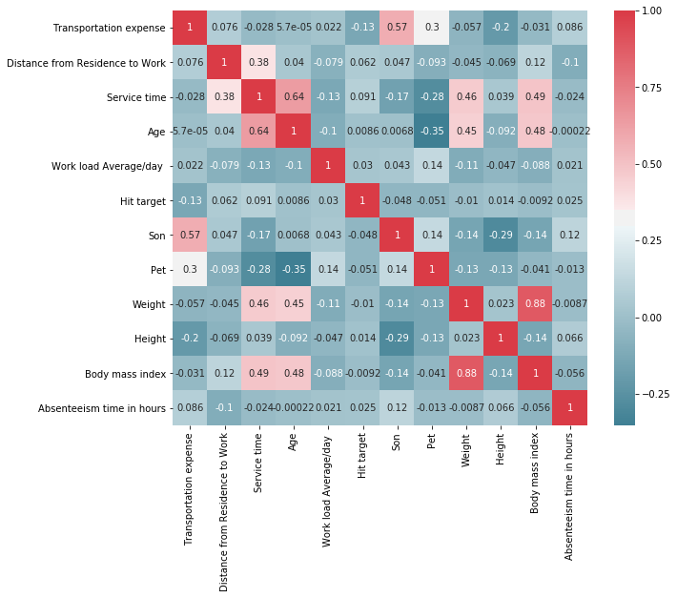

**Fig 2.5:** Correlation between the variables

**Table 2.1:** ANOVA for categorical variable

|  |  |
| --- | --- |
| **Variable name** | **p- value** |
| ID | 0.000149 *** |
| Reason for absence | <2e-16*** |
| Month of absence | 0.0236 * |
| Day of the week | 0.0159 * |
| Seasons | 0.384 |
| Disciplinary Failure | 0.109 |
| Education | 0.694 |
| Social smoker | 0.28 |
| Social drinker | 0.0873 |

After applying correlation analysis and ANOVA out of 20 predictors we are left with 9 predictor variables and the target variable i.e. Absenteeism time in hours. The variables we are considered after applying correlation analysis and ANOVA are:

1. Reason for absence
2. Transportation expenses
3. Distance from residence to work
4. Day of the week
5. Social drinker
6. Workload average/day
7. Service time
8. Height
9. Absenteeism time in hours

**2.2.4 Feature Scaling**

It comes into an action when we are dealing with parameters of different units and scales. It is also known as variable scaling. It is used to limit the range of range of variables so that they can be compared on common basis. Feature scaling is performed only on continuous data. There are two methods to scale the data **Normalisation and Standardisation.** Normalisation is the process of reducing unwanted variation either within or between variables. Normalisation brings all the variables into proportion with one another. It ranges between **0 and 1** and are sensitive to outliers. Normalisation works on all kind of continuous data whereas standardisation works well when data is uniformly distributed.

In our project we have used normalisation as our data is not uniformly distributed. The below plotted histograms shows our data are not uniformly distributed.

**Before Normalisation** **after Normalisation**

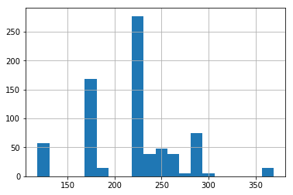 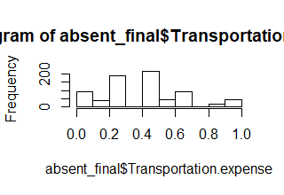

**Fig 2.6:** Normality distribution of transportation expense

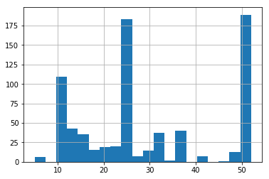 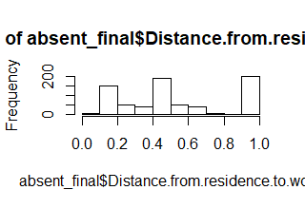

**Fig 2.7:**  Normality dist. of distance from residence to work

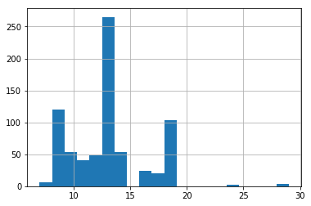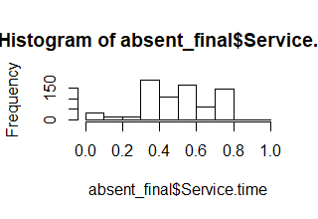

**Fig 2.8:** Normality dist. of service time

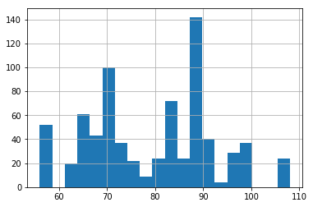 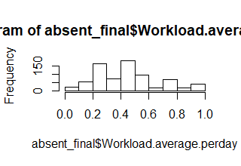

**Fig 2.9:** Normality dist. of weight

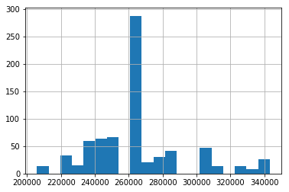 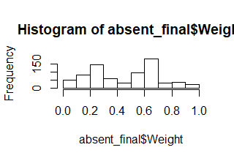

**Fig 2.10:** Normality dist. of work load avg/day

***CHAPTER – 3***

**MODELING**

Data modeling means selecting appropriate ML Algorithm according to our problem statement. There are more than 100 algorithm and we need to select an appropriate one.

**3.1 MACHINE LEARNING ALGORITHM**

Machine Learning means programming computers to optimize a performance criterion using example data or past experience. With help of historical data we try to extract patterns and save it in ML itself. Once a new test case comes in we use that historical pattern to apply on new data to predict its class level.

**3.2 MODEL SELECTION**

There are multiple parameter based on which we select an algorithm to be developed for particular dataset.

1. It depends on problem statement as once we define problem statement then only we will be able to find out which type of problem statement it is.
2. Every ML Algorithm has three components: **Representation, Evaluation and Optimisation.** Some algorithm deliver output in form of business rules some in form of numbers, probability and visualisations.

It depends on client requirement that in which form they want the output. If they want output in form numbers then we will go for regression algorithms.

In our early stages of analysis during pre-processing we have come to understand the customer behaviour pattern on test data. Here in our case the dependent variable “Absenteeism time in hours” is continuous in nature. The table 2.2 represents count of each unique value in the target variable.

**Table3.1:** Absent vs. count of employee

|  |  |
| --- | --- |
| No of hours absent | No of employee absent |
| 8 | 199 |
| 2 | 155 |
| 3 | 110 |
| 1 | 88 |
| 4 | 60 |
| 0 | 36 |
| 16 | 19 |
| 24 | 16 |
| 40 | 7 |
| 5 | 7 |
| 32 | 5 |
| 64 | 3 |
| 80 | 3 |
| 120 | 3 |
| 56 | 2 |
| 112 | 2 |
| 104 | 1 |
| 7 | 1 |
| 48 | 1 |

If the dependent variable is categorical the only predictive analysis that we can perform is **Classification** and if the dependent variable is Interval or Ratio i.e. continuous the normal method is to do a **Regression** analysis or classification after binning. The dependent variable we are dealing with is Regression, for which regression is preferred according to problem statement. We should always start our model building from the simplest to more complex. Here we have used different ML Algorithm on trained data and then applied it on test to predict the future values in both R and Python. Different algorithm gave different results with different accuracy and RMSE.

Before developing any model we need to divide model into train (development) and test (validation). To validate our model first we build our model on training data and then we apply the same model on the test data to predict its target variable. This is because for test data we already have target value. Then we compare its predicted value with the actual value of test data and then we will try to extract accuracy of that model.

The Machine Learning Model we applied in R and Python are as follows:

**3.2.1 *Decision Tree Regression***

Decision Tree is a predictive model based on branching series of Boolean tests. It can be used for both classification and regression. It is one of the most powerful and popular algorithm and belongs to family of supervised learning algorithm. Decision tree is a rule and output of decision tree is in form of simple business rules which is extremely easy to understand by business users.

In our project we have used Decision Tree for both R and Python to predict the output.

**Table 3.2:** Decision tree accuracy table

|  |  |  |
| --- | --- | --- |
| **Decision Tree** | **R** | **PYTHON** |
| **RMSE** | 11.620 | 10.516 |
| **ACCURACY** | 88.38 | 89.484 |

**3.2.2** ***Random Forest***

Random Forest is an ensemble technique that consists of many decision trees. The idea behind Random Forest is to build n number of trees to have more accuracy in dataset. It is called random forest as we are building n no. of trees randomly. In other words, to build the decision trees it selects randomly n no of variables and n no of observations to build each decision tree. It means to build each decision tree on random forest we are not going to use the same data. The method combines Breimans “bagging” idea and the random selection of features.

**Table 3.3:** Random Forest accuracy table

|  |  |  |
| --- | --- | --- |
| **Random Forest** | **R** | **PYTHON** |
| **RMSE (n = 100)** | 11.105 | 11.519 |
| **ACCURACY (n = 100)** | 88.895 | 88.481 |
| **RMSE (n = 200)** | 11.093 | 11.314 |
| **ACCURACY (n = 200)** | 88.907 | 88.686 |
| **RMSE (n = 300)** | 11.114 | 11.359 |
| **ACCURACY (n = 300)** | 88.853 | 88.641 |
| **RMSE (n = 500)** | 11.172 | 11.425 |
| **ACCURACY (n = 500)** | 88.828 | 88.575 |

**3.2.3** ***Linear Regression***

Linear Regression is one of the statistical methods of prediction. It is applicable only on continuous data. To build any model we have some assumptions to put on data and model. Here are the assumptions to the linear regression model.

**Linear relationship**: It assumes that the data which is fed in linear regression model have linear relationship between dependent and independent variable.

**Multivariate normality**: Linear regression assumes that our target variable is normally distributed. It means that it is following the normality assumption.

**No or little Multicollinearity:** Two highly correlated variables in a dataset lead to multicollinearity effect. There is one test called VIF test (Variance Inflation Factor test). We need to run this test before feeding the data to the model to know either our data contains the correlated independent variables or not.

**No Auto Correlation:** It means there should be no correlation between the residuals. When we build a linear regression model we will get residuals (range of errors). Here we assume that there is no auto correlation it means error are independent.

Once our data satisfy these assumptions we go ahead and build linear regression model. Under this model on training data we build equation which carries an intercept and coefficient for all independent variable. Then we save that equation and then once new test data comes in then we allow passing the test case on linear regression equation to estimate the predicted value. Whatever the value predicted that will hold a target value to the new test data.

**Table 3.4:** Linear Regression accuracy table

|  |  |  |
| --- | --- | --- |
| **Linear Regression** | **R** | **PYTHON** |
| **RMSE** | 11.052 | 9.608 |
| **ACCURACY** | 88.948 | 90.392 |

**Table3.5:** Accuracy of all the Models

|  |  |  |  |  |
| --- | --- | --- | --- | --- |
| **Model Name** | **R** | | **PYTHON** | |
|  | **RMSE** | **ACCURACY** | **RMSE** | **ACCURACY** |
| **Decision Tree** | 11.620 | 88.38 | 10.516 | 89.48 |
| **Random Forest**  **n = 100** | 11.105 | 88.89 | 11.519 | 88.48 |
| **n = 200** | 11.093 | 88.90 | 11.314 | 88.68 |
| **n = 300** | 11.114 | 88.85 | 11.359 | 88.64 |
| **n = 400** | 11.172 | 88.82 | 11.425 | 88.57 |
| **Linear Regression** | 11.052 | 88.94 | 9.608 | 90.39 |

*Blue color shows the best accuracy among all the given above models.

***CHAPTER – 4***

**Model Evaluation**

After building number of regression models there are criteria by which they can be evaluated and compared. Model evaluation tells us whether our model is able to accomplish the business object or not. There are different metrics for regression model like **MSE (Mean Square Error), RMSE (Root Mean Square Error), MAPE (Mean Absolute Percentage Error), MAE (Mean Absolute Error) etc.** MSE and RMSE are used for **transition or time series data also called time series analysis** whereas MAPE and MAE are used for normal regression data.

If dataset is transitioned or time based then we go for RMSE. If we want to convert error number in particular percentage we should go for MAPE. Our project is time series multivariate so we have used RMSE as error metric. Accuracy can be calculated as:

**Accuracy = 100 - RMSE**

**4.1 RMSE (Root Mean Square Error)**

RMSE is a popular metric to measure the error rate of time series or transition regression model. It can be only compared between models whose errors are measured in the same units. It can be calculated by squaring the errors, finding their average and taking their square root. It can be mathematically represented as:

|  |  |  |
| --- | --- | --- |
|  |  |  |
| http://www.saedsayad.com/images/RMSE.png  http://www.saedsayad.com/images/actual_predicted.png |  |  |

***CHAPTER – 5***

**WORK LOSS**

The low work performance of the company leads to work loss. One of the major factors of work loss is employee absenteeism. In our project we have predicted the work loss faced by the company in year 2011. We have computed the monthly work loss the company is going to face in coming year with the help of the formula give below. Table 5.1 shows the monthly work loss the company is going to face in year 2011. Work loss can be calculated as:

**Work loss = (Absenteeism time in hours * Work load average/day)/ Service time**

|  | **Workload loss per month** |
| --- | --- |
| **No Absent** | 0 |
| **January** | 6270829 |
| **February** | 5938663 |
| **March** | 15787937 |
| **April** | 10620082 |
| **May** | 7854523 |
| **June** | 8335891 |
| **July** | 15641063 |
| **August** | 5325883 |
| **September** | 6049021 |
| **October** | 8410438 |
| **November** | 10504827 |
| **December** | 8832856 |

**Table 5.1:** Work loss of all the months

***CHAPTER – 6***

**CONCLUSION**

In this project **“Employee Absenteeism”** we have applied different models to predict the final result. For each algorithm we got different accuracy and root mean square error which are acceptable in some case and not considerable in some cases. We applied the algorithm on both R and Python for the same dataset as mentioned in the project.

In R and Python we have selected Linear Regression for predictions as it gave the highest accuracy and rmse which **is 88.94, 90.39 (accuracy) and 11.052, 9.608 (rmse)** respectively. After applying linear regression in both Rand Python we concluded that most of the employees were absent due to health issues and the second reason for their absence was service time. Diseases of nervous system, respiratory system and skin disease are major cause of employee absenteeism. Through this study it is identified that the employees were mostly suffered from health issues. So the company might focus on these two given reasons to minimize absenteeism. Even it is possible to eliminate absenteeism completely by the way of providing valuable means to their internal resources i.e. employees by providing some medical facilities and by creating awareness regarding health. Though absenteeism is invisible but proves fatal for entire company. The work loss the company is going to face every month in year 2011 is given in table 5.1. So by taking preventive measure and reducing absenteeism will help to improve company’s performance.

.

***APPENDIX – A***

***Extra Figures***

***Plots after removing outliers***

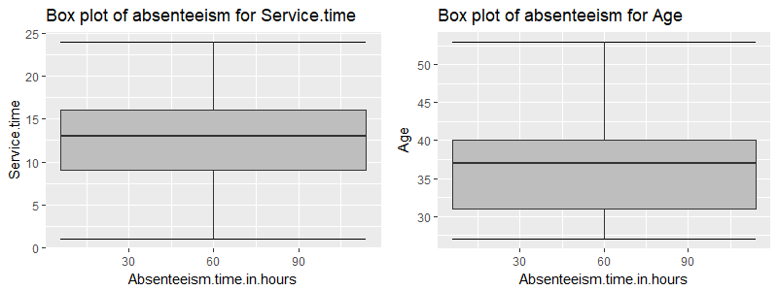

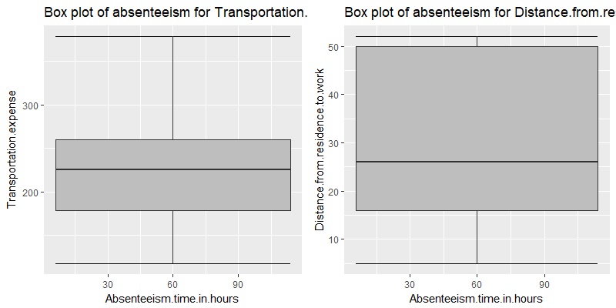

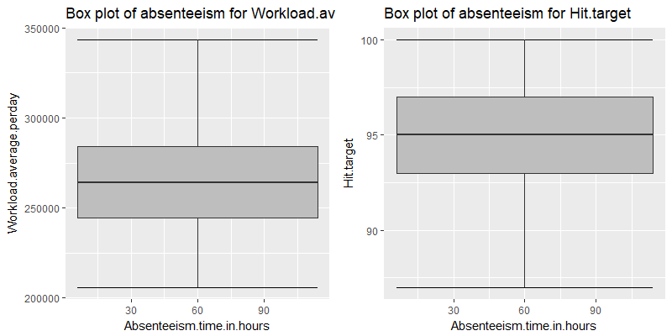



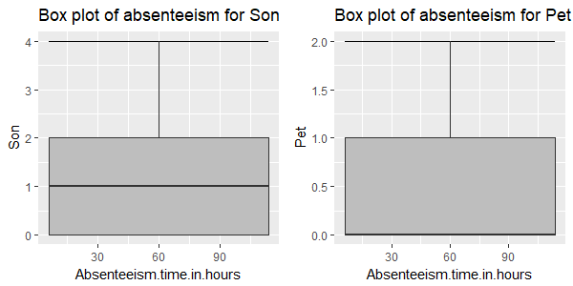

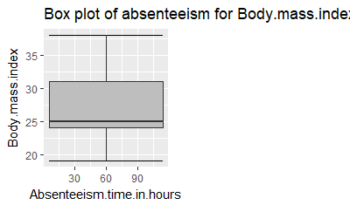

***APPENDIX – B***

***VARIANCE INFLATION FACTOR***

VIF (Variance Inflation Factor) is used to detect and remove multicollinearity. It is one of the assumptions of linear regression. VIF is used only on independent variable. It is calculated by the formula,

VIF = 1/1-r2

Where, r2 = % variance in variables & 1-r2 also called tolerance of the model.

If r2 is high it means the given variable is redundant. So we need not to bring the given variable in the model. It means the given variable is highly correlated. If r2 is low it means the given variable is not redundant and we should include that variable in our model. It means the given variable is less correlated.

Higher the VIF more collinear is the variable which means we should not include that variable in our model. Lower the VIF less collinear is the variable which means it can be included in our model. The VIF values we obtained in our linear regression model are given in table below.

|  |  |  |  |
| --- | --- | --- | --- |
| **Variables Name** | **GVIF** | **Df** | **GVIF^(1/(2*Df))** |
| Reason for absence | 5.210478 | 27 | 1.031040 |
| Month of absence | 4.494072 | 12 | 1.064617 |
| Day of the week | 1.368016 | 4 | 1.039947 |
| Transportation expenses | 1.729534 | 1 | 1.315117 |
| Distance from home | 1.398463 | 1 | 1.182566 |
| Service time | 1.603039 | 1 | 1.266112 |
| Workload avg per day | 1.646295 | 1 | 1.283080 |
| Weight | 1.417460 | 1 | 1.190571 |

***APPENDIX – B***

***Basic Output Terms***

**Residual standard error:** It is also called standard deviation error. It measures the average amount that the coefficient estimates vary from actual average value of our response variable. It helps in calculation of p-value.

**t- value:** It measures how many standard deviation our coefficients are away from 0. Coefficients should be far away from zero because if coefficient of any variable is near to 0 it means that variable is not able to explain the target variable i.e. that variable is an irrelevant variable. With help of t-value we calculate p-value.

**p-value:** It helps us to decide whether to accept or reject the variable i.e. a variable is contributing much information or not.

**F-statistics:** It is a good indicator of whether there is a relationship between our predictor and the response variable. F-statistics should be greater than 1.

**Degrees of Freedom:** Number of observation (training data) – Total number of variable

**R Square:** It is numerical value which tells us the amount of variance of the dependent variable is explained by all independent variable. It tells us how much our model is robust and what the strength of model on training data is.

**Adjusted R Square:** It is derived from R-Square values. Adjusted R Square will penalize the effect of additional variables which are not carrying much information. It should be always less than R Square.

**AIC (Alkaline Information Criteria):** It adjusts the loc likelihood based on the number of observation and complexity of the model.

**BIC (Baisen Information Criteria):** It is similar to AIC but has high penalty for models.

**Omnibus:** Provides combined statistical test for the presence of skewness and kurtosis. Basically it is breakdown of skewness and kurtosis.

**Skew and Kurtosis:** These tests are basically for time series dataset.

**Null Deviance:** It tells us how well the response variable is predicted by the model with intercept only.

**Residual Deviance:** It tells us how well the response variable is predicted by using null deviance and all other independent variables.

***REFERENCE***

1. **“*Edwisor Videos”***
2. **“*Bharatendra Rai”*** *– “YouTube Channel”.*
3. ***“Machine Learning with R”*** – by *“Brett Lantz”.*
4. ***“An Introduction to Data Cleaning with R”*** *–* by “*Edwin de Jonge and Mark van der Loo”.*