2.5.1.198 VCM – 1 Valuation Charge - List

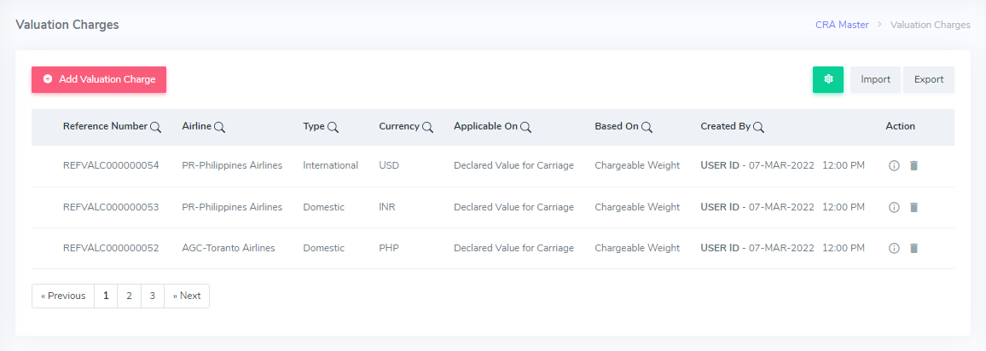

Figure 169.

**Process:**

* The CRA Master allows the user to Add Valuation Charges under the Valuation Charge”.
* This screen will show list of valuation charges in the system.
* The user can create new valuation charges by clicking on “ADD VALUATION CHARGES”.
* The user can upload Valuation Charges master data by clicking the ‘Import’ button.
* Similarly, user can also download Valuation master data by clicking the ‘Export’ button.

**Note: For the updated UI, refer to AM 1 – Agent List screen. Complete process and features of the list screen are explained in AM 1.**

**Rules:**

* 10 latest records get displayed. No. of rows visible to the user is according to the “The rows as per page” option available at bottom of the page. Also, a maximum of 15 rows should be visible to the user on a page.
* By default, latest records get displayed on the top of the table.
* By default, all the columns shown in screen shot get displayed.
* By default, latest records are shown first on the top of the table even after applying filter.
* Updated By Column information get automatically updated as per user activity.
* All the records created manually from “ADD Valuation Charges” will get fetched in the Valuation Charges List automatically.
* The access to this module and windows in this module should be restricted to the senior users of the Advanced CRA department. (Like Super admin-->All the access is given, For Managers,🡪Some level of access is given & For executives, another level of access is provided.)

**Features:**

* The Filter icon would have column names as mentioned in figure below. The columns under list screen would be maintained according to the columns selected by the user to show on the screen.

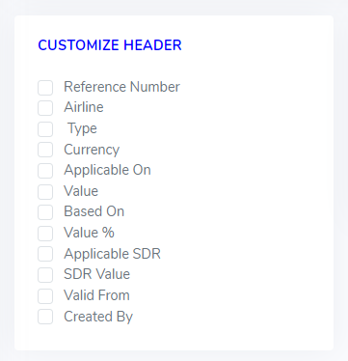

Figure 170.

* Edit, delete and copy buttons would be available on the view screen.
* Any record would be deleted after the confirmation as shown in figure below.



Figure 171.

|  |  |
| --- | --- |
| Reference No. | This is a alphanumeric. seven-letters & nine-digits reference number, created by user & standing in the beginning of each Valuation Charge. |
| Airline | This refers to the code provided for each airline representing the carrier. |
| Type | This refers to the type of cargo weather Domestic or International that valuation charge is associated. |
| Currency | This refers to the currency of airlines in which it is generating invoice. |
| Applicable on | This referring to weather the valuation charge is applicable on Declared value of carriage or No Declared Value of carriage |
| Based on | This refers on what valuation charge is based on weather Gross. Wt. or chargeable Wt. |
| Created By | This refers to the details of the user who last modified the valuation charge details with time stamp to it |
| Action | These are the buttons available to view and delete valuation charge details. |

* **Form Validation**

|  |  |  |  |  |
| --- | --- | --- | --- | --- |
| **Field Name** | **Field Type** | **Field Length** | **Mandatory** | **Source** |
| Reference No. | Numeric | 16 | Y | Backend |
| Airline | Alphabetic | 03 | Y | Backend |
| Type | Alphabetic | 20 | Y | Backend |
| Currency | Alphabetic | 10 | Y | Backend |
| Applicable on | Alphabetic | 10 | Y | Backend |
| Based on | Alphabetic | 10 | Y | Backend |
| Created By | Alpha Numeric | 20 | Y | Backend |
| Action | Buttons | - | Y | Backend |

“Y” represents Yes, and “N” represents No. The mandatory fields would be marked with ‘*’ (red asterisk) on the screen.

1. Pagination is given in the bottom of the table. The user can jump on any page by clicking on page number given on the pagination bar.

2.5.1.199 VCM – 2 Valuation Charge – Add Valuation charge

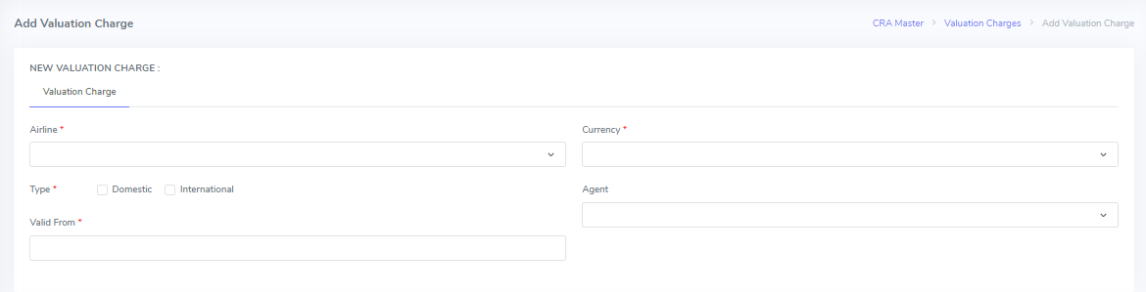

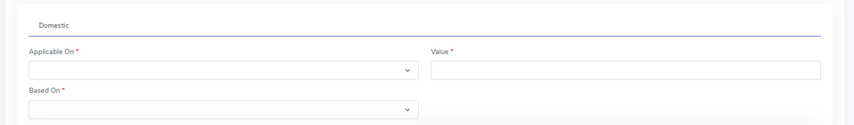

Figure 172 (A).

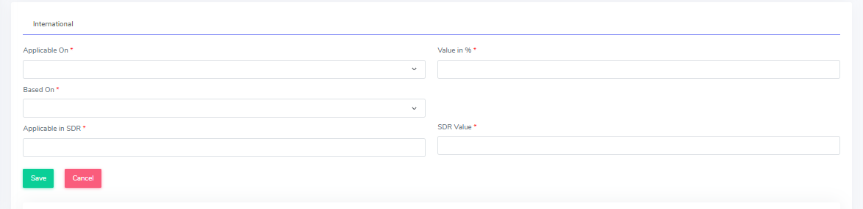

Figure 172 (B)

**Process:**

* This screen is used to add valuation charge in the system.
* The user can add new valuation charge by clicking on ADD Valuation Charge.
* The user needs to fill in all the necessary fields on this screen.
* The user needs to fill the blank fields by typing & select the dropdown fields.
* The user needs to select Type field as “Domestic” or “International”.
* The user needs to click on “SAVE” button to save the valuation charges information successfully.
* Similarly, “Cancel” button to discard the details.

**For the updated UI, refer to AM 2 – Add Agent screen. Complete process and features are explained in AM 2.**

**Rules:**

* The mandatory fields would be marked with ‘*’ (red asterisk) on the screen.
* Airline is mandatory field which need to be filled from the dropdown menu. Airline data is fetched from Airline Master Data.
* Currency is mandatory field which need to be filled from the dropdown menu. The currency data is fetched from Currency Master Data.
* The user needs to opt for Type. It should be selected as “Domestic”, “International”.
* In case, the user opts for Domestic Type, Screen 1 will appear.
* Similarly, in case the user opts for International Type, Screen 2 will appear.
* Agent needs to be filled from the dropdown menu. Agent data is fetched from Agent Master Data.
* Valid From is mandatory field which need to be filled from the Calendar feature manually.
* Applicable On is mandatory field which need to be filled from the dropdown menu. Data is fetched from the system. The user should select either “Declared Value for carriage” or “No value declared” from the dropdown menu.
* Value is mandatory field that needs to be filled manually by typing.
* Based on is mandatory field that needs to be filled from the dropdown menu. User should select either Gross weight or Chargeable weight from the dropdown menu.
* The value in % is mandatory field that needs to be filled manually.
* Applicable in SDR is mandatory field that needs to be filled manually.
* The SDR Value is mandatory field that needs to be filled manually.
* The user needs to Click on “Save” button to save the details successfully.

**Features**

* The Add Valuation Charge screen will have all the details related to a valuation Charge classified into various sections as below:

|  |  |
| --- | --- |
| Airline | This refers to the code provided for each airline representing the carrier. |
| Type | This refers to the type of cargo weather Domestic or International. |
| Currency | This refers to the currency of airlines in which it is generating invoice. |
| Valid From | This refers to the effective date from which the charge will be applicable. |
| Applicable on | This referring to weather the valuation charge is applicable on Declared value of carriage or No Declared value of carriage. |
| Agent | This refers to the agent association to the valuation charge. It is not necessary to fill this field. |
| Based on | This refers on what valuation charge is based on weather Gross. Wt. or Chargeable Wt. |
| Value/ Value % | This refers to the value of the valuation charge in the system in case of Domestic Charge & value% in case of international charge. |
| Applicable in SDR | This shows whether the charge would be applicable in SDR |
| SDR in value | This refers to the value of SDR |

* **Form Validation**

|  |  |  |  |  |
| --- | --- | --- | --- | --- |
| **Field Name** | **Field Type** | **Field Length** | **Mandatory** | **Source** |
| Airline | Alphabetic/  Dropdown | 03 | Y | Fetched from the Airline Master |
| Type | Alphabetic/  Radio Button | 15 | Y | Manual Entry |
| Currency | Alphabetic/  Dropdown | 10 | Y | Fetched from the currency Master |
| Valid From | Date format | 08 | Y | Manual Entry |
| Applicable on | Alphabetic/  Dropdown | 20 | Y | Manual Entry |
| Based on | Alphabetic/  Dropdown | 20 | Y | Manual Entry |
| Agent | Alphabetic/  Dropdown | 10 | N | Fetched from the agent Master |
| Value / Value % | Numeric | 10 | N | Manual Entry |
| Applicable in SDR | Numeric | 10 | Y | Manual Entry |
| SDR Value | Numeric | 10 | Y | Manual Entry |

“Y” represents Yes, and “N” represents No. The mandatory fields would be marked with ‘*’ (red asterisk) on the screen.

2.5.1.200 VCM – 3 Valuation Charge – View Valuation charge

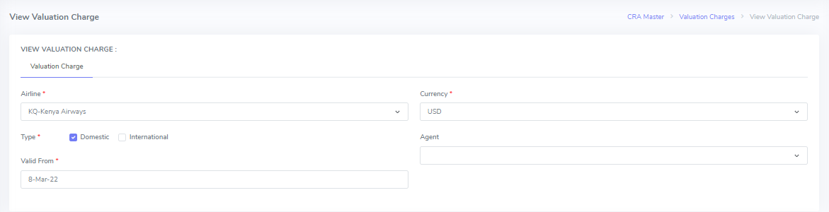

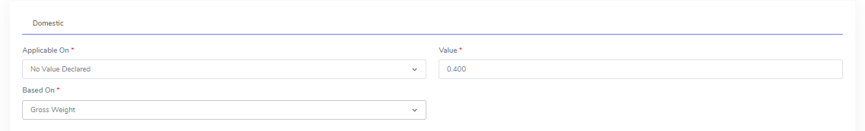

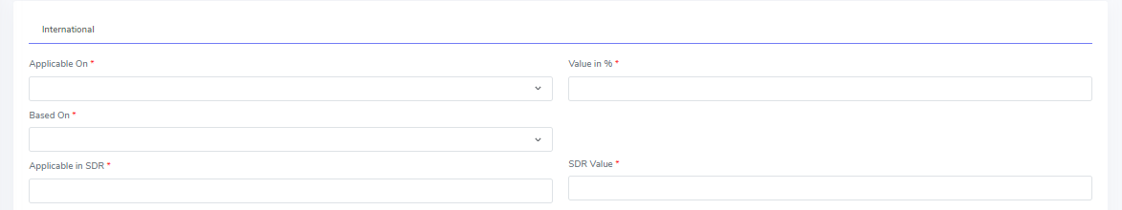

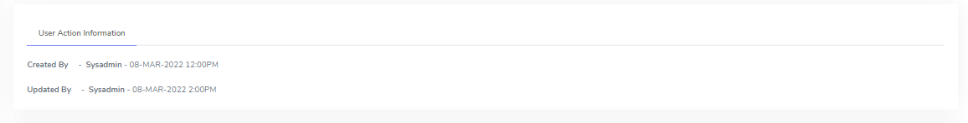



Figure 173.

**Process:**

* This screen is used to view valuation charges details.
* The user can view Valuation charges information by clicking on  button in Action column.
* The user needs to click on “Back” button to view the List back.

**For updated UI, refer to AM 3 – View Agent screen. Complete process and features for view screen are explained in AM 3.**

**Rules**:

* The user can only view the Valuation Charges details and cannot edit the ULD details.
* The user action information is updated automatically as per user Activity.
* The user needs to click on “Back” button at the bottom in order to go back to the List screen.

**Features:**

1. The View Valuation Charges screen will have all the details related to an airline classified into various sections as below:

|  |  |
| --- | --- |
| Airline | This refers to the code provided for each airline representing the carrier. |
| Type | This refers to the type of cargo weather Domestic or International. |
| Currency | This refers to the currency of airlines in which it is generating invoice. |
| Valid From | This refers to the effective date from which the charge will be applicable. |
| Applicable on | This referring to weather the valuation charge is applicable on Declared value of carriage or No Declared value of carriage. |
| Agent | This refers to the agent association to the valuation charge. It is not necessary to fill this field. |
| Based on | This refers on what valuation charge is based on weather Gross. Wt. or Chargeable Wt. |
| Value/ Value % | This refers to the value of the valuation charge in the system in case of Domestic Charge & value% in case of international charge. |
| Applicable in SDR | This shows whether the charge would be applicable in SDR |
| SDR in value | This refers to value of SDR |

* **Form Validation**

|  |  |  |  |  |
| --- | --- | --- | --- | --- |
| **Field Name** | **Field Type** | **Field Length** | **Mandatory** | **Source** |
| Airline | Alphabetic/  Dropdown | 03 | Y | Fetched from the Airline Master |
| Type | Alphabetic/  Radio Button | 15 | Y | Manual Entry |
| Currency | Alphabetic/  Dropdown | 10 | Y | Fetched from the currency Master |
| Valid From | Date format | 08 | Y | Manual Entry |
| Applicable on | Alphabetic/  Dropdown | 20 | Y | Manual Entry |
| Based on | Alphabetic/  Dropdown | 20 | Y | Manual Entry |
| Agent | Alphabetic/  Dropdown | 10 | N | Fetched from the agent Master |
| Value / Value % | Numeric | 10 | N | Manual Entry |
| Applicable in SDR | Numeric | 10 | Y | Manual Entry |
| SDR Value | Numeric | 10 | Y | Manual Entry |

“Y” represents Yes, and “N” represents No. The mandatory fields would be marked with ‘*’ (red asterisk) on the screen.