2.5.1.26 SHG 1 SHC Group – List

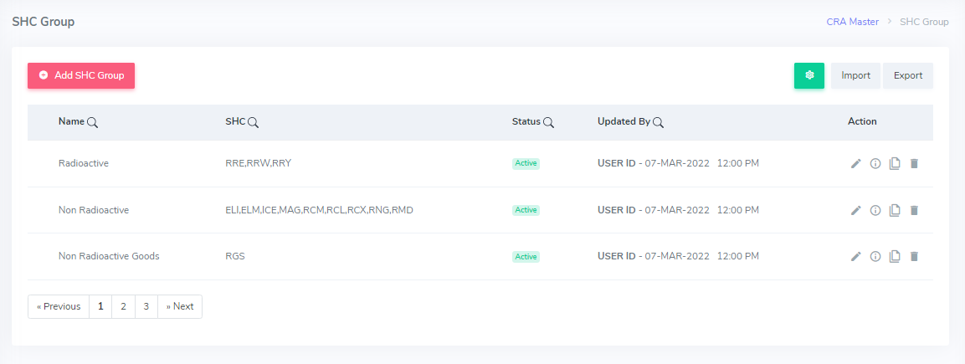

Figure 47.

**Process:**

This screen shows a list of SHC Groups in the system, so that users will be able to cross check the data available under the SHC Group List screen.

* The ‘Add SHC Group’ button on the top left allows the user to create new SHC Groups in the system.
* The user can upload rate type data by clicking the ‘Import’ button.
* Similarly, user can also download rate type information by clicking the ‘Export’ button.

**Note : For the updated UI, refer to AM 1 – Agent List screen. Complete process and features of the list screen are explained in AM 1.**

**Rules:**

* By default, 10 latest records get displayed. No. of rows visible to the user is according to the “The rows as per page” option available at bottom of the page. Also, a maximum of 15 rows should be visible to the user on a page.
* The access to this module and windows in this module should be restricted to the senior users of the Advanced CRA department. (Like Super admin-->All the access is given, For Managers,🡪Some level of access is given & For executives, another level of access is provided.)
* The data reflected on the list screen should match with data available under each record.
* Latest records should get reflected at the top of list.
* Screen Name ( Like ‘SHC Group’) should be visible at the top left corner of the list screen.
* Navigation for the screen should be available at top right corner as shown in the figure. ( CRA Master -> SHC Group).

**Features:**

* The Filter icon would have column names as mentioned in figure 37. The columns under list screen would be maintained according to the columns selected by the user to show on the screen.

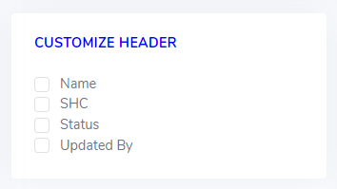

Figure 48.

* Edit, delete and copy buttons would be available on the view screen.
* Any record would be deleted after the confirmation as shown in figure 38.

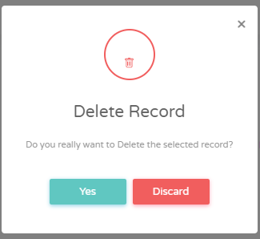

Figure 49.

|  |  |
| --- | --- |
| Name | This refers to the name of SHC Group. |
| SHC | This refers to SHCs which comes under a particular SHC Group. |
| Status | This refers to the status, whether it is Active or Inactive. |
| Updated by | This is the user ID of the user who last updated the record.  This is the time stamp of the last update of the record. |
| Action | These are the buttons available to edit, view, copy and delete details. |

* **Form Validation**

|  |  |  |  |  |
| --- | --- | --- | --- | --- |
| **Field Name** | **Field Type** | **Field Length** | **Mandatory** | **Source** |
| Name | Alpha Numeric | 50 | Y | Backend |
| SHC | Alpha Numeric | 50 | Y | Backend |
| Status | Alphabetic | 10 | Y | Backend |
| Updated By | Alpha Numeric/  Date format/  Time | 50 | Y | Auto fetched through login, time |
| Action | Buttons | - | Y | Backend |

“Y” represents Yes, and “N” represents No. The mandatory fields would be marked with ‘*’ (red asterisk) on the screen.

2.5.1.27 SHG 2 SHC Group – Add SHC Group

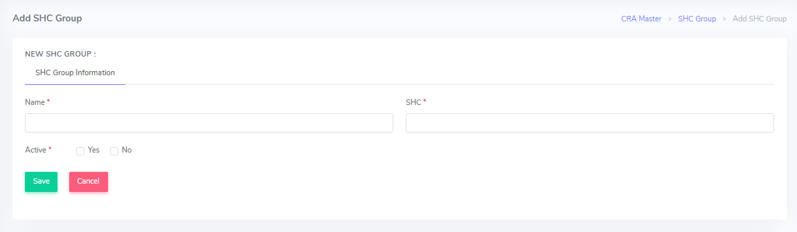

Figure 50.

Process

* The user can create a new rate type by clicking on the “Add SHC Group “button from the list screen. The user has to fill in all the necessary fields on this screen.
* The ‘Save’ button saves the information filled as new record.
* The ‘Cancel’ button cancels the information filled and redirects to the SHC Group List screen.

**For the updated UI, refer to AM 2 – Add Agent screen. Complete process and features are explained in AM 2.**

**Rules**

* Only a single record can be added at once.
* The mandatory fields would be marked with ‘*’ (red asterisk) on the screen.
* If the user clicks on ‘Save’ button without filling all the mandatory fields, the record would not be saved until all mandatory fields are filled.
* If the user clicks on ‘Cancel’ button, it should redirect to the list screen.
* After clicking on ‘Save’ button, the newly added data should be reflected on the list screen.
* Data under dropdown for ‘SHC’ field should be reflected from SHC Master.
* User should be able to select multiple SHCs from the dropdown.
* Screen Name ( Like ‘Add SHC Group’) should be visible at the top left corner of the list screen.
* Navigation for the screen should be available at top right corner as shown in the figure. ( CRA Master -> SHC Group -> Add SHC Group).

**Features**

**SHC Group Information**

|  |  |
| --- | --- |
| Name | This refers to the name of SHC Group. |
| SHC | This refers to SHCs which comes under a particular SHC Group. |
| Active | This shows whether SHC Group is active or not. |

* **Form Validation**

|  |  |  |  |  |
| --- | --- | --- | --- | --- |
| **Field Name** | **Field Type** | **Field Length** | **Mandatory** | **Source** |
| Name | Alpha Numeric | 50 | Y | Manual Entry |
| SHC | Alpha Numeric/  Dropdown | 3 | Y | SHC Master |
| Active - Yes | Alphabetic/  Radio Button | - | Y | Backend |

“Y” represents Yes, and “N” represents No. The mandatory fields would be marked with ‘*’ (red asterisk) on the screen.

2.5.1.28 SHG 3 SHC Group – Edit SHC Group

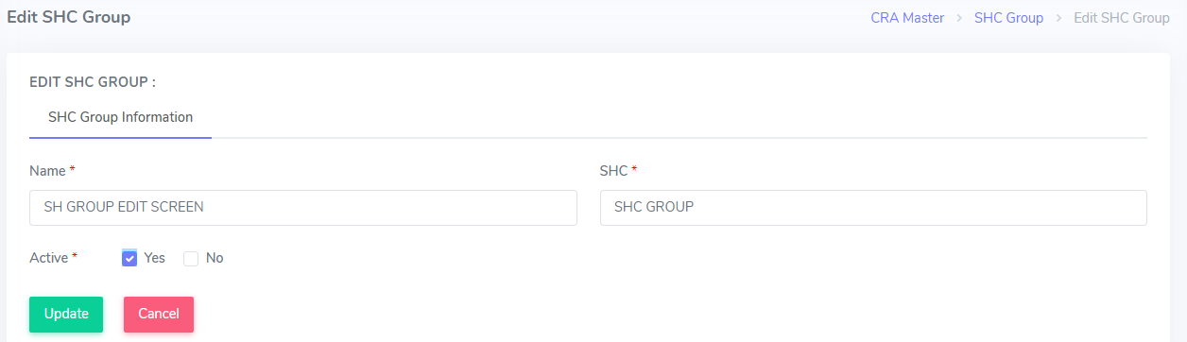

Figure 51.

Process

* This is Edit SHC Group screen which allows user to edit records. User can edit details by clicking on the “Edit” action button. It redirects to the Edit SHC Group page that contains all the detailed information related to a particular SHC Group.
* The “Update” button updates the edited information.
* The “Back” button redirects to the SHC Group List screen.

**Rules**

* Only a single record can be selected to Edit any record.
* All the fields should be available for editing.
* Under the Edit screen, Update and Cancel buttons should be available.
* If the user edits any detail and clicks on ‘Update’ button, data should get updated and should be reflected on the list screen.
* If the user clicks on ‘Cancel’ button, it should redirect to the list screen.
* Screen Name ( Like ‘Edit SHC Group’) should be visible at the top left corner of the list screen.
* Navigation for the screen should be available at top right corner as shown in the figure. ( CRA Master -> SHC Group -> Edit SHC Group).

**Features**

**SHC Group Information**

|  |  |
| --- | --- |
| Name | This refers to the name of SHC Group. |
| SHC | This refers to SHCs which comes under a particular SHC Group. |
| Active | This shows whether SHC Group is active or not. |

* **Form Validation**

|  |  |  |  |  |
| --- | --- | --- | --- | --- |
| **Field Name** | **Field Type** | **Field Length** | **Mandatory** | **Source** |
| Name | Alpha Numeric | 50 | Y | Manual entry |
| SHC | Alpha Numeric/  Dropdown | 3 | Y | SHC Master |
| Active- Yes | Alphabetic/  Radio Button | - | Y | Backend |

“Y” represents Yes, and “N” represents No. The mandatory fields would be marked with ‘*’ (red asterisk) on the screen.

2.5.1.29 SHG 4 SHC Group – View SHC Group

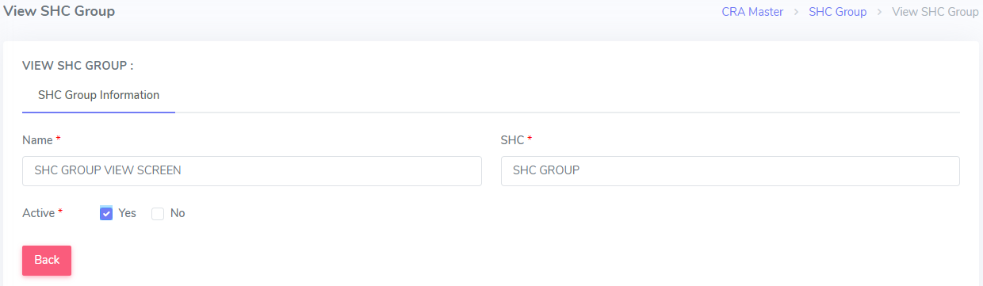

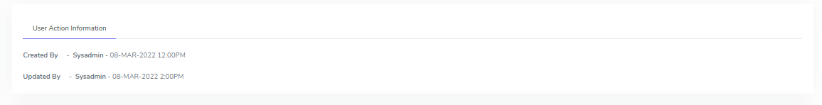

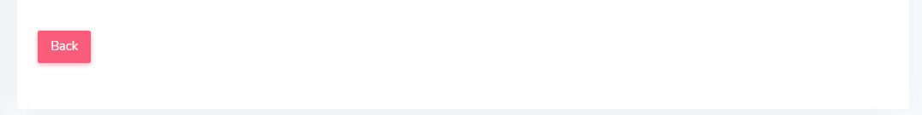

Figure 52.

Process

* The user can view details by clicking on the “View” action button. It redirects to the View SHC Group page that contains all the detailed information related to a SHC Group.
* There is User Action Information available with this screen which shows the User ID and the time stamp of the user which created and last updated the record.
* The “Back” button redirects to the SHC Group List screen.

**For updated UI, refer to AM 3 – View Agent screen. Complete process and features for view screen are explained in AM 3.**

**Rules**

* Only a single user record can be selected to View SHC Group information.
* Only “Back” button would be available on this screen and user cannot edit any details.
* User Action Information will be system generated. ‘Created By’ will show the User ID and time stamp of the user who created the SHC Group in the system.

‘Updated By’ will show User ID and time stamp of the last user that updated the information.

* All the details should be reflected correctly.
* If the user clicks on ‘Back’ button, it should redirect to the list screen.
* Screen Name ( Like ‘View SHC Group’) should be visible at the top left corner of the list screen.
* Navigation for the screen should be available at top right corner as shown in the figure. ( CRA Master -> SHC Group -> View SHC Group).

**Features**

**SHC Group Information**

|  |  |
| --- | --- |
| Name | This refers to the name of SHC Group. |
| SHC | This refers to SHCs which comes under a particular SHC Group. |
| Active | This shows whether SHC Group is active or not. |

* **Form Validation**

|  |  |  |  |  |
| --- | --- | --- | --- | --- |
| **Field Name** | **Field Type** | **Field Length** | **Mandatory** | **Source** |
| Name | Alpha Numeric | 50 | Y | Manual Entry |
| SHC | Alpha Numeric/  Dropdown | 3 | Y | SHC Master |
| Active - Yes | Alphabetic/  Radio Button | - | Y | Backend |

“Y” represents Yes, and “N” represents No. The mandatory fields would be marked with ‘*’ (red asterisk) on the screen.

2.5.1.30 SHG 5 SHC Group – Copy SHC Group

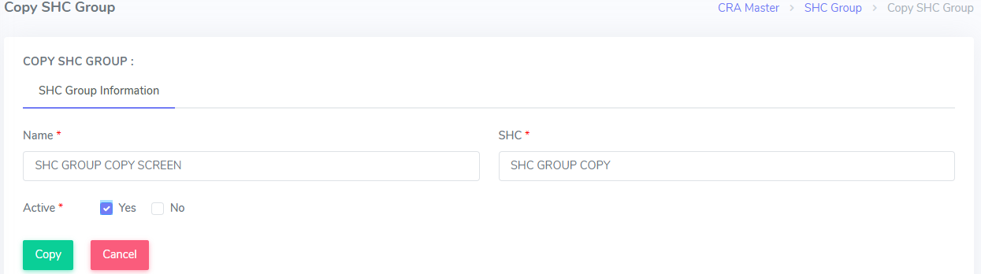

Figure 53.

**Process**

* This screen allows the user to duplicate and existing SHC Group information and create a new record.
* The user can copy an existing record by clicking on the “Copy” action button.
* The “ Copy “ button at the bottom copies the details and save as a new record.
* The “Cancel “ button at the bottom of screen cancels the information filled and redirects to the SHC Group List screen.

**Rules**

* Only a single user record can be selected to Copy any record.
* “Name” field should be unique and it would not be get copied.
* Under the Copy screen, Copy and Cancel buttons should be available.
* If the user copies any detail and clicks on ‘Copy’ button, a new record should be created and should be reflected on the list screen.
* If the user clicks on ‘Cancel’ button, it should redirect to the list screen.
* Screen Name ( Like ‘Copy SHC Group’) should be visible at the top left corner of the list screen.
* Navigation for the screen should be available at top right corner as shown in the figure. ( CRA Master -> SHC Group -> Copy SHC Group).

**Features**

**SHC Group Information**

|  |  |
| --- | --- |
| Name | This refers to the name of SHC Group. |
| SHC | This refers to SHCs which comes under a particular SHC Group. |
| Active | This shows whether SHC Group is active or not. |

* **Form Validation**

|  |  |  |  |  |
| --- | --- | --- | --- | --- |
| **Field Name** | **Field Type** | **Field Length** | **Mandatory** | **Source** |
| Name | Alpha Numeric | 50 | Y | Manual Entry |
| SHC | Alpha Numeric/  Dropdown | 3 | Y | SHC Master |
| Active - Yes | Alphabetic/  Radio Button | - | Y | Backend |

“Y” represents Yes, and “N” represents No. The mandatory fields would be marked with ‘*’ (red asterisk) on the screen.