**A**

**PRACTICAL TRAINING PROJECT REPORT**

**ON**

**(SQL)**

*In partial fulfillment of*

***B.Tech. III yr* (Computer Science & Engg.)**

**Work Carried Out At “Celebal Technologies”**

Submitted To: Submitted by:

---------------------- --------------------------

Mr.Hemant Pareek SQL-1

Assistant Professor Vivek Chhangani

Sharve Parihar

Sailesh Verma

CSE,III Year

# **Acknowledgment**

We would like to express our special thanks to our mentor Mr. Hemant Pareek for his guidance throughout the given project time .

We also thank the Celebal Technologies who gave us a wonderful opportunity and resources to enhance our skills in the field of SQL.

# **Preface**

We have made this report regarding our summer internship in the field of SQL at Celebal Technologies from May –July 2021 .

This report will demonstrate the project we have made during our summer internship and about SQL and its fundamental concepts :-

* SQL Joins.
* Nested and Sub Queries.
* SETs.
* Conditional Statements.
* SQL CASE Statements.

# **CERTIFICATE FROM THE COMPANY**

# **Table of Contents**

**ACKNOWLEDGMENT 2**

**PREFACE 3**

**CERTIFICATE FROM THE COMPANY 4**

**1. TABLE OF CONTENTS 5**

**2. INTRODUCTION 6**

**3. COMPANY/ORGANIZATION OVERVIEW 7**

**4. Details of Technology studied and project work carried out during training 8**

**5. APPLICATIONS 10**

**6. CONCLUSION 11**

# **Introduction**

## **What is SQL?**

* SQL stands for Structured Query Language
* SQL lets you access and manipulate databases
* SQL became a standard of the American National Standards Institute (ANSI) in 1986, and of the International Organization for Standardization (ISO) in 1987.

**2.2 Rules:**

* SQL follows the following rules:
* Structure query language is not case sensitive. Generally, keywords of SQL are written in uppercase.
* Statements of SQL are dependent on text lines. We can use a single SQL statement on one or multiple text line.
* Using the SQL statements, you can perform most of the actions in a database.
* SQL depends on tuple relational calculus and relational algebra.

**2.3 SQL process:**

* When an SQL command is executing for any RDBMS, then the system figure out the best way to carry out the request and the SQL engine determines that how to interpret the task.
* In the process, various components are included. These components can be optimization Engine, Query engine, Query dispatcher, classic, etc.
* All the non-SQL queries are handled by the classic query engine, but SQL query engine won't handle logical files.

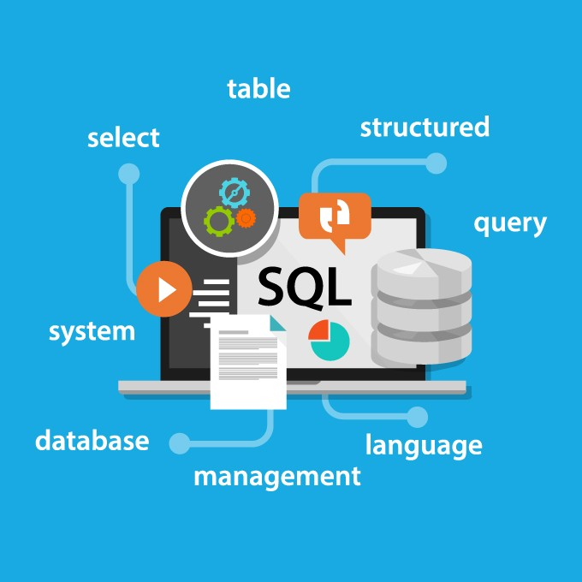

# **Company/Organization Overview**

Celebal Technologies is a premier software services company in the field of Data Science, Big Data and Enterprise Cloud. Celebal Technologies helps you to discover the competitive advantage by employing intelligent data solutions using cutting-edge technology solutions that can bring massive value to your organization. The core offerings are around "Data to Intelligence", wherein we leverage data to extract intelligence and patterns thereby facilitating smarter and quicker decision making for clients. Celebal Technologies solutions are powered by Robotics, Artificial Intelligence and Machine Learning algorithms which offer improved business efficiency in the interconnected world. We have hands-on experience in developing and performing supply chain analytics and media greenlighting solutions, connect the dots across data pits for generating actionable insights. We help modernize legacy and on-premise applications by leveraging modern cloud paradigms such as Microservices, Advance Analytics, API Management and other Cloud-native services. With Celebal Technologies, who understands the core value of modern analytics over the enterprise, we help the business in improving business intelligence and more data-driven in architecting solutions. Our analytics team caters to ad-hoc and defined business analytics

Website: <http://celebaltech.com/>

Phone: 14700659

**Industry:** Information Technology & Services

**Company size:** 201-500 employees

**Headquarters :**Jaipur, Rajasthan

**Type:** Privately Held

**Founded:** 2015

**Specialties:**

Machine Learning, Artificial Intelligence, Big Data, Azure, Business Intelligence, Microsoft Dynamics 365, CRM, Power BI, InternetOfThings, ChatBot, EnterpriseBots, MicrosoftTeams, DeepLearning, NLP, Transformers, Supply Chain Analytics, and DC Migration

# 

# Details of Technology Used and project work carried out during Internship

**Objective:** To extract the data from databases for the following case statements

* SQL Project Planning
* Placements
* Symmetric Pairs
* Interviews
* 15 Days of Learning SQL
* Weather Observation Station 18
* Occupations
* New Companies
* Binary Tree Nodes

Technology Used: SQL(MySQL), Hackerrank IDE

## Flow Chart

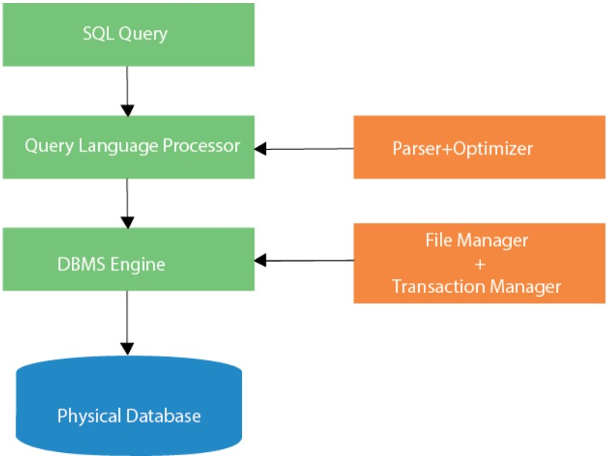

**Project link:**

[**https://docs.google.com/document/d/1lst-AlQJkaGbmdOQCVGVjsHfT3yDWHCadQK3FwnjtOg/edit?usp=sharing**](https://docs.google.com/document/d/1lst-AlQJkaGbmdOQCVGVjsHfT3yDWHCadQK3FwnjtOg/edit?usp=sharing)

# **Applications**

SQL applications that make it so important in a data-driven world where managing huge [databases](https://intellipaat.com/blog/what-is-database/) is the norm of the day.

* SQL is used as a Data Definition Language (DDL) meaning you can independently create a database, define its structure, use it and then discard it when you are done with it
* SQL is also used as a Data Manipulation Language (DML) which means you can use it for maintaining an already existing database. SQL is a powerful language for entering data, modifying data and extracting data with regard to a database
* SQL is also deployed as a Data Control Language (DCL) which specifies how you can protect your database against corruption and misuse.
* SQL is extensively used as a Client/Server language to connect the front-end with the back-end thus supporting the client/server architecture
* SQL can also be used in the three-tier architecture of a client, an application server and a database which defines the Internet architecture.

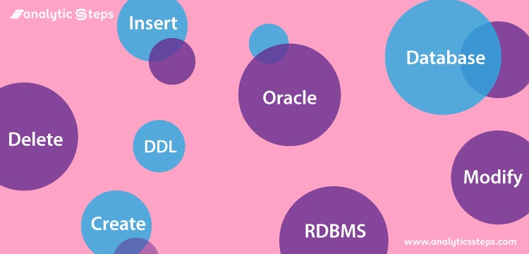

# **Conclusion**

Our overall experience in making the project was great. We have explored advanced knowledge of SQL such as Advanced Joins and Subqueries.

During discussions we have learnt about the already known concepts in more detail.

With all the knowledge we have and the guidance of Celebal Technologies and Mentor , We have successfully completed this project and learned a lot.

**References**

* <https://www.w3schools.com/sql/sql_syntax.asp>
* <https://www.w3schools.com/sql/sql_ref_union.asp>
* <https://www.w3schools.com/sql/sql_join.asp>
* <https://www.geeksforgeeks.org/pivot-and-unpivot-in-sql>.
* <https://stackoverflow.com/questions/4095000/how-to-calculate-the-manhattan-distance-with-sql-function-procedure>